Report Title: EFFECTIVE COMMUNICATION IN THE WORKPLACE.
Student Name: OLUWATOYIN ADETOUN RUFAI.
STUDENT NO-1904787
Module Name: Effective Team Working and Communication.
Lecturer’ Name: TIM HOPKINS.
Date:30.12.19.

Table of content
- Introduction……………………………………………………………………………. p.3
- What is communication…………………………………………………………… p.3
- The importance of communication……………………………………………p.3-4
- The barriers to communication………………………………………………. p.4
- The different types of communication……………………………………. p. 4-5
- The method of communication…………………………………………………p. 5-6
7.The Relevant theories (Shannon and Weaver) ……………………………. p. 6-7
8. Schramm and Berol’s communication model…………………………………. P.7
9.The importance of communication in my workplace………………………. P.8
10 Conclusion……………………………………………………………………………………. p.8
11. Lists of references………………………………………………………………………. p. 9-10
12. Appendices……………………………………………………………………………… p. 11-22

This report will consider communication and its importance; the different elements of communication and it includes how communication can be made effective in a business organisation and the purpose of communication between management and employees. Communication is an act of transmitting or passing information, thoughts or ideas from one place, person or group, organisation to another (Your Article Library, 2019). According to your Article Library (2019), Communication is a process when meaningful conversations are perceived, and understanding are reached among persons. Moreover, Maund, Schriek and Tinkler (2017), defines communication as an interchange of facts, ideas, opinions or emotions by two or more people. The course of any communication needs minimum of one sender, a receiver, and a message that is transferred within a medium of communication. It starts as a thought in the mind of a sender when the individual encodes the messages, normally, in the form of verbal communication for instance, spoken or written words and non-verbal communication for instance pictures or gestures. It is transmitted in body language, vocally or in writing form, and the receiver decodes the message (Maund, Schriek and Tinkler, 2017).
Communication is important in the workplace; it is an essential instrument in attaining productivity and maintaining strong working relationships at all level in the workplace. It helps develop trust among employees. Workers that communicate effectively with colleagues, managers, service users and their family are always precious assets to a business, and it is also a skill that will increase employability when applying for a job (Michael Page, 2019). On the other hand, Michael Page (2019), says poor communication will lead to staff not getting motivated and lack confidence in their organisation.
Written communication is important for the correct keeping of record and it also includes details that is regarding the care needs of residents, for instance, the service users’ care plans, daily care and handover notes, reports and assessments. A written down information should be accurate, correct, educative and with good intention.
As well as acknowledging that communication skills is important, it is important to know that effective communication is vital between management and employees. Effective communication between management and employees keep relationships within the workplace very strong; there is easy access to technology for example colleagues can contact one another anywhere without meeting one to one (Richards, 2019). In addition, Richards (2019), implies that without good communication there will not be trust and honesty amongst staff. Furthermore, Kramer (2014), says effective communication gives employees ability to trust and leaders getting to know what is expected of them. Secondly, management role is to inform, instruct, direct and give direction about the policies and procedures.
There some barriers to communication that could result to poor communication because of restriction to the medium of communication between someone who transmits a message and the receiver (Toppr, 2019). Additionally, Toppr (2019), suggests that the following are some of the barriers to effective communication for instance, language, psychological, emotional, cultural and physical barriers. An example of a barrier is cultural barrier in the workplace. Cultural barriers could arise because there may be people from diverse places in the world with various cultures for example: dressing, religion, foods, drinks and their way of behaving may be different from one culture to another (Toppr, 2019).
According to Kramer (2014), there are different types of communication which includes Verbal communication. Verbal communication involves face to face discussion, telephone, radio or television and other media. Non-verbal communication is another type of communication. Non-verbal communication involves body language, hand gestures or signals, tone of voice, and proxemics. In addition to this, Moss (2012), mentions that non-verbal communication, is a full bunch of information, signals and symbols on how human beings transmits messages. Also, Maund, Schriek, Tinker (2019), adds that non-verbal is known as body language which involves the method, we communicate without written or spoken words that provide meaning to a person. There is also written communication - this includes letter, emails, books, social media and magazine. Lastly is the visual communication which are graphs and charts, maps, logos, and other visual communication aids.
Also, Kramer (2014), says that verbal and written communication in the workplace includes formal and informal communication. Formal communication is the main one that discusses subjects like the policies and procedures of the workplace, job compensation, promotion offer, and important occasion in the organisation, then informal communication is casual chatting for instance inviting a colleague to eat lunch together or a phone call to remind a manager and co-worker of an upcoming meeting. In addition, Kramer (2014), mentioned that communication also includes upward communication which is between employee to manager and then downward communication is among manager and employer.
Furthermore, Brotherton and Parker (2013), implies that good listening is part of communication skills which needs you to pay attention to the verbal and non-verbal messages that is sent, to know the meaning of the message and also active listening is centred to promote interpersonal relationships with colleagues, managers and service users. In addition, spoken or verbal communication is the most common ways that people speak to each other, the message we transmits must include correct explanation and meaning, otherwise, the spoken word will not be understood and as a health care worker, you must make use of your communication skills and capabilities to interpret the message of other people (Maund, Schriek and Tinkler, 2017).
According to Belonwu (2018), ways to improve effective communication are as follows: To begin with, Open meeting is an easier way to communicate how you feel and the love for the job to your team. It is the best approach to communicate effectively with a team because as a leader it will enable you to listen more to your team than you speak. During meeting, do not speak too quickly or mumble words, talk clearly to enable your team to hear you properly. Secondly, Emails will allow you to pass messages to your team without getting them out of their house or duty posts. Thirdly, some people prefer the one to one basis because they understand better when you call them aside and talk to them face to face, maintaining eye contact and in a friendly atmosphere. Lastly, communication via training is specially made to contain information that is essential to your team members role. Most health care workers take training very seriously because it may be part of their appraisal which is beneficial in becoming a skilful individual.
Belonwu (2018), also suggests that another means of communicating effectively to the team is to use simple words that can be easily understood. Secondly, another method is to use the appropriate tone of voice to communicate the message to the team members so that one will not be misunderstood or dissuade the team to cease from communicating out of fear. Thirdly, body language will send a message to the team faster and better, for example, eye contact, hand gestures, sit up straight and use smiles. Also, it is important to thank the team for their time after communication session. Lastly, communication can be done visually by placing visuals at important areas around the workplace which gives room for better understanding. It is suggested that some people get messages easily when pictures and sounds are used (Belonwu,2018). For instance, using presentations like Microsoft power point to communicate to the team and this will enable them to go back to it if they are not clear or unsure about things. Moreover, do not converse and walk away, give room for feedbacks to know how effective the method of communication that is being used (Belonwu,2018).
There are three relevant theories of communication which includes, Shannon and Weaver, Schramm and Berlo. Shannon and weaver model of communication explains that communication can be broken down into 7 very important concepts. These are sender, encoder, channel, noise, decoder, receiver and feedback. The 7th concept (feedback) was the newest type of the theory by Warren Weaver. The model is known as information theory or the Shannon theory because he was the main person who established the theory (Drew, 2019). In addition, Drew (2019), implies that it is also known as the mother of all models because it is recognised everywhere. The model’s primary aim is by explaining how messages are lost and misinterpreted in the communication process and it also provides a structure for examining how messages are sent and received.

Sender (the information source) begins with the person who has the information to start the origin of a message. The process is started when the sender selects a message to send, someone to send the message to, and the channel through which the message will be sent. A sender can send a message in so many ways and this may be through verbal words, in writing, body language and music (Drew, 2019). Secondly, the Encoder (Transmitter) is the person that turns a notion into signals, orally, written or sign language to communicate to an individual then the Channel is the medium that receives information from the sender and encoder and then send it to the decoder and receiver. Thirdly, Noise is when a message is interrupted by noise on its way from the sender to the receiver. The noise could make the receiver misunderstand the message. Finally, Drew (2019), wrote that Receiver (Destination) is where the person finally receives the message and then feedback is the last theory, and this happens when the receiver of the message responds to the sender how well they understood the message.
(Drew, 2019)
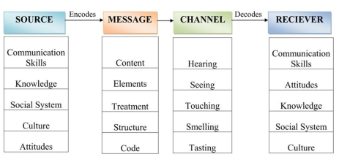
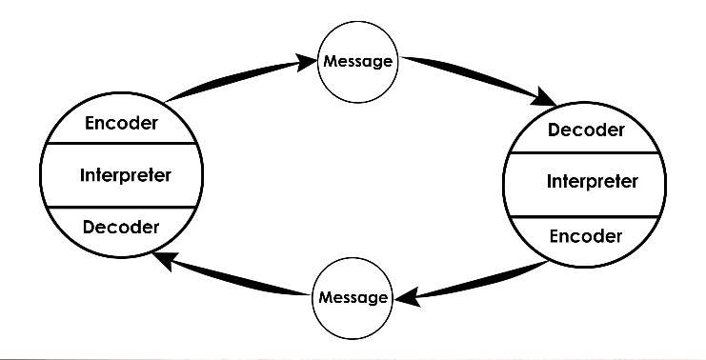
The Osgood-Schramm is a model that is constructed on the theory that communication is a two-way system which involves a sender and a receiver (Hendricks,2019). Furthermore, Hendricks (2019), implies that this model of communication is in a cycle than straight and it requires two people taking turns in sending and receiving messages. The Osgood- Schramm model is simple, and it consists of the following parts. The sender- this is the person who encodes and send the message. In the second place is message and this is shared amongst two people. Also, is the receiver who is the individual who interprets or decodes the message. Finally, in the schramm model of communication is the semantic barriers which is a misunderstanding of the words used that causes the message to be interpreted in a different way that was not planned (Hendricks, 2019). Also, Hendricks (2019), says that the advantages of this model are that it gives a simple way of communicating with the sender and the receiver in a circular way. This allow two people to play a part equally and split their feedbacks which is a verification that the message has been received and decoded.
(Communication Theory, 2019)
In 1960, David Berlo elaborated the straightforward communication model and produced the SMCR model of communication. According to Janse (2018), Berlo SMCR model of communication stands for the mechanism of communication in an uncomplicated way which includes the sender, message, channel and receiver. Janse (2018), explained that the sender of the message is the author who produced and sent the message to the receiver and the sender is also the beginning of the communication process in which the individual encodes the message. Secondly Janse (2018), says that massage is a medium of communication that is sent from sender to receiver through hearing, speaking, video message, and through radio or television. The Channel is the means used to send the message. Lastly, the receiver is the individual who receives and later decodes the message.
(Simplinotes, 2017)
In my workplace communication is important because it enable the flow of information and understanding among various people and departments. for instance, The management, health care workers, domestic and kitchen staffs, and the administrative staff (Your Article Library, 2019). In addition, Maund, Schriek, and Tinker (2017), says active listening needs you to be attentive on the verbal and nonverbal messages sent and understanding it and secondly, good listening is focused on interpersonal relationships with colleagues, nurses, team leader or manager and service users. At work, I communicate using the schramm model of communication. In addition, my workplace communication includes written or oral, interpersonal/interprofessional and interdepartmental. It brings employees together and help with day to day routine and decision making (Your Article Library, 2019). I will be applying schramm model of communication as model used in my workplace. This is when the health care worker on each shift hand over to each other, an instruction from the manager to the nurses or carer and lastly from employee to residents and understanding each other (Hendricks, 2019). In schramm model of communication I am the carer that encodes and send the message through spoken words to the resident who decodes or interpret the message.
Effective and good communication within the workplace is a very vital components generating a favourable environment for employees to work in; It encourages relationships between staffs and service users and there is increase in productivity and profitability and better understanding in the workplace.

References
Belonwu, V. (2018). 20 Ways to Communicate Effectively with Your Team. [online] Small business trends. Available at: https://smallbiztrends.com/2013/11/20-ways-to-communicate-effectively-in-the-workplace.html [Accessed 22 Nov. 2019].
Brotherton, G. and Parker, S. (2013). Your Foundation in Health & Social Care. 2nd ed. London: SAGE Publications, p.237.
Communication Theory (2019). Osgood-Schramm Model of Communication. [image] Available at: https://www.communicationtheory.org/osgood-schramm-model-of-communication/ [Accessed 24 Dec. 2019].
Drew, C. (2019). 7 Keys concept/The Shannon-weaver model of communication. [online] The Helpful Professor. Available at: https://helpfulprofessor.com/shannon-weaver-model/ [Accessed 22 Nov. 2019].
Hendricks, B. (2019). Osgood-Schramm model of communication. [online] Study.com. Available at: https://study.com/academy/lesson/osgood-schramm-model-of-communication-definition-application.html [Accessed 23 Nov. 2019].
Janse, B. (2018). Berlo’s SMCR model of communication. [online] Toolshero. Available at: https://www.toolshero.com/communication-skills/berlos-smcr-model-of-communication/ [Accessed 23 Nov. 2019].
Kramer, L. (2014). Effective Communication Between Management & Employees. [online] Bizfluent. Available at: https://bizfluent.com/about-6679424-effective-communication-between-management-employees.html [Accessed 22 Nov. 2019].
Maund, A., Schriek, M. and Tinkler, P. (2017). Certificate in higher education: Skills for the workplace student yearbook.
Michael Page. (2019). The importance of good communication in the workplace. [online] Available at: https://www.michaelpage.co.uk/advice/management-advice/development-and-retention/importance-good-communication-workplace [Accessed 22 Nov. 2019].
Moss, B. (2012). Communication skills in health and social. 2nd ed. London: Sage Publications, p.183.
Richards, L. (2019). How Effective Communication Will Help an Organization. [online] Chron. Available at: https://smallbusiness.chron.com/effective-communication-organization-1400.html [Accessed 22 Nov. 2019].
Simplinotes (2017). Berlo’s S-M-C-R Model. [image] Available at: http://www.simplinotes.com/communication-models/3/ [Accessed 24 Dec. 2019].
Toppr. (2019). Barriers in communication. [online] Available at: https://www.toppr.com/guides/business-correspondence-and-reporting/communication/barriers-in-communication/ [Accessed 23 Nov. 2019].
Your Article Library. (2019). Communication: Meaning, Purpose, Importance and Principles. [online] Available at: http://www.yourarticlelibrary.com/management/communication/communication-meaning-purpose-importance-and-principles/60291 [Accessed 22 Nov. 2019].

Appendix 1
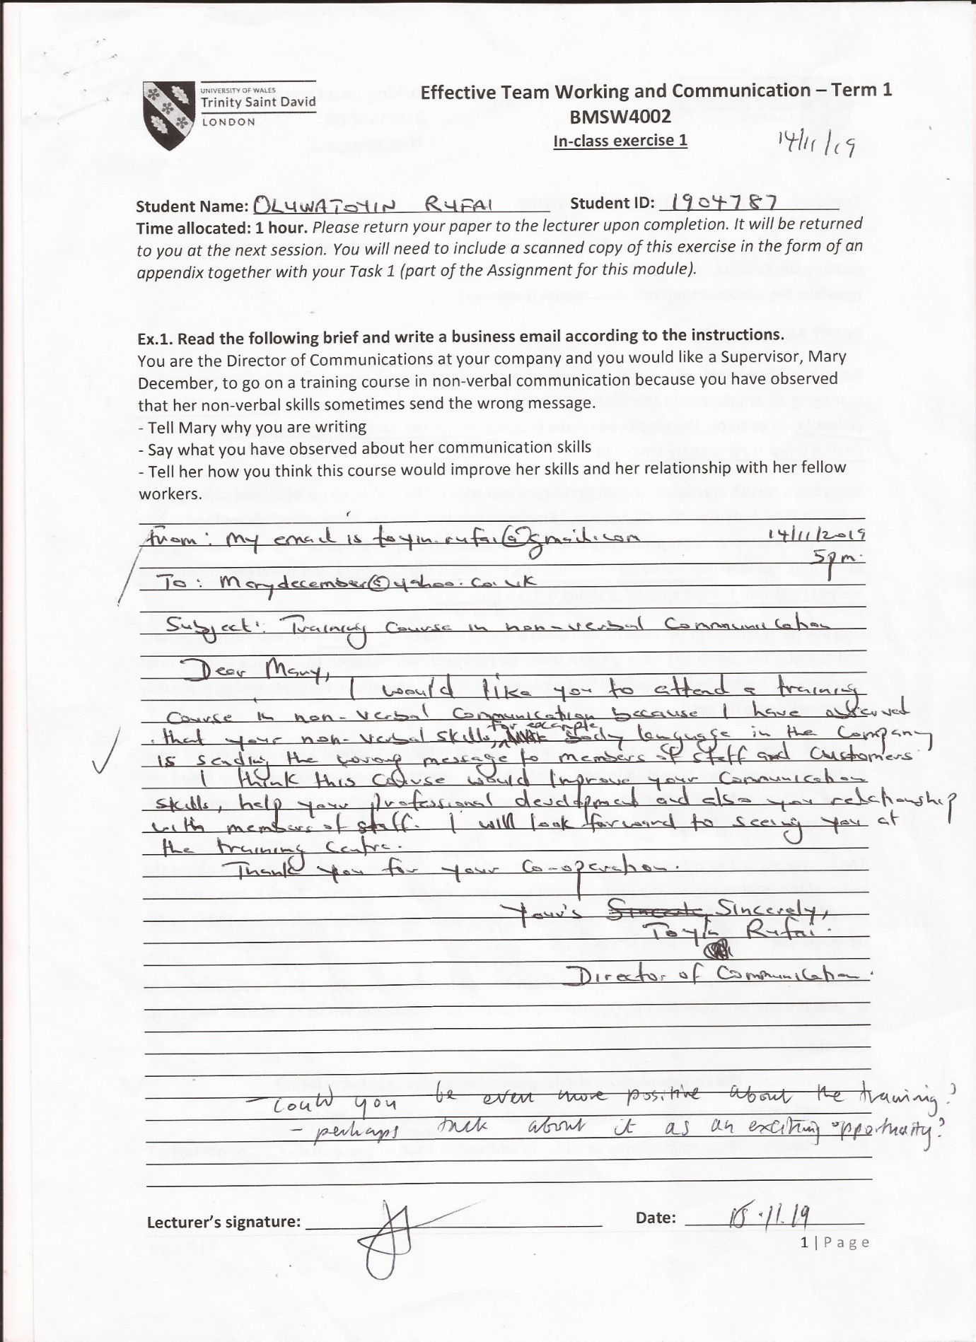

Appendix 2
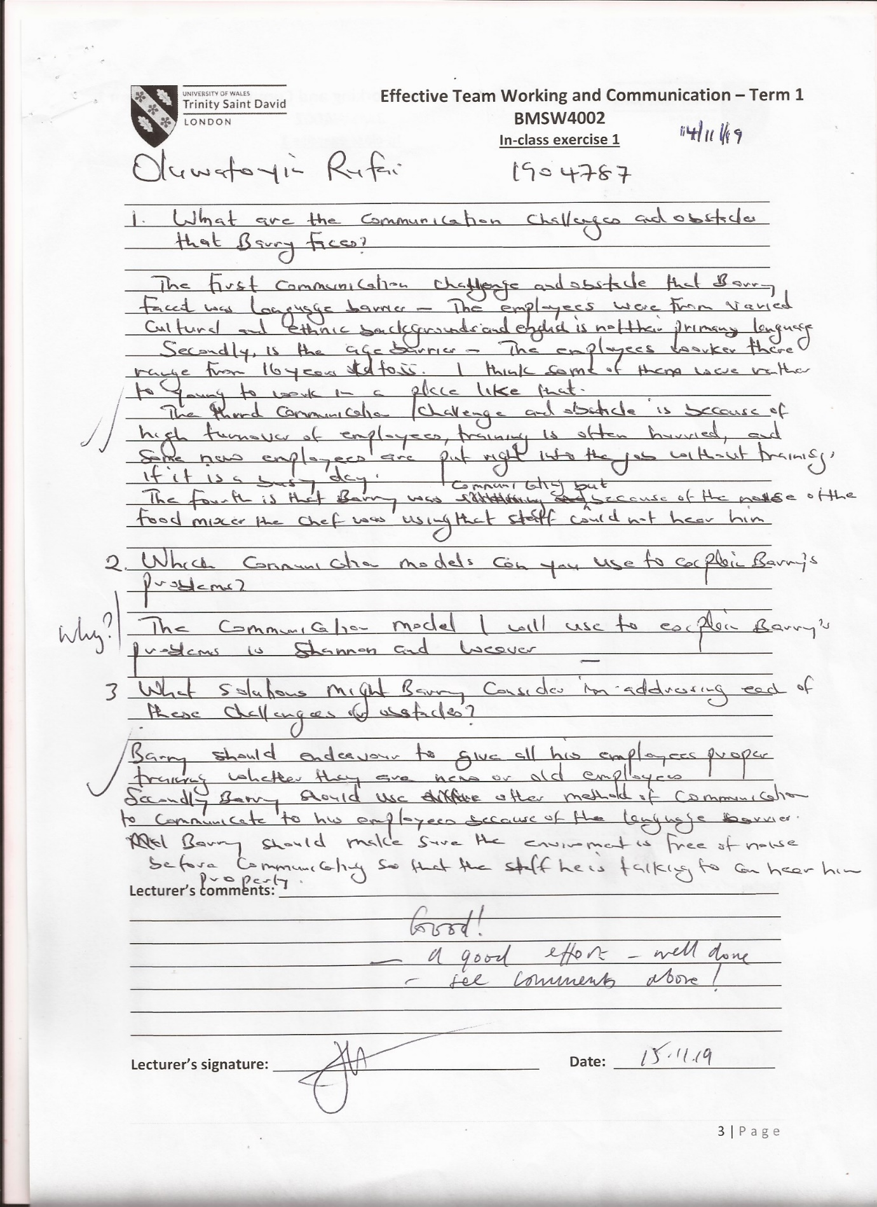

Appendix 3
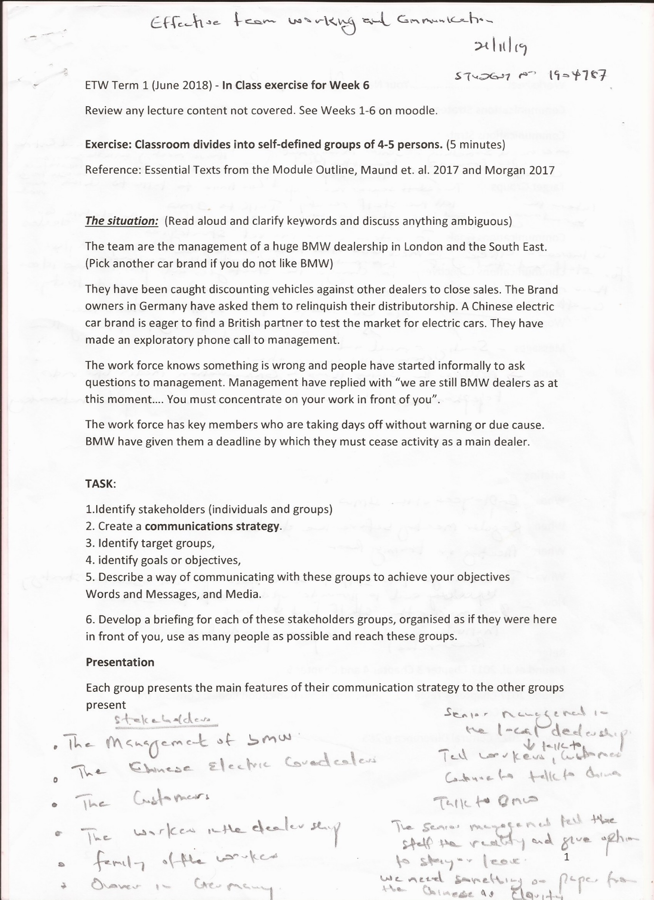

Appendix 4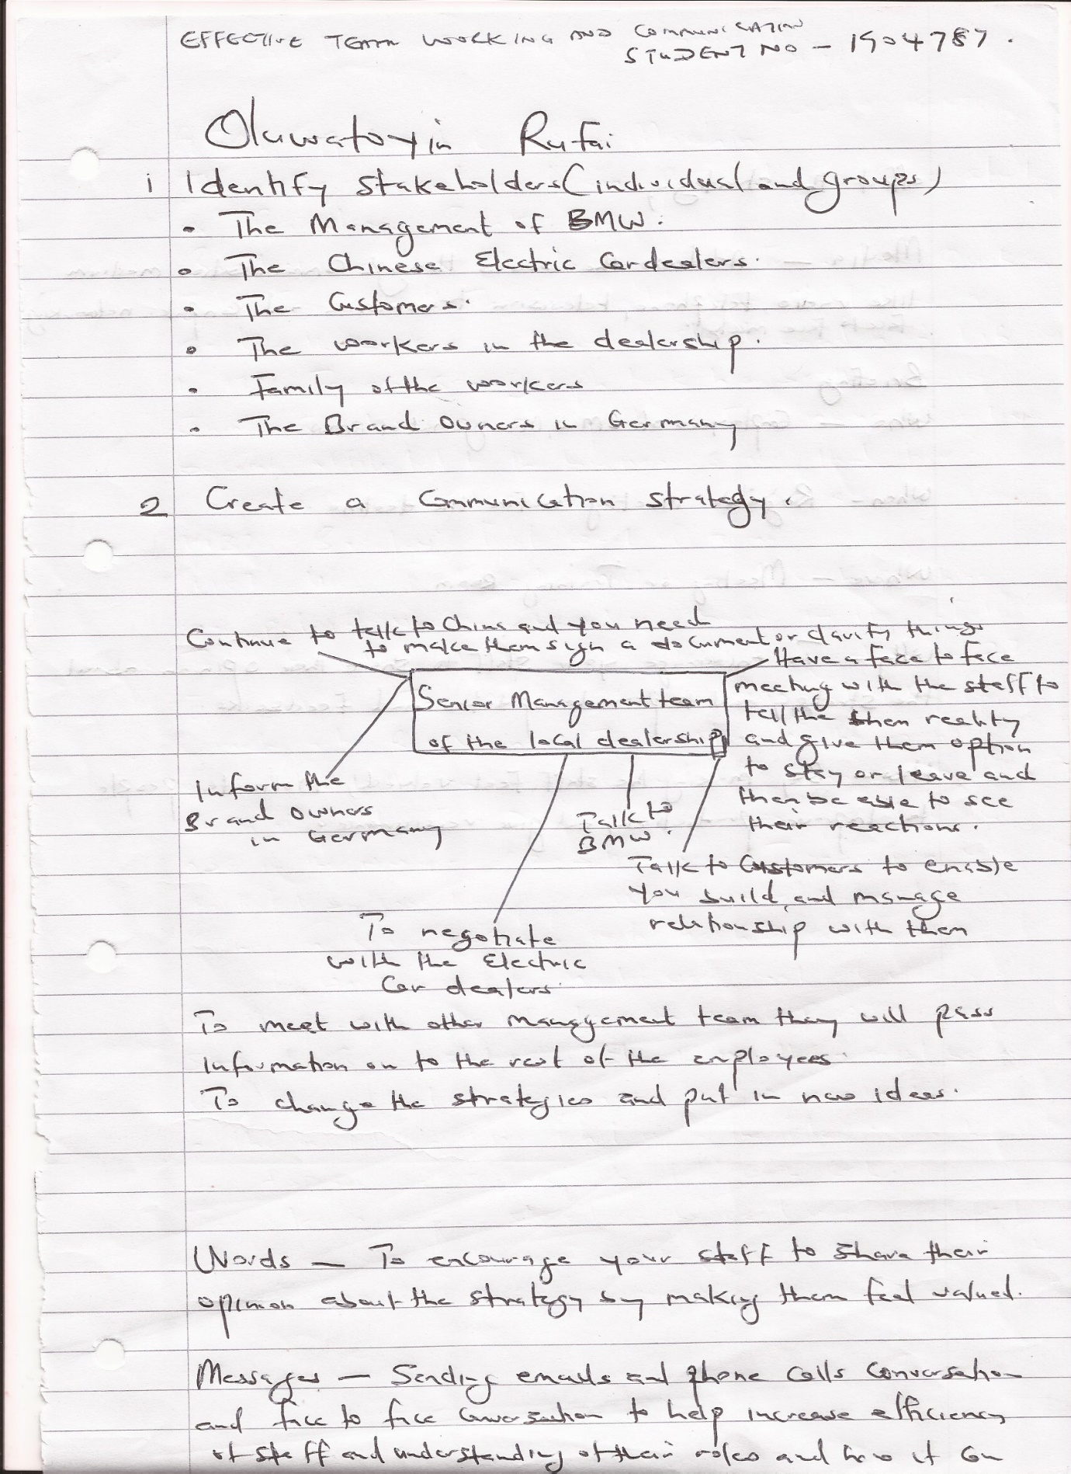

Appendix 5
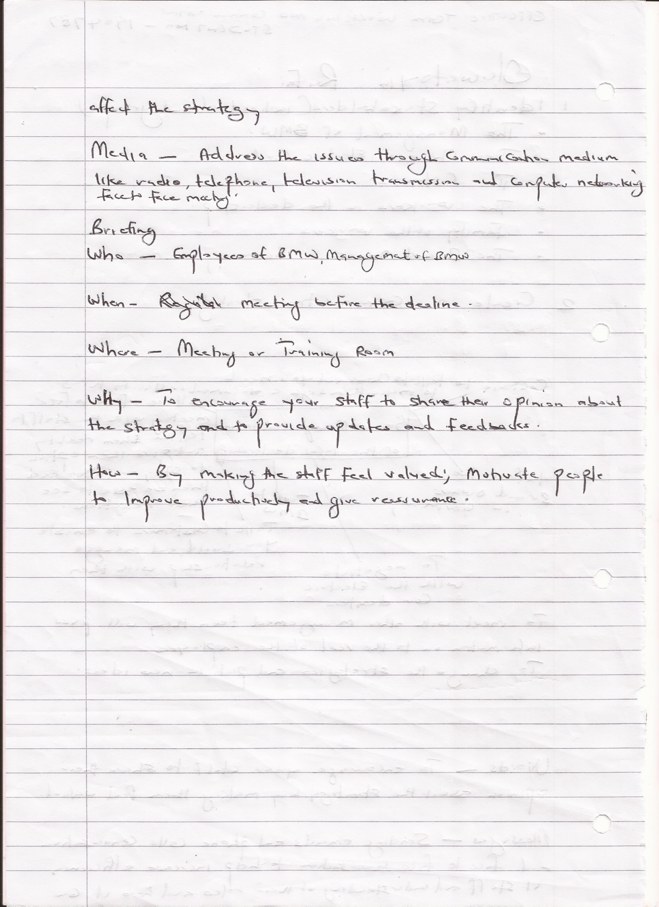

Appendix 6
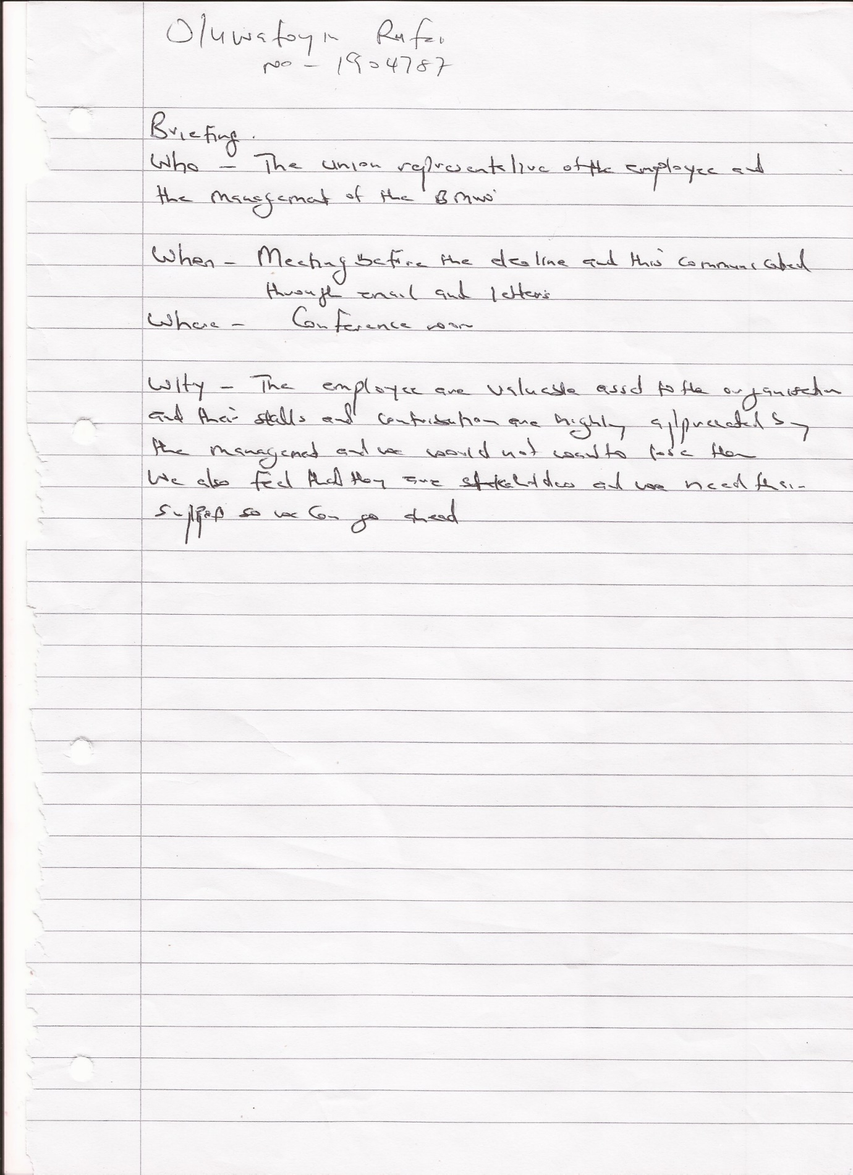

Appendix 7
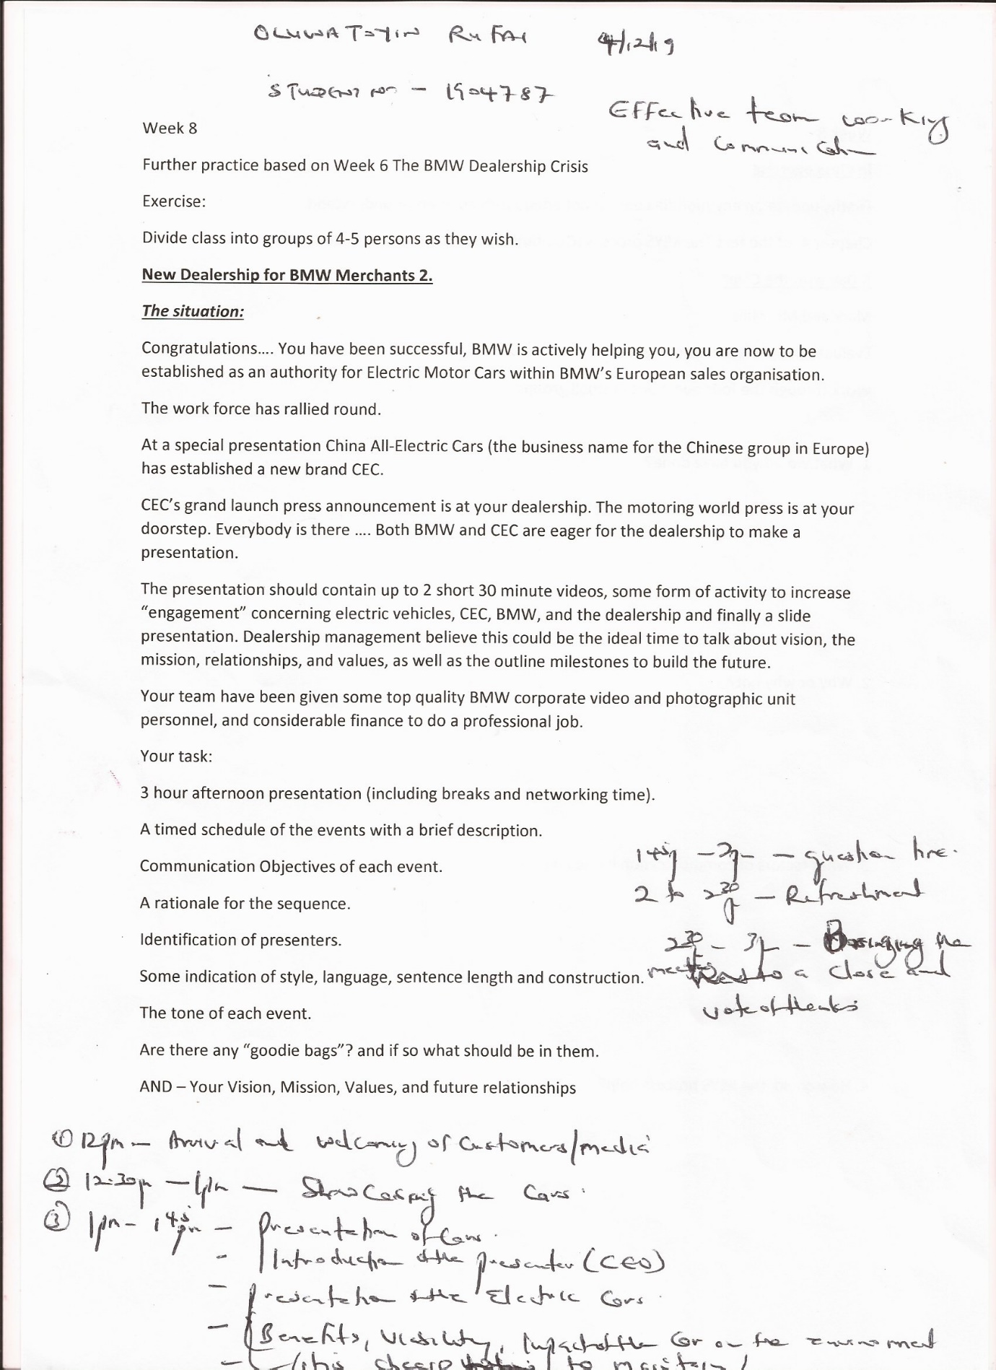

Appendix 8
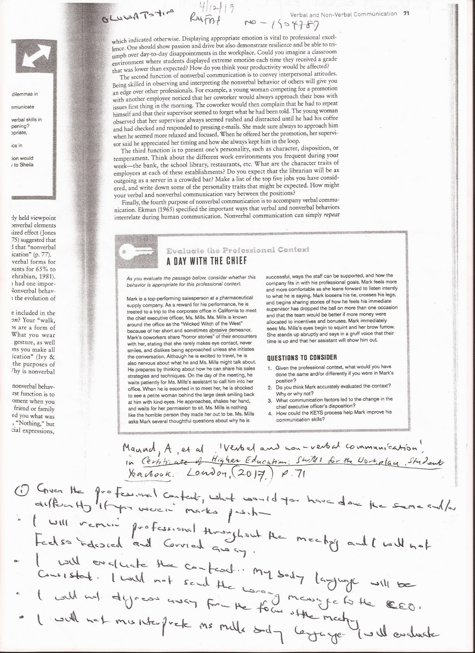

Appendix 9A
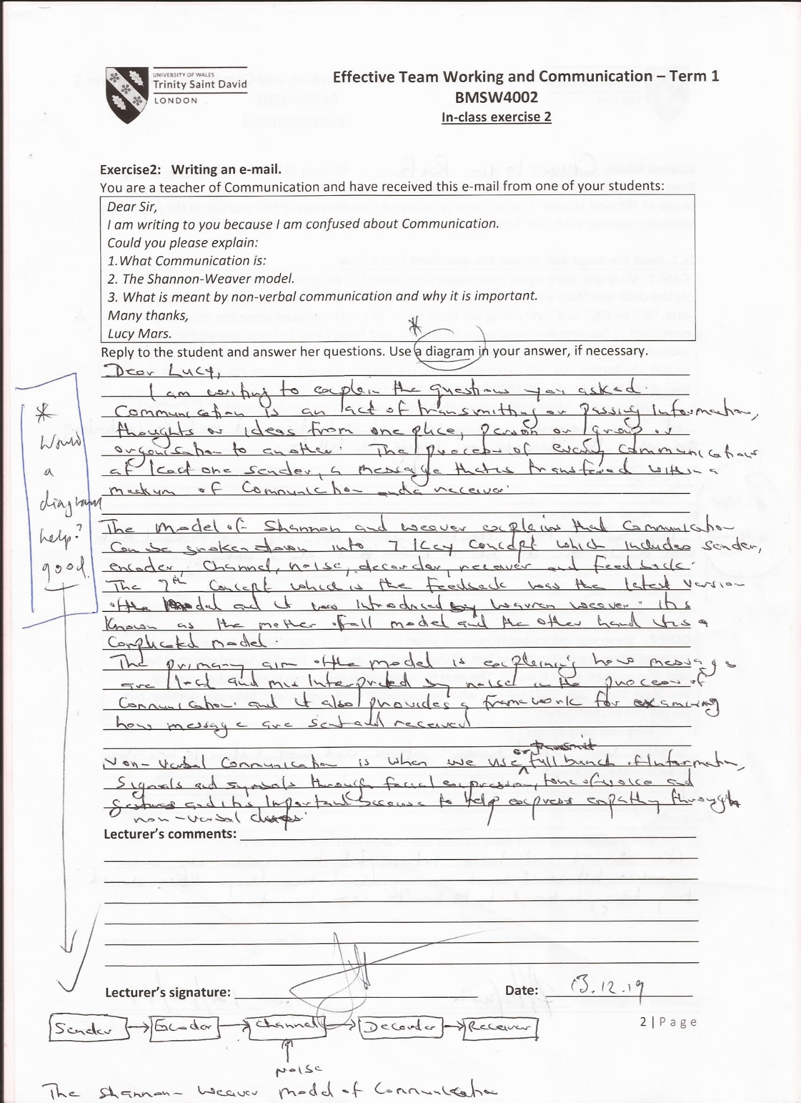

Appendix 9B
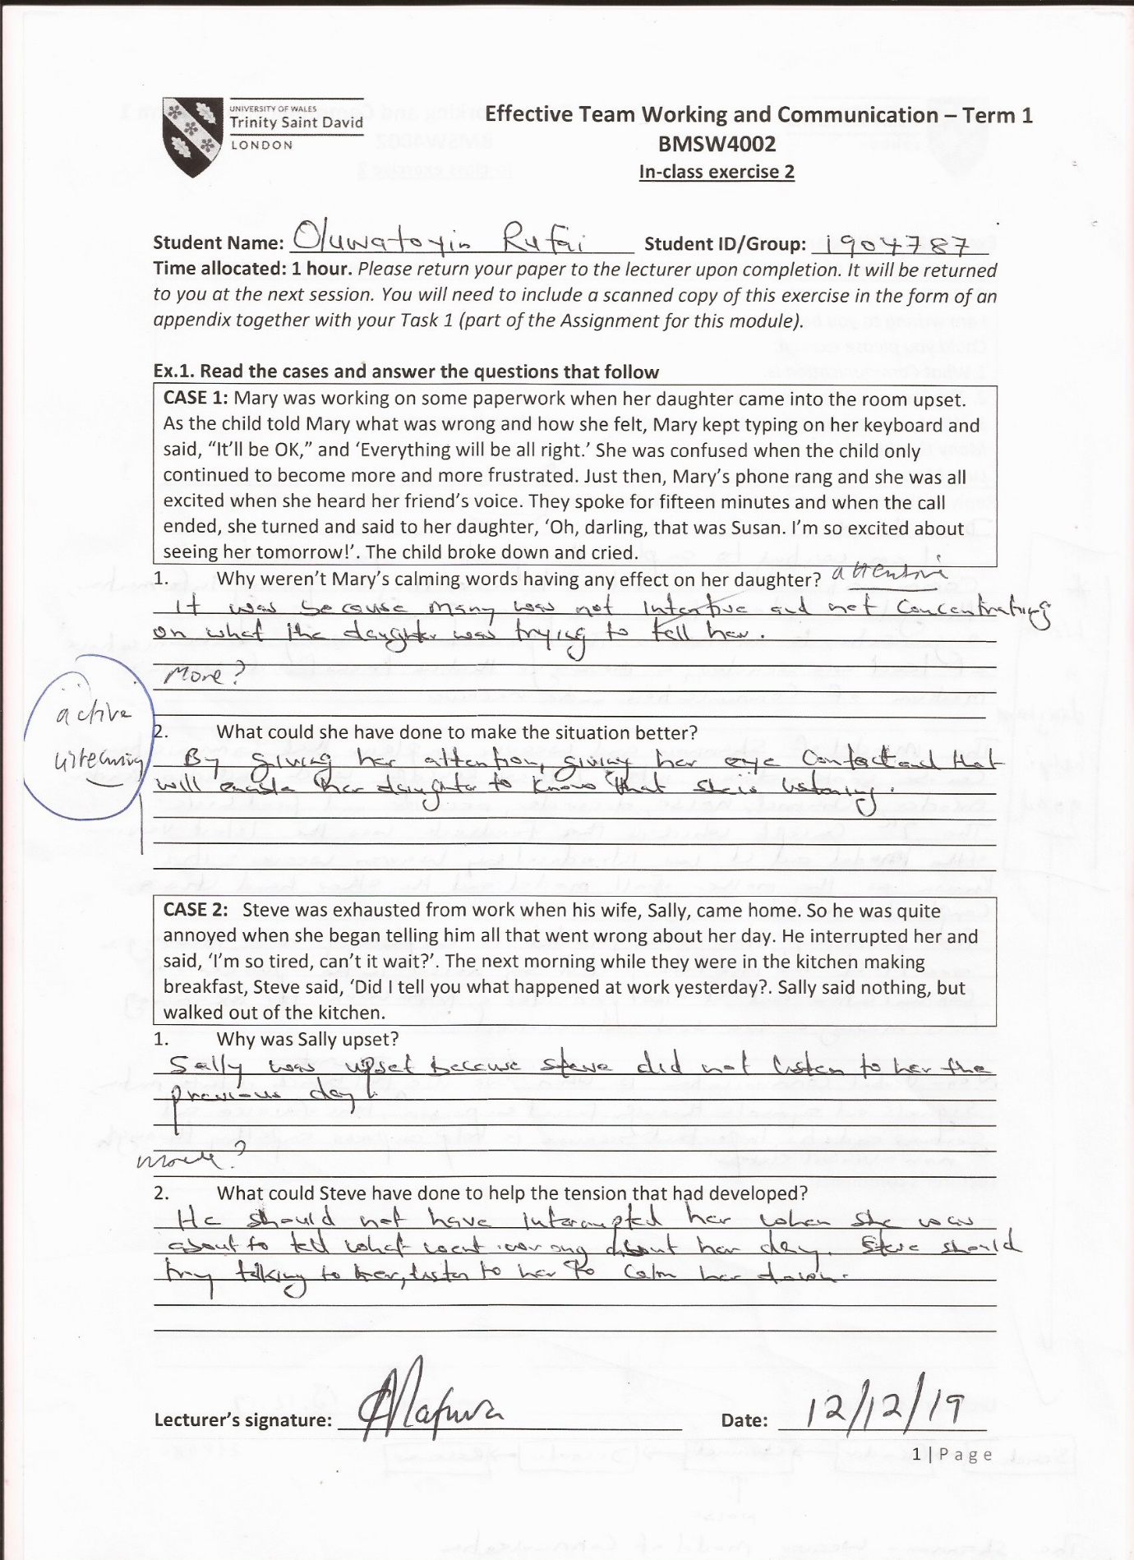

Appendix 10
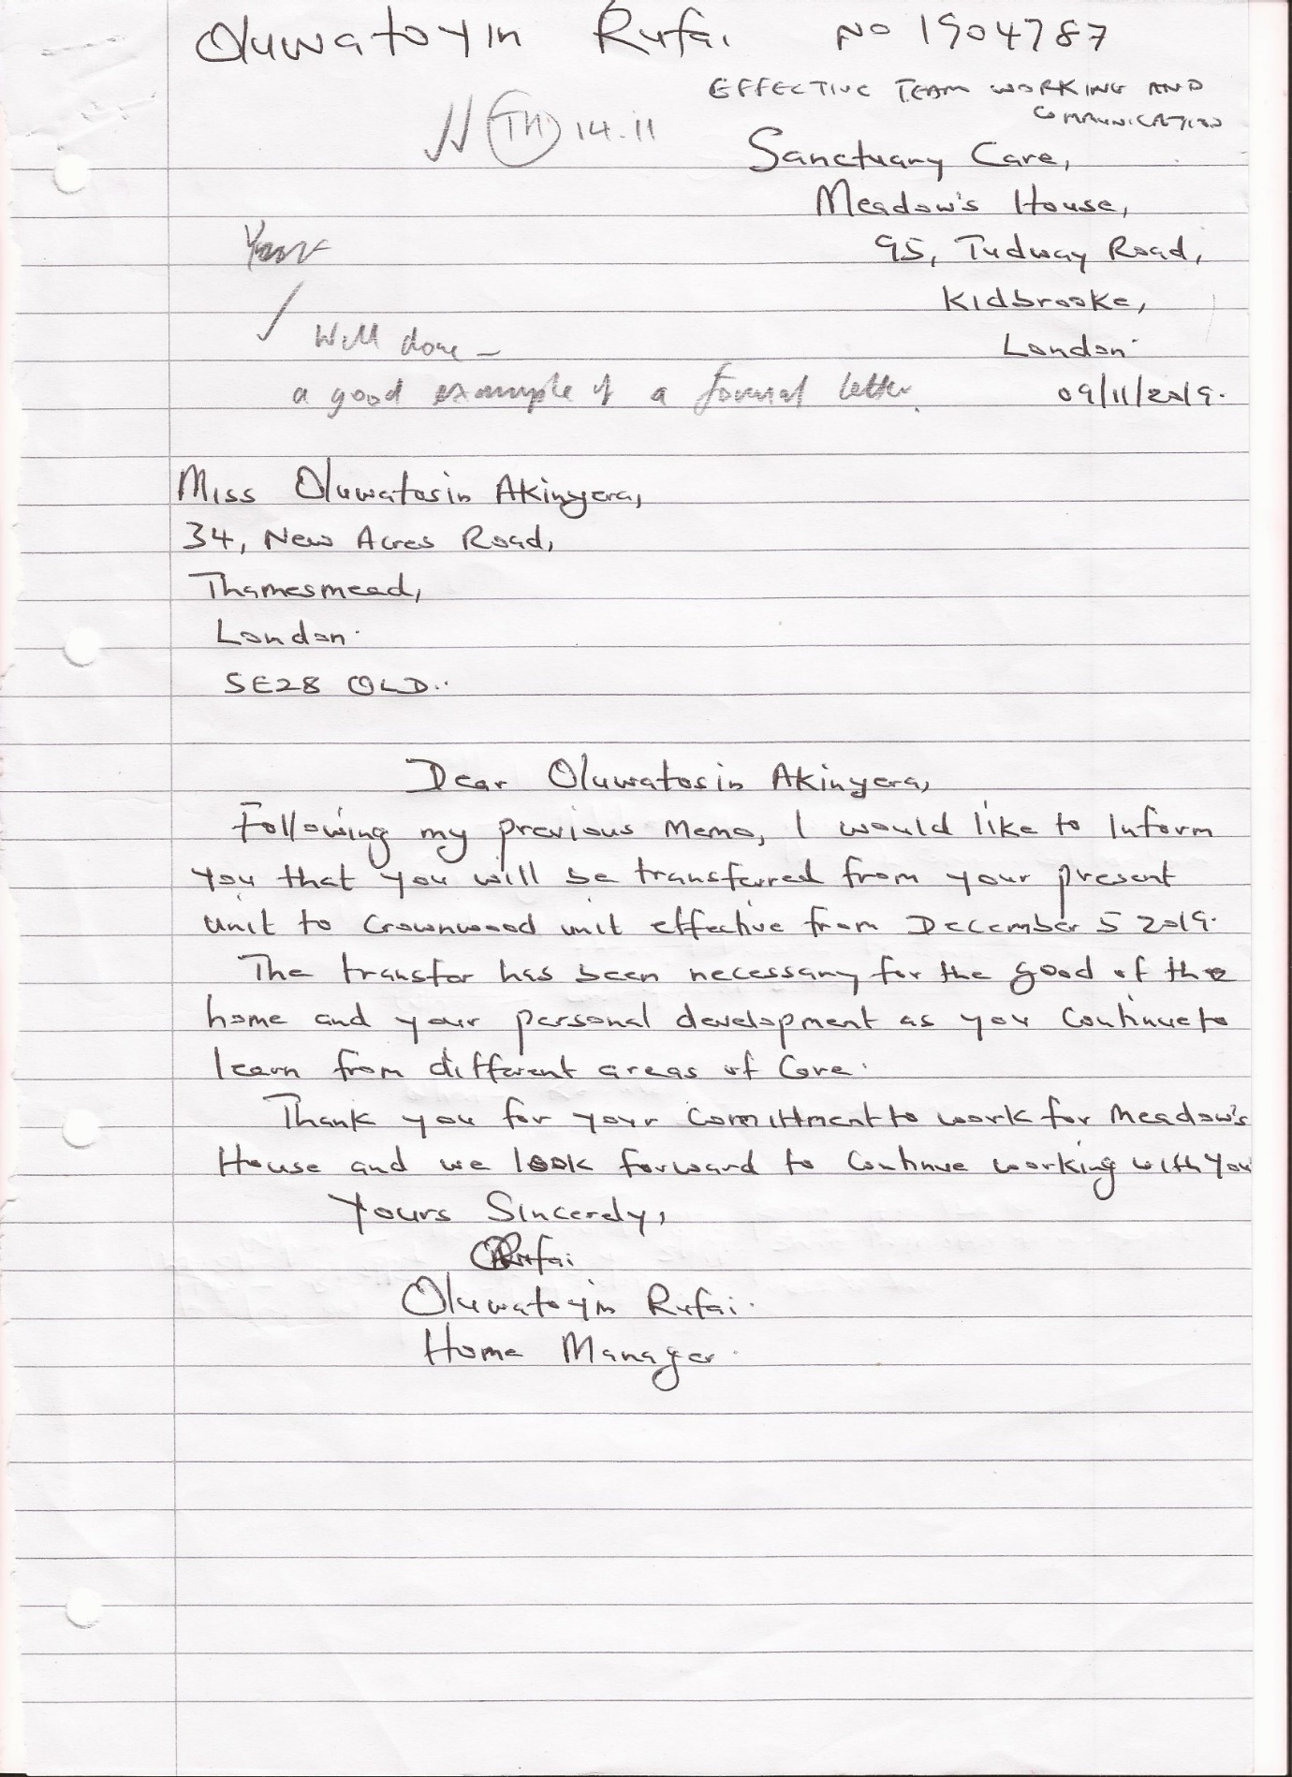

Appendix 11


