

A critical analysis of the occurrence of sexual
misconduct perpetrated by Officers in South
Wales Police and the pertinent features that
characterise it.

Name: Sara Louise Herbert
Student Number: 2112543
School: UWTSD Swansea
Degree: Professional Investigations Bsc (Hons)
Due Date: 1st November 2022
Word Count: 8,800

Declaration

This work has not previously been accepted in substance for any degree and is not being concurrently submitted in candidature for any degree.
Signed Date: 21st October 2022

STATEMENT 1
This dissertation is being submitted in partial fulfilment of the requirements for the degree of BSc Professional Investigation.
Signed: Date: 21st October 2022

STATEMENT 2
This dissertation is the result of my own independent work/investigation, except where otherwise stated. Other sources are acknowledged by footnotes giving explicit references. A bibliography/reference list is appended.
Signed: Date: 21st October 2022

STATEMENT 3
I hereby give consent for my dissertation, if accepted, to be available for photocopying and for interlibrary loan, and for the title and summary to be made available to outside organisations.
Signed: Date: 21st October 2022

STATEMENT 4
I hereby give consent for my dissertation, if accepted, to be available on the university’s IT system to those who have consent to use the system.
Signed Date: 21st October 2022

Acknowledgements

I would like to thank my Tutor Alison Cooke for her support, feedback, and time throughout the process of obtaining my degree.
I would also like to sincerely thank my husband Richard and children Tom and Bella for their endless support and kindness. Their patience, encouragement, and support throughout my time at university has given me the motivation needed to complete my degree. I cannot express how grateful I am.

A critical analysis of the occurrence of sexual misconduct perpetrated by Officers in South Wales Police and the pertinent features that characterise it.

Abstract
This dissertation aims to critically analyse the occurrence of sexual misconduct perpetrated by Police officers in South Wales Police (SWP). This research examines issues relating to witnesses and victims reporting sexual misconduct that they have encountered. Examining why individuals are reluctant to report inappropriate sexual behaviour aids in understanding why this behaviour is accepted and allowed to continue. This research seeks explanations as to why Police officers engage in sexual misconduct. Data obtained will be used to devise strategies of how sexual misconduct can be prevented.

To meet these objectives, SWP were asked to provide quantitative data. Furthermore, SW Police Officers were asked to complete questionnaires. An extensive critical examination of pertinent and current academic literature on the subject was conducted and relevant information was obtained. The information gathered was critically examined and analysed and the researcher was able to achieve the set objectives and confirm the existence of Police sexual misconduct within SWP. The literature review provides information as to why occurrences of sexual misconduct go unreported and why Police officers engage in such behaviours. Using this data and literature review the researcher has proposed recommendations for minimising inappropriate sexual behaviour within the police organisation, with the suggestion that further research would be beneficial

Table of Contents

Abstract....................................................................................................................page 5

Chapter 1 Introduction.....................................................................................page 15
1.1 Introduction.............................................................................................................page 15
1.2 Background …........................................................................................................page 15
1.3 Rationale for research.............................................................................................page 16
1.4 Aim and Objectives.................................................................................................page 17 1.4.1 Aim.......................................................................................................................page 17
1.4.2 Objectives............................................................................................................page 17
1.5 Research structure ….............................................................................................page 18
1.6 Conclusion …..........................................................................................................page 18

Chapter 2 – Literature Review.......................................................................page 19
2.1 How Sexual misconduct affects the Police organisation.........................................page 19
2.2 What is sexual predatory behaviour........................................................................page 19
2.3 Issues in understanding Sexual Predatory misconduct..........................................page 19
2.4 Background.............................................................................................................page 20
2.5 Differences between types of offences...................................................................page 20
2.6 Differences between ranks......................................................................................page 21
2.7 Difference between males and females..................................................................page 21
2.8 Is vulnerability a factor............................................................................................page 22
2.9 Outcomes................................................................................................................page 22
2.10 Existing research which provide explanations for why
officers engage in sexual misconduct...............................................................page 23
2.11 Reporting Misconduct...........................................................................................page 25
2.12 Why Police officers do not report sexual misconduct ….......................................page 25
2.13 Does the Police Culture influence reporting..........................................................page 25
2.14 Strategies to combat Police sexual misconduct....................................................page 26
2.14.1 Training..............................................................................................................page 26
2.14.2 Supervision........................................................................................................page 26
2.15 Effect on staff........................................................................................................page 27
2.16 Conclusion............................................................................................................page 27

Chapter 3 – Methodology….............................................................................page 29
3.1 Introduction..............................................................................................................page 29
3.2 Methods used..........................................................................................................page 29
3.3 Research Methodology............................................................................................page 29
3.4 Research Philosophy...............................................................................................page 30
3.5 Research Approach.................................................................................................page 30
3.6 Strategies for obtaining the information..................................................................page 31
3.7 Methodological Choice............................................................................................page 32
3.8 Time scales.............................................................................................................page 32
3.9 Techniques and Processes….................................................................................page 33
3.10 Limitations.............................................................................................................page 34
3.11 Ethics....................................................................................................................page 34

Chapter 4 - Data Analysis and Findings...................................................page 36
4.1 Introduction..............................................................................................................page 36
4.2 What is analysis?.....................................................................................................page 36
4.3 Themes …...............................................................................................................page 36
4.4 Theme 1, Does sexual misconduct exist within SWP...............................................page 37
4.5 Theme 2, Whether the Complainant was a member
of public or Police Officer......................................................................................page 39
4.6 Theme 3, Gender of the accused and the Complainant.........................................page 41
4.7 Theme 4, The rank of the accused.........................................................................page 43
4.8 Theme 5, Outcome for the accused........................................................................page 43
4.9 Comparison with other forces.................................................................................page 44
4.10 Theme 6, Reporting incidents, analysing issues around why victims
and witnesses do not report sexual Predatory behaviour.….................................page 45
4.11 Third Objective .....................................................................................................page 47
4.12 Fourth Objective....................................................................................................page 48
4.13 Conclusion............................................................................................................page 48

Chapter 5 – Conclusion and Recommendations...............................page 50
5.1 Introduction.............................................................................................................page 50
5.2 Research objectives and findings...........................................................................page 50
5.3 South Wales Police recommendations......…..........................................................page 50
5.3.1 Recruitment..........................................................................................................page 50
5.3.2 Training................................................................................................................page 51
5.3.3 Supervision..........................................................................................................page 51
5.3.4 Support to report concerns...................................................................................page 51
5.4 Future research.......................................................................................................page 52
5.5 Conclusion..............................................................................................................page 52
List of Figures and tables …..................................................................................page 10
List of Appendices …..............................................................................................page 13
List of Abbreviations ..............................................................................................page 14
References….............................................................................................................page 53
Appendices................................................................................................................page 68

List of Figures and tables

Diagram 1 Referrals and investigations carried out by the IOPC in relation to cases of abuse of Position for sexual purpose between 2016-2020 (Source: BBC News 2021) ......................................................................................................................................page 16
Diagram 2 The Research Onion (Source: Saunders et al 2016)
......................................................................................................................................page 30 Diagram 3 Deductive and Inductive approaches to the relationship between theory and research (Source: Bryman 2016
…...................................................................................................................................page 31 Diagram 4 Gantt chart of proposed project timeline
…...................................................................................................................................page 33 Diagram 5 Freedom of Information Act (FOIA) results (Appendix E) showing the percentage of allegations of sexual misconduct in SWP between 2010 and 2021
…...................................................................................................................................page 37 Diagram 6 FOIA results (Appendix E) showing the number of allegations of sexual misconduct in SWP between 2010 and 2021
…...................................................................................................................................page 38 Diagram 7 Questionnaire results - Do you feel that sexual harassment exists with South Wales Police (SWP)?
…...................................................................................................................................page 38 Diagram 8 Questionnaire result - Do you feel that the Abuse of position for a sexual purpose exists within SWP?
…...................................................................................................................................page 39
Diagram 9 FOIA results (Appendix E) showing the percentage of persons employed by SWP who made allegations
….................................................................................................................................. page 40
Diagram 10 - FOIA results (Appendix E) showing the percentage of members of public who made allegations
….................................................................................................................................. page 40
Diagram 11 FOIA results (Appendix E) Comparison of Complainants who were members of the public and employed by SWP between 2010 and 2021
…...................................................................................................................................page 40
Diagram 12 FOIA results (Appendix E) Percentage of male Complainants in SWP
…...................................................................................................................................page 41
Diagram 13 FOIA results (Appendix E) Percentage of female Complainants in SWP
…...................................................................................................................................page 41
Diagram 14 FOIA results (Appendix E) Comparison of male and female Complainants in SWP between 2010 and 2021
….............................................. ....................................................................................page 41
Diagram 15 FOIA results (Appendix E) - Percentage of female perpetrators in SWP ......................................................................................................................................page 42
Diagram 16 FOIA results (Appendix E) - Percentage of male perpetrators in SWP ......................................................................................................................................page 42
Diagram 17 Freedom of Information Act results (Appendix E) Comparison of male or female perpetrators in SWP between 2010 and 2021
…......................................................................... .........................................................page 42
Diagram 18 FOIA results (Appendix E) Comparison of the ranks of the accused in SWP between 2010 and 2021
…...................................................................................................................................page 43
Diagram 19 FOIA results (Appendix E) Comparison of the outcomes for the accused in SWP between 2010 and 2021
…............................................. .....................................................................................page 44
Diagram 20 Comparison between forces (Source: i news 2021) …...................................................................................................................................page 45
Diagram 21 Questionnaire result. If you have been a victim of sexual harassment within SWP, did you report it?
…...................................................................................................................................page 46
Diagram 22 Questionnaire result. If you were to witness sexual harassment within SWP, would you report it?
…...................................................................................................................................page 46
Diagram 23 Questionnaire result. If you were to experience sexual harassment within SWP, would you feel able to report it?
…...................................................................................................................................page 47

List of Appendices

Appendix A: Final Questionnaire Questions.…………………………...…………………page 68
Appendix B: Letter to accompany Questionnaire ……………………………………….page 70
Appendix C: Code of ethics………………………………….………………………………page 71
Appendix D: Freedom of information request response from South Wales Police..….page 72
Appendix E: Freedom of information request data from South Wales Police……….…page 75
Appendix F: Questionnaire data…………………………………………………………….page 76
Appendix G: Graphs of data obtained from the Freedom of Information request and Questionnaires……………………………………………………………………..…………page 77
Appendix H: Initial Questionnaire Questions...…………………………………………....page 86
Appendix I: Sexual harassment in the workplace: Summary of Chwarae Teg report (Source: Police and Crime Commissioner)…………………..…………..………..page 89
Appendix J: Police forces with the largest number of sexual misconduct allegations as % of total force (Source: i news 2021)…………………………………….page 91
Appendix K: Police forces with the largest number of sexual misconduct allegations (Source: i news 2021)…………………………………………………………..page 92
Appendix L: APSP cases 2016 – 2020. Referrals and independent investigations carried out by the IOPC. (Source: BBC News 2021)……………….……page 93
Appendix M: Recommendations from Question 15 of the Questionnaire……………..page 94

List of Abbreviations

SWP – South Wales Police
PSD – Professional standards Department
IOCP – office of Independent Police complaints
PSM – Police sexual misconduct
FOIA – Freedom of Information Act
NPCC - National Police Chiefs Council
HMIC – Her Majesty Inspectorate of Constabulary
MET – Metropolitan Police Force

Chapter 1: Introduction

1.1 Introduction
This research sets out to determine whether sexual misconduct exists within South Wales Police (SWP). This chapter aims to provide a framework and explanation for the research. It outlines the aims and objectives of the study.

1.2 Background
The National Police Chiefs Council of England and Wales (NPCC 2017) has defined Police sexual misconduct as `Any behaviour by a police employee, on or off duty, whereby the employee takes advantage of their position to misuse their powers or authority in order to pursue an improper emotional or sexual relationship`. In addition to vulnerable members of the public, it can also occur amongst co-workers in the form of consenting sex while on duty, improper sexual language, and inappropriate overfamiliar contact (Brown et al, 2019).
Following several high-profile police sexual misconduct cases, and to gain confidence in the Metropolitan Police Force, a dedicated police unit was set up in January 2022. Since this date 625 complaints of domestic and sexual abuse against police employees have been investigated (Symonds BBC news 2022). `Police officers can use their power and authority over people, in and out of the force. There is a risk that this power might encourage unlawful and unethical behaviour or allow inappropriate/criminal behaviour to be hidden` (Symonds BBC News 2022). 643 referrals for `Abuses of Power for a Sexual Purpose` (APSP) were made to the IOPC between 2016 and 2020 (BBC News 2021). According to the IOPC, Abuse of position for sexual gain was the largest form of corruption in 2021, accounting for 60% of their investigations. (Ambrose, The Guardian 2021)

Diagram 1; Referrals and investigations carried out by the IOPC in relation to cases of abuse of Position for sexual purpose between 2016-2020 (Source: BBC News 2021)
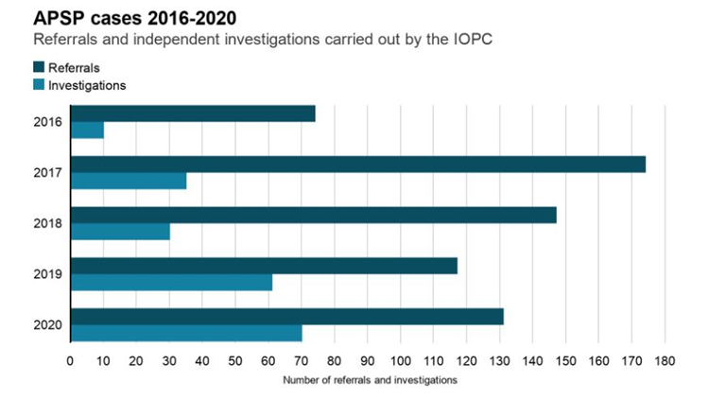

1.3 Rationale for the research
Sexual misconduct can have devastating effects on victims, public opinion, and the reputation of the police force (Cottler et al, 2014). According to Burger's (2016) research, the public has lost confidence in the police because of their participation in criminal behaviour and abuse of authority. Identifying police officers who engage in sexual misconduct is difficult. The way the behaviour occurs is subjective and unique to the situation and individuals involved, which may explain why it is difficult to define and why it goes unreported (Duemig 2022). This is supported by the IOPC (2022) who acknowledge that recognising `abuse of position` is challenging. Many victims refrain from making complaints for fear of not being believed. It is crucial that all Police employees are aware of the warning signs and behaviours of abuse of position and are willing to report any concerns they may have about co-workers. The `blue code of silence` theory helps explain why police officers don`t report their colleagues' sexual misbehaviour, due to loyalty and fear of repercussions (Sweeting et al 2022).
Research on cases committed by SWP officers is scarce, despite there being a plethora of literature on police sexual misconduct in the UK. Future criminal behaviour could be avoided if such officers were identified early in their employment and their behaviour stopped (Harris, 2014). Strategies should be implemented to teach officers how to identify and comprehend sexual predatory behaviour (Fleming, 2009).
Various theories have attempted to explain why police officers commit sexual misconduct, such as Melig's (2012) `bad apple` and `bad barrel` research. An officer is viewed as a `bad apple` if they intend to abuse their authority when they join the police force. Those who do not have this intention may become bad because of the `corrupt` nature of the police force, the `bad barrel`. The connection between Police officers' ability to measure self-control and sexual misconduct was investigated by Gottfredson and Hirschi (1990). Piquero et al (2010) agreed that `A lack of self-control is a predictor of crime and deviance`. Gilmartin and Harris (1998) created the `Continuum of compromise framework` to help understanding how an officer may transition from being `honest` to being `compromised`. This illustrates how acts of omission can develop to acts of commission, much like Punch's (2009) `slippery slope` concept. Sherman (1985) found that officers who committed crimes had a sense of entitlement, believing they deserved special privileges.
This study aims to gather and analyse existing data and research, as well as understanding the views of serving police officers. The outcomes of this study can be evaluated against existing research.

1.4 Aim and Objectives
1.4.1 Aim
The aim of this dissertation is to investigate and critically evaluate whether sexual predatory behaviour exists within South Wales Police. This study examines whether there is evidence that police officers misuse their position by engaging in sexual misconduct with individuals they meet through their duty as a police officer. To do this, the following objectives have been created.

1.4.2 Objectives
Objective 1: Identifying whether sexual predatory behaviour exists within SWP.
Objective 2: Critically analyse issues relating to victims reporting sexual predatory behaviours and co-workers reporting sexual predatory behaviour that they have witnessed. Analysing issues around reporting helps to understand how and why this behaviour is allowed to continue and exist.
Objective 3: To understand why Police officers engage in sexual misconduct
Objective 4: To critically examine the data gathered to formulate a proposal strategy for reducing predatory behaviour within SWP.

1.5 Research structure
Both primary and secondary data has been gathered to achieve the objectives. Police officers who work for SWP have completed questionnaires and results from a Freedom of Information Act request submitted to SWP has been obtained.
A review of the relevant literature has been conducted. The methodology and appropriate research procedures used are described in Chapter 3. Chapter 4 explains the analysis undertaken on the primary data gathered. This data has been discussed, reviewed, and compared to pertinent academic research. The key findings will be reviewed in chapter five.

1.6 Conclusion
This chapter has introduced the research, identified the aim and objectives, and outlined why this research is being conducted. A literature review, discussing the topic in more depth is delivered in the next chapter.

Chapter 2: Literature review

2.1 How Sexual misconduct affects the Police organisation
`Police sexual misconduct is a significant form of corruption` (College of Policing 2022). Along with having a negative impact on victims, this behaviour harms the police forces reputation. According to the United Nations Police (2003), most Police officers are `professional, dedicated, and capable who behave honourably`. However, in contrast a small percentage of police officers misuse their position for sexual gain (IOPC 2012). Many studies claim that police misconduct is prevalent worldwide, while others contend that incidences are infrequent (Gottschalk et al 2012).

2.2 What is sexual predatory behaviour
The term `Sexual Predators` is frequently used by the media to describe police officers who engage in sexual misconduct (Laville, The Guardian 2012). Predatory behaviour is often a behaviour pattern that can start out trivial in nature and can develop into a pursuit type behaviour if not stopped (Duemig 2022). This is supported by Barkan and Bryjak (2014) who identified that the behaviour often entails a series of occurrences that may vary in severity and time. Distinguishing this behaviour may be challenging as initially the behaviour may appear harmless and subtle. This could include ending a message with a kiss or sending messages from a personal phone. However, this can be the start of a pattern of escalating behaviour (IOPC 2022). Deviant officers may favour attending certain incidents or working alone rather than working as a team (IOPC 2012). Those targeted may not realise that what is happening is wrong or may feel uncomfortable speaking up. Often, when one individual speaks up, it inspires others to do the same (IOPC 2022). The College of Police (2022) guidance states that more serious action is likely when an officer engages in predatory behaviour driven by misogyny.

2.3 Issues in understanding Sexual Predatory Misconduct
Some criminal offences, such as theft, and criminal damage may not be considered predatory, thus won`t be investigated as having a sexual element (Duemig 2022). It is possible to overlook connections between behaviours, which prevents predatory behaviour being detected. This is demonstrated in the case of Sarah Everard who was raped and murdered by serving Police Officer Wayne Couzens. Prior to killing Sarah, Couzens carried out a series of low-level sexual assaults. If previous allegations about Couzens behaviour had been investigated, then his sexual predatory tendencies may have been identified. A lack of specially trained officers could explain why officers are unable to effectively address predatory behaviour (IOPC 2012).

2.4 Background
Police Sexual Misconduct has been significantly highlighted and come under national scrutiny over recent years due to a number of high-profile cases (College of Policing 2022). However, this issue is not new and extensive work has been conducted in the last 10 years to understand and raise awareness (IOPC 2022). In 2011, a sexual misconduct case in Northumbria led to changes in Police regulations (Her Majesty Inspectorate of Constabulary- HMIC 2017). As a result, Police organisations must now release the findings of misconduct proceedings.
Over the past 6 years, in England and Wales, 33 police forces have reported 1,491 cases of sexual misconduct which include officers abusing their position (Jayanetti 2019).However, the Home Office (2019) noted that there are approximately 199,753 Police employees in England and Wales. These numbers imply that sexual misconduct is uncommon and represent one incident for every 1,000 police employees. This indicates that most police officers uphold the standards and behave professionally (College of Policing, 2014). However, when sexual misconduct occurs, it can seriously harm the police organisation`s reputation in addition to causing extreme distress for victims. This may affect the propensity of other victims in reporting sexual offences (IOPC 2022).

2.5 Differences between types of offences
Sweeting et al (2022) studied `155 sexual misconduct cases reported by 30 police forces in England and Wales, between November 2018 and April 2019`. This research set out to determine whether there were differences between gender and rank in relation to Police sexual misconduct as well as identifying whether there were variations in case outcomes between police organisations. According to Sweeting (2022), the most frequent type of incident involved police officers having sex with victims, witnesses, or other vulnerable people. It is often Police `Constables` who commit this form of sexual misconduct as they have more contact with victims of crime.

2.6 Differences in ranks
The second most common type of misconduct involved Police officers behaving in a sexually inappropriate manner towards colleagues (Sweeting et al 2022). Higher-ranking officers have less contact with victims of crime and were far `more likely to engage in sexually inappropriate behaviour towards female colleagues`. This is supported by Cockbain and Wortley`s (2015) research who proposed an `opportunistic` theory of crime, suggesting that suitable victims were found through everyday activities, such as the working environment. Power imbalance is created by rank, therefore, `a higher-ranking officer having a relationship with a lower raking colleague and the inappropriate sexual element of it, could meet the definition of sexual harassment` (Johnson et al, 2018). In Sweetings (2022) study Detective constables were more likely to engage in sexual relationships with offenders. The fact that detectives `develop professional working relationships with criminals and `befriend them` may help to explain this` (Nash, 2016).

2.7 Difference between males and females
Maher`s (2010) studies identified that sexual misconduct is mostly attributable to male officers. Stinson et al.’s (2014) study agreed and identified that 99.1% of the perpetrators of sexual misconduct were male. Female officers who engaged in sexual misconduct, often had `relationships with offenders` This was explained by Sweeting (2022) as the perpetrator needing a `source of protection or for police intelligence purposes`. The media often minimised the seriousness of female perpetrators behaviour `emphasizing their good careers` (Cockcroft 2015). Lonsway (2013) found that female officers were more likely to experience `unwelcome sexual attention`, and they found this attention far more upsetting than men. This is supported by Sweeting (2022) who found that male officers were less likely to report sexual misconduct than female officers. This is further supported by Cheng and Hsiaw (2019) who`s research found that `women view a wide range of sexually inappropriate behaviours as intolerable compared to men, men are more likely to provide excuses for such behaviour`.

2.8 Is vulnerability a factor?
It is likely that vulnerability may be a factor when Police officers choose their victims. Cottler et al (2014) found that victims' personal circumstances increase the risk of them being a victim. Most victims in their research were involved with the police so were already seen as vulnerable. However, as defined by the NPCC (2017) `the victim does not have to be vulnerable, the disparity of power between the victim and the officer is enough to constitute misconduct`. Vulnerability also includes children. Sweeting's (2022) research found that 40% of the special constables who committed sexual offences committed these offences towards children. Some officers join the police to have access to vulnerable people and children. This is similar to research involving ‘professional perpetrators’ such as teachers and priests (Christensen and Jansen, 2019). However, Police employees who commit child sexual abuse are rare in the UK.

2.9 Outcomes
`There are many different outcomes for officers who engage in sexual misconduct` (NPCC 2017). Police organisations are taking allegations of sexual misconduct more seriously and Officers who engage in this misconduct are more likely to receive some form of discipline (College of Policing 2014). However, Sweeting's (2020) research found that there were inconsistencies in outcomes for the same offences being committed in different forces. This ranged from no action to dismissal. For example, `in the south 94% of officers were dismissed for having sex with a victim of crime, whereas 72% were dismissed in the Midlands, and only 66% in the North`. The College of Policing (2014) provide guidance on what discipline action officers should receive. Despite this guidance, it is concerning that there are differences in dismissal outcomes. The reasons are unknown but could point to there being differences in management. There must be consistency and transparency when deciding the appropriate outcome (College of Policing 2022). Sexual misconduct complaints are either made by the public or colleagues. The Observer Newspaper submitted a FOI request to Police forces in England and Wales. This data revealed that internal complaints are far more likely to be upheld than public complaints. Only 10% of public complaints compared to 40% of internal complaints relating to sexual misconduct were upheld. This may be because police complainants understand the process and evidence required than public complainants. However, in contrast, once upheld, public complaints are more likely than internal complaints to result in a dismissal of the accused police officer (The Guardian 2019)

2.10 Existing research which provide explanations for why officers engage in sexual misconduct.
Maher (2010) states that `Police work provides an opportunity for sexual misconduct`. Being in a position of trust, often having unsupervised contact with members of public enables officers to engage in PSM. Although most officers don`t engage in PSM, police culture can generate an atmosphere whereby officers tolerate PSM.
Duemig`s (2022) research suggested that examining predatory sexual behaviours displayed by officers can provide an understanding of why the perpetrator behaves in such a way and can assist in understanding why they engage in sexual misconduct. This understanding can also identify the direction that these behaviours may be headed and provide information on potential risk and future dangerousness. Klockars et al (2006) identified that all Police officers have many opportunities to abuse their rights and privileges and could succumb to temptation. Whereas the majority do not abuse their powers, it is important to understand why some do.
There is often a debate surrounding whether PSM can be best described as an individual theory of police corruption (Perry, 2001) or an organisational cultural theory (Gottschalk et al 2012). Melig`s (2012) research into why police officers engage in inappropriate sexual behaviour proposes the idea of the `bad apple` and `bad barrel`. Officers joining the police with the intention of misusing their authority are seen as `bad apples`, officers who don’t have this intention may become ‘bad’ from the `corrupt police environment—the bad barrel`. This `rotten apple` view of police misconduct is often accepted by police organisations, as they don`t need to look any further than individual suspects (Griffen and Ruiz 1999). However, Hyeyoung et al`s (2016) research found that corrupt behaviour is `less likely to be because of individual factors and more likely to be because of organisational factors`. The Mollen Commission (1994) argued against the `bad/rotten apple` theory stating that by Police organisations accepting this, they were preventing change. By maintaining this theory Police organisations are refusing to recognise and acknowledge that a problem exists in the first place. This causes officers to lack confidence and trust in the leadership. It is often only when PSM occurs on a larger, more serious scale that police misconduct is critically examined (O'Connor, 2005). Gottschalk et al (2012) found that when serious sexual misconduct occurs and/or when it is repeated the behaviour will be viewed as bad practice and blamed on poor management, rather than individual acts.
The IOPC has said that the Police organisation are not doing enough to stop deviant sexual behaviours by isolating each individual case and they should carry out a review of the organisation and culture as a whole (The Guardian 2012). A comparable study is the ‘systems theory’ which suggests that the `whole of a phenomenon of misconduct within the Police should be investigated, rather than an individual part` (Scott, 1996). This systems theory argues that activities within a system are interrelated, and events such as sexual misconduct can be explained as a product of interactivity within one another. Systems theorists have argued that to understand the problem, the organisation and how it operates, the system needs to be examined as whole. Therefore, the police organisation contains many interrelated components, which interact with one another and produce good and bad outcomes (Groeneveld, 2005). Klockars et al (2006) agrees with this, he states that officers’ integrity is defined by `individual, organisational, and environmental factors` and not just one factor. (Gottshalk et al, 2012) support these findings and highlight the need to look further than the `bad apples` theory and focus on how `organisational factors can affect police integrity and accountability`.
Griffen and Ruiz (1999) have also suggested that deviant police officers have been able to misuse their position of trust as they have failed to be screened out by psychological testing. This is supported by Arrigo and Clausen (2003) who found that one predicter of future misconduct was a lack of conscientiousness. Detrick et al. (2004) found that officers who showed signs of arrogance and emotional vulnerability often didn`t complete their training and some were dismissed for PSM. Following a review of PSM cases, The IOPC identified that had more thorough checks been carried out on officers’ background prior to them joining the police, concerns around the officers’ conduct would have been identified (IOPC 2012).
Gottfredson and Hirschi’s (1990) `General Theory of Crime` has also been used to explain police misconduct. They suggested that those who `lack self-control are more likely to engage in misconduct as they can’t foresee long-term consequences`, these individuals are `impulsive, insensitive, physical, risk-taking and short-sighted`. This is supported by Pogarsky and Piquero (2004) who agreed that impulsivity affects police misconduct. When officers feel more secure in their role the ‘slippery slope’ research could become relevant. In this case officers take gradual and tentative steps into wrongdoing and if inappropriate behaviour is not stopped, they could go on to commit crimes (Gottschalk et al 2010).
2.11 Reporting Misconduct
Sexual harassment often goes unreported. Research suggests that less than 25% of women make complaints of sexual harassment (Lonsway et al). Victims are unlikely to come forward as they are worried about being believed (Stinson et al, 2015) they may feel `embarrassed, intimated or fear repercussions` (Walker & Irlbeck, 2002). Therefore, the true amount of sexual misconduct is unknown. Also, not all victims see themselves as `victims of sexual harassment`. Research by Magley et al (1999) estimates suggest that less than 20% do.

2.12 Why Police officers do not report sexual misconduct
Women in non-traditional professions are less likely to report sexual misconduct (Ilies et al 2003). Other reasons for the lack of reporting could be due to the nature of the offences and the police `code of silence` (Porter & Prenzler, 2016). Skolnick (2010) agreed with this, he found that `strong group relations and solidarity` prevented officers from reporting wrongdoings. This could be due to the fear of repercussions from peers (Rinsky 2016). The Mollen Commission (1994) found that the `code of silence` was the most serious challenge to eliminating misconduct. However, the `blue code` in policing has many positive aspects (Waddington 2013). Westmarland & Michael Rowe (2018) found that some officers have a strong moral compass when it comes to their beliefs and actions.
Klockars et al (2006) defined `Police integrity as the normal tendency among Police officers to resist temptation to abuse their privileges`. However, when faced with the knowledge that a colleague has displayed inappropriate behaviour this `norm` may compete with the urge to be loyal and show support, resulting in a moral dilemma. Victims having confidence in the organisation to deal with sexual harassment effectively was important when deciding to make a complaint (Brown et al 2018)

2.13 Does the Police Culture influence reporting
`Non-reporting could be due to the `Police culture`, which is sometimes described as aggressive and masculine. This culture could encourage an `environment where inappropriate sexual behaviour may be minimised` (Brown et al 2018). However, this view is criticised by Demirkol and Nalla (2020). They suggested that using police culture to explain the lack of reporting, presumes that `police officers think and behave in the same way`. Instead, their research suggests that officers’ `individual backgrounds and experiences determine their beliefs`. The Code of Ethics contains specific advice in relation to police sexual misconduct (College of Policing, 2014). The Code `requires officers to report colleagues’ wrongdoings`. Westmarland and Rowe (2018) questioned whether this `code’ would be strong enough to offset ‘the blue code culture’. Their research found that when officers understand the Code of Ethics, they are `more likely to report sexual misconduct`.

2.14 Strategies to combat Police sexual misconduct
2.14.1 Training
The initial training new Police Officers receive is the first opportunity for concerns to be identified. This is supported by Sweeting and Cole`s (2022) research who found that during the training stage some officers display warning signs, including, inappropriate language, inappropriate sexual relationships, and sexual behaviour. New recruits become `aware of the potential dangers of their role and the scrutiny they will face`. They `form strong personal bonds with their colleagues and identify themselves as different from members of public` (Boivin et al, 2020). It is vital that all officers receive appropriate training and acknowledge that PSM is not accepted or tolerated, ensuring staff are aware of the signs of PSM and know how to report it. Training should include role plays, case studies, and real-life scenarios to enable officers to identify PSM and develop strategies to address issues (Stinston et al 2015).

2.14.2 Supervision
Supervision of staff is crucial. Investigations by IOPC in relation to reported PSM cases found that more effective supervision should have been carried out by way of dip sampling IT use and keeping records of concerning patterns of behaviour (IOPC 2012). Supervisors can witness at first hand inappropriate behaviours which must be addressed immediately. They need to be mindful of officers’ methods of working, especially if they volunteer to attend certain incidents or be paired up with a certain colleague or whether they are unaccounted for at any time during a shift (Brown et al 2018). Good supervision will enable supervisors to address this behaviour and colleagues should feel able and willing to report any concerns with their supervisors. This is supported by Dungan et al (2015) who found that whistleblowing will occur when `employees are encouraged to do so and are confident they will be supported`. Maher (2010) concluded that a zero-tolerance policy to sexual misconduct is necessary, and supervisors must address and change this culture. He also suggested early intervention systems, to target officers prone to misconduct.
Supervisors can often witness `Banter`. `Banter` can be seen as a form of sexual harassment. There is a fine line when defining `banter` (Giuffre and Williams 1994). Some people enjoy the banter within the office however some perceive it as harassment. Berdahl and Aquino (2009) suggested that `sexual banter encourages an enjoyable atmosphere that helps defuse stressful working environments`. However, studies by Brown et al (2018) found that sexualised banter within the police increases stress levels and decreases productivity.
An unexpected finding of Sweeting et al`s (2020) research found that most officers preferred to make complaints to their supervisor directly, rather than an using a confidential telephone line. This is supported by Wright (2010) who found that 50% of officers believed that the confidential way of reporting wasn`t anonymous. Therefore, positive officer/line manager relationships are vital to ensure that officers report misconduct (Wolfe and Nix, 2017).
The Mollen Commission (1994) found that most Police officers did not join the Police with the intention of committing offences. Circumstances often lead them to change their values. Therefore, the Commision concluded that the Police organisation must share the blame as it failed to take necessary action to ensure that officers remain honest, this could be achieved through effective supervision, training, deterrence, and management. Supervisors must be alert to the possibility of inappropriate behaviour escalating, and to ensure that it is monitored, stopped, and dealt with properly (IOPC 2012).

2.15 Effect on staff
Analysis by Chan et al. (2008) identified that sexual harassment in the workplace is linked to negative outcomes, for the individual and organisation. Merkin and Shah (2014) agree with this and suggest that sexual harassment is linked to disrespect and affects the well-being of the employee. Richman-Hirsch and Glomb (2002) found that being a witness to this also has a negative impact on job satisfaction and performance. Berdahl and Auino (2009) found that employees’ work suffered when they experienced sexual behaviour in their workplaces, regardless of whether they disliked or didn`t mind the behaviour.

2.16 Conclusion
This literature review has identified that sexual misconduct occurs within the Police Organisation and there are concerns in relation to the reporting of it. Many recommendations to combat this have been suggested by the IOPC (2022). Chwarae Teg are a charity that champions women's rights within the workplace. In 2019 the four Welsh police forces requested `Chwarae Teg` undertake a review of sexual harassment in the Police organisation. As a result, SWP and the crime commissioner have identified important key findings and developed recommendations going forward (Appendix I). Even though there is a wealth of information relating to Sexual Misconduct within the Police organisation in the UK, limited research has been conducted on officers perpetrating sexual misconduct in SWP.

Chapter 3: Methodology

3.1 Introduction
This chapter outlines the research methodology used to achieve the objectives and answer the research question. The main aim of this study is to establish whether sexual predatory police behaviour exists within South Wales Police (SWP) and to determine whether this behaviour is recognisable and predictable. By understanding and identifying when officers may participate in deviant behaviour, police organisations can devise and implement efficient intervention techniques to minimize and prevent those behaviours. This is supported by Porter and Prenzler (2016) who suggest that `targeted actions can significantly reduce police misconduct`. However, before this can be done it is important to understand why Police officers engage in sexual misconduct and to understand the challenges associated with victims/witnesses reporting sexual predatory behaviour.

3.2 Methods used
To achieve its goals and objectives, this research study has employed a variety of methods. The researcher has conducted a literature review and analysed data obtained through questionnaires and freedom of information request.
The findings from the questionnaire have been evaluated against findings from the literature review. The literature review has been crucial in obtaining information for this dissertation. The researcher has used the university library by searching terms such as: predatory behaviour, sexual misconduct, abuse of trust, and sexual harassment. According to Walliman and Walliman (2011), research is `an activity that entails learning about something in a systematic way and understanding information that you didn't know`. According to Glatthorn and Joyner's (2005) study, the method used to conduct research should be the most suitable to achieve the goals of the study and replicable if necessary.

3.3 Research Methodology
Research methodology can be explained using the `Research Onion` (Saunders et al 2007). To guarantee that all steps of the research methodology are taken, researchers are encouraged to work through each layer.

Diagram 2: The Research Onion (Source: Saunders et al 2016)
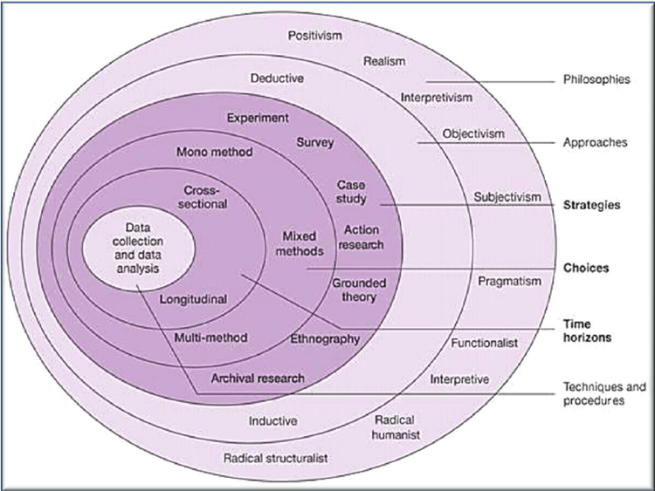

As seen in the above diagram there are six stages that must be followed to build an effective strategy (Raithatha 2017).

3.4 Research Philosophy
The researcher decides what kind of research they intend to conduct at this stage (Saunders, 2016). For this study it involved examining whether sexual predatory behaviour occurs within SWP.

3.5 Research Approach
The `deductive` method was used for this investigation. According to Bryman (2016), a deductive method is employed when the researcher has a theory in mind. The specific hypothesis for this study was that `Sexual predatory behaviour does in fact exist inside SWP`. As part of the study, the researcher tested this theory. A deductive technique is typically used while conducting quantitative research.

Diagram 3: Deductive and Inductive Approaches (Source: Bryman, 2016)
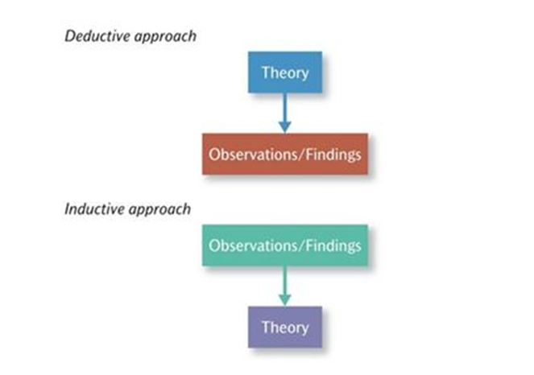

3.6 Strategies for obtaining the information
Adopting a `Mixed Method` strategy, primary and secondary data sources were gathered. The anonymous surveys that officers were required to complete produced primary data. Primary data is information that is obtained for the first time, while secondary data is information that already exists (Anuradha 2021). Poorly written surveys can be tedious (Gillham 2007). Therefore, the questions were carefully structured to prevent respondents from completing the surveys too quickly rather than honestly. Asking the person to answer too many questions can cause them to lose interest, 15 questions were deemed to be sufficient. The questionnaire can be viewed in Appendix A. Research using primary data is advantageous as it allows the researcher to obtain current information and can ask specific questions in relation to the research. Through the examination of the questionnaires, valuable insight can be gained. A variety of methods including utilising focus groups and interviews were considered. However, studies reveal that asking people for information in an anonymous manner increases their likelihood of them giving truthful and accurate answers (Saunders et al 2007). This is supported by Denscombe (2012) who found that anonymous surveys are more likely to yield precise and honest responses. According to Denscombe (2012) people often provide different answers depending on who is asking the questions. For instance, an officer might reply differently or more honestly if a colleague asks about sexually predatory behaviour than if an officer from Professional Standards Department (PSD) poses the same question. In this study officers may have been questioned about individuals they know or have worked with. Case studies were also considered as a method of gathering information. However, Gaille (2018) suggests, everyone has their own unconscious bias. The author of the case studies chooses what counts as `fact` and what does not. The data acquired can be based on the conclusions the author wants you to be aware of. Thus, they could influence the decisions made.

3.7 Methodological Choice
This phase chooses whether to utilise a qualitative, quantitative, or mixed methodology (Melnikovas 2018). This study used a hybrid methodology. The quantitative statistical data was obtained through questionnaires, and the qualitative information was gathered through literature reviews. The questionnaire contained closed-ended questions that required participants to tick a box. Despite the importance of qualitative data, Tewksbury (2009) argues that quantitative data is simpler to analyse. However, qualitative data is deeper and more insightful, providing the researcher a better understanding of the difficulties and providing information that they had not considered. To allow respondents to provide extra information in qualitative detail, an open question was added to the end of the questionnaire.
The secondary data obtained from the literature review was examined alongside the primary data obtained from the questionnaires. According to Walliman (2006), critical analysis is vital, the literature must be effectively evaluated and compared to the main findings. The literature review can be used to confirm the findings from the questionnaires or to argue the importance of the issue according to Creswell (2012). Conducting a literature review has many advantages, including quick and simple access to available research and the capacity to gather a wealth of data (Creswell 2012). However, Burnett (2009) identified that there are also restrictions. A literature review requires enhanced analysis to ensure that the already-acquired information is relevant to the topic of this research as it may have been gathered with a particular objective in mind.

3.8 Time scales
This research was restricted by time. As stated by Saunders et al (2016) researchers should predict how long the research will take. Participants were given one month to complete the questionnaires. This was deemed necessary so that the findings could be compiled and analysed. A Gantt case was formulated at the study's outset to aid in scheduling the data analysis.
Diagram 4: Gantt Chart
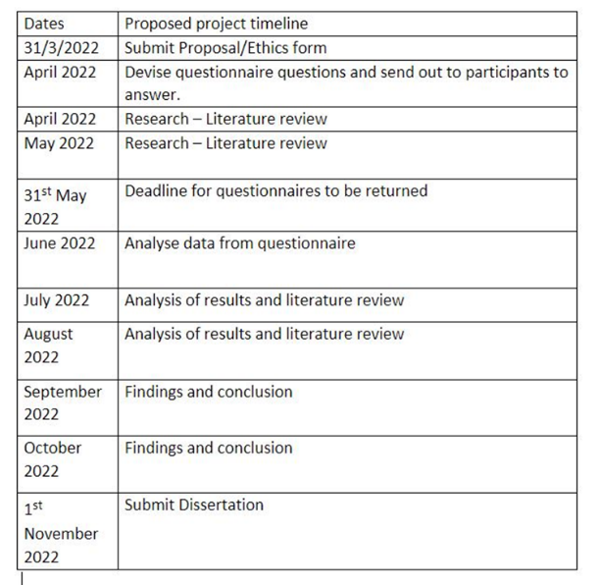

3.9 Techniques and Processes
Saunders et al`s (2007) `Onion theory` concludes with `techniques and processes` This can be described as the data collection and analysis. Having considered the sample size, it was deemed necessary that 30 SWP Officers complete questionnaires. These included male and female officers from various SWP departments. These officers had previously participated with PSD focus groups. According to Saunders et al (2007) numerous employees should receive questionnaires to gather meaningful data. Google forms were used to collect the data. This format was easy to use, and the answers can be presented in many ways. Google Forms works alongside Google spreadsheets to organise data by analysing and summarising the data obtained.
The researcher has analysed the data using `themes` to organize the data gathered from the surveys. Pie charts were created to represent the quantitative results of the questionnaires. Thematic analysis, which methodically identifies repeating patterns, themes, and the frequency of the material to provide `useful data interpretations` has been used to critically analyse and summarise the qualitative data obtained from the literature review. This method has been referred to as a `reflection and thinking` process (Wincup 2017). Finding a solution to a research problem involves developing themes and consistent or comparable responses (Roller, 2019).
The quantitative approach has limitations as it requires a substantial sample size to produce reliable results (Mertens et al 2017). However, qualitative data analysis may also be problematic, as the data collected may not fit the researcher's themes. This analysis can take time and depends on the researcher's ability of in-depth data analysis (Tewksbury 2009). It is beneficial to use both approaches. Data from qualitative research, according to Burnett (2009), `provides interpretations and knowledge that places the data into perspective`, providing insight into quantitative research.
A Freedom of Information (FOI) request was submitted to SWP requesting details of all incidents of sexual misconduct committed by officers for the last ten years. SWP provided a description of the behaviour and confirmed whether the victim was a member of public or Police employee, the gender and rank of those involved and the outcome of the allegation (Appendix D and E).

3.10 Limitations
At this point, it's crucial to acknowledge the research's limitations. The researcher initially created a questionnaire that required in-depth responses and was designed to be sent to a large audience (Appendix H). PSD opposed sending the questionnaires widely, owing to the sensitive nature of the questions. This was due to the possibility that following answering the questions, the participants may require after care and support. The answers provided by the respondents could generate investigations, should offences be disclosed. This raised questions about the researcher’s ability to respond to all concerns that the participants identified. PSD expressed concerns that officers may be less likely to participate in subsequent questionnaires of a similar nature if they had previously participated in this research. PSD plan to conduct similar research in the future and will guarantee that participants receive full support. It was decided to change the questions on the questionnaire and disseminate it to a smaller group of people. The FOI response was subject to further restrictions as SWP were unable to provide information about current investigations.

3.11 Ethics
Due to the sensitive nature of the research, ethical considerations were prioritised throughout. Along with the questionnaires, an explanation was provided in relation to what the participants could expect when completing the questionnaire (Appendix B). Before the research began, a code of ethics was completed (Appendix C). The researcher adhered to this code of ethics.

Chapter 4: Data Analysis and Findings

4.1 Introduction
This chapter proposes to analyse and understand the results obtained from the questionnaires, Freedom of Information Act (FOIA) request and literature review. A questionnaire (Appendix A) was sent to thirty male and female Police officers, from a variety of different departments. Pie and bar charts have been created using the raw data (Appendix F) and the results (Appendix G). A FOIA request was submitted to South Wales Police (SWP) asking for information in relation to allegations of sexual misconduct made from 2010 to 2021. The results obtained were subsequently populated onto charts (Appendix E). This chapter will analyse whether the objectives set at the start of this study have been achieved.

4.2 What is analysis
Analysis involves examining, processing, interrogating, and understanding the data produced. To do this the data needs to be sectioned into themes. This is corroborated by Hsieh & Shannon (2005) who insisted that `data needs to be interpreted through a systematic process of coding and identifying themes or patterns`. The data needs to be separated into qualitative and quantitative data, the data obtained needs to be assessed and the irrelevant data discarded. Only the findings that will provide additional weight to the study should be highlighted. To analyse quantitative content, the data must have been randomly obtained to ensure the validity of the statistical data (Babbie 2010). This contrasts with analysing qualitative data as in this instance the researcher will specifically target data collection techniques (Zhang and Wildemuth 2017). The data analysis throughout this chapter will reflect on the objectives that have been set.

4.3 Themes
The data has been analysed and seven themes have been created from the information provided by the research.

4.4 Theme 1, Does Sexual Misconduct exist within SWP.
This theme was created to answer the first objective, which asked whether sexual misconduct exists within SWP. The information from the FOI (Appendix E) clearly shows that sexual misconduct does in fact exist, with the number of cases being investigated steadily rising over the last 10 years. SWP have noted that there are also still several ongoing investigations from 2019 to 2021 so the figures are likely to be higher. This is supported by the results from the questionnaire whereby 19 out of 30 officers felt that sexual harassment of some sort exists and 17 out of 30 felt that an abuse of position of trust exists within SWP.

Diagram 5 Freedom of Information Act (FOIA) results (Appendix E) showing the percentage of allegations of sexual misconduct in SWP between 2010 & 2021.
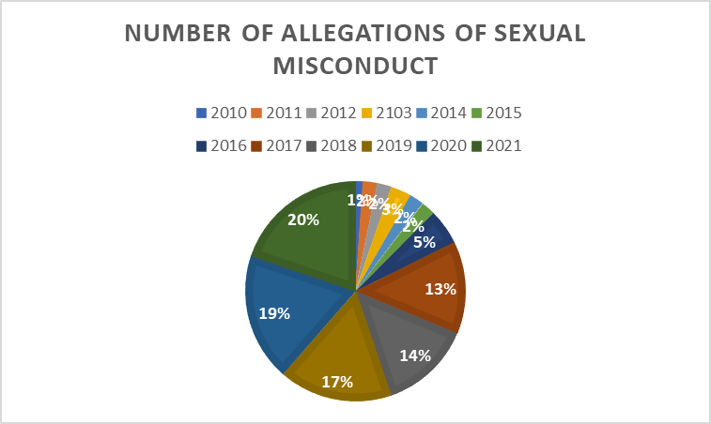

Diagram 6 FOIA results (Appendix E) showing the number of allegations of sexual misconduct in SWP between 2010 & 2021.

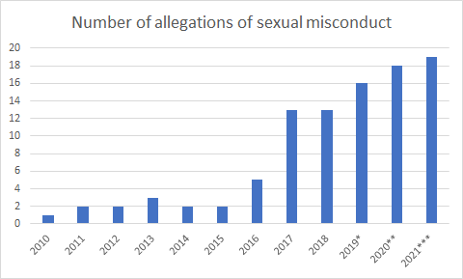
*1 ongoing investigation in 2019
**3 ongoing investigations in 2020
***6 ongoing investigations in 2021

Diagram 7; Questionnaire results. Do you feel that sexual harassment exists with South Wales Police (SWP)?
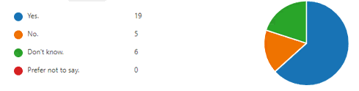

Diagram 8: Questionnaire result. Do you feel that the abuse of position for a sexual purpose exists within SWP?
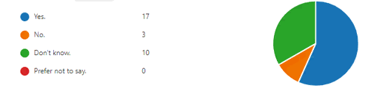

Along with statistics, there are numerous media reports that emphasise the prevalence of predatory police officers who take advantage of their positions of power and professional opportunities to obtain sexual gratification (Gould 2020). The increase of sexual misconduct is supported by research by Janetti (The Guardian 2019) who reported that the Independent Office for Police Conduct (IOPC) had received 643 referrals for sexual misconduct between 2016 and 2021. The actual figure may be significantly higher as not all cases are reported to the IOPC; some are handled by the police organisations.

4.5 Theme 2, Whether the Complainant was a member of public or Police Officer.
The results from the FOIA request show that the number of members of the public making allegations steadily increased from one allegation in 2010 to eleven allegations in 2021.
More members of the public than individuals employed by South Wales Police have been made allegations. The number of allegations made by persons employed by South Wales Police increased from one in 2010 to seven in 2018 but then dropped to three in 2021. Police sexual misconduct is seen as so critical that it is a `national research priority` (NPCC, 2017). The rise in this figure has been explained by Paoline et al (2000) who stated that the danger of policing can `give officers an aggressive outlook in their working lives, which may increase their tendency to abuse their position of authority`.

Diagram 9: FOIA results (Appendix E) shows the Diagram 10: FOIA results (Appendix E) shows the percentage of persons employed by SWP who percentage of members of public who made made allegations. allegations.
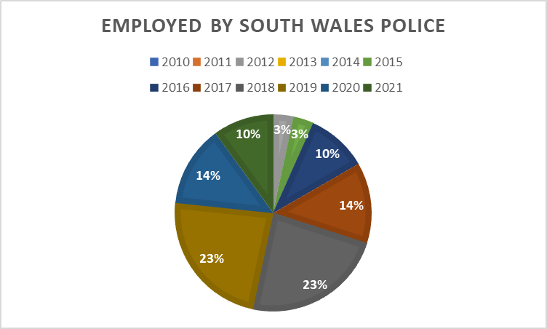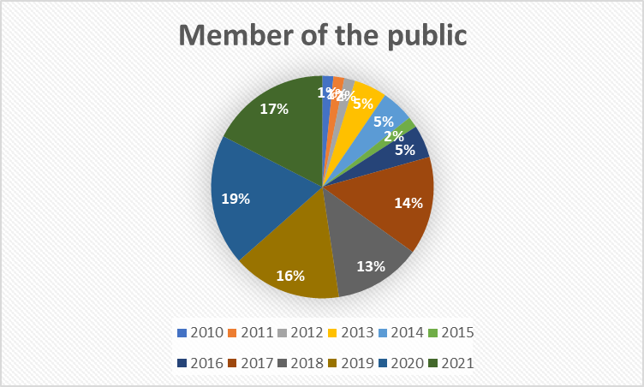

Diagram 11: FOIA results (Appendix E) Comparison of Complainants who were members of the public and employed by SWP between 2010 and 2021.

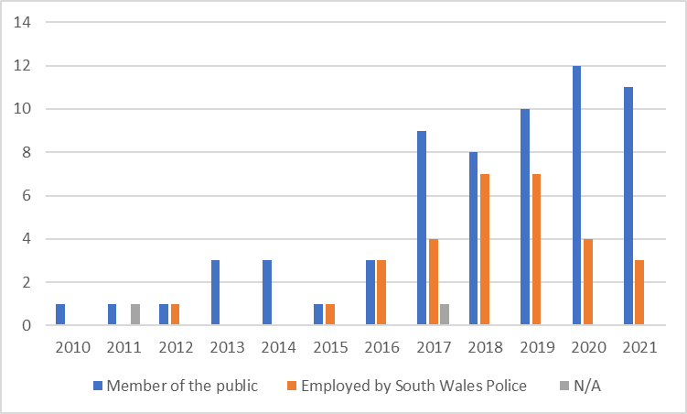
It is not only non-consensual/consensual sexual activity between officers and members of public that is considered misconduct. Consensual sexual behaviour between officers can also be seen as sexual misconduct (Sweeting et al 2020). Their research revealed that out of `155 cases of PSM in England and Wales, 6.5 percent involved officers engaging in sexual activity whilst on duty`. According to NPCC, (2019) officers are required to notify their supervisor's if they engage in sexual relationships with colleagues. The impact of this behaviour can be significant. As an illustration, `a Sussex police officer missed an urgent call to attend a fatal road collision because she was on a phone call to her married police officer lover` (Dearden, The Independent, 2019).

4.6 Theme 3, Gender of the accused and the Complainant.
Most complainants were females. This has increased from none in 2010 to 15 in 2019, this has then decreased to 8 in 2021. Fewer males make complaints than females. The maximum being 6 in 2021. This supports the research that most victims are females.

Diagram 12: FOIA results (Appendix E) Diagram 13: FOIA results (Appendix E) Percentage of male Complainants in SWP Percentage of female Complainants in SWP
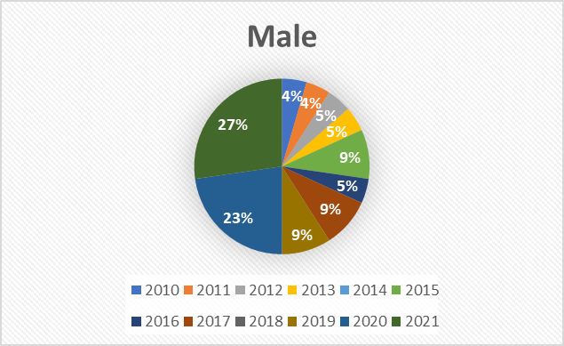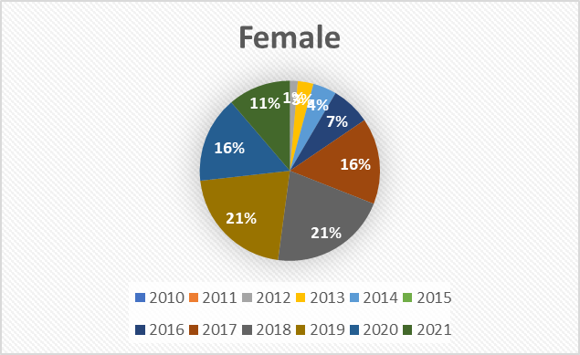

Diagram 14: FOIA results (Appendix E) Comparison of male and female Complainants in SWP between 2010 and 2021
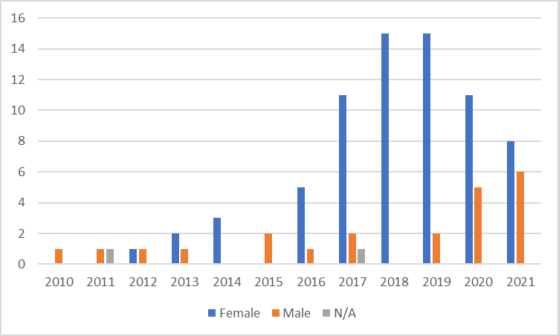

Research by Sweeting et al (2020) shows that female officers are far more likely to report sexual misconduct than their male colleagues. According to research by Benabou et al (2018) women see a wider range of sexually inappropriate behaviours as “unacceptable compared to men and men are more likely to provide excuses for such behaviour”. Research by Adebayo (2005) into police ethics suggests that `female police officers are more ethical than male officers, which is why they are more likely to report their concerns`.

Overwhelmingly, the data from the FOIA show that most of the accused were male. This has increased from 1 in 2010 to 15 in 2021. The data shows that there are some years where no females were accused of sexual misconduct.

Diagram 15 FOIA results (Appendix E) Percentage Diagram 16 FOIA results (Appendix E)
of female perpetrators in SWP of male perpetrators in SWP
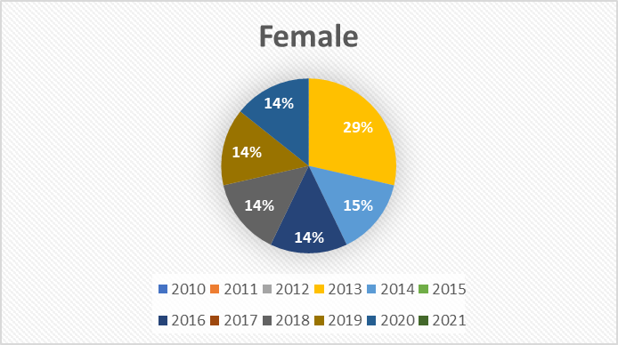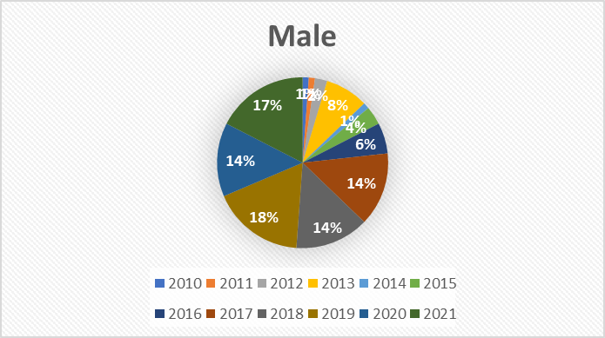

Diagram 17 FOIA results (Appendix E) Comparison of male or female perpetrators in SWP between 2010 and 2021.
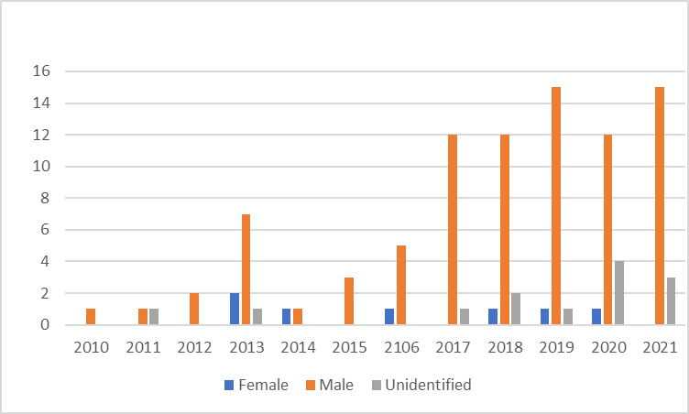
In their study of 548 cases of police sexual misconduct, Stinson et al. (2014) concluded that "99% involved male officers`. This number `may be generally compared to sex offenders, whereby the majority are male` (Sorrentino et al 2016)
4.7 Theme 4, The rank of the accused.
Most of the accused were Police constables. This figure has interestingly increased from zero in 2011 to twelve in 2019, only four in 2020.

Diagram 18: FOIA results (Appendix E) Comparison of the ranks of the accused in SWP between 2010 and 2021
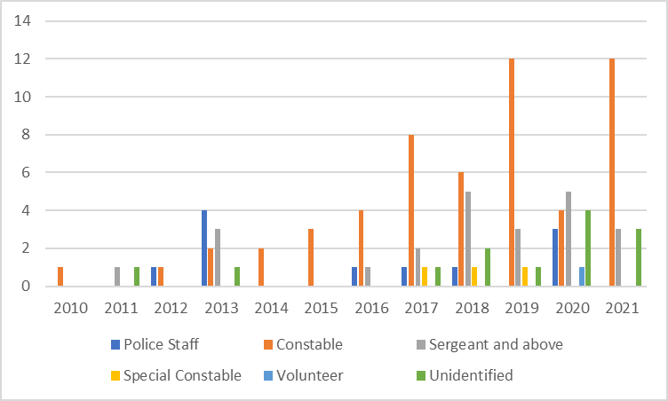

The review of the literature in chapter 2, includes the studies of Cockbain and Wortley (2015) and Sweeting et al (2020). These studies discuss the variations in PSM between ranks. Johnson et al`s (2018) research found that higher-ranking officers usually display sexually inappropriate behaviour towards lower-ranking females. The rank creates a power imbalance and can be defined as workplace bullying or sexual harassment, as the persons involved often display negative verbal and/or physical behaviour and this behaviour is often sexual.

4.8 Theme 5, Outcome for the accused
The results show that in 2017, two persons were convicted. One person was cautioned in 2016. Most outcomes related to no charges being brought or no further court action taken, explained by the complainant wishing that no further action be taken or no engagement with the complainant or a substantial time had elapsed since the incident.

Diagram 19: FOIA results (Appendix E) Comparison of the outcomes for the accused in SWP between 2010 and 2021
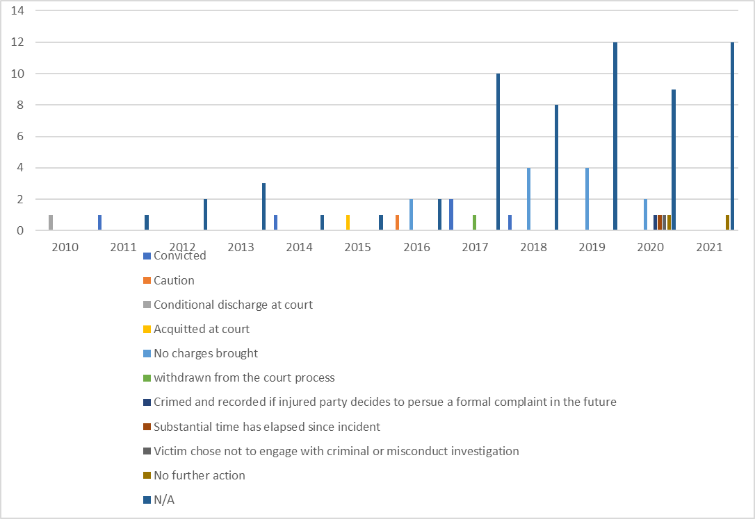
It is extremely concerning that police organisations investigate the offences differently. Police officers who commit sexual misconduct offences face a variety of consequences. This differs not only within the UK but also between countries. In the US, officers involved in this type of behaviour may be transferred rather than receive disciplinary action (Rabe-Hemp and Braithwaite, 2013). In one state officers have been `imprisoned whereas they were asked to write a letter of apology in another` (Stinson et al 2015). This was also highlighted in the literature review by Sweeting et al, (2020).

4.9 Comparison with other forces
There are 46 Police forces in the UK. Walker (i News 2021) submitted a Freedom of information request to these forces and obtained data from forty-one of them, therefore the results could be slightly higher. The chart shows the number of recorded sexual misconduct claims against employees between 2018 and 2021. The allegations made in relation to SWP officers meant that SWP were the 6th highest police force in the UK. During this period SWP had approximately 5,200 police employees, seventeen allegations had been made, equalling 0.3% of the force, seven dismissals and eight officers arrested for sexual offences.

Diagram 20 Comparison between forces (Source: i news 2021)
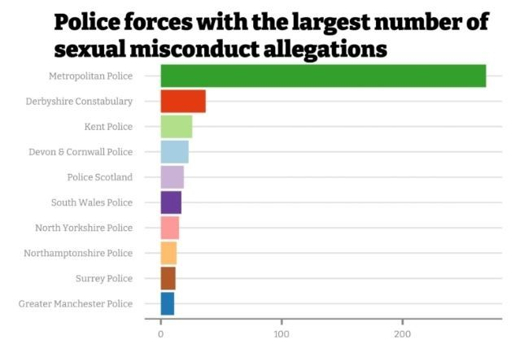
i news also produced results as a percent of the total force. (Appendix J)

4.10 Theme 6, Reporting incidents, analysing issues around why victims and witnesses do not report sexual predatory behaviour
The second objective was to determine why sexual predatory behaviour is not always reported by victims and witnesses. The results from the questionnaires assisted in critically analysing issues relating to victims reporting sexual predatory behaviours and co-workers reporting sexual predatory behaviour that they had witnessed. Analysing issues around reporting will help in understanding how and why this behaviour is allowed to continue and exist. Six persons said that they would not have reported PSM if they had been a victim of it, which is of concern. Not one of the persons who responded said that they would have reported the matter to the Police. However, these results could be interpreted that the other twenty-two person have not been a victim of PSM.

Diagram 21: Questionnaire result. If you have been a victim of sexual harassment within SWP, did you report it?
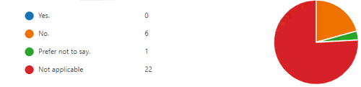
This is supported by research by Holgersson (2019) who found that, `feelings of loyalty to colleagues and/or fear of repercussions or ostracisation may prevent officers from reporting misconduct`

Diagram 22: Questionnaire result. If you were to witness sexual harassment within SWP, would you report it?
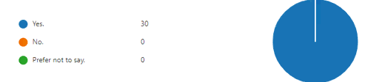
Witnessing sexual harassment can have an extremely negative effect. Police employees who experience or witness sexual misconduct have `low productivity levels and high stress levels` (Brown et al, 2018). Interestingly, all persons who responded stated that they would report sexual harassment if they were to witness it. Reassuringly, a substantial proportion of the persons who responded stated that in the future if they were to experience PSM they would report it. However, there were three respondents that indicated that they wouldn’t report their concerns.

Diagram 23 Questionnaire result. If you were to experience sexual harassment within SWP, would you feel able to report it?
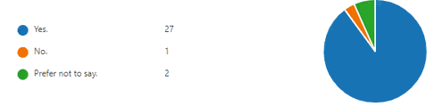
As discussed in the literature review chapter, previous research in relation to why police officers do not report sexual misconduct have suggested that this is due to officers adhering to the ‘blue code of silence’ (Kutnjak et al, 2019). This research suggests police officers may be `protected from detection by their colleagues`. Klockars et al. (2006) devised a scenario research study. They asked officers to read scenarios including different forms of misconduct. Officers were asked to evaluate how serious they thought the behaviour was, what outcome they thought the perpetrator should receive and whether they would report the behaviour. The research identified that officers are more `likely to report behaviour they believe to be serious`.
Sweeting et al (2022) conducted research on reporting sexual misconduct. 382 police officers were asked to discuss police sexual misconduct scenarios to determine if they would report the officer and whether they believed the scenario breached the Code of Ethics. The findings revealed that officers were likely to report concerns, when they thought that the scenario was `breaching the Code and worth disciplining`. Female officers were more likely to make complaints then men. Officers were less likely to report on direct colleagues and sexual misconduct between colleagues was less likely to be reported on. `The seriousness of the behaviour was often minimised, to justify why complaints were not made` (Sweeting 2022). Another reason provided in Sweeting's research was that participants had not witnessed the behaviour themselves so didn`t want to report it as it may not be true.

4.11 Third Objective
The third objective set out to understand why Police officers commit sexual misconduct. The questionnaires and FOIA have not provided data to answer this objective. However, the literature review in Chapter 2 has evidenced that to reduce PSM, the police organisation needs to understand why it occurs. As suggested by Brown et al (2018) Police culture may provide a partial reason, however, it is likely that `individual factors play a part` (Maher, 2008).

4.12 Fourth Objective
The fourth objective set out to formulate a proposal strategy for reducing predatory behaviour within SWP. The data obtained from question 15 of the questionnaire (Appendix G and Appendix M) was examined. The following recommendations were suggested by the officers who responded and suggested that:
SWP to clarify `What is sexual harassment`.
SWP to raise awareness on sexual misconnect via emails/posters/SWP intranet (BOB).
More information and guidance on Professional standards website, to provide information on what to do if someone is a victim or has witnessed sexual harassment and how to report it.
Dedicate sessions on a training day.
Create a dedicate webpage on SWP intranet (BOB).
Officers to complete NCALT packages.
Encourage supervisors, officers and especially new recruits to challenge Sexual misconduct.
SWP to communicate that those who challenge, and report concerns will be supported.
More use and publicity of anonymous reporting methods, suggestions being, a text service or an anonymous online portal.
Champions on the ground to assist people who may feel uncomfortable in reporting.
The outcomes of PSD investigations to be available to officers so police employees can view.

4.13 Conclusion
This chapter has presented the findings of the research from the questionnaire, FOIA request and literature review and addressed the first two objectives. The results obtained from the data was as expected. The fact that the number of recorded PSM has increased over the last ten years suggests that sexual predatory behaviour does exist within SWP Police. However, the increasing number could be attributed to the fact that more Police Officers feel able to report any misconduct that they come across which in turn increases the reported figure. It was interesting to see that six persons stated that they had been victims of PSM and had not reported it. However, all thirty said that if they were to be victims or witnesses of PSM in the future they would report it. This suggests that Police Officers are now more willing to report any concerns that they have due to PSM not being tolerated as it would have been years ago.

Chapter 5: Conclusion and Recommendations

5.1 Introduction
Chapter 2 provided a review of the relevant available literature in relation to police sexual misconduct. Chapter 4 analysed data that has been obtained from SWP. This chapter sets out to identify whether the objectives set at the start have been achieved and will propose recommendations for further work.

5.2 Research objectives and findings
The literature review and analysis have achieved the objectives in relation to identifying that PSM does in fact exist within SWP and has recognised that there are issues in relation to Police employees reporting PSM. Additionally, theories explaining why Police officers engage in sexual misconduct have been proposed. This chapter will seek to achieve the final objective and will provide recommendations from the literature review and analysis to formulate a proposal strategy for reducing predatory behaviour within the police force.

5.3 South Wales Police Recommendations
South Wales police have already commissioned `Chwarae Teg` to undertake a review of sexual harassment with SWP workplace. Focus groups have been established to help understand the impact sexual misconduct has on individual officers and the organisation. SWP have stated that they provide extensive training and advice to Police officers and staff around issues of dishonestly, unethical behaviour and corruption. SWP have stated that they will continue to develop a culture whereby Officers are encouraged to report PSM (Police and Crime Commissioner 2022).

5.3.1 Recruitment
Requesting full disclosure from previous employment is vital, as identified by the IOPC (2022) if enhanced background checks had been carried out prior to officers joining the police, some concerns around the officer’s behaviour would have been identified (IOPC & ACPO 2012). Also, a more enhanced system of psychometric testing for officers would be extremely beneficial and would assist in identifying any concerns surrounding officers.
The UK Government have said that they will recruit 20,000 new police officers in 2023, it is crucial that `police organisations are able to recruit new officers without compromising on standards` (Home Office, 2019). Identifying `officers who engage in this behaviour early on is critical, and a current priority` (NPCC, 2017). It is therefore important to identify any officers that may have tendencies to commit sexual misconduct early in their career before harm can be caused to victims or the police organisation.

5.3.2 Training
As identified in the literature review, initial training for new recruits is the first opportunity for any concerns to be identified. It is vital that new recruits receive appropriate training and are aware of PSM and acknowledge that it is not acceptable. Training to identify PSM is not only necessary at the start of an officer's career, but it is something that needs to be reiterated throughout. An ethical dilemma scenario and discussion could be built in an officer`s monthly supervision session. This is supported by ACPO (2021) who stated that Officers throughout their service need to have clear boundaries of what is appropriate behaviour and what is accepted of them.

5.3.3 Supervision
Supervision of staff is crucial. Investigations by IOPC in relation to reported PSM cases found that more effective supervision needed to be carried out (IOPC 2021). Supervisors can witness at first hand inappropriate behaviours which must be addressed immediately. Good supervision will enable supervisors to address this behaviour and colleagues should feel able and willing to report any concerns that they have with their supervisors. Supervisors must be alert to the possibility of inappropriate behaviour escalating, and to ensure that it is monitored, stopped, and dealt with properly (IOPC 2021).

5.3.4 Support to report concerns.
The failure to challenge and report inappropriate behaviour has a massive impact on being able to deal with the true amount of sexual misconduct. Failing to report and challenge these inappropriate behaviours is a crucial factor in why progress in eradicating sexual misconduct is prevented (IOPC 2022). Officers should be encouraged and supported to report any concerns that they may have, reporting the matter should be a positive experience. Failing to identify these behaviours and subsequently reporting them means that this behavior will continue. It is vital that Officers feel they are supported when they come forward to report their concerns (IOPC 2022)

5.4 Future research
As stated in the limitations section of the Methodology chapter, SWP are committed to ensuring that PSM is not tolerated within the organisation. Further work is being planned for the near future and questionnaires will be sent to all officers who work for SWP. The data obtained will be vital for further research into the issue. Sweeting (2022)'s research has suggested that further work needs to be carried out to identify why different offences are committed more frequently than others in different areas and why officers receive different outcomes to their offences.

5.5 Conclusion
This research study has confirmed my initial hypothesis and identified that PSM does occur within SWP. The data obtained and information from the literature review clearly shows that there have been issues with officers reporting their concerns. However, the rise in the amount of sexual misconduct may be explained by the fact that sexual misconduct is longer tolerated, and individuals are now more willing to report their concerns. It poses the question, `Is sexual misconduct more of a problem now or are the high figures the result of individuals more willing to report it`.
It is obviously a concerning issue and one that needs to be monitored and training continuously provided to all officers to ensure that sexual misconduct is not accepted and officers who engage in this behaviour are weeded out. Further research must be conducted to obtain the views of the officers who work for SWP. Sexual misconduct and abuse of authority for sexual purposes should not be tolerated within SWP, the prevention and reduction of the offences should be priorities. Expectations and guidance is crucial and should be widely publicised to ensure that victims are encouraged to come forward (IOPC 2022

References

Adebayo DO (2005) `Gender and attitudes toward professional ethics: A Nigeria police perspective`. African Security Review 14(2): pages 93–100

Ambrose T (2021) Cases of police abusing role for sexual gain have risen sharply, says watchdog. [The Guardian]. Available at: https://www.theguardian.com/uk-news/2021/oct/26/cases-of-police-abusing-role-for-sexual-gain-have-risen-sharply-says-watchdog. Accessed on 13/10/2022.

Anuradha (2021) What is the Difference Between Primary and Secondary Data. [pediaa]. Available at: https://pediaa.com/what-is-the-difference-between-primary-and-secondary-data/. Accessed on 14/10/2022

Arrigo BA and Claussen N (2003) `Police corruption and psychological testing: a strategy for preemployment screening`. International Journal of Offender Therapy and Comparative Criminology Volume 47(3): pages 272–290.

Babbie, E. R. (2010) The Practice of Social Research. 12th Edition, Wadsworth, Belmont.

Barkan SE, Bryjak GJ (2014) Myths and realities of crime and justice: what every American should know. Jones and Bartlett Publishers, Inc; 1st edition

BBC News (2021) Police sexual misconduct: 'No place' for officers who abuse authority. [BBC News]. Available at: https://www.bbc.co.uk/news/uk-59040905. Accessed on 21/09/2022

Bénabou R, Falk A and Tirole J (2018) Narratives, Imperatives and Moral Reasoning (No. w24798). Cambridge, MA:National Bureau of Economic Research. https://doi.org/10.3386/w24798

Berdahl JL and Aquino K (2009) `Sexual behavior at work: Fun or folly?` Journal of Applied Psychology Volume 94(1): pages 34–47.

Boivin R, Faubert C, Gendron A, et al. (2020) `The ‘us vs them’ mentality: a comparison of police cadets at different stages of their training`. Police Practice and Research Volume 21(1): pages 49–61

Brown J, Gouseti I and Fife-Schaw C (2018) `Sexual harassment experienced by police staff serving in England, Wales and Scotland: a descriptive exploration of incidence, antecedents and harm`. The Police Journal: Theory, Practice and Principles Volume 91(4): pages 356–374.

Brown J, Fleming J, Silvestri M, et al. (2019) `Implications of police occupational culture in discriminatory experiences of senior women in police forces in England and Wales`. Policing and Society Volume 29(2): Pages 121–136. DOI: 10.1080/10439463.2018.1540618.

Bryman, A. (2016). Social Research Methods. 5th ed. Oxford: Oxford University Press.

Burger, J (2016) `To Protect and Serve: restoring Public Confidence in the SAPS`. SA crime quarterly Volume 36. Pages 13-22

Burnett, J (2009) Doing your Social Science Dissertation. London. SAGE Publications.

Chan DKS, Lam CB, Chow SY and Cheung SF (2008) `Examining the job-related, psychological, and physical outcomes of workplace sexual harassment: a meta-analytic review`. Psychology of Women Quarterly Volume 32(4): pages362–376.

Cheng I-H, Hsiaw A (2019) `Reporting sexual misconduct in the #MeToo era`. SSRN Electronic Journal. Available at: https://www.ssrn.com/abstract=3506936. Accessed on 14/09/2022.

Christensen and Jansen (2019) `Gender Comparisons of Offenders: Males and Females Who Sexually Offend Against Children`. Child Abuse and Neglect Forensic Issues in Evidence, Impact and Management. Chapter 7. Pages 117-131

Chware Teg (2019) A fairer Wales where women achieve and prosper [Chwarae Teg]. Available at: https://chwaraeteg.com/. Accessed on 18/10/2022

Cockbain, E. and Wortley, R. (2015). ‘Everyday Atrocities: Does Internal (Domestic) Sex Trafficking of British Children Satisfy the Expectations of Opportunity Theories of Crime?’ Crime Science Volume 4(1): 35

Cockcroft (2015) `Golden Ages, Red Herrings and Post-Keynesian Policing - Understanding the Role of Police Culture in the Police Professionalism Debate`. Nordisk Politiforskning. Volume 2, Issues 2 pages 183 – 196.

College of Policing (2013) Police Sector Standard for the Training of Trainers ‘Trainer Standard’. Available at: https://www.college.police.uk/What-we-do/Standards/Documents/Trainer_Standard.pdf#search=police%20trainers. Accessed on 03/07/2022

College of Policing (2014) Code of Ethics. A Code of Practice for the Principles and Standards of Professional Behaviour for the Policing Profession of England and Wales. Available at: https://www.college.police.uk/What-wedo/Ethics/Documents/Code_of_Ethics.pdf. Accessed on 09/08/2022.

College of Policing (2022) Guidance on outcomes in police misconduct proceedings. Available at; https://www.college.police.uk/article/outcomes-police-misconduct-proceedings-updated-guidance. Accessed on 01/09/2022

Cottler LB, O’Leary CC, Nickel KB, et al. (2014) `Breaking the blue wall of silence: risk factors for experiencing police sexual misconduct among female offenders`. American Journal of Public Health Volume 104(2): pages 338–344. DOI: 10.2105/AJPH.2013.301513.

Creswell, J. W. (2012). Educational research: Planning, conducting, and evaluating quantitative and qualitative research. (4th ed.). Boston, MA: Pearson.

Dearden L (2019) Senior police officer ‘had sex with female officer and domestic violence victim’ while on duty. Chief Inspector Rob Leet and Sergeant Sarah Porter face gross misconduct hearings [Independent (2019]. Available at: https://www.independent.co.uk/news/uk/crime/police-officer-sex-domestic-violence-victim-sussex-iopc-misconduct-a8773576.html. Accessed on 23/09/2022

Demirkol IC, Nalla MK (2020) `Police culture: an empirical appraisal of the phenomenon`. Criminology & Criminal Justice Volume 20(3): pages 319–338.

Denscombe, M (2012) Research Proposals: A Practical guide. McGraw-Hill Education (UK)

Detrick P, Chibnall JT and Luebbert MC (2004) `The revised NEO personality inventory as predictor of police academy performance`. Criminal Justice and Behavior Volume 31(6): pages 676–694

Duemig, E (2022) `Predatory Behavioural Pathways: Illuminating Predatory Footprints to Monitor and Manage Risk`. Journal of Police and Criminal Psychology. Volume 37: pages 212–221

Dungan J, Waytz A and Young L (2015) `The psychology of whistleblowing`. Current Opinion in Psychology Volume 6: pages 129–133.

Fleming, J (2009). The Sage Dictionary of Policing. London Sage

Gaille Brandon (2018) 12 Case Study Method Advantages and Disadvantages. [Brandongaille Small business and Marketing advice]. Available at 21/09/2022: https://brandongaille.com/12-case-study-method-advantages-and-disadvantages/. Accessed on 23/09/2022

Gillham, B (2007) Developing a Questionnaire. 2nd edition. Real world research. Bloomsbury. Continuum International Publishing Group.

Gilmartin, K., & Harris, H. (1998). `Law enforcement ethics: The continuum of compromise`. Police Chief, Volume 5, Pages - 25-28.

Giuffre PA and Williams CL (1994) `Boundary lines: Labelling sexual harassment in restaurants`. Gender and Society Volume 8(3): pages 378–401.

Glatthorn A and Joyner R (2005) Writing the Winning Thesis or Dissertation. A Step-by-Step Guide. 2nd edition. Thousand Oaks, California. Corwin Press

Gottfredson, M.R., & Hirschi, T. (1990). A general theory of crime. Stanford, CA: Stanford University Press.

Gottschalk, P, Dean, G and Glomseth, R. (2012) `Police misconduct and crime: bad apples or systems failure` Journal of Money Laundering Control, Volume 15 No. 1 pages 6 - 24 .

Gould I (2020) Taking Advantage of Victims: Police Officer’s Inappropriate Relationships & Sexual Misconduct. [Actions Against the Police Solicitor]. Available at: https://iaingould.co.uk/. Accessed on 26/09/2022

Gould I (2021) Vulnerable Victims of Crime and Police Sexploitation. [Actions Against the Police Solicitor]. Available at: https://iaingould.co.uk/. Accessed on 26/09/2022

Griffin and Ruiz (1999) `The sociopathic police personality: Is it a product of the “Rotten Apple” or the “Rotten Barrel?”`. Journal of Police and Criminal Psychology. Volume 14, pages 28–37

Groeneveld (2005) Arrest Discretion of Police Officers: The Impact of Varying Organizational Structures. LFB Scholarly Publishing, United States

Harris, C (2014). `The onset of police misconduct`. Policing: An International Journal of Police Strategies & Management, Issue 37(2), Pages 285-304.

Holgersson S (2019) Whistleblowing within the Swedish Police. Nordisk Politiforskning 6(01):24–45. DOI: 10.18261/issn.1894-8693-2019-01-04.

Her Majesty Inspectorate of Constabulary (HMIC) (2017) PEEL: Police Legitimacy 2016 A National Overview. London: HMIC. https://www.justiceinspectorates.gov.uk/hmicfrs/publications/peel-police-legitimacy-2016/.

Hickman MJ, Powell ZA, Piquero AR et al. (2016) `Exploring the viability of an attitudes toward ethical behavior scale in understanding police integrity outcomes`. Policing: An International Journal Volume 39(2): pages 319–337.

Home Office (2019) Home Office Announces First Wave of 20,000 Police Officer Uplift. Home Office. Available at: https://www.gov.uk/government/news/home-office-announces-first-wave-of-20000- police-officer-uplift. Accessed on 09/08/2022.

Hsieh H and Shannon S (2005) `Three approaches to qualitative content analysis`. Qualitative health research, Volume 15, pages 1277-1288. http://dx.doi.org/10.1177/1049732305276687

Hyeyoung, Sloan and John (2016) `Police officer integrity: a partial replication and extension`. Policing; Bradford Volume. 39, Iss. 2, pages 284-301

Llies R, Hauserman N, Schwochau S & Stibal J (2003) `Reported incidence rates of work-related sexual harassment in the United States: Using meta-analysis to explain reported rate disparities`. Psychology, Volume 56, pages 607-631

Independent office for police conduct (IOPC) (2012) Corruption in the Police Service in England and Wales: Second Report—A Report Based on the IPCC’s Experience from 2008 to 2011. Available at: https://assets.publishing.service.gov.uk/ government/uploads/system/uploads/attachment_data/file/243479/9780108511622.pdf. Accessed on 09/08/2022

Independent office for police conduct (IOPC) (2012) The abuse of police powers to perpetrate sexual violence. Published in partnership with Association of Chief Police Officers. Available at: https://policeconduct.gov.uk/sites/default/files/Documents/research-learning/abuse_of_police_powers_to_perpetrate_sexual_violence.pdf. Accessed on 21/09/2022

Independent office for police conduct (IOPC) (2022). Operation Hotton Learning Report. Available at: https://www.policeconduct.gov.uk/sites/default/files/Operation%20Hotton%20Learning%20report%20-%20January%202022.pdf. Accessed on 21/09/2022

Independent Office for Police Conduct (IOPC) (2022) Learning the Lessons 40 - Abuse of position for sexual purpose (APSP). Available at: https://www.policeconduct.gov.uk/learning-lessons-40-abuse-position-sexual-purpose-apsp. Accessed on 21/09/2022

Jayanetti C (2019) Scale of police sexual abuse claims revealed. [The Guardian]. Available at: https://www.theguardian.com/uk-news/2019/may/18/figures-reveal-true-extent-of-police-misconduct-foi. Accessed on 14/10/2022

Johnson, P, Widnall, S, and Benya, F (2018) Sexual Harassment of Women Climate, Culture, and Consequences in Academic Sciences, Engineering, and Medicine. Committee on the Impacts of Sexual Harassment in Academia. Committee on Women in Science, Engineering, and Medicine Policy and Global Affairs A Consensus Study Report of The National Academies of Sciences, Engineering Medicine. The National Academies Press. Washington DC. Available at: www.nap.edu. Accessed on 10/10/2022

Klockars C, Kutnjak I S & Haberfeld M (2006) Enhancing Police integrity. New York Springer.

Kutnjak I, Haberfeld M, Kang W, et al. (2019) `A comparative study of the police code of ´ silence: exploring the relation between the code of silence and societal characteristics`. Policing: An International Journal. Volume 43(2): pages 285–298. DOI: 10.1108/PIJPSM-06-2019-0081.

Laville S (2012) Sexual predators in police 'must be rooted out. Sexual predators in police 'must be rooted out' [The Guardian]. Available at: https://www.theguardian.com/uk/2012/sep/20/sexual-predators-police-rooted-out. Accessed on 01/10/2022

Lonsway K, Paynich R and Hall J (2013) `Sexual harassment in law enforcement: incidence, impact and perception`. Police Quarterly. Volume 16: pages 177–216.

Magley VJ, Hulin CL, Fitzgerald LF & DeNardo M (1999) `Outcomes of self-labelling sexual harassment`. Journal of Applied Psychology, Volume 84, pages 390-402.

Maher TM (2003) `Police sexual misconduct: officers’ perceptions of its extent and causality`. Criminal Justice Review Volume 28(2): pages 355–381. DOI: 10.1177/073401680302800209.

Maher, T. M. (2008). `Police chiefs’ views on police sexual misconduct`. Police Practice and Research: An International Journal, Volume 9(3), pages 239–250.

Maher TM (2010) `Police sexual misconduct: female police officers’ views regarding its nature and extent`. Women & Criminal Justice Volume 20(3): pages 263–282.

Melig, S.G. (2012). Everything You Need to Know about Corruption in Police Departments. Newmarket, Ontario: Brainmass, Inc.

Melnikovas A (2018) `Towards an Explicit Research Methodology: Adapting Research Onion Model for Futures Studies`. Journal of Futures Studies, Volume 23(2): pages 29–44

Merkin RS and Shah MK (2014) `The impact of sexual harassment on job satisfaction, turnover intentions, and absenteeism: Findings from Pakistan compared to the United States`. Springer Plus Volume 3(1): pages 215–228.

Mertens, W, Pugliese A & Recker J (2017) Quantitative Data Analysis. A Companion for Accounting and Information Systems Research 1st ed. Springer.

Mollen Commission (1994) Anatomy of failure, a path for success: The report of the Commission to Investigate Allegations of Police Corruption and the Anti-Corruption Procedures of the New York City Police Department. New York, City of New York.

National Police Chiefs Council (NPCC) (2017) National Strategy to Address the Issue of Police Officers and Staff Who Abuse Their Position for a Sexual Purpose. National Police Chiefs’ Council. Available at: http://www.npcc.police.uk/documents/Abuse%20of%20position%20for%20sexual%20purpose%20National%20Strategy. Pdf. Accessed on 03/07/2022

National Police Chiefs Council (NPCC) (2019) Appropriate Personal Relationships and Behaviours in the Workplace. College of Policing. Available at: https://paas-s3-broker-prod-lon-6453d964-1d1a-432a-9260-5e0ba7d2fc51.s3.eu-west2.amazonaws.com/s3fs-public/2021-02/appropriate_personal_relationships_and_behaviours_ guidance.pdf. Accessed on 03/07/2022

O'Connor, T.R. (2005) Police deviance and ethics. Available at: http://faculty.ncwc.edu/toconnor/205/205lect11.htm. Accessed on 01/09/2022

Paoline EA, Myers SM and Worden RE (2000) `Police culture, individualism, and community policing: evidence from two police departments`. Justice Quarterly Volume 17(3): pages 575–605.

Perry F (2001) `Repairing broken windows: Preventing corruption within our ranks`. FBI Law Enforcement Bulletin; Washington Volume 70, Issue 2. Pages 23-26.

Piquero, N, Schoepfer, A & Langton, L. (2010). `Completely out of control or the desire to be in complete control? How low self-control and the desire for control relate to corporate offending`. Crime & Delinquency. Volume 56(4), Pages - 627 –647

Pogarsky and Piquero (2004) `Studying the reach of deterrence: Can deterrence theory help explain police misconduct?` Journal of Criminal Justice. Volume 32, Issue 4, July–August 2004, Pages 371-386

Porter, L. E., & Prenzler, T. (2016). `The code of silence and ethical perceptions: Exploring police officer unwillingness to report misconduct`. Policing: An International Journal of Police Strategies & Management, Volume 39(2), pages 370–386. DOI:10.1108/PIJPSM-10-2015-0108.

Punch M (2009) Police Corruption: Deviance, Accountability and Reform in Policing. London: Willan Publishing.

Rabe-Hemp CE and Braithwaite J (2013) `An exploration of recidivism and the officer shuffle in police sexual violence`. Police Quarterly Volume 16(2): Pages 127–147. DOI: 10.1177/1098611112464964

Raithatha, Y (2017). Understanding the economic impact terrorism has on the destination decision making: Northern Irish tourists. Doctoral dissertation. Dublin Business School.

Richman-Hirsch WL and Glomb TM (2002) `Are men affected by the sexual harassment of women? Effects of ambient sexual harassment on men`. Psychology of Work: Theoretically Based Empirical Research. Pages 212–240.

Rinsky K (2016) `Whistle-Blowing in American Police Agencies` Crime Psychology Review Volume 2 (1): pages 45–59.

Roller, M. R. (2019). `A Quality Approach to Qualitative Content Analysis: Similarities and Differences Compared to Other Qualitative Methods`. Forum Qualitative Sozialforschung / Forum: Qualitative Social Research, Volume 20(3). https://doi.org/10.17169/fqs-20.3.3385

Saunders, M; Lewis, P & Thornhill, A. (2007). Research Methods for Business Students, (6th ed.) London: Pearson.

Saunders, M., Lewis, P., & Thornhill, A. (2016). Research Methods for Business Students. England

Scott (2015) Institutions and Organizations: Ideas, interests and identities. SAGE, England

Sherman, L (1985) `Becoming Bent - Moral Careers of Corrupt Policemen`. Moral Issues in Police Work, Pages 253-265

Skolnick JH (2010). `Corruption and the blue code of silence`. Police practice and research. An International Journal. Volume 3, issue 1. Pages 7-19.

Sorrentino, R, Friedman, S. H and Hall, R (2016). ‘Gender Considerations in Violence.’ Psychiatric Clinics of North America. Volume 39(4): pages 701–710.

South Wales Police and Crime Commissioner (2019) Sexual Harassment in the Workplace: Summary of Chwarae Teg Report. Available at: https://www.southwalescommissioner.org.uk/en/events/south-wales-police-crime-panel-dec-22/. Accessed on 01/07/2022

Stinson PM, Liederbach J, Brewer S and Mathna B (2015) `Police Sexual Misconduct: A National Scale Study of Arrested Officers`, Criminal Justice Policy Review 2015, Volume 26(7) Pages 665–690

Stinson, P. M., Liederbach, J, Brewer, S. L., and Mathna, B. E. (2015). ‘Police Sexual Misconduct: A National Scale Study of Arrested Officers.’ Criminal Justice Policy Review Volume 26(7): pages 665–690. DOI: 10.1080/15564886.2014.939798.

Stinson PM, Brewer SL, Mathna BE, Liederbach J and Englebrecht CM (2015) `Police sexual misconduct: Arrested officers and their victims`. Victims & Offenders, Volume 10(2), pages 117–151. doi:10.1080 /15564886.2014.939798.

Sweeting F, Arabaci-Hills P and Cole T (2020) `Outcomes of police sexual misconduct in the UK`. Policing: A Journal of Policy and Practice. Available at: paaa052 DOI: 10.1093/police/paaa052. Accessed on 03/07/2022

Sweeting Faye, Cole Terri & Hills Peter (2022) `Is the blue wall of silence a fallacy in cases of police sexual misconduct` International Journal of Police Science & Management, Volume 24(3), pages 285–297. https://doi.org/10.1177/14613557221085504

Sweeting, F and Cole, T (2022) `Sexual Misconduct in Police Recruits as identified by Police Trainers`. Police Journal (Chichester), page 32258–. https://doi.org/10.1177/0032258X211048416

Symonds T (2022) Inside the new Met police unit investigating officer abuse claims [BBC NEWS]. Available at: https://www.bbc.co.uk/news/uk-63162881.amp. Accessed on 13/10/2022

Tewsbury R (2009) `Qualitative versus Quantitative Methods: Understanding Why Qualitative Methods are Superior for Criminology and Criminal Justice`. Journal of Theoretical and Philosophical Criminology, Volume 1 (1)

Tharp AT, DeGue S, Valle LA, et al. (2013) `A systematic qualitative review of risk and protective factors for sexual violence perpetration`. Trauma, Violence, & Abuse Volume 14(2): pages 133–167

United Nations Police (2003) Directive on Sexual Harassment in United Nations Peacekeeping and Other Field Missions. For Military Members of National Contingents, Military Observers and Civilian Police Officers. Available at: https://police.un.org/sites/default/files/directive_on_sexual_harassment_in_united_nations_peacekeeping_and_other_field_missions_for_military_members_of_national_contingents_military_observers_and_civilian_police_officer.pdf. Accessed on 02/09/2022

Waddington PAJ (2013) Professional police practice: scenarios and dilemmas. Oxford: Oxford University Press, pages 3–24.

Walliman N (2006) Social research methods. London Sage

Walliman, N. S. & Walliman N. (2011) Research methods: the basics. Taylor and Francis

Walker A, (2021) Scale of sex misconduct allegations made against UK police employees revealed: How does your force compare. [i News] Available at: https://inews.co.uk/news/sexual-misconduct-allegations-against-police-workers-uk-forces-statistics-1227576. Accessed on 21/09/2022

Walker S and Irlbeck D (2002). Driving while female: A national problem in police misconduct. Department of Criminal Justice, University of Nebraska at Omaha

Westmarland L and Rowe M (2018) `Police ethics and integrity: can a new code overturn the blue code?` Policing and Society Volume 28(7): pages 854–870. DOI: 10.1080/10439463.2016.1262365

Wincup, E (2017) Criminological Research: Understanding Qualitative Methods. 2nd edition. London. Sage Publications.

Wolfe SE and Nix J (2017) `Police officers’ trust in their agency: does self-legitimacy protect against supervisor procedural injustice?` Criminal Justice and Behavior Volume 44(5): pages 717–732.

Wright B (2010) `Civilianising the ‘blue code’? An examination of attitudes to misconduct in the police extended family`. International Journal of Police Science & Management Volume 12(3): pages 339–356

Zhang, Y., & Wildemuth, B. M. (2017). `Qualitative Analysis of Content`. In B. M. Wildemuth (Ed.), Applications of Social Research Methods to Applications to Question in Information and Library Science (2nd ed., pp. 318-329). Belmont, CA: Brooks/Cole.

APPENDICES

Appendix A: Final Questionnaire Questions

1 - Do you feel that sexual harassment exists with South Wales Police (SWP)?
…...........................................................................................
2 - Do you feel that the Abuse of position for a sexual purpose exists within SWP?
…...........................................................................................
3 - If you have been a victim of sexual harassment within SWP did you report it?
…...........................................................................................
4 - If you were to witness sexual harassment within SWP would you report it?
…...........................................................................................
5- If you were to experience sexual harassment within SWP would you feel able to report it?
…...........................................................................................
6 - If you were to witness abuse of position for a sexual purpose by a member of SWP, would you feel able to report it?
…...........................................................................................
7 - On a scale of 1 (strongly disagree) to 5 (strongly agree) to what extent do you agree with the following statement: SWP as an organisation would take reports of sexual misconduct seriously
…...........................................................................................
8 - On a scale of 1 (strongly disagree) to 5 (strongly agree) to what extent do you agree with the following statement: Should they (the victim of the conduct) so wish, SWP would (where the circumstance made it possible) protect their anonymity?
…...........................................................................................
9- On a scale of 1 (strongly disagree) to 5 (strongly agree) to what extent do you agree with the following statement: SWP would work to protect the safety of the person reporting the conduct?
…...........................................................................................
10 - On a scale of 1 (strongly disagree) to 5 (strongly agree) to what extent do you agree with the following statement: SWP would provide support to the person making the allegation?
…...........................................................................................
11- On a scale of 1 (strongly disagree) to 5 (strongly agree) to what extent do you agree with the following statement: SWP would investigate your allegation
…...........................................................................................
12 - On a scale of 1 (strongly disagree) to 5 (strongly agree) to what extent do you agree with the following statement: SWP would provide support resources to the person making the allegation, including counselling services and other support provisions.
…...........................................................................................
13 – Should you have concerns about Sexual Harassment or the abuse of Position for a sexual Purpose, are you aware of how to report your concerns?
…...........................................................................................
14 – Are you aware that you can report concerns overtly to a supervisor and anonymously via Crimestoppers?
…...........................................................................................
15 – Do you have any recommendations for how SWP could raise awareness of how to report sexual harassment or abuse of position for a sexual purpose?

Appendix B: Letter to accompany Questionnaire
I currently work as a detective constable for South Wales Police working in the Major Crime Unit in Western. I am currently studying for a Professional Investigations in Policing degree with the University of Wales Trinity St David. As part of this degree, I must complete a dissertation. For this dissertation I have decided to conduct research into the occurrence of sexual predatory behaviour perpetrated by Police Officers in South Wales Police and the features that characterise this behaviour. The aim of the research is to identify whether sexual predatory behaviour exists within South Wales Police. I intend to analyse issues relating to victims reporting sexual predatory behaviours and co-workers reporting sexual predatory behaviour that they have witnessed. Analysing issues around reporting will help in understanding how and why this behaviour is allowed to continue and exist. To assist in doing this I have designed a questionnaire which contains fifteen questions that I would like South Wales Police officers to answer. The questions are straight forward and will not take long to complete. I will then examine the data gathered from the questionnaires and academic research on the subject to formulate a proposal strategy for reducing predatory behaviour within the police force. The information obtained will be stored appropriately and personal information of the participants will not be disclosed.
The questionnaire is voluntary, and participants can withdraw their involvement at any time. The questionnaire will be anonymous. The professional Standards Department of South Wales Police are fully aware of the work that I intend to carry out and are supportive of the research. The questionnaire will need to be completed by 30th June. Should you have any questions about the questionnaire or the research that I am doing. Please contact me at my university email address: 2112543@student.uwtsd.ac.uk
The following people are available to offer welfare support services:
Amanda Collins, Counselling & Trauma Advisor - Northern & Central BCU ext 27986
Christopher Williams, Counselling & Trauma Advisor - Western & Central BCU ext 27979
Rachel Roberts, Counselling & Trauma Advisor - Eastern & Central BCU ext 27988
Angela Davies Counselling & Triage Contact - Central BCU ext 27987
Sian Willis Counselling & Trauma Advisor - Western & Central BCU ext 52246
Concerns can be reported to: Professional.Standards@south-wales.pnn.police.uk
The link to the questionnaire is attached:
Appendix C: Code of ethics

The participants will be told that by completing the questionnaires, they are giving their implied consent.
They will be informed that their participation is entirely voluntary and that they can withdraw their consent at any point.
The research's aims will be outlined.
The participants will be told about how the data will be stored and used.
Participants will be informed that the questionnaires are anonymous.
Participants will be told that their personal information will not be disclosed.
All participants will be respected.
Involvement in this study should not cause any harm.
The questions will not use offensive, discriminatory or unacceptable language.
The researcher will maintain objectivity whilst analysing the research.
The research methods and findings will be transparent.
Contact details for the professional standards and welfare department will be provided should the participant completing the questionnaire feel the need to discuss the matter further.
Data protection rules will be adhered to throughout the research.

Appendix D: Freedom of information request response
from South Wales Police

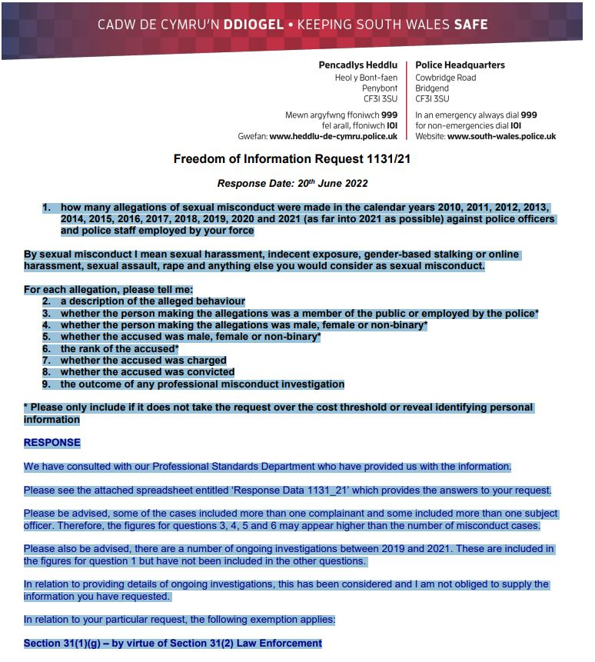
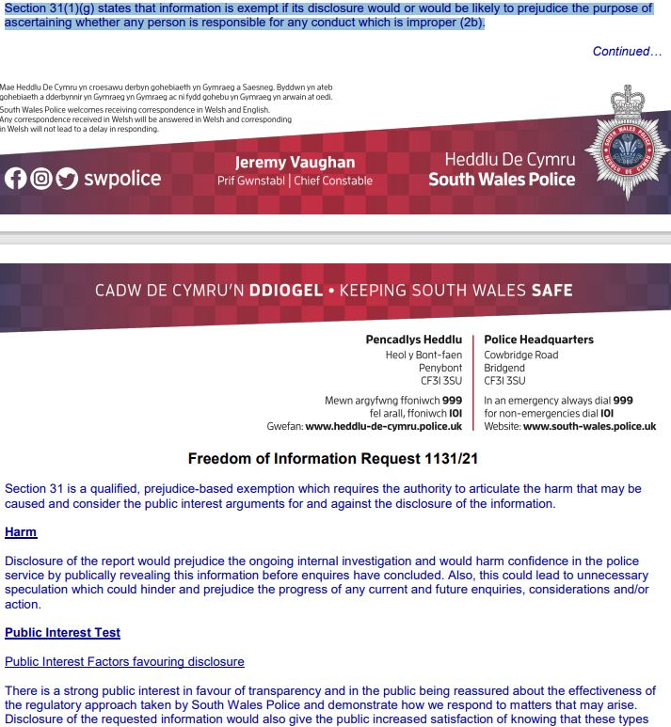
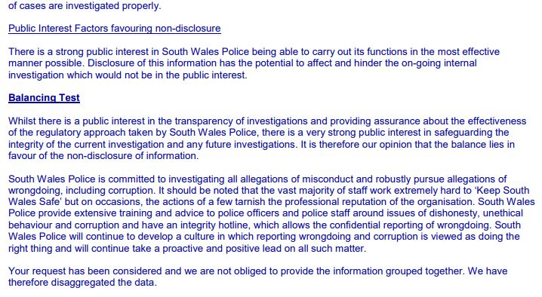
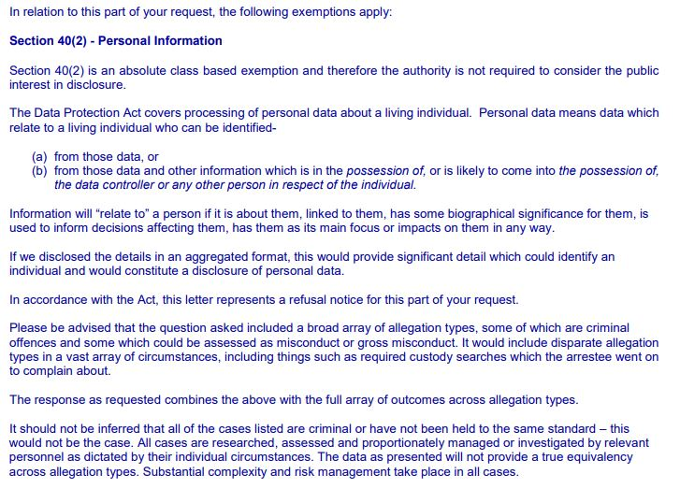

Appendix E: Freedom of information request data from South Wales Police

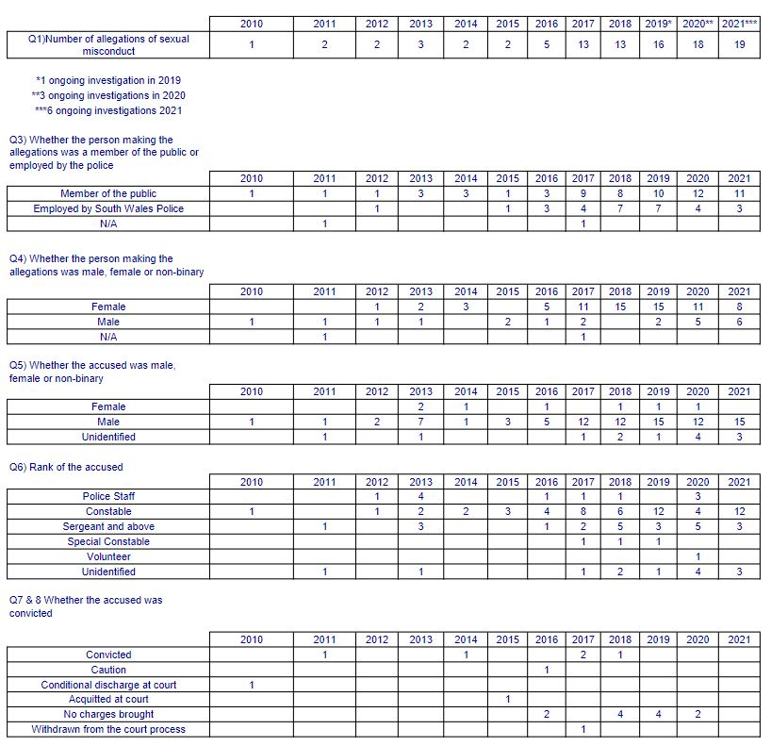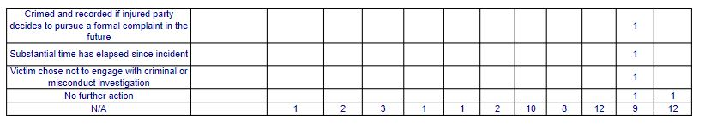

Appendix F: Questionnaire data

Link: APPENDIX F - Questionnaire Data.xlsx

Appendix G
Graphs of data obtained from the Freedom of Information
request and Questionnaires

Number of allegations of sexual misconduct reported to SWP
Whether the person making the allegation was a member of the public or employed by SWP.
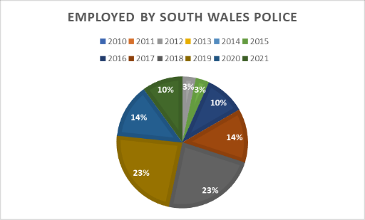

Whether the person making the allegations was Male, Female, or Non identified
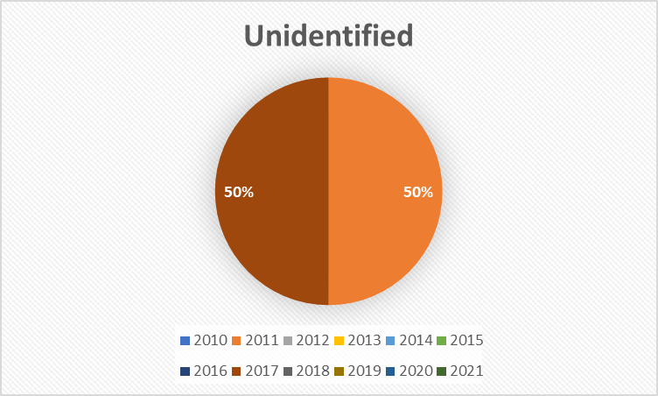

Whether the accused was Male, Female, or Non identified 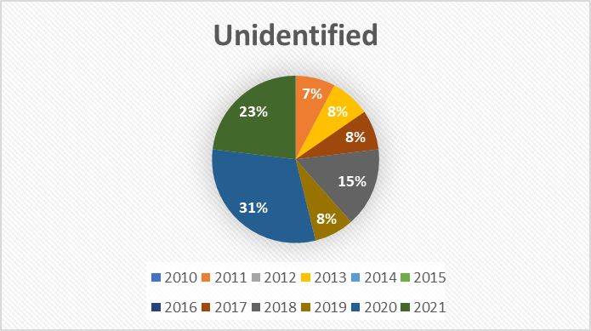

Rank of the accused
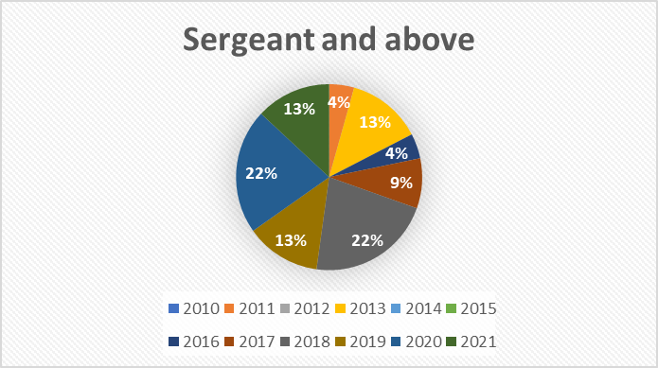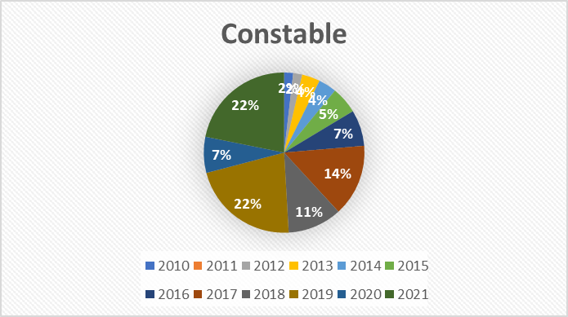
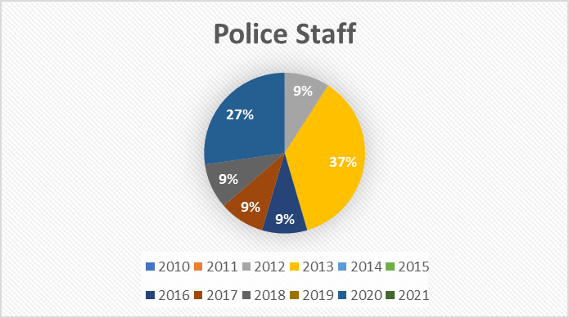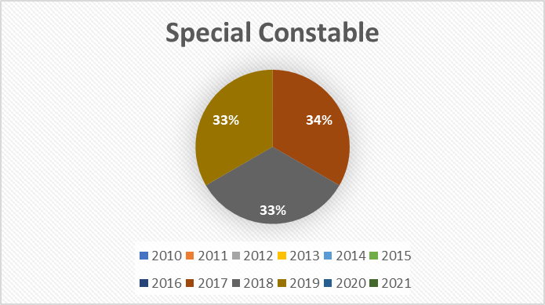
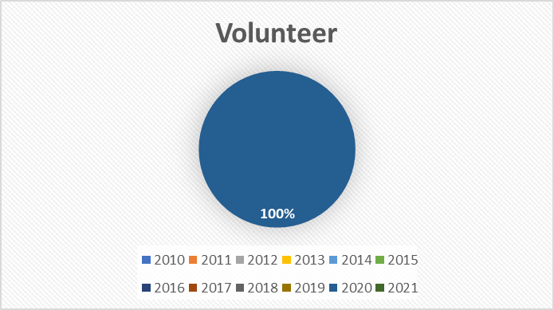

Outcome for the accused
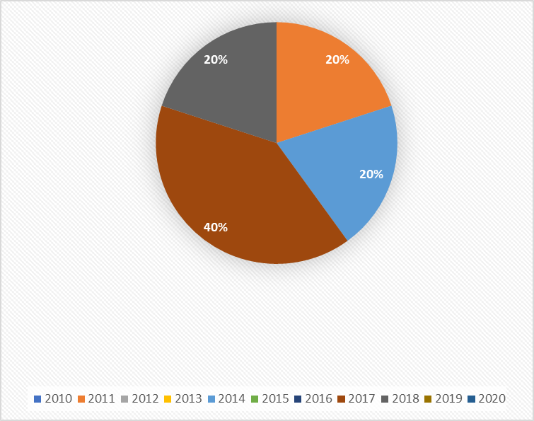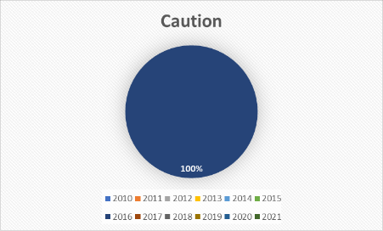
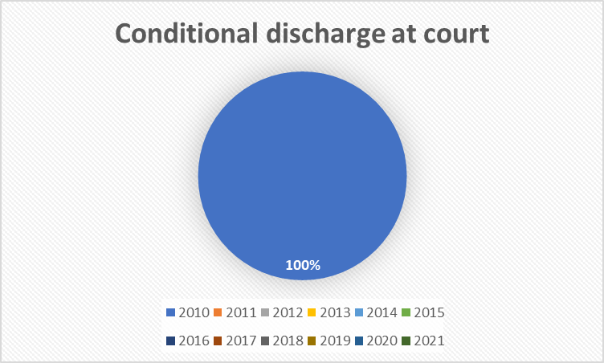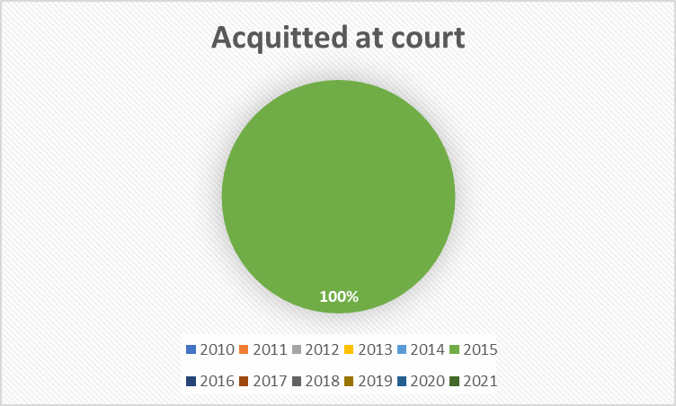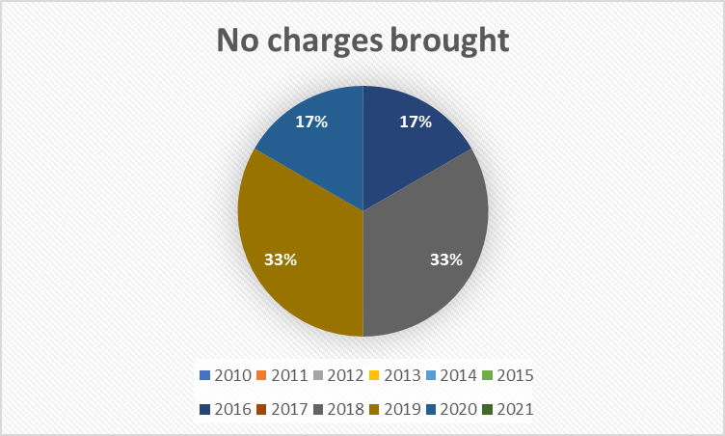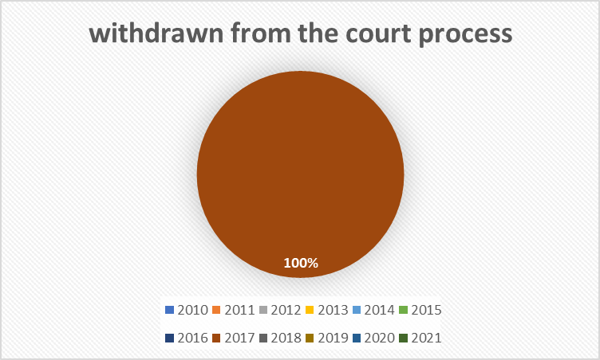
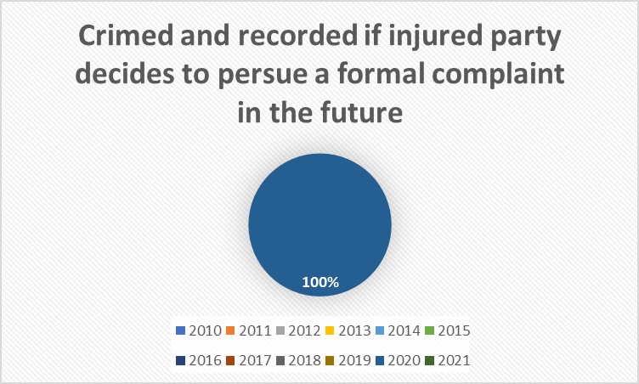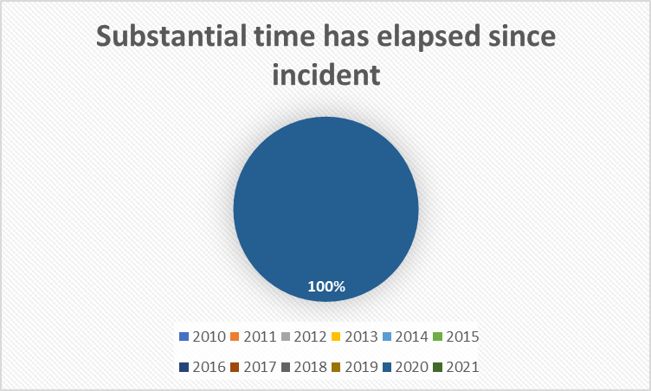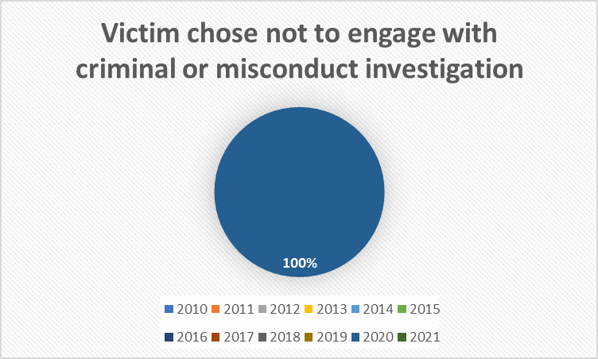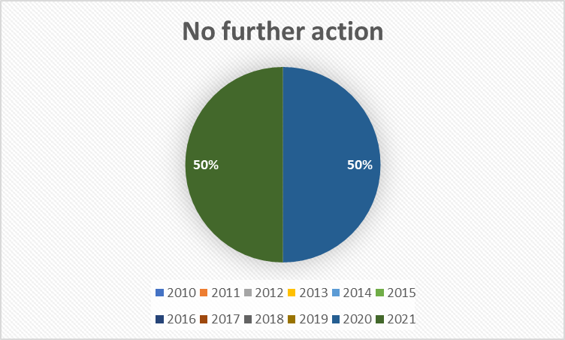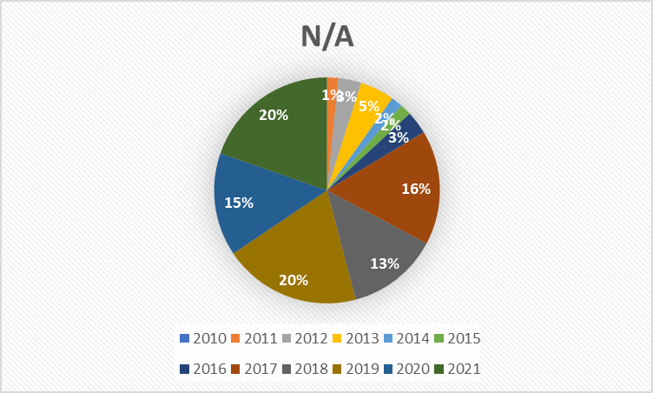

Data obtained from the Questionnaire results

1 - Do you feel that sexual harassment exists with South Wales Police (SWP)?

2 - Do you feel that the Abuse of position for a sexual purpose exists within SWP?

3 - If you have been a victim of sexual harassment within SWP did you report it?

4 - If you were to witness sexual harassment within SWP would you report it?

5- If you were to experience sexual harassment within SWP would you feel able to report it?

6 - If you were to witness abuse of position for a sexual purpose by a member of South Wales Police, would you feel able to report it?
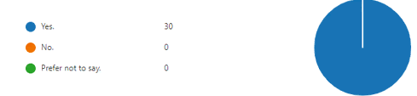

7 - On a scale of 1 (strongly disagree) to 5 (strongly agree) to what extent do you agree with the following statement: SWP as an organisation would take reports of sexual misconduct seriously
81 % rated between 4-5 for this question

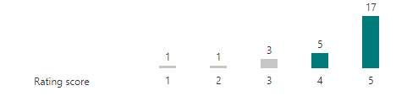

8 - On a scale of 1 (strongly disagree) to 5 (strongly agree) to what extent do you agree with the following statement: Should they (the victim of the conduct) so wish, South Wales Police would (where the circumstance made it possible) protect their anonymity.
63 % rated between 4- 5 for this question
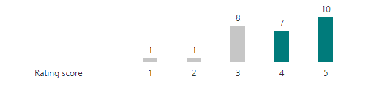

9- On a scale of 1 (strongly disagree) to 5 (strongly agree) to what extent do you agree with the following statement: South Wales Police would work to protect the safety of the person reporting the conduct
77 % rated between 4-5 for this question.
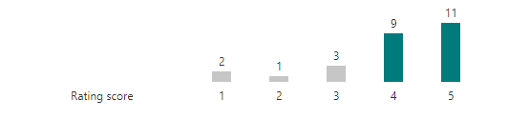

10 - On a scale of 1 (strongly disagree) to 5 (strongly agree) to what extent do you agree with the following statement: SWP would provide support to the person making the allegation
78 % rated between 4-5 for this question.
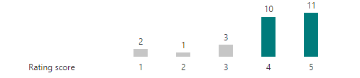

11- On a scale of 1 (strongly disagree) to 5 (strongly agree) to what extent do you agree with the following statement: SWP would investigate your allegation
81 % rated between 4-5 for this question.
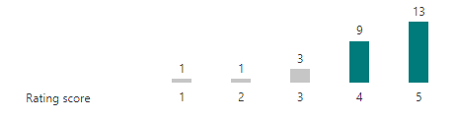

12 - On a scale of 1 (strongly disagree) to 5 (strongly agree) to what extent do you agree with the following statement: SWP would provide support resources to the person making the allegation, including counselling services and other support provisions.
73 % rated between 4-5 for this question.


13 – Should you have concerns about Sexual Harassment or the Abuse of Position for a sexual Purpose, are you aware of how to report your concerns?
82 % of people responded - Yes
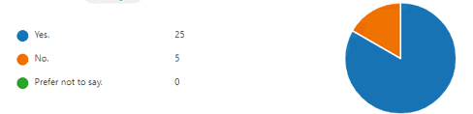

14 – Are you aware that you can report concerns overtly to a supervisor and anonymously via Crimestoppers?
78 % of people responded – Yes
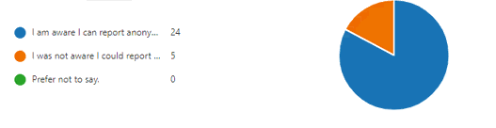
15 – Do you have any recommendations for how South Wales could raise awareness of how to report sexual harassment or abuse of position for a sexual purpose.
- See Appendix M

Appendix H: Initial Questionnaire Questions

1 - How would you define sexual predatory behaviour?
…....................................................................................
2 - Do you feel that sexual predatory behaviour exists within South Wales Police?
Yes/No/Don`t know/prefer not to say
...............................................................................................
3 - What is your perception of sexual predatory behaviour within South Wales police
….............................................................................................
4 - In your opinion which of the following can be categorised as ‘sexual predatory behaviour’
(Please tick the relevant boxes)
Innuendos
Sexual banter
Inappropriate language
Making Sexist remarks
Repeatedly telling sexual stories or jokes that are offensive
Sexual coercion
Over familiar language
Sexual touching
Pushes boundaries sexually
Inappropriate touching
Sexual Harassment
Cyber sexual harassment
Sending/posting unwelcome messages/posts/photos by any electronic means
Stalking
Inappropriate gifts
Anti-social behaviour
Assault
Putting someone down or being condescending to them because of their sex
Using bribes as a reward to engage in sexual behaviour
Feeling uneasy/nervous in someone's presence
Treating someone differently because of their sex
Displaying, using, or distributing sexist or suggestive material
Sexist hostility
Unwanted sexual attention
Other........................................................................................
5- If you have been a victim or witnessed sexual predatory behaviour within the workplace did you report it? Yes/No/prefer not to say
.................................................................................................
6 – If you experienced or witnessed sexual predatory behaviour in the workplace, would you feel comfortable in reporting the matter?
Yes/No/Don`t know/prefer not to say
.................................................................................................
7- To what extent do you agree with the following questions in relation to reporting an incident of sexual predatory behaviour -
Strongly agree – agree – neither agree nor disagree – disagree – strongly disagree
I - South Wales Police organisation will take the report seriously
II- South Wales Police would maintain the privacy of the person making the complaint
III- South Wales Police would take steps to protect the safety of the person making the report
IIII- South Wales Police would support the person making the complaint
V– South Wales Police would believe your allegation
VI- South Wales Police would actively provide support with resources such as counselling, academic services, meetings, or phone calls
8- Are you aware of the processes of how to report sexual predatory behaviour?
Yes/No/Don`t know/prefer not to say
.................................................................................................
9- Do you think South Wales police`s reporting policy is adequate in relation to reporting concerns about sexual predatory behaviour?
Yes/No/Don`t know/prefer not to say
.................................................................................................
10– In relation to raising awareness of sexual predatory behaviour amongst staff which of the following do you think South Wales Police should provide -
I -Arrange workshops about what you could do to stop sexual misconduct
II - Arrange online events about what you could do to stop sexual misconduct
III - Posters to raise awareness
IIII -More information on how to report concerns about sexual predatory behaviour on BOB
V - Specific training in relation to working and interacting with people who have vulnerabilities relating to mental health/learning disability/ substance misuse/domestic violence etc
VI –Any other recommendations for how South Wales Police could improve the system of reporting sexual predatory behaviour?
…..............................................................................................
If you wish to provide further/additional information in relation to your responses to any of the above questions, please provide your contact details below …...............................................................................................

Appendix I: Sexual harassment in the workplace: Summary
of Chwarae Teg report.

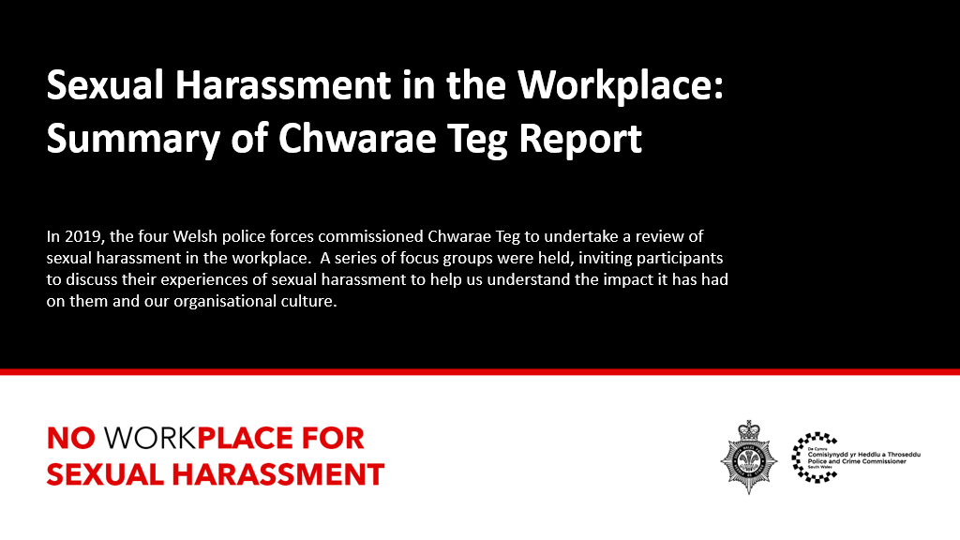
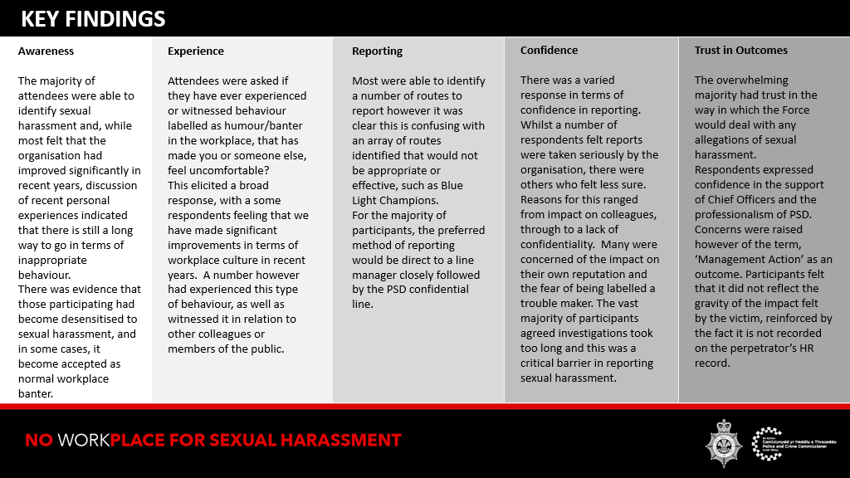
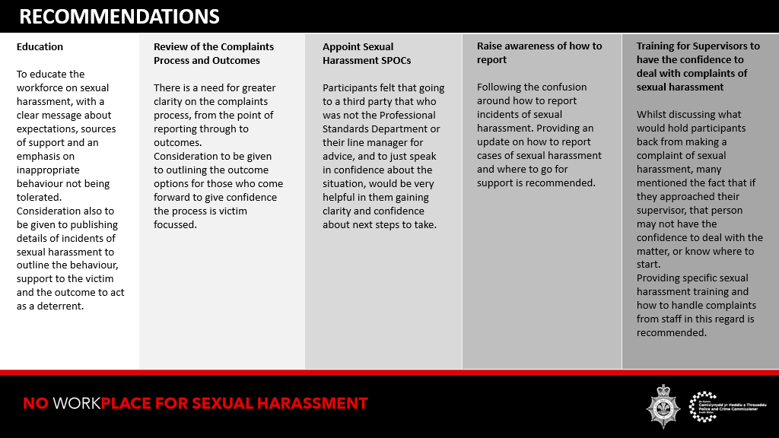
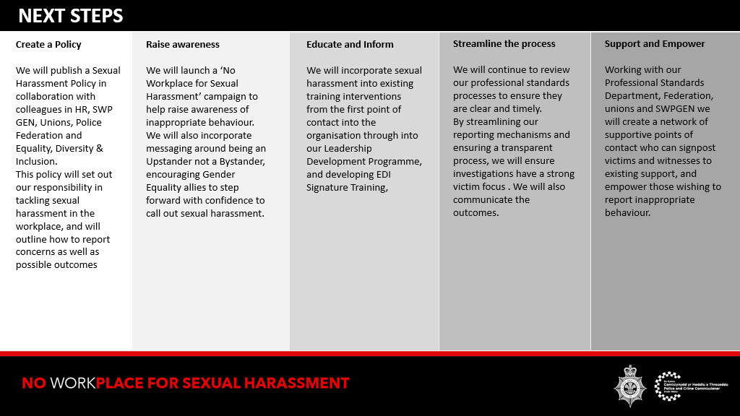

Appendix J: Police forces with the largest number of sexual
misconduct allegations as % of total force (i news 2021)

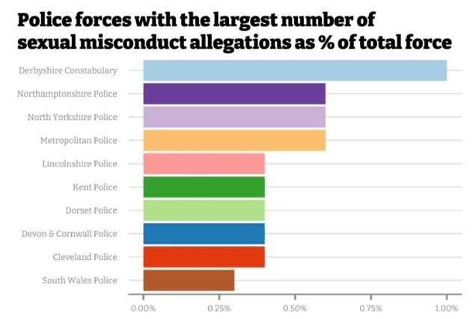

Appendix K: Police forces with the largest number of sexual
misconduct allegations (i news 2021)

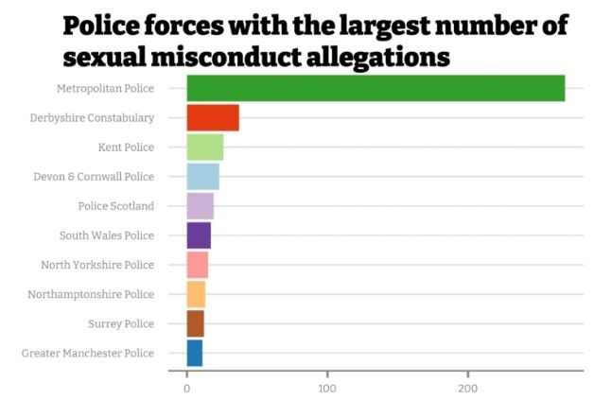

Appendix L: APSP cases 2016 – 2020. Referrals and independent investigations carried out by the IOPC.

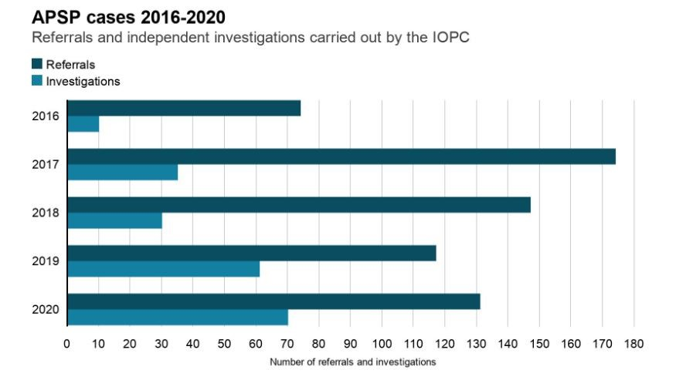

Appendix M: Recommendations from Question 15 of the Questionnaire

I) Keep raising awareness via Force wide emails – LDS new starters
II) The only issues I see is if the perpetrator is in a position of significance, then it can disrupt any allegations, but I would hope that regardless of rank it would still be investigated properly. SWP has a responsibility to all employees to ensure they have a good working environment. Would be good to have more sections with information available to those that need it on PSD site. Not everything is on there that can be reported and if the guidance is there then people can look at it before they decide to report any wrongdoings.
III) Encourage all members of SWP but in particular all Sgts and above to be overt and vocal when challenging SH and calling it out at the time. I have witnessed reluctance to challenge inappropriate behaviour, in particular when it comes from a supervisor. People are afraid to openly challenge because of fear of repercussions. I have done this previously when I witnessed it, but I was not supported by anyone present at the time, including a supervisor the same rank as the person responsible. SWP needs to clarify what constitutes SH. i.e. it is a wide concept and takes form in different ways and means, it includes making the person feel demeaned, uncomfortable, or humiliated. SWP needs to communicate that those who speak up and challenge will be openly supported, and the message will be reinforced to those who by stand in each specific case. Until this message is given and received by officers and staff reporting SH is given and received by officers and staff reporting SH is likely to be at a minimum for fear of lack of support and repercussions from those responsible. This takes places in many different ways, including on a subtle level by excluding a victim from a Teams Day to day work and engagement, blocking their development and in the case of supervisors especially, using their rank to unfairly influence peers and higher raking officers towards the victim if they have challenged them. There needs to be a centralised, independent reporting mechanism which eliminates the opportunity for the report to be `swept under the carpet` and not investigated or dealt with by the persons direct line managers. I have a significant amount of service and whilst there has been an improvement in culture and attitudes over the last 20 years, there is still a long way to go. People need to feel they will not be disadvantaged if they speak up in the first instance. Once this has been achieved them as long as the reporting means is basic (e.g., a link on BOB) I believe people will report. The emphasis needs to be on reassuring people they are able to report in the first instance.
IV) A text service, or an anonymous online portal for reporting. And champions on the ground that can be a point of contact on division is people don’t feel comfortable in reporting.
V) SWP disciplines and fires people for misconduct, the outcomes should always remain on PSD website do people can go back and see a history of punishing those that behave in this way.
VI) More use and publicity of anonymous reporting methods. Mandatory annual scrutiny as part of vetting – anonymous reports taken from colleagues on a 360-degree basis.
VII) Need to change culture where people who know or are related to one another can work in same department
VIII) Ensuring that Supervisors (newly promoted) and the new PC recruits are briefed on this topic and made aware of challenging this behaviour and the reporting mechanisms.
IX) Initial training and a dedicated BOB section
X) Targeted training at male officers with 15 + years’ service. Identify those remaining in a `rugby culture` or `old school cops` mentality.
XI) Posters in the workplace/training
XII) BOB, include information on training days, NCALT
XIII) Statistics
Summary of suggestions
SWP to clarify `What is sexual harassment`
Raise awareness via Force wide emails/posters/SWP intranet (BOB).
More information, advice, and guidance on Professional standards website, to provide information on what to do if someone is a victim or has witnessed sexual harassment and how to report it.
Dedicate sessions on a training day, create a dedicate webpage on SWP intranet (BOB)
Officers to complete NCALT packages.
Encourage supervisors and officers, especially new recruits and to challenge Sexual misconduct
SWP to communicate that those who challenge, and report concerns will be supported
More use and publicity of anonymous reporting methods, suggestions being a text service or an anonymous online portal.
Champions on the ground to assist people who may feel uncomfortable in reporting.
The outcomes of PSD investigations to be available to officers so police employees can view

