Management Economics
(LCBB5008)
Lecturer: Muno Zuwirai
Student Name: Aleksandar Petrov
Student ID: 2112978

Contents
Introduction 3
Profit Maximization Theory and its Application to ASSI 4
Evaluating Pricing Strategy 5
Market Competition 5
Cost Optimization 6
Emphasizing Product Differentiation 7
Customer Retention and Loyalty 7
Economic Theories, Business Environment, and Objectives 8
Demand and Supply Analysis 8
Market Structure 9
Stakeholder Issues 10
Recommendations 12
Conclusion 13
Reference List 14

Introduction
This report is prepared in consideration of the concerns expressed by Jesse Zole, the primary shareholder of All Seasons Supplies Incorporated (ASSI), regarding the company's profitability issue. Since profit maximisation is important to Jesse Zole, the report contains the discussion of profit maximisation theories and how they apply to ASSI. However, it recognises the significance of contemplating additional factors in the development of ASSI. The report entails the larger context in which ASSI operates, delving into economic theories such as supply and demand, business climate, market structure, and stakeholder issues. By analysing these factors, the report aims to assist ASSI's management in striking a balance between profit maximisation, long-term development, and stakeholder gratification.

Profit Maximization Theory and its Application to ASSI
A corporation should maximise earnings, a basic economic principle. This economic strategy promotes maximising profits by maximising income and minimising costs. Following Jesse Zole's remark on All Seasons Supplies, Inc. (ASSI), a major UK retailer's earnings fall, profit maximisation theory may be adopted. The company's major stakeholder, Jesse Zole, has consistently advocated for price increases, notably for ASSI's own brands, to maximise earnings. Profit maximisation suggests raising prices to boost profits. ASSI's premium brands boost sales. This pricing scheme has consequences. Price increases should be carefully considered in light of the market's pricing elasticity and sensitivity to avoid a sales slump. Market research and client behaviour analysis can explain customer demand and competitiveness. ASSI development considerations should moderate profit maximisation. Competition, efficiency, product differentiation, and customer happiness are essential. ASSI must assess the business climate and develop strategies to differentiate itself from competitors, save money and run more effectively, create new and better goods, and gain and keep consumers (Fornell, Rust, & Dekimpe, 2019). Profit maximisation can help ASSI improve profitability, financial performance, long-term viability, and stakeholder satisfaction. To make decisions that align with ASSI's goals and beliefs, management must study profit maximisation. To clarify, consider the following economic chart:
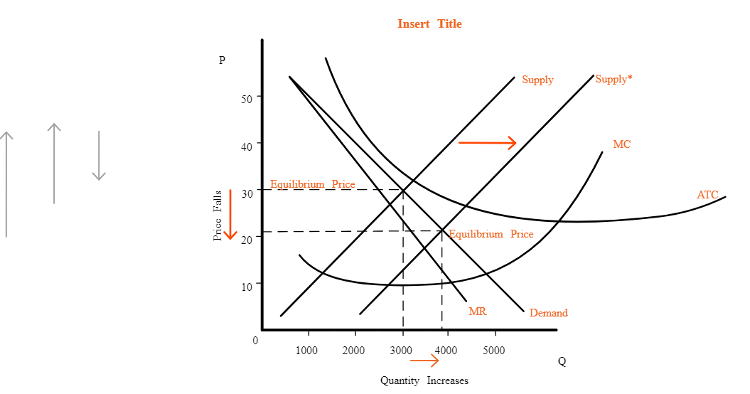
Figure 1: The Economic Chart of Profit Maximization. (Fornell, Rust, & Dekimpe, 2019)
The economic graph above illustrates the connection between marginal revenue (MR) and marginal cost (MC). The profit maximisation chart is another name for this diagram. Maximum profit is achieved when MC equals MR (as seen in the graph). When MR is higher than MC, as seen in the graph, the profit margin improves because the extra money made from selling more units is more than the extra money spent. However, when MC is more than MR, the expense of selling an additional unit outweighs the profit. Managers may maximise profits by setting production at the MC = MR position on the chart. This study guides price decisions and production levels to ensure the company fulfils its profit targets.

Evaluating Pricing Strategy
All Seasons Supplies Incorporated (ASSI) should seriously consider re-evaluating their pricing approach in light of Jesse Zole's recommendation that they do so in order to maximize profits. Decisions on pricing have an obvious effect on revenue, and they also have the potential to profoundly affect customer habits and the intensity of competition in a given market (Kotler & Keller, 2016).
All Seasons Supplies Incorporated (ASSI) needs to think about market dynamics, demand elasticity, and price sensitivity when assessing its pricing strategy. In order to understand how potential price increases or decreases may affect the demand for ASSI's products, it is necessary to do extensive market research and analyze customer preferences and habits. Maintaining competitive pricing in line with the value perceived by customers is just as important as optimizing profit margins. ASSI will be able to maximize profits while still satisfying customers and holding onto market share by doing a thorough analysis of the pricing and positioning tactics employed by its competitors.

Market Competition
When pursuing maximum profit, ASSI must take competition in the market into account. ASSI, as a major consumer products company, has intense competition from other businesses vying for the same set of shoppers. ASSI needs to analyze its market share and come up with tactics to set itself apart from rivals if it wants to maximize earnings. ASSI is able to find possibilities to obtain a competitive edge by analyzing the pricing tactics, product offers, and customer experience of rivals. ASSI can keep and grow its market share by putting an emphasis on product differentiation, superior client service, and value-added features. The organisation is able to keep ahead of its rivals because to its constant vigilance in observing market trends and client preferences. It is also important to evaluate the competitive environment by considering potential obstacles to entry and industry concentration. Pricing, advertising, and product development choices can benefit from an understanding of the competition's market share and strength (Kotler & Keller, 2016). ASSI can maximize earnings and keep a solid foothold in the market if it pays close attention to the competition and adopts tactics that place it there.

Cost Optimization
To achieve its profit goals, All Seasons Supplies, Inc. (ASSI) can use a cost-cutting strategy known as "cost optimization." By keeping costs low and maximizing output, ASSI may increase profits without raising prices. To find waste and opportunities to save money, a comprehensive cost analysis is essential. Possible aspects of this research are the analysis of supply chain processes, improved supplier negotiations, enhanced inventory management, and the streamlining of internal procedures (Drury, 2018).
Through the elimination of waste, reduction of unnecessary spending, and identification of cost-cutting opportunities, ASSI may improve its bottom line. In addition to boosting productivity and decreasing labor costs, investing in technology and automation may help with cost reduction. Through the use of digital technology and the development of streamlined procedures, ASSI may be able to streamline operations and more evenly divide resources. Cost cutting is necessary, but it must be done in a way that doesn't compromise product quality or customer satisfaction. The quality of the customer experience and the value proposition of ASSI's offerings must be thoroughly assessed before any cost-cutting measures are implemented. By implementing a holistic and all-encompassing approach to cost reduction, ASSI can enhance its financial performance, strengthen its competitive position, and maximize profits over the long run. Maintaining efficiency and profitability over the long term requires constant evaluation and reduction of costs through monitoring and analysis.

Emphasizing Product Differentiation
ASSI needs to differentiate its products in order to make the most money possible. By making goods that are new and different, ASSI can give itself an edge over its competitors and excuse higher prices, which increases its profit margins. ASSI should put money into research and development to learn about customer trends, preferences, and new market needs. This will help them make their products stand out. With this information, the company will be able to make innovative goods under its own name. This will set it apart from competitors. Customers need to know what makes ASSI's products special, so it's important that the company has good branding and marketing strategies. By emphasizing the unique features, high quality, and advantages of its products, ASSI can attract and keep customers who want unique and high-quality goods. Also, to stay ahead of the competition, you need to keep coming up with new ideas and improving your products all the time. ASSI can improve its products and stay one step ahead of the game by looking at market trends, analyzing customer comments, and keeping an eye on what its competitors are doing.
By putting a lot of effort into making its goods stand out, ASSI may boost its profits by getting consumers who are prepared to pay more for unique, high-quality products. The company's market position is strengthened by being able to give unique value ideas, which also helps with long-term success.

Customer Retention and Loyalty
Businesses also relay heavily on its customers' continued retention and loyalty in order to maximize its profits. By focusing on establishing reliable connections with clients and maintaining their satisfaction, ASSI may bring in recurrent business, increase the value of every client, and increase profits. Prioritizing personalized experiences, superior customer service, and the implementation of loyalty programs can foster customer loyalty and encourage consumers to continue selecting ASSI over competitors. Regularly soliciting customer feedback, promptly addressing customer concerns, and harnessing technological advances to gain insights into customer behavior can further improve customer retention and loyalty, resulting in profitable, long-term and steady expansion (Peppers & Rogers, 2016).

Economic Theories, Business Environment, and Objectives
The objectives, business environment, and economic theories all play a significant role in decision-making. Understanding economic concepts like supply and demand facilitates ASSI's evaluation of market dynamics and pricing tactics (Verhoef, Reinartz, & Krafft, 2020). The operating environment, which includes elements like competition, rules, and consumer trends, has an impact on ASSI's profitability. A framework for determining strategic direction and coordinating activities is provided by clearly stated company objectives. ASSI may make wise decisions to maximize profitability, negotiate market hurdles, and seize development possibilities by adopting economic theories, evaluating the company environment, and establishing defined objectives.

Demand and Supply Analysis
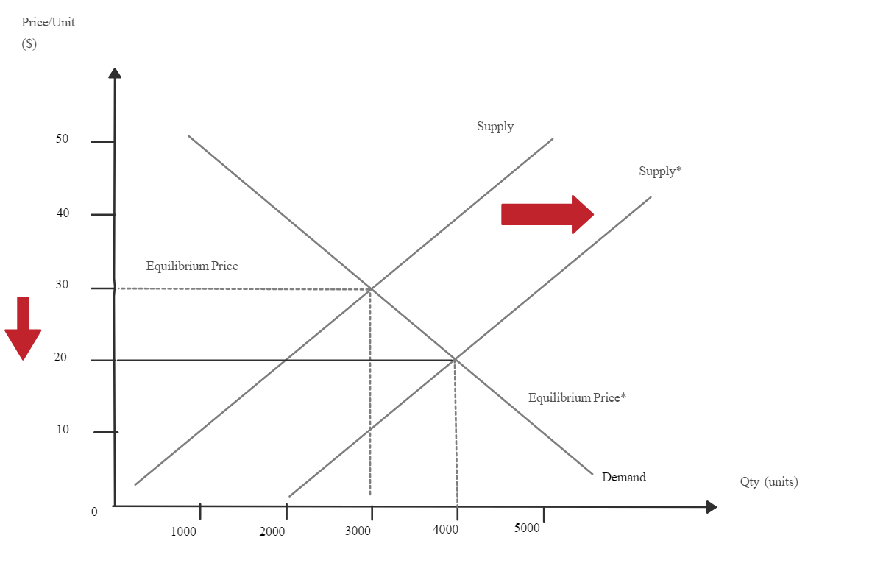
Figure 2: Demand-Supply Illustration. (Verhoef, Reinartz, & Krafft, 2020)
All Seasons Supplies, Inc. (ASSI) executives must take demand and supply analyses into account when determining the best course of action for their company. The production, pricing, and inventory management strategies of ASSI will be more effective if the company has a thorough understanding of the forces that shape demand and supply.
Demand analysis involves considering how consumers behave, what they prefer, and the amount of disposable income they have (Solomon, 2019). ASSI's product demand elasticity can be determined through market analysis, surveys, and sales data. When ASSI considers the impact of cost, revenue, and customer tastes on demand, it can make more intelligent pricing and marketing decisions. ASSI must evaluate its supply-side capabilities, such as its ability to produce, sourcing options, and input costs. A comprehensive understanding of the supply chain facilitates efficient production and reduces the probability of product shortages. ASSI can determine the optimal pricing, production, and inventory management strategies by analyzing the convergence of demand and supply. This strategy can prevent overstocking and stockouts, as well as carrying costs and ineffectiveness in operations. Utilizing demand and supply research, market trends, prospective demand patterns, and the potential influence of external variables such as changing consumer behavior or economic conditions can be better understood (Varki & Colgate, 2017). This information may be utilized by ASSI to anticipate market shifts and promptly respond to new opportunities.
When demand and supply assessments are factored into ASSI's decision-making, the company is better equipped to respond to shifts in the market, maximize resource utilization, and boost profits. To effectively plan and meet consumer demands in a competitive market, a thorough understanding of the intricate relationship between demand and supply is necessary.

Market Structure
Businesses are heavily influenced by the market structure in which it works. When evaluating competition, pricing influence, and market behavior, knowledge of the market arrangement is crucial (Kotler & Keller, 2016).
The retail industry in which ASSI works, consumer goods, is often characterized by a market structure characterized by oligopoly. ASSI faces off against a small number of prominent competitors, as it is among the top four merchants in terms of market share. Due to the nature of the market, the actions of ASSI might have far-reaching consequences for the market and vice versa. ASSI can assess its pricing policies, market position, and product differentiation with the help of market structure knowledge. Oligopolistic markets are characterized by the interconnectedness of individual firms' pricing decisions. That's why it's important for ASSI to not just think about its own expenses and profit goals, but also to evaluate and analyze how its rivals might respond and proceed. In addition, businesses are better able to evaluate the negotiating positions of vendors and consumers and identify entry barriers when it has a firm grasp of the market's organizational framework (Fernie & Fernie, 2015). With this information in hand, ASSI can negotiate with its suppliers, expand its distribution network, and better interact with its clientele.
In addition, ASSI is aided by market structure analysis in the detection of probable market malfunctions, such as asymmetry of information or anti-competitive practices, which may have consequences for legal and moral norms. ASSI can successfully navigate the landscape of competitors, spot development opportunities, and secure a lasting market position by doing a comprehensive analysis of the market structure. By learning the ins and outs of the market, it can make well-informed decisions that help it achieve its goals and boost its profits (Scholes, Johnson & Whittington, 2018).

Stakeholder Issues
In order to maximize long-term profits, firms must consider shareholder concerns when making decisions. Stakeholders are individuals or organizations with a vested interest in the success or failure of the business, and their opinions should be considered (Ross, Westerfield & Jordan, 2017).
Customers are crucial to ASSI's prosperity. Customer satisfaction and loyalty are contingent on businesses delivering products and services that meet and exceed customers' requirements and expectations in terms of quality, cost, and service. ASSI must also make its employees content by providing them with a pleasant workplace, a living wage, and opportunities for professional advancement. Suppliers and business partners are equally important to the success of ASSI. The long-term success of a business is contingent on its ability to maintain positive relationships with its suppliers, adhere to ethical procurement practices, and cultivate mutually beneficial partnerships. Increasingly, stakeholders are concerned with issues of community participation and environmental sustainability. ASSI must be aware of how its actions may impact the surrounding community, make significant contributions to society, and employ environmentally responsible practices to mitigate the negative effects of its operations.
Financial success is also essential to the company's proprietors and investors. Maintaining their confidence and support necessitates transparent and trustworthy reporting, sound governance, and dependable financial returns (Ross, Westerfield & Jordan, 2017). By proactively addressing the concerns of its stakeholders and incorporating their input into decision-making processes, ASSI can increase trust, enhance its reputation, and ensure its long-term success. A comprehensive strategy that considers the requirements of all stakeholders is beneficial to the company's long-term profitability and prosperity.

Recommendations
The following improvement suggestions are based on the sections presented above. ASSI should-
- Complete a thorough price study to find out where the pricing might be improved while thinking about things like how responsive demand is, how much competition there is, and how customers feel about the value they are getting.
- Promote ASSI's specialised brands by rolling out strategic advertising initiatives that highlight their individual benefits.
- Spend more time and resources on creating memorable encounters for each client, providing outstanding service, and launching loyalty programs that reward repeat business and word-of-mouth advertising.
- Examine and improve supply chain management, inventory control, and operational efficiency as well as overall company expenses.
- Monitor industry developments, customer tastes, and new technology to determine how to best position ASSI's products and services.
- Maintain solid connections with vendors and other companies, always acting fairly and ethically, and looking for opportunities to work together for mutual gain.
- Boost the business's commitment to sustainability by cutting down on waste, recycling, and other negative practices.
- Maintain a competitive edge by routinely reviewing the market and making strategic adjustments based on the competitors’ plans, prices, and market position.
- Invest in IT and data analytics to learn more about the customers, streamline the operations, and back data-driven decisions.
- Create an environment where employees feel safe sharing their ideas and taking the initiative to make improvements.

Conclusion
In conclusion, the primary objective of All Seasons Supplies Incorporated (ASSI) is to increase company profitability. However, understanding several profitability and growth elements is important to attain this goal. The goal to optimize earnings is reasonable given ASSI's market dominance and broad retail presence. To improve profitability, there are several key suggestions. ASSI may find the ideal profit-to-customer experience ratio by studying demand and supply, competition, and customer value. Product differentiation and ASSI's own branded items may help justify higher charges and attract new clients searching for something distinctive. Loyalty strategies encourage repeat customers and favorable word-of-mouth by providing individualized experiences. Profit is also dependent on cost optimization, market awareness, and supplier/partner connections. ASSI may develop reliability, goodwill, and sustainability by emphasizing the demands of its stakeholders, including consumers, workers, communities, and the environment.
ASSI may become a major UK consumer goods retailer, adapt to modifications, focus on prospects, and generate revenue while maintaining development by following the above recommendations as well as tracking the dynamics of the market.

Reference List
Drury, C. (2018). Cost and Management Accounting: An Introduction (9th ed.). Cengage Learning.
Fernie, J., & Fernie, S. (2015). Principles of Retailing (2nd ed.). Routledge.
Fornell, C., Rust, R. T., & Dekimpe, M. G. (2019). The Effect of Customer Satisfaction on Consumer Spending Growth. Journal of Marketing Research, 56(2), 265-281.
Kotler, P., & Keller, K. L. (2016). Marketing management (15th ed.). Pearson Education Limited.
Peppers, D., & Rogers, M. (2016). Managing Customer Experience and Relationships: A Strategic Framework (4th ed.). John Wiley & Sons.
Ross, S. A., Westerfield, R. W., & Jordan, B. D. (2017). Fundamentals of corporate finance (12th ed.). McGraw-Hill Education.
Scholes, M., Johnson, G., & Whittington, R. (2018). Exploring strategy: Text and cases (11th ed.). Pearson Education Limited.
Solomon, M. R. (2019). Consumer behavior: Buying, having, and being (13th ed.). Pearson Education Limited.
Varki, S., & Colgate, M. (2017). The Role of Price Perceptions in Building Customer Value and Customer Retention. Journal of Service Research, 20(4), 441-456.
Verhoef, P. C., Reinartz, W. J., & Krafft, M. (2020). Customer Engagement as a New Perspective in Customer Management. Journal of Service Research, 23(3), 274-295.

