This student log propose to describe the supervisory position in hotel administration at Marriot Hotel Leicester, however the shadowing to this departments due to GDPR (GOV.UK, 2015) not only from customers but also from associates they did not allow me to have any experiences so all the references made to this departments are either researched or observed in the time be from other department units.
There are 9 departments in the hotel:
On back office
- Maintenance – with only 3 staff to be able to maintain the full hotel operational
- Human Resources- is in charge of employee recruitment, evaluation, mentoring, and development (Lawler & Boudreau, 2020).
- Finance - Budgeting and forecasting, accounting, financial analysis and reporting cash management among other activities (Yesilhark 2002)
- Sales & Events- where all the reservations for either the rooms or any events happening.
Front of house / Customer facing departments
- Housekeeping – ongoing cleaning in the workplace not only in the rooms as well as public areas.
- Food & Beverage – Restaurant / Bar/ Room Service
- Conference & Banqueting – the practical part from the events department
- Kitchen – provide the foods for all departments within F&B and C&B as well as food for the staff breaks
- Front Office – mainly check in and check outs and this department reply to customers feedbacks
Following that information we have the Hotel organisational chart
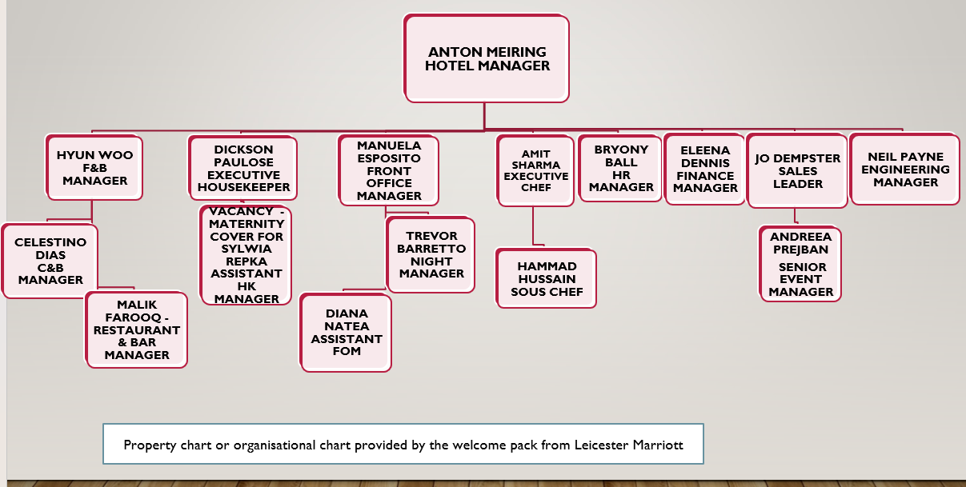

The position of managing back office and administrative operations at the Marriott Hotel Leicester plays a critical role in ensuring that the hotel's operational and administrative tasks run smoothly since any significant issues from other departments must ultimately come through their control. This Journal will critically examine the significance of the supervisory position in this departments, highlighting the key competencies required for success.
Strong organisational abilities are crucial for good administration in the hospitality sector, according to research (Abd El Haleam, 2018)
According to Husain (2013)efficient communication is extremely important to any company development. The supervisory at the Hotel Marriott Leicester must effectively communicate with the members of his or her team as well as other departments and guests. They must be able to provide clear instructions, actively listen to reactions and concerns, and effectively communicate with other hotel staff.
A strong capacity for organisation is another essential skill required for a supervisory role in this field. The management of complex and varied tasks requires organisational competencies, as noted by Robbins and Coulter (2017). The Hotel Marriott Leicester's management must be extremely organised and capable of managing multiple tasks at once. Excellent time management skills, the ability to prioritise tasks, and effective resource management are required. And for this to happen relies on the help and availability of all back office departments to make sure that all the front of house departments, especially those in directly contact with the guests, run smoothly and professionally.
The finance department is in charge of managing the hotel's financial resources, such as budgets, accounts, and financial reports (Coltman, 1997). On the other hand, the human resources department is in charge of managing the hotel's employees, from recruitment and training to compensation and benefits, (Go et al., 1996). So on The department of Sales and Events is in charge of generating revenue by selling clients event spaces and services, managing bookings and contracts, and ensuring customer satisfaction during events, (Golden-Romero, 2017).
Furthermore can be highlighted that this “back office” departments are the soul of the hotel when departments like Conference and Banqueting, food and beverage, front office and housekeep are the face, when they are the main focus from the point of view of the guests and for this same reason they need to have an exceptional problem solving skills. As mentioned by Smith and Mazin (2018), the ability to solve problems is a crucial skill required for every position of supervision. A good management should be able to anticipate problems, develop risk-reduction strategies, and effectively handle unexpected challenges however in a company this size it need a support team to so.
Leading others is another crucial skill required for this position. A successful management strategy must have leadership, as noted by Northouse (2018). The manager needs to lead by example, inspire his or her team, and create a productive and positive work environment. In order to support your team in their professional development, it must be able to inspire them to achieve your goals. Moreover there are some main communication methods that help to keep updated to make sure that all departments have the necessary support to achieve the desired objectives and fulfil the necessities of all guests.
Below some of the communication methods between departments 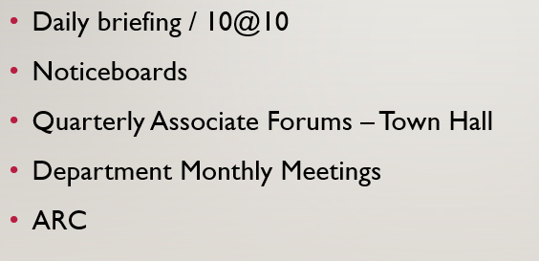
I had the opportunity to observe one of the 10 @10 meeting what stand for a 10 minutes meeting at 10 am every day where they discuss the occupancy of the hotel, the meetings and events of the day and any issues as well as any other information to pass on.
Moreover the management team must also possess outstanding technical skills. The technical competencies are crucial for managing complex systems and processes, as noted by Laudon and Laudon (2022). Consequently, managers, assistant managers and in some cases supervisors must be efficient at using software programmes like Microsoft Office most useful software you should be able to utilise and property management systems, the most common in the Leicester Marriot hotel, and as I could witness in the majority of the same chain hotels program that all of them need to learn are, OSCAR PMS, KRONOS, FIAT and probably some others that I am not aware because in my placement did not had a chance of shadow any of those back office departments close. Additionally, they need to understand how financial management works and be able to analyse and evaluate financial data.
So on some of the information that I was able to gather in the other departments where I participate on I can confirm some of the type of programs used:
- OSCAR PMS the main and most used system at the hotel system.
According to Oscar, (2023) is a property management system that support and assists “Reservation management - Rate management - Guest registration - Food & Beverage – Invoicing – Housekeeping - Financial reporting - Statistical reporting - Email marketing - Customer relationship (CRM) - API integration”, so all the departments in the hotel have their associates unique passwords so they can access the system.
- KRONOS is other not less important, as it depends on the payments of the associates.
According UKG (Ultimate Kronos Group),(2023) Kronos is a unified system for managing the labour force that consists of scheduling shifts, monitoring attendance, managing payments when they are late, fully managing the payment schedule, maintaining employee records, and analysing the labour force and as well as planned for justify RH processes with the ability to optimise services.
- FIAT, discrepancy system report
This program is used in the hotel to report any discrepancy between the current system and the current situation, as Mr Dickson explain, Housekeeping manager as example we can have a costumer in the room when the F.O. system show that the same room is vacant so for this propose at the end of the day they will fill a discrepancy form using this program.

In conclusion, I could oversee factors that make me believe the supervisory position of back office and administrative operations at the Marriott Hotel Leicester is a crucial area and calls for a number of key competencies. Good relationship, strong organisational skills, the ability to solve problems, leadership, and technical proficiency are all crucial for success in this departments. The management can ensure that the hotel's administrative and operational tasks are carried out effectively and efficiently by developing these skills and understanding their significance.

References:

Abd El Haleam, N. (2018) “The role of some general features in the development of management abilities among employees in the hospitality sector,” Journal of Association of Arab Universities for Tourism and Hospitality, 15(1), pp. 77–83. Available at: https://doi.org/10.21608/jaauth.2018.47973.
Coltman, M.M. (1997) Financial control for your hotel. John Wiley & Sons.
Go, F.M., Monachello, M.L. and Baum, T. (1996) Human Resource Management in the Hospitality Industry. New York: John Wiley & Sons.
GOV.UK (2015) Data protection, GOV.UK. GOV.UK. Available at: https://www.gov.uk/data-protection (Accessed: March 5, 2023).
HUSAIN, Z., 2013. Effective communication brings successful organizational change. The Business & Management Review, 3(2), pp. 43.
Laudon, K.C. and Laudon, J.P. (2022) Management Information Systems managing the digital firm. Harlow, England: Pearson.
Lawler, E. and Boudreau, J.W. (2020) Achieving excellence in human resources management: An assessment of human resource functions. Stanford, CA: Stanford University Press.
Northouse, P. G. (2018). Leadership: Theory and practice. Los Angeles: Sage.
Oscar (2023) Oscar Hotel Software, Redforts. Available at: https://redforts.com/en/ (Accessed: March 5, 2023).
Robbins, S. P., & Coulter, M. (2017). Management. Harlow, UK: Pearson.
Smith, A. D., & Mazin, R. (2018). Developing effective problem-solving skills. New York: Routledge.
UKG (2023) Kronos Workforce Central, Kronos Workforce Central Software Reviews, Demo & Pricing - 2023. Available at: https://www.softwareadvice.com/hr/ukg-workforce-central-profile/ (Accessed: March 5, 2023).
YESILHARK, M., 2002. What are the roles and responsibilities of a finance department. GRIN Verlag.
Golden-Romero, P. (2017) Hotel Convention Sales, services and Operations. London: Routledge.
(Coltman, 1997) Top of Form
Bottom of Form

