

BUSINESS DEVELOPMENT PROPOSAL

Student Name: Aayushy Pradipkumar Patel
Student ID: 2503361
Course Title: MBA- International Business
Supervisor: Balendran Kandasamy
Title: Nutri cook- Ready-to-cook food business
Submission date:
Word count:

TABLE OF CONTENTS

Executive Summary
Business opportunities for nutricook
- Growing demand for healthy, convenient food
- Large Indian and Yeah. South Asian population in the UK.
- Health-conscious consumers.
- Subscription meal plans.
- Online direct to consumer sales.
- Corporate partnerships like offices, university and student accommodations.
- Sustainable packing.
Nutri Cook has strong business opportunities in the growing UK market for healthy, convenient food meals, and an increasing number of busy professionals and students. By offering authentic Indian meal kits made with fresh veggies, sprouts, pulses and Spices also pre-portion ingredients. Nutri cook can meet this demand while promoting healthy eating habits. These trends create significant business opportunities for Nutri Cook.
Market needs and proposed solutions
Market needs | Proposed solutions
- Simple cooking. | Pre portioned Ingredients and Easy to follow cooking steps enable people with limited cooking experience to prepare delicious meals.
- Fresh ingredients. | Consumers prefer healthy and fresh vegetables, spices and other high-quality raw ingredients without any preservatives or colors or chemicals.
- Healthy eating. | Consumers are increasing seeking nutritious, balanced meal instead of fast food and processed products.
- Affordability | Customers want cost effective meal options that offer good value without compromising quality and taste.
- Reduce food waste | Pre-portion ingredients minimize waste and help consumers to use only what they need.
- Convenience | Busy professionals, students and families need quick meal solutions that reduce Preparation time.
- Indian cuisine | There is strong demand for fresh, authentic Indian meals that are easy to prepare at home.

Target customers
Students: University students looking for affordable, healthy and easy to cook meals.
Busy professionals: Working individuals with limited time who want nutritious home cooked food.
Families: Household seeking convenient balanced meals that are quick to prepare.
Health, health-conscious consumers: People who prepare fresh, preservative free, chemical free and any color free nutritious meal options.
Indian Communities: Customers who enjoy authentic Indian cuisine with convenient preparation.
Young adults: Consumers aged 80- 40 who value convenience, quality, and healthy eating in their daily lifestyle.
Value proposition
Nutri Cook offers a practical way for consumers to prepare delicious Indian meals using fresh, carefully measured ingredients and straightforward cooking instructions. The meal kits remove the hustle of shopping, ingredient preparation, and meal planning, making healthy food, cooking faster and more enjoyable. By combining authentic flavor, nutritional balanced, affordable pricing and environment friendly packaging, Nutrigook provides a reliable solution for people seeking convenient, high-quality home cooked food that fit into busy, modern lifestyles.
Competitive advantage
Nutri Cook differentiates itself by offering authentic Indian ready to cook meal kits. Made with fresh, pre-portioned ingredients and easy to follow recipes. Unlike many competitors that focus on western style meal kits, Nutri Cook specialized in nutritious Indian cuisine while reducing preparation time and food waste. Its combination of high-quality ingredients balance nutrition, affordable pricing, eco-friendly packaging and convenience subscription. Creates a unique value proposition that appeals to Busy professionals, students, family and health-conscious consumers.
Operational highlights | Financial highlights
Fresh ingredients Sourced from trusted local suppliers. | Affordable pricing with a competitive profit margin.
Efficient inventory Management to minimize food waste. | Recurring income through weekly and monthly subscriptions.
Reliable deliveries through logistics partners. | Opportunity for steady revenue growth as the customer base expands.
Eco friendly packaging and quality control process. | Strong long-term profitability through customers' retention and repeat purchase.

Key Success Factors
- High-quality ingredients
- Authentic Indian recipes
- Competitive pricing
- Filling gap between ready to eat and restaurant food
- Effective marketing

INTRODUCTION
BACKGROUND CONTEXT
Industry: ready to cook food meal industry- a sector experiencing significant growth due to changing consumer lifestyle and increasing demand for nutritious, time-saving meal solutions.
Location: the business is planned to launch in Kingsbury, harrow, London- one of the Uk’s most diverse cities, where there is large population of students and working population, immigrants and health-conscious consumers who needs convenient food options.
Important current trends: several macro trends support the business opportunity,
Several macro trends: This trends support opportunity, including rising health awareness, busy work schedules, growing interest in-home cooking, increase demand for ethnic food and greater concern for food waste and sustainable packaging, smart, spoilage-alert packaging, personalization in food (gsfoodservice.co.uk).
Consumers are also becoming more willing to purchase fresh ingredients through online subscription and delivery services. Nutri cook response to these trends by offering ready to cook Indian meal kits containing pre portioned fresh ingredients and recipe cards, enabling customers to prepare healthy, authentic meal quickly while reducing preparation time, ingredient waste, and reliance highly on processed convenience food.
Problem statement: many consumers are facing challenges in preparing food for their daily lifestyles, due to many reasons.
problems | Solved by Nutri cook
Food preparation is Time consuming | Less time consuming as it is already proportioned
Don't know recipe | It has recipe card
Grocery shopping | All ingredient in the one place
Processed food | Healthy chemical free food
Wastage of food | Reduce the food waste

As a result, students and working capital, immigrants and other families often relay on takeaways or highly processed convenience food which may be expensive, less nutritious, unhealthy. Indian population in United Kingdom is 1,864,318 and majority of the people is living in London city (world population review).
This gap in the market highlights the need for an innovative solution that combines convenient, affordable, healthy and authentic Indian flavors. Nutri cooks address the problem by providing fresh ready-to-cook meal kits that reduce preparation time, minimize food waste, and enable consumers to prepare balanced food easily.
Aim: The aim of this business development proposal is to evaluate the feasibility of launching Nutri cook, a healthy ready to cook meal kit, developing a sustainable business model, and preparing a practical business plan for successful market entry and long-term growth.
Objectives
- To assess the market feasibility of launching Nutri cook in the Uk.
- Research the target market by analyzing customer needs, preferences, and value proposition and purchasing behavior.
- To evaluate competitors and determine Nutri cooks unique selling proposals and competitive advantages.
- To identify the potential risks and recommended appropriate risk management strategies.
Research questions
- Is there sufficient market demand for a healthy ready to cook meal kit?
- Who is the Nutri cook targeting customers and what competitive advantage can Nutri cook establish?
- What are the customers purchasing behavior and their preferences?
- What are the key risks associated with launching Nutri cook, and how can these risks be managed effectively?
Structure of the report
- In this proposal, the information included is market research, customer validation, and competitor analysis.
- Develop packaging, branding and a simple online ordering system.
- Finalize recipes, nutrition standards, suppliers, and pricing.
- Complete food safety and standard, legal and operational requirements.
- Launch a small pilot in London and collect customer feedback.
- Improve product and marketing based on results.
- Expand delivery, subscriptions, products range and partnerships.

Company description
Business identity and legal structure:
Nutri Cook is a UK based food business focused on providing convenient, nutritious, ready-to-cook Indian meal kits and healthy food options. Its identity is built around freshness, affordability, balanced nutrition, convenient and culturally familiar meals. The business aim to serve students, busy professionals, families, immigrants and seeking healthier meal solutions. Nutri cook can operate as a private limited company registered with Companies House, providing separate legal identity from its owners. The business would also need appropriate food business registration, food hygiene compliance, insurance, suppliers' agreement and other applicable licenses and permissions before commercial operations begin.
Business type: food business (new venture)
Business name: Nutri cook
Business location: Kingsbury, London
Business structure:
- Founder/managing director: overall strategy,finance and business decisions.
- Operational manager: meal kit production and inventory, suppliors, quality control
- Marketing manager: branding, social media, advertising, and customer acquisition.
- Finance and administration: budgeting, accounts, payroll, compliance.
- Delivery and logistics: orders, distribution, and customer delivery.
- Customer service: customer enquiries, feedback, and subscription.
Product description
A food meal kit ready to cook which contains pre-contained ingredients for a particular recipe. One product will be enough for two people. Also, it is nutritionally calculated and has chemical-free ingredients.
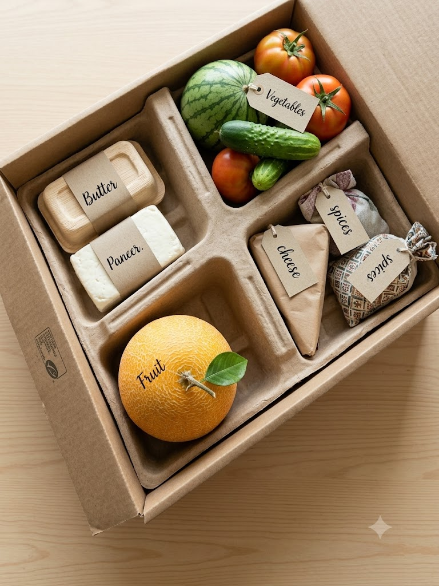

- Butter: for non-stick cooking procedures.
- Vegetables: pre portioned ingredients for a particular recipe. Vegetables are completely raw, without any chemicals and fresh.
- Spices: pre portioned spices which will be used to enhance teste and authentic flavors.
- Fruit: To complete the nutrition value at the end of the day.
- Recipe card: for people who don't know how to make the food.
Problem solved by the product: the kits reduce preparation time, reduce food waste, balance nutrition, easy to prepare, save time for grocery shopping, homemade food.
Brief history of finding ideas: Nutri Cook Is founded from the idea of making healthy, nutritious and convenient Indian meals easier to prepare for people with busy lifestyle. The concept was developed after identifying the challenges faced by students, working professionals, families and immigrants who want homemade food. But often lack the time for shopping and the preparation of multi-ingredients. It combines convenience with Familiar Indian flavors by providing pre-portioned fresh ingredients, spices and simple recipes in Ready to cook milk kids. The business began as the proposed food service concept focused on affordability, nutrition, and reducing food waste. Is the idea developed Nutritional expand its vision to include weekly subscription, online orderings and wider range of nutrition Indian meals. Creating a convenient alternative to traditional takeaway foods.
Mission: Nutri Cook's mission is to make food Accessible and enjoyable by delivering thoughtful portion ingredients and easy recipes directly to customers, the business aims to encourage healthier eating habits while saving customers time, reducing unnecessary food waste, and maintaining the authentic taste of Indian cuisine. Nutri Cook is committed to offering practical and affordable meal solutions that benefit modern lifestyles without compromising. and quality, freshness, and nutrients.
Vision: Nutri Cook's vision is to become a trusted and innovative food brand that transforms people enjoy nutritious Indian meals. It aims to build a strong presence across the UK. By combining traditional flavors with modern convenience, Nutri Cook seeks to create a sustainable food ecosystem where customers can access, affordable, fresh and balanced meals while supporting responsible sourcing, efficient packaging and reducing food waste.
Values and principles:
- Quality: fresh and reliable ingredients
- Nutrition: balanced eating
- Affordable: healthy food at reasonable prices
- Sustainability: reduce food waste and packaging impact
- Innovation: creating better and smarter meal solutions
- Authenticity: Indian flavors
Business objectives:
- Build a strong customer base in UK.
- Offer variety of Indian food meals.
- Maintain high standards and hygiene, food quality, and customer satisfaction.
- Expand Nutri cook in recognized sustainable food brand.

