BA Business Management

Marketing Fundamentals
LCBB4004
Module Coordinator/ Lecturer: Mr. Ze Zook

Valentina Georgieva Pencheva: 2023164
Level 4 / Term 1 / Group 1
Assessment 2

- The role of marketing in creating value for customers.
- Stakeholder engagement and their impact on the marketing activities of an organisation

Table of Contents
Introduction 3
Customer value and satisfaction – creation, delivery, communication 3
Stakeholders – types and importance 8
Conclusion 10
References 12

Introduction
In today’s competitive and uncertain environment, marketing appears to be a crucial function for business organisations, as it is a direct contributor to the creation of customer value, as well as brand image and identity. Thus, marketing efficiency and effectiveness have direct implications on a company’s ability to develop competitive advantage over rivals. The majority of consumer markets are already mature and are featured with many players and companies offering similar products. In such cases, marketing can be the single most important influence on purchasing and loyalty decision made by consumers which would determine the position of the brands in the marketplace. Furthermore, marketing can serve as a tool for tackling times of crisis. The most recent example of a massive disruption on global markets is the pandemic outbreak which evidenced the importance of effective marketing to keep customers engaged, loyal and informed.
This report has the main aim of analysing the role of marketing in creating, delivering and communicating customer value. In addition to that, it assesses the importance of addressing stakeholder needs and diverting resources into strategies which strengthen a brand’s level of competitive advantage. These objectives are fulfilled through investigating and analysing a large number of academic sources and industry reports which enlighten the topic and assist in exploring its various perspectives.

Customer value and satisfaction – creation, delivery, communication
In the world of marketing, achieving high level of customer satisfaction is a key goal. The significance of the concept of customer satisfaction is considered to continuously increase in alignment with increased globalisation, higher competitiveness of companies, evolving customer needs and expectations and technological development (Yang and Peterson, 2004). Customer value is the pre-requisite for customer satisfaction and loyalty which in turn, affect the position of the company in the marketplace.
Customer value is defined as the perceived benefit of the consumers from their experience with the brand (Kotler and Armstrong, 2018). It is also referred to the perception of buyers of what the product offering of the company is worth (Kotler and Armstrong, 2018). It is important to note that customer value does not have a specific universal representation and, instead, it varies across individuals and significantly depends on their personal criteria and definition of it (Kotler and Armstrong, 2018). Customer satisfaction is defined as the degree to which customers are happy with the company and its products, service, capability, communication and overall experience (Kotler and Armstrong, 2018). Customer value is a direct factor of influence on customer satisfaction which is why it is crucial for businesses to maximise it. Especially now, when the global economy continues to experience the consequences of COVID-19 pandemic and the majority of businesses and consumers have been massively affected by it, customer value is seen as a main determinant of consumer behaviour and attitudes towards different brands.
Companies are focused on the creation, delivery and communication of value to consumers. This is perceived to be a main function of business entities and a sufficiently important process which can affect all other units of corporate activity. The next figure illustrates the process of value creation, delivery and communication. As presented, it has five main integral elements – understanding the market and customer needs, designing customer-driven marketing strategy, developing an integrated marketing programme that delivers superior value, establishing profitable relationships and capturing value back from consumers (Kotler and Armstrong, 2018).
Figure 1 – The process of creating, delivering and communicating value
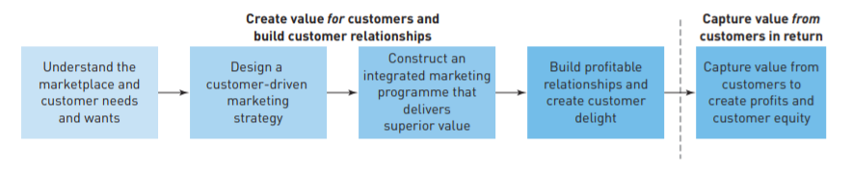
Source: Kotler et al. (2012)
Understanding the market and consumer needs and wants is a process requiring continuous research of the market by using various tools and techniques. As discussed by Ayuba and Kazeem (2015), customer-oriented businesses need to conduct regular market research, so that they are aware of current trends in their industries and adjust to changing customer needs and expectations. In-depth market research can provide business organisations with data which has the power of defining their future development and growth. There is sufficient evidence that objective and detailed market research is pre-dominant to successful market performance and profitable business (Ayuba and Kazeem, 2015). This is mainly due to the fact that the output of the market research provides companies with direct insights which can be incorporated in strategies, so that the business is up-to-date and directly relevant to customer needs and desires. In this way, the product offering of the brand would be as close as possible to what customers expect and this would definitely contribute to the establishment of greater value and higher satisfaction of both potential and actual customers (Ayuba and Kazeem, 2015).
When the research on industry trends and customer needs is completed, companies have to design a customer-driven marketing strategy. This is based on two main processes, including the choice of specific segments to serve and the construction of a value proposition (Kotler et al., 2012; Gbadamosi et al., 2013). Nadube and Didia (2018) define market segmentation as the division of the customers on the market into different segments using diverse criteria and shared traits. Segmentation can be based on several distinctive approaches, such as geographic (based on location), demographic (based on a demographic feature like age and gender), behavioural, psychographic and other similar (Nadube and Didia, 2018).
The main aim of market segmentation is to assist companies into developing different marketing approaches and tactics which would better address the needs of the specific segment. Due to globalisation, technological development and the rapid pace of economic development, the majority of consumer markets are already mature and penetrated. This is also associated with a wider choice of consumers and improved access to many different items and companies. All this imposes challenges on business organisations as diverse customer base requires diverse marketing initiatives.
Thus, the division of the market into different segments helps brands to better organise potential customer groups, understand what would be effective in each of them and decide on how to implement it in practice (Nadube and Didia, 2018). This also assists companies to specifically identify their target markets and decide on the segments they will address. This then serves as an initial point of targeting and positioning – the use of specific tools to address selected audiences and the efforts made by the company to construct a specific image and perception formed by consumers regarding the brand (Nadube and Didia, 2018).
The emphasis placed on value creation is also illustrative for the efforts made in third stage of the value process presented above. Many companies rely on the use of different tools for value creation and formation of a plan on how value design would address customer needs. Simatupang et al. (2017) state that value chain thinking assists brands in the decisions of marketing mix and this is why, it is recommended that a generic value planning is initiated prior the decisions regarding the marketing mix elements.
As illustrated on the next figure, the generic value planning consists of four main stages, including goals of companies in align to customer needs, design of value (conception, detailing and testing), delivery to consumer and capture plan (communication, incentive provision, brand image building) (Simatupang et al., 2017). This provides companies with an overview of what is expected and needed from their value propositions and allows better planning and allocating resources across the elements of the marketing strategy – the marketing mix, consisting of product, price, promotion and place (Simatupang et al., 2017).
Figure 2 – Generic value creation thinking
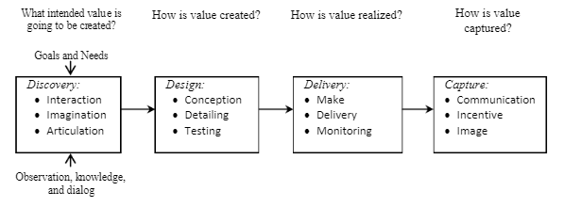
Source: Simatupang et al. (2017)
All this is then used by companies to create a specific marketing strategy focusing on the four main elements – product, price, promotion and place.
Product element is associated with the whole type and variety of products and services offered by companies (Kotler and Armstrong, 2018). This is the element which defines the other three strategic actions and thus, is the initial decision that companies make. The products offered represent the identity of the brand, its mission and the results from market research which has been conducted in advance. The majority of companies are aiming at offering a wide choice for consumers and use that as a main source of competitive advantage, especially in markets where products offered are not unique and highly differentiated (Kotler and Armstrong, 2018).
Pricing strategies are also crucial in such markets. Many scholars perceive price not only as the charge paid in exchange for the product but also consider the additional cost for the consumer which affects the purchasing power, such as delivery cost (Kotler and Armstrong, 2018). There are many different strategies which can be used, including penetration (setting relatively lower price to achieve cost advantage over rivals), skimming (setting relatively higher price to reflect the quality of the product), competitive (setting price according to rivals’ strategy), psychological (setting price which is likely to be better perceived by consumers - £0.99 instead of £1.00) and many more (Kotler and Armstrong, 2018).
Promotion element of the marketing mix is related to the way the brand communicates with its customers and stakeholder groups. As shown on the following figure, promotion element is based on several main activities and tactics, emphasising on direct marketing, advertising choices, sales promotions used, personal selling and public relations (Todorova, 2015).
Figure 3 – Promotional mix
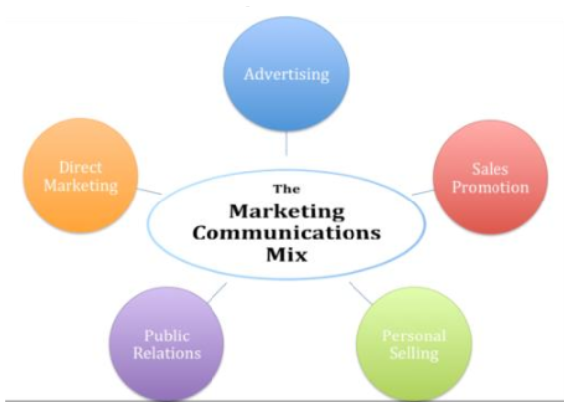
Source: Todorova (2015)
Place element of the marketing mix refers to the delivery channels used by the brand and the ways through which customers can obtain the product (Kotler and Armstrong, 2018). Examples of delivery channels include direct sale and use of intermediaries.
Apart from the marketing mix, companies should also develop profitable relationships with consumers and engage them with the brand in the long-run to ensure sustainability (Kotler and Armstrong, 2018). This requires the establishment of a high-quality customer service and customer relationship management strategy (Kotler and Armstrong, 2018).
The last phase of the process is capturing value back from customers which is emphasising on pursuing feedback and using it to improve business operations and customer experience (Kotler and Armstrong, 2018).

Stakeholders – types and importance
Stakeholders are third parties which influence the operations of a company or are interested in the activities of the business (Zyl, 2013). Different stakeholders express different interest in the business depending on their role and association with it.
In general, stakeholders can be divided into internal and external. Internal stakeholders are the ones which are within the organisation, such as employees, owners and managers (Zyl, 2013). External stakeholders are the ones which are outside the borders of the organisation but are still related to it and interested in its activities (Zyl, 2013). Examples include suppliers, investors, customers, local community and government (Zyl, 2013). It should be noted that the interests of stakeholders vary not only across different types but within the same segment as well and can often be in conflict with each other. This is very important to be understood due to the contrasting interests of stakeholders in many instances.
For example, if employees, managers and owners are considered, their interests can be mutually exclusive. If owners want higher profit margins, this might mean cutting employees’ salaries. If employees want better working conditions, this might mean increasing business cost and decreasing profits. If managers want to reinvest in the business to achieve long-term gains, this might be in conflict with owners’ objective for short-term profit and returns. This is why it is of significant importance for companies to identify all of its internal and external stakeholders, analyse their needs and pursue different strategies which address them without conflicting or negatively affecting corporate goals and operations (Johnson et al., 2017). Finding the right balance in satisfying various stakeholders’ needs with the existing resources constraints requires appropriate analytical, managerial and communication skills.
Thanks to the variations in stakeholders’ interests and level of influence in an organisation, stakeholder mappings is often applied as an analytical tool for building effective stakeholder management strategies (Johnson et al., 2017). Stakeholders with maximum interest and influence deserve close attention; hence, their needs should be managed accordingly (Simon, 2016). In contrast, minimum efforts should be spent on stakeholders with low interest and influence. Keep completely informed appears to be an appropriate strategy for stakeholders with high level of interest but low influence. Respectively, stakeholders with high influence but low interest should be kept satisfied (Simon, 2016).
Figure 4 – Effective stakeholder management strategies based on mapping outcomes
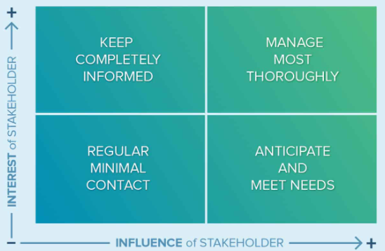
Source: Simon (2016)
According to stakeholder theory, companies have responsibility not only to employees and consumers, but also to a wider scope of related parties which can be affected in any way by business operations and activities (Zyl, 2013). In addition to that, engaging stakeholders and addressing their various needs is nowadays perceived as a main source of establishing competitive advantage and achieve sustainable development in the long run (Zyl, 2013). If this is avoided or neglected by companies operating in competitive markets, it is very likely that they will either fail or not perform up to the level of their potential and capabilities (Zyl, 2013). For this reason, modern business entities are prioritising the formation of long-term and stable relationship with various stakeholder groups. This is also believed to positively affect brand image and reputation, attractiveness for investors and consumers and lower risk of not complying with legal and governmental regulations (Kotler and Armstrong, 2018).
There are many different ways through which companies can identify their stakeholders and analyse their needs. One of the most popular methods is own research and brainstorming which provides an overview and mapping of various stakeholders. It can also be used as a starting point for analysing and assessing their needs, the degree of impact on the business if not satisfied, reliance and dependency of the company on the perceptions and attitudes of the specific stakeholder group, importance and contribution to future development and potential strategies which can be used to address concerns and expectations of each group (Zyl, 2013).
The stakeholder theory developed significantly throughout the years. In the beginning it was believed that companies only need to report activities and strategies to internal stakeholders with the primary aim of keeping them informed for main changes and expected performance in the short-run (Zyl, 2013). However, with the increased interest towards corporate social responsibility and the shift of views towards corporate governance and transparency, stakeholder engagement became more and more important in time.
Nowadays, large business organisations tend to develop separate departments which are responsible entirely for communicating with various stakeholders and developing special reports for different groups (Zyl, 2013). This is considered to have a direct positive influence on company’s performance in the marketplace and brand image with strong implications on financial position. It is also a main priority for companies operating in industries which are often accused of having a negative impact on third parties. Some examples include fashion retailers, which use child labour in Asian factories, or airline companies responsible for causing excess pollution.
The last examples are particularly relevant from the point of view of Carroll’s CSR pyramid (Carroll, 1991). As explained by the model, the achievement of economic, legal, ethical and, most importantly, philanthropic objectives are key pillars of modern CSR with emphasis on being able to address and satisfying various stakeholders’ needs (Carroll, 1991).

Conclusion
To sum up, marketing is identified as being among the main business functions of companies operating in rival environments. However, marketing is effective only if it is based on in-depth research of the needs and expectations of consumers and other stakeholder groups. The concept of engaging stakeholders is crucial and complementary to the main marketing initiatives and tools used by companies in contemporary business environment. According to the accessed evidence, it can be a driver of success or a cause of failure, depending on the way it is used and incorporated. Modern business entities rely extensively on marketing initiatives but base them on regular and in-depth market research conducted regularly. They also adjust marketing strategies to evolving and constantly changing needs of consumers and other stakeholder groups. In this relation, engaging stakeholders is one of the pre-requisites of effective and successful marketing strategies and increases in importance for companies across the globe. It is also of increasing interest of scholars and industry analysts. However, some gaps in knowledge still remain and the current paper can serve as a foundation of a more excessive, in-depth and detailed research, covering a wider range of perspectives of the matter.

References
Ayuba, B. and Kazeem, A. (2015) The Role of Marketing Research on the Performance of Business Organisations, European Journal of Business and Management, Vol. 7(6), pp. 148-156.
Carroll, A. (1991) The Pyramid of Corporate Social Responsibility: Toward the Moral Management of Organizational Stakeholders, Business Horizons, Vol. 34, pp. 39-48.
Fahy, J. and Jobber, D. (2015) Foundations of Marketing. 5th edition, McGraw Hill
Gbadamosi, A., Nwankwo, S. and Bathgate, I. (2013) Principles of Marketing. Palgrave
Jobber, D. and Ellis-Chadwick, F. (2016) Principles and Practice of Marketing. 8th edition, McGraw Hill
Johnson, G., Whittington, R., Angwin, D., Regner, P. and Scholes, K. (2017) Exploring Strategy. 11th edition, Pearson
Kotler, P. and Armstrong, G. (2018) Principles of Marketing. 17th edition, Pearson
Kotler, P., Armstrong, G. and Parment, A. (2012) Principles of Marketing. 2nd edition, Pearson
Nadube, P. and Didia, J. (2018) Market Targeting and Strategic Positioning, International Journal of Marketing Research and Management, Vol. 8 (1), pp. 32-45.
Pride, W. and Ferrell, O. (2015) Foundations of Marketing. 6th edition, Cengage Learning
Simatupang, T., Pibonrungroj, P. and Williams, S. (2017) The Emergence of Value Chain Thinking, International Journal of Value Chain Management, Vol. 8(1), pp. 40-52.
Simon, B. (2016) What Is Stakeholder Analysis and Mapping and How Do You Do It Effectively? [online] Available: https://www.smartsheet.com/what-stakeholder-analysis-and-mapping-and-how-do-you-do-it-effectively [Accessed: 27 April 2021]
Todorova, G. (2015) Marketing Communication Mix, Trakia Journal of Sciences, Vol. 13(1), pp. 368-374.
Tsai, M., Tsai, C. and Chang, H. (2010) The Effect of Customer Value, Customer Satisfaction, and Switching Costs on Customer Loyalty, Social Behaviour and Personality: An International Journal, Vol. 38(6), pp. 729-740.
Yang, Z. and Peterson, R. (2004) Customer Perceived Value, Satisfaction and loyalty: The Role of Switching Costs, Psychology and Marketing, Vol. 21(10), pp. 799-822.
Zyl, A. (2013) The Importance of Stakeholder Engagement in Managing Corporate Reputations, International Journal of Innovation and Sustainable Development, Vol. 7(1), pp. 46-60.

