John Hughes
1708241
Networking & Cybersecurity

Research, Analysis, and Investigation of Digital Cybersecurity Incidents, and Executing Digital Forensic Assessment

2023/2024 Semester One
Digital Forensics
ACCA7031
Dr Nitheesh Murugan Kaliyamurthy

Submission Date: 12th January 2024
Word Count: 5000
Internal Verifier: Munyaradzi Murira
Contents

List of Acronyms 3
1. Task 1 Digital Forensics Research 4
1.1 The Digital Forensics Principles & Processes 4
1.1.1 Identification 4
1.1.2 Preservation 4
1.1.3 Collection of Data 5
1.1.4 Examination and Analysis 5
1.1.5 Presentation 6
1.2 Intersection of Digital Forensics & Cybersecurity 6
1.3 Emerging Trends 6
1.4 Key Challenges 7
1.4.1 Anti Forensics 7
1.4.2 Privacy Laws 7
1.4.3 Technological Challenges 8
1.5 Job Market 8
1.5.1 National Jobs Market 8
1.5.2 International Jobs Market 9
2. Task 2 9
2.1 Hardware - Forensic Recovery of Evidence Device (FRED) 9
2.2 Open-Source Tools 10
2.2.1 dd Command Line 10
2.2.2 Autopsy 11
2.3 Commercial Tools 11
2.3.1 FTK Imager 11
2.3.2 Cellebrite UFED 4PC 12
3. Team Activity – Simulating a Digital Forensic Investigation of an HDD Analysis 13
3.1 Preparing HDD for Team B 13
3.2 Analysis of HDD Received from Team C 16
3.3 Analysing HDD Attempt 2 19
4. Team Activity – Simulating a Digital Forensic Investigation of a Mobile Phone 22
4.1 Huawei POT-LX1 P Smart Analysis 22
4.2 Ulefone Note 14 Analysis 25
Appendices 29

List of Acronyms

A
AI Artificial Intelligence

C
CD
COPPA Children's Online Privacy Protection Act

D
DF Digital Forensics
DVD Digital Versatile Disc

E
EU European Union
exFAT Extended File Allocation Table
ext4 Fourth Extended Filesystem

F
FAT32 File Allocation Table 32-bit
FRED Forensic Recovery of Evidence Device
FTK Forensic Toolkit

G
GDPR General Data Protection Regulations
GLBA Gramm-Leach-Bliley Act
GUI graphical user interface

H
HDD Hard Disk Drive

I
IoT Internet of Things

N
NaaS Network as a Service
NIST National Institute of Science & Technology
NTFS New Technology File System

R
RF Radio Frequencies
RO Read Only
RW read/write

S
SaaS Storage as a Service
SD Secure Digital
SOAC School of Applied Computing

U
UFED Universal Forensic Extraction Device
UKGDPR United Kingdom General Data Protection Regulations
UNODC United Nations Office on Drugs and Crime
USB Universal Serial Bus

V
VM Virtual Machine
VPN Virtual Private Network

Task 1 Digital Forensics Research

Digital forensics (DF), is a discipline that encompasses the processing & analysis of digital evidence, continually adapting to the ever-changing technological landscape. This dynamic field is crucial to supporting legal investigations by extracting relevant material from digital data. As technology evolves at an exponential rate, the field of digital forensics is faced with ongoing challenges and opportunities, giving rise to specialised subfields, including data/disk forensics, network forensics, database forensics, mobile forensics, cloud forensics, and memory forensics [1].
In the book Digital Forensics, by Andres Arnes, the author describes a series of processes that derive from Lockard’s Exchange Principle – when two objects come into contact, an exchange of materials occurs between them. This principle applies to all forensic sciences and forms the basis of processing digital evidence [2].

The Digital Forensics Principles & Processes

As stated by the National Institute of Standards & Technology (NIST), several scientific advisory organisations have highlighted the need for strengthening and clarifying the scientific methods of forensic investigations. This has resulted in a progression of forensic techniques being fine-tuned into standardised principles that are recognised by a multitude of national legal systems [3].

Figure 1 DF Investigation process

Identification

According to the United Nations Office on Drugs and Crime (UNODC), the first principle in performing investigations is to take the relevant steps to ensure the actions of the investigator does not alter the evidence itself. This is achieved by first securing the area in which the evidence is found to protect from corruption. With the area secured, preliminary assessments can identify digital evidence sources such as computers, storage devices and other digital media. The state of such devices should also be identified and recorded, including whether they are powered on, their physical setup and whether they display any signs of physical damage [4].

Preservation

With the evidence identified, storage in a secure location is necessary to prevent damage to evidence. Faraday containers may be used to block harmful Radio Frequencies(RF), as shown in figure 2.

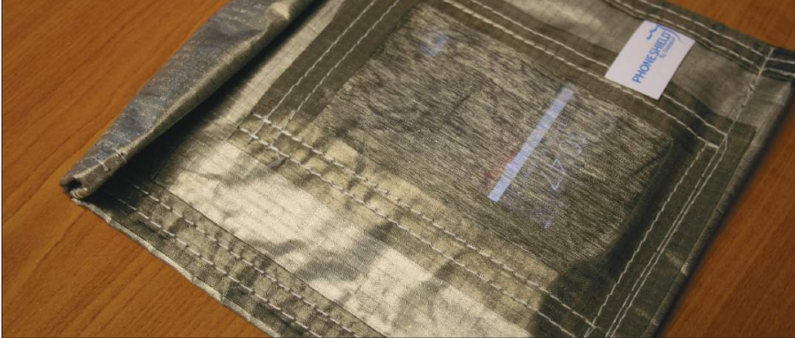
Figure 2 Faraday Container, adapted from [5]
As part of the preservation process, it is imperative to document and maintain a chain of custody that details the handling and transfer of evidence between each person involved. This document should provide a time stamped, unbroken chain of information on who handled the evidence, when, and where, ensuring it is not only preserved, but also admissible in a court of law [6].

Collection of Data

According to SANS Institute, evidence must be collected in a secure manner to prevent the contamination of evidence. This is achieved by taking a digital copy of the evidence known as disk imaging. There are multiple tools available for disk imaging, but the author stresses the concept of using a write-blocking feature when performing this task. With read-only (RO) capabilities, the chances of the evidence being inadvertently compromised is greatly reduced [7].
With the disk image obtained, a hash function can be utilised via the use of a cryptographic algorithm to present a digital fingerprint of the file. The algorithm takes an input and returns a fixed-size string of bytes known as a hash value. Even a minor change to the input will result in an altered hash value output. As shown in figure 3, this method verifies the integrity of data if the hash values are matched.

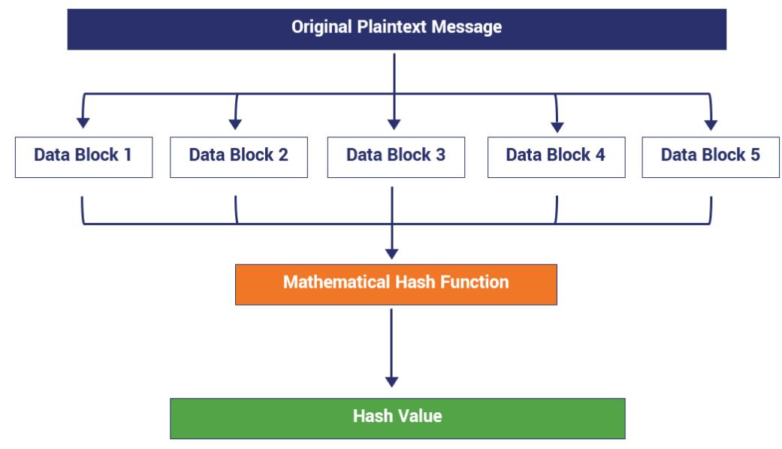
Figure 3, Application of hash function, adapted from [8]

1.1.4 Examination and Analysis
The analysis of digital data in forensic investigations extends beyond the examination of photographs, emails, social media, and web browser activities. It necessitates a systematic and detailed scrutiny of all data residing on devices pertinent to the case at hand. Crucial to this process is the identification and understanding of the file system's format and structure. This encompasses an exploration of file directories and the examination of unallocated space to comprehend the organization and storage of data. Timestamps within this data are instrumental in constructing a reliable and chronological sequence of events. Additionally, the analysis of log files is essential, as it aids in pinpointing user activities and interactions with the device. To ensure a comprehensive and thorough examination, a diverse array of forensic tools is employed, enabling a wide-ranging and in-depth portrayal of the events under investigation [2].

1.1.5 Presentation

There are several requirements for the successful process of presentation of evidence. Failure to meet these requirements could result in jeopardising the outcome of the entire case. Primarily, the presentation is about conveying the information found in the investigation in a clear manner that is understandable to a non-technical audience such as a judge and jury. With legal court cases being challenged by an opposition, it is imperative that the presentation stands up to scrutiny. This requires accurate information only relevant to the case, delivered in an objective unbiased manner. Any signs of bias or external influence would render the presentation null and void in a court of law. Such material would therefore need to adhere to the legal requirements and rules of the court. The information would also need to be delivered by an expert witness capable of clear communication and capable of articulating technical concepts in a manner that is easily understood [9].

Intersection of Digital Forensics & Cybersecurity

The fields of cybersecurity and DF intersect each other in many ways. There is a skillset overlap in that professionals require a broad understanding of computer networks, systems and protocols. This is particularly pertinent on the forensics side, as investigators require a knowledge of cybersecurity to navigate through complex technologies whilst understanding security breaches [2].
The two fields complement each other in combating digital crimes. Cybersecurity focuses on detecting, preventing and reacting to threats, whilst DF analyses the incidents to establish the facts of the events. Digital forensics also aids the progression of cybersecurity by understanding the nature of risk and the effectiveness of security measures. Additionally, cybersecurity professionals will often perform aspects of digital forensics techniques to identify weaknesses and vulnerabilities in a security system [10].

Emerging Trends
In recent years, the integration of Artificial Intelligence (AI) has led to significant advancements in data processing. As stated by Costatini et al, AI algorithms can analyse large volumes of data in pattern recognition and machine learning. Such technology is particularly useful in cases where patterns may not be immediately apparent to human reading, such as financial data or large volumes of image and video data. AI models also deliver predictive analytics to the field. Such large volumes of past data can project forecasts of future crimes [11].

Key Challenges
The dynamic nature of DF is inherently challenging. Investigators are faced with a multitude of obstacles ranging from legal issues to technology advancements.

Anti Forensics
A common issue for investigators is the attempt for perpetrators to conceal their digital footprint through deletion, destruction or encryption of data. The following table of anti-forensics methods and countermeasures is formed from information in the paper Digital Forensics vs Anti Forensics by Yaacub et al [12]:

Table 1 Anti forensics measures/countermeasure, adapted from [12]
Anti-Forensics measure | Investigator Countermeasure
Data Deletion: A common technique that can have varying levels of complexity such as deleting files, reformatting drives or rewriting over data | Using data recovery tools to recover data. This becomes more challenging if data is overwritten.
Data encryption such as Advanced Encryption Standard (AES) is highly secure and particularly challenging to decrypt | Finding decryption keys or clues stored in digital evidence or password cracking.  Appeal to the individual for keys  Apply to the organisation for access to stored data
Steganography: This involves embedding data in a file to conceal it from others, such as hiding an image in a text file or a file system that appears as unallocated space | Steganalysis tools can detect anomalies that uncover hidden data, such as unusual file sizes or inconsistencies in file structures.
Trail obfuscation: The use of VPNs or Proxies to conceal IP addresses and physical locations | Tracing through layers of connections and applying to service providers for assistance in exposing illegal activities
Physical damage: The oldest method of destroying evidence, if done thoroughly is the most effective method of anti-forensics | Attempt to recover from partially damaged devices. Investigate linked devices for residual data

Privacy Laws

Privacy laws have a significant impact on investigations. It is important to only examine the relevant information whilst respecting the privacy of sensitive data not relevant to the investigation. In many jurisdictions this is mandated by law. An example may be, in a case where child pornography is suspected, it is necessary to access the personal photos and videos on a suspect’s device. However, accessing these file types may not be warranted for a case of credit card theft. The following laws encountered are as follows:
- General Data Protection Regulations (GDPR) – A law that protects the privacy of data within the European Union (EU) and the transfer of data beyond EU areas. In terms of digital forensics, this means investigators can only data relevant to the case. Data minimisation also restricts the data storage to the minimum size and timespan required [13].
- United Kingdom General Data Protection Regulations (UKGDPR) – As part of the Brexit requirements, the EU regulation was added to the Data Protection Act 2018 to form UKGDPR, mirroring the EU version [14].
- The Federal Trade Comission states that US regulations are more complex in that they have separate federal and state laws for individual topics such as Children's Online Privacy Protection Act (COPPA) and Gramm-Leach-Bliley Act (GLBA) [15].

Technological Challenges

Digital forensics is a dynamic field that constantly evolves in accordance with the development of technology. At the forefront technological challenges is cloud computing. From data Storage as a Service (SaaS) to Network as a Service (NaaS), such environments are inherently difficult to for forensic investigators due to their dynamic distribution across multiple jurisdictions and parties. Multi-tenancy services involving many clients on shared infrastructure make it challenging for investigators to access data in a time-sensitive manner [10].
Another significant shift in the current state of digital forensics is the expansive range of devices and data sources available for investigation. The proliferation of smartphones, tablets, Internet of Things (IoT) devices, has exponentially increased the volume and diversity of digital evidence. This evolution demands a broader skill set from forensic analysts, who encounter many different operating systems, applications, and storage environments [10].

Job Market
As a minimum requirement job roles in DF require a clean character background, no criminal record and no conflicts of interest. Knowledge and experience are highly valued. The following jobs are currently available to the right applicants:

National Jobs Market

Role: Digital Forensics Analyst, permanent
Employer: CGI
Location: Reading
Salary: N/A
Advertised: Indeed.com

Role: Immigration Enforcement - Criminal & Financial - Head of Forensics Data Assurance
Employer: Home Office
Location: Manston
Salary: £41,600
Advertised: Indeed.com

International Jobs Market

Role: Digital Forensics Lead
Employer: Kyyba
Location: East Hanover, New Jersey
Salary: N/A
Advertised: Monster.com

Role: Digital Forensics Analyst
Employer: Alvarez & Marsel
Location: Brisbane, Australia
Salary: $140,000 AUD
Advertised: adzuna.com.au

Task 2

DF investigators have a vast array of resources available for specific scenarios and environments. Below is a list of tools commonly used for analysis:

Hardware - Forensic Recovery of Evidence Device (FRED)

FRED systems are purpose-built DF workstations designed for data recovery, analysis and processing. These systems feature high performance disk imaging, capable of analysing multiple drives simultaneously or sequentially, with write blocking or read/write (RW) capabilities. FREDs also operate on both Windows and Linux OS and boast feature flexibility that allows the user to switch between various storage device types as and when required. Known for their scalability, high performance and strong construction, They are well adopted in the field of DF [16].
The FRED system boasts the following features [16]:
- USB 3.2 HotSwap Drive Tray Ecosystem
- Compatible with SATA III, M.2/NVMe PCIe, M.2 SATA and Forensic Media Card Reader
- User controlled “write-protect” mode
- true 12 Gbs SATA/SAS RAID controller for handling very fast data transfers
- Air cooled ventilation, magnum heat sink, steel tower enclosure
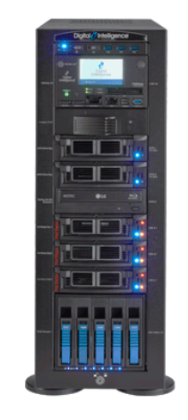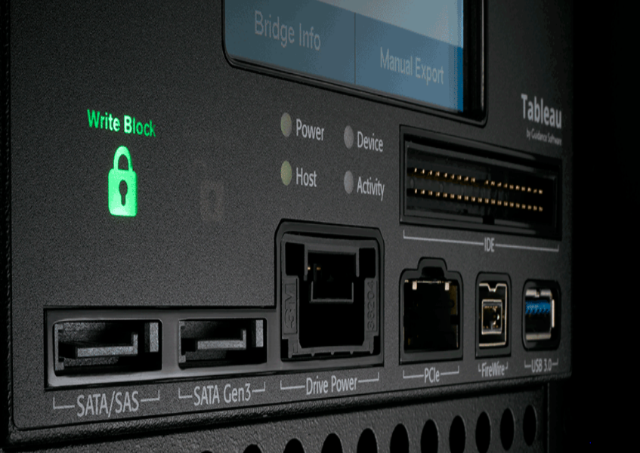
Figure 4 FRED Forensic Workstation, adapted from

Open-Source Tools

Some of the open-source tools for DF are listed as follows:

dd Command Line

dd is a command line utility for Unix type operating systems such as Linux. With its origins dating back to the 1974 Unix version 5, it is a primitive tool for converting and copying files, making it useful due to its reliability and versatility. dd is also capable of analysing infected storage devices by imaging the device in its current state. Its primary features are listed as follows [17]:
- Disk Imaging – dd is renowned for its dependability in producing data copies that are accurate byte-for-byte disk images, making it a reliable option when the investigator requires a simple instrument for reliability.
- Data Recovery - Even if storage devices are damaged or partially corrupted, dd can be used to recover data. Experienced forensics professionals can optimize data recovery by carefully configuring dd's parameters to handle errors and bad sectors during the copying process.
- Hash Values - To ensure evidence integrity, dd can provide hash values (such as MD5 or SHA-1) for the images it generates. This way, investigators can confirm that the data remains unaltered and not corrupted since the imaging process.
- Versatility in File Systems – Due to its low-level mode of operating, dd is capable of handling all file system types, accurately generating an image of the storage device, regardless of the file system such as FAT32, NTFS, ext4. By treating any device as a block of data, it can image even the most obscure systems or legacy file types.
Whilst dd is well used among the DF field, it is not without drawbacks. Utilizing dd necessitates a comprehensive grasp of command-line interfaces, along with a thorough knowledge of file systems and storage devices. Improper use of dd has the potential to overwrite data, resulting in irreversible data deletion. Additionally, the imaging process, particularly with sizable drives, can be time-consuming [2].

Autopsy

Autopsy is a well-established open-source DF application that facilitates data retrieval, incident management, and cybersecurity investigations. Developers, Basis Technology, have provided flexible access to Autopsy on both Windows and Linux operating systems. Its key features include [18]:
- Data Recovery - Autopsy can retrieve erased files and information from a range of digital media types including hard drives, USB, and SD cards.
- Data Analysis - Autopsy can analyse Timelines, emails, web artefacts and registry files.
- Keyword Searching - It facilitates keyword searches, which are essential for efficiently locating specific information by targeting the usage of regular expressions.
- Report Generation - Autopsy enables the production of thorough documentation that reports investigation's process and conclusions.
Some of the drawbacks of Autposy lies in its performance issues. In extensive investigations, it can be hindered when analysing large data sets. Additionally, acquiring proficiency in its advanced features and modules requires considerable experience, despite its graphical user interface (GUI) enhancing user accessibility. Autopsy also as limitations in supporting non-Windows systems. Whilst compatible with Linux, its primary focus and optimization is aimed at Windows OS, which may limit its applicability in certain scenarios. Being an open-source platform, Autopsy also relies heavily on its community for development and updates. This reliance can lead to inconsistencies in the regularity and quality of its updates, impacting its overall efficacy and evolution [19].

Commercial Tools

FTK Imager

AccessData, a prominent software company, has developed FTK Imager, a widely recognized digital forensic imaging tool. FTK Imager is extensively employed for acquiring and analysing digital evidence within the domain of digital forensics. Its core functionalities include [20]:
- Disk Imaging Simplicity - Typically used for disk imaging of hard drives, flash drives, CDs/DVDs, and other storage media, usability is provided through its GUI, making it accessible even to those who are not deeply versed in digital forensics.
- Mounting Images – Users can mount disk images as a drive in physical or logical (partition) form, providing convenience for user analysis.
- Compatibility with FTK Suite - The capabilities of the Forensic Toolkit (FTK) suite are improved in digital investigations with the seamless integration of FTK Imager. This integration provides forensic specialists with a full solution by enabling effective data analysis, evidence management, and detailed reporting.
- Recognised Reliability - FTK Imager is renowned for its dependability in maintaining data integrity and processing efficiency. The instrument guarantees the forensic soundness of the imaged data, which is essential for the admission of evidence in court.
As a commercial product, the FTK suite comes with a cost, which might be prohibitive for individuals or organisations with budget constraints. However, the FTK Imager is available a standalone free tool. In comparison to open-source tools, FTK Imager offers limited options for customisation and flexibility in terms of adding new features or plugins [20].

Cellebrite UFED 4PC
Cellebrite has developed a complete and cutting-edge forensic tool designed specifically for extracting data from mobile devices such as phones and tablets. Cellebrite UFED 4PC (Universal Forensic Extraction Device) is extensively used by law enforcement, military, intelligence, corporate security, and IT specialists to retrieve and examine data from mobile devices. Significant capabilities include [21]:
- Mobile Data Extraction - It is compatible with thousands of iOS, Android, and other feature phone devices, including the newest models, and can extract a wide range of data types from different mobile devices, including call logs, messages, contacts, images, videos, and app data.
- Deconding And Analysis – Cellebrite technology decodes and parses the extracted data, presenting an organised format for analysis, including data from many different cloud services and social media platforms.
- Forensic Integrity - UFED 4PC is widely recognised for maintaining the integrity of data, ensuring that it is admissible in legal proceedings.
- Technical Support - UFED 4PC is regularly updated by Cellebrite to accommodate new devices and technologies, guaranteeing its applicability in rapidly changing mobile contexts.
As a premium tool, UFED 4PC comes at a varying cost depending on licensing options of packages and services. Prices are not publicly available as clients must contact Cellebrite directly for quotes. Cellebrite stresses the importance of its full package included in the quote, comprising of software, hardware, updates and training. Further to cost issues, it is important for the users to understand the legal implications of utilising Cellebrite features, particularly regarding privacy laws across multiple jurisdictions [21].

Team Activity – Simulating a Digital Forensic Investigation of an HDD Analysis

TEAM MEMBERS: John Hughes, Ellis Bennet, Connor Wilson, Lara Costa, Dawid Trachim, Rohan Chavan

Preparing HDD for Team B

TOOLS REQUIRED:
- SOAC lab PC
- Oracle VirtualBox
- Kali Linux VM
- MD5 Hash generator
- VeraCrypt file encryption
- FTK Imager

SIMULATED CRIME SCENARIO: Appendix A

RECEIVING HDD:
Upon receipt of the HDD, a chain of custody was formed by documenting the first point of possession. This involved documenting the team member that received the device, time, date, model number, and physical condition.

CHAIN OF CUSTODY:

RISK ASSESSMENT:
Before preparing the HDD with the scenario data, a risk assessment was performed to ensure that correct procedures were followed.
Chain of Custody | From point of receival of HDD to handover to team B, a chain of custody was maintained to prove proper handling, transfer and storage was met
Hardware Risks | Condition of HDD was assessed upon receiving the device, to ensure it was functional, compatible and fit for purpose
Data Privacy and Compliance | To Ensure that any data used complies with privacy laws and regulations, we ensured that no personally identifiable information was present on the disk. We also ensured that financial data was fictional and not in breach of laws
Data Integrity | To assess risk related to data loss or corruption, we tested its accessibility and ensured the data was retrievable. All data on drive was also backed up
Ethical Integrity | Ethical standards were always adhered to, ensuring data and device were appropriate and acceptable
Incident Response Plan | Incident response plan consisting of backing up data, ensuring device functionality

HDD PREPARATION:
STEP 1:
Accessing the HDD on the SOAC computer, its initial state was found to be formatted in exFAT file structure for USB and SD cards. This file system was unfit for our intended usage that involved partitioning the 256GB free space into separate logical drives. As there was no existing data to back up, it was decided to reformat the device into NTFS file system and create partitions for data storage.
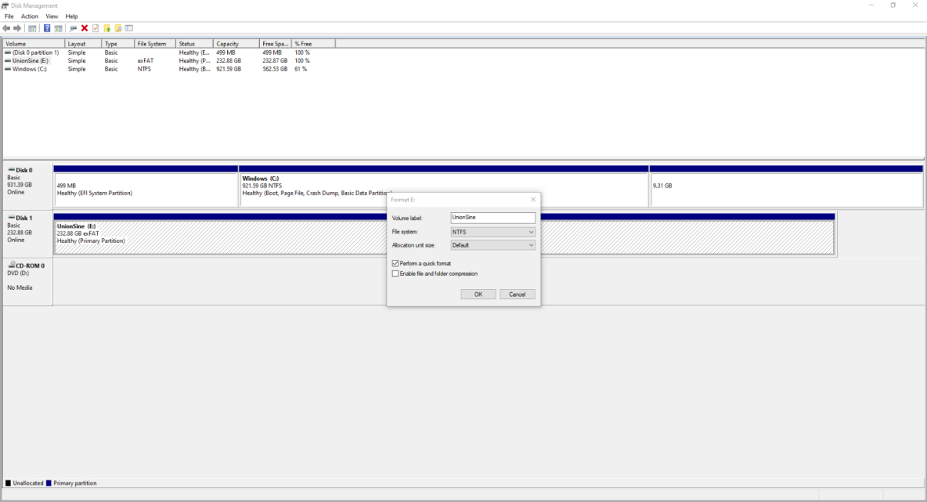

STEP 2:
Six partitions were created. Partition I was changed to “hidden” and chosen to add data. A spreadsheet containing customer and payment details was created and placed on drive I.
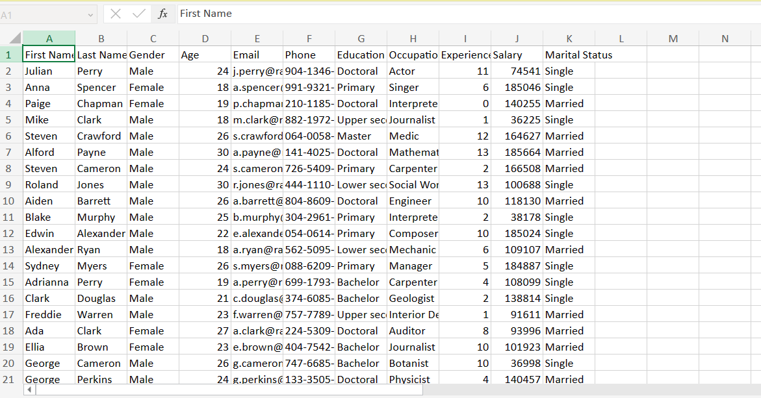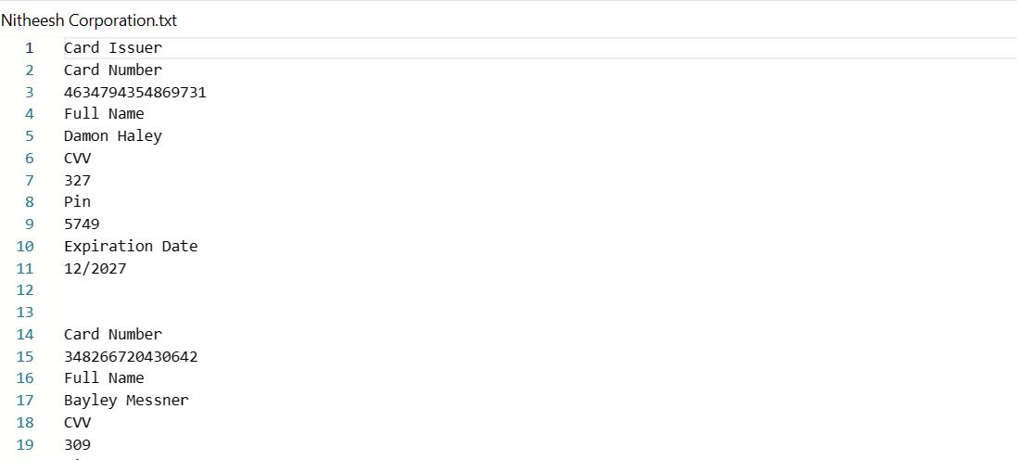
STEP 3:
The partition was then password protected with “nitheesh123hseehtin” as the chosen password. This was then hashed using MD5.
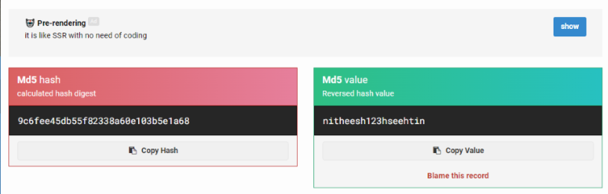

STEP 4:
To add a degree of complexity to the scenario, steganography was used to hide more data. This was done by hiding .jpeg images of bank statements within mp4 video files. Using Windows Command Prompt, the “copy /b” command acts as a basic form of steganography by appending Barclays_statement.jpg image to the meeting.mp4 video file, creating a new meeting2.mp4 to conceal the data.
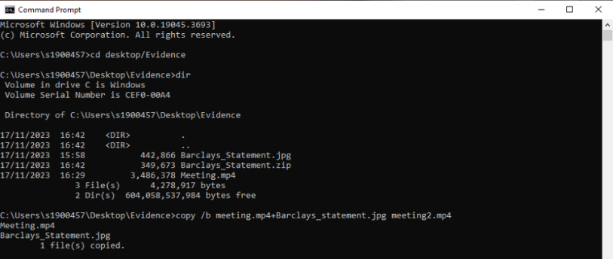

STEP 5:
The data is then encrypted using VeraCrypt
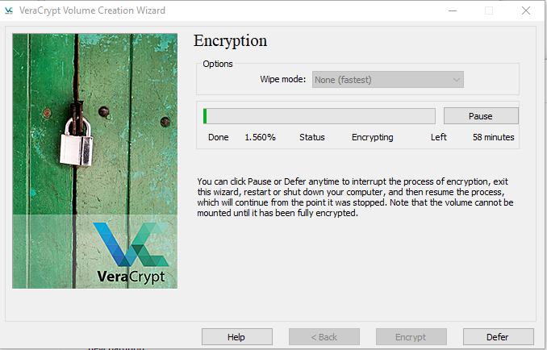

STEP 6:
Batch files are collected and converted into executable files.
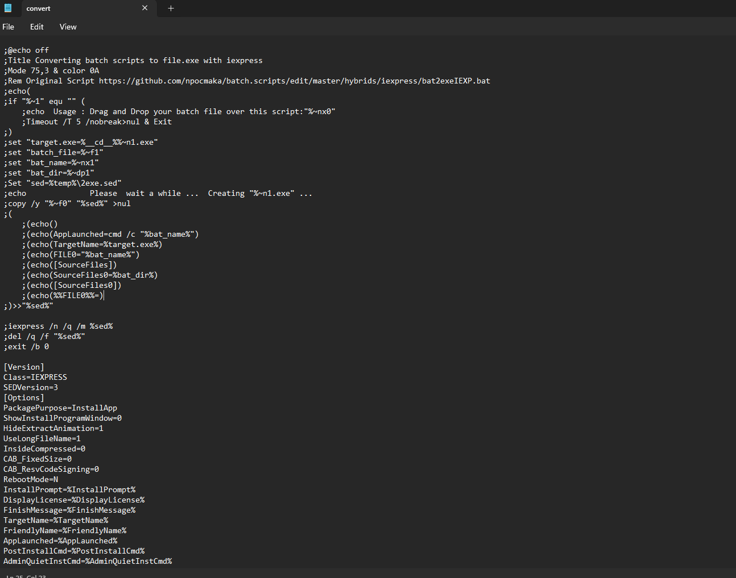
To protect the physical computers and university network, they are then tested on a Windows VM to evaluate their behaviour. Once established to be safe, they are added to the HDD on partition H
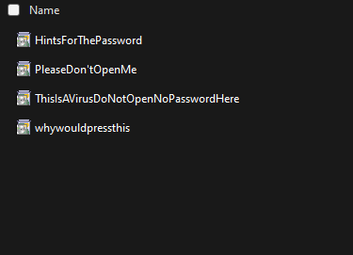

STEP 7.
With the data prepared, the storage device was deemed ready to hand over to Team B.

Analysis of HDD Received from Team C

TOOLS REQUIRED:
- SOAC lab PC
- Games lab PC
- Oracle VirtualBox
- Kali Linux VM
- FTK Imager
- Autopsy Software

SIMULATED CRIME SCENARIO: Appendix B

RECEIVING HDD:
Due to Team C still preparing their HDD, there was some delay to receiving it. Eventually, we received a
Upon receipt of the HDD, a chain of custody was formed by documenting the first point of possession. This involved documenting the team member that received the device, time, date, model number, and physical condition.

CHAIN OF CUSTODY:

RISK ASSESSMENT:

ACCESSING HDD DATA:
STEP 1.
After documenting the chain of custody, the HDD was accessed via USB using Kali Linux VM to protect the physical infrastructure within the SOAC lab. It was found to be of 1TB capacity, making it significantly more challenging than the 256GB HDD that we were tasked with preparing. The size of the storage device was too much for the SOAC lab computers to proceed with the disk imaging process.

STEP 2.
Relocating to the games lab where there was access to PCs with larger capacity, we were able to disk image the HDD using Forensic Imager. This tool was chosen for its ability to copy data in read-only mode, maintaining the integrity of the original data.
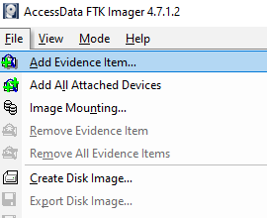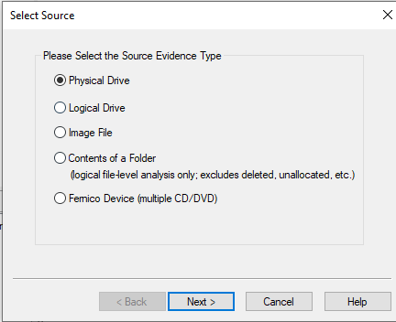

STEP 3.
To create an exact copy of the data, a dd image was selected, for bit-by-bit imaging.
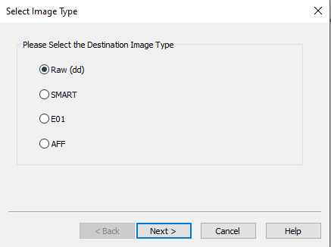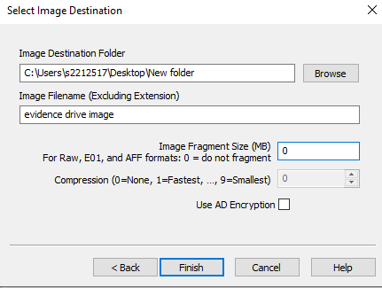

STEP 4.
Upon attempting to mount the disk image, it was established that the data was unreadable due to corruption. We the approached Team C for further information as they had not yet supplied the scenario that would provide context for the simulated crime.
After discussion with Team C, it was established that the data was corrupted and they could not access it either. They explained a scenario that involved the use of two different VMs, a Kali Linux attacker and a Windows victim.
Both VM disk images were disk imaged and transferred onto the HDD in separate partitions. This is potentially where the corruption occurred, as the disk imaging process may not have accounted for the complexity of nested operating systems (OS images within a physical disk).
Further to this problem, it was established that Team B used a Reverse Shell malware payload from Metasploit framework which may have led to unintended consequences of the data. This may have led to altered file structures or damaged files, potentially explaining the corruption.
The HDD was then handed back to Team C and they agreed to a renewed preparation of the device.

Analysing HDD Attempt 2

TOOLS REQUIRED:
- SOAC lab PC
- Games lab PC
- Oracle VirtualBox
- Kali Linux VM
- FTK Imager
- Autopsy Software

SIMULATED CRIME SCENARIO: Appendix B

RECEIVING HDD:

STEP 1:
On receipt of the HDD for a 2nd time, another disk image was taken using FTK imager and Autopsy. Using MD5 and SHA1 hashing, it was established that the disk image was accurate and uncompromised.
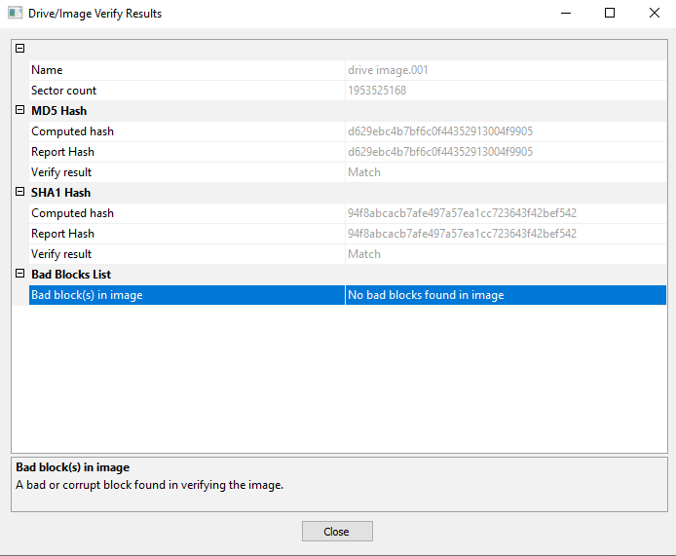

STEP 2.
It was discovered that files within the HDD were encrypted with Kali Linux tools. We had to import the files onto a Kali Linux VM to try and decrypt them. This involved installing the necessary Python and PIP for decryption.
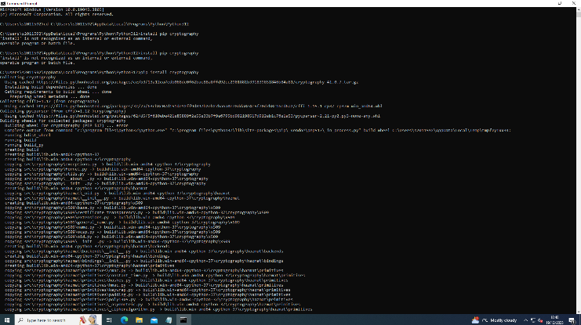

STEP 3.
The following evidence was extracted and analysed. It contained a number of PNG and JPEG image files, text files with no extension named "read," "task," "text," "textcopy," "write," Files with a .py extension, which are Python script files and Files with .Zone.Identifier, which are typically associated with files downloaded from the Internet and contain security zones information set by Windows.
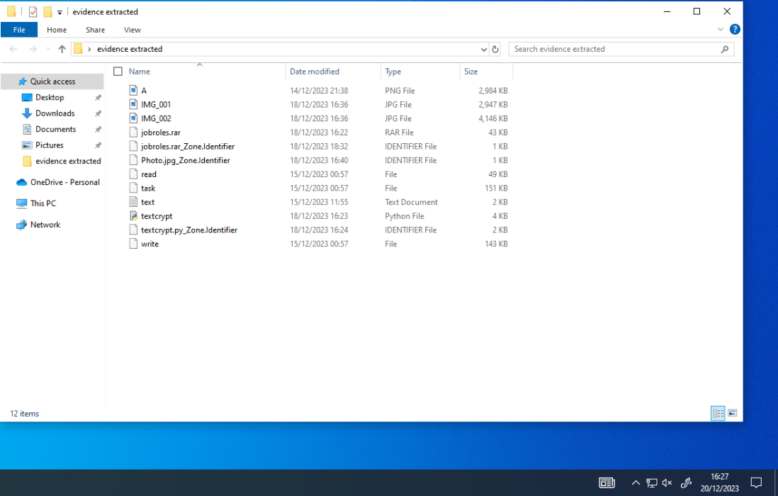

STEP 4.
In Kali Linux, the following files were extracted for further analysis
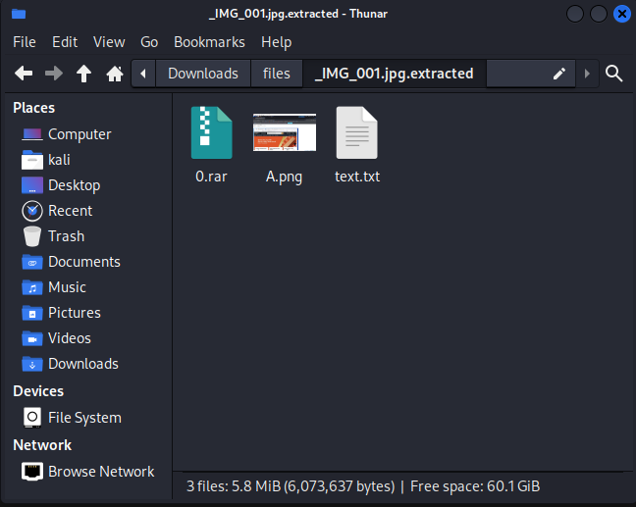

STEP 5.
Using the binwalk tool in Kali Linux, we were able analyse the disk image for any embedded files that may have been hidden using steganography
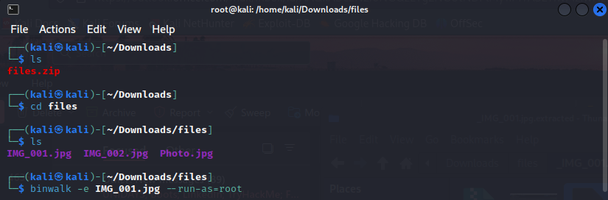

STEP 6.
The Binwalk scan resulted in this embedded code, which was encrypted
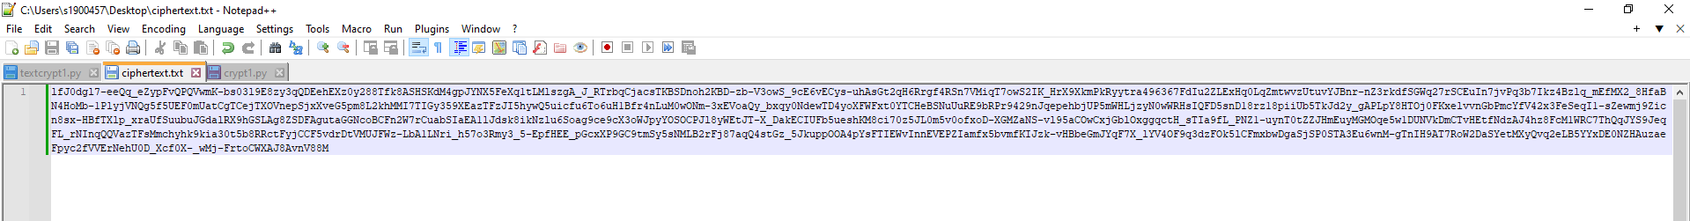

STEP 7.
The following python code was used to decrypt the data within the “cyphertext.png” file. It was found to contain the discovery of the PGP private key
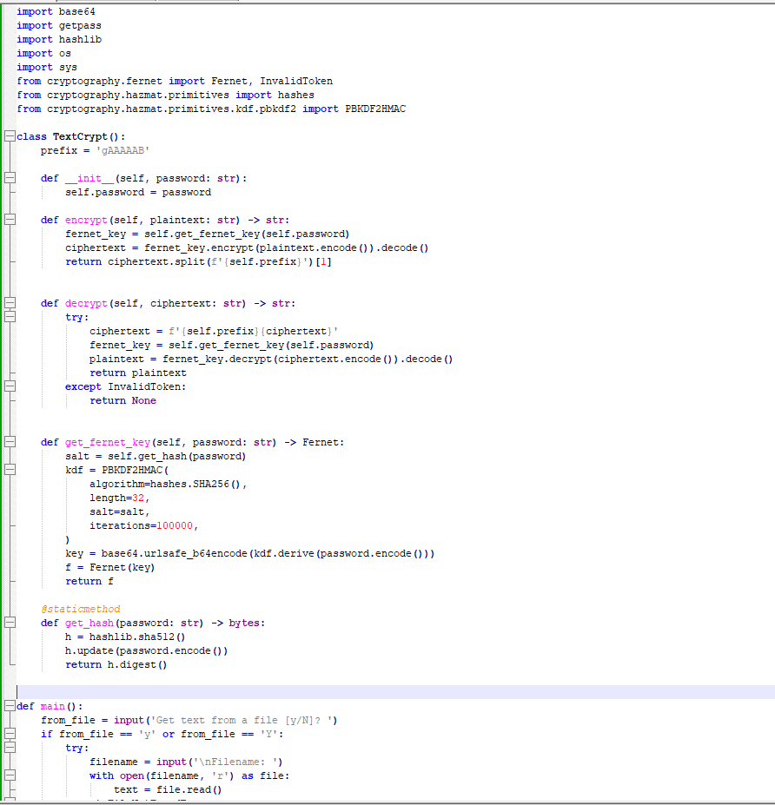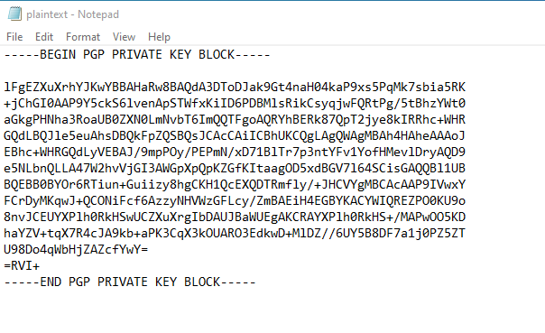

STEP 8.
Using the “textcrypt1.py” python script, the “ciphertext.txt” file is decrypted with the previously found PGP private key, decrypting the file into plain text
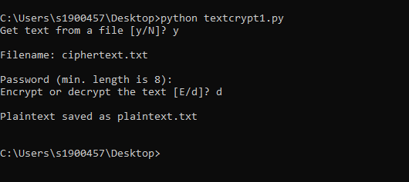

STEP 9.

Team Activity – Simulating a Digital Forensic Investigation of a Mobile Phone

Huawei POT-LX1 P Smart Analysis

TOOLS REQUIRED:
- SOAC lab PC
- Games lab PC
- Oracle VirtualBox
- Kali Linux VM
- FTK Imager
- Cellebrite Physical Analyser
- Autopsy Software

SIMULATED CRIME SCENARIO:
A hypothetical situation where an individual is suspected of divulging confidential corporate information to competitors. This suspicion arises from the individual’s pattern of leaving the country and taking unannounced leave, in violation of contractual obligations.
RECEIVING MOBILE PHONE:
Upon receipt of the device, a chain of custody was formed by documenting the first point of possession. This involved documenting the team member that received the device, time, date, model number, and physical condition.

CHAIN OF CUSTODY:

RISK ASSESSMENT:
Before investigating the device, a risk assessment was performed to ensure that correct procedures were followed.
Chain of Custody | From point of receival to handover to team B, a chain of custody was maintained to prove proper handling, transfer and storage was met
Hardware Risks | Condition of phone was assessed upon receiving the device, to ensure it was in working condition and compatible with Cellebrite tools
Data Privacy and Compliance | All aspects of the device were required for analysis. It was deemed necessary to disk image the entire device
Data Integrity | To assess risk related to data loss or corruption, we tested its accessibility and ensured the data was retrievable. All data on drive was also backed up
Ethical Integrity | Ethical standards were always adhered to, ensuring data and device were appropriate and acceptable
Incident Response Plan | Incident response plan consisting of backing up data, properly storing device in Faraday bag, ensuring no data was lost or courrupted

STEP 1:
The Huawei POT-LX1 P Smart was externally intact, bearing minor cosmetic blemishes. However, its battery was critically low, and it lacked a SIM card, preventing immediate analysis via Cellebrite. Once powered on, the device exhibited a boot loop—a recurrent startup failure commonly stemming from flawed updates. Given the device's infrequent use, this seemed the likely cause, though hardware or software defects could not be discounted.
STEP 2.
Without the device functioning properly to enter developer mode, a successful disk image was unrealistic. The following screenshots show Cellebrite failing to capture data.
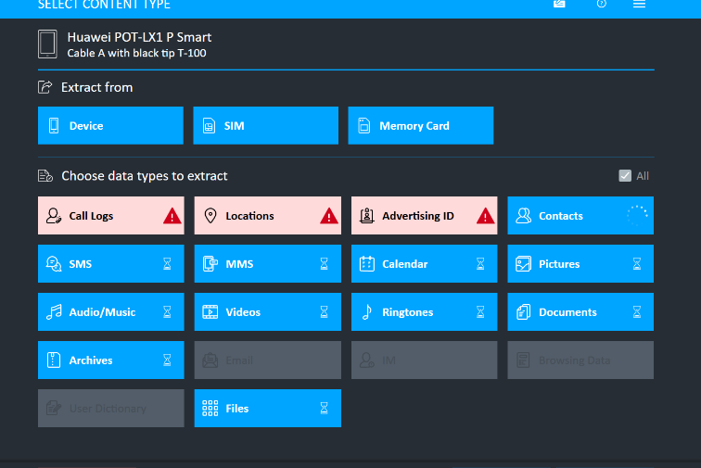

STEP 3.
Periodically, the device accessed recovery mode, a dedicated pre-boot partition for system restoration. A factory reset through this mode was deemed necessary to stabilize the device for imaging, despite the resultant data loss, as it offered the sole viable path to enable Cellebrite acquisition.
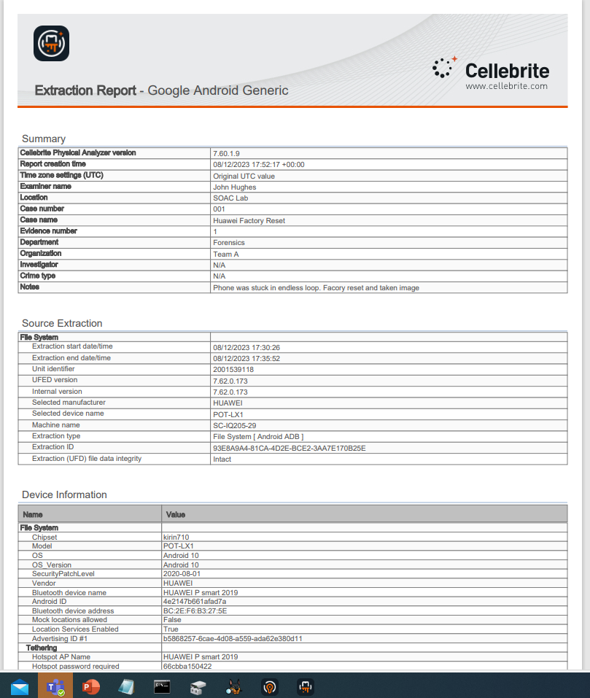

STEP 4.
As the device was factory reset, no relevant data was found. The device was returned to storage and a replacement device was used for the task.

Ulefone Note 14 Analysis

STEP 1.
Upon preliminary inspection of the substitute mobile device, a Ulefone Note 14, it was noted to operate on the Android platform, secured by a four-digit PIN (1224), and presented no evident physical impairments.
STEP 2.
Data extraction was facilitated using Cellebrite Physical Analyser
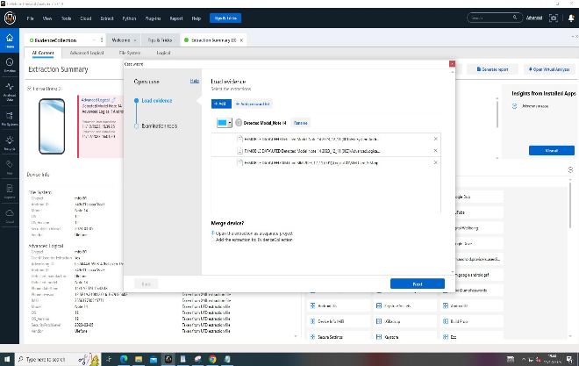

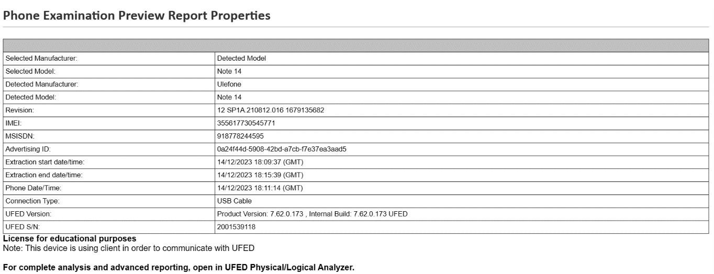
STEP 3.
Following the initial data extraction, our next step involved selecting relevant forensic applications for targeted analysis offered by the enriched applet analyser, selecting specific applications for a more granular investigation
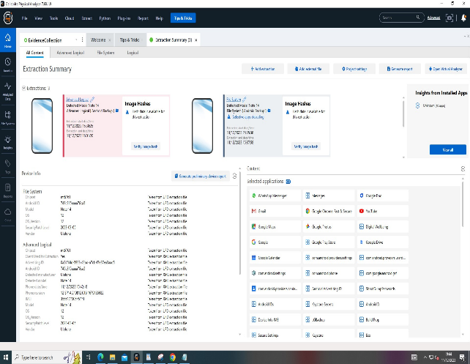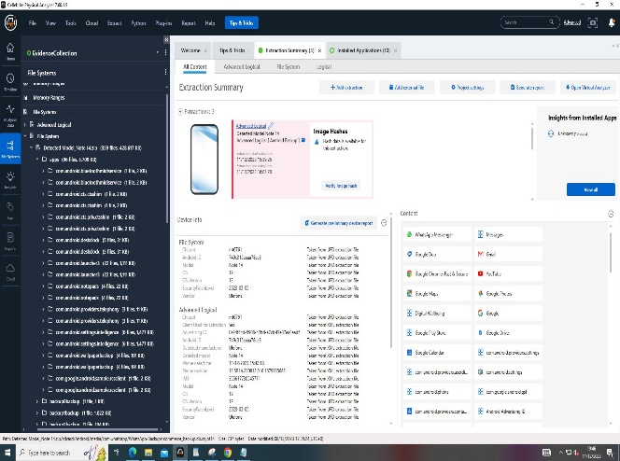

STEP 4.
Cellebrite's forensic analysis extracted multiple photographs from the device, with embedded geolocations in the metadata indicating the user's domestic and international travel history.
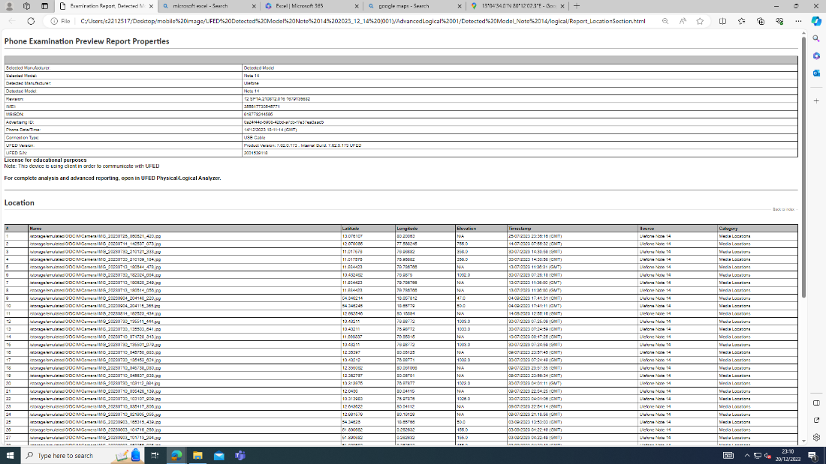

STEP 5.
Using Cellebrite Physical Analyzer, we identified and retrieved a photograph from the WhatsApp Images directory, which depicted a credit card, potentially relevant to the financial aspects of the investigation.
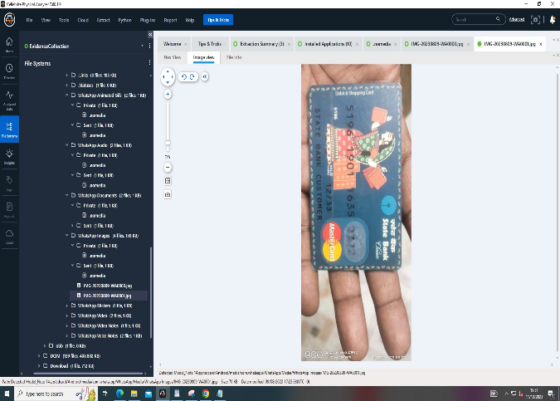

Further examination revealed a sequence of .WAV audio files, likely to contain verbal communications, which were catalogued for review noting their timestamps

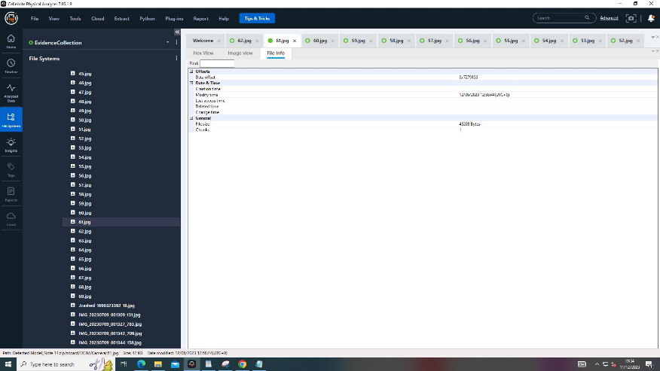

The following screenshot shows photos organised via facial recognition, with “Dr Kaashif” identified as a potential person of suspicion to the investigation
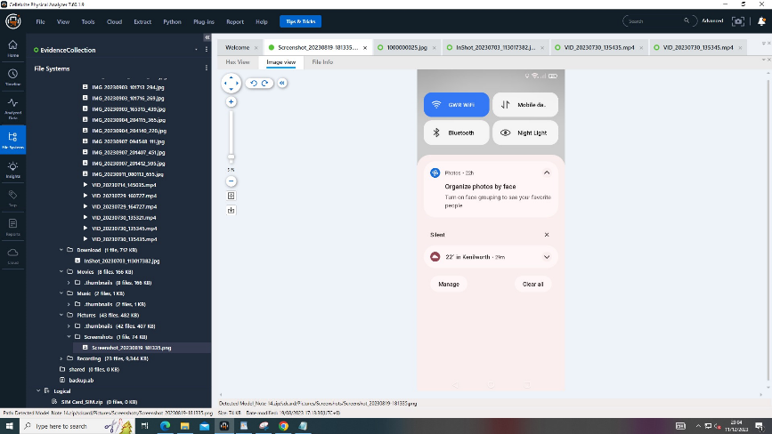

The following data was extracted and categorised into call history, multimedia files and metadata showing the geolocations of the suspects travels
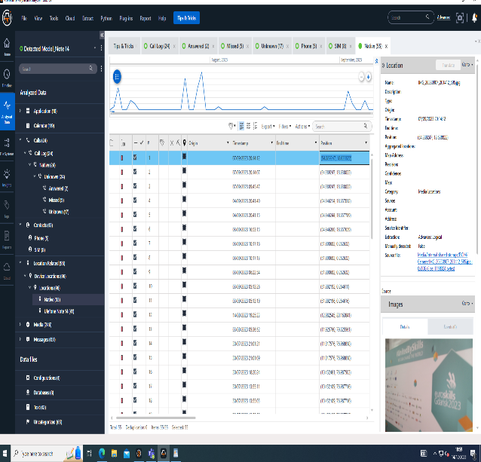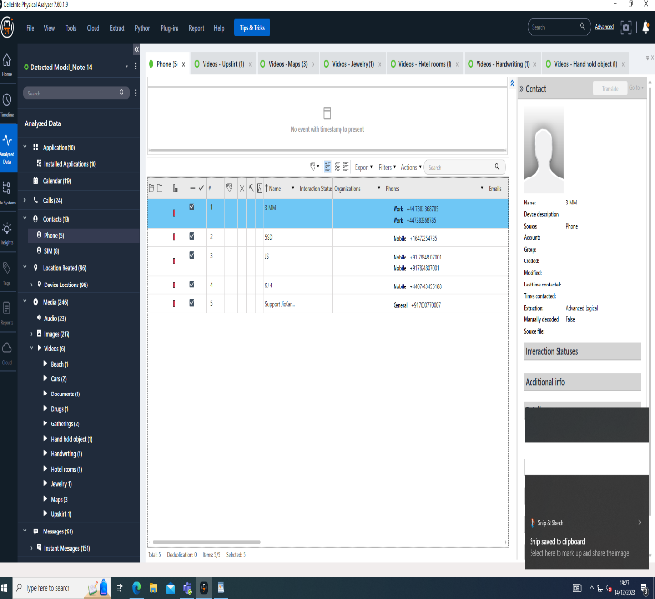

Using the coordinates supplied in the geolocation metadata, the suspects travels are mapped using google maps
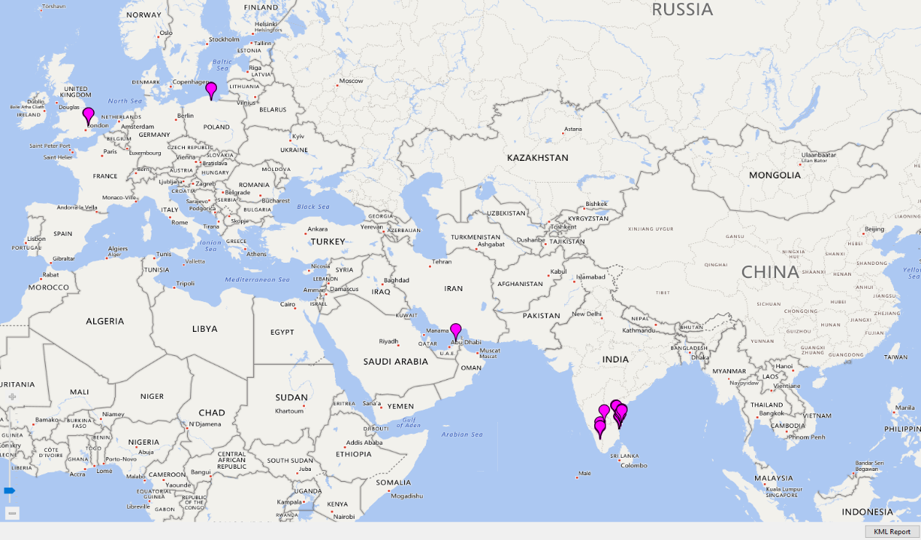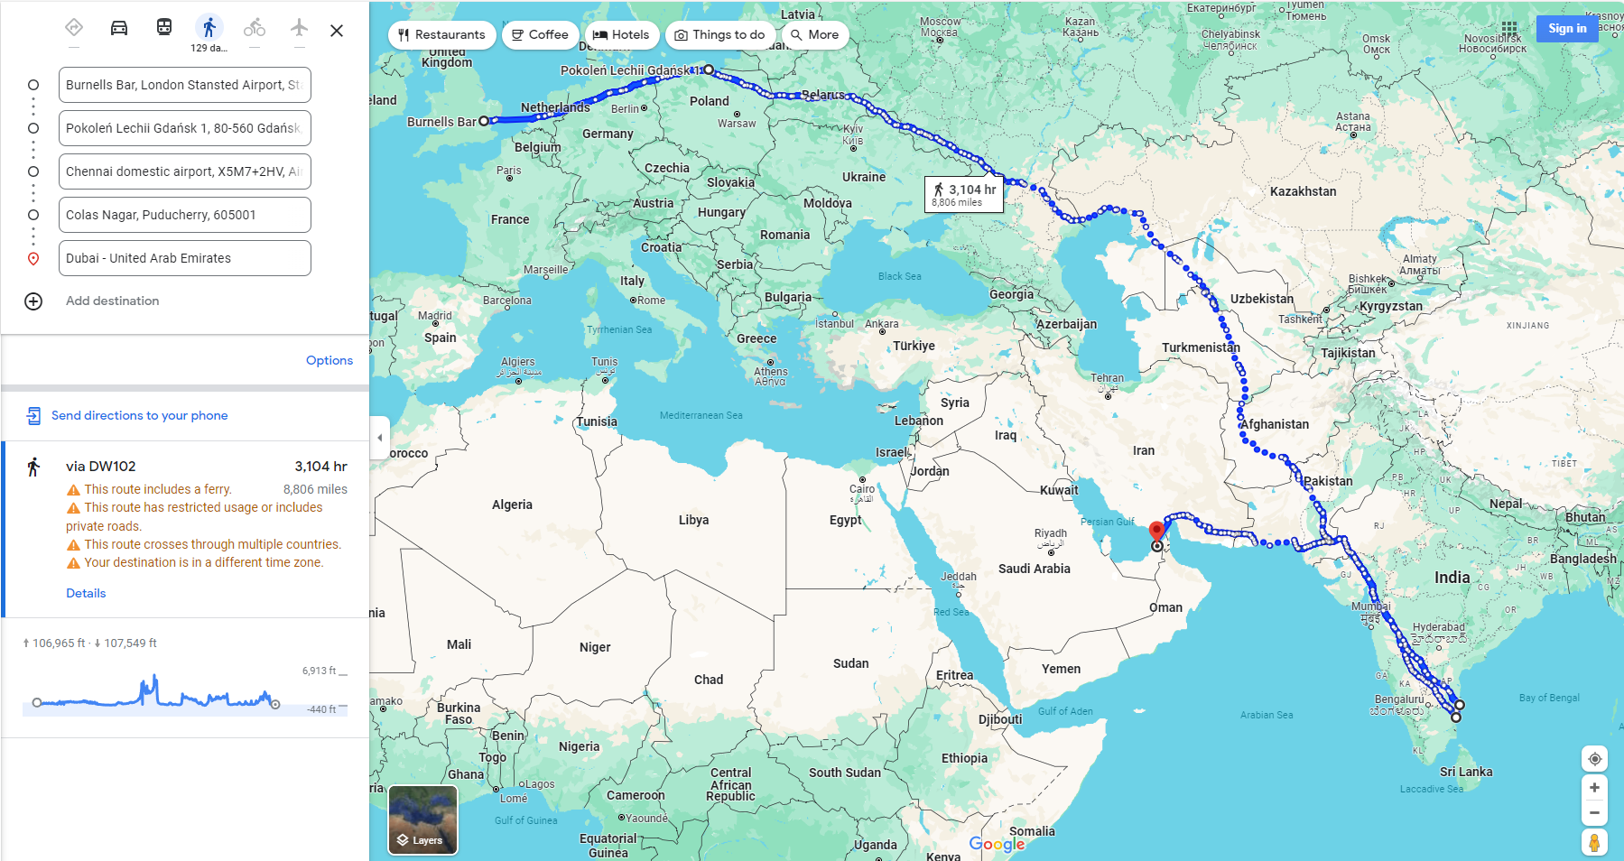

References

[1] D. Paul Joseph and J. Norman, ‘An Analysis of Digital Forensics in Cyber Security’, in First International Conference on Artificial Intelligence and Cognitive Computing, R. S. Bapi, K. S. Rao, and M. V. N. K. Prasad, Eds., Singapore: Springer Singapore, 2019, pp. 701–708.
[2] A. Årnes, Digital forensics. John Wiley & Sons, 2017.
[3] Lyle, James R, ‘Digital Investigation Techniques: A NIST Scientific Foundation Review’. National Institute of Standards and Technology, May 2022. Accessed: Dec. 12, 2023. [Online]. Available: https://www.nist.gov/publications/digital-investigation-techniques-nist-scientific-foundation-review
[4] ‘Standards and best practices for digital forensics’. UN, Mar. 2019. Accessed: Dec. 23, 2023. [Online]. Available: https://www.unodc.org/e4j/en/cybercrime/module-4/key-issues/standards-and-best-practices-for-digital-forensics.html
[5] A. Lennox-Steele and A. Nisbet, ‘A forensic examination of several mobile device Faraday bags & materials to test their effectiveness’, 2016.
[6] ‘Improving Chain of Custody in Forensic Investigation of Electronic Digital Systems’, IJCSNS Int. J. Comput. Sci. Netw. Secur., vol. 11, no. 1, Jan. 2011, Accessed: Dec. 23, 2023. [Online]. Available: https://www.researchgate.net/publication/267400650_Improving_Chain_of_Custody_in_Forensic_Investigation_of_Electronic_Digital_Systems
[7] ‘An Overview of Disk Imaging Tool in Computer Forensics’. SANS, 2021. Accessed: Dec. 15, 2023. [Online]. Available: https://sansorg.egnyte.com/dl/a5Kgok6990
[8] C. Crane, ‘Hashed Out’, The SSL Store. [Online]. Available: https://www.thesslstore.com/blog/what-is-a-hash-function-in-cryptography-a-beginners-guide/
[9] J.-P. A. Yaacoub, H. N. Noura, O. Salman, and A. Chehab, ‘Advanced digital forensics and anti-digital forensics for IoT systems: Techniques, limitations and recommendations’, Internet Things, vol. 19, p. 100544, Aug. 2022, doi: 10.1016/j.iot.2022.100544.
[10] Mohammad Shahid Husain, Mohammad Zunnun Khan, Critical Concepts, Standards, and Techniques in Cyber Forensics. Hershey PA, USA: IGI Global, 2020. [Online]. Available: https://www-igi-global-com.ezproxy.uwtsd.ac.uk/gateway/book/233673
[11] S. Costantini, G. De Gasperis, and R. Olivieri, ‘Digital forensics and investigations meet artificial intelligence’, Ann. Math. Artif. Intell., vol. 86, no. 1, pp. 193–229, Jul. 2019, doi: 10.1007/s10472-019-09632-y.
[12] J.-P. A. Yaacoub, ‘Digital Forensics vs. Anti-Digital Forensics: Techniques, Limitations and Recommendations’. ProQuest, Mar. 2021. Accessed: Dec. 13, 2023. [Online]. Available: https://arxiv.org/pdf/2103.17028.pdf
[13] General Data Protection Regulations (GDPR). Accessed: Dec. 13, 2023. [Online]. Available: https://gdpr-info.eu/
[14] Data Protection Act 2018. Accessed: Dec. 13, 2023. [Online]. Available: https://www.legislation.gov.uk/ukpga/2018/12/part/2/chapter/2/enacted
[15] Federal Trade Comission (FTC). Accessed: Dec. 13, 2023. [Online]. Available: https://www.ftc.gov/news-events/topics/protecting-consumer-privacy-security
[16] ‘FRED by Digital Intelligence’. Accessed: Dec. 13, 2023. [Online]. Available: https://digitalintelligence.com/products/fred/
[17] ‘dd (Unix)’. Wikipedia. [Online]. Available: https://en.wikipedia.org/wiki/Dd_%28Unix%29#:~:text=In%201990%2C%20David%20MacKenzie%20announces,11%5D%E3%80%91
[18] ‘Autopsy User Documentation 4.0’. Apr. 06, 2016. [Online]. Available: https://sleuthkit.org/autopsy/docs/user-docs/4.0/#:~:text=This%20is%20the%20User%27s%20Guide,develop%20your%20own%20Autopsy%20modules
[19] D. Manson, A. Carlin, S. Ramos, A. Gyger, M. Kaufman, and J. Treichelt, ‘Is the Open Way a Better Way? Digital Forensics Using Open Source Tools’, in 2007 40th Annual Hawaii International Conference on System Sciences (HICSS’07), Jan. 2007, pp. 266b–266b. doi: 10.1109/HICSS.2007.301.
[20] A. Alshammari, ‘Detection and Investigation Model for the Hard Disk Drive Attacks using FTK Imager’, Int. J. Adv. Comput. Sci. Appl., vol. 14, no. 7, 2023, doi: 10.14569/IJACSA.2023.0140784.
[21] ‘Cellebrite UFED’. Cellebrite. [Online]. Available: https://cellebrite.com/wp-content/uploads/2022/11/Solution_Overview_Cellebrite_UFED_LTR.pdf

Appendices

APPENDIX A:

APPENDIX B:

