
Skills for the Workplace
Module Assignment Submission
Student Name: | Gemma Morrison
Student Number: | 1910977
Module No: | BMSK4002
Module Title: | Effective Team Working and Communication  Part 2

Statement of Confirmation of Authenticity
By the act of making this submission, the student declares that this is the work of the student named above. The work has not, in whole or in part, been knowingly presented elsewhere for assessment, or where assessment has been built on a previous assessment, this has been identified. Where materials have been used from other sources it has been properly acknowledged. If this statement is untrue, the student acknowledges that an assessment offence has been committed.
Attention is drawn to the plagiarism and unfair practice policies of both the University and of ILM.

Table of Contents
Part 2 Communication 3
1.0 3
Communication Cycle 3
2.0 5
Assessing Own Communication Skills 5
Gap Analysis 6
PDP 6
References 7
Appendix A 7
Skills You Need Communication Quiz 7
Mind Tools Communication Quiz 9

Part 2 Communication

This report will discuss the cycle of communication and what is needed to be done for effective communication to take place. It will then talk about how my own communication skills are and what I can do to improve them, so that I can effectively communicate with my colleagues at work.

1.0

Communication Cycle

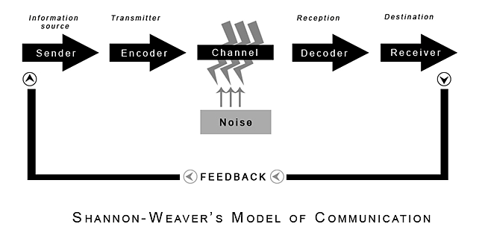
(Shannon and Weaver, 1949)

Communication within the workplace is paramount. It can be done verbally and non-verbally. Communication is a very technical thing and must be done properly so that the correct message is sent to the receiver.

There are several models which help to understand the cycle that communication follows. Shannon and Weaver created a model in 1949 that explains the method of communication (pictured above). This model shows the different steps that are needed for good communication.

According to Shannon and Weaver (1949), the six steps of communication are sender, encoder, channel, decoder, receiver and feedback.

Sender – This is the first stage of the communication cycle. This is where a person has thought about something that they need to communicate whether it be by using language (speaking, email, letter) or whether it is using body language.

Encoder – This is where the person who has decided they need to communicate something and they are now getting this message organised in their mind if they are going to say it or on a piece of paper/screen if it is a written message. During this step it is important for the person wanting to communicate to take several things into account before doing it. They need to think about if they are going to be sending the correct message across. According to Mulder(2019), this is where the person sending the message needs to get the message into a form that the receiver can understand. The sender will need to think about the language they are using and whether the receiver will understand. For example, if a sender uses a lot of technical words and jargon, the receiver’s vocabulary may not be as advanced as the sender’s and this would then affect the way the receiver understands the message they are receiving. The person sending the message also needs to think about if what their going to say is going to cause offence to the receiver due to cultural differences, educational differences or even the way they were brought up.
Channel – Now this is the step where the message is sent, whether that be verbally or non-verbally. Now this is a tricky step and can be very difficult if doing it through letter or by email. If the sender is giving this message through the medium of speech, they need to consider what body language and facial expressions they are using so that the correct message can be conveyed, as sometimes the words alone are not enough. For instance, the sender may say something that might come across as offensive and upset the receiver; but if the message is delivered with the correct facial expression, such as a smirk, or correct body language such as a shoulder bump, this would then allow the receiver to understand that what was being said was meant as a joke. In an email or a letter, it can be difficult to convey a message in they way that a sender could face to face as there is no option of using body language or facial expressions, so communications must always be kept professional in these methods.

Receiving – According to Mulder (2019), the next step of the process is receiving. This is what happens when the sender has conveyed their message and it has entered either the receiver’s sight, hearing or both.

Decoder – According to Blenkinsop (2010), this is the stage where the receiver has heard or read the message that the sender has sent. The receiver is now decoding the information they have been given, verbally and non-verbally into an understandable language. Just like how every person is unique, every person will decode messages uniquely according to their culture, their knowledge and their social stance. Therefore, it’s important for the sender to take these things into account before conveying their message. It is easily possible to give the same message to two different people, but the message will be decoded differently by these people and they can potentially receive different messages.

Feedback - Now this is the last step of the communication cycle. This is when the receiver has interpreted the message that has been sent to them and they reply. Most of the time, these replies are given consciously and verbally. Non-verbal, conscious replies can also be given such as a smile or a nod of the head. There are times, though, that there can be some sub-conscious replies that are non-verbal that are given. These are normally facial expressions such as confusion, or how the statement or message has made them feel. If the communication method is face to face, the sender can then interpret the non-verbal communication that has been given to them and reply to that communication, such as if there is a look of confusion on the receiver’s face, they can then see that they may not be able to understand what is being communicated to them, so they can offer to re-phrase what they have just communicated in a way that the receiver may be able to understand. This cycle will then continue until the end of the conversation, or the end of the communication.

There is another factor that needs to be considered within the communication cycle that isn’t an actual step or stage. This is noise. According to Mulder (2019), there are two types of noise. Internal noise and external noise. External noise is what is going on in the surroundings, like music playing, another loud conversation going on in the vicinity, a ticking clock, a door slamming etc. These external noises can detract the attention of the receiver from the sender. It is sometimes possible to reduce these factors making it easier for the sender to convey their message to their receiver with less distractions making it easier for the receiver to concentrate and understand the message being communicated. There is also internal noise. This is what is happening with either the receiver or the sender. It can be things such as looking at a phone so not able to concentrate properly on the communication; a headache. A headache can hugely affect some peoples’ attention spans. If a sender is experiencing the internal noise, they may struggle to encode their message properly making it difficult for the receiver to decode the message efficiently and if a receiver is experiencing internal noise, they will struggle to decode the message that the sender is conveying efficiently.

Within a business there are many modes of communication and they all need to be followed carefully using the communication cycle theory to be done effectively. A manger within a business must be able to adapt and change how they encode a message for each person they want to deliver it to if necessary, as mentioned before different people can interpret messages differently, so as a manager, this needs to be taken into account. Within a business, it would be advantageous to the team if communications were kept formal where possible, especially in any written communication as it is very difficult to decipher whether the person who is sending the message is joking or serious as there is no tone of voice, facial expressions or body language used in written communications.

If communication is poor within a business, it can lead to reduced productivity as staff members may not fully understand what is expected of them, because they have not understood what has been said to them. According to QLD.gov.au (2016), how effectively a business owner communicates will define how well the business will do. A business owner that doesn’t show active listening skills (making eye contact, nodding, asking open-ending questions) will run the risk of losing deals and losing the respect of employees.

A business owner who can display good communication skills such as conveying their messages in an appropriate way, use the appropriate facial expressions, use appropriate body language and use active listening skills will gain respect from their prospective clients, employees and suppliers which then lead on to being able to run their business effectively. If they communicate efficiently, they are more likely able to get people to do what they want them to do. People normally tend to respond better to requests rather than orders.

In summary, here is a list of to do’s and not to do’s when communicating within a business.

To Do | Not To Do
● Think about what you are trying to say. | ● Have external noises during the communication cycle where possible.
● Take into consideration who you are communicating with. | ● Use an inappropriate tone of voice.
● Ensure that your listener is ready to listen. | ● Be too informal. This can sometimes mix up the message you are trying to send.
● Use appropriate non-verbal cues. | ● Seem uninterested when somebody is trying to communicate with.
● Use active listening skills. | ● Be occupied with anything else during the communication cycle.
● Use appropriate tone of voice. | ● Use jargon and language the receiver may not understand.
● Ask open ended questions. | ● Use inappropriate body language.

2.0

Assessing Own Communication Skills

Before this module, I believed I had good communication skills on a one to one basis. I have always struggled talking to bigger groups of people, especially giving presentations. To help me with this module and knowing how other people feel that I communicate, I asked a few colleagues at work to fill in a questionnaire so that I could look at the results and see where I could improve with my communication. For the other half of this module, I had to give a presentation on ‘Effective Team Working’ and I asked the people who watched me deliver the presentation to give me feedback. I also took part in two online surveys regarding communication skills, which I have attached the results to this report. (See Appendix A).

The results I had back surprised me. I felt that I was better at communicating than I am. From the information that I obtained from my colleagues; it seems that they don’t always think I’m listening when I am. This is normally because due to working in a care home, I tend to be doing a few things at once. I felt quite upset at that as I thought I was a good listener and thought my colleagues felt the same. I have vowed to be better and have come up with an action plan to improve this skill, which I have provided in my gap analysis.

I also learnt from my colleagues that I have a poker face. They say that when speaking to me, they don’t really get much of a clue of what I’m thinking. Again, this shocked me. I have decided that I should do some research and take the time to practice on my communication skills. There are lots of resources online I can use to help me improve my skills.

According to mindtools (2019), I am a capable communicator, but I need to think about my approach to communicating when sending and receiving messages. They have a link to click on that can give me some useful information to help me make improvements where I need to.

According to Skills You Need (2019), my emotional intelligence, my communicating in groups and my listening skills are average. My verbal communication skills are below average. With these assessments come some pointers on how I can improve each sector, which I will take heed to.

The feedback I received from my fellow students also surprised me. I felt that I was terrible at delivering presentations and I always get massive feelings of anxiety before delivering one, but the comments I had for my feedback were all positive. They said the presentation I gave was very well thought out, well laid out and that I spoke clearly and loudly enough, and that the presentation was easy to follow. From these comments, I have had a bit of boost of confidence and have realised that that is where I need to improve. My confidence. Giving presentations isn’t something I do regularly in my line of work, but from my experience of this one, I know I need to spend more time practicing saying my presentation out loud. I think this will make me more comfortable when the time comes to delivering it.

Gap Analysis

Objective | Current Position | Deficiency | Action
What do I want to do? | What can I already do? | What am I lacking? | How do I fix this?
I want to feel more comfortable talking in bigger groups of people. | I can talk in groups of people, but not fluently and confidently. | Confidence that I am going to remember what I need to say. | When I know I’m going to be delivering a presentation, I need to spend longer preparing to speak in front of people.
I want to communicate effectively with my colleagues consistently. | I can communicate with my colleagues effectively most of the time. | Appropriate facial expressions. Sometimes my face doesn’t say what I’m thinking, and this can give my colleagues the wrong idea. | When I am communicating with my colleagues, I need to get rid of any internal noise within me, so I can really concentrate on what they are saying so that I can respond appropriately.
I Want my colleagues to feel that I am really listening to them when they are speaking to me. | I do listen to my colleagues and act on anything they have said. | I am lacking giving them my full attention when they are speaking to me, which gives them the impression sometimes that I’m not hearing what they are saying. | When a colleague wants to speak to me, either put the task I am currently doing on hold and give them my full attention, or if I can’t put the task on hold, ask them if they would mind waiting until I have finished so that they will have my undivided attention.

PDP

Objectives | Tasks | Success Criteria | Time Frame | Resources
List your Goals | What do you need to do to achieve these goals? | How will you identify your success? | When do they need to be done by? | Who or what do you need to help you?
Improve my listening skills. | Resources on the internet giving me training and pointers how to do this. | I will ask my colleagues again after I have done my ‘training’ to reassess me. | 1 month. | I need resources online and my colleagues as my assessors.
Improve my facial expressions whilst communicating. | I need to use some online resources to know how to let my face react and I need to practice at home with my family. | My colleagues will tell me that my facial expressions are now matching what they think I am thinking. | 2 months. | I will need the internet, my family and my colleagues.
Improve my verbal communication skills. | I need to take what I have learnt from this module and put it into practice. | My colleagues will tell me when I ask them to reassess me in 1 month time. | 1 Month | I will need to you use mindtools and skills you need for the advice they have given me and I will need my colleagues to tell me if I am improving or not.

This report has opened my eyes and shown me that I am not as good at communicating as I thought I was. By evaluating my skills as a communicator, I have now been able to put some strategies in place so that I can try and improve them so that I am able to communicate with my team at my fell potential.

References

Blenkinsop, P. (2010) The Communication Cycle. [online] Available at: http://manyana-education.blogspot.com/2010/10/communication-cycle.html Accessed: 15.05.20
MindTools (2019) How good are your communication skills? [online] Available at: https://www.mindtools.com/pages/article/newCS_99.htm Accessed: 15.05.20

Mulder, P. (2019). Communication Cycle model by Shannon and Weaver | ToolsHero. [online] Available at: https://www.toolshero.com/communication-skills/communication-cycle-shannon-weaver/ Accessed: 16.05.20

Qld.gov.au. (2016). Communicating effectively for business | Business Queensland. [online] Available at: https://www.business.qld.gov.au/running-business/marketing-sales/managing-relationships/communicating-effectively Accessed 16.05.20

Shannon, C. and Weaver, W. (1949) The Mathematical Theory of Communication. Urbana: University of Illinois Press.

Skills You Need (2019) Interpersonal Skills Self-Assessment. [online] Available at: https://www.skillsyouneed.com/ls/index.php/343479 Accessed: 15.05.20

Appendix A

Skills You Need Communication Quiz

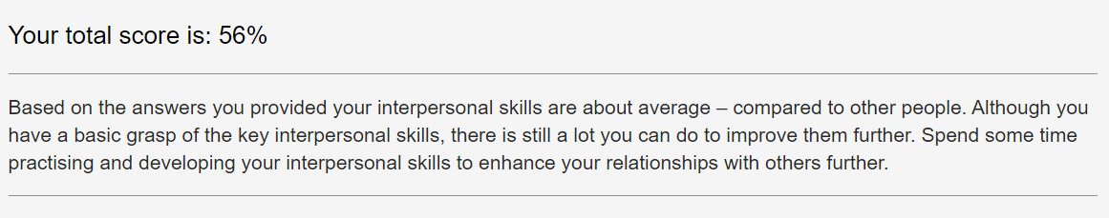
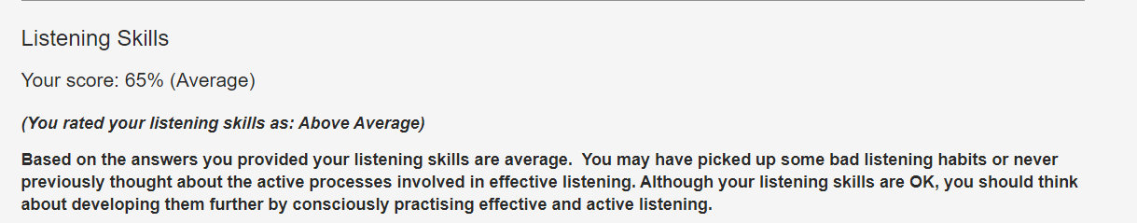
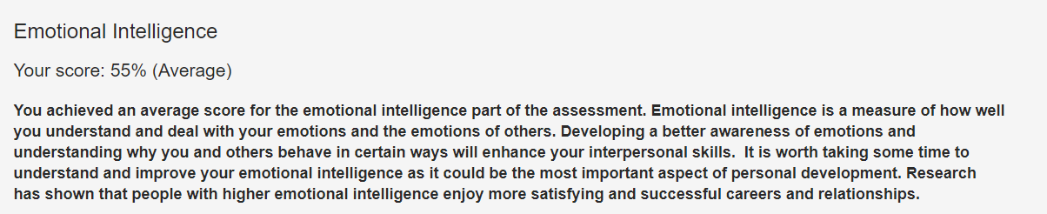
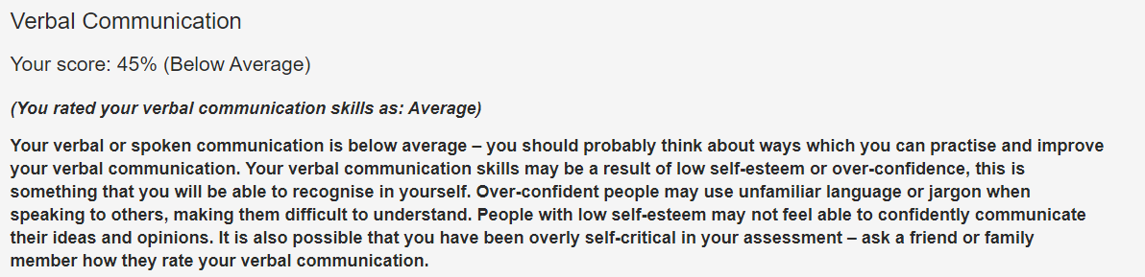
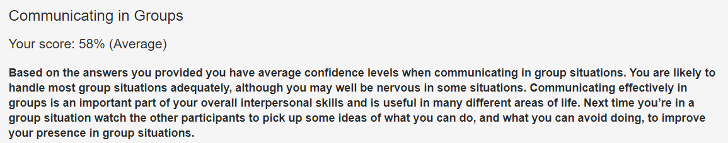

Mind Tools Communication Quiz




