

Assessment: Individual Report – TESCO PLC

Strategic Analysis and Evaluation of Tesco PLC: An Application of Strategic Management Frameworks

Module Name: Programme Name: Master of Business Administration
Module Name: Strategic Management
Module code: LCMB7003
Lecturer’s Name: Dr Hoang Dang Nguyen
Student Name : Md Sohidul Islam
Student ID : 2504070
Group : 03 ,Term 2
Word Count : 5097
Submission Date : 01st May 2026

AI Acknowledgement

I acknowledge the use of ChatGPT (https://chatgpt.com/) on 21 March 2026 to write my
notes into submission format using the prompt(s):
1. Please give me recent statistical data about BP at the university level.

I acknowledge the use of Grammarly (https://www.grammarly.com/) on 29 April
2026 to check my work using the prompt(s):
1. Please check the following text for readability, grammar and syntax.

I confirm that I have not presented any AI-generated text as my own work. I confirm I
have copies of my drafts, notes, and other resources I used before and after the use of
AI tools which I may be asked to provide in evidence.

Table of Contents
Introduction and Organisational Overview 3
Company Background 3
Mission, Vision and Business Model 4
Industry Context 4
External and Internal Environment Analysis 5
Macro Environment Analysis (PESTEL) 5
Political Factors 5
Economic Factors 5
Social Factors 6
Technological Factors 6
Environmental Factors 6
Legal Factors 7
Value Chain Analysis of External Strategic Factors 7
Internal Analysis: Resources and Capabilities 9
Tangible Resources 9
Intangible Resources 9
Organisational Capabilities 9
VRIO Analysis 10
CSR and Sustainability Strategy 11
Environmental Strategy 11
Social Initiatives 12
Governance and Ethical Supply Chain 12
Balanced Scorecard Analysis 12
Financial Perspective 12
Customer Perspective 13
Internal Process Perspective 13
Learning and Growth Perspective 14
Strategic Choices and Implementation 14
Business-Level Strategy Evaluation 14
Corporate-Level Strategy Evaluation 14
Recommended Strategic Choice 15
Change Management and Strategic Implementation 15
Strategic Evaluation and Recommendations 15
SWOT Analysis Linked to PESTEL 15
Critical Evaluation of Current Strategy 16
Strategic Recommendations 16
Reflective Account Using Gibbs Reflective Cycle 17
Description 18
Feelings 18
Evaluation 19
Analysis 19
Conclusion 20
Action Plan 20
Conclusion 21
Reference 22

Introduction and Organisational Overview

Company Background
Tesco PLC is one of the largest retail organisations in the United Kingdom and is one of the leading grocery retailers in Europe. The company was formed in 1919 by Jack Cohen, and it has grown into a multinational retailer with thousands of branches spread out across a number of countries (Tesco Plc, 2024).
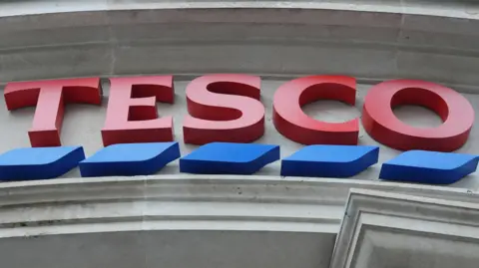
Figure 1: TESCO PLC (Tesco Plc, 2025)
In the UK, Tesco has the biggest market share in the grocery sector and at any given time, it accounts for around 27-28% of all supermarket sales as per industry reports (Tesco Plc, 2025). This dominant position represents the ability of the firm to combine large-scale operations with the participation of customers in the market. Tesco operates through different segments of business, such as food retail, convenience stores, online retail of groceries and financial services through Tesco Bank. The company also has large logistics and distribution networks that are necessary to support its network of stores all over the country (Tesco Plc, 2025). From a strategic point of view, it is the scale, operational efficiency and the use of data in the retail model that allow Tesco to compete well in a very competitive supermarket industry. However, due to its vast organisational scale, it needs to constantly strategically adapt itself to technological changes, consumer expectations and price pressures in the retail environment.

Mission, Vision and Business Model
Tesco's strategic direction is influenced by its basic mission: "Serving customers a little better every day” (Tesco Plc, 2024). This statement represents a customer-centric philosophy near the values of convenience and quality of service. The firm's business model is a combination of supermarkets, convenience stores, online retail platforms, and loyalty programmes such as the Clubcard scheme, which enable the firm to collect valuable customer data to provide better personalised marketing strategies (Reuters, 2026). This combined model of retailing allows Tesco to offer competitive pricing and still retain customer loyalty and brand trust.

Industry Context
The UK grocery retailing industry is very competitive. Major competitors include Sainsbury's, Asda, Aldi, Lidl and Morrisons, who compete in a market where profit margins are low, and price competition is high. Discount retailers such as Aldi and Lidl have secured significant market share in the past couple of years, so it's fierce competition (Tesco Plc, 2025). In addition, consumers have low switching costs, which means that they can easily switch between retailers in search of lower prices. As a result, firms need to keep continuously enhancing their operational efficiency and strategic placement in order to keep up with the competition in the sector.

External and Internal Environment Analysis

Macro Environment Analysis (PESTEL)
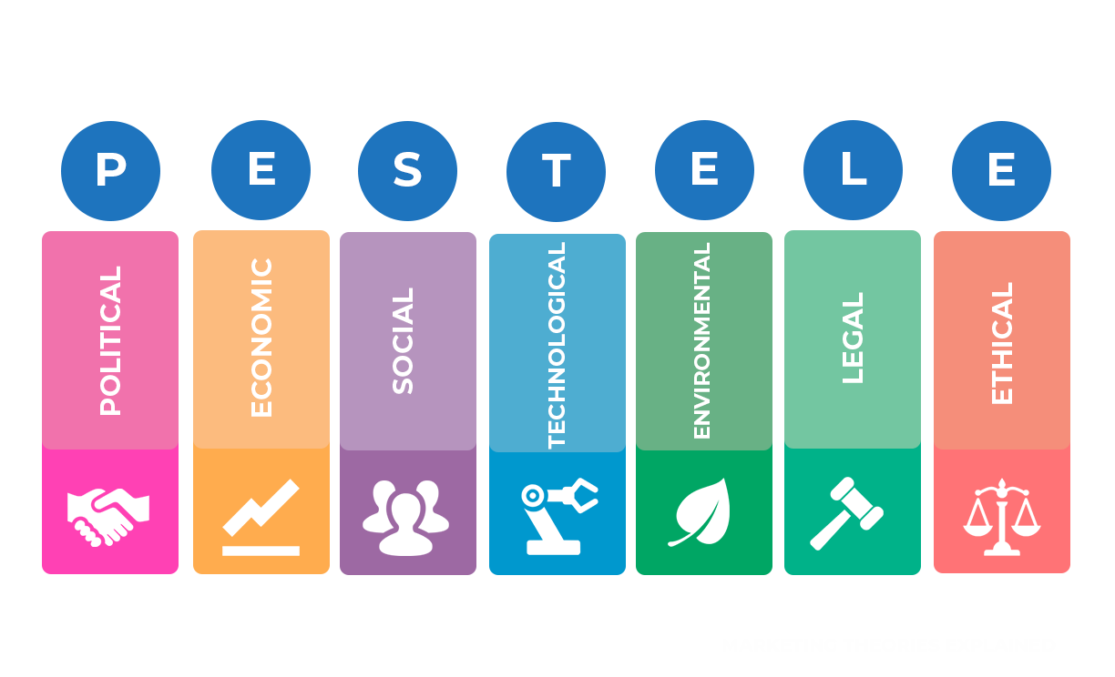
Figure 2: PESTEL Analysis (Gouldson and Sullivan, 2014)

Political Factors
Tesco works in a politically sensitive food market where regulation and trade policy impact cost, sourcing and availability. UK food rules on safety, labelling and traceability place greater demands for compliance across Tesco's supply chain. Brexit has contributed to the friction with customs checks and paperwork for the movement of food across the border (Baird et al., 2024). That's important as the UK is still structurally dependent on trade, but Tesco also sources overseas. In response, Tesco has tried to reduce exposure by deepening domestic sourcing, according to its reporting on its 2025 sustainability, which says that nearly 95% of Tesco's total product spending is with UK-based suppliers. Politically, this is not only a sourcing decision, but a resilience strategy as well in case of a disruption (Tesco Plc, 2025).

Economic Factors
Economic pressure has caused value to be the core of Tesco's strategy. UK grocery inflation was reported to be 4.3% as of March 2026, following a protracted period of cost-of-living squeeze, which has left real consumer purchasing power lower and price sensitivity higher (Tesco Plc, 2025). In such conditions, shoppers are more aggressive in their price comparison and change their retailer with ease. Tesco's strategic response has been to enhance its cost leadership through price matching, scale efficiencies and increased control over the supply chain. This is commercially important as Tesco's market share has reached 28.7% in the 12 weeks to 22nd February 2026 and demonstrates the power of value positioning in generating economic pressure converted into share gains if successfully implemented (Tesco Plc, 2025).

Social Factors
Social change is impacting the structure of Tesco's demand. Consumers are more demanding about convenience and healthy products as well as flexible shopping channels. This is the support of Tesco's multi-format model of convenience stores and digital services, complementing larger supermarkets (Gouldson and Sullivan, 2014). Health is also important from a strategic perspective, as affordable and healthy food is part of Tesco's customer promise as stipulated in its annual reporting. At the same time, there is still a material online demand. Reuters reported that Tesco's online retail sales grew 11.2% year on year, helped by the rapid expansion of deliveries (Tesco Plc, 2025). Whoosh is now operating from 1600 stores and is reaching over 70% of the UK's population. Social trends therefore favour retailers that move beside each other, in combination of access, speed and relevance.

Technological Factors
Technology has improved the competitiveness of Tesco as it has made the business more efficient and developed a better understanding of its customers. Digital retail platforms make it easier to grow online, and automation makes the fulfilment and logistics more precise (Baird et al., 2024). More importantly, customer data analytics can enable Tesco to better personalise offers and manage demand. Technology is therefore both a strategy of differentiation and cost efficiency, and is strategically central rather than operationally optional.

Environmental Factors
Environmental sustainability is a strategically increasing issue in the retail sector. The UK Government has committed to becoming net-zero carbon by 2050, and this places pressure on businesses to restrict the impact on the environment. Tesco has responded by setting ambitious sustainability targets with a number of objectives, including reducing greenhouse gas emissions and increasing energy efficiency in its stores and distribution centres (de Waal, van Nierop and Sloot, 2017). The company has also initiated efforts towards the reduction of plastic waste and the use of more recyclable packaging. These environmental strategies not only meet the regulatory expectations, but are also a way to ensure positive brand reputation among the environmentally conscious consumer.

Legal Factors
The legal environment also determines the decisions of how Tesco operates. Employment legislation, minimum wage and worker protection laws have an impact on labour costs throughout the retail industry. In addition, the UK competition law ensures the regulation of the behaviour of markets and prevents anti-competitive behaviour by major supermarket chains (Fatricia, 2017). Compliance with these legal frameworks necessitates that Tesco has transparent pricing policies and fair relations with the suppliers. Consequently, the legal environment embraces the relevance of responsible corporate governance and ethical business practices with the overall strategic approach in Tesco's business.

Value Chain Analysis of External Strategic Factors
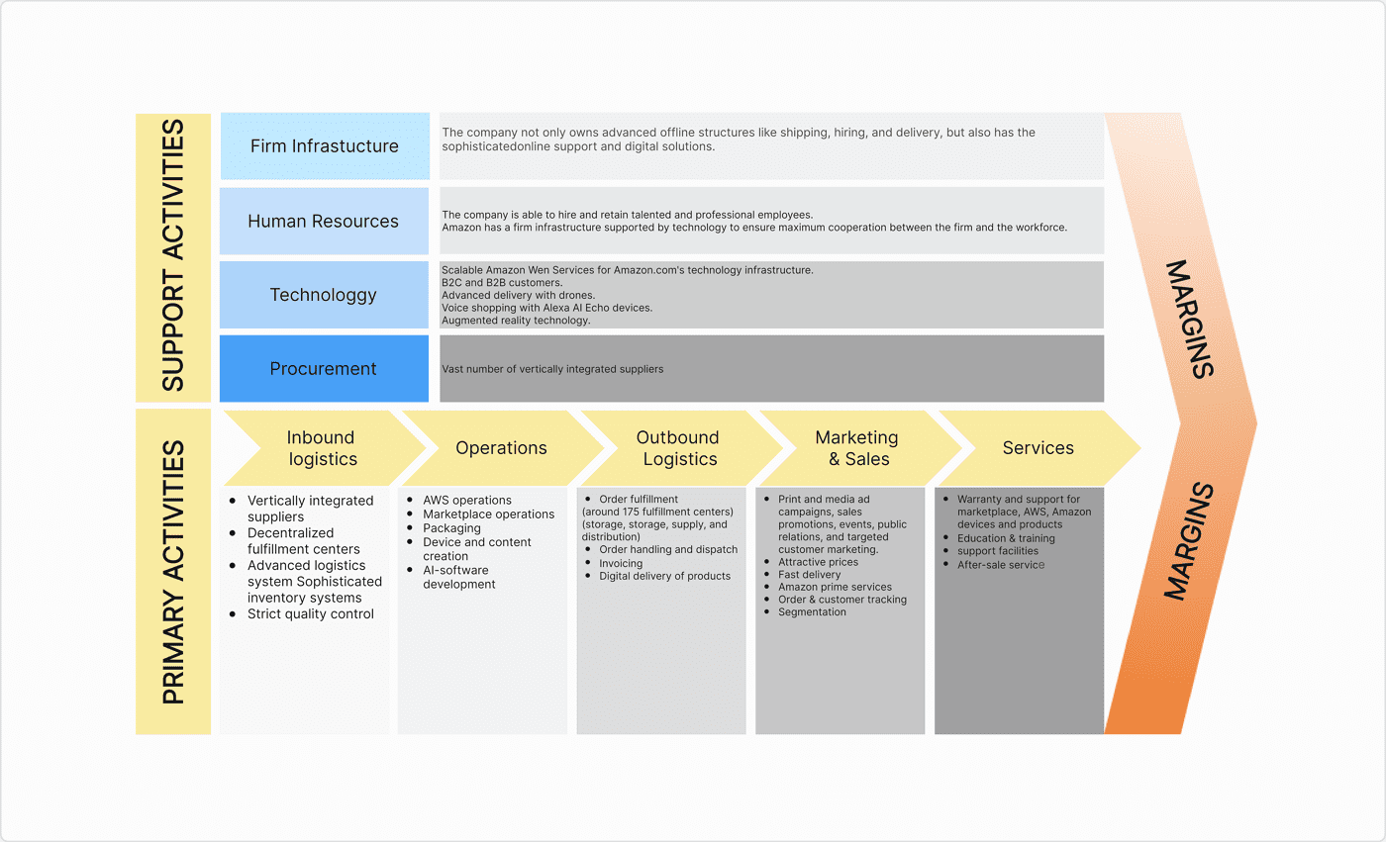
Figure 3: Value Chain Framework (Mudambi and Puck, 2016)

The value chain of Tesco provides insights into how PESTLE factors (political, economic, social, technological, legal and environmental) influence its critical success factors (CSFs) and challenges. Politically, food (and trade) standards, as well as sourcing with post-Brexit implications, affect inbound logistics (Mudambi and Puck, 2016). One CSF is how Tesco can provide a compliant and robust supply chain by building partnerships with local suppliers. However, high administration costs and supply chain constraints due to regulatory conditions presents a challenge; therefore, Tesco must be adaptive to sourcing.
Economically, Tesco has been impacted by rising inflation and cost of living and these in turn are impacting its supply chain and market strategies (Olarewaju et al., 2024). A critical factor for success is a low cost strategy (including procurement, transportation and store operation) to enable Tesco's low price strategy. But another CSF is margin, as Tesco needs to offer low prices while benefiting from economies of scale and economies of scope in a very low margin and highly competitive market.
Social determinants are crucial to Tesco's marketing, sales and services. The changing consumer needs for convenience, healthy living and digital experiences is a CSF for Tesco to have an omnichannel strategy (Tesco Plc, 2024). This includes its websites and next-day delivery. But it has challenges of adapting to consumer expectations and consistent service quality, online and offline.
Value chains are affected in many ways, particularly in its operations and marketing. An important CSF is Tesco investing in data analytics and IT to optimise operations and better understand and serve their customers, such as Clubcard (Mudambi and Puck, 2016). But using IT carries the risk of not maintaining its technological competitiveness.
Procurement and operations are becoming more important. A CSF is Tesco's ability to introduce sustainable innovations, such as reducing emissions and packaging. This enhances brand image. But it also affects costs and complexity, a big challenge (Mudambi and Puck, 2016). Legally, labour and competition law in human resources and procurement are important. Good governance and ethics are another success factor. The challenges here are due to rising labour and other costs from compliance. To succeed, Tesco must align value chain activities to the external environment, while dealing with issues of cost, innovation and sustainability.

Internal Analysis: Resources and Capabilities

Tangible Resources
Tesco has great tangible resources to have a competitive position in the UK grocery market. The company has over 3,700 stores across the United Kingdom and a vast distribution and logistics infrastructure (de Waal, van Nierop and Sloot, 2017). This huge retail network allows Tesco to enjoy economies of scale in the procurement, transportation and inventories. In addition, the benefit of having good financial resources is that the firm is able to invest continuously in technology, improvement of digital platforms and improvements in the supply chain. These assets enable operational stability as well as being able to react quickly to changes in the market for Tesco.

Intangible Resources
Tesco's intangible resources are also a vital strategic resource. The Tesco brand continues to be one of the most recognised retail brands in the UK, and this helps to reinforce the consumer's trust and loyalty (Baird et al., 2024). The company's Clubcard loyalty programme, which has more than 20 million members, generates a wealth of customer data. This data enables Tesco to personalise promotions, to improve the offer of products and to strengthen long-term customer relationships.

Organisational Capabilities
Tesco's capabilities lie in the Supply chain efficiency, data-driven decision making and omnichannel retail integration (Gouldson and Sullivan, 2014). These capabilities improve the cost management and the quality of service. As a result, Tesco can effectively compete against discount retailers and operate with loyalty and resilience.

VRIO Analysis
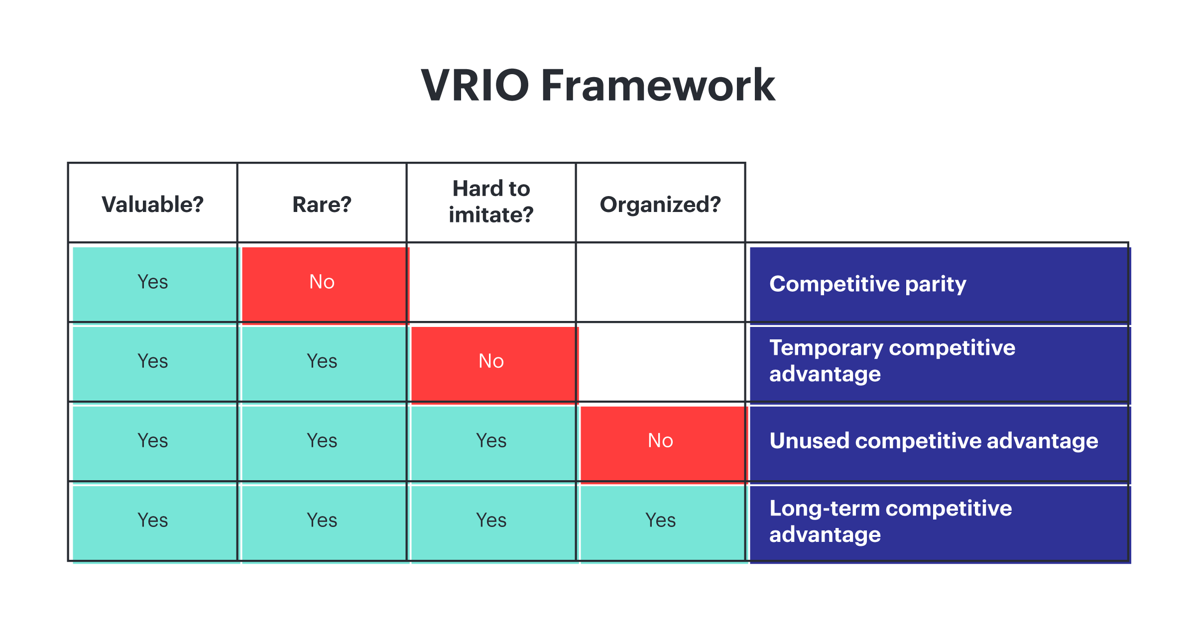
Figure 4: VRIO Framework (Fatricia, 2017)
Resource/Capability | Valuable? | Rare? | Imitable? | Organised to Exploit? | Advantage
Extensive UK store network | Yes | Yes | No | Yes | Temporary competitive advantage
Clubcard data ecosystem | Yes | Yes | Yes | Yes | Sustained competitive advantage
Advanced logistics and supply chain | Yes | Moderately | No | Yes | Temporary competitive advantage
Strong brand reputation and customer loyalty | Yes | Yes | Moderately | Yes | Competitive advantage
Table 1: VRIO Framework for Tesco PLC (Self-made)
The VRIO framework is used to judge whether the organisational resources are able to create sustained competitive advantage. Tesco has many valuable and strategic capabilities to help it to lead the UK grocery market. One of its core resources is its extensive chain of stores in the UK, comprising more than 3700 retail outlets, at a variety of formats (Hasan et al., 2023). This allows more convenience and targeting. However, this resource can be easily imitated by the other big retailers who can build similar store networks. The other resource is Tesco's database, containing over 20 million Clubcard customers. This resource allows Tesco to track shoppers' behaviour and to provide tailor-made offers to customers (Gouldson and Sullivan, 2014). This resource is difficult to replicate due to the quality and quantity of the data gathered in the past years. Hence, this creates a competitive advantage. Tesco's advanced logistics and supply chain infrastructure also helps to improve cost efficiency and the availability of products in stores. In addition, the great brand name and customer trust help establish customer loyalty and support the firm's competitive status in the UK supermarket industry.

CSR and Sustainability Strategy

Environmental Strategy
Environmental sustainability has become an integral part of Tesco's overall business strategy. The company has committed to making its operations net zero carbon by 2035. This target reflects the growing Government regulations and the rising customer and stakeholder expectations in the UK retail sector (Hasan et al., 2021). Tesco has already taken enormous steps to reduce its operational greenhouse gas emissions by over 60% compared with 2015 levels (Gouldson and Sullivan, 2014). This reduction has been achieved mainly by the use of renewable electricity and improved energy efficiency in shops and distribution centres. Tesco has also introduced several initiatives to minimise plastic waste and to improve sustainable packaging. The company wants to ensure that the packaging for use with its own brand products is either recyclable or reusable. These actions show that sustainability is not only a corporate responsibility initiative but an important part of Tesco's long-term business strategy and day-to-day operations.

Social Initiatives
Tesco is also keen on social responsibility, with initiatives on food waste and the welfare of the community. The company has made a commitment to reduce food waste throughout its operations and food supply chain. Through the Tesco Community Food Connection programme, undistributed food from the stores is redistributed to charities and local organisations (Önören, Arar and Yurdakul, 2017). Since the introduction of the programme, millions of meals have been donated to communities across the UK. Tesco have also established its own targets in line with global targets towards sustainability, like this target to halve food waste by 2025. These initiatives develop better relationships with the community and their resources in Tesco, whilst also achieving resource efficiency in their day-to-day activities.

Governance and Ethical Supply Chain
Strong governance practices that support Tesco's sustainability agenda: The company emphasises ethical sourcing, responsible supplier relationships and transparent supply chain management (de Waal, van Nierop and Sloot, 2017). Tesco works with suppliers to help them to meet standards of compliance from labour to environmental standards in global sourcing networks. Sustainability initiatives are, therefore, not only about regulatory compliance. They help to improve corporate reputation, to underpin consumer trust and support Tesco's long-term competitive positioning in the retail sector.

Balanced Scorecard Analysis
The Balanced Scorecard framework is a multidimensional view of assessing organisational strategy. Rather than only the focus on financial performance, the model considers the contribution of customer value, internal operations and organisational learning in long-term competitiveness (Castro and Moreira, 2023). In Tesco's case, the framework highlights the manner in which the firm integrates cost leadership, customer engagement and operational efficiency to maintain its market leadership in the UK grocery retail sector.

Financial Perspective
The financial perspective is the analysis of whether or not Tesco's strategic initiatives lead to enhanced economic performance. The most important goals are revenue growth and operating cost efficiency. Tesco has revenues of around PS68 billion in 2023/24 as a group, which is reflective of the company's good standing within the UK grocery market (Bouguerra et al., 2023). However, the profit margins in supermarket retail trades are often relatively low, at between 3% and 4%. As a result, operational efficiency is of strategic importance in its maintenance (Bouguerra et al., 2023). Tesco focus on improving the efficiency in procurement, lowering the cost of procurement and increasing the volume of sales through competitive pricing strategies. Key performance indicators include profit margin, sales and operating profits growth on a year-to-year basis. These indicators are used to judge whether the pricing strategies and cost control mechanisms that are in place with Tesco are proving to be effective in maintaining profitability in a very competitive market environment.

Customer Perspective
The customer perspective is concerned with the development of long-term loyalty and trust of the consumers. Tesco's strategic objective is to develop customer relationships and maintain value for money. The Clubcard loyalty programme, which has over 20 million members, is at the centre of this strategy. Customer data collected through the programme is used in Tesco to provide personalised promotions and targeted offers (Bouguerra et al., 2023). This approach to the data is much more likely to lead to increased customer retention and increased repeat purchasing behaviour. In addition, Tesco monitors customer satisfaction levels and service quality in the physical stores and online. These metrics are useful in determining if Tesco is really effective in maintaining the trust of its brand and engagement of its consumers in a very competitive retail environment.

Internal Process Perspective
The internal process perspective focuses on the efficiency of the operation of the operational activities of Tesco. Strategic objectives include improving the efficiency of the supply chain and developing our digital retail capabilities. Tesco has a very integrated distribution system for thousands of stores throughout the UK (Aithal, 2017). Efficient inventory management and rapid inventory replenishment help reduce operational costs and minimise shortfalls in products. Key indicators in this context are inventory turnover rates and online delivery performance. The growth and development of Tesco's online grocery platform has meant that logistics optimisation and fulfilment efficiency are increasingly important.

Learning and Growth Perspective
The learning and growth perspective is concerned with innovation and workforce development. Tesco invests in employee training programmes and digital skills development to support the transformation in the use of technology (de Waal, van Nierop and Sloot, 2017). Enhanced digital capability enables Tesco to better use data analytics, automation and customer engagement systems.

Strategic Choices and Implementation

Business-Level Strategy Evaluation
Tesco's strategy to compete in the UK grocery retail market is a cost leadership with some differentiation. High price, consumer power and economic pressure in the external environment make the cost leadership strategy desirable (Castro and Moreira, 2023). Tesco leverages the economies of scale, supply chain and power of buying for cost savings and low pricing. This is aided by price-matching discounters and increasing private labels.
But cost leadership has its risks. Price wars erode profits and create risks of price wars. Thus, Tesco uses some aspects of differentiation such as premium products, branding and personalisation via its loyalty card. This allows Tesco to maintain value for customers and dodge de-commoditisation (Dabic and Kiessling, 2019). As for its strategy, cost leadership is still relevant. This is because in the current global economic climate, with inflation and a subsequent decline in customer purchasing power, consumers are very sensitive to prices. Lower prices help to attract and retain customers and increase market share. But differentiation should be preceded by cost leadership, not the other way around.

Corporate-Level Strategy Evaluation
Tesco's corporate-level strategy has to do with related diversification and incremental growth. It is engaged in banking, convenience stores and the internet. This allows cross-selling, based on branding and customer data, through its distribution (Dabic and Kiessling, 2019). Tesco's foray into online grocery and fast delivery is socially driven. The Internet is critical to growth as convenience and speed become important. Similarly, new store sizes permit Tesco to meet urban demand and offer convenience.
But there are risks when expanding. Serving various segments draws resource allocation and coordination. Past experiences of Tesco's overseas expansions warn us of the perils of overstretching (Franco, 2021). As such, the company is concentrating on its main business and, particularly, in the UK, where it is still ahead of the competition.

Recommended Strategic Choice
Consideration of cost leadership combined with high-tech differentiation is a good strategy. Cost leadership is consistent with the environment and competitors. Automation and analytical processes, as well as supply chain management, will reduce costs and increase efficiency (Franco, 2021). The company should diversify in terms of digital transformation and related diversification, not aggressive expansion. Online operations and implementation of data analytics will lead to competitiveness and engagement.

Change Management and Strategic Implementation
Change management at Tesco has been quite good, particularly since its earlier problems. It has engaged in reorganisation, improved governance and embraced digital technologies. This has enabled it to be more efficient and gain trust from stakeholders.
Technology has informed the delivery of its strategy, such as logistics and customer service. Tesco's digital push in its operations and customer delivery is a response to social and technological developments. And sustainability is there for the environment. However, challenges remain. The management of large organisations may not be as responsive as needed. Changes in thousands of stores and supply chains are problematic. And there are tensions with cost efficiency in relation to sustainability. Finally, change management has worked for Tesco, but it needs to be flexible, quick in innovation and ensure the capacity of the organisation matches changes in the environment.

Strategic Evaluation and Recommendations

SWOT Analysis Linked to PESTEL
The strengths of Tesco are linked with economic and technological factors in PESTEL. It is strong in economies of scale, branding and technology for data management (Castro and Moreira, 2023). Economic factors on efficiencies translate to cost reduction and efficiencies, while technology manages customer relations and efficiencies.
Weaknesses reflect internal constraints shaped by external pressures. Margins are low as a consequence of economic considerations (Castro and Moreira, 2023). Doing business in the UK affects sales. Also, the size of the business increases costs, decreasing flexibility.
Opportunities generally arise in social, technology and environment. The rise of online shopping. Consumers' preference for "green" products provides an advantage (Castro and Moreira, 2023). Big data and automation have promise for efficiency and personalisation.
Macroeconomic, market and regulatory factors pose challenges. Price pressures exist due to competition with discounters (Castro and Moreira, 2023). Cost inflation and rising costs reduce profits. Rise in regulatory expenses and requirements.

Critical Evaluation of Current Strategy
Tesco's strategy is a good fit with the environment. Low-cost strategy matches economic factors and high buyer power, and online capabilities match technological and social factors. Environmental recognises environmental pressures (Dawes, 2020). But there are challenges. Too much emphasis on cost leadership could be unprofitable, particularly in a cost-focused industry. Competitors may also follow suit on pricing. And in the rapidly changing world of technology, investment is required, which may drain resources.

Strategic Recommendations
First, Tesco must invest in technology and information. Using big data and artificial intelligence (AI) for forecasting, inventory management and marketing. This leads to improved productivity and so cost and differentiation (Franco, 2021). Second, Tesco needs to build a stronger supply chain. Local sourcing and multiple sourcing can reduce the political and economic risk. It can solve the issues of PESTEL in regulatory and global conditions. Third, Tesco should support sustainability (Hasan et al., 2021). Packaging and transport can boost their branding. And green marketing can help meet the desired customer engagement. But it's also a chance to expand due to the growing demand for green products (Baird et al., 2024). Finally, Tesco should focus on value differentiation. While continuing to offer low prices, Tesco should offer more services, innovation and loyalty cards. This reduces the need to discount.
Lastly, Tesco should be responsive. This can be done by being market-responsive. This is essential in the dynamic world of technology and society-altered retailing markets. The above methods are consistent with the most up-to-date strategic management, which deploys both external and internal resources (Mudambi and Puck, 2016). This will enhance Tesco's sustainability and performance through the competitive advantage of indoor efficiency, innovation and sustainability.

Reflective Account Using Gibbs Reflective Cycle
Reflective practice is an important process in postgraduate learning because it enables students to scrutinise their learning experience critically and to improve their analytical and research skills. Gibbs' reflective cycle is a structured framework which has six stages: description, feelings, evaluation, analysis, conclusion and action plan (Nurlatifah, Purnawarman and Sukyadi, 2023). This reflective account is an evaluation of the process followed while researching, analysing and preparing the strategic management report on Tesco PLC. The reflection demonstrates the way the academic research, critical thinking and the application of theory were developed throughout the process of completing the assignment.
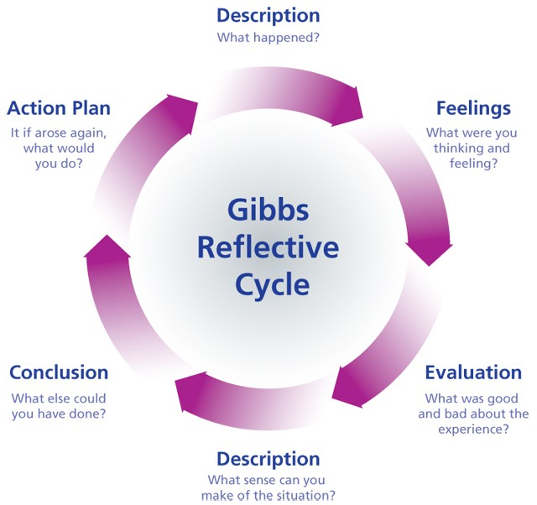
Figure 7: Gibbs Reflective Cycle (Nurlatifah, Purnawarman and Sukyadi, 2023)

Description
This assignment required using strategic management concepts to develop an understanding of Tesco PLC and its approach in the UK grocery market. The report looked at an external and internal analysis using the PESTEL, Value Chain and VRIO frameworks, and performance assessment using the Balanced Scorecard. The purpose of the report was to assess the effectiveness of how Tesco dealt with environmental factors, including inflation, technology and sustainability, to achieve a competitive advantage (Nurlatifah, Purnawarman and Sukyadi, 2023). My strategy undertook a literature review of journals, industry reports and Tesco reports. This was analysed to identify prominent themes regarding Tesco's strategy, such as cost leadership, digitalisation and optimisation of supply chain and sustainability. The comments on the assignment were lengthy because of a focus on theory-practice integration in terms of the influence of external PESTEL factors on Tesco's value chain activities and its critical success factors. This includes a structured type of analysis to ensure consistency between analysis models so that the analysis doesn't get fragmented.

Feelings
At first, I was well-acquainted with strategies of strategic management. However, it became more complex to apply data to an organisation using it. I couldn't say I struggled greatly with the theories; rather, understanding how to apply different situations to these theories and then use that to effectively plan for the company (Trimasse, 2025). I found it difficult to write descriptively. For example, while I was able to detail the external factors of economic change or technology but not address how these factors impacted the Tesco value chain. This left some uncertainty as to whether my research was up to the postgraduate expectation (Trimasse, 2025). However, over time, I became more confident in being able to make a link between theory and practice and a causal linkage of the impact and effects of external factors.
The real companies' data also increased my confidence and determination. I also began to recognise that strategies are implemented and practices are used, rather than just being taught. This allowed me to develop my skills to think more strategically and feel more confident about the use of strategic principles.

Evaluation
This report assisted in building my capability in this area. A strength of my assignment was to use various conceptual frameworks to logically examine Tesco's strategy. The PESTEL analysis helped to determine pressures, and the Value Chain analysis helped to assess the impact of pressures on internal processes and critical success factors. This enabled the analysis to be more detailed (Potter, 2015). The other major strength was the inclusion of current information. The inclusion of information regarding inflation, consumer trends and the rise of the digital economy helped to bring the environment to life and make the connection between business theory and practice. This helped to make the report more valid and show knowledge of theory.
But there was room to improve. There was also some descriptive rather than critical analysis. For example, while analysing Tesco's low-cost strategy, I sometimes didn’t evaluate the potential risks and limitations for the future (Potter, 2015). Lastly, there was a difficulty in sourcing recent information as it required synthesising and analysing the information from different sources. Time management was another challenge (Potter, 2015). The strict nature of the assignment meant some parts of the assignment required more analysis; this excluded some discussion and critical analysis, but did mean the assignment was more focused

.

Analysis
This assignment recognised the need to use a number of strategic management theories to get a better understanding of strategy. This assignment highlighted that PESTEL factors aren't external but crucial to value chain activities. Economic influences such as inflation put a pressure on Tesco to pay attention to cost structure and efficient supply and internal processes. This drives the importance of synchronising activities to the environment (Trimasse, 2025). One lesson was the role of cost leadership in responding to economic and value-conscious shoppers. As seen with Tesco, low prices and cost efficiency are critical. However, our research showed that cost leadership is not the only success factor, as it leads to lower profit margins and possibly entry into new ventures. This suggests cost leadership needs to be complemented with technology and data-focused differentiation.
The VRIO analysis also emphasised the importance of intangible strategic resources. The Tesco loyalty card's use of data analytics is an example of how businesses can use data as a resource to create value by increasing customer engagement and loyalty (Trimasse, 2025). This confirms the VRIO framework that highlights the significance of the uniqueness of resources. The other takeaway was the emergence of sustainability. Sustainability (PESTEL) is an important factor for the activities and supply chain of Tesla. Sustainability improves brand awareness and regulatory compliance, but it also has cost and operational demands and requires strategic attention.

Conclusion
Overall, this whole exercise has helped me learn more about the application of theory to a real-world situation. It has helped me understand how the external environment is related to internal organisational processes and strategies. It has also enhanced my skill of critically analysing rather than describing strategies (Trimasse, 2025). Also, it helped me to enhance my research and communication skills. I realised the importance in using credible data to support any claims I make and the need to link them with the practical concerns. It was also a good lesson in becoming more critical in my analysis and time-management for my future assignments.

Action Plan
Objective | Specific Action | Measure | Timeframe
Improve academic sources | Use more peer-reviewed journal articles | Minimum 20 academic referencesper assignment | Next semester
Strengthen analytical writing | Practise applying strategic frameworks to companies | 2 analytical practice summaries per week | Next 8 weeks
Improve time management | Create assignment timeline before research | Weekly research and writing schedule | From next assignment
Enhance framework application | Apply PESTEL, VRIO and SWOT to different firms | Analyse 3 companies using these models | Within 2 months
Table 4: Action Plan of Gibbs Reflective Cycle (Self-made)

Conclusion
This report involved the strategic position of Tesco PLC with the utilisation of key strategic management frameworks. The analysis revealed that Tesco operate in a highly competitive UK grocery market, which is influenced by economic pressure, strong rivalry and changing consumer behaviour (Mudambi and Puck, 2016). External analysis identified the impact of inflation, technological change and sustainability expectations on the strategy of Tesco. Internal analysis demonstrated that Tesco's competitive advantage is supported by a great logistics infrastructure, brand reputation and customer data capability. The evaluation also found that Tesco is a combination of cost leadership, digital innovation and sustainability initiatives. Overall, Tesco's strategic flexibility will remain essential to its long-term competitiveness in the ever-changing retail landscape.

Reference
Aithal, P.S. (2017) A Critical Study on Various Frameworks Used to Analyse International Business and Its Environment, papers.ssrn.com. Rochester, NY. Available at: https://ssrn.com/abstract=3073051.
Baird, J., Preeti Dhuria, Payne, H., Crozier, S., Lawrence, W. and Vogel, C. (2024) ‘Implementation of a UK supermarket intervention to increase purchasing of fresh fruit and vegetables: process evaluation of the WRAPPED natural experiment’, International Journal of Behavioral Nutrition and Physical Activity, 21(1). Available at: https://doi.org/10.1186/s12966-024-01679-3.
Bouguerra, A., Hughes, M., Cakir, M.S. and Tatoglu, E. (2023) ‘Linking Entrepreneurial Orientation to Environmental Collaboration: A Stakeholder Theory and Evidence from Multinational Companies in an Emerging Market’, British Journal of Management, 34(1). Available at: https://doi.org/10.1111/1467-8551.12590.
Castro, R. and Moreira, A.C. (2023) ‘Mapping Internal Knowledge Transfers in Multinational Corporations’, Administrative Sciences, 13(1), p. 16. Available at: https://doi.org/10.3390/admsci13010016.
Dabic, M. and Kiessling, T. (2019) ‘The performance implications of knowledge management and strategic alignment of MNC subsidiaries’, Journal of Knowledge Management, 23(8). Available at: https://doi.org/10.1108/jkm-03-2019-0129.
Dawes, J. (2020) ‘The Ansoff Matrix: A Legendary Tool, But with Two Logical Problems’, SSRN Electronic Journal[Preprint]. Available at: http://dx.doi.org/10.2139/ssrn.3130530.
de Waal, A., van Nierop, E. and Sloot, L. (2017) ‘Analysing supermarket performance with the high-performance organisation framework’, International Journal of Retail & Distribution Management, 45(1), pp. 57–70. Available at: https://doi.org/10.1108/ijrdm-03-2016-0042.
Fatricia, R.S. (2017) ‘STRATEGIC ANALYSIS OF TESCO SUPERMARKET’, Jurnal Manajemen Terapan dan Keuangan, 6(2), pp. 69–86. Available at: https://doi.org/10.22437/jmk.v6i2.4046.
Franco, S. (2021) ‘The influence of the external and internal environments of multinational enterprises on the sustainability commitment of their subsidiaries: A cluster analysis’, Journal of Cleaner Production, 297, p. 126654. Available at: https://doi.org/10.1016/j.jclepro.2021.126654.
Gouldson, A. and Sullivan, R. (2014) ‘Understanding the Governance of Corporations: An Examination of the Factors Shaping UK Supermarket Strategies on Climate Change’, Environment and Planning A: Economy and Space, 46(12), pp. 2972–2990. Available at: https://doi.org/10.1068/a130134p.
Hasan, A., Bahadori-Jahromi, A., Mylona, A., Ferri, M. and Tahayori, H. (2021) ‘Investigating the Potential Impact of Future Climate Change on UK Supermarket Building Performance’, Sustainability, 13(1), p. 33. Available at: https://doi.org/10.3390/su13010033.
Hasan, A.U., Bahadori-Jahromi, A., Mylona, A. and Barthorpe, M. (2023) ‘A quantitative case study to assess the performance of UK supermarket buildings in relation to future climate change and modern construction techniques (MMCs)’, Engineering Future Sustainability, 1(1). Available at: https://doi.org/10.36828/efs.205.
Mudambi, R. and Puck, J. (2016) ‘A Global Value Chain Analysis of the “Regional Strategy” Perspective’, Journal of Management Studies, 53(6), pp. 1076–1093. Available at: https://doi.org/10.1111/joms.12189.
Nurlatifah, L., Purnawarman, P. and Sukyadi, D. (2023) ‘The implementation of reflective assessment using Gibbs’ reflective cycle in assessing students’ writing skill’, Nucleation and Atmospheric Aerosols, 2621(1). Available at: https://doi.org/10.1063/5.0143375.
Olarewaju, T., Dani, S., Obeng-Fosu, C., Olarewaju, T. and Jabbar, A. (2024) ‘The Impact of Climate Action on the Financial Performance of Food, Grocery, and Supermarket Retailers in the UK’, Sustainability, 16(5), pp. 1785–1785. Available at: https://doi.org/10.3390/su16051785.
Önören, M., Arar, T. and Yurdakul, G. (2017) ‘Developing Competitive Strategies Based on SWOT Analysis in Porter s Five Forces Model by DANP ’, Journal of Business Research - Turk, 9(2), pp. 511–528. Available at: https://doi.org/10.20491/isarder.2017.282.
Potter, C. (2015) ‘Leadership Development: an Applied Comparison of Gibbs’ Reflective Cycle and Scharmer’s Theory U’, Industrial and Commercial Training, 47(6), pp. 336–342. Available at: https://doi.org/10.1108/ICT-03-2015-0024.
Reuters (2026) ‘UK grocery inflation edges higher to 4.3%, says Worldpanel’, Reuters, 3 March. Available at: https://www.reuters.com/business/retail-consumer/uk-grocery-inflation-edges-higher-43-says-worldpanel-2026-03-03/ (Accessed: 16 March 2026).
Shaw, B. and Luiz, J.M. (2018) ‘The Impact of Distance (External) and Organizational Factors (Internal) on the Knowledge Chain of Multinational Corporations: South Africa as a Host Country’, Thunderbird International Business Review, 60(3), pp. 295–311. Available at: https://doi.org/10.1002/tie.21892.
Tesco Plc (2024) Our History, Tesco PLC. Tesco PLC. Available at: https://www.tescoplc.com/about/our-history (Accessed: 18 March 2026).
Tesco Plc (2025) Tesco PLC Annual Report and Financial Statements, https://www.tescoplc.com. Tesco Plc. Available at: https://www.tescoplc.com/media/ky0bfwpo/tesco_ar25_interactive.pdf (Accessed: 17 March 2026).
Trimasse, N. (2025) ‘The use of reflective reports in higher education’, Reflective Practice, 26(1), pp. 1–18. Available at: https://doi.org/10.1080/14623943.2024.2424520.

