Using one of the establishments visited how easy is it to gain a sense of what constitutes Welsh culture using St Fagans National Museum of History as an example?

- Iron age village and Medieval dining hall reconstructions
- Standards of living
3.1 Welsh identity in the modern era- Capel Celyn
3.2 Welsh Devolution in the modern era- Welsh Devolution

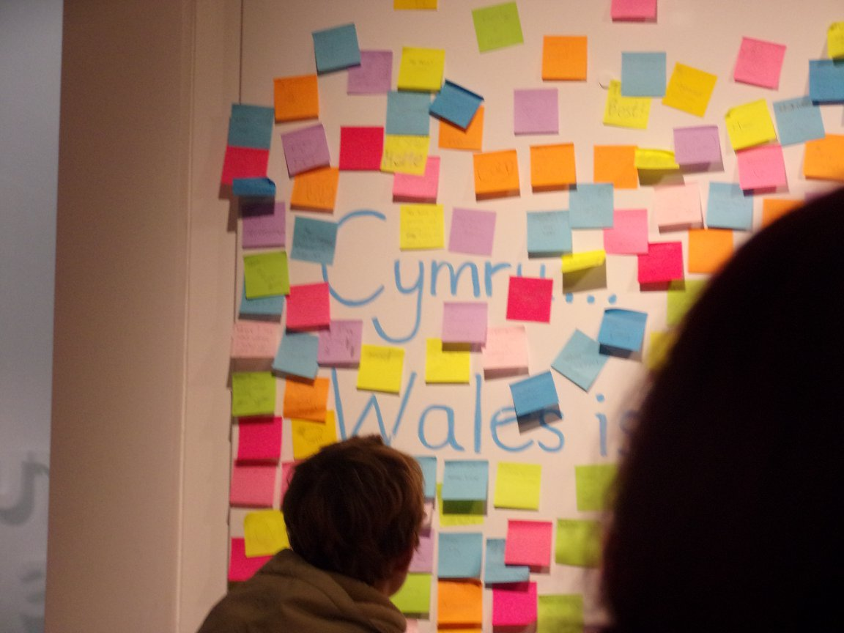
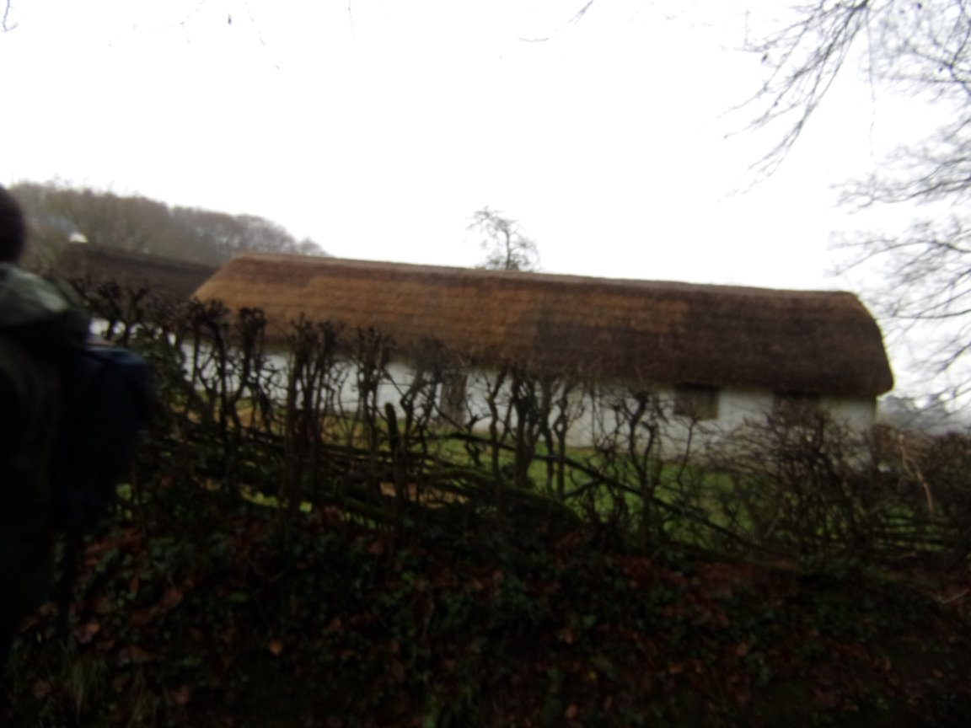
- Iron age village and medieval dining hall reconstructions
When visiting the Museum of St Fagans there were a number of reconstructions which were built using evidence from archaeological remains. This can be seen from the Medieval dining hall and the Iron Age village. These reconstructions allow us to experience the culture of Wales’ past through an immersive, hands on experience. The use of reconstructions allow visitors to gain a more sensory and memorable visit to the museum, for example the museum runs overnight stays for school children within the iron age village and medieval dining hall. This provides a more personal experience for the children which allows them to engage with cultural history.
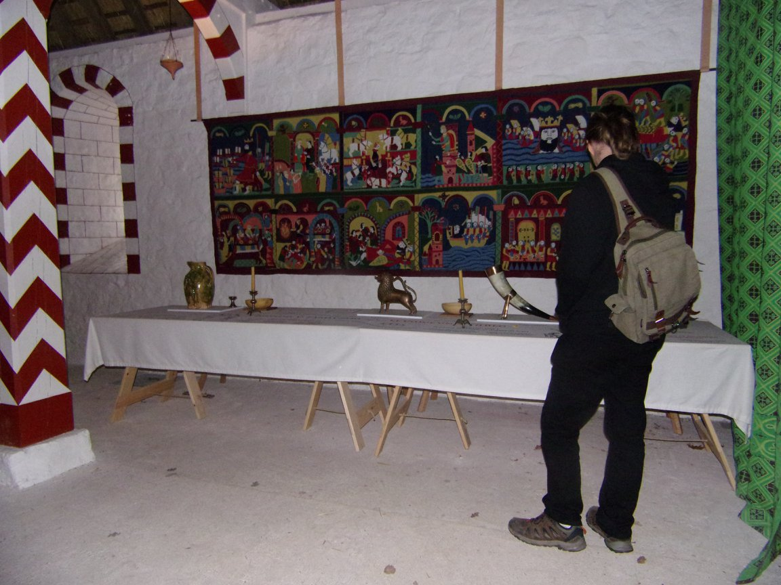
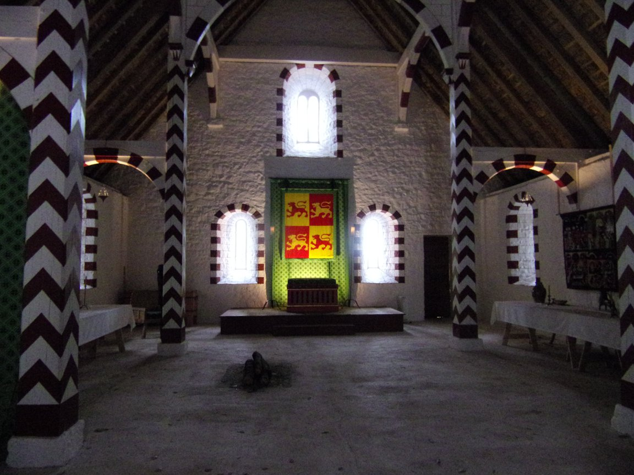

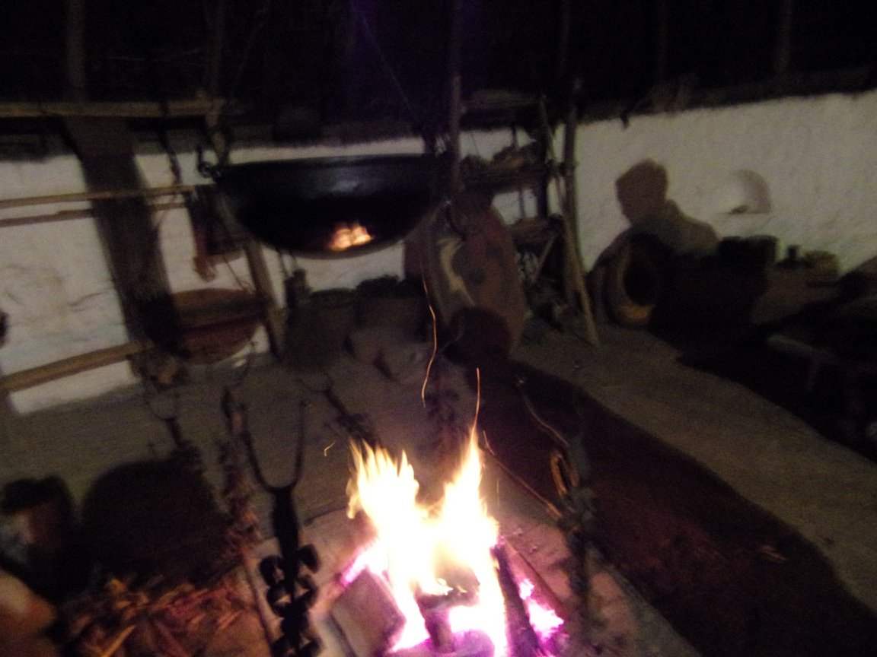
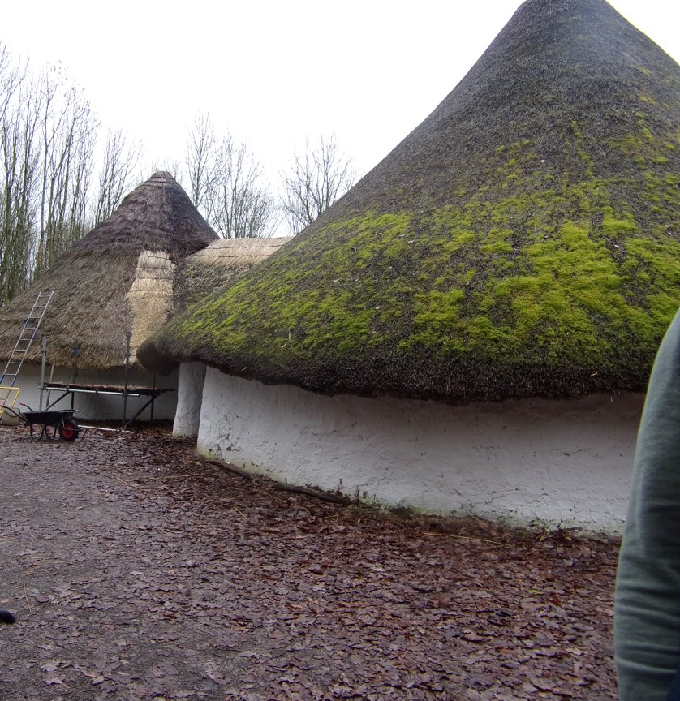
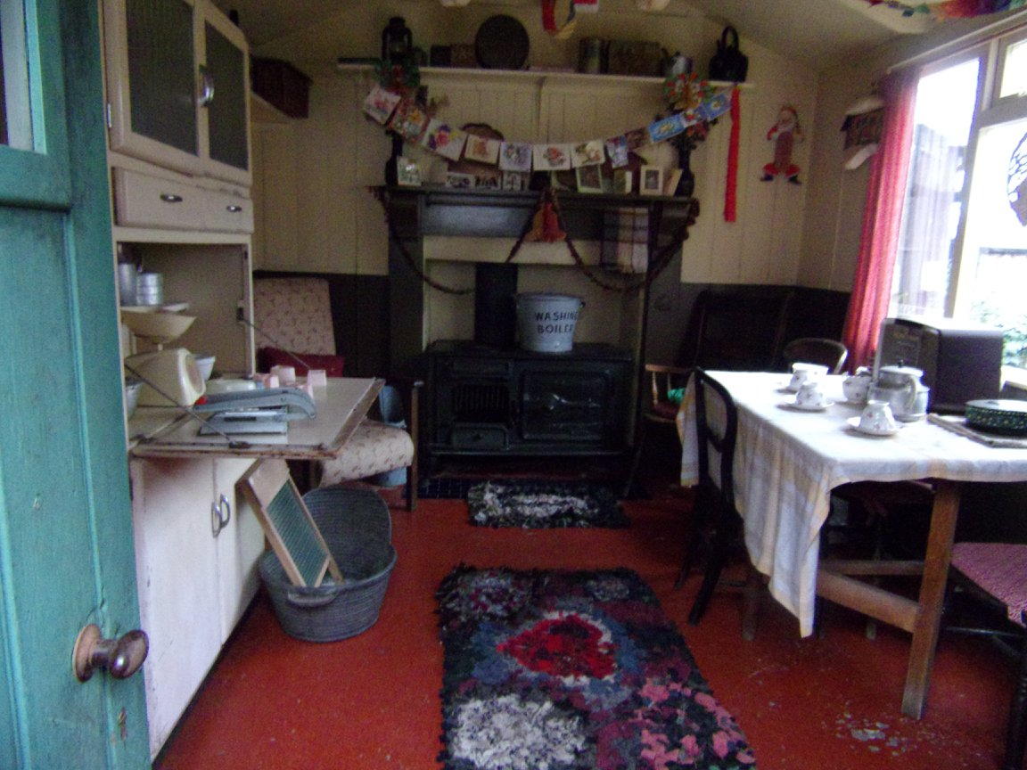
2. Standards of living
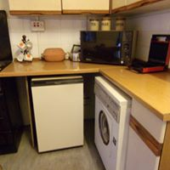
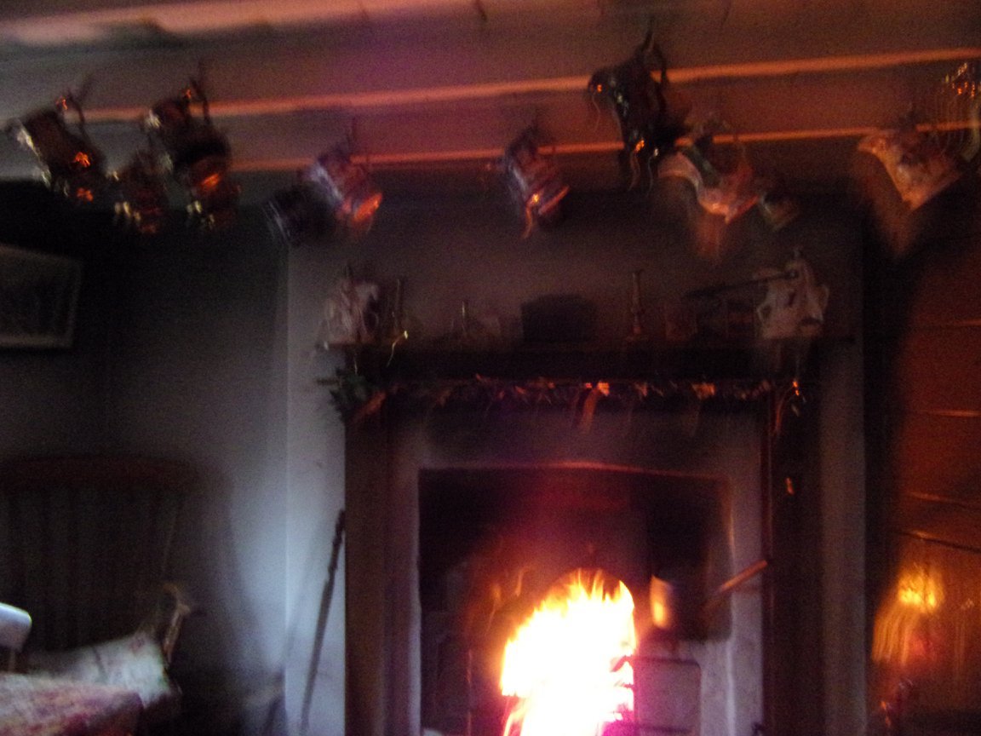
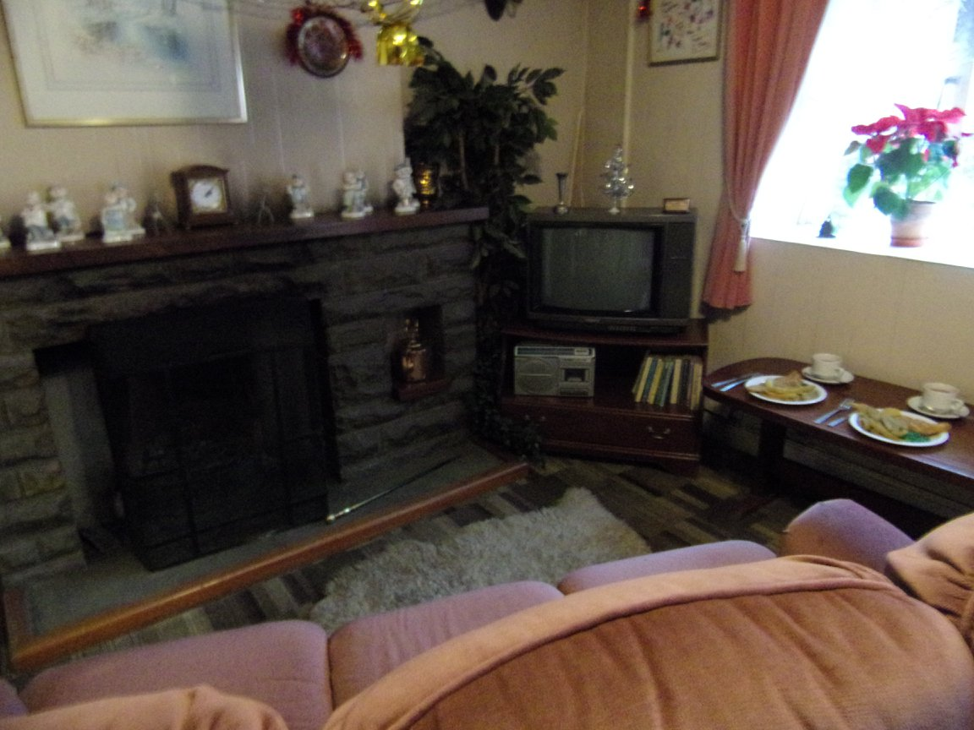
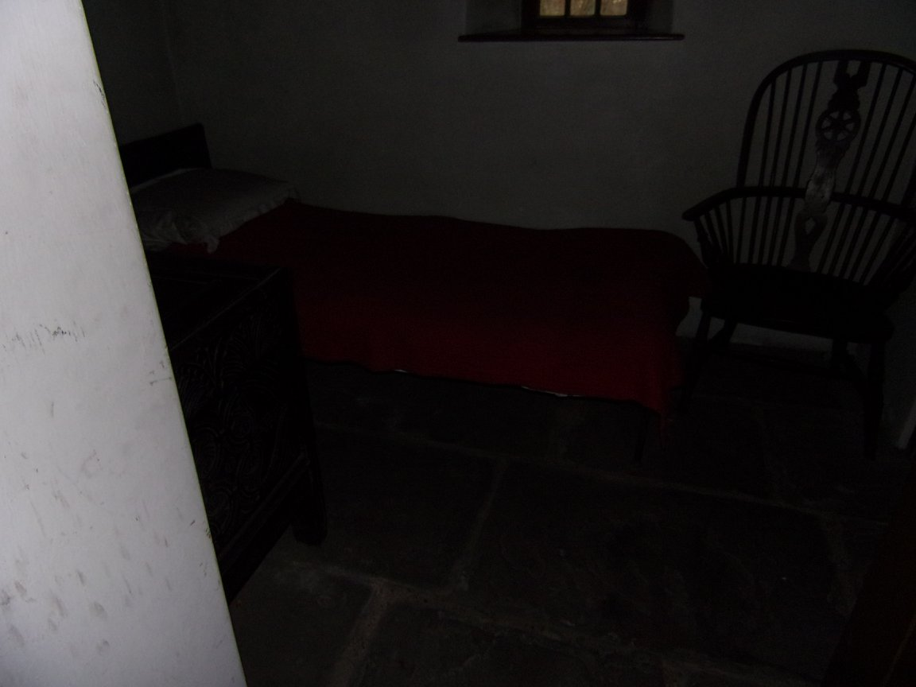
St Fagans also looked into how housing has changed in Wales within the last 150 years. This can be shown by the way that St Fagans provided a timeline of the interior of an average Welsh house from the late 1800’s all the way through to 1980. They did this by having several identical houses from the outside but the interior was decorated in a certain time period. This helps to show how much housing has changed within the 100 years between the late 1800’s and 1980 because in the first house there was only basic furniture whereas by the last house in the 1980’s there was a television, a washing machine and a microwave. Throughout the row of houses the visitor is able to comprehend how much Welsh life has changed within the last 150 years from no electricity and sparse furniture in the first house through to modern household appliances such as dishwashers in the last.
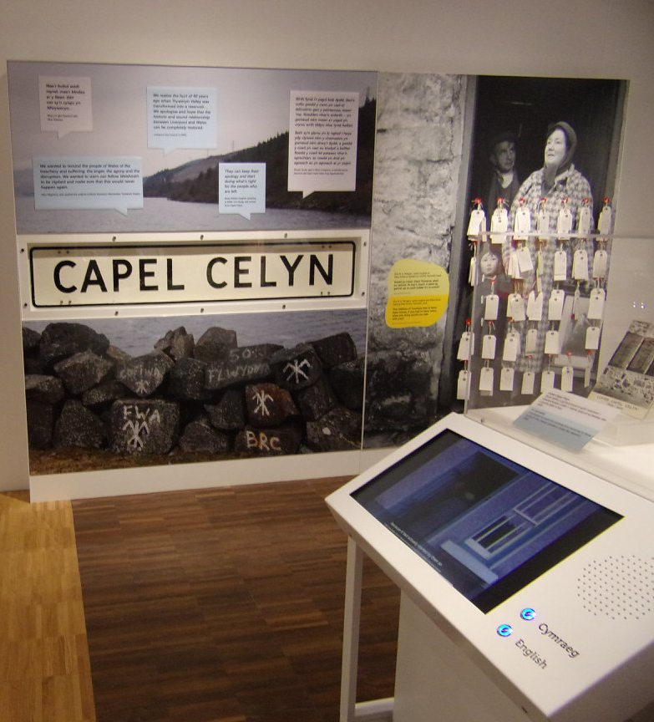
3.1 Welsh Identity in the modern era- Capel Celyn
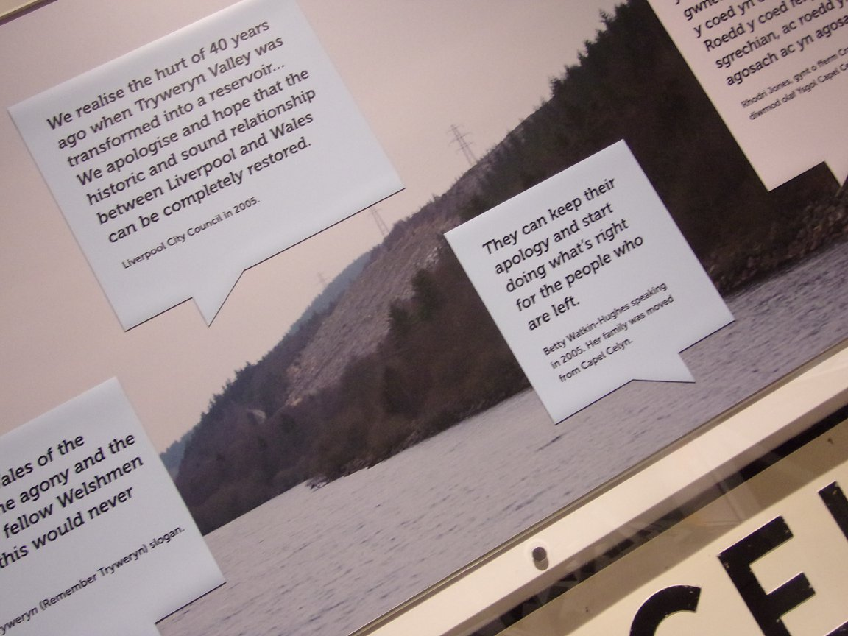
In the room Cymru i or Wales is St Fagans has exhibits on Capel Celyn and Welsh devolution. In 1965 a small hamlet in the Tryweryn valley called Capel Celyn was drowned to provide more water for Liverpool in the post war population boom. This was a great cause of frustration in Wales at the time because Capel Celyn was seen as being a “stronghold of the Welsh language and its traditional rural culture” which was being sacrificed for an English city's needs. 35 out of 36 of the MP’s representing Wales voted against the flooding at the time “the inability of Welsh MPs to stop the plan showed how powerless Wales was in a political sense. Although to Wales at the time it seemed like “the voice of protest from Capel Celyn was not heard” it would be very important when it came to Wales becoming stronger as a nation in the future.
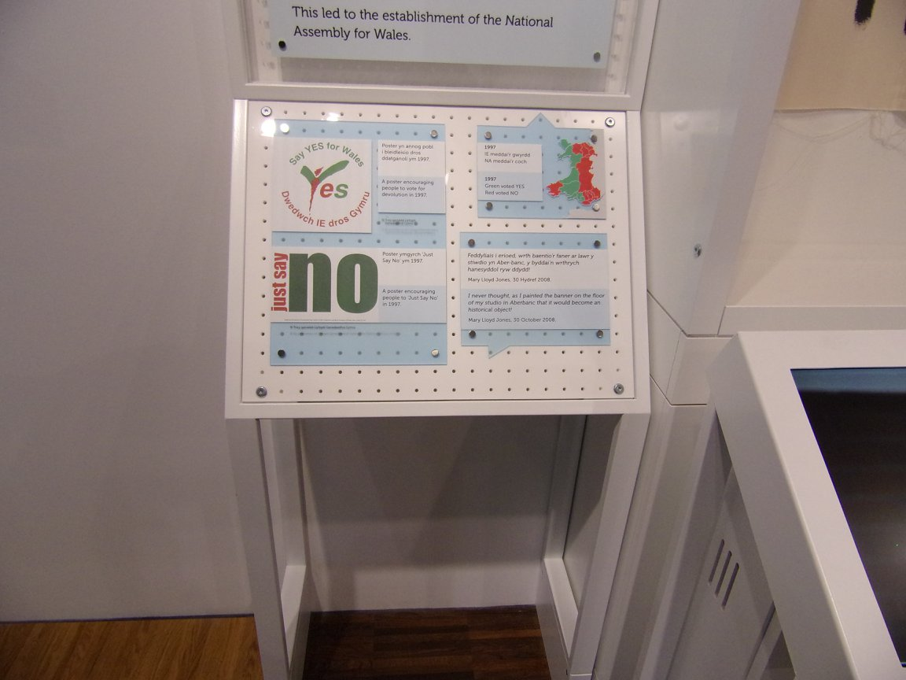
3.2 Welsh Identity in the modern era- Welsh Devolution
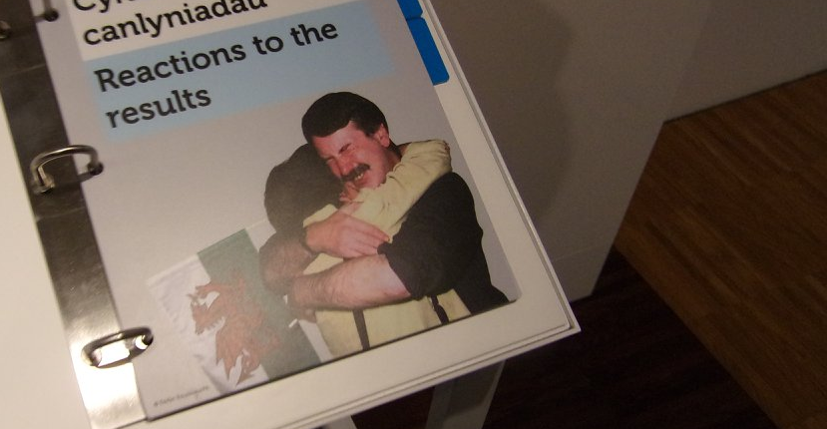
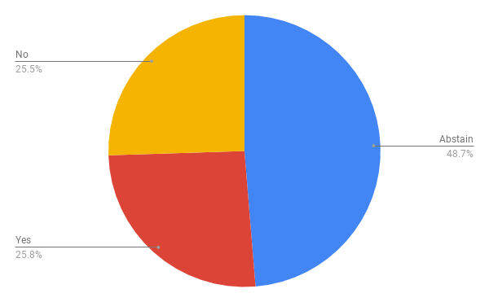
In 1997 Wales was offered a chance of having more power within the government because instead of one welsh secretary they would have got an assembly with 60 people. They would have had less legal power than the proposed Scottish Government but the assembly would have been able to amend existing laws. When the vote was counted on the 18th September 1997 only 51.3% of the population voted and the vote was so close that out of 1.1 million votes there wasa winning margin of only 6721 votes. This data shows that although Wales did get their own assembly and therefore a better say within government in 1997 nearly half of the population of Wales decided not to vote and nearly half of those who did voted for no.
Please note this essay uses the Harvard referencing system with footnotes

Bibliography
Browne, Adrian. "How Welsh devolution has evolved over two decades.", accessed 03.01. 2019.
James, E. W. "Painting the World Green: Dafydd Iwan and the Welsh Protest Ballad." Folk Music Journal 8 (2005): 594-618, Arts Premium Collection, accessed 03.01.2019.
Shipton, Martin. Flooding of Tryweryn Valley was done for Liverpool to sell water at profit - peer claims; The people of the village of Capel Celyn were forced to move out a law allowing Liverpool to flood the valley was passed: MGN Ltd, 2015.

594 James
594-5 James
Shipton 2015
Shipton 2015
Shipton 2015
Browne 2017
Browne 2017
Browne 2017

