University of Wales Trinity Saint David
Wales Institute of Science & Art



Application of automation in wastewater treatment
Control & Automation (ACMA5001)

Owen Bell
2316885
27th April 2026
Word Count: 2515
Contents
1 Evolution of Sewage Farms & Wastewater Industry 3
2 Instrumentation, Control & Automation 7
3 Process Optimisation & Plant Management 9
4 Future of Wastewater Management 11
5 Conclusion 13
6 Bibliography 14

Figure 1 - The Eighth Report, (The Lancet, 1912) 4
Figure 2 - Wastewater Treatment Levels (Tchobanoglous, Burton and Stensel, 2003) 5
Figure 3 – Closed Loop Control System Diagram (Bolton, 2021) 7
Figure 4 - Integrated PLC-SCADA Framework (Kabir and Anjum Anick, 2024) 8
Figure 5 - SCADA Plant Overview (Dieu, 2001) 9

Evolution of Sewage Farms & Wastewater Industry
As technology has advanced industries have evolved and improved their efficiency with the wastewater treatment industry being no different. Wastewater treatment has existed throughout many centuries. Sonune and Ghate (2004) define wastewater treatment as the “process where solids in wastewater are partially removed through decomposition into minerals or stable organic solids”. Where some aspects of the modern sanitation systems can be dated back to the Ancient Greeks in 300BC with an early example of an urban sewage and drainage system. The system design by the Ancient Greeks had “communal toilets that drained into pipes which carried the wastewater to a collection basin outside the city. From there, brick-lined conduits continued to carry the wastewater to agricultural fields”. (Lofrano and Brown, 2010), the wastewater would then have been used to fertilise fields and is one of the earliest examples of a Sewage Farm.

Jumping forward to 1189 in London Lofrano and Brown (2010) mention that wastewater was collected in “cesspits with the contents transported to the countryside and sold as fertiliser for agricultural purposes with people who did this job referred to as rakers or gongfermors”, which continued in Britain until the Industrial Revolution where the importance of waste and wastewater disposal was realised and began experimenting to improve environmental conditions of its cities Lofrano and Brown (2010) state the principle followed was “the solution of pollution is dilution” which led to the construction of the Bazalgette sewer system which was made up of a series of sewers and pumping stations which would be released into the Thames. Lofrano and Brown (2010) continued to state that because of “the lack of understanding of the need to remove pollutants before releasing into the river Thames” and the “closing of the cesspools and the introduction of the flush toilet led to the crisis known as the great stench”.

However, after the great stench crisis in 1912 The Royal Commission on Sewage Disposal introduced the concept of Biochemical Oxygen Demand (BOD) shown in Figure 1 introducing one of the earliest standards and tests applied to waste water and caused governments to begin mandating waste treatment. Vigiak et al. (2019) explain that BOD is “an indicator of organic pollution in freshwater bodies” where a High BOD concentration “reduces oxygen availability and can degrade aquatic habitats and biodiversity with BOD being an indicator of water quality” (Vigiak et al., 2019).
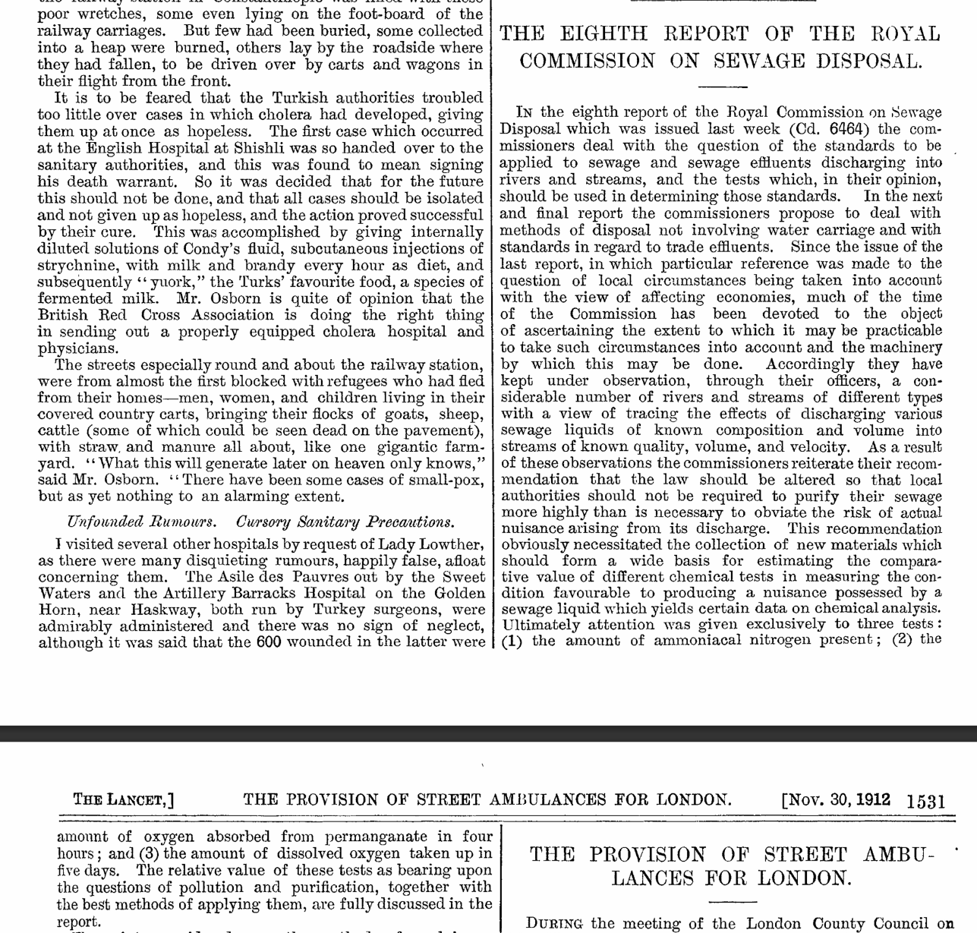
Figure 1 - The Eighth Report, (The Lancet, 1912)
Because of government mandates and the introduction of regulations and standards wastewater treatment has developed into various treatment phases; Tchobanoglous, Burton and Stensel (2003) summarise these phases in Figure 2 below, where preliminary phases removes large objects to prevent “maintenance and operational problems”, after which primary treatment introduced sedimentation to remove the remaining floating materials in the wastewater whereas, advanced primary treatment according to Tchobanoglous, Burton and Stensel (2003) added additional “chemicals and filtration methods to enhance the removal of remaining solids and organic matter”. Tchobanoglous, Burton and Stensel (2003) continue by explaining secondary treatment “biological and chemical processes remove most of the remaining organic matter” with some secondary processes focused on the removal of nutrients such as nitrogen, phosphorus or both known as biological nutrient removal (BNR). Lastly, Tchobanoglous, Burton and Stensel (2003) add that the remaining phases use “additional combinations of unit operations and process to remove residual solids and other constituents that are not already significantly removed” by the previous phases.
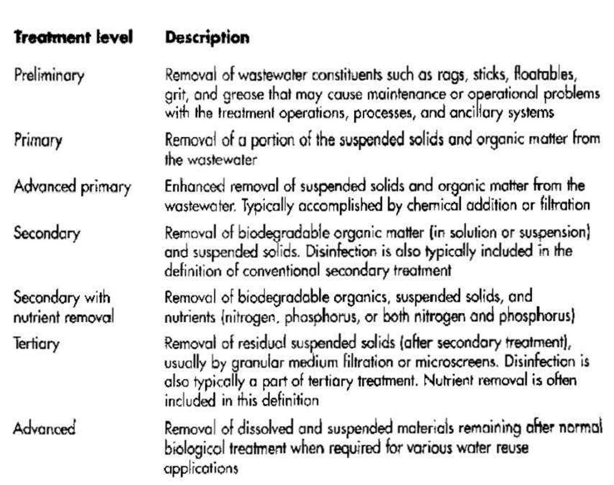
Figure 2 - Wastewater Treatment Levels (Tchobanoglous, Burton and Stensel, 2003)
Moreover, it was until the 1980s that “secondary treatment was the most common method used for the removal of BOD and Total Suspended Solids (TSS) with nutrient removal being used in special circumstances in the United States” (Tchobanoglous, Burton and Stensel, 2003), with a degrading quality of water this led to the implementation of the Federal Water Pollution Control Act Amendments and the Needs Assessment Survey conducted by the US Environmental Protection Agency to monitor and improve the wastewater treatment facilities in America.

Additionally, in Europe wastewater treatment facilities are based on the European Urban Waste Water Treatment Directive of 1991 and European Water Framework Directive of 2000 which “imposed a timetable for wastewater treatment plants to meet minimum standards for discharging based on the population served and the type of water” (Maere et al., 2016), leading us into the modern day wastewater treatment facilities with the adoption of Instrumentation, Control & Automation (ICA).

Today some of the main standards impacting the industry are ISO 50001 which focuses on energy efficiency “intended to contribute to the efficient use of an organisations energy resources by optimising its processes to save energy and minimise environmental impacts” (Machnik-Slomka et al., 2024) and ISO 14001 which allows organisations to reduce the environmental impact of their operations with the ISO standards introduction to the wastewater industry it allowed organisations to “respond to increasing demands that require controlling the negative effects of process or service activities” (Herrera-Navarrete et al., 2021), with the tool from ISO 14001 based off a FMEA to help the organisations in the industry use a “method that helps determine failures in a wastewater treatment system in the form of an automated checklist to evaluate the conditions and its compliance with ISO 14001” (Herrera-Navarrete et al., 2021).

Instrumentation, Control & Automation
ICA has been an aspect within wastewater treatment since the 1970s and according to Olsson et al. (2005) has “demonstrated to increase capacity of BNR by 10 – 30%” displaying the importance of controlling operational parameters within the industry. This is due to the primary aim of automatic control being to reduce inefficiencies with Gray (2014), noting ICAs are comprised of a “detecting or sensing element, a measuring or indicating element and a controller”. This is supported by Bolton (2021) explaining that in order for an ICA to be automated the system needs to be a closed loop system as it includes a comparison element that “compares the required value of the variable being controlled with the measured value and produces an error signal” Bolton (2021), continues that “if the output is the required value then there is no error signal” causing no signal being sent to adjust the controlled value until a difference reoccurs which will then create an error signal restarting the closed loop and adjusting the control value.

Moreover, the “control law implementation element determines what actions the system should take depending on the error signal" (Bolton, 2021), received from a sensor this being a Programable Logic Controller (PLC) which “are industrial digital controllers designed to execute deterministic logic in real time” (Kabir and Anjum Anick, 2024).

Lastly, Bolton (2021) describes the correction and measurement elements of the closed loop system whereby the correction element “produces a change in the process with the aim to correct or change the controlled condition” typically being an actuator and the measurement element which “produces a signal relating to the variable condition of the process” such as sensors with Bolton (2021) illustrating a closed loop control system in Figure 3 below.
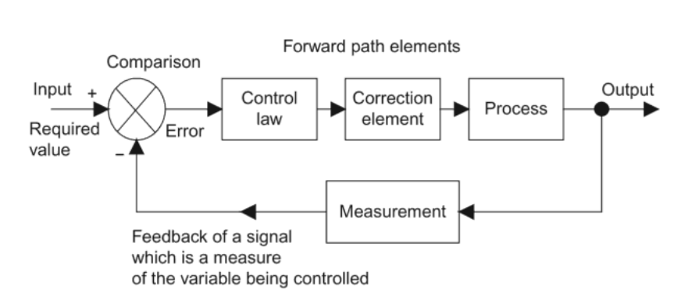
Figure 3 – Closed Loop Control System Diagram (Bolton, 2021)
Despite ICA being incorporated within the wastewater treatment industry since the 70s it is only now that it has become so prevalent, Olsson (2007) attributes this to several factors being the development of technology such as “on-line in situ nutrient sensors and respirometers, improvements in actuators with variable speed drives in pumps and compressors”. In addition, “software packages like SCADA can be used for data acquisition and plant supervision alongside the development of control theory and automation technology providing powerful tools for evaluating control strategy performance and process engineers becoming educated in control ideas” (Olsson, 2007).

The technological advancements made allow the wastewater industry a PLC-SCADA automation structure with “PLCs repeatedly scanning inputs, running control programs and updating outputs whilst supervisory control and data acquisition (SCADA) provide platforms that collect operational data from distributed assets to visualise process conditions through human-machine interfaces” (Kabir and Anjum Anick, 2024). Furthermore, Kabir and Anjum Anick (2024), adds that the PLC layer within wastewater treatment is responsible for the control logic being, “sequences for backwashing, sludge wasting, batch reactor phases, chemical preparation and safety interlocks, plus continuous control for aeration, pumping, filtration and pressure management”, with Kabir and Anjum Anick (2024) providing a diagram of an Integrated PLC-SCADA Framework seen in Figure 4 below.
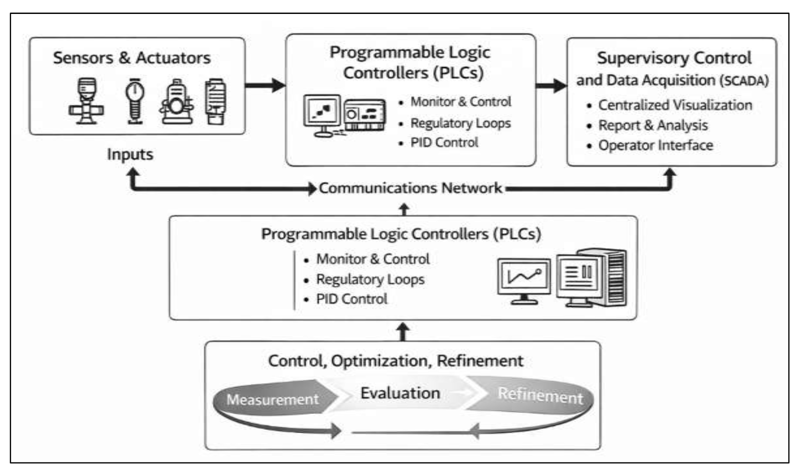
Figure 4 - Integrated PLC-SCADA Framework (Kabir and Anjum Anick, 2024)

Process Optimisation & Plant Management
With the incorporation of PLC-SCADA systems in the wastewater industry, it has enabled process engineers to effectively monitor wastewater plants efficiency receiving alerts when an issue occurs enabling the maintenance of “essential functions under disturbances including equipment faults” (Kabir and Anjum Anick, 2024) and implement improvements to optimise the process because of the real time reports of each phase from SCADA. This is supported by Kabir and Anjum Anick (2024) who stated that it enables those responsible for the process to implement changes and refine the process with “scheduled changes for loop tuning adjustments, equipment alteration strategies with the effect of an actions being evaluated through before and after comparisons”, where in comparison to how the efficiency of a wastewater plant would be monitored previously is far more effective with Dieu (2001) noting that “prior to 1998 wastewater operations were monitored on a text based operating system named SETCONPC which was a difficult and tedious task to monitor operations”. Whereas a PLC-SCADA system provides a user friendly design for operators that can “display the real time information such as wet-well level, effluent flow, blower and clarifier status, chlorine residual and totaliser readings on a single display” (Dieu, 2001) as shown in Figure 5 below.
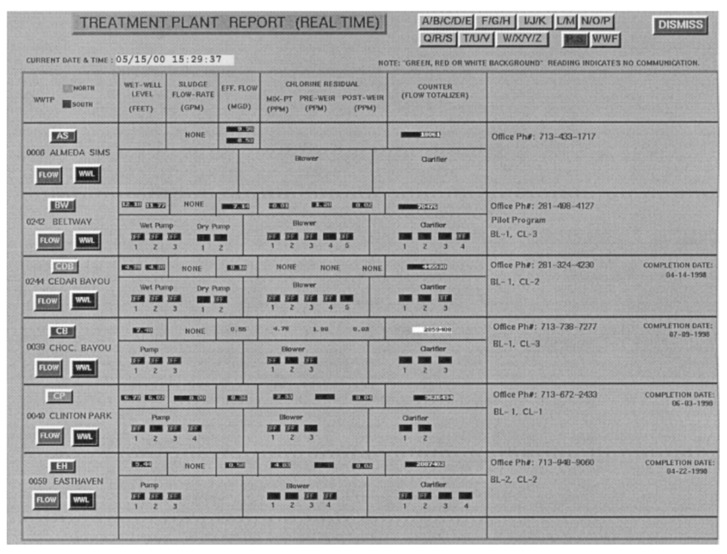
Figure 5 - SCADA Plant Overview (Dieu, 2001)
In addition to easier to monitor, process operations the PLC-SCADA system enables autonomous operation with the PLC measuring and controlling the process to achieve the desired result determined by the engineers continuously. This also enables process engineers to implement changes seamlessly with changes previously taking “weeks by removing commissioning transition periods with equipment outages” (Kabir and Anjum Anick, 2024) with the aim of process optimisation within wastewater treatment the “systematic improvement of operational outcomes such as reducing energy use, minimising chemical dosing, stabilising effluent quality, decreasing downtime and lowering variation in critical process variables” (Kabir and Anjum Anick, 2024).

Future of Wastewater Management
Looking at the improvement in technology and development of Artificial Intelligence (AI) the future of the wastewater treatment industry is likely to only become more efficient and refined. Starting with the equipment that is used to monitor and control the wastewater treatment process will draw similarities to the 1970s to modern day where gradual improvements will be made to the sensors, actuators and controllers such as PLCs becoming more responsive and cost effective.

Moreover, AI could have a massive impact on the industry with improved process optimisation with Obiuto et al. (2024) noting that “AI could enhance simulation models by learning from datasets, identifying patterns and optimising complex systems in real time” Obiuto et al. (2024) continues by outlining that the benefit of this is it “could lead to more accurate and adaptive simulation models to optimise processes that can predict system behaviour with higher precision”. However, for AI models capable of machine learning from datasets and if implemented from real time data to understand and optimise decisions would require some form of validation to confirm the AI model is improving the process which could take years to properly establish an effective model. Therefore, AI could cause a shift in the workforce with the demand for process engineers to own and optimise each phase of a wastewater treatment plant reducing and focus for engineers who are proficient in programming to maintain the AI model.

Additionally, Obiuto et al. (2024) suggest another possible area within the industry that might have major advancements is “multi-scale modelling that can simulate processes occurring at different scales simultaneously by integrating models at molecular, microscopic and macroscopic levels building an understanding of phenomena in wastewater treatment systems leading to increasingly accurate predictions and optimised system designs”.

Another aspect of wastewater plants that might change are the regulations and their impact on how treatment plants operate and their commitment to being environmentally friendly with a greater emphasis on carbon emissions to achieve net zero targets set by governing bodies where future technologies “will focus on gases production and recovery” according to Soares (2020) who breaks down that “Ammonia, Methane, Hydrogen and Carbon Dioxide can be separated from wastewater and reused to obtain renewable energy or chemical production”, helping to deliver a circular economy and reduce global warming.

However, the development of new technologies coincides with new challenges and risks, especially with the potential of greater dependence on those technologies. The main threat posed are cyber-attacks, where methods implemented by hackers are becoming more advanced, Agidie (2025), calls for “a greater need for enhanced protection in sectors that rely on SCADA systems to collect data” as failure to implement security procedures could result in critical and depended upon services being interrupted and compromising in the wastewater industries case the purification of water, as a result the future of the wastewater industry needs improved security frameworks implemented to protect systems susceptible to cyber-attacks with suggestions for a “multilayer framework composed of various countermeasures applied to different network layers including attack prevention mechanisms like firewalls, attack detection mechanisms such as process anomaly detection and post attack mechanisms that can restore processes to a manageable state” (Tuptuk et al., 2021).

Conclusion
To conclude, wastewater systems have existed for centuries nonetheless, the processes involved have evolved from what it once was in Ancient Greece and the Industrial Revolution with modern day treatment plants nearing autonomous operation with the implementation of PLC-SCADA systems used to monitor results from sensors and to make adjustments through actuators and are responsible for the control logic, sequencing, preparation and safety interlocks that are applied within every phase of the process where components are becoming cheaper and more efficient whilst a knowledge and understanding of the processes has been developed over the years, alongside, regulations forcing organisations to develop better processing methods. Whilst, in a not too distant future machine learning through AI models that can recalibrate real time information to deliver an improved process will become the normal and enable the industry to be fully autonomous.

Furthermore, regulations will likely become stricter as greater onus is placed on organisations to reduce their impact on the environment through renewable methods, recovery and repurposing of chemicals and other byproducts of the wastewater industry with targets to achieve net zero and a circular economy.

However, the new era of wastewater industry poses challenges with a demand for a workforce skilled in programming and AI rather than the past dependence for process engineers with the responsibility for process optimisation being split between AI models and engineers. Additional security to protect critical systems such as PLCs, SCADA and possibly AI servers and the infrastructure of the wastewater industry need to be reinforced with procedures not fully established to manage and combat cyber-attacks with cyber-attacks becoming a more prevalent and preferred method used by hackers to interrupt and compromise wastewater treatment plant operations.

Bibliography
Agidie, S.T. (2025). Water/Wastewater Treatment Plants Must Implement a Cyber Resilience - ProQuest. [online] Proquest.com. Available at: https://www.proquest.com/openview/45bafd8348e780a8fed6f10e7f08daf2/1?cbl=18750&diss=y&pq-origsite=gscholar [Accessed 21 Apr. 2026].
Bolton, W. (2021). Instrumentation and Control Systems. [online] Google Books. Available at: https://books.google.co.uk/books?hl=en&lr=&id=gcDvDwAAQBAJ&oi=fnd&pg=PP1&dq=Instrument [Accessed 17 Apr. 2026].
Dieu, B. (2001). Application of the SCADA system in wastewater treatment plants. ISA Transactions, [online] 40(3), pp.267–281. doi:https://doi.org/10.1016/s0019-0578(00)00053-7.
Gray, D. (2014). Centralized and Automatic Controls in Ships. [online] Pergamon Press Ltd. Available at: https://www.sciencedirect.com/science/chapter/monograph/abs/pii/B9781483213552500066 [Accessed 17 Apr. 2026].
Herrera-Navarrete, R., Colín-Cruz, A., Arellano-Wences, H.J., Sampedro-Rosas, M.L., Rosas-Acevedo, J.L. and Rodríguez-Herrera, A.L. (2021). Municipal Wastewater Treatment Plants: Gap, Challenges, and Opportunities in Environmental Management. Environmental Management, [online] 69. doi:https://doi.org/10.1007/s00267-021-01562-y.
Kabir, T. and Anjum Anick, K.M.T. (2024). View of PLC–SCADA–Integrated Electrical Automation Frameworks for Process Optimization in Water and Wastewater Treatment Facilities. [online] Rast-journal.org. Available at: https://rast-journal.org/index.php/RAST/article/view/93/92 [Accessed 15 Apr. 2026].
Lofrano, G. and Brown, J. (2010). Wastewater management through the ages: A history of mankind. Science of The Total Environment, [online] 408(22), pp.5254–5264. doi:https://doi.org/10.1016/j.scitotenv.2010.07.062.
Machnik-Slomka, J., Pawlowska, E., Klosok-Bazan, I. and Goňo, M. (2024). Evaluation of the Energy Management System in Water and Wastewater Utilities in the Context of Sustainable Development—A Case Study. Energies, [online] 17(19), p.5014. doi:https://doi.org/10.3390/en17195014.
Maere, T., Neethling, J., Clark, D., Pramanik, A. and Vanrolleghem, P.A. (2016). Wastewater Treatment Nutrient Regulations: An International Perspective with Focus on Innovation. [online] Research Gate. Available at: https://www.researchgate.net/profile/Peter-Vanrolleghem/publication/305490602_Wastewater_treatment_nutrient_regulations_An_international_perspective_with_focus_on_innovation/links/589b152da6fdcc32dbe2b58d/Wastewater-treatment-nutrient-regulations-An-international-perspective-with-focus-on-innovation.pdf [Accessed 18 Apr. 2026].
Obiuto, N.C., Ugwuanyi, E.D., Ninduwezuor-Ehiobu, N., Ani, E.C., Olu-lawal, K.A., Obiuto, N.C., Ugwuanyi, E.D., Ninduwezuor-Ehiobu, N., Ani, E.C. and Olu-lawal, K.A. (2024). Advancing wastewater treatment technologies: The role of chemical engineering simulations in environmental sustainability. World Journal of Advanced Research and Reviews, [online] 21(3), pp.019–031. doi:https://doi.org/10.30574/wjarr.2024.21.3.0649.
Olsson, G. (2007). Automation Development in Water and Wastewater Systems. Environmental Engineering Research, [online] 12(5), pp.197–200. doi:https://doi.org/2007.12.5.197.
Olsson, G., Neilsen, M., Yuan, Z., Lynggaard-Jense, A. and Steyer, J.P. (2005). Instrumentation, Control and Automation in Wastewater Systems. [online] Google Books. Available at: https://books.google.co.uk/books?hl=en&lr=&id=RW6aprXf7l0C&oi=fnd&pg=PR4&dq=Instrument [Accessed 15 Apr. 2026].
Soares, A. (2020). Wastewater treatment in 2050: Challenges ahead and future vision in a European context. Environmental Science and Ecotechnology, [online] 2, p.100030. doi:https://doi.org/10.1016/j.ese.2020.100030.
Sonune, A. and Ghate, R. (2004). Developments in wastewater treatment methods. Desalination, [online] 167(167), pp.55–63. doi:https://doi.org/10.1016/j.desal.2004.06.113.
Tchobanoglous, G., Burton, F.L. and Stensel, H.D. (2003). Wastewater Engineering Treatment and Reuse . Fourth ed. [online] Metcalf & Eddy, Inc, pp.1–25. Available at: https://d1wqtxts1xzle7.cloudfront.net/55688838/Wastewater_treatment_and_reuse-libre.pdf?1517478116=&response-content-disposition=inline%3B+filename%3DWastewater_Engineering_Treatment_and_Reu.pdf&Expires=1776288845&Signature=Iko-2OqBJbzMSsXLSgcvX0BsbFfGQKIZiYlfPCPvltNhT4sYkn1ogxq04xsY9XEsNNk9o1aihmrI2GtvJFjWls7PVZ7ikSy9EOzMWSJ20kYkH~CBtZjdxCxnGrh-lKqo50nDPsc9Ytfuu6squ0lX~qlGxI7QQbH8-uUe9N2brgQgNlKSSZH09Qo2yTo-ZACetBbYDRm9hjnPnKipIxT6O6aDa7mlzkmkpT1eT6ObG9otQg29iAZMZ302MgR4ZN-pB3eKebSF01udPYSwPqaNxIvvUl~smYfsl5OrC94n25Q0FRj33FdFjTY2gJLmPTJheQzCF4rNnvMsjbt7zW7dBw__&Key-Pair-Id=APKAJLOHF5GGSLRBV4ZA [Accessed 15 Apr. 2026].
The Lancet (1912). Eighth Report of Royal Commission on Sewage Disposal. The Lancet, [online] 30 Oct., pp.1530–1531. Available at: https://ia800607.us.archive.org/view_archive.php?archive=/8/items/crossref-pre-1923-scholarly-works/10.1016%252Fs0140-6736%252801%252940973-1.zip&file=10.1016%252Fs0140-6736%252801%252941378-x.pdf [Accessed 15 Apr. 2026].
Tuptuk, N., Hazell, P., Watson, J. and Hailes, S. (2021). A Systematic Review of the State of Cyber-Security in Water Systems. Water, [online] 13(1), p.81. doi:https://doi.org/10.3390/w13010081.
Vigiak, O., Grizzetti, B., Udias-Moinelo, A., Zanni, M., Dorati, C., Bouraoui, F. and Pistocchi, A. (2019). Predicting biochemical oxygen demand in European freshwater bodies. Science of The Total Environment, [online] 666, pp.1089–1105. doi:https://doi.org/10.1016/j.scitotenv.2019.02.252.

