


School of Applied Computing | Title of Coursework  Synthesize a Solution to a Potential Real-Life Scenario:  “Che-Si Construction Co” | Code ACCB4024
Module
Networks and
Cyber Security Essentials
Student:  Theresa Darzins  No 1909721 |  | Lecturers:  - Dr N. Kaliyamurthy  - Dr C Campbell  Date: December 2020

Contents
1.0 INTRODUCTION 1
1.1 Report Structure 1
1.2 Discussion 2
1.3 Network Security Summary 4
1.4 Potential Impact Definitions; Low, Moderate and High Security Breaches 5
2.0 REVIEW OF LITERATURE 6
2.1 Policies 6
2.2 Infrastructure 6
3.0 DESIGN AND IMPLEMENTATION 7
3.1 List Possible Vulnerabilities 7
3.2 Use Packet Tracer Design and Detect Attacks 8
3.3 Detect Vulnerabilities Using Plain Texts 8
3.4 Recommend Ways to Mitigate 8
3.5 Explain the Importance of Digital Signatures/Data Encryption 8
3.6 Give Examples How to Implement to Match Above 8
3.7 Write Guidelines for Staff, Vendors and Clients 8
4.0 MITIGATION/RECOMMENDATIONS 9
4.1 Strategy to Up-Date Che-Si’s Existing Policies 9
4.2 Mitigating its Flaws Like Compromising Staff’s Personal Data 11
4.3 Ten Step Approach 11
5.0 CONCLUSION 12
5.1 Network 12
5.2 Threats and Vulnerabilities 12
5.3 Access Control and ID Management 12
5.4 Compliance and Operation Security 12
5.5 Application Data and Host Security 12
5.6 Egress Filtering 12
5.7 New Policies Written to be Adhered to 12
5.8 10-Step Approach 12
6.0 ANNEXURE 13
6.1 Design and Detect Attacks 13
6.2 Detect Vulnerabilities using plain text 13
6.2.1 D Sniff Password Sniffing in Non-Switched Environment 14
6.2.2 Scoop LM Tool Sniffing NT Usernames and Encrypted Passwords 14
6.3 Write Guidelines 15
6.3.1 Rules for Using Personal Devices at Work 16
6.3.2 Sample Mobile Device Policy 16
7.0 REFERENCES 22

Figure 1 Logical Diagram of Network BEFORE 11
Figure 2 Logical Diagram AFTER Changes Made 11
Figure 3 The Ten-Step Approach 12
Figure 4 - D-Sniff Password Sniffing in Non-Switched Environment 15
Figure 5 - Scoop LM Tool Sniffing NT Usernames and Encrypted Passwords 15

Table 1 The Importance of Security in a Network 5
Table 2 Goals of Security CIA by Federal Information & Information Systems 6
Table 3 Strategy to Up-Date Che-Se's Existing Policies 10

Abstract

The Company network needs to be accessible by authorised users and members of the public, on mobile devices whilst simultaneously retaining sufficient integrity in order avoid being compromised.

To fight against cyberattacks a multi-pronged approach is needed. Consistency is key, therefore the best defences are:

- Policies and Procedures, combined with

- centralised matrix of malware reporting, to spearhead detection,

- increased awareness of social engineering, and

- ensuring Anti-Virus Software downloaded on all:

- Che-Si Staff,
- Clients’ and
- Vendors’

personal and mobile devices used to access the Company Server.

There is no one ‘magic bullet’, so many must be employed to good effect.

1.0 INTRODUCTION

1.1 Report Structure
This report is split into 7 Sections:
- INTRODUCTION
to discuss Networks and Importance of Security

- REVIEW OF LITERATURE
to demonstrate the flaws in their Security and Policies

- DESIGN AND IMPLEMENTATION
to:

- List the Vulnerabilities and
- Design and detect attacks
- Detect vulnerabilities using plain texts
- Recommend mitigation steps
- Explain the importance of digital signatures/data encryption
- Give examples how to implement to match above
- Write guidelines for Staff Members, Vendors and Clients

- MITIGATION/RECOMMENDATION
Devise a Strategy to up-date Che-Si’s existing policies to mitigate its flaws compromising security of staff’s personal data

- CONCLUSION

- ANNEXURE

- Design and Detect attacks
- Detect vulnerabilities using plain texts
- Document screenshots
Write Guidelines for:
- Staff
- Vendors
- Clients

- REFERENCES

1.2 Discussion

^{[1]} Every 30 seconds $1.2 million is spent online. By 2021 $6 trillion is estimated to be lost to cybercrime.
Nowadays organisations are relying more and more upon Networks and Cloud storage, so securing data is becoming increasingly important.
Network security covers:
- hardware,
- software and
- cloud technologies
The three main principles of Network Security are CIA:

- Confidentiality – keep data away from those who are unauthorised to see
- Integrity – protect data from alteration
- Availability – accessible to those that need it

To satisfy security requirements, all three of the above need to be considered, and these are some of the methods used:

- access control
controlling who has access to the network through the use of passwords.
- antivirus/antimalware software
monitor network traffic in real time and also scan activity logs for suspicious behaviour that may be related to a malware attack.
- behavioural analytics
people’s behaviour in the network can be predicted. There is behavioural analytics software available that can identify abnormal behaviour within the network and isolate any threats.
- data loss prevention
blocks data from being taken outside of the network, which stops it from potentially getting into the hands of anyone malicious
- email security
email is one area of network security that is most often targeted. This can be through phishing emails, the sending of suspicious links that could download viruses or malware, or scams. Modern email security is quite adept at identifying suspicious-seeming emails and can either filter them out or present a warning. Some email security measures can also block the sending of certain information and data out of the network.
- Firewalls
firewalls act as a gatekeeper between the network and the outside world and they filter incoming data according to predefined rules to prevent anything suspicious from entering the network.
- web security
blocks people in the network from accessing certain websites that could commonly contain threats to the network.

The most common attacks are:
    - Hacking – unauthorised access
    - Phishing – sending e mails to get users to reveal passwords
    - Malware – software that spies on user’s information
    - Distributed denial of Service – flooding the website so authorised users cannot access

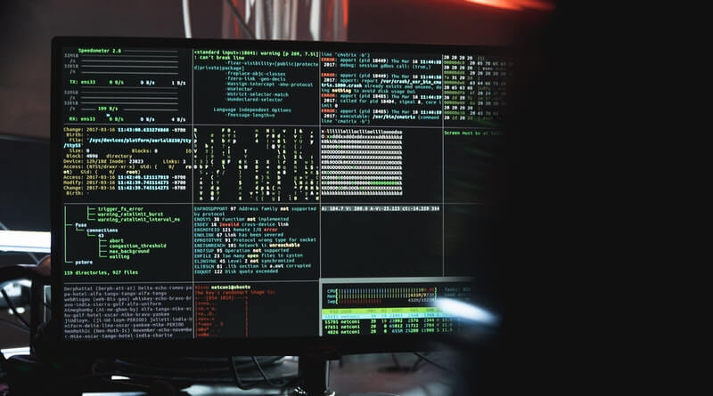
There are three main network security controls:

- Physical
Preventing physical access to the network;
- the physical cables,
- routers, etc,
through the use of locks and biometric scanners.

- Technical
Network security;
- protecting data stored in the network,
- or is sent out of or into the network,
by preventing unauthorized access by outsiders and malicious access by employees within the network.

- Administrative network security
  - having an administrator/s who control how much access individuals can have to the network and who monitor network access.

1.3 Network Security Summary
Table 1 The Importance of Security in a Network
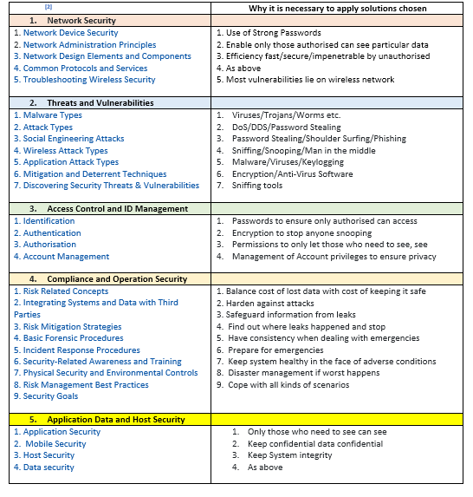

1.4 Potential Impact Definitions; Low, Moderate and High Security Breaches
Table 2 Goals of Security CIA by Federal Information & Information Systems
Confidentiality, Integrity and Availability,
U.S. Federal Information Processing Standards ^{[3]}
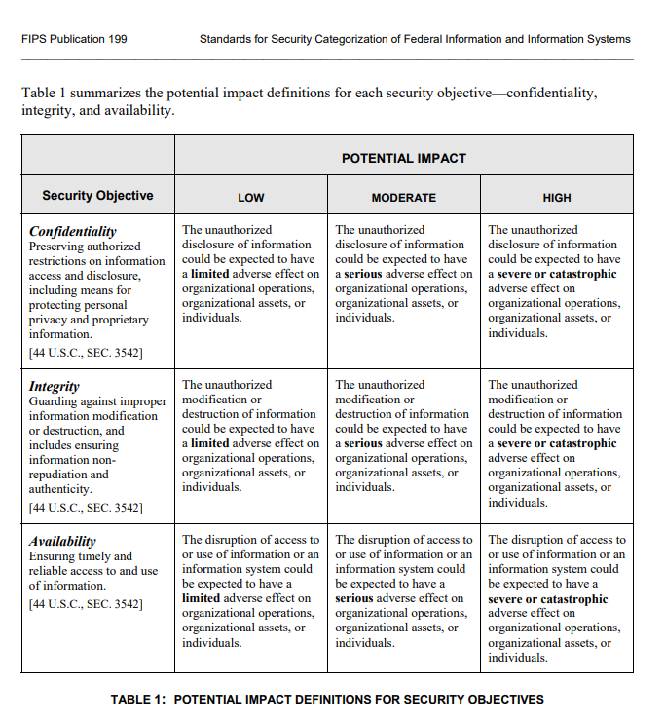

2.0 REVIEW OF LITERATURE
To demonstrate to Che-Si’s Policy Makers the existing flaws in their:

- Policies
- Infrastructure

2.1 Policies
^{[4]} To ensure Company Policies circumvent flaws in the Network:
- Stress the importance of Network Security and the implications of security breaches and how malware could affect the company
- Train employees so they can identify phishing and spoof e mails and remind to check sender before opening any attachments
- Shadow Policy; do not let employees download software without prior approval
- Ensure Employees au fait with Policies regarding data sharing
- Ensure there is an IT Policy and it is implemented:
- Password Management; use complicated not easy to guess passwords
- Remote Access; only connect to one network at a time and use most up to date anti-virus software
- Social Media Regulation; nothing company-related financial, operational or legal to be shared, and bigotry will not be tolerated
- E Mail only to be used for business purposes
- Secure File Systems; only send files through secure encrypted system, not plain text
- Lock Devices when not in use; sign out
- Reporting System for Security issues

2.2 Infrastructure
Ensure following are implemented:
- Constant monitoring
Prevents viruses

- Centrally administer password system
To provide secure environment

- Website management system
To ensure if employees visit risky websites they cannot unwittingly infect the network

- Segmented Guest Wi-fi
To keep Co. secure data separate (and therefore safe)

- Central Admin for Anti-Virus/Malware
To ensure everyone running same managed software solutions. Programs not updated on time may not block viruses. If users are running different antivirus software this can adversely affect other applications.

3.0 DESIGN AND IMPLEMENTATION

- List possibilities of vulnerabilities of threats and attacks from various locations and devices
- Design and detect attacks documenting
- See Annexure
- Detect vulnerabilities using plain texts
- See Annexure
- Recommend ways to mitigate
- Explain importance of Digital Signatures/Data encryption
- Give examples of how to implement matching above
- Write guidelines for Staff, Vendors and Clients
- See Annexure

3.1 List Possible Vulnerabilities
^{[5]} Network infrastructure is the most important area to secure and any vulnerabilities need to be tested and eliminated. This depends upon:
Location of devices; firewall/IPS on the network and configuration
What attackers see when they perform port scans/how they can exploit vulnerabilities in network hosts
Network design; internet connections, remote access capabilities, layered defences, and placement of hosts on the network
Interaction of installed security devices, such as firewalls, intrusion prevention systems (IPSs), antivirus, and so on
What protocols in use
Commonly attacked ports that are unprotected
Network host configurations
Network monitoring and maintenance

If someone exploits a vulnerability in one of the items in the above list or anywhere in the network’s security, the following can happen:

- A hacker can launch a denial of service (DoS) attack, which can take down your Internet connection — or your entire network.
- A malicious employee using a network analyser can steal confidential information in e-mails and files sent over the network.
- A hacker can set up back-door access into your network.
- A hacker can attack specific hosts by exploiting local vulnerabilities across the network.

Before assessing network infrastructure security, do the following:

- Test systems from the outside in, the inside out, and the inside in (that is, on and between internal network segments and demilitarized zones [DMZs]).
- Obtain permission from partner networks to check for vulnerabilities on their systems that can affect your network’s security, such as open ports, lack of a firewall, or a misconfigured router.

3.2 Use Packet Tracer Design and Detect Attacks
See Annexure

3.3 Detect Vulnerabilities Using Plain Texts
See Annexure

3.4 Recommend Ways to Mitigate
^{[2]}
- Network:
Divide into subnets
- Threats and Vulnerabilities:
Make wireless non-Vlan
- Access Control & ID Management:
Inter-Vlan routing used to separate departments
- Compliance and Operation Security:
Harden system using Back Up plans and Sniffing Tools to record, analyse and prevent cyberattacks
- Application Data and Host Security:
Separate core system from wireless

3.5 Explain the Importance of Digital Signatures/Data Encryption
Sending plain text leaves the user open to man in the middle attacks whereby

3.6 Give Examples How to Implement to Match Above
Dual encryption is secure way to mitigate interference from 3rd parties.

3.7 Write Guidelines for Staff, Vendors and Clients
See Annexure

4.0 MITIGATION/RECOMMENDATIONS

DEVISE
- A strategy to up-date Che-Si’s existing Policies
- Mitigating its flaws like compromising Staff’s personal data

4.1 Strategy to Up-Date Che-Si’s Existing Policies
Table 3 Strategy to Up-Date Che-Se's Existing Policies
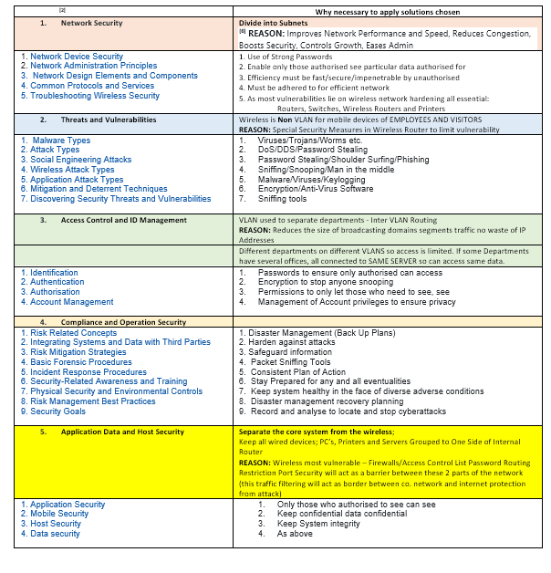

Figure 1 Logical Diagram of Network BEFORE
^{[2]} Before any changes implemented:
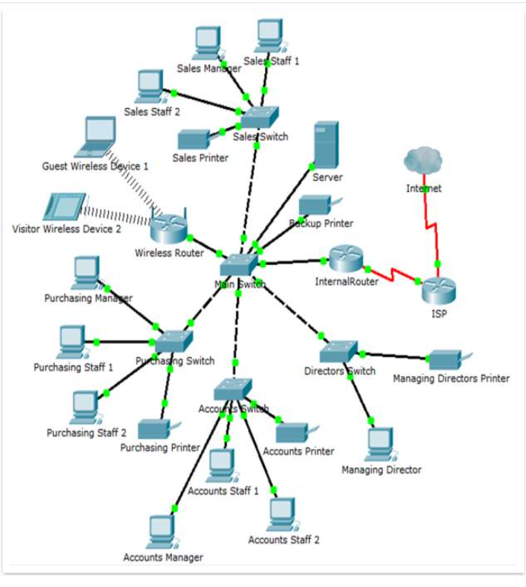

Figure 2 Logical Diagram AFTER Changes Made
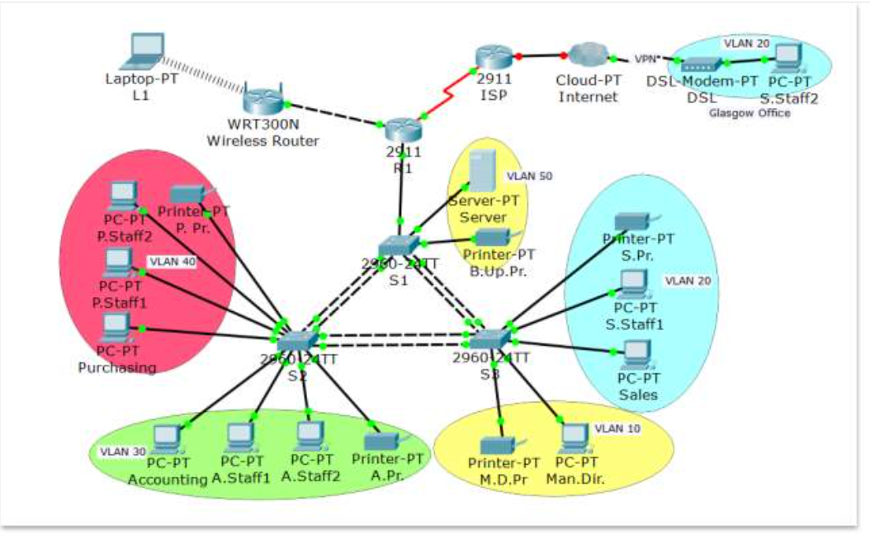

4.2 Mitigating its Flaws Like Compromising Staff’s Personal Data

Regarding Firewall; Packet filtering ^{[7]} the SANS Institute recommends Egress filtering as it looks at traffic allowed to leave as well as entering.

^{[8]} Malware has evolved to become well-hidden, however it is so prevalent, the vast majority of it is spotted.

“The real problem relates to consistency; are attacks being deflected throughout organisations over the long term? This is the true measure of depth of defence”.

4.3 Ten Step Approach
^{[9]} In order avoid unduly impacting other procedures a ten-step approach is advised before changes implemented.
Figure 3 The Ten-Step Approach
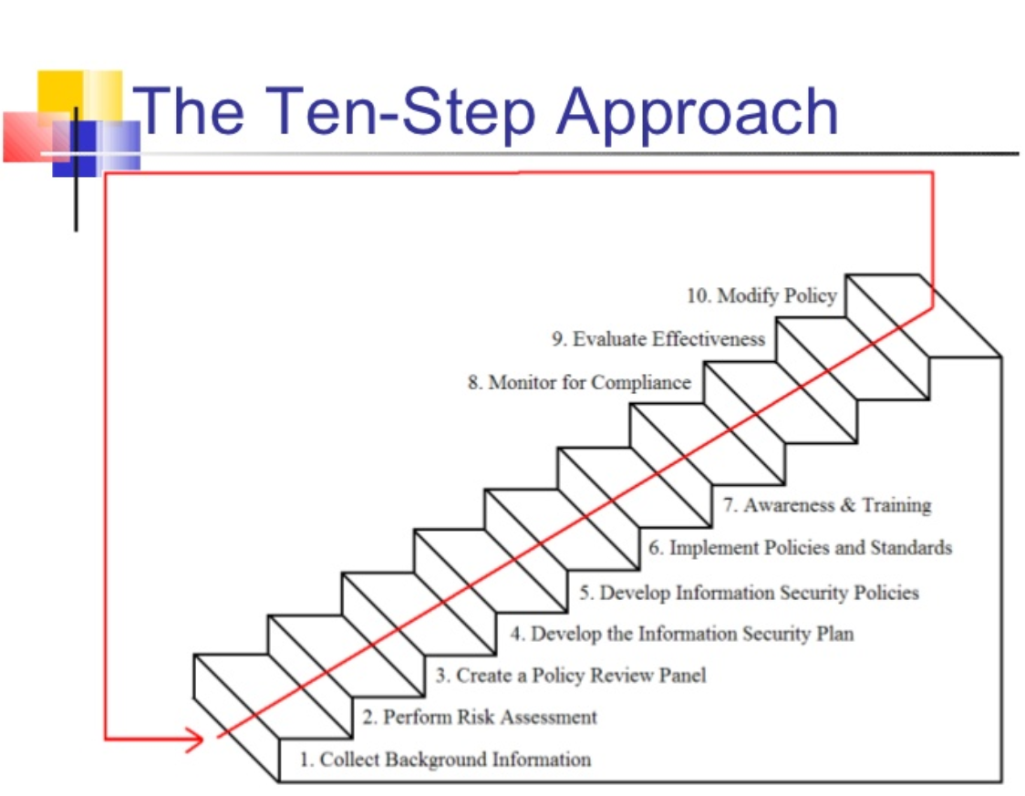

5.0 CONCLUSION

In order to harden the Network, the following recommendations need to be carried out:

5.1 Network
Divide into subnets
- to improve security and speed

5.2 Threats and Vulnerabilities
Make wireless non-Vlan
- to limit vulnerability

5.3 Access Control and ID Management
Inter-Vlan routing used to separate departments
- no waste of IP address and limit access

5.4 Compliance and Operation Security
Harden system using Back Up plans and Sniffing Tools to record, analyse and prevent cyberattacks
- Safeguard information and record/prevent cyberattacks

5.5 Application Data and Host Security
Separate core system from wireless Firewall/Access Control List
- Traffic filtering will act as a barrier between co. network and internet

5.6 Egress Filtering
To enable sight of data leaving the network as well as entering

5.7 New Policies Written to be Adhered to
Software has to be approved before being downloaded to mobile devices which are used for accessing the Company Network.

5.8 10-Step Approach
Before implementing change, a 10-Step approach needed to ensure compliance with other procedures already in place.
1683

6.0 ANNEXURE

- Design and Detect attacks
- Detect vulnerabilities using plain texts
- Document screenshots

- Write Guidelines for:
- Staff
- Vendors
- Clients

6.1 Design and Detect Attacks

^{[10]} The greatest threat from corporate systems is mainly internal. It is felt that moving to a switched environment provides greater security, however this is not entirely true as anyone with a laptop and sniffing tools could still snoop and:
- Glean passwords (see Fig 4 below)
- See other sensitive information

6.2 Detect Vulnerabilities using plain text

Examples of plaintext protocols:
  - smtp,
  - pop3,
  - snmp,
  - ftp,
  - telnet and
  - http.

The most well-known encrypted protocol that is vulnerable to sniffing and cracking attacks is Microsoft’s LM (LAN Manager) protocol, used for authenticating Windows clients. Microsoft endeavoured to address weaknesses in LM, with NTLM (V1 and V2). NTLM is an improvement, but is still susceptible to a sniffing and cracking attack.

6.2.1 D Sniff Password Sniffing in Non-Switched Environment
Figure 4 - D-Sniff Password Sniffing in Non-Switched Environment
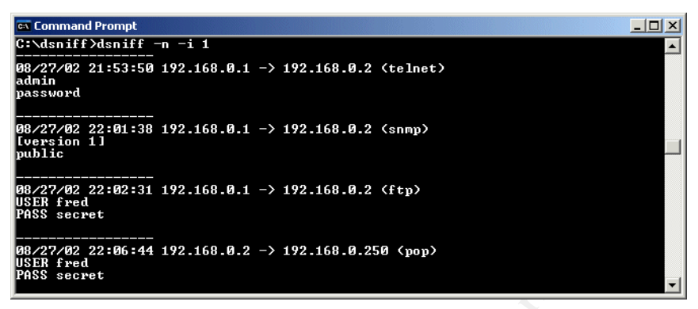
To eavesdrop on traffic a computer network card is put in ‘promiscuous’ mode so that it captures all the traffic coming in and out to snoop on passwords and other sensitive information.

6.2.2 Scoop LM Tool Sniffing NT Usernames and Encrypted Passwords
Figure 5 - Scoop LM Tool Sniffing NT Usernames and Encrypted Passwords
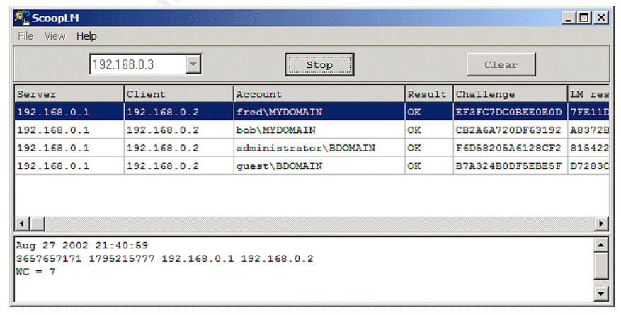

6.3 Write Guidelines

For:
- Che-Si Staff Members
- Vendors and
- Clients

To responsibly use their Personal and Mobile Internet Devices

- Policies and Procedures, combined with

- centralised matrix of malware reporting, to spearhead detection,

- increased awareness of social engineering, and

- ensuring Anti-Virus Software downloaded on all:

    - Staff,
    - Clients’ and
    - Vendors’

personal and mobile devices used to access the Company Server.

6.3.1 Rules for Using Personal Devices at Work
^{[11]} A smartphone or smartwatch could act as a Trojan Horse as the device is brought within the firewall of the company. Simple access to a camera has the potential to cause much harm if the device has access to the network. Setting a password and permissions for location are essential.

6.3.2 Sample Mobile Device Policy
^{[13]} Purpose:
This policy outlines use of mobile devices by employees of Che-Si.
This policy should be read and understood by:
- all employees,
- Vendors and
- Clients
who:
- Want to use, or are using, a personal mobile device for work
- Use a company owned mobile device
- Bring a personal mobile device onto company property
Policy Use of Personal Mobile Devices:
- Employees may have the opportunity to use their personal devices for work purposes when authorized in writing, in advance, by the employee and management.
- Personal electronic devices include, but are not limited to, personally owned cell phones, tablets, laptops and computers.
- The use of personal devices is limited to certain employees and may be limited based on technology. Contact the HR department for more details.
Stipend for Personal Device Use:
- Employees will receive an agreed-upon monthly stipend to use personal devices based on the position and estimated use of the device.
- If an employee obtains or currently has a plan that exceeds the monthly stipend, Che-Si will not be liable for the cost difference.
- The device remains the property of the employee who is responsible for all repairs or replacement of the device.
Employees who:
- have not received authorization in writing from management and
- who have not provided written consent

will not be permitted to use personal devices for work purposes.
- Failure to follow policies and procedures may result in disciplinary action up to and including termination of employment.
Use of company owned mobile devices:
- Certain employees may be issued a company owned mobile device.
- Use of these devices is contingent upon continued employment with Che-Si and the device remains the sole property of Che-Si.
- Company provided mobile devices are part of a ‘family plan’ with shared minutes and include data usage.
- Excessive use of minutes or bandwidth for non-business activity is discouraged and may result in a Payroll deduction for personal usage.
Security:
- Employees must put a PIN, password or other security measures in place on every device that is used to access company information.
- Further, employees are required to have mobile device management (MDM) software installed on their personal mobile devices as recommended by Che-Si.
Mobile Device Management Software:
This software will:
- monitor all emails,
- text messages and
- photos,
- along with the physical location of the device
This software must be installed by the IT department prior to using the device for work purposes.
- When possible, employees should use two-factor or two-step verification for added application/device security.
- Employees may not use any cloud-based apps or backup that allows company-related data to be transferred to unsecure parties (see “approved app list” at the end of this document).
- Due to security issues, mobile devices may not be synchronized to other devices in the employee’s home.
- Making any modifications to the device hardware or software, or installing additional hardware or software, beyond authorized and routine installation updates is prohibited unless approved by the IT department.
- Employees may not use unsecure Internet sites.
- Family and friends should not use personal devices that are used for company purposes.
- Employees whose personal devices have camera, video, or recording capability are restricted from using those functions anywhere in the building or on company property at any time unless authorized in advance by management.
- An employee may not store information from or related to former employment on the company’s device.
Behaviour:
While at work, employees are expected to exercise the same discretion in using their personal devices as is expected for the use of company devices.
- Company policies pertaining to:
- harassment,
- discrimination,
- retaliation,
- trade secrets,
- confidential information and
- ethics
apply to the use of personal devices for work-related activities.
- Excessive personal calls, e-mails, or text messaging during the work day, regardless of the device used, can interfere with employee productivity and be distracting to others.
- Employees must handle personal matters on non-work time and ensure that friends and family members are aware of the policy.
- Exceptions may be made for emergency situations and as approved in advance by management.
- Mobile devices shall be turned off or set to silent or vibrate mode during meetings, conferences, and in other locations where incoming calls may disrupt normal workflow.
Work Hours:
- Non-exempt employees may not use their mobile devices for work purposes outside of their normal work schedule without authorization in advance from management.
This includes but is not limited to:
- reviewing,
- sending, and
- responding to e-mails or text messages,
- responding to calls or making calls.
Employees may not use their personal devices for work purposes during periods of unpaid leave without authorization from management.
- Che-Si reserves the right to deactivate the company’s application and access on the employee’s personal device during periods of unpaid leave.

Privacy:
No employee should expect any privacy except that which is governed by law.
Che-Si has the right, at any time, to monitor and preserve any communications that utilize Che-Si’s networks in any way, including:
- data,
- voicemail,
- telephone logs,
- Internet use,
- network traffic,
- etc.,
to determine proper utilization, regardless of the ownership status of the device used to access the company’s networks.
Management reserves the right to:
- review,
- retain, or
- release personal and company-related data
on mobile devices to government agencies or third parties during an investigation or litigation.
Management may:
- review the activity and
- analyse usage patterns and
- may choose to publicize this data to assure that Che-Si’s resources in these areas are being utilized according to this policy.
Furthermore, no employee shall knowingly disable any network software or system identified as a monitoring tool.
Inspection:
- At any time, the employee may be asked to produce the mobile device for inspection.
- The purpose of these inspections is to ensure that the employee is following company policy.
Safety:
- Employees are expected to follow applicable state or federal laws or regulations regarding the use of electronic devices at all times.
- Employees whose job responsibilities include regular or occasional driving are expected to refrain from using their mobile devices while driving.
- Regardless of the circumstances, including slow or stopped traffic, employees are required to pull off to the side of the road and safely stop the vehicle before placing or accepting a call or texting.
- The only exception to this stipulation is if the call can be placed or accepted entirely hands-free.
- Special care should be taken in situations where there is traffic, inclement weather, or unfamiliar areas.
- Employees who are charged with traffic violations resulting from the use of mobile devices while driving will be solely responsible for all liabilities that result from such actions.
- Employees who work in hazardous areas must refrain from using mobile devices as doing so can potentially be a major safety hazard.
Lost, Stolen, Hacked, or Damaged Equipment:
- Employees are expected to protect mobile devices used for work-related purposes from loss, damage, or theft.
- In an effort to secure sensitive company data, employees are required to have remote wipe software (MDM) installed on their mobile devices by the IT department prior to using the devices for work purposes.
- This software allows all data to be erased remotely in the event the device is lost or stolen. The remote wipe process will remove all programs and data from the phone and reset it to factory defaults.
- Che-Si will not be responsible for loss or damage of personal applications or data resulting from the use of company applications or remote wiping.
- Employees must notify management immediately in the event their mobile device is lost or stolen.
- If the mobile device is damaged, the employee must notify management immediately.
- The employee will be responsible for the cost of repair or replacement.
- Employees may receive disciplinary action up to and including termination for damage to company owned mobile devices caused wilfully by the employee.

Termination of Employment:

- Upon resignation or termination of employment, the mobile device will be reset to factory defaults using the remote wipe software.
- Che-Si will not be responsible for loss or damage of personal applications or data resulting from the remote wipe.

Approved App List | App Name | Function/Purpose

Signed by: |  | Date:
Print Name

REMEMBER TO HAVE YOUR ATTORNEY REVIEW THIS DOCUMENT.

7.0 REFERENCES
[1] | IMPOF (2020, May 1) The importance of Network Security [Online] Available:  Importance of Network Security (impoff.com)  Accessed: 2020 Dec 1
[2] | Student (2019, Dec 10) Security Procedures for a Small Computer Network [Online] Available:  Security Procedures for a Small Computer Network (ukdiss.com)  Accessed: 2020 Dec 1
[3] | FIPS 199, U.S. Federal Information Processing Standards. (2004, Feb). Goals of Security: CIA Confidentiality, Integrity and Availability [Online]. Available:  FIPS 199, Standards for Security Categorization of Federal Information and Information Systems (nist.gov)  Accessed: 2020 Dec 1
[4] | Custom Information Services (2018 Jun 7) 10 Common Flaws in Your Network Security and 10 Important IT Usage Policies Cybersecurity [Online] Available:  10 Common Flaws in Your Network Security | Custom IS  10 Important IT Usage Policies | Cybersecurity | DFW | CIS (customis.com)  Accessed: 2020 Dec 1
[5] | K. Beaver (2018 Jul 11) Hacking for Dummies [Online] Available:  Know Your Network Infrastructure Vulnerabilities to Avoid Hacks (dummies.com)  Accessed: 2020 Dec 1
[6] | A. Welekwe, (2020, Nov 12). Variable Length Subnet Mask Tutorial [Online] Available:  Variable Length Subnet Mask (VLSM) Tutorial - Fully Explained (comparitech.com)  Accessed:
[7] | H.H. Carr et al, The Management of Network Security, New Jersey, Pearson, 2010  p149
[8] | M. Gregg, Certified Ethical Hacker, Prentice Hall, Pearson, 2017, p.234
[9] | A. Moesriami. (2012, Oct 10). Institute of International Finance. Information Security Policies and Standards [Online] Available:  information-security-policies-and-standards-13-728.jpg (728×546) (slidesharecdn.com)  Accessed: 2020 Dec 1
[10] | T. King (2006, Jun/Jul) Packet Sniffing in a Switched Environment. Sans Institute Reading Room [Online] Available:  packet-sniffing-switched-environment-244[5488][2305843009217663723].pdf  Accessed: 2021 Jan 3
[11] | Arvig (2019, Feb 21) Developing a Policy for Devices in the Workplace [Online] Available:  Developing a Policy for Devices in the Workplace? | Arvig Blog (arvigbusiness.com)  Accessed: 2021 Jan 3
[13] | AGJ Systems (2014, Sept 4) AGJ Sample Mobile Device Policy  AGJ-Sample-Mobile-Device-Policy.pdf (d2oc0ihd6a5bt.cloudfront.net)  Accessed: 2021 Jan 3

