Title page:
Student Name: Mohammed Moqbul Ali | Student Number: 1713426
Module name: Leading and implementing workplace change | Module code: BMSW 6103
Assignment Title: Change management and conflict resolution portfolio | Lecturer: Dr Dennis Pepple
Submission Date: 20th of July 2021

Content page:
Topics Page number

Introduction: ……………………………………………………………………………………..3

Part A: Kotter’s change model: ………………………………………………………………4

Part B: Thomas-Kilmann Conflict Model: …………………………………………………..9

Part C: Terms of reference: ………………………………………………………………….12

Part D: Proposal: ………………………………………………………………………………17

Part E: reflection: ………………………………………………………………………………21

Conclusion: …………………………………………………………………………………….22

References: …………………………………………………………………………………….23

Appendix 1: Project Cost Schedule: ………………………………………………………27

Introduction:
Workplace harassment is nothing new in this horizon and may not be able to eliminate completely, however, peoples are more concern and conscious about their personal life and feeling, ever than before. Workplace harassment has a significant amount of negative impact on employees and organisations. It damages individuals mental and physical health which ultimately impact on workplace culture, productivity and costing money.
Google is a multinational worldwide internet search engine founded by Sergey Brin and Larry Page in 1998. Google’s headquarter based in California and has more than 70 offices in 50 countries. Currently over a billion people uses Google’s product. Google’s fun and flexible work culture is most satisfying factors for entire workforce. The main business competitors of Google are Yahoo and Microsoft Bing.
In 2018 Google employees are dissatisfied due to the harassment related complain which forced them to global walkout on the street to protest.

More than 500 google staffs sent an open letter to Google CEO Sundar Pichai, demanding for stop protecting the perpetrators, published in New York Times and Business standard on 21 June 2021. Employees complained that employees are force to have one-to-one with their harasser, harasser works at the next desk, HR does not make any alteration and the victim is forced to bear the burden. Employees described their Google workplace has a history of workplace harassment.
According to New York Times (2021) assistance director Mr Samat admitted google are slow to make decisions although he defend that “The reality is that these are very large decisions.”
Google are required to implement changes sooner than later to save its reputation and protect from further damage.
An organisational change can describe a change from its current state to a desired state through various transitional phase lead through its people side and technical side.
In this portfolio the first part will use and critically evaluate Potter’s eight steps change management model to explain how this change can be implemented. In the second part Thomas-Kilmann’s conflict resolution model will explain on how to resolve the problem effectively. In the third section, a Terms of Reference would draw for engaging independent consultant and provides project guidelines and complicacy. Whereas the fourth section will provide the responses, recommendation and effective solution from the consultant. Lastly the portfolio will end with my personal learning reflection and a brief conclusion.

Part A: Kotter’s Eight steps Change Management Model:
Critical evaluation of how Kotter’s change management model to resolve the Google issues identified in the case study about the ‘MeGoo’ movement that led to a global walkout over racism and sexism harassments.
There are various models of organisational change management in the literature are available (Sidorko 2008, p.307; Stewart and Kringas 2003, p.676; Buchanan 1993, p.684; Smith 2011, p.115; Pillay et al. 2012, p.59), among these models one of the significant and eminent model is Kotter’s eight steps model (Kotter, 1996) of planning, leading and managing changes is a best practice change management framework (Chappell, 2016) widely recognised (Pollack and Pollack, 2014) and prominent in the change management field (Appelbaum, et. al., 2012).
Kotter’s change management model is “...as a vision for the change process” (Mento et al. 2002, p.45) consists of eight successive stages or steps to accomplish the effective change.
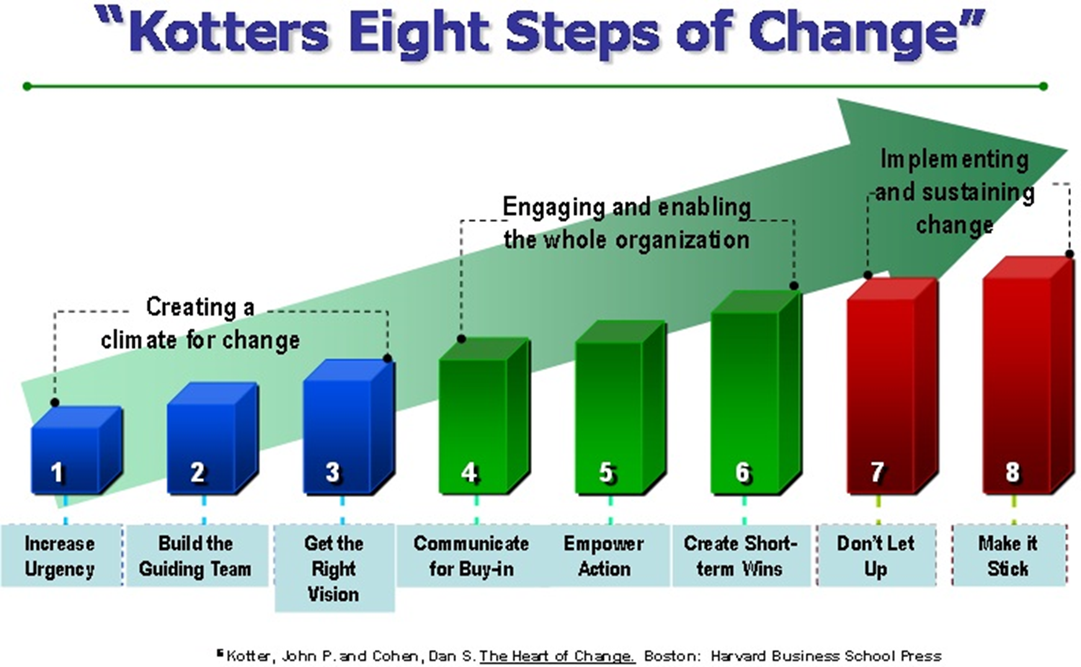
Figure 1: Kotter, John & Cohen, Dan. (2004).

Although Kotter’s eight-step change model considered efficient model (Ansari and Bell 2009, p.160; Cegielski et al. 2006, p.311)., yet, it is not out of criticism, the Model has many advantages and limitations, which describes as below:

Advantages of Kotter’s change model:
Easy and simple to implement: The model consists of eight successive steps which are laid out in a systematic and logical order, makes smooth transition from one step to another, hence it is easy to implement.
Emphasis on buy-in for change: The model emphasises employees’ involvement and acceptance, create motivation by creating and communicating vision, building coalition and providing need of urgency.
Relevant to big organisations: the advantage of this model it suits in all types of organisations including big organisations. As big organisation has huge number of employees and its more appropriate to motivate employee first toward the urgency and goal of the change rather than break in the middle.
Although, the success of the model is dependent on fully completed and successive use of steps one after another.
Disadvantages of Kotter’s change model:
Too simple: According to Jick (1993), Connors and Smith (1999) and Beer and Eisenstat (2000), Kotter’s eight-step change model models is too simple in nature and is a time-consuming process to bring changes in a straight implementation process. (Rose 2002).
The model only described what to do but not provided details on how it should achieve (Pfeifer et al. 2005, p.297), not sufficiently guided detailed in all situations (Applebaum et al. 2012, p.775).
Rigid model: although the model is easy to use but hard to move the steps around. All the eight steps must complete in order, skipping or moving the steps will create problem in the finishing line and never makes changes stick (Applebaum, et. al. 2012).
Time consuming: Furthermore, implementing changes by using eight steps is a time-consuming process (Rose 2002).
Apply only at top-down management where leaders at the highest position enforce which followed by the subordinate employees. It does not allow two-way communication.
Despite of many limitations of Kotter’s eight steps organisational change model, it can be implemented to make changes at Google to tackle harassment In the context of Google case study “MeGoo”.
Kotter’s eight steps organisational change model in terms of Google case study are described as below:
Stage 1: establishing a Sense of Urgency:
In this first stage according to Kotter (1996 p.36) a sense of urgency is crucial for the organisation to make change. Kotter (1996) suggested that organisations trying to make changes without creating a sense of urgency is the biggest mistake, as it causes high complacency, less motivation for change and less power to put everyone together.
Kotter also mentioned that there are many reasons for workforce complacency, for example, the absence of major and visible crisis or organisational structure that focuses employee’s leeway.
In this stage leaders must defrost the status quo by establishing an urgent need for change to avoid a crisis/danger or a reason for doing something different.
Kotter (1996) mentioned that normally good leadership can create a strong sense of urgency as this is usually requires a bold or a risky action, cautious managers will not be able to push the urgency at all. Kotter (1996 p.44) exhibited nine ways organisations can raise the level of urgency, for example, more honest discussion about the firm’s problem, insist people to talk regularly with unsatisfied stakeholders.
In the context of Google case study sexual or racial harassment is the current dissatisfaction as this could lead the organisation into future threat. Google needs to employ a sets of bold top management leaders to change organisation’s structure so that strong message will covey to all level of employees to make changes happen and no one can escape from doing harassment.
Stage 2: Creating the Guiding Coalition:
Any single individual is not able to lead and manage the change process, a guiding coalition team is essential for restructure or reset the strategies to make change initiative is critical to its success.
This guiding coalition team should made up by engaging key stakeholders and providing adequate power, sponsorship and authority to be able to lead and drive the change process. To build a right coalition who can make change happen needs to find right people those are able to create trust and develop common goal. Kotter (1996 p.61) emphasised without trust the teamwork will not work and change will fail.
In the context of Google, a multi-national and wider geographical team needs to create to make sure all cultural views are explored so that the change managed accurately due to the various cultural and national background.
3. Develop a vision and strategy
The guiding coalition team’s first task is to develop and formulate a clear and sensible vision to provide implicit and explicit explanation on why people should make this change happen.
The main purpose of the clear and good vison is to clarify, motivate and align individuals so that they can work with some degree of autonomy and will not end up with conflict and nonstop meetings.
The main characteristic of the vision should be imaginable, desirable, flexible, feasible and easily communicable.
In the context of Google case study, the purpose of tackling/stopping sexual or racial harassment is clear as this will damage organisation reputation and make the overall stakeholder dissatisfied.
4. Communicating the change vision
Good and well communication reduce uncertainty in the organisational change process (Bordia et al., 2004), reduce ambiguity, affect the way of stakeholders’ responses and their confidence to organizational change (Nelissen and Van Selm, 2008).
Klein (1996) suggests repeated and effective communication strategies increase people’s memory which supports Kotter’s suggestion as “ideas sink in deeply only after they have been heard many times” (Kotter, 1996, p. 90). Kotter also suggested that two-way communication is better and more effective than one way.
In the context of Google case study, google change team need to circulate the change vision throughout all media including google theme page using every possible language setting and considering sense of appealing language structure.
5. Empowering broad-based change:
According to Kotter (1995) employees are empowered through successful communication of vision, gaining required training and development opportunity, by removing structural barriers and aligning systems to the vision. According to Kotter (1996) four major barriers to empower employees: structures, skills, systems, and supervisors (Kotter, 1996, p. 102). In a study shows that structure, supervisor’s attitudes, and training play significant role in employee empowerment (Klidas, et. al., 2007).
Google are required to set up and provide tailored training programmes to all employee on what activities are considered as harassment and how to minimise the workplace harassment. Therefore, google to set up localised training centres led by specialised instructors to empower staffs. Training programmes should explore both the cost and effects of harassment and the benefits of harmonised and peaceful working environments.

6. Generating short-term wins
In Kotter’s view generating short-term win is recognition of work being done and to see changes are working along the ultimate vision or target.
The short-term wins help changes in different ways, for example, it shows effort is paying off, test the vision, giving change team a little hope for future success and make changes if necessary.
Short-term wins also remove barriers from employees’ minds (Drtina, et. al., 1996) and provide enough evidence to show that change has achieve desired results (Ford et al., 2008).
Google needs to obtain and produce clear information and statistical data to show reduced harassment directly proportionate with the employee’s satisfaction and organisations increased productivity to encourage everyone for further development on this change.
7. Consolidating gains and producing more change:
Kotter states initial sign of victory is not the end or final of the change, but this can use to tackle other issues, like as structures or systems which are not align with the expected changes (Kotter, 1995).
According to Jansen (2004), committed employees are less likely make barriers and wanted maintain status quo, whereas uncommitted employees are more likely to resist (Hambrick, et. al., 1993). Therefore, consolidate or finalise victory too soon will destroy employee’s momentum or commitments (Kotter, 1996, p. 66). In agreeing with Kotter, Kerber and Buono (2005) suggests that “changes are associated with continuous improvement methods” (Choi, 1995).
As soon as the better result shows on earlier stage 6 Google should not stop all change related activity and declare the final victory too soon.
8. Anchoring new approaches in the culture:
Kotter (1995) believes that new change behaviours must be anchor is social norms and shared value otherwise it will be degraded once the change forces are alleviated.
According to Massey and Williams (2006) a structure for support is required to sustain the changes e.g., training, mentoring or coaching opportunities. Buchanan et al. (2005) stated that the process for institutionalisation changes includes training to establish ideas, competence and commitment in secure.
Kotter further emphasised that when anchoring new change in corporate culture it should show employees on (1) “how the new approaches, behaviours and attitudes have helped improve performance” (Kotter, 1996, p. 67); and (2) ensuring that “the next generation of management personifies the new approach” (Kotter, 1996, p. 67 & Applebaum, et. al. 2012).
Finally, Google needs to establish a permanent change management team which should include various levels of members from every local offices around the world, get regular feedback from involved stakeholders and improve implement continuously.

Part B: Thomas-Kilmann Conflict Model:
A conflict is a disagreement or struggle between two or more individuals or groups on achieving desired goals, when the management of conflict is the philosophy of dealing on how to resolve the conflict effectively and successfully using a set of skills and techniques.
According to Mukhtar & Habib, (2010) Conflict starts when groups or individual have different interest, beliefs and values or opinions on something important to them (Mukhtar & Habib, 2010) or has negatively affected on something they care about (Thomas, 1992 p.653)
Conflict resolution is “the process used by parties in conflict to reach a settlement” (Sweeney and Carruthers, 1996, p. 327).
Thomas-Kilmann Conflict Mode Instrument (TKI) used to assess involved parties’ behaviours in the situation of a conflict and mainly describes in two different dimensions: (1) assertiveness, where one party wants to gain his or her own interests, and (2) cooperativeness, where one party wants to meet other party’s interests (Rahim, 2000).
Thomas-Kilmann conflict management model consist of five mode of conflict resolution strategies: competing, collaborating, compromising, avoiding and accommodating (Thomas, 1976; Thomas & Kilmann, 1974).
Thomas and Kilmann described although we may prefer our own opinion or interest, however, this may change according to conflict situations or our personal disposition.
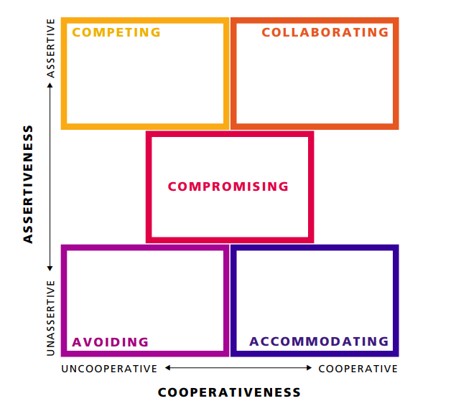
Figure 2: Thomas-Kilmann conflict management model; Source: Thomas. K. W., (1976).

Competing is assertive and uncooperative dimensional approach mode when an individual believed to be right in his or her position and simply wants to win over others at any cost by using aggressive behaviours e.g., authority or threatened if necessary (Thomas & Kilmann, 1974).

Advantages | Disadvantages | Usefulness In terms of Google case study
Better effectiveness in decision, uphold person value and behaviours. | Misuse of power, create hostile situation and damage workplace good relationship. | Victim standing firm means getting own rights, however when perpetrators compete, they win by force.

Collaborating mode is when both parties integrate and satisfies their needs and concern fully by becoming openness and exchanging information to reach into an acceptable solution which satisfy cooperating and problem-solving criteria (Barki & Hartwick, 2001) and is both assertive and cooperative dimensional (Thomas & Kilmann, 1974).
Advantages | Disadvantages | Usefulness In terms of Google case study
Provides best solution, give chances to listen each other and keep everyone moral high, satisfies both parties, met their needs fully, enhances creativity and good relationships in the workplace. | It is not easy but difficult to implement, it takes time and efforts to come to an acceptable solution by each party. | This is the best option to apply In the google conflict. Google are required to collaborate, communicate and listen from both sides to find the root cause of the issue and make a satisfactory solution for the conflict. Therefore, harassment will not occur anymore.

Compromising is where give and take policy applies on mutually agreed situation and partially satisfies all involved parties by sharing and splitting the difference (Barki & Hartwick, 2001). In this mode the middle ground is determined and accepted by all parties through assertiveness and cooperativeness approach (Thomas & Kilmann, 1974).
Advantages | Disadvantages | Usefulness In terms of Google case study
Conflict resolve quickly and easily and working relationship stays in place. | The party who is completely right win half and lose half, the party who is wrong take advantages. | In this mode neither the victim nor the harasser wants to take blame without their own fault. Dissatisfaction will remain in peoples’ heart.

Avoiding mode is a situation when one or both parties do not pursue their concerns immediately where the conflict resurface is very high and seems withdrawal from the conflict (Rahim, 1992). This mode represents unassertive and uncooperative dimensions (Thomas & Kilmann, 1974) and the individual simply withdrawing from a threatening situation or diplomatically sidestepping or postponing an issue for a future better time.
Advantages | Disadvantages | Usefulness In terms of Google case study
Maintain good relationship, provide time to get required strength. | Conflict does not resolve, may get worsen and burst out. | Victim suffers in silence, although it saves victim by knowing from others, victim may obtain enough proofs and supports to come back in the right time. However, lapse of time kills the vitality of the claim.

Accommodating is self-sacrificing approach where an individual satisfies the other party’s interest over his or her own interest (Thomas & Kilmann, 1974), It seems appropriate when the someone consider himself or herself is wrong, preserving harmony and avoiding disruption. This mode follows unassertive and cooperative dimensions.
Advantages | Disadvantages | Usefulness In terms of Google case study
Maintain good relationship, shows sympathy. | Counterproductive, other parties take advantages. | This is not acceptable by anyone in harassment situation as no one wants to give up or take the blame.

In summary, although TKI is a powerful tool to resolve conflict in the modern workplaces, however, the application of this tool in Google harassment case is not much useful and effective apart from collaboration mode.

Part C: Terms of reference
Background and Purpose:
Tech giant Google employees are dissatisfied due to the workplace related harassment issues which includes sexual harassment, racial discrimination and abuse of power in the organisation. It is obvious that employees are not just merely unhappy about the situation, but also the level of dissatisfaction is so massive that it force them to come out on the street to show their anger.
In the case study Google chief executive Sundar Pichai admitted the issue, recognised the employees’ constructive feedback and promised to do the appropriate action to resolve the issue effectively.
As google is a highly trusted organisation over several billion people worldwide, its employee is the key stakeholder and important assets for imputing the vital information into the system.
As a result, Google draws the following Terms of Reference (TOR) for the consultant to provide best recommendation for appropriate solution. This TOR provides objectives of the project work, any issues or concern during the project life cycle, Methodology of work, expertise required, reporting system and the work plan.
The project will require an extensive use of data analysis software, feedback monitoring excel programme, legal experts professionals for introducing new policies and procedures by analysing appropriate and valid data.
Objectives:
The main objective of this project is to combat all kind of harassment including sexual harassment, racial discrimination and unfair treatment to Google employee, aiming from thousands of cases to zero tolerance as soon as possible. The overall target of the project is to achieve the followings objectives:

Objective | Description | Target and time
To collect accurate data | collection of appropriate and valid data from any involved/affected individuals; make local sub team who can communicate with key stakeholder to obtain appropriate and valid data, accumulate them to understand in-depth for facilitating the project work to provide enough communication within the relevant stakeholder for example staff, managers, suppliers and directors which is needed to establish equal right, fair treatment, level field to introduce zero tolerance on any kind of harassment including sexual, racial or cultural harassment or any unfair dismissal. | Contact entire employees by email and get response at least from 50% within 2 weeks of the project start.
To prepare suitable policies and procedure | To alter or make new policies and procedure which is transparent, readily available to everyone and rigid enough so that not able to bend easily nor escape from doing harassment activities. | Prepare draft policy document within 2 weeks and finalised copy by the end of 4 weeks of the start of the project.
To provide appropriate training and education | To provide appropriate education and training to all staff to make them aware what activities fall under harassment, how to keep someone away from doing this activity and to gain adequate knowledge and skills on how to save themselves effectively so that the perpetrator may not be able to take advantage of the situation. | Arrange training programme from week 2 and target to provide training up to 70% employee by week 6 of the start of the project.
To arrange support for victims and discipline the perpetrator | facilitate necessary support for the victims; assure them the allegation will be heard sooner than later and a fair and unbiased treatment will provide to everyone, while at the same time to take necessary disciplinary actions against perpetrators those are guilty. | Support 95% victim within 5 weeks period from the start of the project and take 100% disciplinary action within this timeframe.

Issues
The key issues to be consider in this phase are:
1. Communication: importance to be provided on effective communication process with various stakeholder including Google employee, the project scope needs to establish various channel for example, internal and external media, websites, leaflet, news articles, group discussions and individual consultation to communicate key messages effectively among everyone involved.
2. Education and training: to make sure the training programme are appropriate to the topic and easy to understand by all the employees. To make sure all employees are able participate into the training sessions.
3. Policy and procedure: to make sure the policies are not contradictory from each other nor restricted by other rules etc. and remains in the organisation once the project work is finish.
The other issues to be considered in this project work are:
Google is a worldwide organisation, and its workplaces are in all over the world, make sure local area team should have representative who are aware of their race, religion and cultural backgrounds.
People uses many different languages and may have difficulties to communicate in one language such as English only.
Employees are working in different time zone areas.
Some of the employees may have various illnesses or disabilities.
Employees could have agile flexible working pattern which facilitate harassment or allowing for false accusation.
Some employees may desperately work for money and may consider accepting all kind of harassment without reporting the truth.
Since this project handle the sensitive nature of work, hence the project team and external agency who are involve in this project need to maintain extreme confidentiality while they need to take active listening and empathetic approach as well as.

Methodology
1. the key phases of this project are:
(a) collection of appropriate and valid data from any involved/affected individuals; make local sub team who can communicate with key stakeholder to obtain and analyse appropriate and valid data which may facilitate the project work.
(b) preparing and producing suitable policies and procedures; need to know what policies and procedures are to be included e. g., should the harassment issue be included in the organisation’s gross misconduct or not.
(c) providing adequate education and training facility to all employees and management personnel; communicate need of training according to Kotter’s model as described in part ‘A’ and encourage to attend, provide enough facilities, like as arrange locally, so that everyone can participate.
(d) facilitate necessary support for the victims; assure them the allegation will be heard sooner than later and a fair and unbiased treatment will provide to everyone.
(e) to take necessary disciplinary actions against perpetrators those are found guilty.
2. Stakeholder’s involvement: contact every stakeholder by emailing, in writing or by meeting one-to-one or in group to get their opinions and feedback. The project team need to maintain liaison with portfolio team and project sponsor at the start and end and in addition every now and often to provide the progress of the work and the work schedule.
3. Content and duration of task: the content which described in section 1 of this part and their duration of work should be as follows:
(a) collection of data – within 2 weeks of project work start.
(b) making policies and procedures – within 4 weeks of project work start.
(c) training and education – within 6 weeks of project work start.
(d) implementation of policies – within 6 weeks of project work start and
(e) closer of project and provide feedback meeting within 7 weeks of the project start.
4. how to collect information and analysis data: by asking every individual as mentioned in section ‘2’ and by recording all the information into excel spreadsheet accurately for clear monitoring, analysing and evaluating purposes.
Expertise
The type of work involve is to gather information and obtain data from honest response from entire workforce, store and analyze data correctly also preparing suitable policies and supporting victims while punishing the guilty.
This project requires individual who possess adequate skills and abilities on eliciting and recording information most accurately, has expertise on employment legislation etc.
The project work requires at least one individual from each 50 offices/countries and 5 other members from central head office.
The remote team will initially collect data from stakeholders and pass it to central team while central team will produce the policies which will communicate to local office by the remote team.

Reporting
The project manager needs to write clear, elaborate and up-to-date reports on completion of every milestone in English language to the project sponsor. The report should consist of table of content which include introduction, work completed and wark to complete with schedule date preferable in word document, whereas the work schedule should draw excel Gant Chart attached as annexes.
The project manager will be responsible for reporting to project portfolio team and project sponsor will be main approval authority for any document, policy or budget.
In addition to the above, the project report should be translated into other local languages where local offices are based for viewing of the involve parties as long as not contradict with local legislation.
Work plan
This project anticipates minimising harassment conflict between employees and Google organisation by gathering appropriate data, introducing appropriate policies and education/training staff while supporting the victim and discipline the perpetrator.
The project initially allocates £1m (one million sterling pounds) on successfully completion of the project work.

Part D: Consultant proposal
Introduction –Thank you for your invitation. May we take this opportunity to put forward our project plan to resolve the Google harassment issues effectively and successfully. For your information Ali & Ali is the renowned international consulting firm based in Birmingham dealing with various project successfully against harassment and discrimination for the last 20 years. We have sub-offices and local delegates all over the world. Please find our project plan and cost schedule as below.
The issues within Google workplace –The world leading organisation Google now faced new challenge to tackle sexual, racial and gender harassment including unfair treatment, misconduct and abuse of power from superiors.
The consequences of harassment issue make detrimental impact on Google. Employee will lose their motivation and trust within the organisation and will leave the workplace which will cause additional cost to recruit and train, will be hard to find new talent quickly. The workplace will be hostile environment poor employee relationship which will increase employee absentee from work, as a result productivity will decrease.
Above all, the organisation must pay for the cost of the successful claim and good reputation will destroy in the eyes of the valued customer.
Planning and proposals:
Roberts (2011) described a project has five stages: discovery, initiation, delivery, closure and realisation.
Our planning will include all these phases and in discovery phase we will use Nadler-Tushman Congruence Model figure 3 to study your organisation, define problem and estimate its complexity and effort required.

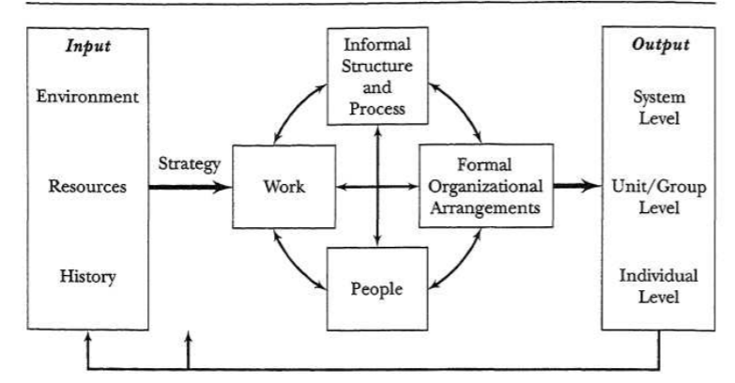
Figure 3: Nadler-Tushman Congruence Model. Source: Nadler and Tushman, (1992 p.54).
According to the Nadler and Tushman model (1980,1992) the inputs must be compatible, consistent and congruent with the outputs. In this model the 4 components; task, employee, organisational structure and culture plays as catalyst, without these nothing can go well. Therefore, at Google organisation employees’ satisfactions are of great importance. Organisational structure to be change by changing strategies and by constructing good policies, for example, establishing better complaint reporting management system. Google work culture is different from traditional organisation, however, these work culture may be favourable for the harassment and discrimination. For example, working alone on unsocial hour may not suitable and appropriate for a female employee.
Google needs to decentralise decision making process and power of authority should not lie on one person hand, decision making on recruitment and on harassment conflict issue the power should distribute to a multi sectional task force. A new workplace culture needs to establish for easy reporting system and apart from directly to line manager, anonymous reporting and whistleblowing system, CCTV camera, do not work alone policies, avoid working unsocial hours, checking and monitoring on new recruitments, listen and resolve issues sooner than later, provide better support and compensation for victims should be adhered to in all situations.
Considering organisational environmental position, employees are part of the core element of organisation. Hence, Google must respond any issues promptly and adapt all necessary changes appropriately because Google employee’s satisfaction can provide better result from inputs to outputs, suppliers to customers and purchasing to marketing. Therefore, our plan prioritised employee satisfaction by listening from them, giving them appropriate training and education facilities and providing better harassment management policies and procedure.
At the initiation phase we will create our central project team with 5 member of staff including project manager and local area teams will form by 1 delegate from each of the 50 google workplace country. The local team will remain as a bridge of communication between the central team and the local employees.
In this phase we will collect all the necessary data for completion of project work. We think analysis of full and accurate data is vital for making the proper decision and better for the next phase of project work implementation.
According to study published by Equality and Human Rights Commission (2020), “around half of victims does not report their experience of harassment to anyone in the workplace. Barriers to reporting included:
• the view that the employer would not take the issue seriously
• a belief that alleged harassers, particularly senior staff, would be protected
• fear of victimisation
• a lack of appropriate reporting procedures.”
The next part of the work will involve training and educating of all staffs including senior managers and executives at the google headquarter and at the local offices. Local area training and education will design and by the local team considering employees various needs and cultural background.
We highly stretch on training and education because behaviours may occur intentionally or unintentionally. Peoples’ knowledge and perceptions varies from person to person. Again, while an activity could be permitted or norm on one culture or one group of people but totally different from others. For example, kissing or hugging with different gender is normal in European or English culture while prohibited on Indian or Japanese culture.
Therefore, proper training and education will make the employee fully aware of which behaviour is appropriate in which place.
Finally, those people will cause the issue intentionally and by knowingly the proper and stricter policy and procedure will force then down. At the same time, the new policies will remove the barriers of reporting any unaccepted behaviours and will protect the victim from unnecessary further harassment or victimisation. The reporting system will design in such a way so that victims can report freely and anonymously.
If you are happy with our above plan, we will deliver the project work within the schedule time and within the allocated budget then will declare the closure of the project officially. However, we do not believe this is the end of our work, for your satisfaction and for our future learning from any unintended mistake, we will meet you and your team after 1 weeks of end of project to get your feedback and to know how the success of the project work.

Cost and time:
We estimate the project work will complete within 6 weeks of the start of the project by utilising of 55 expert consultants. The first 2 weeks will be data collection and proper analysis of data, next 2 weeks to educate and train employees and the last 2 weeks to cover creating and implementing appropriate policies and procedure by proper discussion with all staff.
Here, 6 weeks = 30 working days x 55 people = 1650 consultation days x £500/day = £825,000. In addition to that travel cost, food, communication cost with employees, training cost, printing policies and publication cost would be £175,000.
Therefore, we estimate the total cost of this project will be £1m (one million Great British pound sterling). Please see the breakdown of the cost on Appendix 1 attached for your information. However, we would like to remind you here about the golden rule of Iron Triangle of project work below. If you decide to increase the project scope within any point of the project work, by keeping the same quality of work, this will ultimately increase the project time and cost. However, the overall benefit outweighs cost.

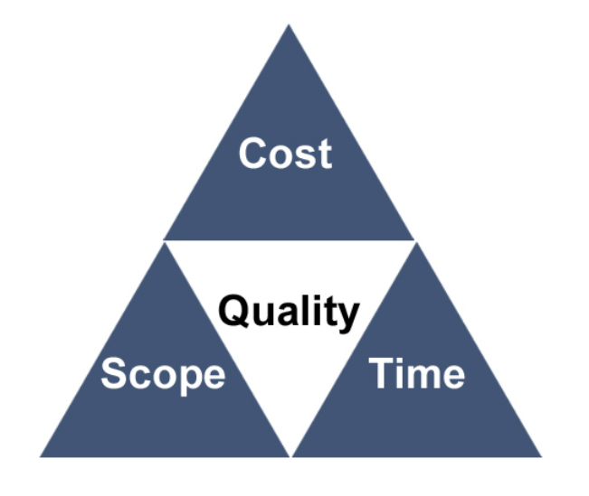
Figure 4: Iron Triangle, Source: https://www.prince2.com/uk/blog/project-triangle-constraints
Executive summary:
High profile organisation google are facing multiple harassment and discrimination claim resulting global walkout by the employee. Instant reaction has been taken by the organisation to resolve the issue adequately and effectively by making appropriate changes. In this circumstance, renowned consulting firm Ali & Ali has been given the responsibility to execute the project according to TOR drawn by the Google organisation. Consulting firm Ali & Ali established that the work is very sensitive due to nature of the work, culture of the organisation and diversity of the employee. They proposed to communicate with all employees, collect and analyse date, train and educate employee and implement rigorous policies within 60 working days for estimated cost of £1 million pound.
Part E: reflection:
Applying Graham Gibbs' Reflective Cycle 1988 to my learning experiences of this module:
Description: in this module I studied Leading and implementing workplace change management and designed a framework for a Change management and conflict resolution portfolio for organisational change in Google to overcome harassment issues as part of my assignment.
Feelings: I was excited to learn this topic on how to make new changes in the organisation as I knew making essential and appropriate changes are very important to compete and survive. However, the assignment was very long, and I was worried whether I could complete the assignment on time.
Evaluation: Although I learnt some of the topics in advance for example, Kotter’s Model and some project work on my previous modules which overall helped me in here however, I also gained lots of extra knowledge about the change management theories and models, for example Thomas-Kilmann conflict Management Model and my teacher was very helpful he explained well about the change management in the class as well as.
Analysis: on looking back I realised my teacher was so helpful and experience on this subject that he has not only taught us well but encouraged and empowered us so that we could explore further and learn better. This helped me to look various ways on how to make effective changes on organisation and found different models and techniques to use on organisational changes.
Conclusion: I understand that organisations need to make changes constantly to make better and to survive in this competitive world.
Action plan: in future I will apply this change management learning on my future course of MBA study.
Conclusion:
In the case study Google are facing workplace harassment which related to sex, race, religion and disability. People are abusing their power causing discriminations and harassments at google workplace. Google realised to make necessary changes urgently is inevitable.
This report outlined Kotter’s eight steps change management model and Thomas-Kilmann conflict management theory to resolve the Google issue and mange changes more accurately to make it more stable in the long run. Although Kotter’s eight steps model is the best to serve the purpose, however, it has many advantages and disadvantages as well as. A suitable term of reference has been drawn for the consultant on this purpose and the best recommendation has been obtained for the possible effective solution.
Google is an international organisation, its workplace is based all over the world, hence the issue involves with many different race, religion and cultural background, therefore, careful consideration has been taken to planning and on delivering project work.
Making change is not difficult but making effective, successful and sustainable change is hard. For this reason, according to business studies, around 80% of change initiatives fail to achieve ultimate target value. Therefore, Google allocated reasonable amount of time and resources to make necessary changes.
References:
- Ansari, S. & Bell, J. (2009) Five easy pieces: a case study of cost management as organizational change. Journal of Accounting & Organizational Change 5:139-167
- Appelbaum S, Habashy S, Malo J, Shafiq H (2012). Back to the future: revisiting Kotter's 1996 change model. Journal of Management Development 31:764-782.
- Barki, H., & Hartwick, J. (2001). Interpersonal conflict and its management in information system development. MIS Quarterly, 25, 195-228.
- Burnes, B. (2009 p.386). Managing change, Pearson Education Limited, London, England
- Beer, M. & Eisenstat, R.A. (2000). The silent killers of strategy implementation and learning. Sloan Management Review, 41(4), 29-40.
- Bordia, P., Hunt, E., Paulsen, N., Tourish, D. and DiFonzo, N. (2004), “Uncertainty during organizational change: is it all about control?”, European Journal of Work and Organizational Psychology, Vol. 13 No. 3, pp. 345-65.
- Buchanan D (1993) Review of 'A Strategy of Change: Concepts and Controversies in the Management of Change'. Journal of Management Studies 30:684-686.
- Buchanan, D., Fitzgerald, L., Ketley, D., Gollop, R., Jones, J.L. and Saint Lamont, S. (2005), “No going back: a review of the literature on sustaining organizational change”, International Journal of Management Reviews, Vol. 7 No. 3, pp. 189-205.
- Business Standard.com, Published April 10, 2021: Google is at its peak, but employees see cracks and question CEO Pichai. Available at: https://www.business-standard.com/article/international/500-workers-ask-sundar-pichai-to-stop-protecting-harassers-at-google-121041000247_1.html(Retrieved on 30 June 2021).
- Cegielski C, Hall D, Rebman C (2006) Enterprise resource planning systems implementation success. International Journal of Information Systems and Change Management 1:301-317.
- Chappell, S., Pescud, M., Waterworth, P., Shilton, T., Roche, D., Ledger, M., Slevin, T. and Rosenberg, M. (2016). Exploring the Process of Implementing Healthy Workplace Initiatives: Mapping to Kotter's Leading Change Model. Journal of Occupational and Environmental Medicine. 58. 1. 10.1097/JOM.0000000000000854.
- Choi, T. (1995), “Conceptualizing continuous improvement: implications for organizational change”, Omega: International Journal of Management Science, Vol. 23 No. 6, pp. 607-24.
- Connors, R., & Smith, T. (1999). 180 days to a 180-degree turnaround. Journal of Business Strategy, 20(3), 1-5.
- Dmitry Uspenskiy (2012 p.34). Change Management Approach for Enterprise Transformation and Improvement.
- Drtina, R., Hoeger, S. and Schaub, J. (1996), “Continuous budgeting at The HON Company”, Management Accounting, Vol. 77 No. 7, pp. 20-4.
- Equality and Human Rights Commission (2020). Sexual harassment and harassment at work Available at:https://www.equalityhumanrights.com/en/publication-download/sexual-harassment-and-harassment-work-technical-guidance (Retrieved on 20 June 2021)
- Ford, R., Heisler, W. and McCreary, W. (2008), “Leading change with the 5-p model: ‘complexing’ the swan and Dolphin hotels at Walt Disney world”, Cornell Hospitality Quarterly, Vol. 49 No. 2, pp. 191-205.
- Hambrick, D.C., Geletkanycz, M.A. and Fredrickson, J.W. (1993), “Top executive commitment to the status quo: some tests of its determinants”, Strategic Management Journal, Vol. 14 No. 6, pp. 401-18.
- Jansen, K.J. (2004), “From persistence to pursuit: a longitudinal examination of momentum during the early stages of strategic change”, Organization Science, Vol. 15 No. 3, pp. 276-94.
- Jick, T.D. (1993). Managing change. Boston: Richard D Irwin.
- Kerber, K. and Buono, A.F. (2005), “Rethinking organizational change: reframing the challenge of change management”, Organization Development Journal, Vol. 23 No. 3, pp. 23-16.
- Klein, S.M. (1996), “A management communication strategy for change”, Journal of Organization Change Management, Vol. 9 No. 2, pp. 32-46.
- Klidas, A., van den Berg, P.T. and Wilderom, C.P.M. (2007), “Managing employee empowerment in luxury hotels in Europe”, International Journal of Service Industry Management, Vol. 18 No. 1, pp. 70-88.
- Kotter, J. (2008). A sense of urgency. Harvard Business School Press, Boston.
- Kotter, J. (2005). Our iceberg is melting. St. Martin’s Press, New York.
- Kotter, J. (1996). Leading Change. Harvard Business School Press, Boston.
- Kotter, John & Cohen, Dan. (2004). The Heart of Change: Real-Life Stories of How People Change Their Organizations. Performance Improvement. 43. 10.1002/pfi.4140430712.
- Lewin, K (1951) Field Theory in Social Science, Harper and Row, New York.
- Massey, L. and Williams, S. (2006), “Implementing change: the perspective of NHS change agents”, Leadership & Organization Development Journal, Vol. 27 No. 8, pp. 667-81.
- Mento A, Jones R, Dirndorfer, W (2002). A change management process: Grounded in both theory and practice. Journal of Change Management 3:45-59.
- Mukhtar, S. & Habib, M. N. (2010). Private Sector managers approach to conflict management: A study of relationships between conflict management styles and personality type. Interdisciplinary. Journal of Contemporary Research Business, 2,1, 304-312.
- Nadler, D. A., Tushman, M. L. (1992). Designing organizations that have good fit: A framework for understanding new architectures.
- Nelissen, P. and van Selm, M. (2008), “Surviving organizational change: how management communication helps balance mixed feelings”, Corporate Communications: An International Journal, Vol. 13 No. 3, pp. 306-18.
- Pfeifer T, Schnitt R, Voigt T (2005) Managing change: quality-oriented design of strategic change processes. The TQM Magazine 17:297-308.
- Pillay J, Hackney R, Braganza A (2012) Informing strategic IS change: Towards a 'metalearning' framework. Journal of Strategic Information Systems 21:58-71
- Prince2.com project work. Available at: https://www.prince2.com/uk/blog/project-triangle-constraints
- Rahim, M. A. (2000). Empirical studies on handling conflict. International Journal of conflict Management, 11, 5-8.
- Rahim, M. A. (1992). Managing conflict on organizations. Westport, CT: Praeger Publishers.
- Roberts, P., (2011). Effective Project Management. London: Kogan Page.
- Rose, K.H. (2002). Leading change: A model by John Kotter.
- Sidorko P (2008) Transforming library and higher education support services: can change models help? Library Management 29:307-318
- Smith I (2011) Organisational quality and organisational change: Interconnecting paths to effectiveness. Library Management 32:111-128.
- Stewart J, Kringas P (2003) Change Management - Strategy and Values in Six Agencies from the Australian Public Service. Public Administration Review 63:675-688.
- Sweeney, B., & Carruthers, W. L. (1996). Conflict resolution: History, philosophy, theory, and educational applications. School Counselor, 43, 326-44.
- The New York Times, Published June 21, 2021; By Daisuke Wakabayashi: Google Executives See Cracks in Their Company’s Success. Available at:https://www.nytimes.com/2021/06/21/technology/sundar-pichai-google.html(Retrieved on 30 June 2021)
- Thomas, K.W. (1992). Conflict and negotiation processes in organizations.
- Thomas, K.W. (1976). Conflict and conflict management. In M.D. Dunnette (Ed.), Handbook of industrial and organizational psychology (pp. 889-935). Chicago: Rand McNally.
- Thomas, K. W., & Kilmann, R. H. (1974). Thomas-Kilmann conflict MODE instrument. Tuxedo, New York: XICOM.

Appendix 1: Project Cost Schedule

