

MBA – Master of Business Administration
MARKETING MANAGEMENT
LCMB7001

Assessment 2

Student name – Clerina Perara
Student ID - 2215775

Table of Contents
Introduction 3
External challenges in the marketplace 3
Internal issues and role of marketing within boohoo 6
Recommendations 8
Conclusion 9
Reference list 10
Appendix -Issues regarding digitalization 12

Introduction
An adequate marketing condition designates a successful expansion of any business. A business firm can face major problems regarding its globalization. Such issues may include the unstable focus on consumer demand, competitive market policies, managing its business reputation, awareness, and competition of branding image. To mitigate these issues there must focus on creative business policies. This study is conducted based on the marketing analysis of Boohoo, an online business retailing organization in the UK, that comprises more than 36,000 products with approximately £856.9 million in selling revenue in 2019 (Wheeler, 2021). For the global growth of this business, it suffered from such issues, however, through some efficient and effective marketing strategies, this can survive most of the issues.

External challenges in the marketplace
Globalization challenges
Globalization has paved a new way for organizations to expand their business operation in a broader marketplace. In the case of Boohoo, there is a challenge to reaching local customers in the UK as the cost of living has increased in recent globalization issues. In August 2022, Boohoo reported a 13% fall in its year-on-year profit as a result of a downfall in consumer demand that it had expected (Drapersonline.com, 2022). Global issues of the pandemic Covid-19, the Russia-Ukraine war, market rate changes, and others have affected British people to limit their expenses in recent days. The annual inflation rate in the UK in October 2022 reached 11.1% which is a 41-year high (Commons Library.parliament.uk, 2022). It is reflected in Figure 1.
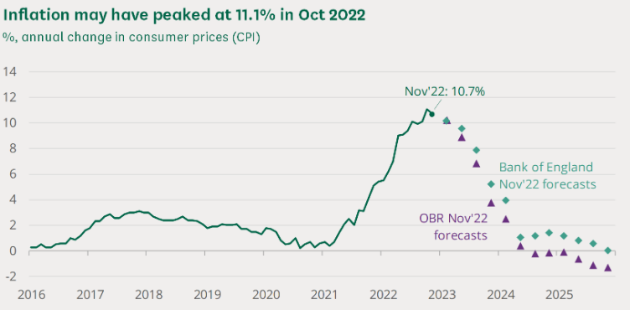
Figure 1: Inflation rate in the UK
(Source: Commons Library.parliament.uk, 2022)
The pandemic crisis has impacted the company’s sales and Boohoo has reported a more than 18% downfall in its shares in the first quarter of the financial year 2022 (Theguardian.com, 2022). On the other hand, to maintain its position as a reputable market player during the Russia-Ukraine war, Boohoo has supported Ukraine and suspended all sales in Russia. As a result, Boohoo has faced a loss of 0.1% in Boohoo Group’s revenue collection (Business-live.co.uk, 2022). All these challenges of the global marketplace have affected Boohoo’s business operation widely and thus it needs innovative strategies for marketing to gain customers' involvement.
Issues regarding digitalization
Different issues of digitalization are another challenge for organizations as they require technology implementation and acceptance by all stakeholders. [Referred to Appendix]
The competitive market of the company
Boohoo has been involved in higher market competition with all its competitors such as Zara, Asos, and different others. It has been observed that Boohoo has collected the highest revenue of 1.2 billion British pounds in the UK (Statista.com, 2022). Alternatively, some external factors such as suppliers, customers, new market players, and others are impacting the business of Boohoo.
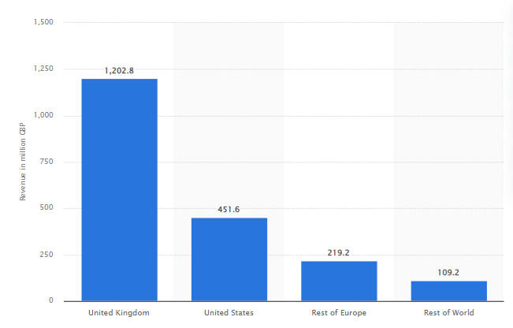
Figure 2: Revenue Collection of Boohoo
(Source: Statista.com, 2022)
Porter’s five force analysis is going to be evaluated in the following to showcase the competitive position of Boohoo.
- Suppliers’ power (Low)
Boohoo group is more transparent about its supply chain and it ensures the highest performance from sustainable business operations. Presently, the company has incorporated 1100 suppliers in its business and has decided to take more measures for a transparent supply chain (Drapersonline.com, 2021). It has been observed that the power of suppliers in Boohoo’s business is lower as the company has more options to select its suppliers by measuring their sustainable business practices. On the other hand, the competitive position and market reputation of Boohoo have also influenced the company to connect with its potential suppliers.
- Customers’ power (High)
Boohoo is facing a challenge in managing customer retention in business as recently the company has recorded more product returns and refunds. On the other hand, the recently introduced policy of Boohoo charges customers £1.99 for every parcel they return to the company (Drapersonline.com, 2022). This initiative has affected the customer retention rate of Boohoo immensely. On the other hand, the availability of other fashion brands such as Zara, Asos, and others has created more options for customers, thus the power of customers is high.
- Competitors’ power (High)
Asos is one of the major competitors of Boohoo and the collected revenue of this company is £3.94B (Marketbeat.com, 2021). On the other hand, Zara’s owner Inditex has expected to enhance sales by 30% by 2024 (Retail-insight-network.com, 2022). Therefore, competitors' power in business is higher for Boohoo.
- Substitute’s power (low)
Substitute’s power is lower as Boohoo is involved in sustainable product development as demanded by customers.
- New entry’s power (low)
The power of new market entry is also lower as Boohoo has already developed a huge customer base in the global marketplace.
Information management system
Information management in the time of digitalization has become another external challenge for Boohoo. Recently, the company has included the “Aiimi Insight Engine” to manage huge customer and employee data in business (Retailtechnology.co.uk, 2022). Challenge to connect with all stakeholders so that they can understand the business initiatives of Boohoo has been observed in its information management system implementation. Challenges to automating data management, and securing access to information in the digitized system have also affected Boohoo’s supply chain and marketing practice.
Customer satisfaction
Customer engagement is the focus of Boohoo to increase its sales and thus it has adopted the “test and repeat model” to enhance customer satisfaction (Boohoo.com, 2022). In this process, Boohoo needs to check customers' reorders of different products so that it can develop strategies for higher customer satisfaction. On the other hand, ethical business practices, ensuring sustainable sourcing, affordable product prices, and quality material, lower use of chemicals and others are also focused on by Boohoo to mitigate its customer satisfaction challenge.

Internal issues and role of marketing within boohoo
The rapid growth of Boohoo Group Plc. influenced by several internal and external challenges. To describe the internal issues of this company, there has been determined different internal influencing factors through an analysis of the SWOT model. This focused on the company's key strengths, opportunities, weaknesses, and threats.
Internal factors analysis through SWOT
Strengths  - Highly automated and effective distribution of centers  - Highly increase financial growth  - Strong presence in the global competitive market  - Successful implementation of “fashion-for-all” business approach | Weaknesses  - Less diversification for body-positivity mobility  - Controversy makes the brand reputational damage  - Less adaptability in the rural market.
Opportunities  - Business dealing with reputed personalities Jon Jones, Quavo and others that enhance its visibility.  - In the era of covid-19 pandemic online business stores get more popular  - Digitalized fitting technologies help to gain a positive experience in shopping | Threats  - Rapid changes in customer demand for fashion  - Highly competitive business market  - Economical volatility of the UK.
Table 1: SWOT Analysis
(Source: Created by Author)
By this analysis, it has been shown that the company has faced major issues with suppliers' less loyalty. Moreover, its business model can easily copy by its competitors. For overcoming this issue, a company should organize a platform model that effectively incorporates the end-users, vendors, and suppliers. One of the significant weaknesses of Boohoo is that its price range of products is difficult to adopt by rural citizens and less adoption of products in the urban marketplace (Duffy, and Watts, 2022). Mostly this company faces the infringement of its IPR, especially in its business market of China.
Role of marketing strategies to mitigate the issues
Based on the analysis, Boohoo faces problems from the perspective of a high inflation rate in the UK, the pandemic scenario that affects the global revenue of the country, and the Russia-Ukrain war. However, the company has followed some significant marketing theories to overcome this problem. Multinational marketing and Global marketing theories are essentially approved by the company. However, as this is an online marketing organization, the management of the Covid-19 situation becomes easier for this industry. It can enhance the annual revenue while non-essential retail shops were closed during the social distancing condition of a pandemic, compared with the last year (Statista.com., 2023). The business earned about 183 million pounds in the UK. The overall income in 2020 for 3 months was about 367.9 M pounds.
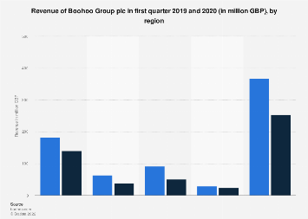
Figure 3: Boohoo’s revenue during the pandemic
(Source: Statista.com, 2023)
Verishop, SHEIN and Asos are the strongest competitors of Boohoo. To implement the strongest presence beyond such rivalries, it should imply effective business strategies. The main aim should be the customer’s demand. Nowadays, people’s demand for the fashion sense rapidly changed, and this must focus on unique fashion styles. As this is an online organization, it this becomes more popular with young customers (Arora et al., 2022). Hence it should develop supply chain management and service delivery technologies. It has taken different attractive offers and replacement policies, refund strategies and the “cash on delivery” for its offered services, which significantly influence the customer's interest.

Recommendations
Based on the value proposition Boohoo sets its global e-commerce marketing aim, incorporating different stakeholders. The main moto is to manage the consumer's proposition, the latest ideas on fashion with a suitable price range and better-experienced customer service policies. Boohoo follows the “Test and Repeat” inventory model to hold its value proposition. To successfully conducted the marketing strategies and value proposition there have been some issues with this company. Therefore, some recommendations for its sustainability advantages of competitiveness may be as follows:
- Company should build up a unique branding image to overcome the “Intellectual Property Rights” infringement issue.
- Boohoo faces a significant loss based on the high customer pressures regarding cost-of-living and return policies, reported approximately £882.4 Million or a 10% revenue drop for this aspect of Boohoo. It should strengthen online delivery technologies and loyal return policies.
- Boohoo Plc should develop a strong adaptability strategy in its urban marketplace and should concentrate on the price distribution of its offered products. It can follow the standard price distribution for managing the inflation rate of the company to set suitable price.
- To mitigate the global entry obstacles, it should be focused on the cross-cultural business strategies of the company.
- For getting effective Sustainable Competitive Advantages, the company has to analyze and determine the targeted market demand in the competitive marketplace.
- Brand loyalty is another aspect of a value proposition. Based n the customers' experiences, it should be fixed on the key requirements to boost the attractiveness of products.
- The online advertising strategies may be more significant for this company’s growth. According to Gunn, 2022, the active Instagram customers of Boohoo are about 7.4 M and Boohoo Man contains 1.7 M based on the data 2021.

Conclusion
Boohoo Group Plc. is the online fashion retailing industry of the UK, facing many competitive challenges in the global marketplace along with several technological issues, networking business policy problems, and internalization issues. This study is conducted based on its marketing strategies and its facing problems. To mitigate such issues the company has adopted some significant business strategies. This report has mentioned those strategies along with the internal and external business influencing factors of this industry are discussed based on SWOT and porter’s model analysis. Thus, some relevant effective recommendations are connected with this company, which have been discussed. The company can globalize the business by implementing such recommended ideas.

Reference list
Anang, E. and Wang, Q., (2022). How News Reports and ESG Publication Financially Affect Firms. Journal of Corporate Finance Research/Корпоративные Финансы| ISSN: 2073-0438, 16(3), pp.38-62.
Bailey, I., (2019). Content cut. Ragtrader, (Sep 2019), pp.14-15.
Boohoo.com, (2022). Boohoo UK, Available at: https://www.boohoo.com/ [Accessed on: 9/1/2023]
Business-live.co.uk, (2022). Online fashion giant Boohoo suspends sales in Russia after invasion of Ukraine, Available at: https://www.business-live.co.uk/retail-consumer/online-fashion-giant-boohoo-suspends-23273547 [Accessed on: 9/1/2023]
Commonslibrary.parliament.uk, (2022). Consumer goods and energy prices pushing inflation higher, Available at: https://commonslibrary.parliament.uk/research-briefings/cbp-9428/#:~:text=The%20cost%20of%20living%20has,goods%20and%20services%20for%20households. [Accessed on: 9/1/2023]
Drapersonline.com, (2021). Boohoo publishes list of 1,100 suppliers, Available at: https://www.drapersonline.com/news/boohoo-publishes-list-of-factories-and-fourth-leveson-report#:~:text=Boohoo%20Group%20has%20today%20published,transparent%20about%20its%20supply%20chain. [Accessed on: 9/1/2023]
Drapersonline.com, (2022). Boohoo ‘must re-educate customers’ to meet its challenges, Available at: https://www.drapersonline.com/news/boohoo-must-re-educate-customers-to-meet-its-challenges [Accessed on: 9/1/2023]
Marketbeat.com, (2021). boohoo group - BOO Competitors, Available at: https://www.marketbeat.com/stocks/LON/BOO/competitors-and-alternatives// [Accessed on: 9/1/2023]
Ozuem, W. and Willis, M., (2022). Brand Relationship and Engagement. In Digital Marketing Strategies for Value Co-creation (pp. 131-156). Palgrave Macmillan, Cham.
Reid, L.F., Marvell, A., Parker, D. and Ward, P., (2021). Virtually the Same: Understanding Consumer Experience in an Omnichannel Environment. In The Value of Design in Retail and Branding (pp. 123-135). Emerald Publishing Limited.
Retail-insight-network, (2022). Zara's owner Inditex registers €14.8bn in sales for H1 2022, Available at: https://www.retail-insight-network.com/news/zara-inditex-h1-2022/ [Accessed on: 9/1/2023]
Retailtechnology.co.uk, (2022). Fashion retailer boohoo group has chosen a new provider to supply next gen data management, Available at: https://www.retailtechnology.co.uk/news/7703/boohoo-enhances-data-management/ [Accessed on: 9/1/2023]
Statista.com, (2022). Revenue of Boohoo.com Plc. group during the fiscal year 2021/22, by region, Available at: https://www.statista.com/statistics/794936/boohoo-plc-group-revenue-by-region/#:~:text=This%20statistic%20shows%20the%20revenue,million%20in%20the%20United%20States. [Accessed on: 9/1/2023]
Theguardian.com, (2022). Boohoo shares drop 18% as new Leicester factory reports threaten sales, Available at: https://www.theguardian.com/business/2020/jul/13/boohoo-shares-drop-18-as-new-leicester-factory-reports-threaten-sales [Accessed on: 9/1/2023]
Vlados, C., (2019). Change management and innovation in the “living organization”: The Stra. Tech. Man approach. Management Dynamics in the Knowledge Economy, 7(2), pp.229-256.
von Berlepsch, D., Lemke, F. and Gorton, M., 2022. The Importance of Corporate Reputation for Sustainable Supply Chains: A Systematic Literature Review, Bibliometric Mapping, and Research Agenda. Journal of Business Ethics, pp.1-26.
Wood, J., (2022). The value of corporate rescue. In The Interpretation and Value of Corporate Rescue (pp. 112-141). Edward Elgar Publishing.

Appendix -Issues regarding digitalization


