Design, Simulate and Evaluation of a potential real-life Communication System
By Laurance Cutforth P146632
Emerging Network Technologies
University of Wales Trinity Saint David
School of Applied Computing
Swansea Wales
Lecturer: Dr Carleane Campbell

Abstract: - this document has been made to provide a brief explanation about modulation, such as ASK, PSK and QAM and a comprehensive IoT security network designed for the prevention of crime in Caribbean islands. This is achieved through the use of simulation software such as Simulink and NetSim to run experiments on how noise effects modulation of data and how noise affects data on a network. The ultimate goal of this document is to give the University of Wales Trinity Saint David a suggestion of the types of devices needed for such a network and what is the best modulation methods to use.

Table of Content

Design, Simulate and Evaluation of a potential real-life Communication System 1
Table of Content 2
Table of Figures 3
Introduction 4
Research and Evaluation of Modulation Schemes 4
Modulation in a communication system 4
ASK 5
PSK 5
QAM 6
Noise Experiment 6
ASK 7
PSK 9
QAM 12
Wireless Network Design & Evaluation 15
Concept 15
Assumptions 15
Physical topology 15
Wireless Network Evaluation 19
Logical topology 20
Simulation 21
PSK No Noise 21
PSK with noise 22
QAM No noise 24
QAM noise 25
Comparison of PSK and QAM 27
Conclusion 27
References 28

Table of Figures
Figure 1: ASK Modulation [6] 5
Figure 2 : PSK modulation 6
Figure 3 : ASK No Noise Error calculator display 7
Figure 4 : ASK No Noise modulation display 7
Figure 5 : ASK 10% Noise Error calculator display 8
Figure 6 :ASK 10% Noise Modulation display 8
Figure 7 : ASK 30% Noise Error calculator display 8
Figure 8 : ASK 30% Noise modulation 9
Figure 9 : PSK No Noise Error calculator display 9
Figure 10 : PSK No Noise Modulation display 10
Figure 11 : PSK 10% Noise Error calculator display 10
Figure 12 : PSK 10% Noise Modulation display 11
Figure 13 : PSK 30% Noise Error calculator display 11
Figure 14 : PSK 30% Noise Modulation display 12
Figure 15 : QAM No Noise Error calculator display 12
Figure 16 : QAM No Noise Modulation display 13
Figure 17 : QAM 10% Noise Error calculator display 13
Figure 18 : : QAM 10% Noise Modulation display 14
Figure 19 : QAM 30% Noise Error calculator display 14
Figure 20: QAM 30% Noise Modulation display 14
Figure 21 : Physical Topology of the Caribbean island Network 16
Figure 22 : Physical Topology of IoT Farm 16
Figure 23 : Physical Topology of Countryside Police station and Junction box 18
Figure 24 : Physical Topology of Police HQ in the City 18
Figure 25 : Physical Topology of the intercity IoT network 19
Figure 26 : Logical Topology of the Caribbean island network 20
Figure 27 : PSK Simulation results No Noise (Application results 1-15) 21
Figure 28 : PSK Simulation results No Noise (Application results 16-29) 21
Figure 29 : PSK Simulation results No Noise (Application results 30) 22
Figure 30 : PSK Simulation results Noise (Application results 1-15) 22
Figure 31 : PSK Simulation results Noise (Application results 16-29) 23
Figure 32 : PSK Simulation results Noise (Application results 30) 23
Figure 33 : QAM Simulation results No Noise (Application results 1-15) 24
Figure 34 : : QAM Simulation results No Noise (Application results 16-29) 24
Figure 35 : QAM Simulation results No Noise (Application results 30) 24
Figure 36 : QAM Simulation results Noise (Application results 1-15) 25
Figure 37: QAM Simulation results Noise (Application results 16-29) 26
Figure 38 : QAM Simulation results Noise (Application results 30) 26
Figure 39 : Results of changing the multi cast application into a unicast 26

Introduction

The author of this document has been employed by the University of Wales Trinity Saint David (UWTSD), as a consultant to analyse and propose a wireless monitoring system. This system will be used to combat an ongoing predial larceny problem on several Caribbean islands, this larceny problem mostly revolves around agricultural crops and livestock theft, that target farms ready to take their produce to market. Another major concern for these islands, is the increased in armed robberies within cities and large towns centres, that target citizens taking public transport [1].
To achieve the goals of this assignment, the author will provide a brief explanation on digital modulation techniques such as Amplitude Shift Keying (ASK), Phase Shift Keying (PSK) and Quadrature Amplitude Modulation (QAM), and how they are used in modern communication systems. As a method to help explain modulation the author will provide examples of an experiment using the “MATLAB” and “Simulink” [2] software, this experiment will consist of testing performance of the modulation types with various levels of channel noise.
For the proposition of a wireless monitoring system, the author will be showing a simple physical topology to uses as an explanation of their idea, to do this the “Cisco Packet Tracer” [3] software will be used to design the network. The author will also make a simple logical topology, to show the possible issues that can arise on a live system using channel noise, this will be done using “NetSim” [4] a simulation software.

Research and Evaluation of Modulation Schemes

Modulation in a communication system
Digital modulation methods such as ASK, PSK and QAM are used to transfer a digital bit stream over an analogy channel, such as the telephone landlines communications that have a limited frequency range. These methods of modulation are used to allow wireless signals to be sent over a larger area, with a reduction in the degradation caused by background interference and noise [5].
The modulation methods focused upon in this document are Amplitude Shift Keying (ASK), Phase Shift Keying (PSK) and Quadrature Amplitude Modulation (QAM), these modulation methods are used to enhance the strength of signals in both Communication Technology and Computer Network Communications that use wireless access points for connecting devices in a Internet of Things (IoT) environment [6].

ASK
Ask systems are used to represent binary data in the form of variations in an amplitude of a signal, this is best explained by showing that this method uses the binary value of 1 to send an amplitude carrier wave on a specific frequency for a fixed duration of time [7]. Figure 1 below shows an example of an ASK modulation. As can be seen in figure 1 the data is being sent on the binary value 1 and no data is sent on 0.
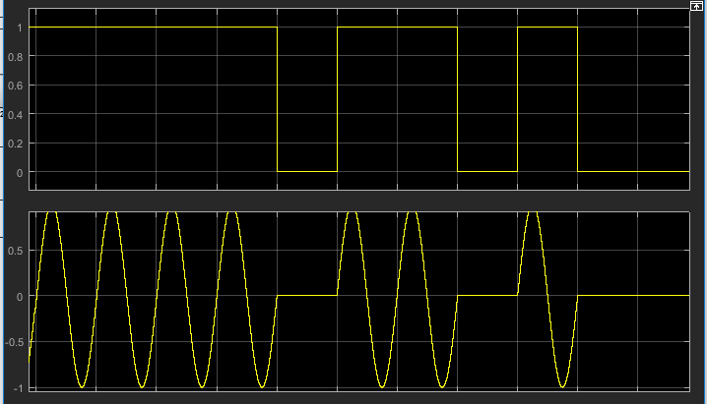
Figure 1: ASK Modulation [6]
The advantages of using ASK in a large network is the cost, the reason for this is that the simplest of ASK systems is a switch that used a switch using binary digits to turn on and off, this modulation method can be used to transmit digital data over optical fibre. The biggest disadvantage for using ASK is that it is very sensitive to atmospheric noise and distortions, this can cause issues with packet delays and even loss, ASK is also very power hungry and has low efficiency.

PSK
As the name suggests PSK is the method of modulating digital data by changing the phase of a constant frequency signal, this is accomplished by changing the sine and cosine inputs at precise time intervals. This method of modulation is often used for RFID and wireless local area networks. Figure 2 shows the tell-tale signs of a PSK modulation method with the phase changes shown as a M in the signal.
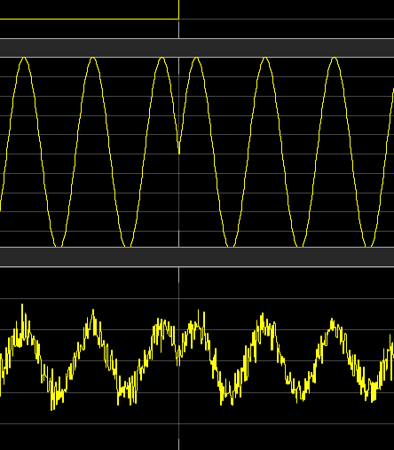
Figure 2 : PSK modulation
The advantage of using PSK is that it allows digital data to be sent over a radio communication signal more efficiently than Frequency shift keying (FSK) [7]. This means that it sends data with a lower amount of delay and packets loss caused by atmospheric noise and distortion, than other modulation methods such as ASK. Another advantage of PSK is that it is less susceptible to errors compared to ASK and occupies the same bandwidth, also a higher data rate can be achieved by using higher levels of PSK like QPSK which a 2 bit per constellation is and 16-QAM which represents 4 bit per constellation. The disadvantage of PSK is that it is a very complex system and has a lower bandwidth efficiency.

QAM
QAM is a commonly used modulation method that is used for modulating digital signals to be used over radiocommunication, this is a signal that has two carriers shifted in a phase of 90 degrees and the resulting output is that of both amplitude and phase variations. As QAM is a frequently used modulation method it is often used to broadcast applications, in the UK for example 16 QAM and 64 QAM are used for digital television using Digital Video Broadcasting.
When compared to ASK and PSK QAM is shown to be more efficient in transporting data over a radio communication and it allows communication systems to utilize both amplitude and phase variations. The disadvantage of QAM is its susceptibility to background noise, and the fact that it uses amplitude component that makes it consume more power than PSK by itself [8].

Noise Experiment
The experiment conducted in this section of the document is designed to show the differences in performance between ASK, PSK and QAM, this experiment will evaluate their performance in the presence of different levels of channel noise. The levels of noise that will be used are: -
- No noise
- 10% noise
- 25% noise
The reason for this variation of noise is to give a wide range of performance data, each experiment will be run for 1000 seconds to provide a long enough time frame for comparable results. The Simulink software has a built-in randomised interference when running simulations, this gives the limitation of not being able to run a truly no noise test as random sound will always occur.

ASK

No noise

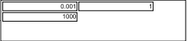
Figure 3 : ASK No Noise Error calculator display
Figure 3 shows the results of the Error calculator after running the ASK simulation, the data recorded shows the percentage of bit rate errors, the number of packets failed to go through, and the number of bits sent during the simulation.
The data shown in Figure 3 is recorded as so: -
- Bit Errors Rate (BER) 0.001%
- Number of Errors 1
- Bits Transmitted 1000

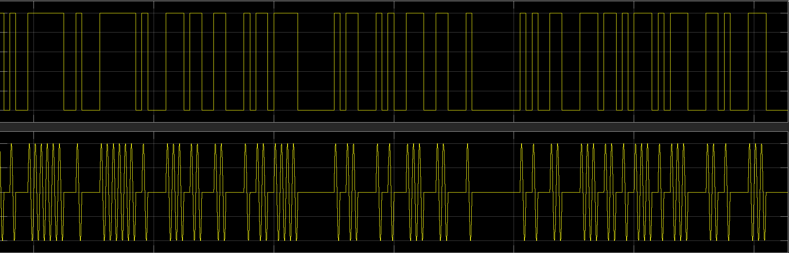
Figure 4 : ASK No Noise modulation display

Figure 4 shows the of a successful ASK modulation, it shows the Digital data being modulated into Analog data, also shown in Figure 4 is the amount of delay in the modulation is very low giving a clearer signal.

10% noise

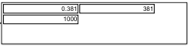
Figure 5 : ASK 10% Noise Error calculator display
The data shown in Figure 5 is recorded as so: -
- Bit Errors Rate (BER) 0.381%
- Number of Errors 381
- Bits Transmitted 1000

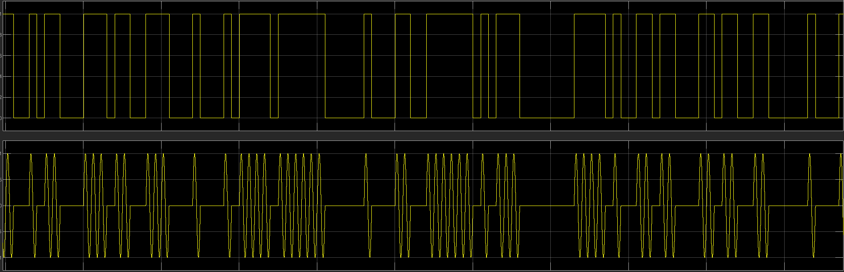
Figure 6 :ASK 10% Noise Modulation display

30% noise

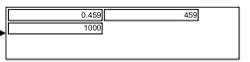
Figure 7 : ASK 30% Noise Error calculator display
The data shown in Figure 7 is recorded as so: -
- Bit Errors Rate (BER) 0.459%
- Number of Errors 459
- Bits Transmitted 1000

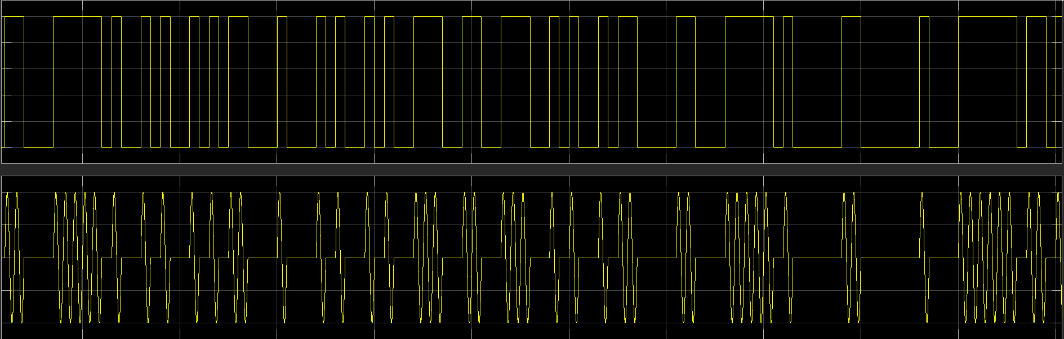
Figure 8 : ASK 30% Noise modulation

Comparison of ASK noise Levels

By comparing the results of the ASK noise simulations, the affects of background noise can be seen. The data shown in Figures 3, 5 and 7 paints the picture that as noise increases so does the errors that occur, this is further illustrated by Figures 4,6 and 8 that show the clear increases in delay of the transported bits in the simulation. The author predicts that this will be the case with both PSK and QAM as well, so they will give a brief comparison of them further in.

PSK

No noise

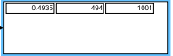
Figure 9 : PSK No Noise Error calculator display
The data shown in Figure 9 is recorded as so: -
- Bit Errors Rate (BER) 0.4935%
- Number of Errors 494
- Bits Transmitted 1001

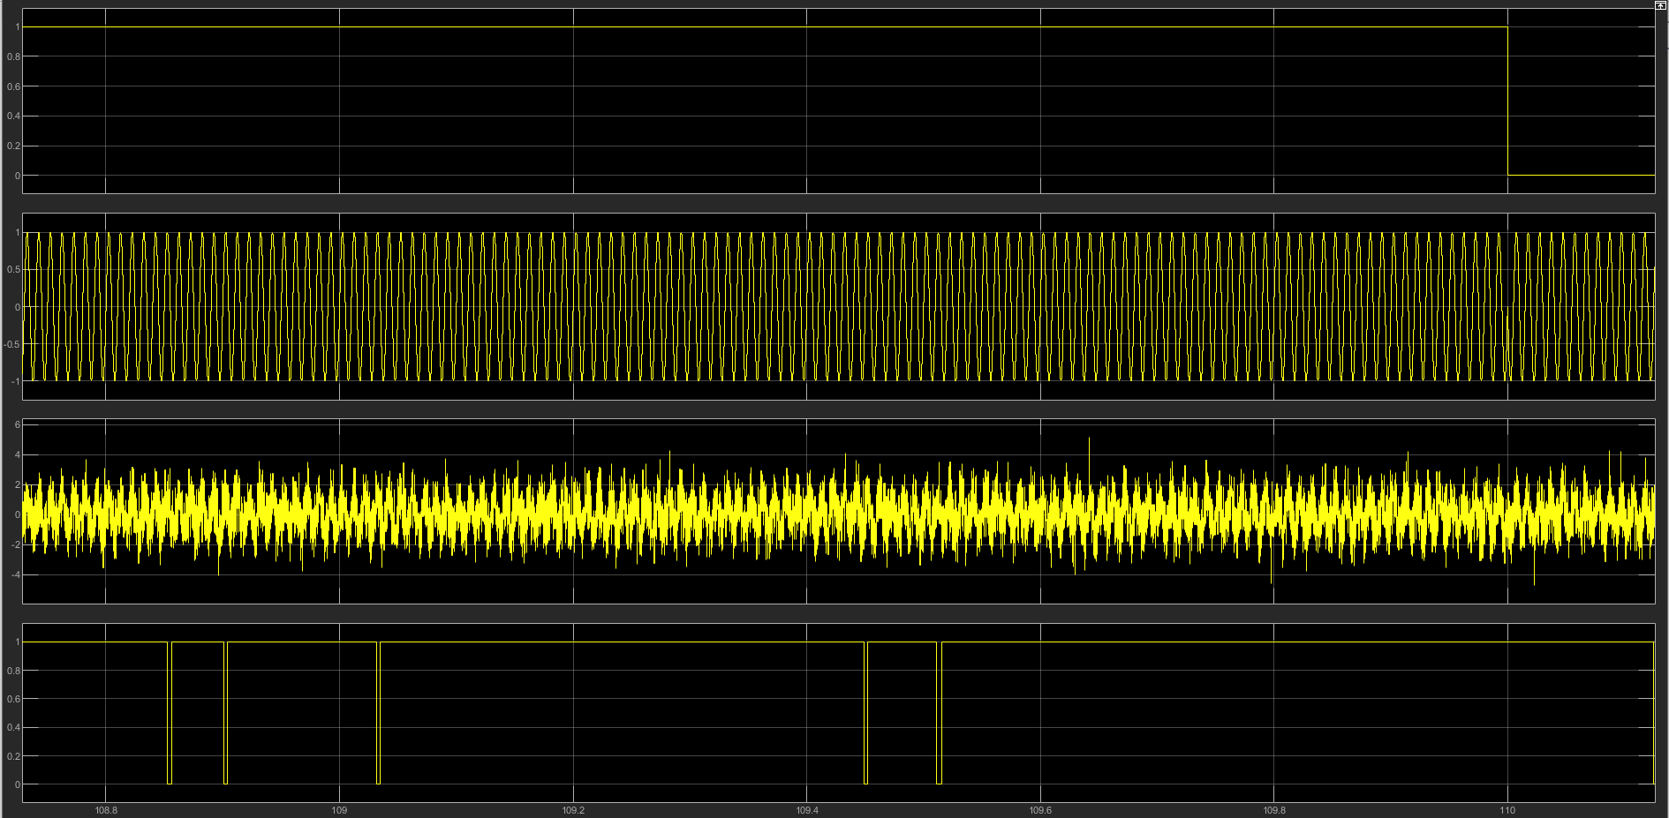
Figure 10 : PSK No Noise Modulation display

10% noise

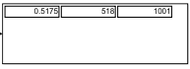
Figure 11 : PSK 10% Noise Error calculator display
The data shown in Figure 11 is recorded as so: -
- Bit Errors Rate (BER) 0.5175%
- Number of Errors 518
- Bits Transmitted 1001

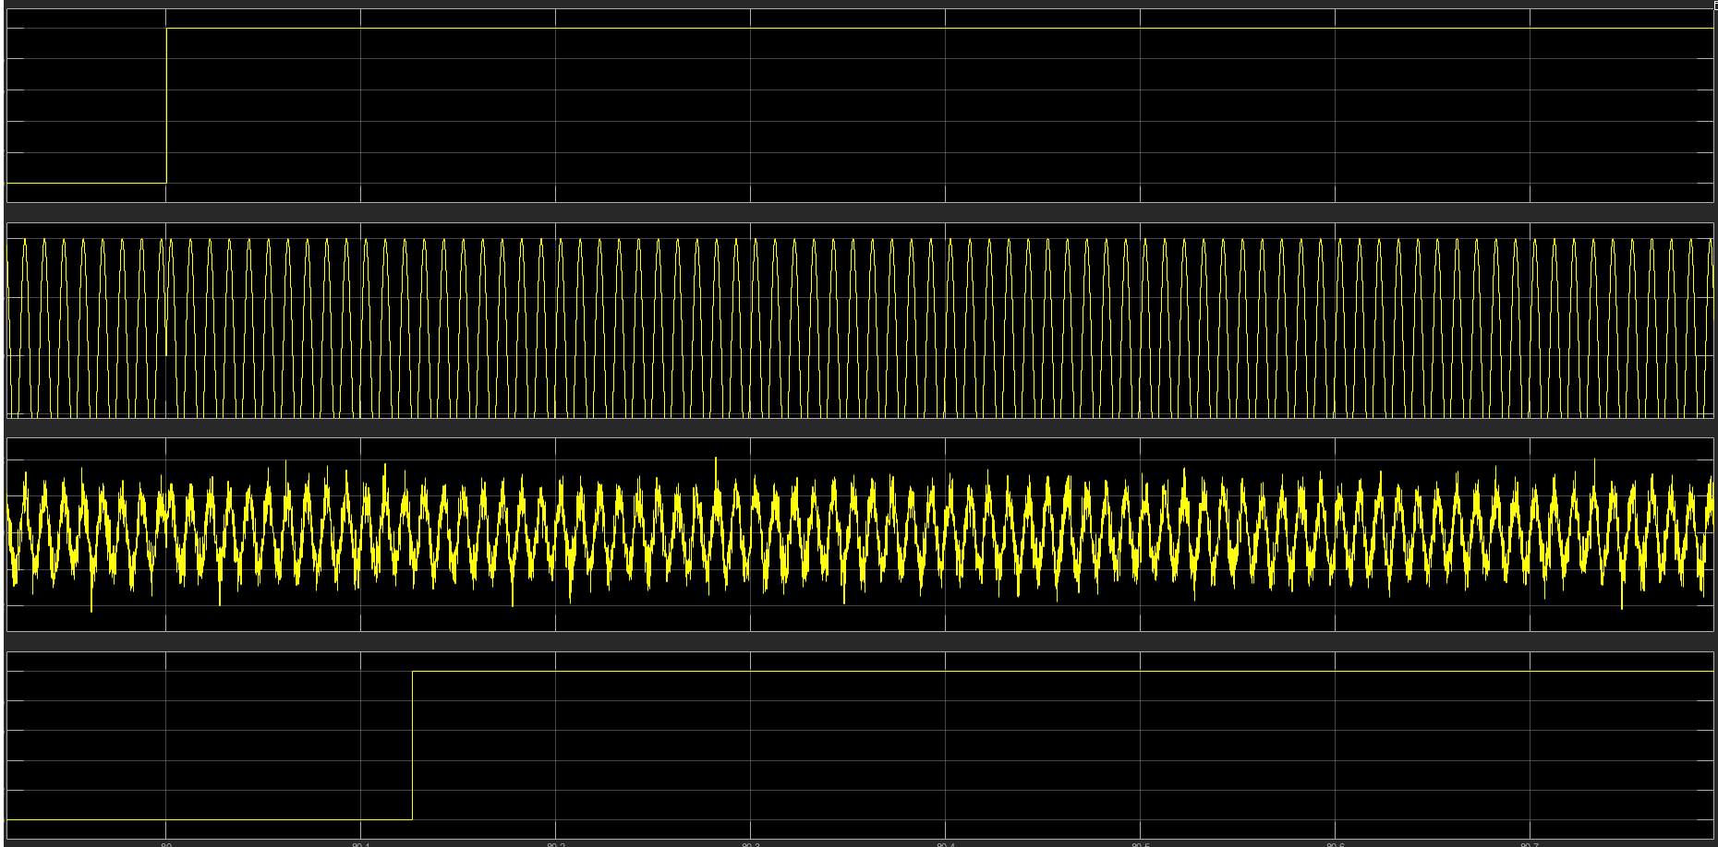
Figure 12 : PSK 10% Noise Modulation display

30% noise

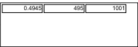
Figure 13 : PSK 30% Noise Error calculator display
The data shown in Figure 13 is recorded as so: -
- Bit Errors Rate (BER) 0.4945%
- Number of Errors 495
- Bits Transmitted 1001

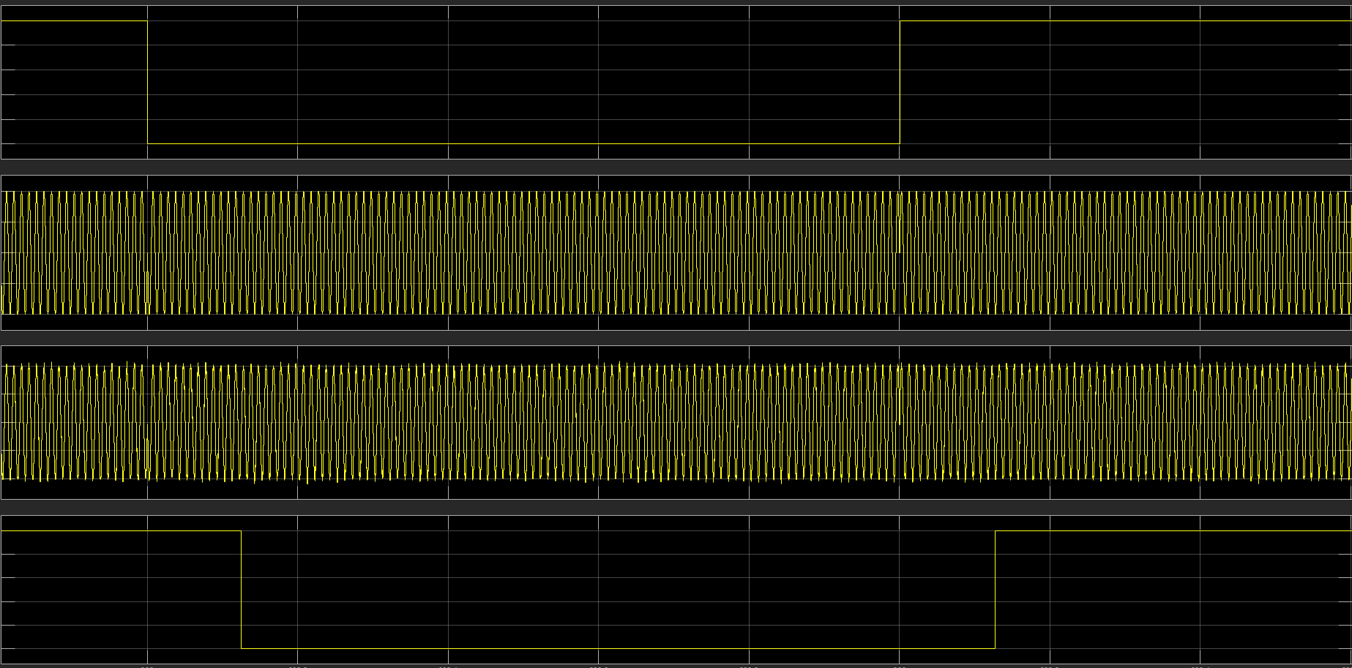
Figure 14 : PSK 30% Noise Modulation display

Comparison of PSK noise Levels

As predicted earlier in the comparison of ASK, Figures 9, 11 and 13 do show a marked intensification of errors when the noise levels increase. It is also shown that in figures 10, 12 and 14 the amount of delay increases when there is more noise as predicted.

QAM

No noise

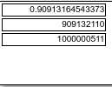
Figure 15 : QAM No Noise Error calculator display
The data shown in Figure 15 is recorded as so: -
- Bit Errors Rate (BER) 0.90913164543373%
- Number of Errors 909132110
- Bits Transmitted 1000000511

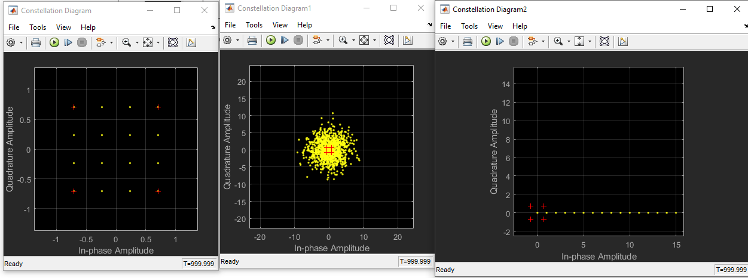
Figure 16 : QAM No Noise Modulation display
Figure 16 shows the constellation diagrams used for monitoring QAM simulations, within the Simulink software. Going in order of left to right, the first diagram shows that 16 QAM is being used and that the bits are in phase while being sent. The second diagram shows the amount of noise interference happening during the simulation, the wider spread the noise the worse the interference. The last diagram shows the results of the simulation, as the dots indicate the how much of the carrier waves bits were received, in the case of this experiment all the carrier waves are received.

10% noise

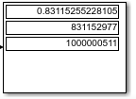
Figure 17 : QAM 10% Noise Error calculator display
The data shown in Figure 17 is recorded as so: -
- Bit Errors Rate (BER) 0.83115255228105%
- Number of Errors 83115277
- Bits Transmitted 1000000511

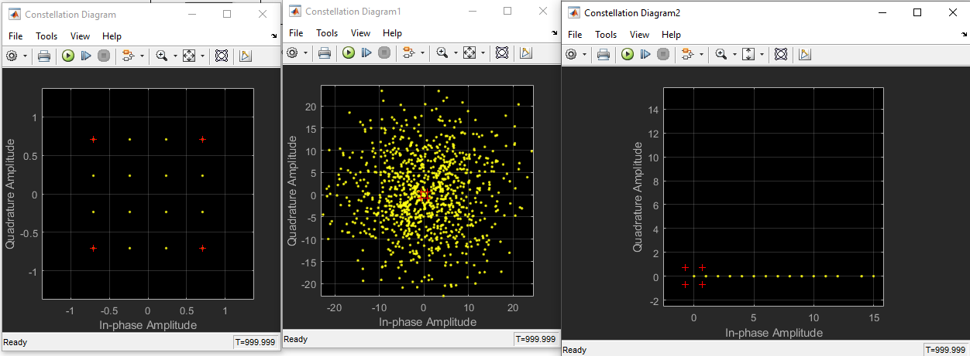
Figure 18 : : QAM 10% Noise Modulation display

30% noise

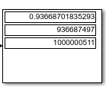
Figure 19 : QAM 30% Noise Error calculator display
The data shown in Figure 19 is recorded as so: -
- Bit Errors Rate (BER) 0.93668701835293%
- Number of Errors 936687497
- Bits Transmitted 1000000511

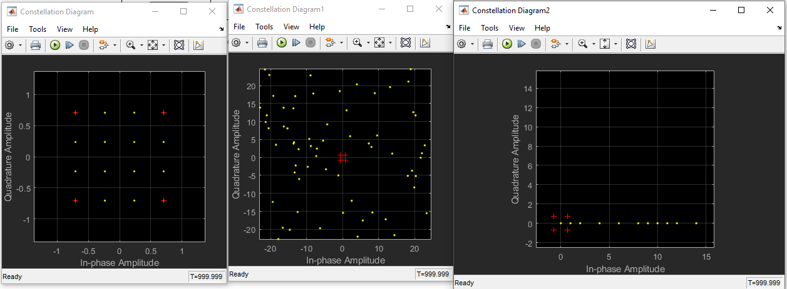
Figure 20: QAM 30% Noise Modulation display

Comparison of QAM noise Levels

The data shown by Figures 15, 17 and 19 while affirming the earlier prediction made by the author, it also shows an irregularity. This anomaly is in the no noise simulation of Figure 15, it shows that it is producing more errors than the other QAM simulations. This is an interesting anomaly possibly caused by the randomised noise that Simulink automatically generates for its simulations, another possibility is that it is a simple error in the software as the diagrams shown in Figures 16, 18 and 20 do follow the authors prediction, as it can be seen that there is more noise and packet loss in Figures 18 and 20 when compared to Figure 16.

Wireless Network Design & Evaluation

Concept
The concept of this network design is to provide UWTSD, with a proposal of a wireless monitoring system that could be used to resolve ongoing crimes on Caribbean islands. To achieve this the author has made a simple physical topology, to provide as an example to show how the IoT network would work. Also, a simulation that depicts a logical topology of the network has been used to generate data on how data traffic would travel in the network.

Assumptions
There are several assumptions the author has made when making these topologies and has taken into consideration.
- All the farms would have similar or the same devices on their networks, so only one farm has made to symbolise them all in the topologies
- Each farm is connected to a network junction box
- There is funding to provide each with fencing
- Different types of terrain
- The farm data will go to a countryside police station first
- The city police station would have more security as a larger building
- The bus station would be within the wider city network
- While providing real world examples is optional, specific brands are not needed
- Limitation of the NetSim software will cause errors to arise in simulations
- Limitations of the Packet Tracer software made making name changes to devices difficult
- This is for an IoT city

Physical topology

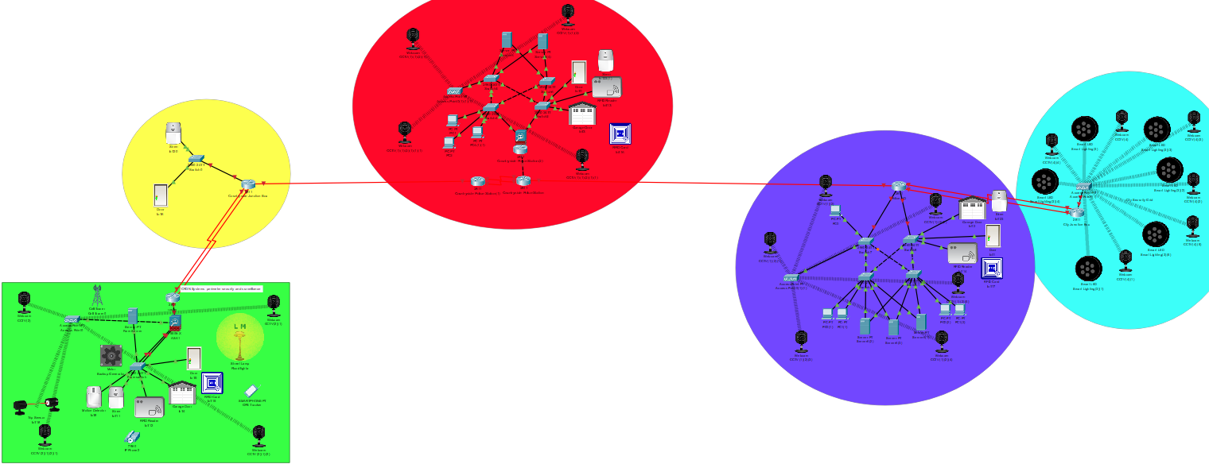
Figure 21 : Physical Topology of the Caribbean island Network

Figure 21 shows the overall physical topology, in this image each area of the network is connected physically, this is because the most reliable connection is a physical connection, also the countryside police station has a dedicated line to both the police HQ and the countryside junction box.
The purpose of the direct line is to provide a reliable connection, between the high traffic centres of the networks. Take the junction box for example, large amounts of data will be going through this network hub such as video data from multiple farms, as this is a large amount of important security-based data it would require the most reliable methods to transport it to the police servers.
Many of the devices used in this topology are duplicated for each area, such as the CCTV IoT cameras these are in each area of the network. These cameras are the major force used to prevent crime, as they are a visual deterrent to potential criminals and can be used in unison with pattern recognition software to potentially indicate the likelihood of an individual having a hidden weapon such as a knife or gun.

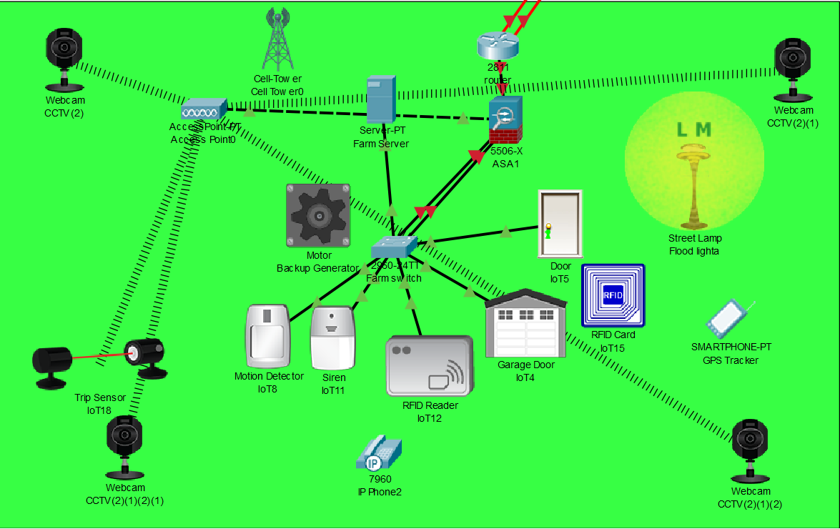
Figure 22 : Physical Topology of IoT Farm

Figure 22 shows the farm area of the network, as each farm can have a different overall terrain (such as hilly or flat land), the author designed this area of the network to be a generalisation that should work for any farm. The devices used in the farm are: -
- Flood lights, these are to be used in a combination of intruder detecting devices, to provide high levels of light at night in the event that an intruder is detected.
- GPS Trackers, this device is used to provide the police and farm owners to track any livestock that a thief has taken.
- Motion detection, this is used to detect intruders and can be set to not detect below or above specific ranges, such as bigger than a dog and smaller than a cow.
- Trip Sensor, this is one of the oldest methods of perimeter protection, and with recent advances with IoT Technologies it can be used to alert the authorities of an intruder without making them aware.
- Siren, burglar alarms have been used for years to secure homes and alert police to a brake in, similar systems can be put in place for a farm.
- IoT doors and RFID reader, one of the simplest methods of securing a building is having sturdy and secure doors, by using RFID readers as a lock system livestock, produce and tools can be secured in their facilities such as a barn.
- Cell tower, this is a backup method for transferring data between farms and the police station.
- IP phone, in the event of an intruder it is important for the farm employees to be able to contact each other and the police.
- Backup Generator, in the event of a power outage the generator can be set to automatically provide the farm with power, ensuring that the farms IoT Security system is still functioning,
- Firewall, this is used to protect the network from cyberattacks, the chances of such attack is low at first but with time become more likely.
- Server, this server is used to store all the farms data, from CCTV video surveillance to each time a door is accessed, this data will be sent to the police station servers after being stored.

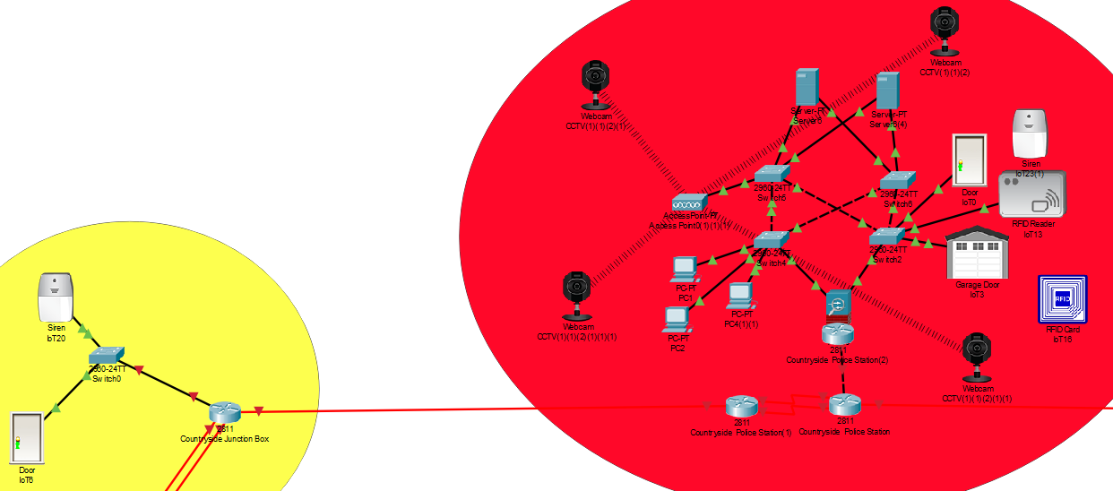
Figure 23 : Physical Topology of Countryside Police station and Junction box

The security of the junction box shown in Figure 23 is simply an IoT door and siren, the reason for this is that it is one box of many and is only used to direct traffic. If one of the junction boxes is damaged the siren will alert the authorities and other boxes would be able to take over the traffic load.

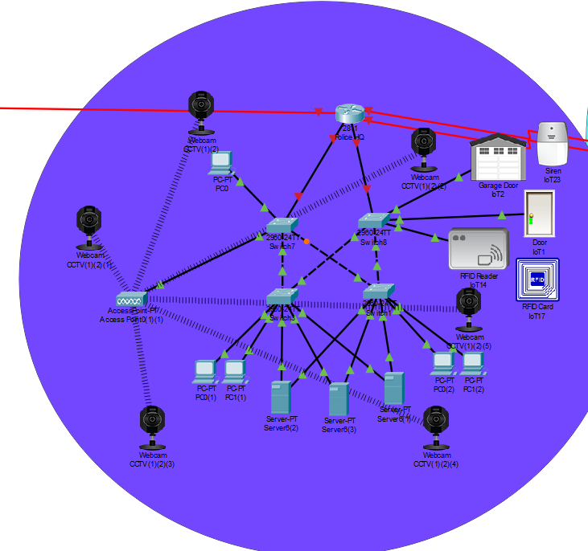
Figure 24 : Physical Topology of Police HQ in the City

While the police station in Figure 24 is shown as its own area of the network, it is physically located within the city, this allows for the demonstration of a secure building in an IoT environment. Also, it should be noted that all the data the countryside police station generates, is sent to the HQ to be kept as evidence and backups in case of server malfunctions.
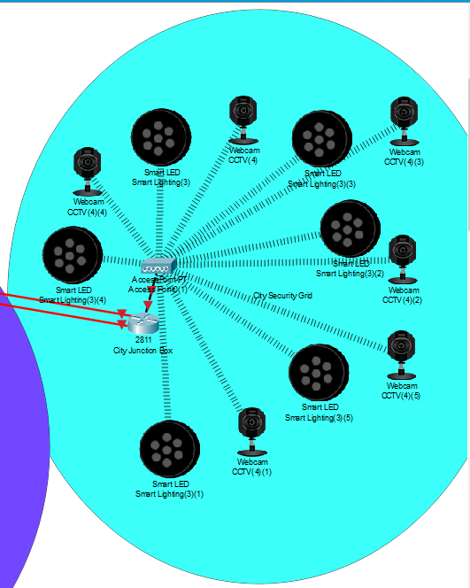
Figure 25 : Physical Topology of the intercity IoT network

Figure 25 shows the representation of the city’s IoT network, there is a limited amount of hardware possibilities that can be used to secure a city centre and a bus station, so the author has decided to treat both as the same area and provide as much feasible precautions that can be taken. As stated, earlier CCTV camera with pattern recognition technology can be used to prevent crime, but that is the problem it is only a preventative measure and only really during the day. So, to assist with the cameras the author is suggesting to use Smart IoT city lighting that is motion activated and can be used to prevent crime at night, this type of lighting is currently in use in Glasgow UK [9] a city known for its knife crime.

Wireless Network Evaluation

To evaluate the wireless network the author has made a simulation, using the NetSim software. This simulation will test the practicality of using PSK and QAM in an IoT security focused network, the reason ASK is not included within this simulation because of the limitations of the NetSim Software.
The parameters of this evaluation are: -
- Delay
- Throughput
- Packet loss
- No Noise
- Noise
After the data for both experiments have been generated, they will be compared with the results of the Simulink experiment to see if the results collaborate that the modulations with higher error rates have more packet loss.
Shown in Figure 26 is the logical topology for the network, it has been setup to show traffic between the devices and the police servers. In this simulation data generated by the farm is sent to the Countryside Police servers, this data is then sent to the Police HQ servers. Figure 26 also shows that there are a multitude of data being transmitted across the network from GPS to Video.
As there is a large amount of data it has been decided that the author will be focusing on 3 applications, Application ID 2 the database transfer from the Countryside Police servers to the Police HQ. Application ID 7 one of the Video streams to a Police server, and Application ID 20 the GPS data being sent to the farm server.

Logical topology

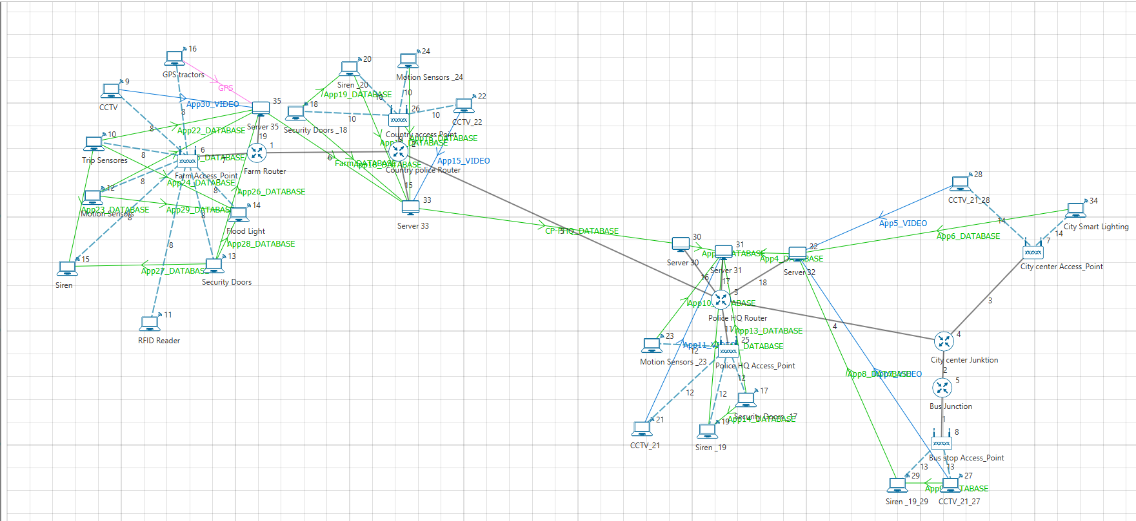
Figure 26 : Logical Topology of the Caribbean island network

Simulation

PSK No Noise

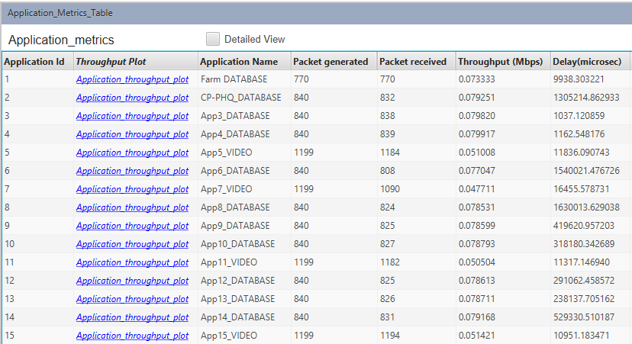
Figure 27 : PSK Simulation results No Noise (Application results 1-15)

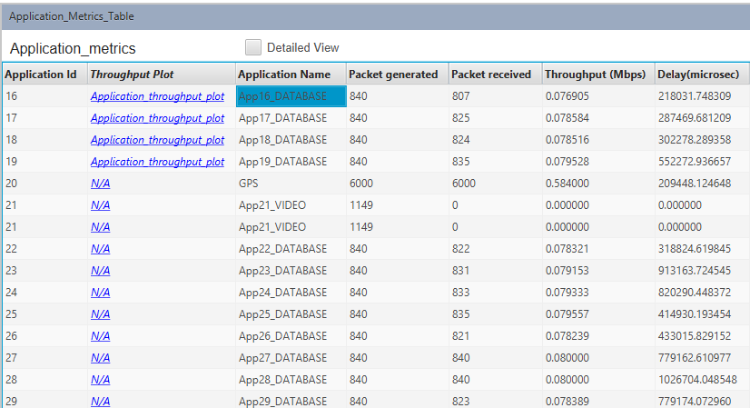
Figure 28 : PSK Simulation results No Noise (Application results 16-29)

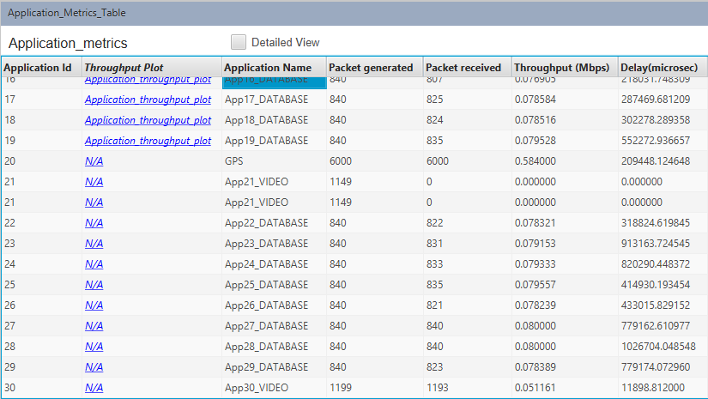
Figure 29 : PSK Simulation results No Noise (Application results 30)

The results in Figures 27, 28 and 29 shows: -
- Application ID 2
  - Packets sent 840
  - Packets Received 832
  - Throughput (Mbps) 0.079251 Mbps
  - Delay (Seconds) 1.3s
- Application ID 7
  - Packets sent 1199
  - Packets Received 1090
  - Throughput (Mbps) 0.047711 Mbps
  - Delay (Seconds) 0.02s
- Application ID 20
  - Packets sent 6000
  - Packets Received 6000
  - Throughput (Mbps) 0.584000 Mbps
  - Delay (Seconds) 0.21s

PSK with noise

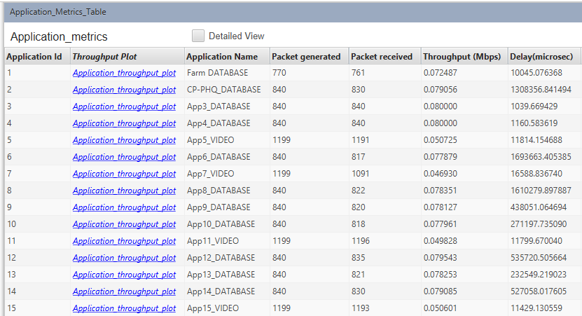
Figure 30 : PSK Simulation results Noise (Application results 1-15)

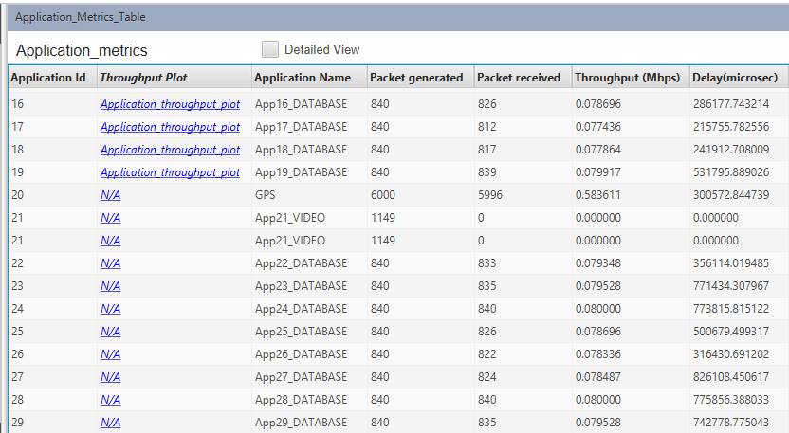
Figure 31 : PSK Simulation results Noise (Application results 16-29)
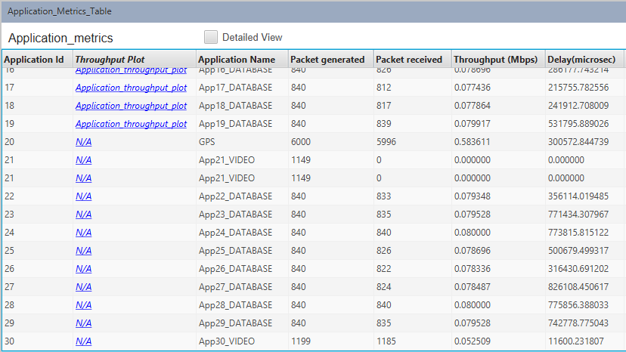
Figure 32 : PSK Simulation results Noise (Application results 30)

The results in Figures 30, 31 and 32 shows: -
- Application ID 2
  - Packets sent 840
  - Packets Received 830
  - Throughput (Mbps) 0.079056 Mbps
  - Delay (Seconds) 1.3s
- Application ID 7
  - Packets sent 1199
  - Packets Received 1091
  - Throughput (Mbps) 0.046930 Mbps
  - Delay (Seconds) 0.017s
- Application ID 20
  - Packets sent 6000
  - Packets Received 5996
  - Throughput (Mbps) 0.583611 Mbps
  - Delay (Seconds) 0.3s

QAM No noise

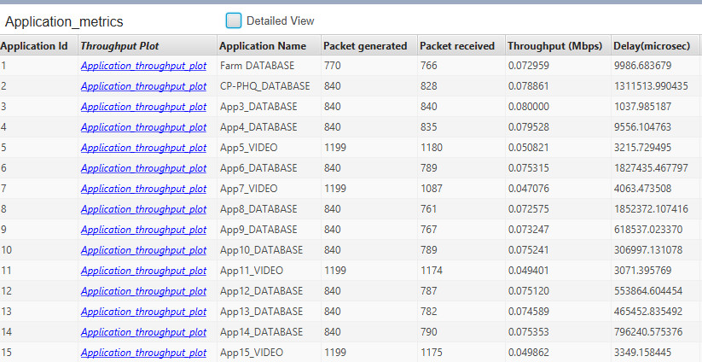
Figure 33 : QAM Simulation results No Noise (Application results 1-15)

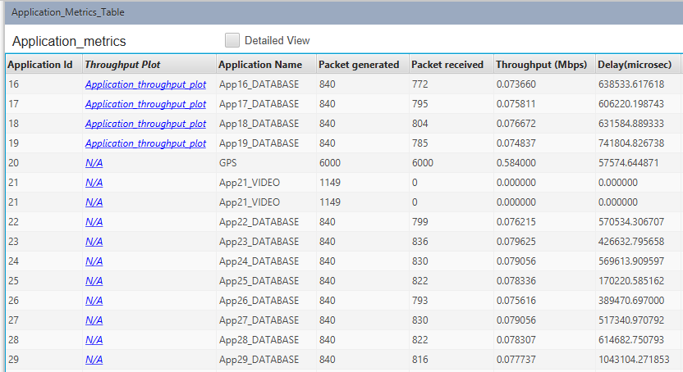
Figure 34 : : QAM Simulation results No Noise (Application results 16-29)

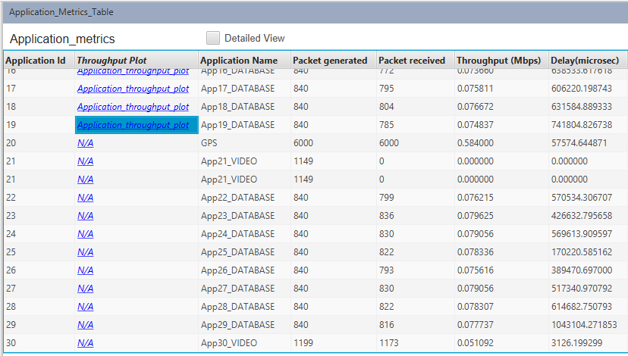
Figure 35 : QAM Simulation results No Noise (Application results 30)

The results in Figures 33, 34 and 35 shows: -
- Application ID 2
  - Packets sent 840
  - Packets Received 828
  - Throughput (Mbps) 0.078861 Mbps
  - Delay (Seconds) 1.3s
- Application ID 7
  - Packets sent 1199
  - Packets Received 1087
  - Throughput (Mbps) 0.047076 Mbps
  - Delay (Seconds) 0.004s
- Application ID 20
  - Packets sent 6000
  - Packets Received 6000
  - Throughput (Mbps) 0.584000 Mbps
  - Delay (Seconds) 0.6s

QAM noise

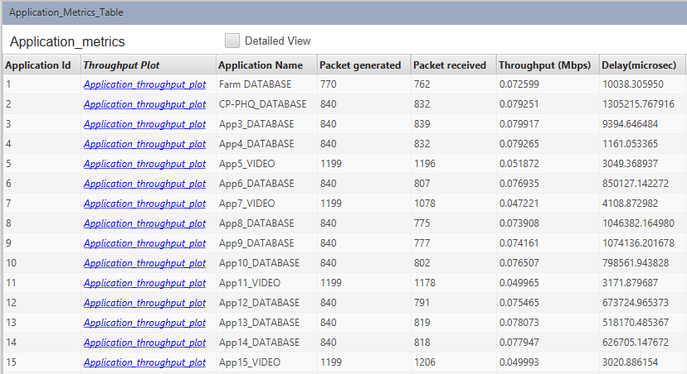
Figure 36 : QAM Simulation results Noise (Application results 1-15)

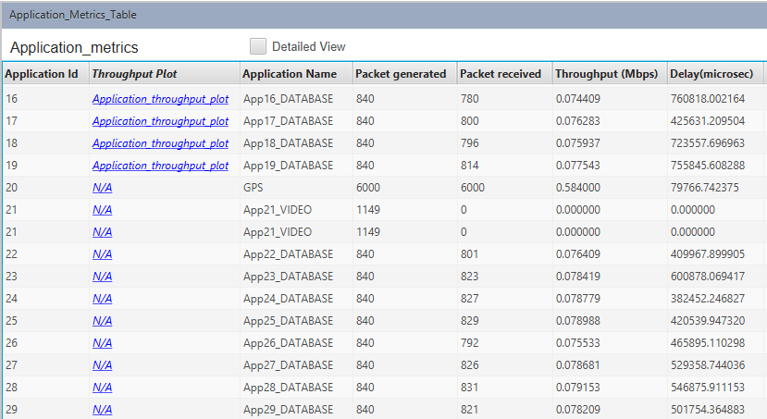
Figure 37: QAM Simulation results Noise (Application results 16-29)
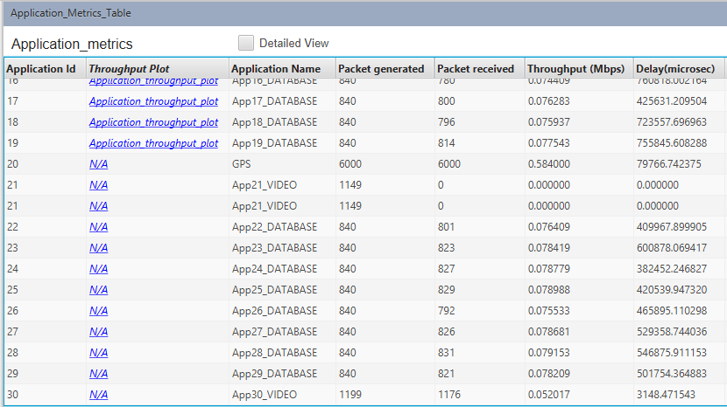
Figure 38 : QAM Simulation results Noise (Application results 30)

The results in Figures 36, 37 and 38 shows: -
- Application ID 2
  - Packets sent 840
  - Packets Received 832
  - Throughput (Mbps) 0.079251 Mbps
  - Delay (Seconds) 1.3s
- Application ID 7
  - Packets sent 1199
  - Packets Received 1078
  - Throughput (Mbps) 0.047221 Mbps
  - Delay (Seconds) 0.003s
- Application ID 20
  - Packets sent 6000
  - Packets Received 6000
  - Throughput (Mbps) 0.584000 Mbps
  - Delay (Seconds) 0.08s

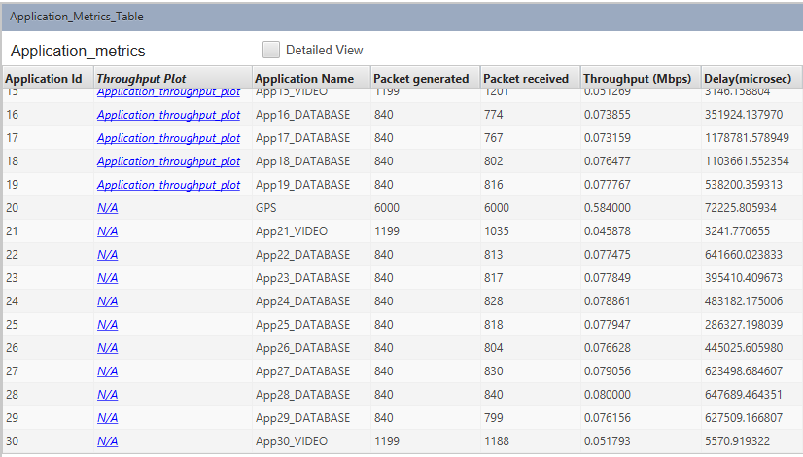
Figure 39 : Results of changing the multi cast application into a unicast

During this experiment an anomaly can be seen in Figures 28, 31, 34 and 37, they show that Application ID 21 while sending 1149 packets, not one of them is being received. This could be caused by many different reasons, such as a bottle necking within the network, the problem with this idea is that none of the other applications are having this issue. To investigate this issue the author changed the application from a Multi cast video stream to a Unicast stream, this fixed the problem, as seen in Figure 39, the assumption for this issue is that the software used was not able to handle the data throughput of the simulation.

Comparison of PSK and QAM

The data that has been generated suggests, that QAM on average has more packet loss and delay than PSK. The evidence shows that Application ID 2 while no noise PSK had a packet loss 8 packets while no noise QAM lost 12 packets, this suggests that QAM is less stable than PSK, but this could be explained by the software’s randomised sound generated more errors. The data shows that the delay of Application ID 20, is reduced when using QAM over PSK, this could be an indicator that QAM as the fastest modulation would be better for using in the farm environment.
The data generated by QAM and PSK shows that with Video streaming, QAM is consistently transmitting more data and at a higher reliability such as less packet loss when compared with PSK. As Video streaming will be a constant with this network design, (as it is the main method of crime prevention used) the author is suggesting that QAM is used as the main modulation method used for this project.

Conclusion
In conclusion the author has found that PSK while being slower than QAM on average it was also shown to be more robust and reliable in the experiments, it should be considered that the time of the experiments was short and a longer one could show QAM to be more reliable. The data shown in the Simulink and NetSim Simulations has led the author to decide that QAM should be used as the main modulation type for the network, as it is able to handle larger amounts of data throughput, as shown by the NetSim experiment and it is also already widely used in many countries for digital broadcasts.
It was found that ASK is the cheapest form of modulation and can be used to transmit digital data over a radio communication and Fibre lines, but this method of modulation has high power consumption, with this information the author suggests that it should be used as the backup communication device between the farms and the Countryside Police station.

References

[1] “M7X01691_sem1_CW1_2018_19_EmergingNetworkTechnologies (3).” .
[2] “Simulink - Simulation and Model-Based Design - MATLAB &amp; Simulink.” [Online]. Available: https://uk.mathworks.com/products/simulink.html. [Accessed: 16-Apr-2019].
[3] Cisco, “Packet Tracer | Cisco NetAcad,” netacad.com, 2017. [Online]. Available: https://www.netacad.com/courses/intro-packet-tracer/.
[4] “NetSim-Network Simulator &amp; Emulator | Home.” [Online]. Available: https://www.tetcos.com/. [Accessed: 16-Apr-2019].
[5] L. Wang, Q. Gao, K. Zhang, Y. Zhang, and Z. Feng, “Modulation classification of mixed signals using fast independent component analysis,” in 2016 IEEE Wireless Communications and Networking Conference, 2016, pp. 1–5.
[6] O. A. Tool, “Simulation and Evaluation of Computer Networks.” pp. 1–66.
[7] Wei Li, Ming Li, and Ning Hua Zhu, “All-optical generation of ASK, PSK, and FSK radio-frequency signals,” in 2016 Progress in Electromagnetic Research Symposium (PIERS), 2016, pp. 2362–2362.
[8] “QUADRATURE AMPLITUDE MODULATION.” [Online]. Available: https://www.slideshare.net/ahsanhalini/quadrature-amplitude-modulation-54999195. [Accessed: 16-Apr-2019].
[9] “Intelligent Street Lighting | Future City Glasgow.” [Online]. Available: http://futurecity.glasgow.gov.uk/intelligent-street-lighting/. [Accessed: 17-Apr-2019].

