Management Accounting: SBUS5118
Georgina Buckland: 1404838
Conventional Budgeting in a changing environment

Budgeting in a Changing Environment
Introduction
The changing economic environment has led to new emerging budgeting techniques. Over the last 50 years, budgetary control techniques have seen a clear shift towards more advanced processes. A proposed definition of budgeting is a ‘forecast of the financial results and financial position of a company for one or more future periods.’ (Bragg, 2017) It has been suggested that traditional accounting procedures are vital to ensure the long term success of a business, however a more modern approach proposes that beyond budgeting is the most effective accounting technique for today’s volatile business environment.
Evolution of Budgeting Processes
As can be seen from Appendix 1, the process of budgeting has become increasingly advanced over the last 50 years. The 1970’s brought about the zero based budgeting practise. In comparison with earlier traditional processes, this process was developed to allow for more accuracy. It can be described as, ‘a technique for building a budget from zero.’ (Davies, 2017) The way in which, ‘every activity needs to be justified, explaining the revenue that every cost will generate for the company’, (Callaghan, 2014) allows for further efficiency than the previous processes. This method acts to increase coordination and communication in a business where employees are motivated in being incorporated into the decision making process. However, in reference to the assignment question, this process can be considered to be both time consuming and ‘burdensome’ where communication errors could result in ‘bad practice’.
The following 10 years brought about the introduction of rolling budgets and rolling forecasts. This seemed to stem further away from the zero based budgeting idea where, ‘key business drivers are forecast on a continual basis.’ (Cognizant, 2011) This particular process seems logical to incorporate information from experience to make predictions for the future. While this approach may improve a company’s responsiveness, it can be argued that their effectiveness is somewhat limited. Due to some unpredictable industries, rolling budgets are often more focussed on short term progress. For this reason, it seems there is some validity in describing this method as ‘constraining’ where the, ‘vision and decisions may lack the tactical depth required for growing a business’. (Davoren, 2017)
Where rolling budgets and forecasts perhaps fall short on looking at the businesses long term plans, the balanced scorecard process that followed seems to tackle some of the weaknesses of its previous progressions. The process can be described as, ‘a measurement system that can be used to monitor and enhance performance within the financial, customer, internal business processes, and learning and growth segments of a business.’ (Davoren, 2015) This approach would be beneficial in the clarification of the company’s strategy and therefore translates strategy into an action. However, with connotations to the assignment question, it seems that this process is both timely and inconsistent management practices can result in ‘bad practice’.
By the 2000’s, budgetary control had evolved further, which brought about the introduction of activity based budgeting. ‘Activity-based budgeting is a planning system under which costs are associated with activities, and budgeted expenditures are then compiled based on the expected activity level.’ (Accounting Tools, 2018) This technique is different to the predecessors whereby managers are forced to assess the business’ activity and determine any non-value activities. The process itself supports performance management and scorecards, however due to the necessary resources, it is a costly and burdensome process.

Beyond Budgeting
The previous evolution of budgetary control saw a gradual shift from traditional processes to more advanced budgeting. From the 1960’s, the provided progressions presented different ways of accounting with their individual benefits to a company, however, each method also had its own drawbacks. Modern management accounting proposes the idea that perhaps budgets are actually constraining and damaging to a business, and beyond budgeting provides an alternative approach.
‘Beyond Budgeting means beyond command-and-control toward a management model that is more empowered and adaptive.’ (The Adaptive Management Model, 2014)
In the past, traditional accounting has provided a structured approach to a business’s budgetary control. The modified theory of beyond budgeting provides businesses the opportunity to become more dynamic when adapting to changes to ensure they stay competitive within their markets. Unlike previous budgeting approaches such as rolling budgets and forecasts, beyond budgeting is arguably not as ‘constraining’ where resources are made available as needed as appose to allocated through annual budgets and teams have the freedom and capability to act. This method is currently adopted by large companies such as Toyota. This is a company where, ‘resources are made available just-in-time to meet each customer order. There are no fixed targets, no annual budget contracts and people are trusted with information to make the right decisions.’ (Beyond Budgeting Institute, 2018) By utilizing beyond budgeting, Toyota was able to remain as one of the best managed manufacturing corporations in the world, even when the market recently, ‘collapsed by over 30 percent’. (Beyond Budgeting Institute, 2018) This demonstrates the way in which beyond budgeting can allow a company to stay agile in order to face any unforeseen alterations in either the micro or macro environment.
Where more traditional approaches to budgetary control focused more on meeting set goals, beyond budgeting provides a business with the opportunity for continuous improvement and value creation. Unlike the more centralised approaches, with beyond budgeting, each team exists in a ‘supplier and consumer relationship’. (The Adaptive Management Model, 2014)For Toyota, ‘the management focus is on continuously improving systems and meeting internal and external customers’ needs. Everyone has a voice and is expected to contribute to the continuous improvement of their work. Medium-term operational goals aimed at best practice are set at every level.’ (Beyond Budgeting Institute, 2018) This highlights a key difference between beyond budgeting and fixed performance contracts. It is clear to see that this modern approach helps to focus everyone on improving customer outcomes rather than hierarchal relationships of traditional processes.
As a result of this, both coordination and communication within a business can be improved. This shows some similarities to that of zero based budgeting whereby all staff work towards the same goal. ‘In Beyond Budgeting organisations, people work within an open and self-managed environment. Clear governance principles set the right climate and build the mutual trust needed to share knowledge and best practices.’ (The Adaptive Management Model, 2014) This demonstrates the change in leadership that beyond budgeting can bring about. Rather than traditionally being led by detailed rules and budgets, beyond budgeting focusses all employees on the company’s clear values and aspirational goals. It has been argued that, ‘the success of the beyond budgeting model is highly correlated with the way it is implemented within the organisation. However, when managers have been using the traditional budgeting system for a long time there exists a risk, managers are not capable of making the transition.’ (Sardjoe, 2009) This provides an argument to suggest that perhaps the success of beyond can be limited. Where the approach allows for more decentralized management, it seems vital to ensure communication is both clear and suitable in certifying all members of the organisation understand the values of the business. Perhaps the more established traditional approaches are a ‘safer’ method to use, where managers are well experienced with the process.
Although there are clear possible risks associated with this practice, perhaps the key to beyond budgeting is ensuring companies have a driven and proficient workforce. Beyond Budgeting stems away from the pre-existing command and control model on traditional budgetary control methods. In reference to the question, beyond budgeting helps to tackle a weakness of traditional approaches by reducing bad practice. Rather than viewing functions of a business as, ‘obedient machines’, the beyond budgeting method allows for the opportunity of self-management teams. Although, when used effectively, this can both act as an encouragement for innovation and a motivation to employees, it seems that perhaps there is a risk associated with beyond budgeting. The type of employees that this process would suit fall under the theory Y category. (McGregor, 1957) These are the types of employees who strive for innovation and would be motivated to achieve the high performance climate that beyond budgeting offers. By this process, ‘theory Y managers have an optimistic, positive opinion of their people, and they use a decentralized, participative management style. This encourages a more collaborative, trust-based relationship between managers and their team members.’ (The Adaptive Management Model, 2014) It is clear to see that beyond budgeting encourages this approach. It seems that if beyond budgeting companies like that of Toyota were to employ a majority of theory X, perhaps this process would not be as well suited as employees tend to avoid responsibility and often lack ambition.
Conclusion
To conclude, the shift from traditional budgetary control is clear to see within the last 50 years. However, it seems the most salient development is seen with the recent introduction of beyond budgeting. Differing greatly from its predecessors, this management model actually acts to tackle some of the established weaknesses of traditional approaches. This empowered and adaptive model overcomes the constraining nature of set annual budgets and allows a business more agility in today’s rapidly changing environment. The decentralised approach builds upon a company’s coordination and communication and encourages innovation in an attempt to stay competitive. Where beyond budgeting seems more suited to theory y employees, it could be seen as a risk for some organisations. However, Toyota acts as a prime example of the effective use of beyond budgeting. For this reason, it seems that since its introduction in 2005, although still controversial, the success of beyond budgeting has already been recognised. And with the general consensus that traditional budgets are becoming out-dated and obsolete, it seems likely that companies will continue to turn to this form of budgetary control to benefit from its many recompenses.

References
Accounting Tools, 2018. Activity Based Budgeting. Accounting Tools.
Beyond Budgeting Institute, 2018. Beyond Budgeting Institute; From command and control to empower and adapt. [Online]
Available at: http://old.bbrt.org/beyond-budgeting/bb-bbo.html
[Accessed 25 April 2018].
Bragg, S., 2017. Accounting Tools. Budgeting.
Callaghan, S., 2014. Five myths (and realities) about zero-based budgeting. Strategy and Corporate Finance.
Cognizant, 2011. Replacing the Annual Budget with Rolling Forecasts. Cognizant.
Davies, S., 2017. Zero Based Budgeting. Investopedia.
Davoren, J., 2015. AZCentral. [Online]
Available at: https://yourbusiness.azcentral.com/advantages-disadvantages-rolling-budget-1728.html
[Accessed 26 April 2018].
Davoren, J., 2017. Advantages & Disadvantages of a Rolling Budget. AZCentral.
McGregor, 1957. The Human Side of Enterprise. 2nd ed. s.l.:Kean University.
Sardjoe, 2009. Is the use of Budgets out of Date?, s.l.: s.n.
The Adaptive Management Model, 2014. Benefits of Beyond Budgeting. Beyond Budgeting; The Adaptive Management Model.

Appendix 1
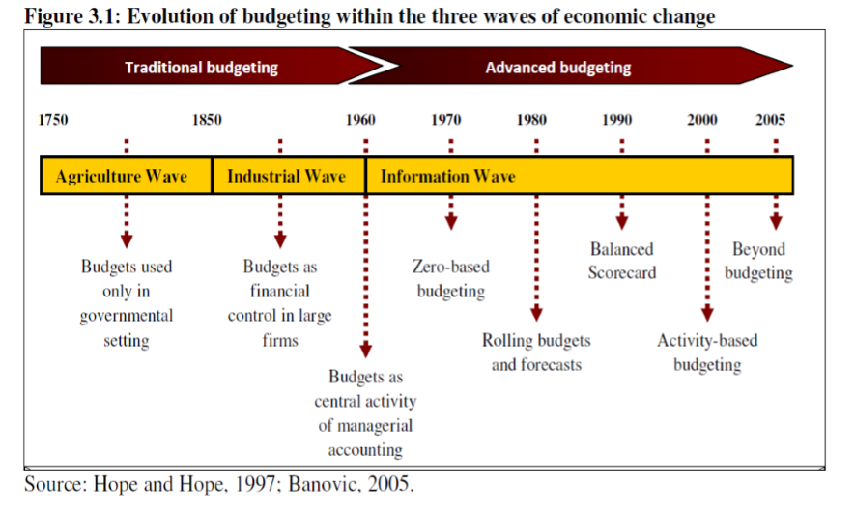
The evolution of management accounting from 1750 to 2005.

