PROBLEM SOLVING AND DECISION MAKING
Name of the Student:VIOLETA ZISU:
Name of the University: Trinity Saint David
Student ID: 2130492
Module Code: BMSW4004_LON
Lecturer’s Name: Akinseye Aluko
Task 2
Table of Contents
Task 2: Report 7
Introduction 7
The issue that is found in the place of work 7
Lack of policies which empower bullies 8
Lack of synergy in the workplace 8
Analysing Information 9
Root Cause Analysis 9
Job insecurity 9
Low self-esteem 9
Target characteristics 9
Applying situational analysis models 10
SWOT analysis of Unilever 10
Strengths 10
Weaknesses 10
Opportunities 10
Threats 11
PESTEL Analysis of Unilever 11
Political 11
Economical 11
Social 11
Technological 12
Legal 12
Environment 12
Range of Alternative Solutions 12
Solution 1: Announcing to fire bullies from the company 12
Solution 2: Promote the negative aspects of bullying 12
Solution 3: Counsel the perpetrators 13
Evaluation of Alternative solutions 13
Weighted decisions making matrix 13
Implementing the solution 14
Communication plan with stakeholders 16
Stakeholders 16
Employees 16
Consumers 16
Investors 17
Suppliers 17
Government bodies 17
Monitoring and Review Techniques 20
Awareness 20
Desired 20
Knowledge 21
Ability 21
Reinforcement 21
Conclusion 21
References 22

Task 2: Report

Introduction
There is a very common concern in the place of work for employees as they go through some kind of conflict with their colleagues or face issues created during the time of bullying. The issue with these conflicts is detrimental to the unity of the company (Salin, 2021). With the help of this unified force, the company can keep the synergy between every member of the team. The issue, in this case, is that the matter of disunity is at large as compared to the unison which is necessary to write the definition of a successful commercial brand. In this report, the learners are going to use Unilever which is a company located in the United Kingdom. The practice of bullying is simple harassment which makes the life of an individual drastically miserably for a long period.
The victim of bullying is greatly affected by the impact of this malpractice which eventually pushes them beyond the limit of tolerance. The outcome can be a sudden violent act of revenge or a serious step where the victim plans to end his/her own life (Hartin, Birks and Lindsay, 2020). The scope of bullying has been very high as both men and women are a victim of this activity. Many studies show more than 72% of professional employees are aware of the fact that bullying in a place of work happens daily. The next one is that they can show 27% of the professionals have seen someone get bullied while the rest 21% were the victims of this incident.

The issue that is found in the place of work
The most common thing that is found in the place of work is a rise in conflict between two colleagues of the company. The issue is that the conflicts are bringing credible insights into the culture of bullying in a company as big as Unilever. This is the reason why the brand has been struggling a little to keep up with the rate of sales as it used to be when it was founded a century ago. This is the work of a department which is found in every big and small company that can solve the issue all by themselves. This is the human resource department headed by the human resource manager who can end these conflicts and stop bullying as soon as possible (Høgh et.al 2021). Unfortunately, the culture has spread its root deep into the system of this multinational brand located in the United Kingdom. The reason for this drastic downfall of the brand is associated with the loose code of conduct and poor induction of laws that empowers the victims of bullying. This is the issue that is being faced by the professionals who are working for Unilever at the moment.

Lack of policies which empower bullies
The sheer lack of these policies is a mirror that points out the flaws which have been made by Unilever for a long time (Hodgins, MacCurtain and Mannix-McNamara, 2020). The issue can be detrimental as the company will suffer from various forms of criticism which are framed by the rivals of company. A source of internal criticism will come if these problems never go unchecked. Hence the absence of these policies will reduce the synergy and breed hatred against one another that runs deep into the system of the company.

Lack of synergy in the workplace
The lack of synergy is indeed an important reason which culminates to the extent that bullying becomes a culture in a corporate workplace (León-Pérez, Escartín and Giorgi, 2021). The valid reason for this intangible asset to never be founded in this area is simple. This happens due to a mix of various cultures and ethnicities. Many human beings cannot accept something different which leads to the problem that is being faced by Unilever at the moment.

Analysing Information

Root Cause Analysis

Job insecurity
The fear of job insecurity is serious which leads to the development of a culture that promotes bullying. The largest companies in the world of technology have started to lay off their employees and this fear prevails over other companies in different industries (Sarwar, Naseer and Zhong, 2020). This leads to several psychological disorders which culminate in the bullying of an individual.

Low self-esteem
The person who bullies someone suffers from the concerns of low self-esteem in themselves. As a means to hide this flaw, they try to create an environment where they become a bully (Choi and Park, 2021). This leads to mental anxiety in both the perpetrator and the victim.

Target characteristics
There are people in a workplace who look a little different than others. The normal culture is to accept the way they look and focus more on their talents. Unfortunately, these physical features make them a victim of bullying by default (Day et.al 2022). The effect is very severe as they lose confidence in themselves and start to hate their existence.
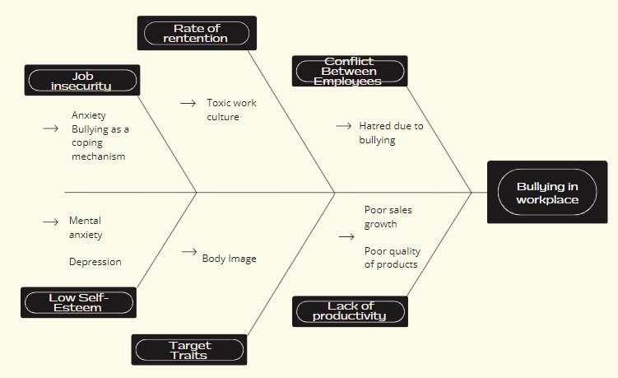
Figure 1: Fishbone Diagram
(Source: Self-Created)

Applying situational analysis models

SWOT analysis of Unilever

Strengths
The brand name and a wide range of products are the first two strengths of the company The other two strength of the company includes a global presence which goes back decades. The rapid expansion into the international market has made this company gain the shape of an economic giant in itself (Płodowska, 2021). Hence it shows this company is an expert in surviving different types of market conditions and prospering through all of them.

Weaknesses
The product is sold in every mall of the world as Unilever holds a range of these consumable goods. The issue is that they are very dependent on their logistical support and supply chain which can be disrupted for multiple reasons. The next weakness is that the company sell products that can be easily made by a rival for a cheaper price (Zhang and Fan, 2020). The last issue is that business depends on consumable products and nothing else which is a sign showing a lack of prosperity.

Opportunities
The business can persevere through tough times if they diversify the range of products from consumable to something else like technology is a good example of this change. The next is that products that are healthy for fitness enthusiasts can be developed in large volumes to meet their demands (Lieu et.al 2021). People are more conscious about the environment which becomes another opportunity to develop and promote eco-friendly products.

Threats
The company faces tough competition from its rivals hence the profit margin is very low. The local brands can make the same product for a lesser price which can take away the customers from the business. The business does not try to grow into other industry which makes Unilever heavily dependent on this one.

PESTEL Analysis of Unilever

Political
The current war between Russia and Ukraine has led to economic sanctions on the country. Therefore, the products cannot be sold in Russian markets which means the company lost their customers in Russia.

Economical
The economic situation of the UK has been poor for several years which become worse after Russia invaded Ukraine (Płodowska, 2021). Hence the price of these products sold by Unilever is substantially higher than one can think. This reduced the demand for the products and a reduction in the sales rate.

Social
The company conducts CSR activities by setting natural benchmarks for beauty standards. Many creams enhance skin tone but promote soft racism through their ads (Salins, Mendon and Aithal, 2019). Therefore, the brand changed the name of these products and started promoting ads which made people understand that every complexion is beautiful in their way.

Technological
Unilever relies on automation as it empowers digital marketing to promote its products constantly on social media and websites. They have secured an automated supply system which restocks the shelves as soon as it is empty in a store.

Legal
The wide range of products means multiple brands under Unilever exist and operate in a dynamic manner (Mulongo, B., 2022). Thus, the legal team have to always look for the laws and copyright acts of every country to avoid any trial sessions in a country.

Environment
The design and packaging of the products are friendly to the environment. Unilever also promotes sustainability and eco-friendly business models to save the planet from climate change.

Range of Alternative Solutions

Solution 1: Announcing to fire bullies from the company
The hard method goes the best in these cases and firing the bullies for such malpractices will not encourage this culture in the workplace (Garrick and Buck, 2022).

Solution 2: Promote the negative aspects of bullying
The negative aspects of bullying are scary as it leads to suicide and self-harm. A session which is an hour-long is enough to promote the negative aspects of bullying.

Solution 3: Counsel the perpetrators
This goes a long way to help them develop a character which is compassionate and kind (Young Oh, Song and Hong, 2020). The therapy will solve their problem and end the thoughts of bullying others in their mind forever.

Evaluation of Alternative solutions

Weighted decisions making matrix
 | Weight | Employee Inspiration | Uncensored conversation of employees about their physical and mental well-being | Malleable Plan
Accounts | 3 | 15 | 12 | 9
Collaboration | 5 | 20 | 25 | 20
Incident Structuring | 4 | 12 | 20 | 8
Edification | 5 | 5 | 10 | 25

Implementing the solution
Activities | 1st to 3rd week | 3rd to 6th week | 6th to 9th week | 9th to 12th week | 12th to 15th week
Drafting the policy to prevent bullying
Discussion of the policy content
Hearing out every employee in the company
Having proper surveillance system to prevent such things from happening in the future
Revision of the policy and evaluating feedbacks for better changes
Table 1: Gantt chart
(Source: Self-Created)

Communication plan with stakeholders
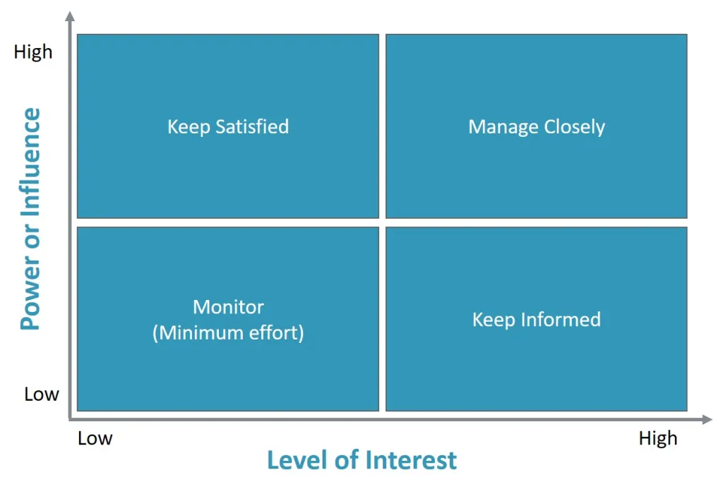
Figure 2: Stakeholder’s Power Interest Matrix
(Source: self-created)

Stakeholders

Employees
The employees of a company are the backbone of the brand without whom the business can never be operable.

Consumers
The presence of consumers will create demand for the product without which the company cannot conduct any business (De Bakker, Rasche and Ponte, 2019).

Investors
The investors put their money into the business hence they want it to be successful.

Suppliers
The business will be operational only if the supplies reach the manufacturing hub quickly.

Government bodies
The body will ensure the company maintains the laws and always pays taxes as stipulated by the brand.
Stakeholders | Interest | Key Interest and Issues | Communication Vehicle | Frequnecy | Comments
Employees | High | The employees look for a healthy work environment where the mind is not in a constant state of agony. | Emails | Emails | This is a way the employee will be happy and productive
Customers | High | The customers do hate bullying and looks for a company that excels on ethical grounds of business. | Social media and TVCs | As and when there is a room for such relevant ads | The customers can be engaged with vouchers and offers to promote the benefits of brand loyalty
Government Bodies | Medium | The involvement of the UK government is a little moderate as they do not want employees of a company to suffer from PTSD or panic attacks caused by bullying | Press Releases | Thrice a year | The rules stated by the legal body has to be followed
Suppliers | Low | The suppliers do not have much role to play in this as long as they get the due share of the profit for their timely supplies. | Direct communication and emails | Once every 30 days | Have influence over the product that are necessary to the customers
Investors | Medium | The investors will be involved in this matter as it hampers productivity that takes a toll on their investment. | Direct communication | Once every 6 months | Makes a way to gain the profits from simple risks that follows.
Table 3: Stakeholder Communication Plan
(Source: Self-Created)

Monitoring and Review Techniques
ADKAR model is being used to find out the areas which hurt the company’s sense of integrity. The model for Unilever defines an equal system that is presented in this context:

Awareness
The senior managers get to know this culture of bullying is the reason why this company lacks creativity and a high rate of retention (Sulistiyani, Ali and Astuti, 2020).

Desired
The culture of bullying can be stopped by terminating employees who endorse such behaviour. The ones who instigate can be given a notice period to find another job which will promote integrity within the team.

Knowledge
The employees must be taught that the managers are with them in these cases (Bjereld, Y., Daneback and Mishna, 2021). Unilever can hold a mandatory workshop to show bullying is not an option for its negative impact on an individual’s life and the workforce.

Ability
The employees will gain awareness about the ill effects of bullying and stand up for the ones who are being bullied by a member of the company.

Reinforcement
Unilever benefits from these laws and proper enforcement of the products to sustain the integrity of the business.

Conclusion
The report shows the analysis of the company which brings to light the SWOT and PESTEL of the company. The range of alternative solutions is explored in this report to suffice the ways this job can be done in another way. The weighted analysis gives a brief description of the time the managers need to bring an effective change in the organisation. This shows the amount of money which is needed to implement the policies which can stop bullying once and for all. The ADKAR model has been used for the sake of monitoring the procedures followed during the implementation of the policies.

References
Website
unilever, (2023), Driving superior performance with our purpose-led, future-fit business, Available at: https://www.unilever.com/ [Accessed on: 5th April 2023]
Journals
Bjereld, Y., Daneback, K. and Mishna, F., 2021. Adults’ responses to bullying: The victimized youth’s perspectives. Research Papers in Education, 36(3), pp.257-274.
Choi, B. and Park, S., 2021. Bullying perpetration, victimization, and low self-esteem: Examining their relationship over time. Journal of youth and adolescence, 50, pp.739-752.
Day, S., Bussey, K., Trompeter, N. and Mitchison, D., 2022. The impact of teasing and bullying victimization on disordered eating and body image disturbance among adolescents: a systematic review. Trauma, Violence, & Abuse, 23(3), pp.985-1006.
De Bakker, F.G., Rasche, A. and Ponte, S., 2019. Multi-stakeholder initiatives on sustainability: A cross-disciplinary review and research agenda for business ethics. Business Ethics Quarterly, 29(3), pp.343-383.
Garrick, J. and Buck, M., 2022. Bullying. In The Psychosocial Impacts of Whistleblower Retaliation: Shattering Employee Resilience and the Workplace Promise (pp. 139-151). Cham: Springer International Publishing.
Hartin, P., Birks, M. and Lindsay, D., 2020. Bullying in nursing: How has it changed over 4 decades?. Journal of Nursing Management, 28(7), pp.1619-1626.
Hodgins, M., MacCurtain, S. and Mannix-McNamara, P., 2020. Power and inaction: Why organizations fail to address workplace bullying. International Journal of Workplace Health Management, 13(3), pp.265-290.
Høgh, A., Clausen, T., Bickmann, L., Hansen, Å.M., Conway, P.M. and Baernholdt, M., 2021. Consequences of workplace bullying for individuals, organizations and society. Pathways of job-related negative behaviour, pp.177-200.
León-Pérez, J.M., Escartín, J. and Giorgi, G., 2021. The presence of workplace bullying and harassment worldwide. Concepts, approaches and methods, pp.55-86.
Lieu, P.T.H., Arunjit, N., Buapradabkul, S. and Nathaniel, D., 2021. Unilever Company Strategic Business Analysis.
Mulongo, B., 2022. Influence of Strategic Planning Practices on Performance at Limuru Tea Company Limited (Doctoral dissertation, University of Nairobi).
Płodowska, J., 2021. Analysis and assessment of strategic divestment plan of the brand Lipton by Unilever (Doctoral dissertation, Katedra Procesów Zarządzania).
Salin, D., 2021. Workplace bullying and gender: An overview of empirical findings. Dignity and inclusion at work, pp.331-361.
Salins, M., Mendon, S. and Aithal, P.S., 2019. A Comprehensive Analysis of Top Indian Cosmetic Company: LAKME. International Journal of Case Studies in Business, IT, and Education (IJCSBE), 3(2), pp.79-90.
Sarwar, A., Naseer, S. and Zhong, J.Y., 2020. Effects of bullying on job insecurity and deviant behaviors in nurses: Roles of resilience and support. Journal of Nursing Management, 28(2), pp.267-276.
Sulistiyani, E., Ali, A.H.N. and Astuti, H.M., 2020. Change management strategies to implement a fingerprint based attendance system in information systems department using ADKAR model. Applied Technology and Computing Science Journal, 3(1), pp.22-29.
Young Oh, E., Song, D. and Hong, H., 2020. Interactive computing technology in anti-bullying education: The effects of conversation-bot’s role on K-12 students’ attitude change toward bullying problems. Journal of Educational Computing Research, 58(1), pp.200-219.
Zhang, L. and Fan, Z., 2020, November. Analysis of Unilever’s Branding and Marketing Strategy in China. In 2020 International Conference on Management, Economy and Law (ICMEL 2020) (pp. 288-291). Atlantis Press.

