Module Title:
Strategic Management
Module Code:
LCMB7003
Assessment Title:
Individual Report: Organisational Expansion Plan
Selected Organisation:
ZARA (Inditex Group)

Student Name: Fatema Tuj Johura Misha
Student ID: 2434270
Word Count: 5369
Submission Date: 22nd December 2025

Table of Contents
1. Introduction and Purpose of the Report 3
2. Selection of Organisation and Target Market 5
2.1 Overview of ZARA and Strategic Rationale 5
2.2 Selection of Target International Market 6
3. Comprehensive Strategic Analysis 7
3.1 Macro-Environmental Analysis: PESTLE 7
3.2 Industry and Competitive Environment: Porter’s Five Forces 9
3.3 Internal Analysis: VRIO Framework 11
3.4 Critical Evaluation of Analytical Frameworks 13
4. Strategy Development and Formulation 14
4.1 Strategic Direction and Growth Options: Ansoff Matrix 14
4.2 Competitive Strategy: Porter’s Generic Strategies 15
4.3 Market Entry Strategy 16
4.4 Corporate Social Responsibility and Sustainability 18
4.5 Strategic Risks and mitigation measures 19
5. Performance Evaluation Framework 20
5.1 Selection of Performance Measurement Framework 20
5.2 Financial Performance Measures 21
5.3 Customer and Market KPIs 21
5.4 Internal Process and Sustainability Metrics 22
6. Conclusion and Strategic Recommendation 23
6.1 Conclusion 23
6.2 Strategic Recommendations 24
References 25

1. Introduction and Purpose of the Report
Strategic management is an important capability in a new world where globalisation is accelerating, technology is disrupting, and consumers are growing more volatile in their ability to provide sustainable competitive advantage to multinational organisations. Although international expansion creates a great opportunity to grow, such business also subjects firms to an increased strategic complexity due to the existence of different regulatory environments, cultural distinctions, competition, and operational risk (Zhang, L., 2023). This means that organisations need to embrace planned and scientific strategic planning methods to review external environments, internal strengths, and approaches of consistent expansion planning.
ZARA is one of the most powerful actors of the worldwide fast-fashion market as it is a flagship brand of the Inditex Group. Being known as the vertically-integrated business model and the highest speed-to-market rates, ZARA has revolutionized the traditional fashion retailing and synchronized the real-time consumer data with prompt design, manufacturing, and distribution. Despite the brand having a solid presence in Europe, the Americas, and certain Asian regions, the changing market conditions and the growing competition require strategic renewal on a regular basis by focusing on international expansion.
The main purpose of this report will be to prepare a detailed organisational expansion strategy of ZARA that would consider strategic preparedness and propose a reasonable entry into a new foreign market (Zhang, E., 2024). The report will use inherent strategic management models to examine the macro-environmental variables, competitive environment, and internal resource foundation of the organisation, hence allowing development of evidence-based and context-specific expansion strategy.
The report is structured in a way that it starts with the rationale of the choice of ZARA and the target market. It is then accompanied by an in-depth strategic analysis which involves the use of models like PESTLE, Porter's five forces and VRIO model. A strategic development tool such as the Matrix of Ansoff and Porter's Generic Strategies arethereafter used to develop a market entry strategy. Lastly, a performance measurement model will be established to measure the success and viability of the suggested expansion plan. Taken together, the report reflects a methodical and critically enlightened use of strategic management theory to a practical scenario of international business.

2. Selection of Organisation and Target Market

2.1 Overview of ZARA and Strategic Rationale
ZARA is the flagship of the Inditex Group that is commonly known as the innovator of the fast-fashion business model. In contrast to classical clothing retail companies that use time-consuming product development, and outsourced supply chain, ZARA implements a highly integrated value chain with design, production, logistics, and retail processes. The construction allows the company to translate new fashion trends into the finished products and ship them to the stores within several weeks, which reduces the inventory risk and improves responsiveness to consumer preferences (Yan, 2024).
Competitively, the hybrid nature of cost efficiency and differentiation that is adopted by ZARA defines its competitive positioning strategy. Although the brand does not spend a lot of money on advertising, it tries to distinguish itself with regular product updates, small production batches, and exclusive retail store spots. This gives consumers the sense of exclusivity and urgency, which forms a high level of brand loyalty. ZARA, as part of the Inditex portfolio, serves the high-end fast-fashion market, as the main driver of growth of the entire group and the operational standard of excellence.
ZARA has built a strong global footprint with thousands of stores in Europe, North America, Latin America, and in some selected markets in Asia and a fast-growing online shopping platform. Although this has been a massive footprint, growth capabilities in a number of the more developed markets are becoming more and more limited due to the saturation in the markets, the escalating cost of operation and the growing intensity of competition by the global competitors and digital-native fashion brands (Yin, 2022). Moreover, the changing consumer demands to be sustainable, ethically sourced, and digitally connected necessitate the consistent change of strategies.
These factors highlight the strategic importance of ZARA to continue with international expansion to emerging markets that are high growth. The new region expansion will enable the company to diversify income, enjoy economies of scale, and continue to grow in the long term without being over-dependent on developing markets (Xie and Yang, 2023). The high level of internal competence of ZARA, especially the responsiveness of its supply chain, data-driven decisions, and global brand name, offer a very firm base in the exploration of new international markets where the demand on affordable and trend-following fashion grows (Sitaro, 2020).

2.2 Selection of Target International Market
The target market that will be selected in the proposed expansion by ZARA is Vietnam, a fast-growing economy in the southeast of Asia. Vietnam is a good place to be because of its strong economic growth, rising middle middle, young population and rising integration into the world trade systems (Yan, 2024). This has resulted in the fashion and apparel retail industry in the country expanding by a huge percentage over the last ten years owing to increased disposable incomes as well as a surge in urbanisation.
In the aspect of market attractiveness, the demographic setup in Vietnam is very much aligned with the core customer base of ZARA. The high percentage of population is composed of individuals below the age of 35 years, digitally connected, and more affected by the world fashion trends due to use of social media and through exposure to the outside world. This population change has pushed to increased demand for fast fashion brands that have provided modern designs at affordable costs (Zhu, 2022). In addition, both physical and online retail can become viable due to the rapid development of contemporary shopping malls and online shopping in big cities like Ho Chi Minh City and Hanoi.
Vietnam is a good location strategy that aligns with the organisational capacity of ZARA. The country is already a major player in the global apparel production, which gives ZARA a prospect of increasing its integration of the supply chain regionally and minimizing the lead time. This geographic position near the current Asian manufacturing centres helps ZARA to operate in accordance with its vision of fast-response approach and corresponds to its focus on efficiency and flexibility of operations (Wang, 2024).
Also, Vietnam is becoming more open to foreign direct investment as well as its engagement in several free trade agreements enhances the ease of access to the market and decreases the trade barriers to international retailers (Xie and Yang, 2023)
. Although there are the challenges like the regulatory complexity and local competition development, ZARA has utilized its experience of successful cross-border operations conducted since the late 2000s and the ability to adjust the store format to the local situations, which reduces the risk of these risks.

3. Comprehensive Strategic Analysis

3.1 Macro-Environmental Analysis: PESTLE
The macro-environmental feasibility conducted with the help of the PESTLE framework will allow an analysis of the external factors that will influence the expansion of ZARA to Vietnam and its strategic implications.
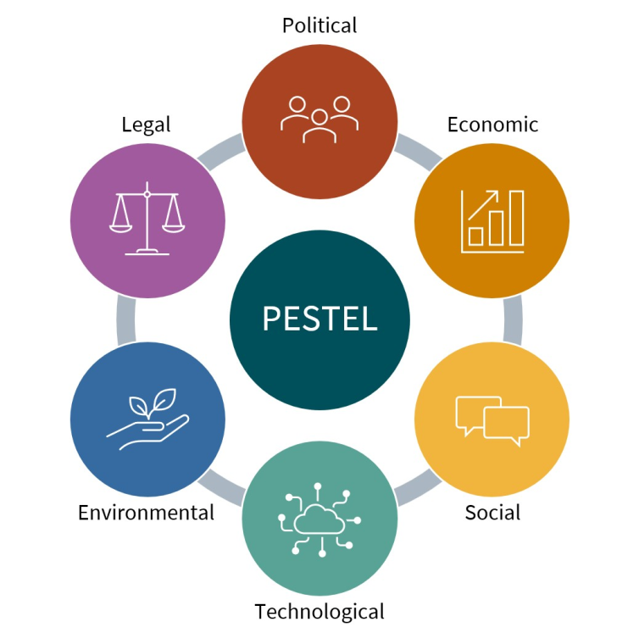
Figure 1: Standard PESTLE framework for analysing the macro-environment (Zhu, 2022).
Political Factors: Vietnam political factors are defined by the relative stability in the form of a single-party system that offers continuity to the policies and predictable government. Vietnam has an aggressive policy of foreign direct investment especially in the retail and manufacturing sectors as part of its economic modernisation program. The political environment is also favourable to ZARA entry because it eliminates uncertainty in the policies and this favours long term strategic planning. Nevertheless, the state control over some of the regulatory procedures can delay the administrative authorizations, which means ZARA will have to take a tentative, compliance-based entry approach, which may include enlisting the help of the seasoned local legal and regulatory consultants.
Economic Factors: Economically, Vietnam has been showing a stable GDP growth, increasing disposable incomes, and a fast-growing urban middle-income (World Bank, 2024). These patterns add pressure on low-cost but stylish clothes and this is similar to the value proposition of ZARA. However, the distribution of income levels is still uneven among regions, and this implies that the pricing of ZARA should be well-calibrated to prevent the over-positioning of the brand as inaccessible (Shabir and Albishri, 2021). This is strategically effective in the ability to be selective in the urban market and focus on the major cities with the greatest purchasing power and fashion consciousness.
Social Factors: The opportunity provided by social factors is high. The population of Vietnam is youthful, digitally savvy, and is getting affected by worldly fashions via social media platforms. This population change is biased towards quick-fashion companies that can update their products fast and respond to trends. Nevertheless, Vietnamese consumers too will be increasingly sensitive to ethical sourcing and sustainability matters (Wang, 2024). It means that the communication strategy of ZARA needs to rely more on transparency, responsible sourcing, and adherence to sustainability policies of Inditex in order to increase legitimacy and brand acceptance.
Technological Factors: Regarding technological aspects, Vietnam has been digitising fast and boasts a high rate of smartphone penetration that makes strategies of omnichannel retail. The consumer purchasing behaviour, especially that of young consumers is undergoing transformation due to e-commerce and social commerce. In the case of ZARA, it solidifies the strategic role of primary integration of online and offline channels at the very beginning of operations with the help of sophisticated data analytics and inventory management tools to maximise the demand forecast and minimise stock inefficiencies.
Legal Factors: The legal considerations are the adherence to labour laws, regulations on foreign ownership and consumer protection laws. Vietnam has been enhancing its regulatory clarity by signing trade agreements but there is still poor enforcement. This poses the operational risks linked to labour standards and governance of the supply chain. In a tactical move, ZARA has to strengthen supplier surveillance systems and make sure that Inditex global codes of conduct are carefully observed to reduce reputational and operational risks.
Environmental Factors: Last but not least are the environmental factors which are becoming salient. The environmental issues that Vietnam is struggling with include urbanisation and industrial pollution, and the regulatory pressure towards sustainable business practices is slowly increasing (Shabir and Albishri, 2021). This would require a proactive sustainability initiative in the case of ZARA whose fast-fashion business concept has been criticized the world over due to its negative environmental effects. Incorporating environmentally friendly shops and marketing sustainable lines may address the expansion goals towards the environmental goals, enhancing the legitimacy in the long run.

3.2 Industry and Competitive Environment: Porter’s Five Forces
The Five Forces model by Porter offers an understanding of the competitive forces in the fashion retail industry of Vietnam, as well as their effects in the strategy positioning of ZARA.
The competition in the market of fashion retailing in the Vietnamese market is increasing. There are already established international brands like H&M and Uniqlo as well as domestic retailers with the ability to price their products competitively. The price sensitivity, quick trend following and high marketing visibility are the driving forces that cause rivalry. Nevertheless, the high speed-to-market and small run of production of ZARA lessens the direct price competition and enables the company to differentiate itself by exclusivity. The strategic approach that should be employed by ZARA is, instead of competing on price, it must use its fast-response model to continue differentiation.
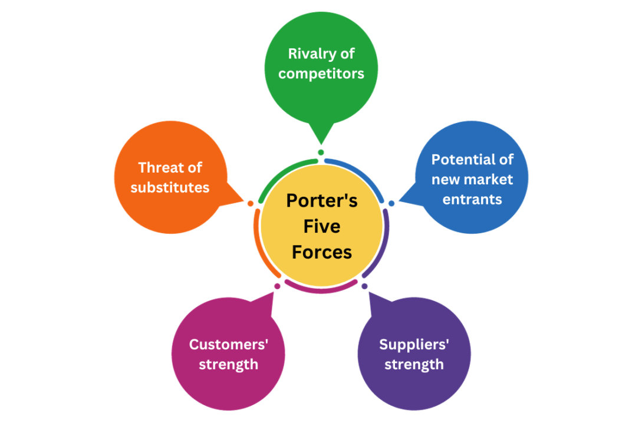
Figure 2: Porter’s Five Forces model illustrating industry competitive pressures (Zhang, L., 2023)
The threat of new entrants is average. Capital requirements of fashion retail are comparably low, with brand recognition, location of prime retail stores, as well as, the establishment of efficient supply chains being a major impediment. The brand equity and experience of operating in different countries around the world gives ZARA a shield against new entrants. However, the analogue fashion brands increase the entry threshold in digital platforms, which implies that ZARA has to constantly invest in online interactions in order to protect the market share.
The power of suppliers in the apparel industry is moderate. The large garment producing platform of Vietnam minimizes the reliance on single suppliers. The vertically integrated model of ZARA, however, minimizes the supplier power considerably because it has control on designing, scheduling production and distributing the products (Ruan, Sang and Zeng, 2022). This is an ability that is added to strategic flexibility and cost control, which strengthens the competitive advantage of the company in reacting to unpredictable fashion trends at ZARA.
The purchasing power of customers is intense. The switching costs can be low and the consumers have many substitutes, both local and international. Vietnamese customers are cost-effective and they are becoming more knowledgeable courtesy to the internet (Vietnam Briefing, 2025). This exerts a strain on margins and requires unending innovation. The demand is partially mitigated by the fact that being the first to have a new product and having to buy a limited number of items makes ZARA a more appealing target than a major retailer in the majority of cases.
The threat of substitutes is medium to high. Alternatives are the old school clothing spaces, second hand fashion platforms and the upcoming sustainable fashion brands. The increasing environmental consciousness can prompt consumers to look for alternatives to fast fashion (Ruan, Sang and Zeng, 2022). This highlights the strategic value of including sustainability efforts in the value proposition of ZARA in order to minimise threat of substitution and attract changing consumer preferences.
In general, the competition in the environment is tough but can be effectively overcome, when ZARA could capitalize on its unique operation benefits and does not overly compete on prices.

3.3 Internal Analysis: VRIO Framework
The VRIO model can help analyse the internal resources and capabilities of ZARA to establish their ability to provide a long-term competitive advantage in the Vietnamese market.
Responsiveness in the supply chain is a very rare and valuable capability of ZARA. The vertically integrated model of the brand makes it respond to new fashion trends quickly, as it should make the design-to-store cycles as short as possible. It cannot be easily replicated because of the magnitude, organisation, and resources involved, and it is completely entrenched into the organisational framework of Inditex. It is therefore a long-term competitive edge in markets that are typified by dynamic consumer tastes.
The design to store speed also supports the strategic positioning of ZARA. ZARA based on the real-time sales information to make design decisions should be contrasted with competitors that are dependent on long forecasting cycles. Their dynamic capability is especially useful in trend-based urban markets in Vietnam, where the tastes of the consumer change very quickly. This capability is well leveraged through the organisational synergy that prevails between design, production and retail.
Another important resource is brand equity. The bold designs at affordable prices have made ZARA to be recognised worldwide as fashionable and thus offers instant credibility in the new markets. Although brand recognition is not completely uncommon amongst international retailers, the correlation that ZARA is associated with speed and fashionableness increases the differentiation (Aftab et al., 2018). This brand equity brings at least a short-term competitive advantage particularly when it comes to first time market entry.
Digital integration is an increasingly competitive source of advantage. The high data analytics, RFID-powered inventory solutions and omnichannel capabilities of ZARA help the company to improve demand prediction and operational productivity (Yan, 2024). Despite the growing efforts of competitors to invest in other comparable technologies, the early adoption and integration within ZARA give the company an advantage in a relative sense that will facilitate scaling and customer engagement.
All these resources and capabilities favour ZARA in the context of international expansion. The VRIO analysis shows that ZARA has various sources of sustained competitive advantage which can be successfully applied to Vietnam in case they are adjusted to local market conditions.

3.4 Critical Evaluation of Analytical Frameworks
PESTLE combined with Porter's Five Forces and the VRIO framework help us have a structured and multidimensional view of the strategic situation of ZARA. Both frameworks have a unique analytical value, but each of them has its limitations when used independently.
PESTEL works best in determining the opportunities and threats at the macro-level, especially in the new markets like Vietnam where the political, economic and social forces play a major role in determining the strategy. Nevertheless, it is too static to address quick changes in the market and company-level flexibility, which have become the focal point of fast-fashion competition.
Porter's Five Forces is an informative source of information regarding the industry structure and competition intensity with the emphasis made on power relations and profitability drivers (Liu, Huang and Pan, 2024). However, the model will be relatively stable in terms of industry boundaries and could be understating the effect of disruption of digital and fast-cycle trends that define modern fashion retail.
VRIO framework is able to overcome these limitations through the VRIO framework that emphasizes on firms’ specific resources and dynamic capabilities. It facilitates further understanding of how the internal strengths of ZARA can be used to deal with external pressures (Yin, 2022). Nevertheless, VRIO does not explain external volatility and institutional limitations fully, especially in developing economies.
The combination of these frameworks helps to overcome the shortcomings of each of them and gives a more detailed strategic evaluation. This triangulation method will increase the methodological rigour and facilitate evidence based and strong strategic decisions regarding international expansion of ZARA.

4. Strategy Development and Formulation

4.1 Strategic Direction and Growth Options: Ansoff Matrix
The Matrix of Ansoff is an organized approach of analysing the strategic growth options of ZARA in terms of analysing the product-market relationship of the company. The most applicable strategic options in the case of the proposed expansion to Vietnam are the market development and diversification.
Market development entails the introduction of the already existing product line of ZARA into a new geographical market. This alternative has slightly less strategic risk than diversification, where ZARA would use its developed formats of fast-fashion, its operational procedures and brand recognition and tailor itself to the local market conditions. Since ZARA has demonstrated the capacity to recreate its business model in various global markets, market development is a strategic appropriate strategy (Li, Liu and Zhou, 2024). Internal support of the strategy is high as the supply chain is vertically integrated, its design processes are evidence-driven, and it has the global sourcing capabilities.
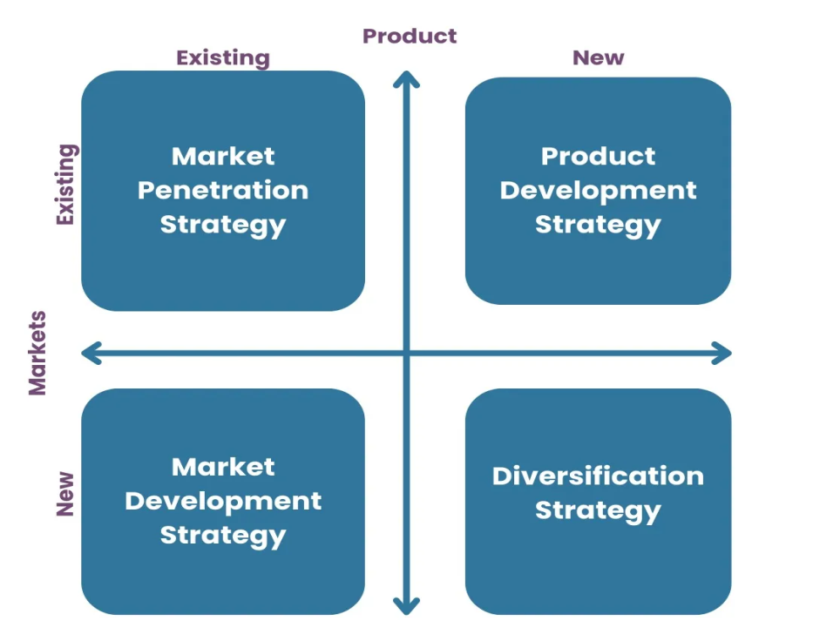
Figure 3: Ansoff Matrix outlining strategic growth options (Liu, Huang and Pan, 2024).
In its turn, diversification, especially related and unrelated diversification, would imply the creation of new product lines or new business models as well as market penetration. Although this may have the potential to broaden revenue streams, it would greatly increase the level of risk since market knowledge would be low, the level of operation would be too complicated and the brand image may suffer dilution (Baena, 2024). Diversification can make the ZARA lose its strategic focus and business performance in an emerging market like Vietnam, where consumer tastes are shifting, yet price elasticity is very high.
In terms of risk analysis, market development will enable ZARA to strike a balance between the growth ambition and the strategic control. It facilitates the learning in small steps, testing of demand and commitment of resources gradually and maintaining strategic flexibility (He, 2022). Moreover, the strategy is in line with the past expansion trajectory of ZARA, which focuses on geographic replication of its core model instead of radical product innovation at the early market entry stages.
Based on this, market development is recognized to be the most strategically appropriate growth alternative to the entry by ZARA into Vietnam. It utilizes the available competitive advantages and minimizes the level of exposure to excessive uncertainty which contributes to sustainable international expansion.

4.2 Competitive Strategy: Porter’s Generic Strategies
The generic strategies framework by Porter recognizes three key bases of competitive advantage, namely cost leadership, differentiation, and focus. The strategic positioning of ZARA, however, does not fit in the category of one or another, it takes a hybrid strategy that incorporates cost-efficiency and differentiation.
ZARA does not engage in the purest form of cost leadership as it does not compete on the lowest price as a fundamental approach. Instead, it is cost efficient due to operational excellence, vertical integration and less inventory risk which helps it to offer competitive prices without compromising on margins (Fadel and Konis, 2024). At the same time, one of the aspects that make ZARA stand out is quick product turnover, attentiveness to trends, and perceived exclusivity achieved with the help of small production batches.
This combination positioning is strategic in the Vietnamese market (Zhang, 2025). The sensitivity of prices among the consumers would require affordability and the growing fashion consciousness and exposure to the world trends will trigger demand for differentiated offerings (Duoyan, 2021). ZARA is well positioned with its capability to provide trendy items at affordable prices in between the high-end international brands and the low-priced domestic stores.
The longevity of this competitive edge lies in the fact that ZARA must still be able to keep its speed of operation and chain management (Chen, 2023). Competitors like H&M and Uniqlo also have the scale benefits, but the ability of ZARA to design and store in a short-cycle is not easily replicated. Nevertheless, the threat of imitation is going to grow as competitors invest in digital technologies and agile sourcing.
ZARA should be ready to strengthen its dynamic capabilities, especially its data analytics, inventory optimisation and fast decision-making to maintain its competitive edge (Berbiche, Hlyal and el Alami, 2020). The establishment of strategic balance in terms of cost control and differentiation in the Vietnamese context will be essential in order to ensure that the margins are not lost, and the brand differentiation is maintained.

4.3 Market Entry Strategy
The choice of a market entry mode is essential in balancing risk, control and resource commitment. The major entry modes that can be used by ZARA are joint venture, franchising and wholly owned subsidiaries.
Franchising:
Franchising has low financial risk and penetrates the market speedily but there is a huge limitation of the strategic and operational control. In the case of ZARA where the company competitiveness is largely anchored on close liaison between designing, production and retailing, franchising is a big threat (Aftab et al., 2018). Loss of control on operations of the stores, visual merchandise and inventory control may jeopardize brand consistency and responsiveness to operations.
Joint Venture (JV):
JVs bring in risk-sharing and local market experience that may facilitate smooth sailing through regulations and cultural acclimatization. But joint ventures are also associated with coordination problems and risk of strategic misalignment. The differences in the goals of the partners can undermine the fast-decision-making culture and independence of operations at ZARA.
Wholly Owned Subsidiary:
A wholly owned subsidiary is the most strategically relevant entry mode that ZARA should adopt in its expansion to Vietnam. Though this solution demands more initial investment, and it puts the firm at a higher financial risk, it provides the greatest control of the operations, brand implementation and integration of the supply chains (SISDM Conference Proceedings, 2024). Complete ownership will allow ZARA to recreate its global model of operation without compromising on the design of its stores, product flow, and customer experience.
High control is strategic to ensure that the core competencies of ZARA are safeguarded, especially its speedy supply chain and data-driven merchandising (Berbiche, Hlyal and el Alami, 2020). Also, the fact that Vietnam is improving its regulatory environment and welcoming foreign investment reduces institutional barriers that are related to wholly owned entry.
In comparison, the short-term risk associated with the alternative modes of entry is lower; nevertheless, the alternative methods also limit the potential of ZARA in using its competitive advantages to the fullest extent. Thus 100 per cent. subsidiary, which could be gradually implemented with the first flagship stores in the most significant urban centres, is the most harmonious and strategically consistent entry strategy.

4.4 Corporate Social Responsibility and Sustainability
Corporate social responsibility (CSR) and sustainability are becoming the primary focus of strategic legitimacy, especially among fast-fashion retailers with a business in the emerging markets (Zhang, E., 2024). The move of ZARA to Vietnam should be supported with global sustainability plans of Inditex, such as responsible sourcing, less negative impact on the environment, and ethical workers.
The apparel industry of Vietnam has had a track record of receiving criticism over the labour conditions, wages and safety at the workplace. As a result, ZARA should actively implement compliance on the suppliers on the Code of Conduct of Inditex, which stipulate fair labour conditions, transparency and frequent audit. This will not only reduce the reputational risk, but also enhance the stakeholder trust by the regulators, consumers and civil society (Reuters, 2025).
Environmentally, there is an emerging pressure on regulation and social aspects on pollution and consumption of resources in Vietnam. Sustainability efforts of ZARA eco-efficient stores, recycled materials, water-efficient production, among others, must be highly incorporated into the market entry strategy (Baena, 2024). The message about these efforts should be conveyed properly to overcome the criticism of fast fashion and attract the attention of environmentally conscious customers.
Community engagement and contribution to the local economic development are also market specific expectations of CSR. Through investment in local employment, training programmes and sustainable supply chain alliances, ZARA is able to improve its social licence to operate as well as strengthening their long-term market presence.

4.5 Strategic Risks and mitigation measures
Although ZARA has strategic advantages to its growth into Vietnam, there are a number of risks involved. Supply chain risk is brought about by the complexity of the operations and possible disruptions (Chen, 2023). Diversified sourcing, improved inventory tracking and contingency logistics planning can help to reduce this.
The regulatory risk will comprise alterations in labour legislation, taxation, and foreign investment regulation. ZARA must have a close interaction with the government bodies and hire local legal advisors to make sure there is adherence and flexibility (International Journal of Emerging Business and Economic Research, 2024).
The risk of cultural and consumer behaviour is due to the discrepancy between the international brand products and the local tastes (Duoyan, 2021). This risk may be lowered by the incessant market examination, regionalisation of product selections and being receptive to consumer comments.
All this will make proactive risk management a key to the protection of ZARA strategic objectives and sustainable performance in the Vietnamese market.

5. Performance Evaluation Framework

5.1 Selection of Performance Measurement Framework
In order to measure how successful the suggested expansion into Vietnam by ZARA can be, the Balanced Scorecard (BSC) is chosen as the most suitable performance measurement framework. Balanced Scorecard is not a mere financial figure and it includes customer, internal process and learning or innovation areas thus offering a comprehensive evaluation of strategic performance (Fadel and Konis, 2024). This is especially true in the case of expansion internationally where short term financial performance may not capture the strategic advances or long-term value generation.
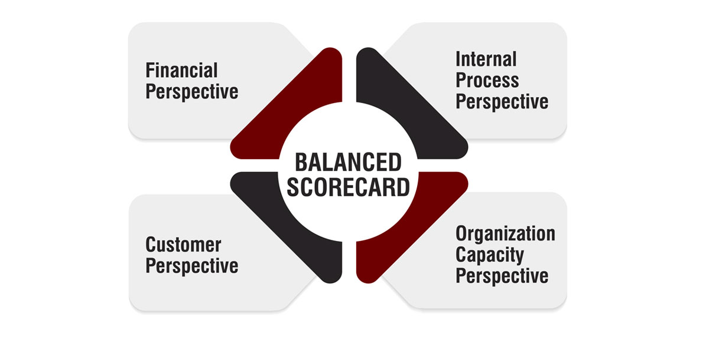
Figure 4: Balanced Scorecard framework linking strategy to performance metrics (He, 2022).
The Balanced Scorecard provides the opportunity to closely match the strategic goals and operational implementation in the environment of the fast-fashion business model of ZARA. It helps the organisation to keep track of the extent to which competitive advantages, including speed of the supply chain, brand differentiation, and digital integration, are converted into market performance. Although the Triple Bottom Line is an excellent source of sustainability information, the Balanced Scorecard is more effective to incorporate a combination of sustainability measures, financial, and operational KPIs. As a result, Balanced Scorecard is an actionable, planned, and strategic framework to evaluate the performance of ZARA in market entry in Vietnam.

5.2 Financial Performance Measures
Financial performance indicators play a significant role in determining how the expansion of ZARA is a viable business. One of the major indicators of the market acceptance and penetration of demands is the revenue growth. The growth in sales per year in Vietnam would indicate the success of the entry strategy and product-market fit by ZARA.
Another critical measure is the market share, which will determine the ZARA competitive standing to the international and local fashion retailers. An expanding market share in major urban centres would be a pointer of effective differentiation and brand penetration (Alon, 2020).
Such metrics like cost efficiency measures, e.g. operating margin and logistics cost as a percentage of sales are particularly important since ZARA relies on using fast-response supply chains (He, 2022). The indicators will be monitored to make sure that growth is attained without compromising profitability. All these financial indicators help the management to assess the achievement of expansion goals in a sustainable way financially.

5.3 Customer and Market KPIs
Customer-oriented indicators will give the picture related to the brand performance and market involvement of ZARA in Vietnam. The success of marketing and store location policies can be evaluated on brand awareness with the help of market surveys, social media coverage, and foot traffic.
The satisfaction and brand loyalty is a proxy of customer retention rates, which are especially significant in the fashion retail sector where the switching cost is low. Retention trends could be tracked with the help of repeat purchase frequency and participation in the loyalty programme.
Online interactions, such as online traffic, mobile application usage, and social media referencing, are becoming crucial considering that the digital uptake in Vietnam is high. High levels of digital integration signify the correspondence to the consumer behaviour and contribute to the omnichannel strategy of ZARA. All these KPIs evaluate the level to which ZARA is establishing a lasting relationship with its customers instead of addressing only the short-term sales.

5.4 Internal Process and Sustainability Metrics
The metrics of operational effectiveness of ZARA include internal process measurements. The responsiveness of the supply chain in terms of design-to-store lead time and speed of stock replenishment is a direct indicator of the core competitive advantage of ZARA. Short cycle time in Vietnam would ensure effective replication of the fast-fashion model in Vietnam.
Another important indicator is inventory turnover, which shows the efficiency of selling and replacement of products. High turnover lowers the risk of markdown and helps to make a profit.
The sustainability dimension of expansion is taken into account with the environmental performance indicators including energy consumption per store, the share of sustainable materials used, and rates of waste reduction (Li, Liu and Zhou, 2024). The metrics conform to the environmental commitment of Inditex and respond to the increasing stakeholder expectations. Collectively, internal and sustainability KPIs will guarantee that the operational performance and responsible business practices will be incorporated into the strategic performance appraisal.

6. Conclusion and Strategic Recommendation

6.1 Conclusion
This report has managed to formulate an elaborate strategic expansion plan of ZARA into the Vietnamese market through a systematic application of the time-tested strategic management models. It was revealed that Vietnam is a promising growth prospect due to high economic performance, young and high-fashion people, high rates of digitalisation and growing receptiveness to foreign brands on retail. The PESTLE and Five Forces analyses revealed potential opportunities as well as competitive threats of the market, the VRIO analysis proved that ZARA has considerable internal resources that could allow it to maintain competitive advantages.
Tactically, a market development strategy was selected as the most appropriate to grow and this would help ZARA to capitalize on its current model of fast-fashion and deal with risk. It was demonstrated that the hybrid competitive strategy that combines cost efficiency with differentiation in terms of speed and trend responsiveness were rather consistent with the preferences of Vietnamese consumers. The offer to penetrate the market using a wholly owned subsidiary means taking full control of the operations and safeguarding the core competencies of ZARA, as well as allowing the company to execute the brand consistently.

6.2 Strategic Recommendations
1. Performance Management: The recommendation is that to expand into Vietnam, the Balanced Scorecard should be embraced by the management of ZARA to track the financial, customer, internal process, and sustainability performance. The framework will guarantee that there is strategic alignment and accountability since long term objectives will be translated into operational results, which can be achieved especially in the initial market entry stages (Inditex, 2021).
2. Governance and Compliance: In order to reduce the regulatory and institutional risks, ZARA ought to institute effective governance practices, such as the involvement with the local government, adherence to labour and consumer protection legislation and alignment to the worldwide codes of conduct that Inditex adheres to. Such steps will minimize reputational and operation risk of supply chain governance.
3. Operational Localisation: The sourcing, logistics, and product assortments of ZARA are to be selectively localised to enhance responsiveness to the local consumer preferences without losing its fast-fashion model. These adaptations should be determined by data-based demand forecasting and in-the-field market feedback (Ullah and Khan, 2025).
4. Market Implementation: The growth must be implemented as a progressive process of opening wholly owned flagship stores in large cities like Ho Chi Minh City and Hanoi. This strategy will enable ZARA to explore market demand, streamline operations and control financial risk besides integrating omnichannel.
5. Strategic Outcome: All in all, the opportunity of expanding to Vietnam is a strategically viable offer, as it is in line with the long-term growth objectives of ZARA. The proper implementation will improve the presence in the region in Southeast Asia, will diversify the revenue streams, and will strengthen the global competitive position of ZARA.

References
- Aftab, A., Yuanjian, Q., Kabir, N. and Barua, Z. (2018) Super Responsive Supply Chain: The Case of Spanish Fast Fashion Retailer Inditex-Zara, International Journal of Biometrics. DOI: 10.5539/IJBM.V13N5P212. Accessed: 15 December 2025.
- Alon, I. (2020) ‘A systematic review of international franchising’, Journal of World Business, 55(2). Available at: https://www.sciencedirect.com/science/article/pii/S1525383X20000249 (Accessed: 21 December 2025).
- Baena, V. (2024) The shift from fast fashion to socially and sustainable fast fashion: The pivotal role of ethical consideration of consumer intentions to purchase Zara, Corporate Social Responsibility and Environmental Management. DOI: 10.1002/csr.2803. Accessed: 15 December 2025.
- Berbiche, N., Hlyal, M. and el Alami, J. (2020) Exponential success through integrated supply chain optimization, emotional intelligence and reputation-based leadership: Zara model, IOP Conference Series: Materials Science and Engineering. DOI: 10.1088/1757-899X/827/1/012058. Accessed: 15 December 2025.
- Chen, X. (2023) Market Analysis of Fast Fashion Brands in the Context of New Retailing: The Case of Zara (China), Advances in Economics, Management and Political Sciences. DOI: 10.54254/2754-1169/49/20230469. Accessed: 15 December 2025.
- Duoyan, H. (2021) Research on ZARA Strategy from the Perspective of SWOT Analysis Method, Proceedings of the 2021 6th International Conference on Social Sciences and Economic Development (ICSSED 2021). DOI: 10.2991/ASSEHR.K.210407.041. Accessed: 15 December 2025.
- Fadel, K. and Konis, E. (2024) Analyzing the Influence of Marketing Strategies on Consumer Behavior in the Fast Fashion Industry: The Case of Zara in Cyprus, Revista de Gestão Social e Ambiental. DOI: 10.24857/rgsa.v18n8-160. Accessed: 15 December 2025.
- He, H. (2022) Fast Fashion Supply Chain Issues in the New Marketing Environment: Zara, BCP Business & Management. DOI: 10.54691/bcpbm.v34i.3134. Accessed: 15 December 2025.
- Inditex (2021) Transforming with a unique model. Available at:https://static.inditex.com/annual_report_2021/en/documents/unique-model.pdf (Accessed: 21 December 2025).
- International Journal of Emerging Business and Economic Research (2024) ‘Vietnamese consumers’ behaviour towards sustainable fashion’. Available at:https://ijeber.com/uploads2024/ijeber_04_197.pdf (Accessed: 21 December 2025).
- Li, R., Liu, W. and Zhou, S. (2024) Digital Transformation of Supply Chain Management in the Fast Fashion Industry: A Case Study of Zara, SHS Web of Conferences. DOI: 10.1051/shsconf/202418104019. Accessed: 15 December 2025.
- Liu, S., Huang, Y. and Pan, Q. (2024) Analyzing the Strategic Impact of Zara’s Branding Strategies on Consumer Engagement and Market Position, SHS Web of Conferences. DOI: 10.1051/shsconf/202418503018. Accessed: 15 December 2025.
- Reuters (2025) ‘Zara owner Inditex’s transport emissions jump in 2024’, Reuters, 14 March. Available at:https://www.reuters.com/business/retail-consumer/zara-owner-inditexs-transport-emissions-jump-2024-2025-03-14/ (Accessed: 21 December 2025).
- Ruan, T., Sang, D. and Zeng, Q. (2022) Research on ZARA’s Business Environment and Marketing Strategies in China, Proceedings of the 2022 2nd International Conference on Enterprise Management and Economic Development (ICEMED 2022). DOI: 10.2991/aebmr.k.220603.106. Accessed: 15 December 2025.
- Shabir, S. and Albishri, N. (2021) Sustainable Retailing Performance of Zara during COVID-19 Pandemic, Open Journal of Business and Management. DOI: 10.4236/OJBM.2021.93054. Accessed: 15 December 2025.
- SISDM Conference Proceedings (2024) ‘Fast fashion and sustainability: a paradoxical relationship’. Available at:https://www.researchgate.net/publication/379189252_SISDM-2023_Sustainable_Fashion_Design_-II_FAST_FASHION_AND_SUSTAINABILITY_A_PARADOXICAL_RELATIONSHIP (Accessed: 21 December 2025).
- Sitaro, T.D. (2020) ‘Fast fashion and sustainability: the case of Inditex-Zara’, Fordham University Research Commons. Available at:https://research.library.fordham.edu/cgi/viewcontent.cgi?article=1044&context=international_senior (Accessed: 21 December 2025).
- Ullah, M. and Khan, S. (2025) Success through strategic supply chain practices in fast fashion: a comparative study of Inditex-Zara and SHEIN, Universal Journal of Management. Available at:https://www.hrpub.org/download/20250330/UJM2-12140469.pdf (Accessed: 21 December 2025).
- Vietnam Briefing (2025) Vietnam e-commerce sector outlook: key growth trends. Available at:https://www.vietnam-briefing.com/news/vietnams-e-commerce-sector-outlook-in-2026.html/ (Accessed: 21 December 2025).
- Wang, J. (2024) Analysis of ZARA's Social Media Marketing Strategy in China, Advances in Economics, Management and Political Sciences. DOI: 10.54254/2754-1169/102/2024ed0095. Accessed: 15 December 2025.
- Xie, Y. and Yang, Q. (2023) Comparative Analysis of Marketing Strategies of Fast Fashion Brands ZARA and H&M, BCP Business & Management. DOI: 10.54691/bcpbm.v39i.4162. Accessed: 15 December 2025.
- Yan, J. (2024) Analysis of Zara's Financial and Market Performance, Highlights in Business, Economics and Management. DOI: 10.54097/8rjgkw66. Accessed: 15 December 2025.
- Yin, Z. (2022) How Fast-Fashion Brands Went Viral—Taking Zara as an Example, Proceedings of the 2022 2nd International Conference on Enterprise Management and Economic Development (ICEMED 2022). DOI: 10.2991/aebmr.k.220603.086. Accessed: 15 December 2025.
- Zhang, E. (2024) Behind Zara’s success: An analysis of brand marketing and management in fast fashion, SHS Web of Conferences. DOI: 10.1051/shsconf/202419902005. Accessed: 15 December 2025.
- Zhang, L. (2023) ZARA Brand Strategy Analysis Based on Customer Perceived Value, Advances in Economics, Management and Political Sciences. DOI: 10.54254/2754-1169/41/20232024. Accessed: 15 December 2025.
- Zhang, L. (2025) Research on Zara’s supply chain system. Available at:https://www.researchgate.net/publication/394775904_Research_on_Zara%27s_Supply_Chain_System (Accessed: 21 December 2025).
- Zhu, T. (2022) International Business Strategy of Fast Fashion Brands (On the example of Zara), Journal of Education, Humanities and Social Sciences. DOI: 10.54097/ehss.v4i.2770. Accessed: 15 December 2025.

