BA Business Management
Management Economics
Assessment Component 1: Individual Essay
Lecturer name: Khai Le
Student name: Florina Madalina Gugoi
Student ID:2111163

Table of Contents
Introduction: 3
Industry Overview: 3
Current State of the UK Mobile Network Industry: 3
Key Players and Market Share: 3
Recent Developments: 3
Profit Maximisation Theory in the UK Mobile Network Industry 4
Concept of profit Maximisation theory: 4
Application to the UK Mobile Network Industry: 4
Limitations and considerations: 4
Challenges and Opportunities: 5
Challenges: 5
Opportunities: 6
Economic theories and business environment analysis: 6
Demand and Supply Chain Analysis: 6
Demand side analysis: 6
Supply-side analysis: 7
Market Structure: 7
Business Objectives: 7
Stakeholder Analysis: 8
Balancing these stakeholders' interests involves: 9
Sustainable growth strategies: 9
Recommendations: 9
Conclusion: 10
References: 11

List of figures:
Figure 1: Profit maximisation theory 4
Figure 2:Stakeholders Analysis 8

Introduction:
The mobile network industry is the most essential element of the UK digital infrastructure, which EE, O2, Vodafone, and Three control. The research conducted by Banchs et al. (2019) shows how changeable this sector is over the recent past and will be shortly. However, it offers opportunities and severe difficulties because of the appearance of 5G and changes in customer demands (Dhasan and Kowathanakul, 2021). Observing the state of the UK mobile network industry is necessary to understand better the connections between profit maximisation and sustainable business growth. By reviewing the opportunities for 5G expansion and digital partnerships and the threats related to infrastructure, legislation, and saturation, it is possible to determine the current needs of market players using different economic theories of demand, supply, and market structure.

Industry Overview:

Current State of the UK Mobile Network Industry:
According to Lutu et al. (2020), the United Kingdom has about 84 million mobile connections, and nearly 97% of its 68 million inhabitants use their mobile devices; all the mobile telecommunications networks' companies have been redesigned to offer quality services to companies and people in the United Kingdom". The UK mobile network industry is one of the most significant changing markets, with intense competition, unprecedented technology advancement and changing customer needs. The sector's most significant priorities are the rollout and enrichment of 5G networks, and all the leading firms have already launched services that include cutting-edge rapid, low-latency, and high-capacity innovations (Attaran, 2023).

Key Players and Market Share:
In 2024, four major mobile network operators dominate the UK market. They include EE and O2, which account for about 32% and 31% of the market, respectively (Samdanis and Taleb, 2020). Other market leaders include Vodafone, which accounts for about 20% of the market (Alsop, 2022), and Three, which currently accounts for 16%. These data adequately reflect the competitive environment in the sector, but they are subject to change. At present, the success of these companies can be explained by the fact that EE benefits from its early 5G launch and O2 gains from its Virgin Media brand (Zebari, Zebari, and Al-Zebari, 2021). Three is famous for its data-centric offering, and Vodafone remains hugely successful internationally.

Recent Developments:
The industry has had a significant move to merge Vodafone UK and Three UK since the fight began in 2023. According to Liu et al. (2020), with a market share of almost 36%, the largest mobile provider in the UK could also become the most significant if it receives approval from authorities. Given the ever-increasing congestion in the market, the industry needs to seek new revenue sources. Furthermore, other significant obstacles include the high cost of 5G infrastructure deployment and regulations imposed to boost rural coverage. As a result, the industry must work sustainably to reduce environmental effects (Hoory and Bottorff, 2022). To that end, operators have made it a top priority, promising to minimise the impact by employing programs to recycle devices and employ sustainable energy sources, among other methods.

Profit Maximisation Theory in the UK Mobile Network Industry

Concept of profit Maximisation theory:
According to profit maximisation theory, businesses balance expenses and revenues to maximise profits. When marginal revenue (MR) and marginal cost (MC) are equal, this happens economically (Lowe, Nama, and Preda, 2020). The underlying premise of this idea is that businesses are logical entities driven chiefly by profit. The following figure represents profit maximisation theory:
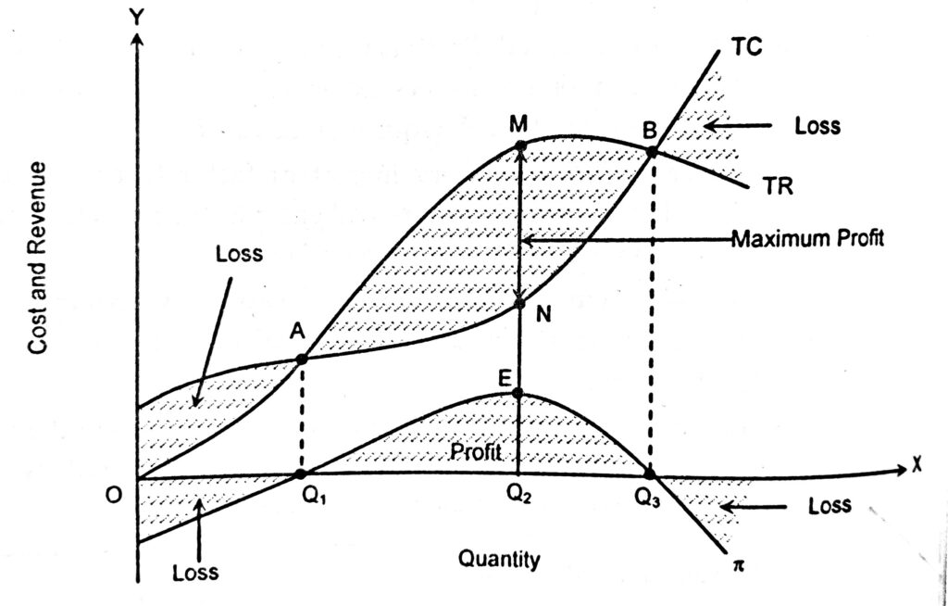
Figure 1: Profit maximisation theory
Source: (Lowe, Nama, and Preda, 2020)

Application to the UK Mobile Network Industry:
There are many ways in which profit maximisation appears in the UK mobile network industry:
Pricing strategies: To optimise revenue and maintain competitiveness, operators modify rates and data plans. Investment choices: Weighing the expenses of the 5G infrastructure against prospective earnings in the future (Paul, 2021). Market expansion: Pursuing mergers to obtain economies of scale, such as the Vodafone-Three combination. Offering extra services like IoT solutions or video streaming to diversify income sources is known as service diversification.

Limitations and considerations:
Profit maximisation is essential; however, the UK mobile network industry has certain limitations and things to remember.
Regulatory framework: Profit-maximisingOfcom's spectrum allotment and pricing rules impact profit-maximising tactics. Long-term investments: The deployment of 5G infrastructure will challenge the short-term profit maximisation strategy due to its significant upfront expenses and delayed returns (Forge and Vu, 2020). Market saturation: When penetration rates are high, growth sometimes occurs at the expense of rivals, escalating rivalry on prices (store. Mintel, 2022). Social obligations: Pursuing only profit maximisation may clash with demands for universal coverage and bridging the digital divide. Technological evolution: The quick technological changes necessitate constant investment, which affects profitability in the near run. Customer retention: In a market where there is competition, putting the needs of the client first occasionally takes precedence over maximising profits right away (Forge and Vu, 2020).
These elements require a more sophisticated strategy for profit maximisation in the UK mobile network sector that balances immediate financial objectives, long-term viability, and social expectations.

Challenges and Opportunities:

Challenges:
Several notable barriers shape the following state and potential of the UK mobile network industry. To begin with, there are the vast infrastructure costs associated with the rollout of 5G, amounting to as much as £30 billion (Mourtzis, Angelopoulos, and Panopoulos, 2021). While this expense is necessary to enable new technologies and meet the surging demand for data, it is also somewhat risky. It has tenuous short-term returns, particularly in less profitable rural areas. At the same time, the sector faces considerable regulatory pressures from Ofcom in the form of complex rules for spectrum auctions, stringent coverage obligations, and potential involvement in mergers, such as the one between Vodafone and Three. These regulatory requirements can significantly disrupt the operators' business plans and profits. Another obstacle is market saturation, exacerbated by the fact that the UK's mobile phone penetration already exceeds 100% (Mourtzis, Angelopoulos, and Panopoulos, 2021). As a result of this saturation, operators must find new sources of revenue by offering value-added services and moving into adjacent markets like the IoT, thereby increasing their competition for the same small pool of customers and leading to price competition and lower profit margins. Finally, cybersecurity risks have spiked with the advent of 5G. Since operators must shield against various threats, ranging from data breaches and network security flaws to dangers to IoT devices and even state-sponsored attacks, adopting robust security mechanisms is expensive (Gaber et al., 2021). As such, such measures are vital to preserving consumer and regulatory confidence, and as mobile networks continue to grow more sophisticated and data-oriented, they will only become more critical. Cybersecurity remains a significant concern as 5G networks move closer to SDN and virtualisation, introducing new security challenges.

Opportunities:
Numerous prospects drive the UK mobile network industry's potential for significant development and innovation. With its unparalleled speeds and low latency, 5G technology is poised to revolutionise several industries and open new opportunities (Sobrinho et al., 2023). An enormous ecosystem of interconnected devices is being created by the Internet of Things (IoT), which is growing thanks to this cutting-edge network architecture. 5G and IoT are opening new markets and use cases for mobile carriers, from smart cities and driverless cars to industrial automation and remote healthcare.
Partnerships for digital transformation provide an additional development path. To support businesses' digital transformation, mobile carriers are working with businesses in various industries more and more. According to McClellan, Cervello-Pastor, and Sallent (2020), to provide customised solutions, such as private 5G networks for industrial facilities or intelligent logistics systems for supply chain management, these collaborations take advantage of the operators' network capabilities and knowledge. Mobile operators may build valuable, long-lasting partnerships with business clients by establishing themselves as significant facilitators of digital change.
The sector is also exploring new revenue sources to expand beyond conventional phone and data services. Since operators can provide digital wallets, mobile payments, and microloans with their large customer base and secure infrastructure, the mobile financial services sector is new. Augmented reality applications, cloud gaming platforms, and video streaming services are other new business opportunities that may quickly be implemented due to the 5G network's enhanced capabilities (Tang et al., 2021).

Economic theories and business environment analysis:

Demand and Supply Chain Analysis:

Demand side analysis:
Demand for mobile services in the UK is influenced by numerous variables affecting market trends and consumer behaviour. Cost sensitivity is essential since all else is constant, and lower service costs usually generate elevated demands. According to Golmohamadi (2022), "income levels have a considerable effect on the consumption pattern for conventional goods and services", and people, on average, seem to adopt premium services at a greater rate. This pattern is reinforced by altering consumer tastes, specifically the surge in popularity of data-heavy phone applications such as games or streaming. Introduction and adoption rate of other products Cisco's annual report 2022 or smartphones that utilise the 5G network follows the same pattern and considerably impacts the demand for 5G-related services. According to Kanakadhurga and Prabaharan (2022), these factors determine consumers' willingness to pay for mobile services and the amount requested at different price points.

Supply-side analysis:
UK mobile network suppliers face several supply-side constraints and issues that restrict their ability to provide services. For example, concerning spectrum, the need for high spectrum fees makes it difficult to achieve sufficient availability. At the same time, the limits of technical possibilities mean it is impossible to maximise the growth of supply. Furthermore, natural scarcity restricts the supply of spectrum, with regulatory allocation as a result. Alongside this, the significant infrastructure costs limit the operators' theoretical potential to improve coverage and service quality, including with the current 5G deployment. Kanakadhurga and Prabaharan (2022) stated that network equipment's technological capabilities directly impact the kind and volume of services that may be provided. The regulatory environment significantly impacts operators' capacity to grow and modernise their networks in rural or underserved regions.

Market Structure:
According to Moller, Nenonen, and Storbacka (2020), the UK mobile network industry can be considered a typical example of an oligopolistic market structure. An oligopoly is observed when "a small number of firms have the large majority of market share". The market is appropriate to be defined as an oligopoly because only four leading companies – EE, O2, Vodafone, and Three – dominate the sector and possess almost 90% of the market share. Moreover, the industry is oligopolistic because there are significant barriers to entry. They include the large capital requirements needed to establish a network and the limited supply of spectrum licenses. These two crucial factors determine the market's oligopolistic nature.
This market structure highly conditions the industry's pricing and the overall level of competition. Because there are only a few significant players in the market, they cannot survive without each other; these companies are interdependent (Kim, Wang, and Roh, 2021). Therefore, they follow a general strategy whereby each operator considers the possible reaction of its competitors to a specific price or investment decision. Thus, the businesses involved in the industry are frequently restricted in their willingness to change prices independently because this move can trigger a "price war". Moreover, there are periodic "price wars" in this sector, which can take place, for example, as a reaction to new technology or changes in the regulatory environment (Kim, Wang, and Roh, 2021).

Business Objectives:
While profit maximisation remains the primary concern, UK mobile network operators increasingly follow various other goals to ensure sustainability and long-term success. These include:
- Market Share: Operators want to expand their customer base, as they consider market share an essential indicator of their competitiveness and profit potential.
- Customer satisfaction: The main goals are customer assistance productivity, the introduction of new goods, and service quality improvements, which would help to enhance the operator's retention or even make a customer a fan.
- Sustainability: A robust environmental agenda, including emission reduction and recycling campaigns, that respond to market and other legal requirements
- Technological Leadership: Investments in emerging technologies such as IoT and 5g to outpace contenders and dictate trends in the market
- Social responsibility: Digital gap reduction by “giving free internet in rural areas and cheap services to tribes in Amazonia.”

Stakeholder Analysis:
According to Bakhtiari et al. (2024), stakeholder analysis is a strategic process that involves determining and assessing the interests and influence of important people, groups, or organisations that may impact or be impacted by a firm's decisions.
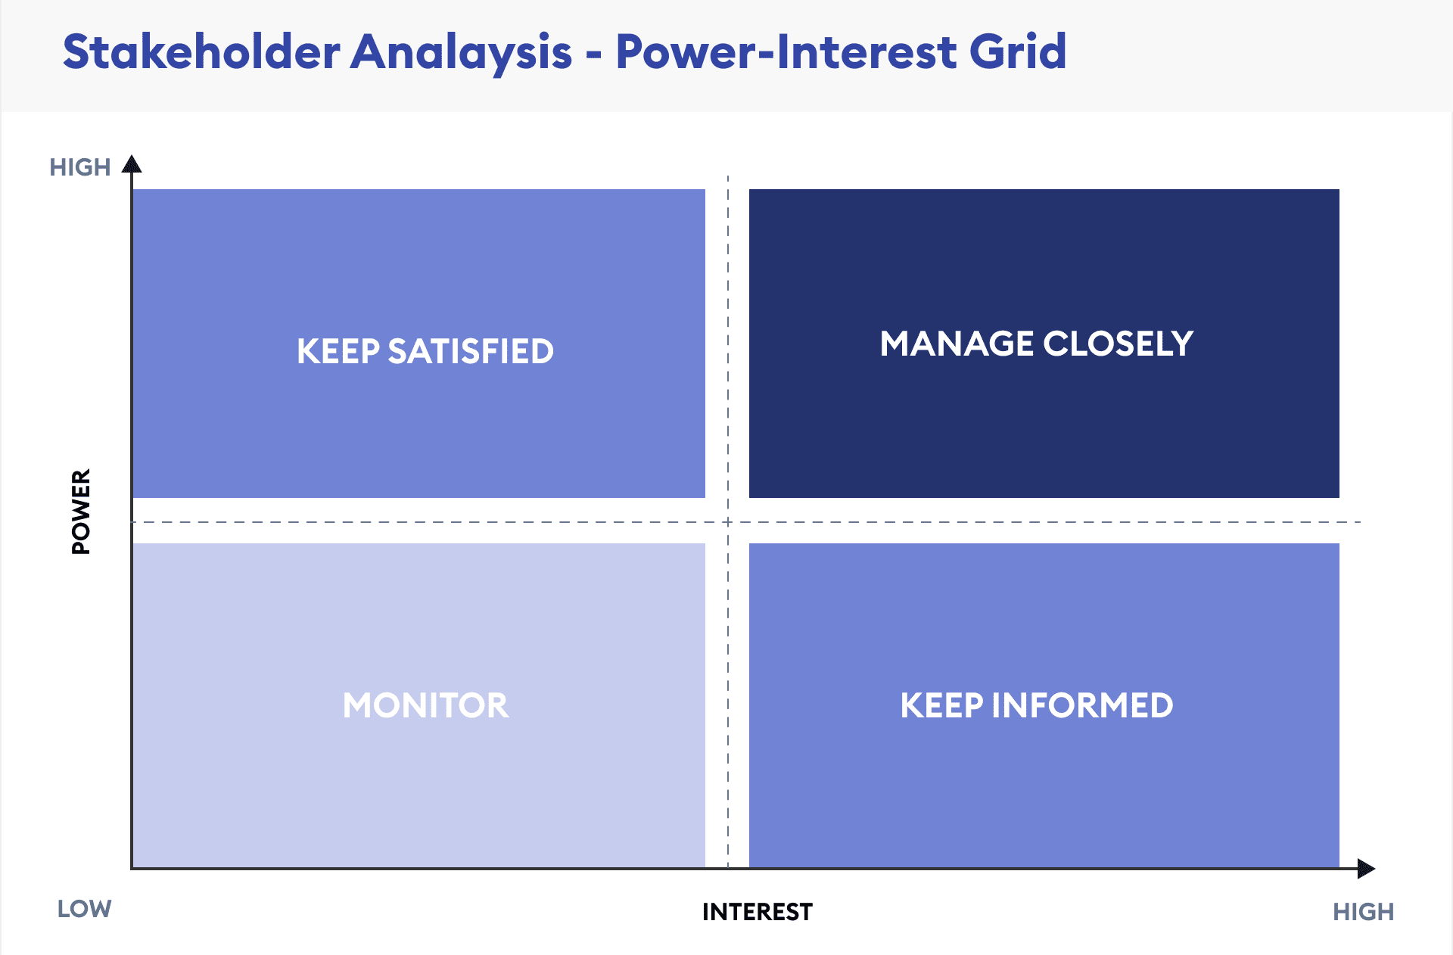
Figure 2:Stakeholders Analysis
Source: (Hoory and Bottorff, 2022)
According to Mendelow's Power-Interest Matrix, the UK mobile network industry players are divided into four groups based on their power and level of interest. In the high power, high interest "Key Players" category are the consumers, who are looking for a reliable and affordable service covering most places; governments and regulators, who are ensuring fair competition, efficient spectrum management, and the protection of the customers; and stockholders, who are expecting expansion of the business and financial returns. Suppliers and partners interested in fair contracts and stable commercial relationships operate in the high-power, low-interest "Keep Satisfied" section. Meanwhile, employees and environmental groups are assigned to the low power, high interest "Keep Informed" category: on the one hand, the former seek promotions, consistent pay, and job safety, while on the other hand, the latter are interested in the preservation of the environment and reduction in emissions.

Balancing these stakeholders' interests involves:
Long-term viability and sustainability in the UK mobile network industry depend on striking a balance between the interests of many stakeholders. Preserving market position and operational legitimacy entails prioritising regulatory compliance and consumer satisfaction (Mourtzis, Angelopoulos, and Panopoulos, 2021). To satisfy shareholder expectations, corporations must simultaneously assure profitability. Engaging with local communities promotes easier infrastructure development while implementing fair labour practices and sustainable operations and answers concerns about employees and the environment. Working with suppliers on moral business practices supports the sector's sustainability. In a complex and changing industry landscape, this strategic approach to stakeholder management supports long-term survival and growth by fostering a balanced ecosystem (Paul, 2021).

Sustainable growth strategies:
The mobile network industry in the United Kingdom is employing many approaches to guarantee long-term development. Businesses are investing significantly in edge computing, creating AI tools for network optimisation, and establishing 5G infrastructure, among other innovative projects. Customer-centric strategies emphasise omnichannel customer assistance, service personalisation, and raising QOE (quality of experience) indicators (Hoory and Bottorff, 2022). The promotion of e-waste recycling initiatives, the use of energy-efficient technology, and the use of renewable energy sources all contribute to environmental sustainability. Operator collaborations with tech startups, academic institutions, and industry consortiums are critical in driving innovation and creating industry standards. Together, these tactics seek to strike a balance between customer happiness, environmental responsibility, and technical advancement (Samdanis and Taleb, 2020).

Recommendations:
- 5G Infrastructure Acceleration: Plan for nationwide coverage while prioritising urban rollout. Regulators should encourage rural growth and simplify the distribution of spectrum.
- Encourage Innovation Partnerships: Work with startups, tech companies, and academic institutions to promote developments in edge computing, AI, and IoT.
- Enhance cybersecurity and network resilience: Implement robust measures against cyberattacks and disruptions. Adopt stringent cybersecurity regulations for the entire sector.
- Implement the circular economy and renewable energy strategies to support Sustainable Development. Regulators must incentivise sustainable initiatives.
- Resolve the ‘Digital Divide’ by delivering equal access to cutting-edge mobile services across all terrains and human settlements. Support the options and initiatives on digital literacy and cheap access.
These ideas seek to establish a robust, creative, and inclusive mobile network industry in the UK by combining expansion with social demands.

Conclusion:
The UK mobile network industry is currently at a tipping point, with an oligopolistic market structure based on four great competitors. As for the sector's development and innovation, 5G is increasingly transforming the way the industry is developing. Due to the complex stakeholder landscape requiring strategic management, the sector focuses more on sustainability and digital divide reduction. Additionally, cybersecurity and networking resilience have become critical factors as the technological world develops. There is room for optimism about the sector's future, although some uncertainties will define the market. For example, numerous economic sectors are anticipated to change because the 5G technology's full potential is unlocked, in addition to the impact of the IoT and AI discoveries. For operators, the key challenges to overcome are regulatory pressures, market saturation, and high infrastructure costs.

References:
Alsop, T. (2022). Vodafone mobile/fixed Market Share by Country in 2020. [online] Statista. Available at: https://www.statista.com/statistics/261003/vodafones-market-share-by-country/ [Accessed 13th October 2024].
Attaran, M. (2023). The impact of 5G on the evolution of intelligent automation and industry digitisation. Journal of ambient intelligence and humanised computing, 14(5), 5977–5993.
Bakhtiari, V., Piadeh, F., Chen, A.S. and Behzadian, K. (2024). Stakeholder analysis in applying cutting-edge digital visualisation technologies for urban flood risk management: A critical review. Expert Systems with Applications, 236, p.121426.
Banchs, A., Gutierrez-Estevez, D.M., Fuentes, M., Boldi, M. and Provvedi, S. (2019). A 5G mobile network architecture to support vertical industries. IEEE Communications Magazine, 57(12), pp.38-44.
Dhasan, D. and Kowathanakul, S. (2021). The impact of service quality, promotions and customer engagement in determining customer loyalty in the Thai mobile network industry. Abac Journal, 41(1), pp.209-240.
Forge, S. and Vu, K. (2020). Forming a 5G strategy for developing countries: A note for policymakers. Telecommunications Policy, 44(7), 101975.
Gaber, T., El Jazouli, Y., Eldesouky, E. and Ali, A. (2021). Autonomous haulage systems in the mining industry: cybersecurity, communication and safety issues and challenges. Electronics, 10(11), 1357.
Golmohamadi, H. (2022). Demand-side management in the industrial sector: A review of heavy industries. Renewable and Sustainable Energy Reviews, 156, p.111963.
Hoory, L. and Bottorff, C. (2022). What Is a Stakeholder Analysis? Everything You Need to Know. [online] Forbes. Available at: https://www.forbes.com/advisor/business/what-is-stakeholder-analysis/ [Accessed 13th October 2024].
Kanakadhurga, D. and Prabaharan, N. (2022). Demand side management in microgrid: A critical review of key issues and recent trends. Renewable and Sustainable Energy Reviews, 156, p.111915.
Kim, Y., Wang, Q. and Roh, T. (2021). Do information and service quality affect perceived privacy protection, satisfaction, and loyalty? Evidence from a Chinese O2O-based mobile shopping application. Telematics and informatics, 56, p.101483.
Liu, G., Huang, Y., Li, N., Dong, J., Jin, J., Wang, Q. and Li, N. (2020). Vision, requirements and network architecture of 6G mobile network beyond 2030. China Communications, 17(9), pp.92-104.
Lowe, A., Nama, Y. and Preda, A. (2020). A research agenda for problematising profit and profitability. Accounting, Auditing & Accountability Journal, 33(4), pp.681-698.
Lutu, A., Perino, D., Bagnulo, M., Frias-Martinez, E. and Khangosstar, J. (2020), October. A characterisation of the COVID-19 pandemic impact on mobile network operator traffic. In Proceedings of the ACM internet measurement conference (pp. 19–33).
McClellan, M., Cervelló-Pastor, C. and Sallent, S. (2020). Deep learning at the mobile edge: Opportunities for 5G networks. Applied Sciences, 10(14), p.4735.
Möller, K., Nenonen, S. and Storbacka, K. (2020). Networks, ecosystems, fields, market systems? Making sense of the business environment. Industrial Marketing Management, 90, pp.380-399.
Mourtzis, D., Angelopoulos, J. and Panopoulos, N. (2021). Smart manufacturing and tactile internet based on 5G in industry 4.0: Challenges, applications and new trends. Electronics, 10(24), 3175.
Paul, G. (2021). Huawei's ability to eavesdrop on Dutch mobile users is a wake-up call for the telecoms industry—the Conversation.
Samdanis, K. and Taleb, T. (2020). The road beyond 5G: A vision and insight of the critical technologies. IEEE Network, 34(2), pp.135-141.
Sobrinho, Á., Vilarim, M., Barbosa, A., Candeia Gurjão, E., FS Santos, D., Valadares, D. and Dias da Silva, L. (2023). Challenges and Opportunities in Mobile Network Security for Vertical Applications: A Survey. ACM Computing Surveys.
Store. Mintel (2022). UK Mobile Network Providers Market Report 2021. [online] store.mintel.com. Available at: https://store.mintel.com/report/uk-mobile-network-providers-market-report [Accessed 13th October 2024].
Tang, Y., Dananjayan, S., Hou, C., Guo, Q., Luo, S. and He, Y. (2021). A survey on the 5G network and its impact on agriculture: Challenges and opportunities. Computers and Electronics in Agriculture, 180, p.105895.
Zebari, G.M., Zebari, D.A. and Al-zebari, A. (2021). Fundamentals of 5G cellular networks: A review. Journal of Information Technology and Informatics, 1(1), pp.1-5.

