

Student name: Rayssa Silva
Student ID: 2417813

Module name: Protecting and Supporting Families in Health and Care
Module code: BMHP5021

Lecturer name: Amanda Jones
Assessment (REPORT): An examination and analysis of how the ‘Early Help’ system is signposted to UK families by their local authority website.

Table Contents
- Introduction ………………………………………………… 03
- The Early Help System………………………………………………. 04
2.1 Multi-agency Working in Early Help ………………………………. 05
2.2 Comparative Analysis of Local
Authority Websites …………………………………………………………… 06
2.3 Accessibility and User Experience …………………………………. 07
2.4 Visibility and Communication of Early Help ………………………. 07
3. Comparative Discussion ……………………………………………….. 09
4. Recommendations ……………………………………………………… 09
5. Conclusion ………………………………………………………………. 10
6. References ………………………………………………………………. 11

1. Introduction
Early Help is a key part of England's safeguarding framework, providing support to children and families as soon as additional needs are identified. It aims to prevent problems from escalating and reduce the need for later statutory intervention. Rather than waiting until a child is at risk of significant harm, Early Help encourages professionals to identify concerns early and work with families to improve outcomes and build resilience (Roy, 2022).
The approach is underpinned by the Children Act 1989 and the Children Act 2004, which place children's welfare at the centre of decision-making and promote joint working between agencies (Children Act, 1989; Children Act, 2004). The Early Help System Guide further emphasises the importance of coordinated services working together to provide timely and appropriate support (Department for Education, 2022).
Effective Early Help relies on collaboration between agencies. Children and families may require support from education, health, social care, the police and voluntary organisations. Through communication, information sharing and joint decision-making, professionals can identify concerns early and provide coordinated support. This collaborative approach is recognised as a key principle of effective safeguarding in Working Together to Safeguard Children and by the NSPCC (Department for Education, 2026; NSPCC, 2025).
This report compares how Leicester City Council, Norfolk County Council and Tower Hamlets Council present and signpost Early Help services through their websites, assessing accessibility, communication and ease of access to support.
2. The Early Help System
The Early Help system provides coordinated support to children, young people and families when additional needs begin to emerge. Its main aim is to address concerns early and prevent difficulties from escalating to the point where statutory intervention is required (Department for Education, 2022). By focusing on prevention, Early Help seeks to improve children's wellbeing and strengthen family resilience (Roy, 2022).
The approach is based on the Children Act 1989 and the Children Act 2004, which place children's welfare at the centre of decision-making and promote collaboration between agencies. The Early Help System Guide further supports a coordinated approach in which professionals identify needs, assess risks and strengths, and provide timely support (Department for Education, 2022).
A key principle of Early Help is its child-centred and strengths-based approach. Professionals work with families to build on existing strengths and develop solutions that improve outcomes. Support may be needed for issues such as educational difficulties, emotional wellbeing, mental health concerns, financial hardship or housing problems, which can increase vulnerability if left unresolved (Roy, 2022).
The Early Help Assessment helps professionals and families identify needs and agree support plans, while a Lead Professional may coordinate services when multiple agencies are involved (Department for Education, 2022). Early Help forms part of the wider safeguarding continuum and does not replace child protection procedures where significant harm is identified.
2.1 Multi-agency Working in Early Help
Multi-agency working is central to effective Early Help because the needs of children and families are often too complex for a single service to address alone. Support therefore relies on collaboration between professionals from education, health, social care, housing, police and voluntary organisations. By sharing expertise and information, agencies can develop a fuller understanding of a child's circumstances and provide coordinated support.
The importance of this approach is highlighted in Working Together to Safeguard Children, which identifies safeguarding as a shared responsibility and stresses the need for effective communication, information sharing and joint decision-making (Department for Education, 2026). The NSPCC (2025) also argues that multi-agency working helps professionals identify concerns earlier and respond before problems escalate.
Different professionals contribute unique insights. Teachers may recognise changes in attendance or behaviour, health professionals may identify developmental or mental health concerns, and social workers can provide a broader understanding of family circumstances. Sharing this knowledge can improve decision-making, reduce duplication and ensure more consistent support for families.
However, effective collaboration can be challenging. Differences in organisational priorities, referral thresholds and professional roles may create barriers to partnership working. Roy (2022) suggests that successful Early Help depends on trust, communication and a shared understanding of responsibilities, as well as formal procedures.
Overall, multi-agency working is essential to ensuring children and families receive timely, coordinated and effective support.
2.2 Comparative Analysis of Local Authority Websites
The previous sections have examined the principles of Early Help and the importance of providing timely, coordinated support to children and families. Given that local authority websites are often the first source of information for individuals seeking help, their effectiveness can significantly impact access to support. Clear, accessible and well-structured online information can reduce barriers to engagement and support the preventative objectives of Early Help (Department for Education, 2022; Department for Education, 2026).
This section compares the official websites of Leicester City Council, Norfolk County Council and Tower Hamlets Council from the perspective of a service user seeking information and support. The analysis is informed by the criteria outlined in Table 1. It focuses on key aspects such as accessibility, ease of navigation, visibility of Early Help services, clarity of information and overall user-centred design.
Table 1. Evaluation criteria used in the comparative analysis
Evaluation criterion | Why it matters
Accessibility | Ensures information can be accessed by a wide range of users, including those with additional needs or limited English proficiency.
Ease of navigation | Helps users locate relevant services quickly and with minimal effort.
Visibility of Early Help | Encourages timely access to support before concerns escalate.
Clarity of information
  Reduces misunderstanding by presenting information in a simple and organised way.
User-centred approach | Considers whether the website supports people who may be experiencing vulnerability or seeking urgent help.

2.3 Accessibility and User Experience
All three local authority websites demonstrated a clear commitment to accessibility by providing automatic translation tools, helping users whose first language is not English access information more easily. Despite this shared feature, the overall user experience varied considerably across the websites (Table 1).
Leicester City Council offered the most intuitive and user-friendly experience. Its clean page layout, larger text and logical navigation structure made information easy to find while minimising the number of clicks needed to access relevant services. This streamlined approach is particularly beneficial for users who may be seeking support during stressful or uncertain circumstances (Leicester City Council, 2026).
Tower Hamlets Council also provided relatively straightforward navigation, particularly through its effective search function. However, some aspects of the design may limit accessibility for certain users. The smaller font size, heavy reliance on icons and reduced colour contrast in some headings could make information more difficult to read, especially for people with visual impairments or lower levels of digital confidence (Tower Hamlets Council, 2026).
Norfolk County Council adopted a simple and uncluttered visual design and featured a prominent search bar. However, the organisation of information appeared less intuitive than the other two websites. Service categories were not clearly structured around users' needs or priorities, which may result in individuals spending additional time searching for the support most relevant to their situation (Norfolk County Council, 2024).
Overall, Leicester City Council provided the strongest user experience by successfully combining accessibility, clear navigation and ease of use. This reflects the principles of user-centred digital public services, which emphasise reducing barriers and ensuring information is easy to locate, particularly for individuals who may be experiencing vulnerability, uncertainty or crisis (Kattel & Takala, 2023).
2.4 Visibility and Communication of Early Help
The three local authority websites differed in how they presented and signposted Early Help services.
Tower Hamlets Council communicated Early Help most directly. Searching for "Early Help" immediately generated relevant results, allowing users to access support quickly. The Children and Family Social Care section also highlighted the Multi-Agency Support Team, reflecting the collaborative approach promoted in Working Together to Safeguard Children (Department for Education, 2026). The inclusion of topic-based Frequently Asked Questions further improved access by helping users identify relevant information without navigating multiple pages (Tower Hamlets Council, 2026).
Although Leicester City Council required users to move through several pages before reaching detailed Early Help information, the content was clearly organised and written in accessible language. The website also promoted wider community initiatives alongside statutory services, demonstrating that Early Help extends beyond safeguarding interventions and includes activities that strengthen family resilience.
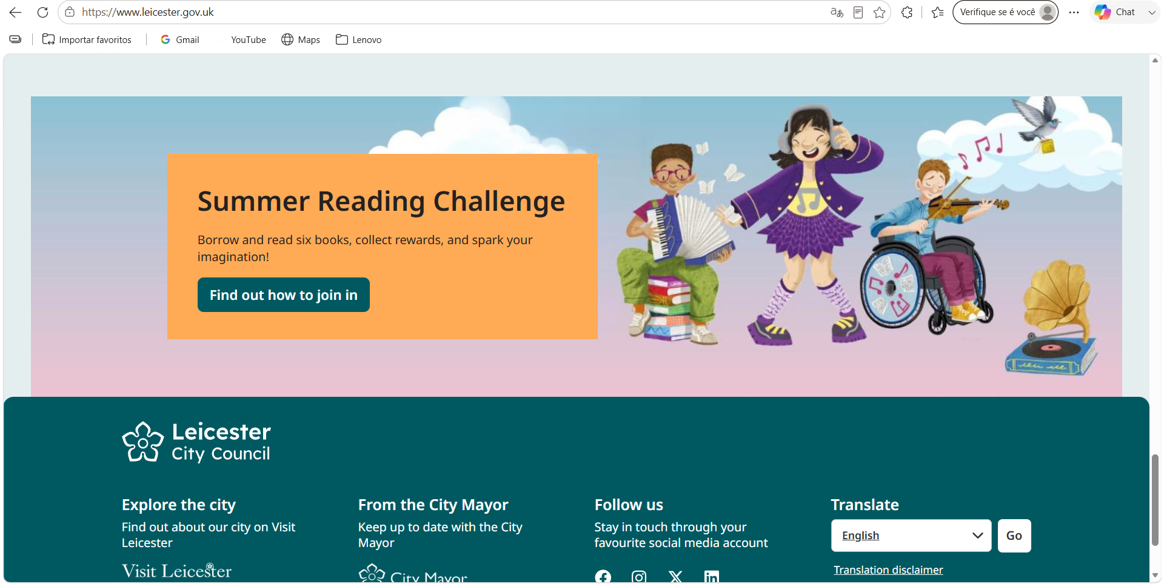
Figure 1. Leicester City Council homepage highlighting the Summer Reading Challenge. Source: Leicester City Council (2026).

The Summer Reading Challenge, shown in Figure 1, illustrates how the website promotes community engagement rather than acting solely as a source of statutory information. Regularly updated activities may encourage families to interact with local services more frequently, increasing awareness of the wider support available.
By comparison, Norfolk County Council provided clear information once users reached the Early Help section. However, users were first required to select "Learn More" before being directed to support services.
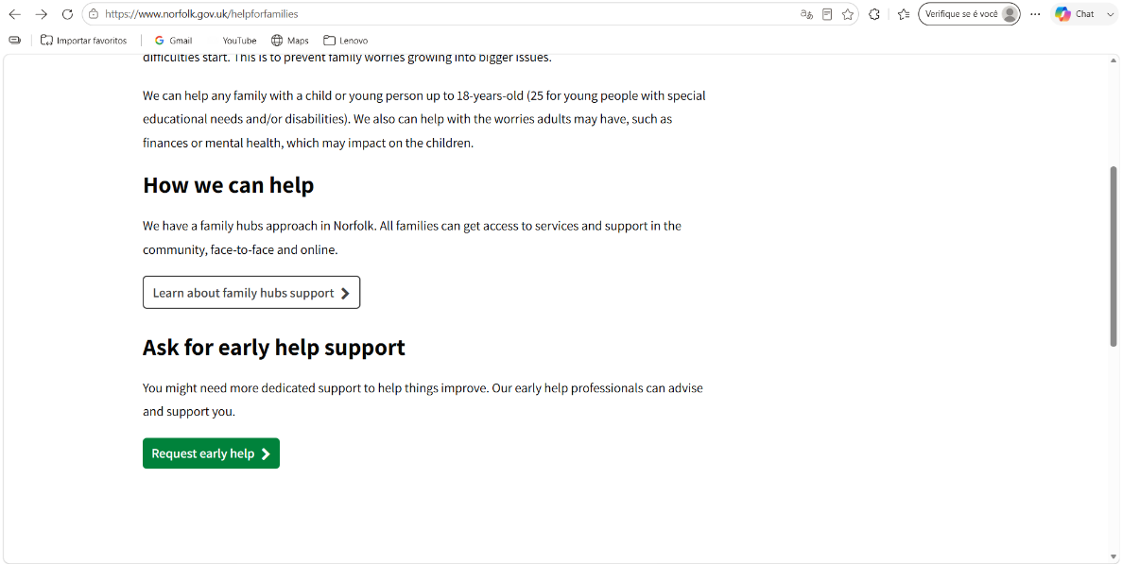

Figure 2. Navigation pathway to Early Help on the Norfolk County Council website. Source: Norfolk County Council (2024).

Although only one additional step is required, placing the Request Early Help option before explanatory content could improve accessibility for users seeking immediate support. Simplifying the navigation pathway would better reflect the preventative principles of Early Help by reducing barriers to accessing services (Department for Education, 2022).
3. Comparative Discussion
The comparison found that all three local authorities provide useful information about Early Help, but differ in how effectively users are guided towards support. Tower Hamlets Council communicated Early Help most directly, while Leicester City Council offered the strongest overall user experience through clearer navigation, better readability and a more intuitive layout. Norfolk County Council also provided relevant information but required a less direct navigation pathway.
These findings suggest that the effectiveness of Early Help websites depends not only on the information provided but also on how easily users can locate it. Families seeking support may already be experiencing stress or uncertainty, making clear and accessible digital communication an important part of effective safeguarding. This reflects the principles outlined in the Early Help System Guide and Working Together to Safeguard Children, which emphasise timely access to coordinated support (Department for Education, 2022; Department for Education, 2026).
4. Recommendations
Based on this analysis, three improvements could strengthen local authority websites.
First, Request Early Help options and safeguarding contacts should be more prominent on the homepage, reducing the number of steps required to access support.
Second, accessibility could be enhanced through assistive technologies such as text-to-speech functions, improving access for users with visual impairments or reading difficulties.
Finally, websites could provide clearer links to emergency contacts, children's social care, police and other safeguarding partners, reinforcing the multi-agency approach that underpins Early Help.
5. Conclusion
This report examined how three local authority websites communicate and signpost Early Help services. Although all three provided useful information, Leicester City Council offered the strongest overall user experience in terms of accessibility, Tower Hamlets Council communicated Early Help most effectively, and Norfolk County Council would benefit from a more straightforward navigation pathway.
The findings indicate that effective safeguarding extends beyond the provision of services alone. Clear, accessible and user-centred digital communication can help families access support more quickly and contribute to better outcomes for children and families.

6. References:
Children Act 1989. (1989) Chapter 41. London: HMSO. (Accessed 08 August 2026)
Children Act 2004. (2004) Chapter 31. London: HMSO. (Accessed 08 August 2026)
Department for Education. (2022) Early Help System Guide: A Toolkit to Assist Local Strategic Partnerships Responsible for Their Early Help System. Available at: https://assets.publishing.service.gov.uk/media/628de13be90e071f5f7e1bd2/Early_Help_System_Guide.pdf (Accessed: 8 August 2026).
Department for Education. (2026) Working Together to Safeguard Children 2026: A Guide to Multi-Agency Working to Help, Protect and Promote the Welfare of Children. Available at: https://assets.publishing.service.gov.uk/media/69fb1c28d0e316a40f269a5b/Working_together_to_safeguard_children_2026_a_guide_to_multi_agency_working.pdf (Accessed: 8 August 2026).
Kattel, R. and Takala, V. (2023) ‘The case of the UK’s Government Digital Service: The professionalisation of a paradigmatic public digital agency’, Digital Government: Research and Practice, 4(4), pp. 1-15. Available at: https://doi.org/10.1145/3630024 (Accessed: 8 August 2026).
Leicester City Council. (2026) Home. Available at: https://www.leicester.gov.uk (Accessed: 8 August 2026).
Norfolk County Council. (2024) Home. Available at: https://www.norfolk.gov.uk (Accessed: 8 August 2026).
NSPCC. (2025) Safeguarding Children and Child Protection. Available at: https://learning.nspcc.org.uk/child-protection-system (Accessed: 8 August 2026).
Roy, J. (2022) ‘Signs of Safety: The View From Early Help’, Child Care in Practice, 28(3), pp. 482-498. Available at: https://doi.org/10.1080/13575279.2020.1799755 (Accessed: 8 August 2026).
Tower Hamlets Council. (2026) Home. Available at: https://www.towerhamlets.gov.uk (Accessed: 8 August 2026).

