[Date]
Rumyana Bicheva (2527182)
[company name]
[Document title]
[Document subtitle]

Contents
1. Introduction 2
2. Requirements 2
2.1 Website planning considerations, purpose and target audience 2
2.2 Functional and Design Requirements 3
3. Implementation 3
3.1 HTML and CSS Web Development Concept 3
3.2 Website Implementation using HTML and CSS 4
3.2.1 HTML Structure 4
Head elements 5
Body elements 5
Footer elements 7
3.2.2 CSS Styling and Layout 10
3.3 Validation 11
3.3.1 HTML validation 11
3.3.2 CSS result 11
4. Evaluation 12
4.1 Research 12
4.1.1 Usabily&Utility 12
4.1.2 Accessibility 13
4.1.3 SEO 13
4.2 Website Evaluation 14
4.2.1 Usability&Utility 14
4.2.2 SEO 14
4.2.3 Accessibility - WCAG2.1 14
4.3 Website Comparison 16
5. Conclusion 17
6. References 17
Appendices A 19
Appendix B 31
Appendices C 34

1. Introduction
Websites play an essential role in modern life. They are new way of access to information and online services through web browsers on a wide range of devices. As a result, web development has become one of the most important areas of computing, supporting the creation of websites that are functional, accessible, and user-friendly.
Web development is the process of designing, building, testing, publishing, and maintaining websites and web applications that are accessed through a web browser. There are different types of websites depending on their purpose. From a technical point of view, websites can be static or dynamic. Static websites have fixed content, while dynamic websites can display changing content and interact with users. From a development perspective, websites are generally divided into two main areas: front-end and back-end development. The first is focused on everything users see and interact with, while back-end development manages the server, business logic, databases, and the processes that operate behind the scenes.[1] [2]
This report presents the design and development of a static fashion website created for designer Vanya Manolova. The project focuses only on front-end development using HTML to create the website structure and CSS to control its design and layout. The aim is to develop a multi-page website with a consistent layout, intuitive navigation, and responsive design principles. The report describes the project requirements, implementation process, validation results, and evaluates the final website in terms of usability, accessibility, SEO and mobile friendliness.

2. Requirements
Before developing a website, several key factors should be considered to ensure it meets user needs and project objectives. These include defining the website's purpose, identifying the target audience, planning and organising the content, creating a clear navigation structure, and designing an attractive and consistent interface. It is also important to ensure good usability, accessibility for all users, responsive design for different devices, fast performance, and basic search engine optimisation (SEO). Considering these principles helps create a functional, user-friendly, and effective website.[3]

2.1 Website planning considerations, purpose and target audience
The purpose of the website is to promote fashion designer Vanya Manolova and her fashion brand - AmatoModa. The website showcases the designer's exclusive clothing collections, produced in limited series to emphasise originality and individuality, while also presenting her bespoke design service. In addition to ready-made collections, the designer creates custom garments tailored to each client's personal style, preferences, and measurements. The website is aimed at both individual customers seeking unique, personalised fashion and business clients interested in purchasing designer collections or establishing professional collaborations with the AmatoModa brand.

2.2 Functional and Design Requirements
The website is designed to consist of six interconnected web pages with a clear and consistent navigation menu, allowing users to move easily between different sections. It provides information about the fashion designer Vanya Manolova and AmatoModa brand presenting Spring/Summer 2026 and Autumn/Winter 2026 collections, together with information about the custom clothing design service in page MADE FOR YOU. An additional Production page explains the main stages of the garment-making process, from design and pattern making to tailoring and quality control. The website also includes Contact Us page for individual customers and business enquiries. Login page was added to support possible future development of the website. A consistent layout, typography, colour scheme, and images are used throughout the website to create a professional appearance. In addition, the website is developed using valid HTML and CSS and follows basic accessibility and search engine optimisation (SEO) principles.

3. Implementation
The website is developed as a front-end project using HTML and CSS.

3.1 HTML and CSS Web Development Concept
The front end represents the visual part of a website, including the layout, colours, typography, images, navigation menus, and other user interface elements. It is responsible for providing a positive user experience by ensuring that web pages are visually appealing, responsive, and easy to use. Front-end developers typically use HTML, CSS, and JavaScript. [1]
HTML (HyperText Markup Language) is the standard markup language used to define the structure and content of a web page. It organises elements such as headings, paragraphs, images, hyperlinks, tables, and forms. HTML provides the foundation of every web page by describing the meaning and organisation of its content. [2]
CSS (Cascading Style Sheets) is used to control the presentation and visual appearance of HTML elements. It defines colours, fonts, spacing, borders, layouts, and page positioning, allowing developers to separate the website's design from its content. CSS also supports responsive web design, enabling websites to adapt to different screen sizes and devices. [2]
Together, HTML and CSS form the core technologies of front-end web development. HTML provides the page structure, while CSS enhances its visual design and layout. Combined with JavaScript, these technologies enable developers to create modern, user-friendly, and interactive websites that function consistently across different web browsers and devices.

3.2 Website Implementation using HTML and CSS
Starting with creating folder VanyaManolova and for coding I will use Visual Studio Code.

3.2.1 HTML Structure
Fig.1 shows the standard structure of HTML5 document, including the <!DOCTYPE html> declaration, the root <html> element, the <head> section and the <body> section, which contains the visible content. The <html> element is the root element of the webpage. The lang="en" attribute specifies that the website is written in English, improving accessibility and helping browsers and search engines identify the page language.[2]

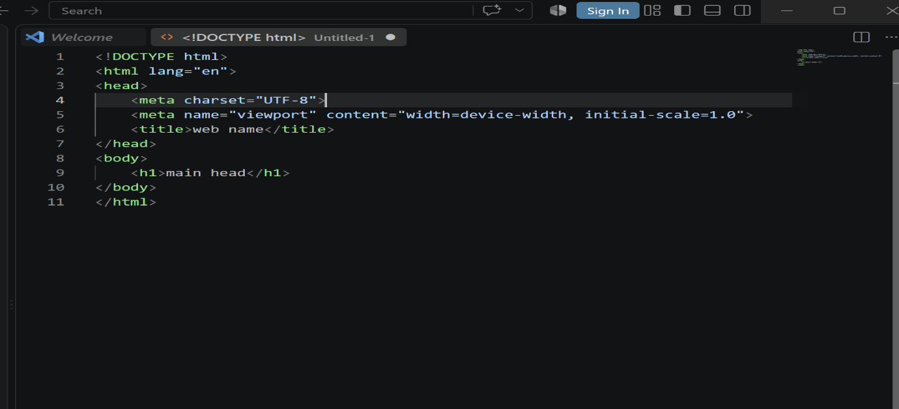
figure 1 Basic structure of HTML

Head elements
The meta element provides additional information, or metadata, about an HTML document. It is placed inside the head section and can provide information or instructions to web browsers, web servers, and search engines. The charset meta element defines UTF-8 character encoding for correct text display, while the viewport meta element enables responsive design, ensuring that the website displays correctly on different devices, Fig.2.
[2] [4]

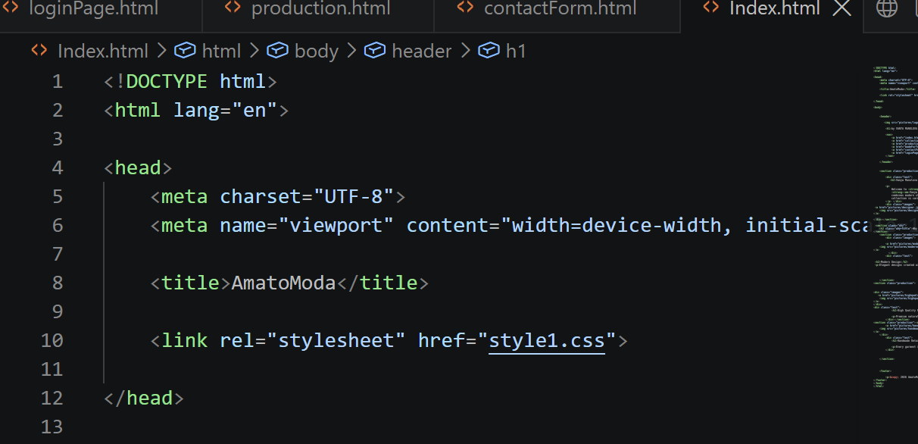
figure 2 My website AmatoModa - HTML <head> elements

Body elements
The header element is a content that will be displayed on each page. I put the AmatoModa logo, the designer's name (Vanya Manolova), and the main navigation menu with links to other pages. This provides a consistent layout and allows users to navigate easily throughout the website, Fig.3
figure 3 Amatomoda website - Header elements
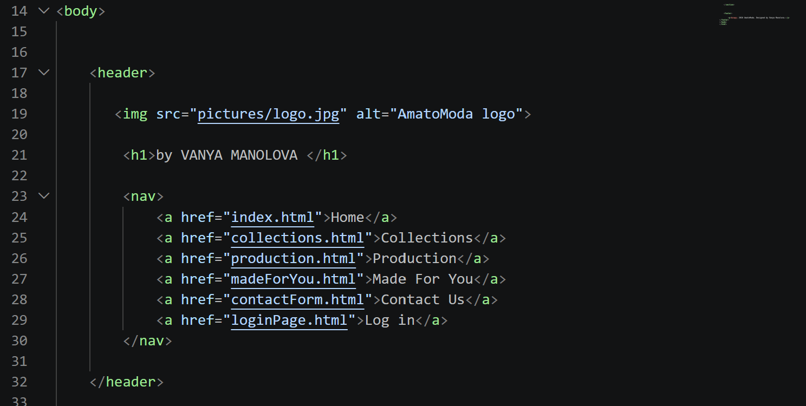

The HTML pages is organised into separate sections to create a clear and consistent structure. The section element was used to divide the content into logical parts, while div elements with classes is used to group related content and provide more precise CSS control.
The Home, Production, and Made for You pages use the production class to arrange text and images within their main sections. The Collections page uses a slightly different structure, with separate text and images containers, allowing collection descriptions and groups of images to be displayed differently while sharing the general website styles. Hyperlinks were also added to selected images using a element, allowing users to open larger versions of the fashion images. Additional classes were used where specific styling was required.

Contact and Login Forms
Contact Us page - div elements with the classes were used to organise the contact details and the form into separate areas. The required attribute was added to prevent empty fields from being submitted. Labels in Contact and Login form were linked to the corresponding fields using for and id, while name attributes were added to identify the entered data when the forms are submitted.

Footer elements
The element is used to define the footer section of the website. It contains copyright information and is displayed at the bottom of each page.
Figures 4, 5, 6, 7, 8 and 9 show the HTML pages displayed in a web browser. The corresponding HTML code is provided in Appendices A.
figure 4 AmatoModa Home Page
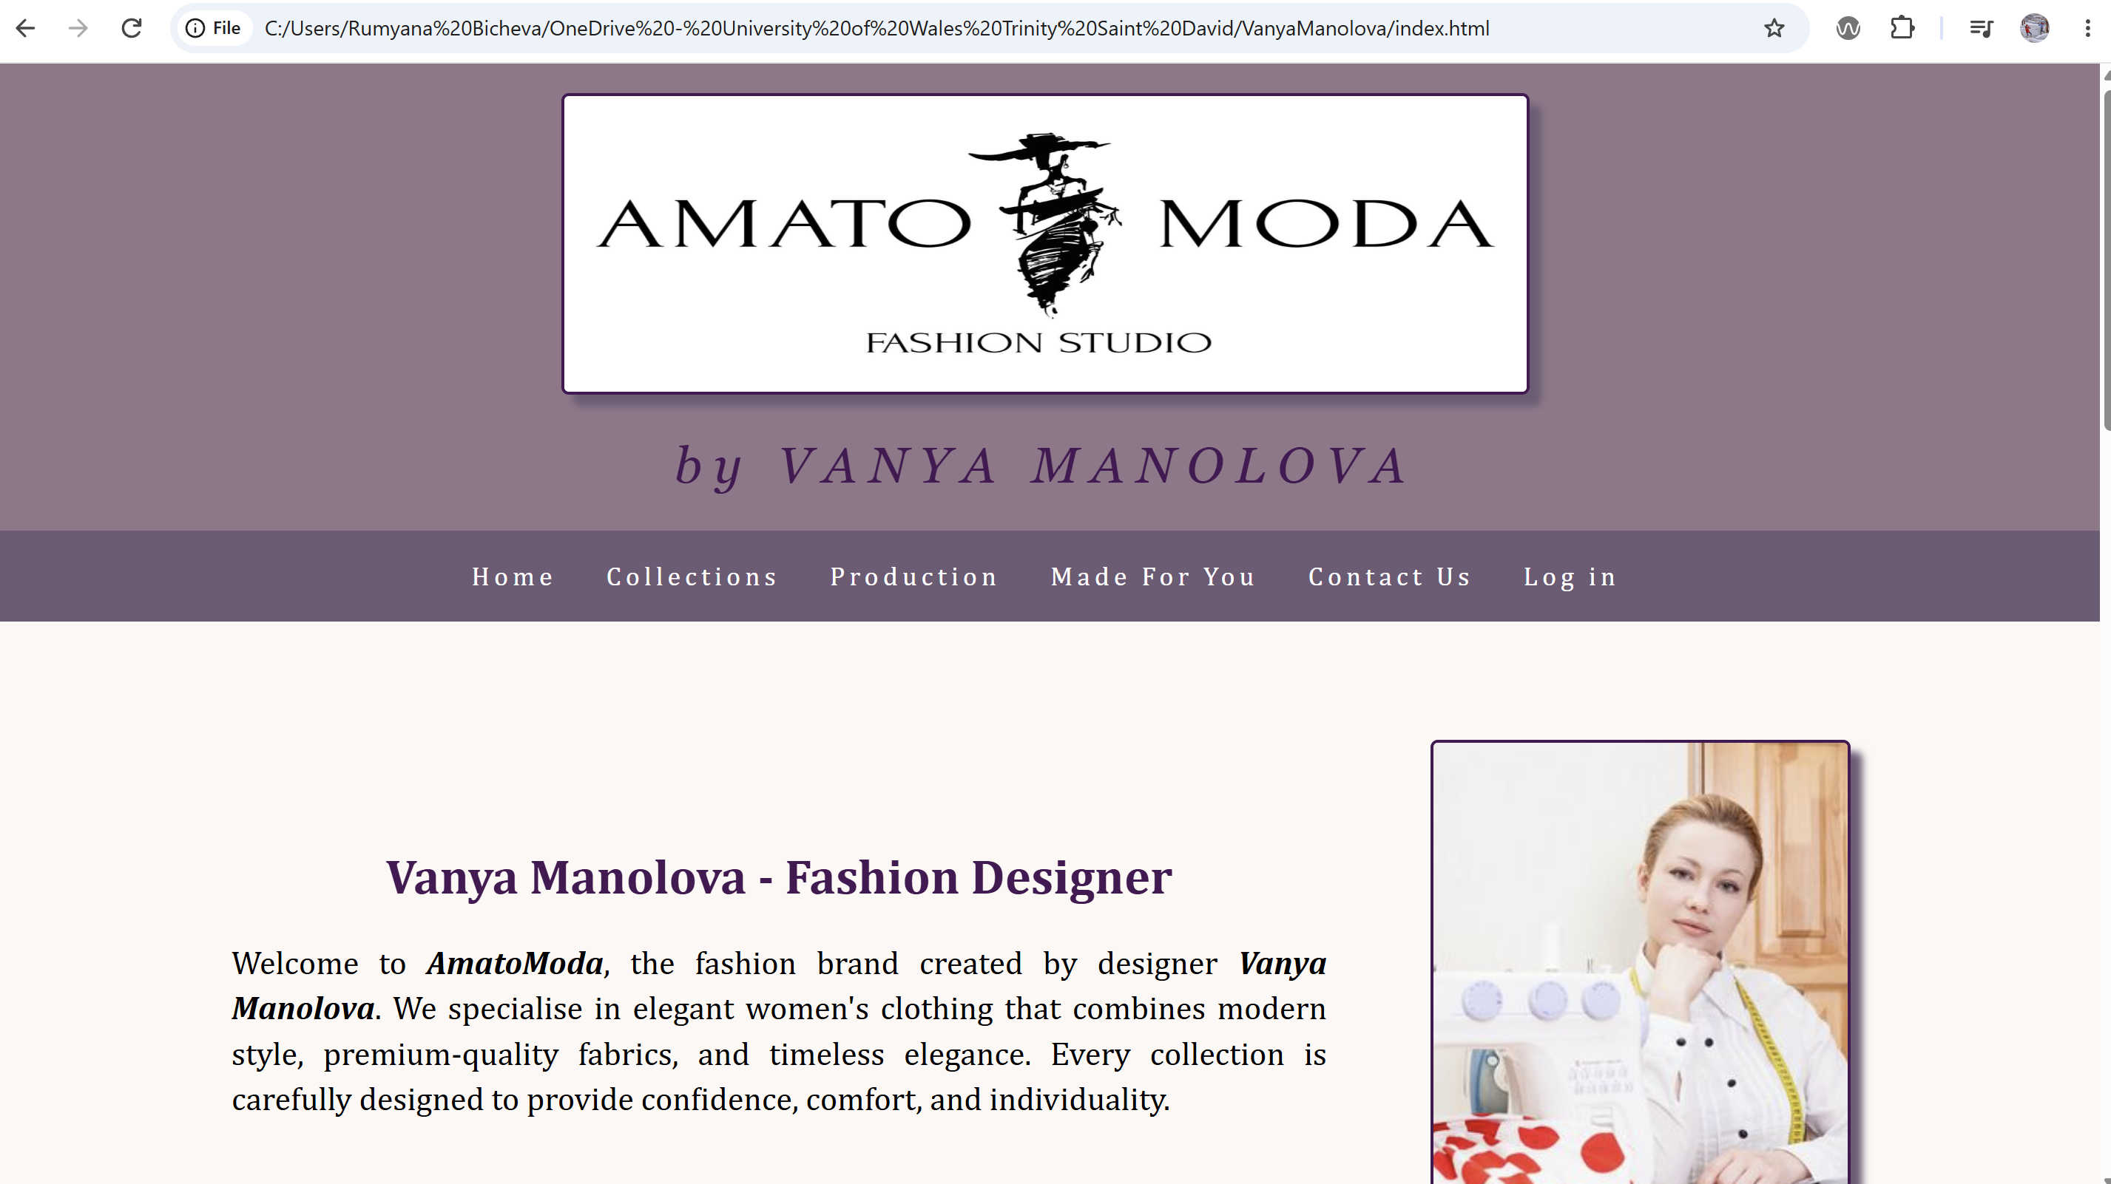

figure 5 AmatoModa page Collections
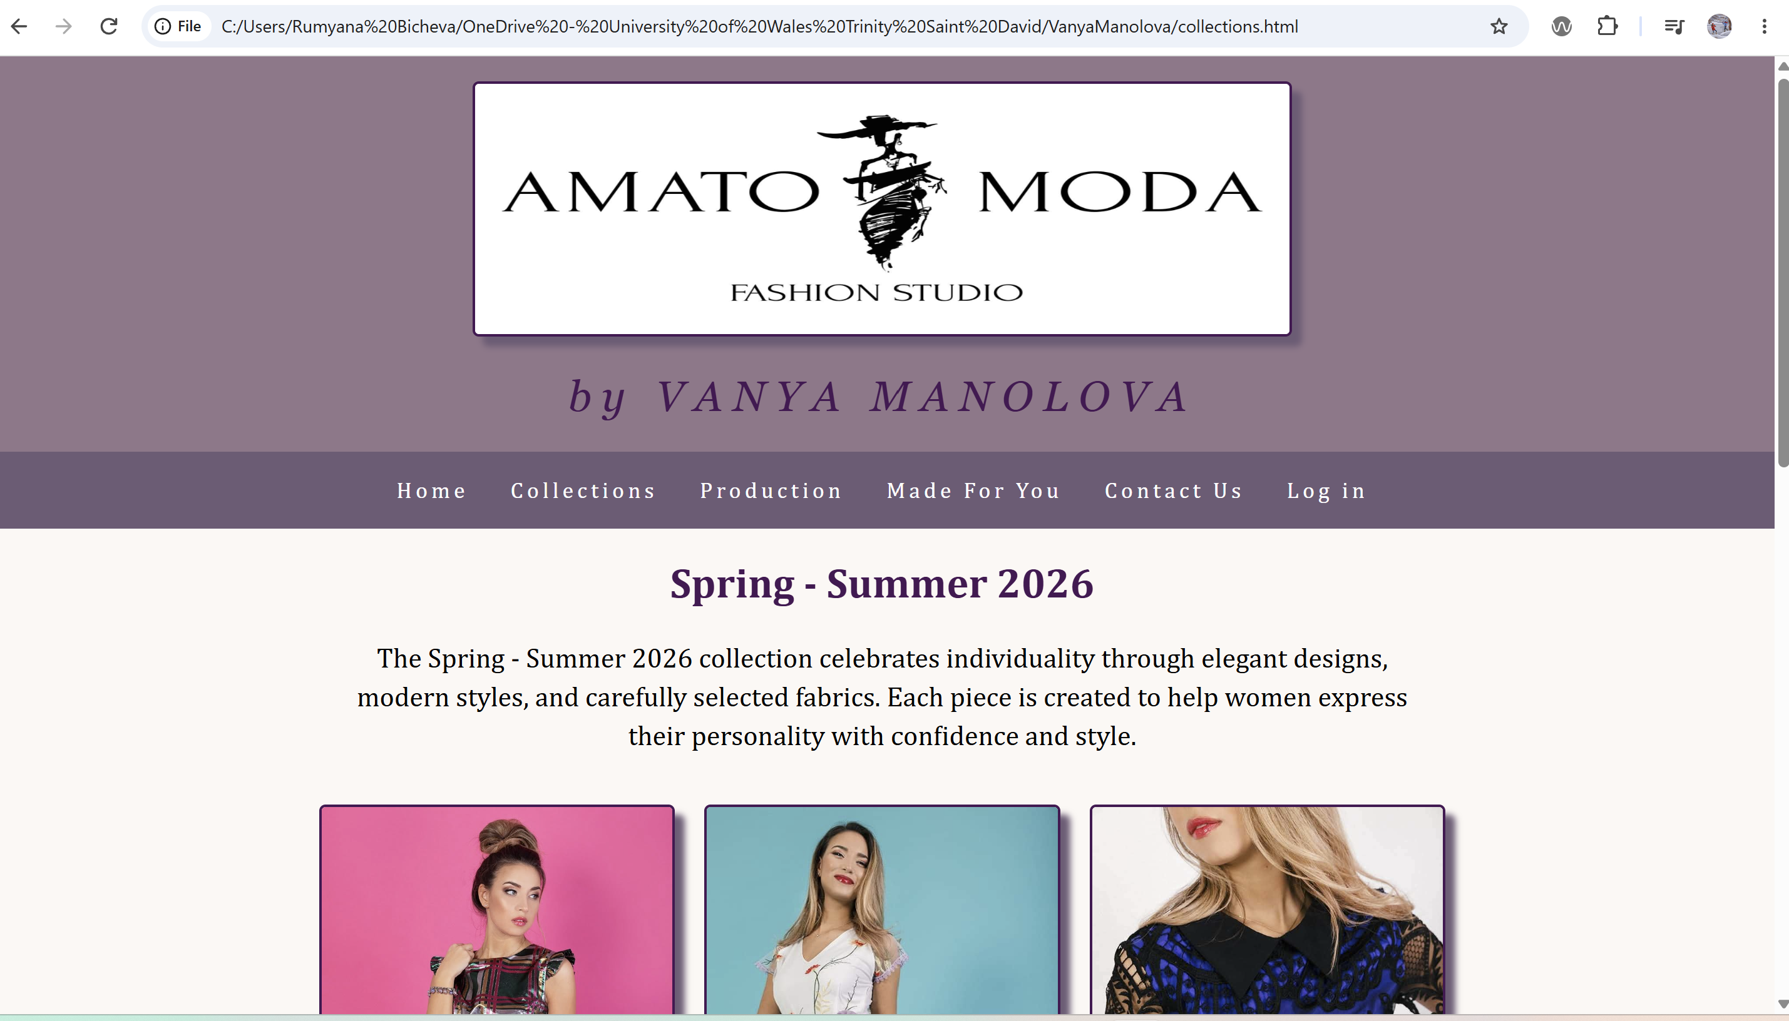

figure 6 Page Production
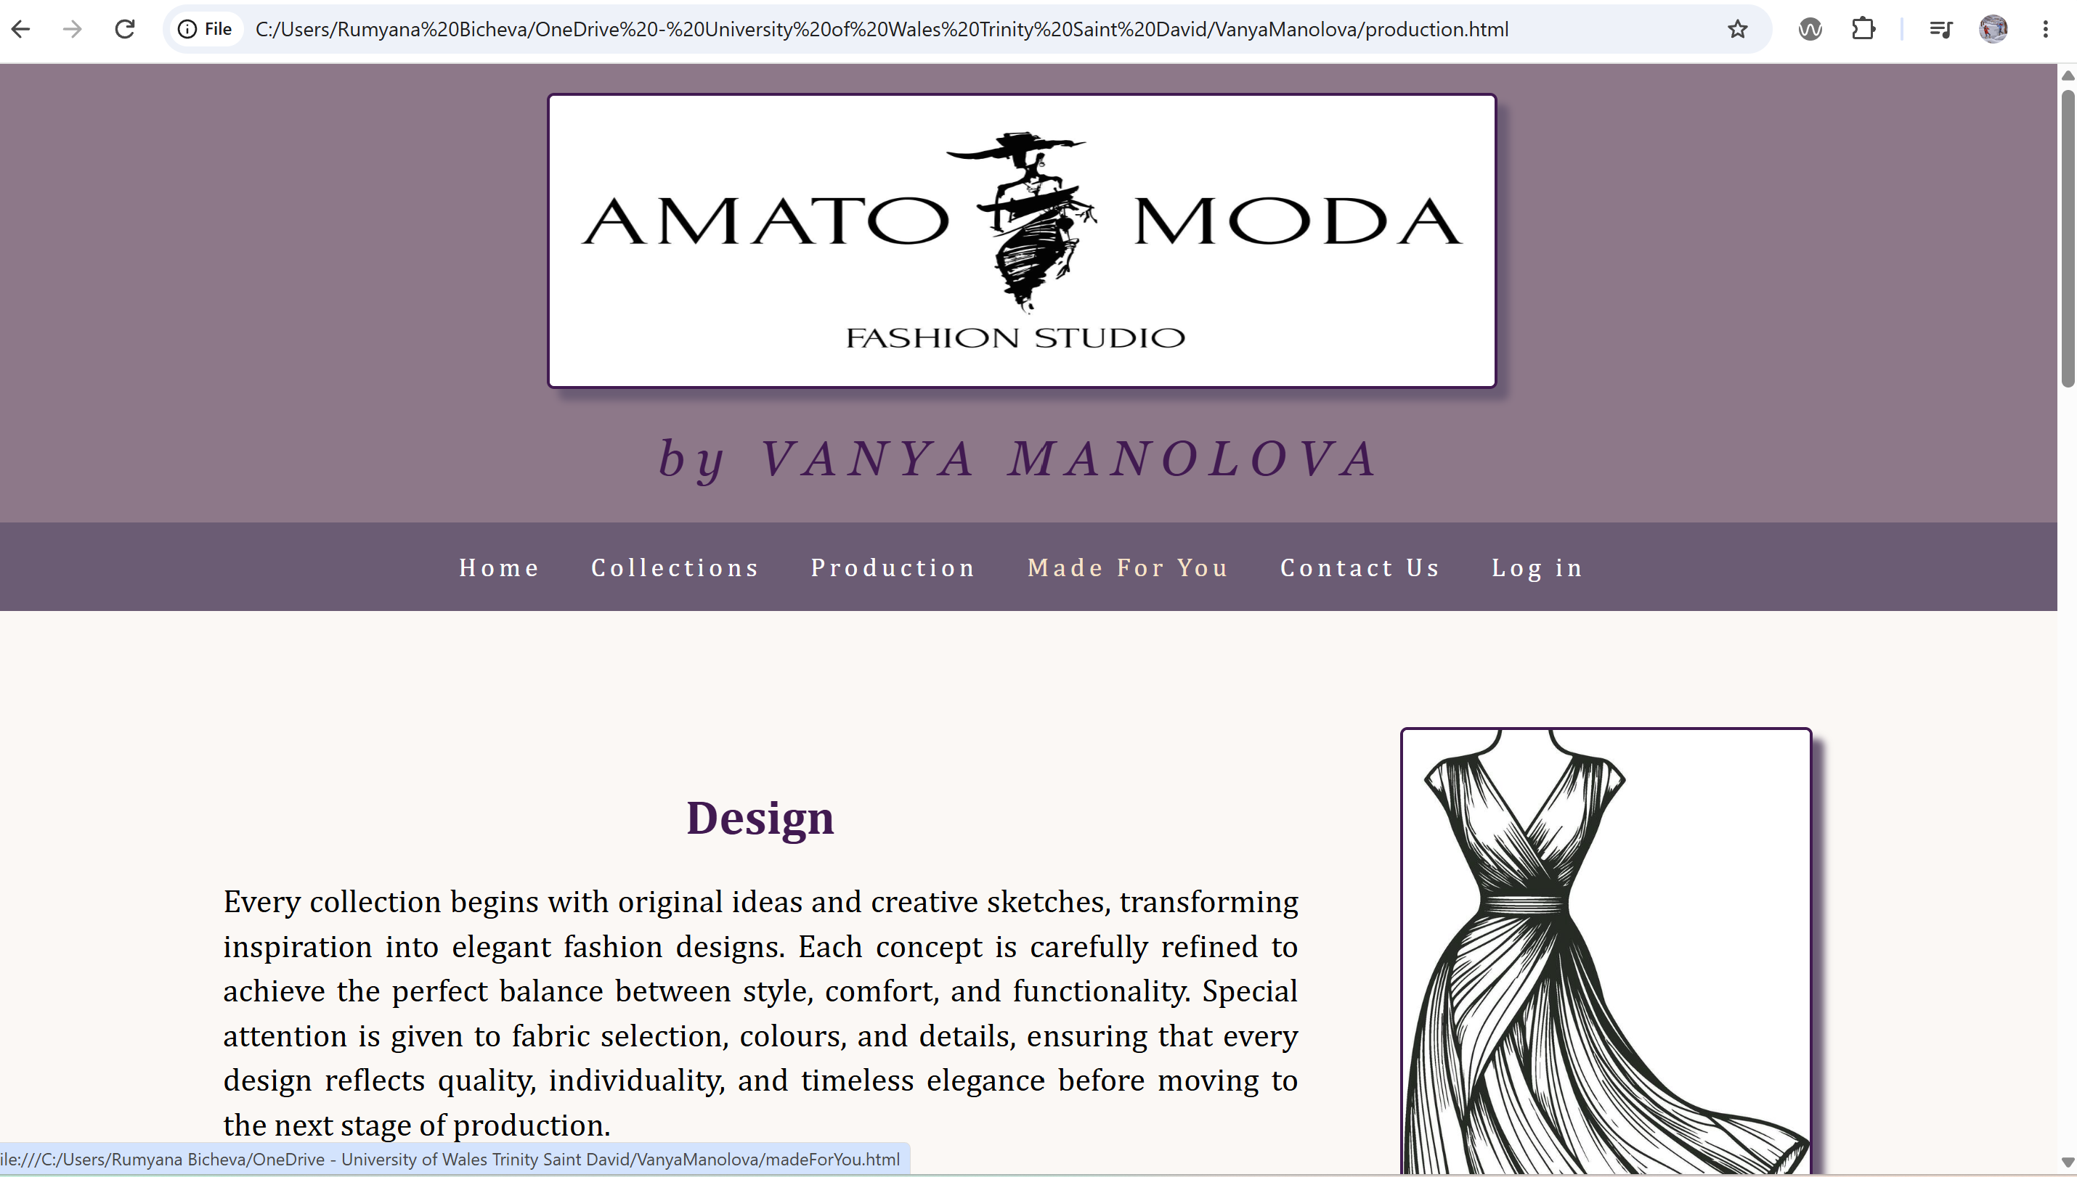

figure 7 Made for You page
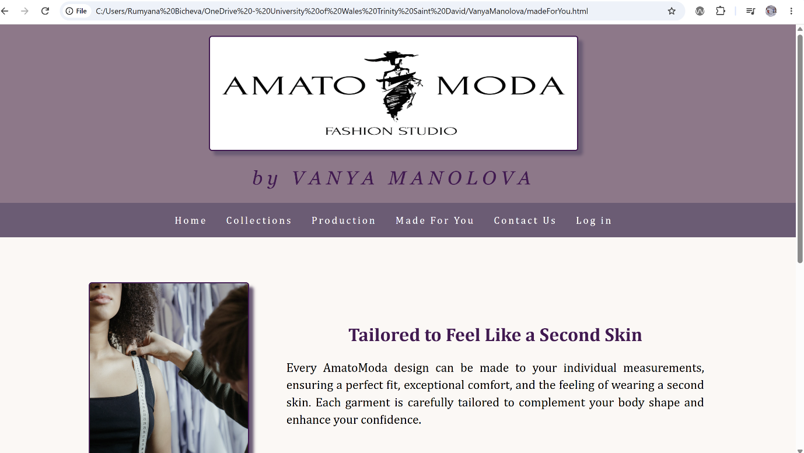

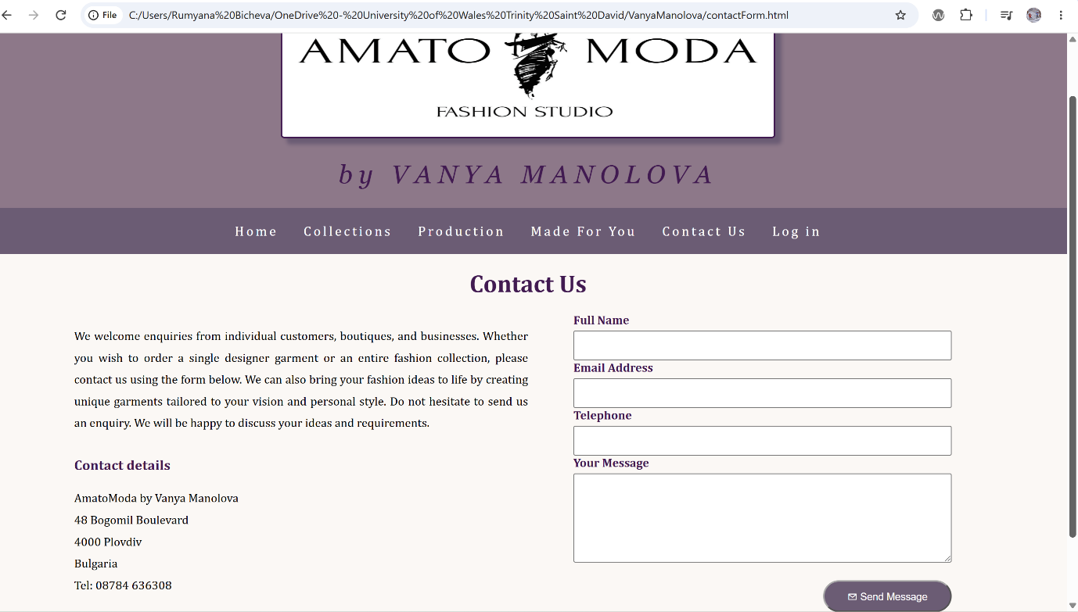
figure 8 Contact Us page
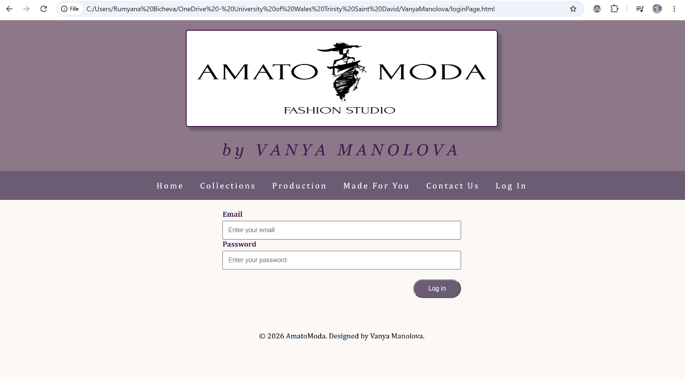
figure 9 Login page

3.2.2 CSS Styling and Layout
While HTML defines the structure and content of a website, CSS is responsible for its visual presentation, including colours, fonts, spacing, borders, positioning, and page layout. This separates the website's structure (HTML) from its presentation (CSS), making the code easier to maintain and update.

The external CSS file,style1.css, was linked inside the head section. The production and contact classes use Flex to position content, while images include borders, shadows, and a hover zoom effect. Buttons were styled with custom CSS using purple colours, rounded corners, and a hover effect, Appendix B

3.3 Validation
The World Wide Web Consortium (W3C), founded in 1994 by Tim Berners-Lee, the inventor of the World Wide Web, is an international organisation that develops standards for web technologies such as HTML and CSS. Following these standards helps ensure that webpages are correctly structured, compatible, accessible and can work consistently across different browsers and devices. [5]

3.3.1 HTML validation
All HTML pages were validated using the W3C HTML Validator, with no errors or warnings identified. Fig.10 - Index.html result.
figure 10 Validationn result Index.html
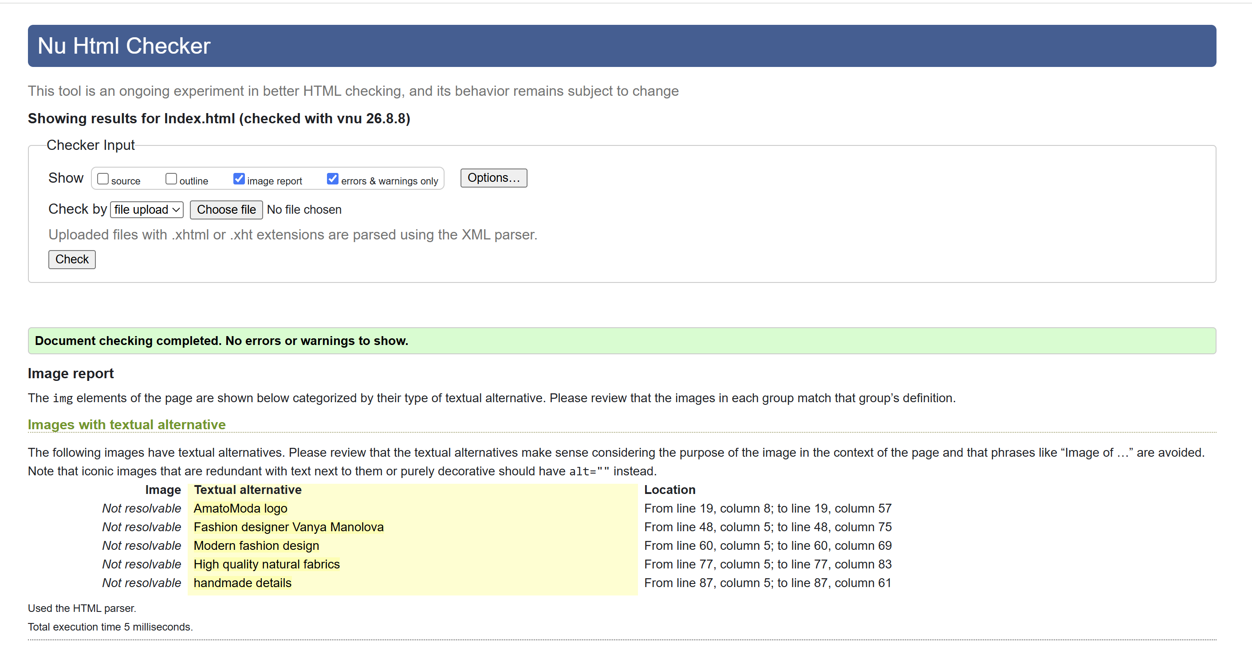

3.3.2 CSS result
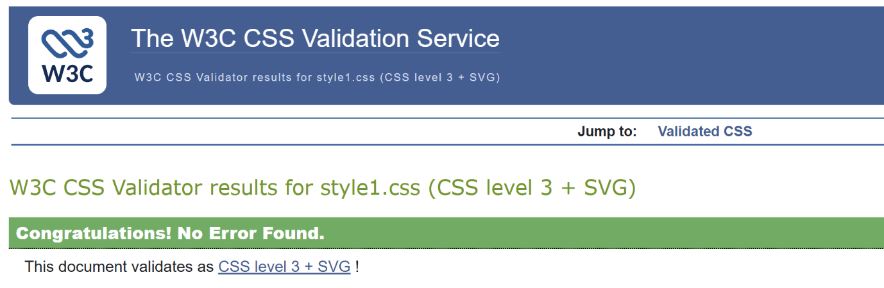
Fig.11: W3C CSS validation result for style1.css - no errors identified.
figure 11 Result for CSS

The validation results confirmed that the HTML and CSS follow W3C standards. This helps ensure cross-browser compatibility and improved accessibility.

4. Evaluation
According to Duckett, good web design practices from the end-user perspective include a consistent page layout, prioritising important information, creating a clear visual hierarchy, grouping related content, and using consistent navigation and styling. These practices improve usability and make the website easier for users to understand and navigate.[6]
Today, website quality is evaluated using principles and standards such as usability, accessibility and SEO, which consider both user satisfaction and how effectively the website achieves its intended purpose.

4.1 Research

4.1.1 Usabily&Utility
Website usability refers to how easy a website is to use. Nielsen identifies five main components: learnability, efficiency, memorability, errors, and satisfaction. He also distinguishes usability from utility: utility refers to the required functionality, while usability describes how easy and pleasant it is to use. Poor usability can cause users to leave a website, while user testing can help identify and improve usability problems.[7]
Research evaluated the usability of 20 popular e-commerce websites from different categories. Two usability experts evaluated the websites against Nielsen’s principles, while 233 participants completed the System Usability Scale questionnaire to measure perceived usability and user satisfaction. The results showed that most websites violated several important usability principles. Problems included poor error prevention and recovery, lack of help and documentation, limited flexibility, inconsistent design, and failure to provide features such as recently viewed products. The SUS scores ranged from 40 to 75, and only 5 of the 20 websites scored above the benchmark of 68. The researchers also found that websites with more severe usability problems had lower levels of user satisfaction.[8]
The study concluded: websites did not follow recognised usability principles, resulting in generally low user satisfaction. The researchers recommended improving consistency, error prevention, user guidance, navigation and support features to create a more effective and user-friendly experience.[8]

4.1.2 Accessibility
Website accessibility means designing websites so they can be used by all people, including people with disabilities. WCAG2.1 builds on WCAG2.0 and retains its four principles: Perceivable, Operable, Understandable and Robust (POUR), with additional requirements for mobile accessibility and users with visual, cognitive and learning disabilities .[9]
A research study developed an interactive platform designed to teach CS students how to understand and apply WCAG2.1 in web development. 79 students have completed 17 practical exercises focused on identifying and correcting accessibility problems in web development. Designed websites achieved a System Usability Scale (SUS) score of 80.1 out of 100. The study demonstrated the importance of accessibility knowledge in web development, as developers need to recognise and remove barriers that may prevent people with disabilities from accessing and using websites effectively, which actually benefits everyone.[9]

4.1.3 SEO
Search Engine Optimisation (SEO) is the process of improving a website’s visibility and ranking in search engine results. SEO considers elements such as keywords, page titles, website structure and links, helping search engines understand and rank website content. Higher visibility can increase the number of users visiting a website. [10]
A research study investigated the use of an SEO algorithm to optimise website link structure. The results showed reduced distances and stronger relationships between linked pages after optimisation. The study concluded that SEO can improve website structure and search ranking, helping users find relevant information more easily and potentially increasing website traffic.[10]

4.2 Website Evaluation

4.2.1 Usability&Utility
My website provides useful and clear information about the business. Users can also submit enquiries through the Contact Us form. The content is clearly organised and provides relevant information about the designer, collections and services. The website has good usability, with navigation, colours, fonts and layouts across the pages. Responsive CSS improves the layout on smaller screens, while the image hover effect makes the collections more interactive.
Future improvements will be functional back-end system, improved mobile navigation and a search function.

4.2.2 SEO
SEO techniques were applied to the AmatoModa website. Descriptive page titles and structured headings help search engines understand the content and organisation of each page. Images include descriptive alt attributes, while internal navigation links connect the main pages. Relevant keywords are also included naturally within the content.
As an immediate improvement, meta descriptions will be added to all pages to improve visibility in search results.

4.2.3 Accessibility - WCAG2.1
Perceivable: Images include descriptive alt text. Contrast testing passing WCAG AA requirements,Fig.13,14.
Operable: A clear and consistent navigation menu allows users to access all main pages easily.
Understandable: Clear headings, navigation names and form labels make the content and controls easy to understand.
Robust: Semantic HTML, correctly associated form labels and attribute lang="en" support compatibility with browsers and assistive technologies.
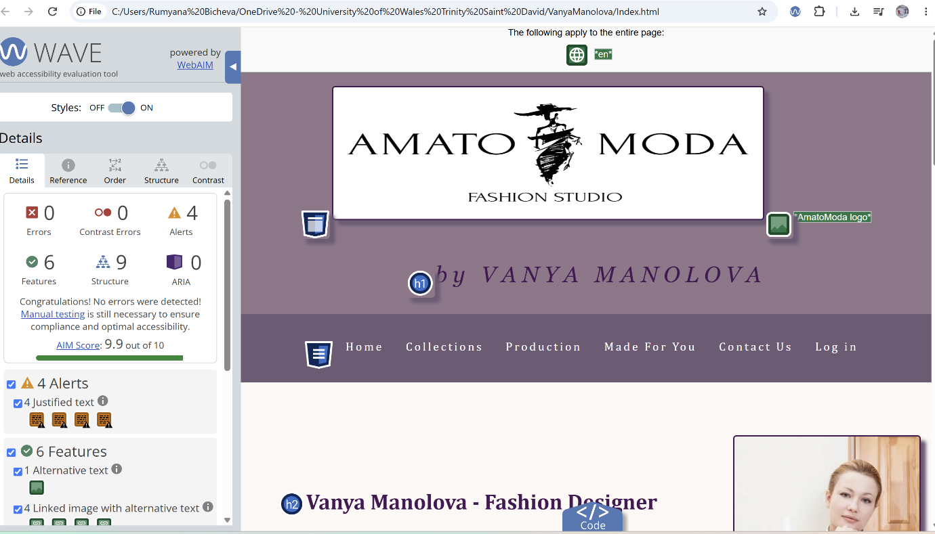
WAVE test - good compliance with the WCAG 2.1, Fig.12.
figure 12 Accessesibility evaluation

figure 13 Contrast test 1
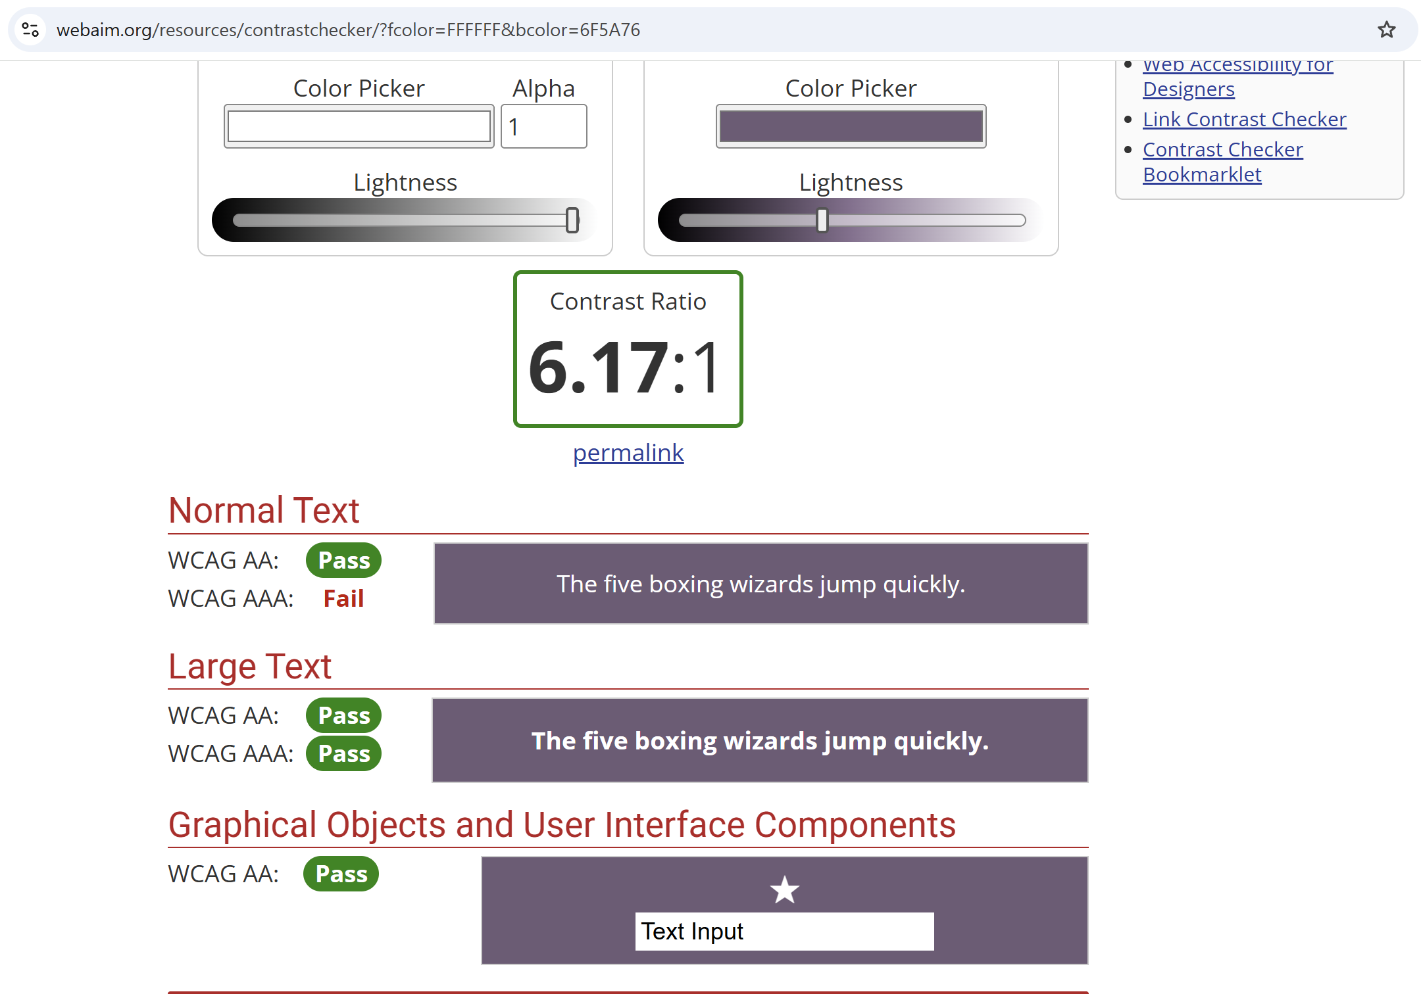
figure 14 Contrast test 2
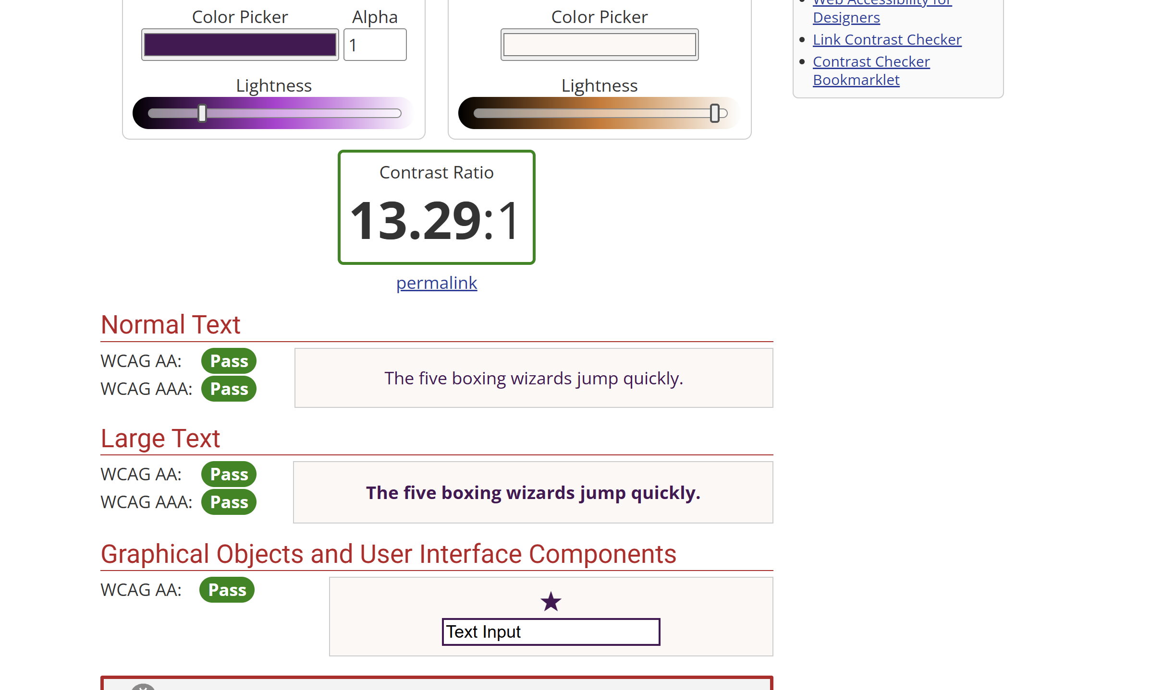

4.3 Website Comparison
Overall, Karen Millen performs better against the evaluated criteria. It achieved significantly better accessibility results in WAVE and has a clearer SEO heading structure. Hollister provides more clearly adapted mobile layout. Karen Millen’s mobile search and menu can be more difficult to use. Therefore, Karen Millen is the stronger website overall, while Hollister performs better in mobile friendliness. The full comparing table and testing results are in Appendices C.
Compared with mentioned websites, AmatoModa is a smaller and simpler website with limited functionality. However, its simple structure provides clear navigation and reduces complexity for users. The website performed well in the accessibility tests, SEO and structure can be improved. There is also no a product search, online purchasing and a functional back-end login system. These could be considered for future development.

5. Conclusion
The project successfully achieved its objectives by developing a functional static website using HTML and CSS. The website provides clear navigation, consistent styling, and responsive layout while following basic usability, accessibility, and SEO principles. The validation process confirmed that the code met web standards after minor corrections. Overall, the project strengthened practical skills in front-end web development and demonstrated the importance of planning, implementation, and evaluation during website creation.

6. References

[1] J. Duckett, Front-End Back-End Development with HTML, CSS, JavaScript, jQuery, PHP, and MySQL, John Wiley & Sons, Incorporated, 2022.
[2] J. Wolf, HTML and CSS: The comprehensive guide, Packt Publishing Ltd, 2025.
[3] P. Hong, Practical web design: Learn the fundamentals of web design with HTML5, CSS3, bootstrap, jQuery, and vue. js, Packt Publishing Ltd, 2018.
[4] L. Donahoe and M. Hartl,Learn Enough HTML, CSS and Layout to be Dangerous: An Introduction to Modern Website Creation and Templating Systems, Addison-Wesley Professional, 2022.
[5] The World Wide Web Consortium. "w3.org." https://www.w3.org/about/. [Online]. Available: https://www.w3.org/about/, access: 08.08.2026
[6] J. Duckett, HTML & CSS: design and build websites, Wiley Indianapolis, IN, 2011.
[7] J. Nielsen, "Usability 101: Introduction to usability," 2012,
[8] S. Hamid, N. Z. Bawany and K. Zahoor, "Assessing Ecommerce Websites: Usability and Accessibility Study", 2020 International Conference on Advanced Computer Science and Information Systems (ICACSIS), pp. 199–204. [Online].doi: 10.1109/ICACSIS51025.2020.9263162.
[9] T. Chatziemmanouil and C. Katsanos, "Accessibility Academy: Interactive Learning of the WCAG 2.1 Web Accessibility Guidelines", 2024 IEEE Global Engineering Education Conference (EDUCON), pp. 1–7. [Online].doi: 10.1109/EDUCON60312.2024.10578915.
[10] H. Xu, "Website Link Structure Optimization Based on SEO Algorithm", 2022 IEEE Asia-Pacific Conference on Image Processing, Electronics and Computers (IPEC), pp. 1300–1303. [Online].doi: 10.1109/IPEC54454.2022.9777341.

Appendices A
figure 15 Index.html
<!DOCTYPE html>
<html lang="en">

<head>
<meta charset="UTF-8">
<meta name="viewport" content="width=device-width, initial-scale=1.0">
<meta name="description" content="AmatoModa by
Manolova offers elegant women's fashion,
high-quality natural fabrics and bespoke garments">
<title>AmatoModa</title>

<link rel="stylesheet" href="style1.css">

</head>

<body>

<header>

<img src="pictures/logo.jpg" alt="AmatoModa logo">

<h1>by VANYA MANOLOVA </h1>

<nav>
<a href="index.html">Home</a>
<a href="collections.html">Collections</a>
<a href="production.html">Production</a>
<a href="madeForYou.html">Made For You</a>
<a href="contactForm.html">Contact Us</a>
<a href="loginPage.html">Log in</a>
</nav>

</header>

<section class="production">

<div class="text">
<h2>Vanya Manolova - Fashion Designer</h2>

<p>
Welcome to <strong><em>AmatoModa</em></strong>,
the fashion brand created by designer
<strong><em>Vanya Manolova</em></strong>.
We specialise in elegant women's clothing that
combines modern style, premium-quality fabrics,
and timeless elegance. Every
collection is carefully designed to provide confidence,
comfort, and individuality.
</p>
</div>
<div class="images">
<a href="pictures/designer.jpg">
<img src="pictures/designer.jpg" alt="Fashion designer Vanya Manolova">
</a>

</div></section>

<section class="why">
<h2 class="why-title">Why Choose Us?</h2>
</section>
<section class="production">
<div class="images">

<a href="pictures/moderndesign.jpg">
<img src="pictures/moderndesign.jpg" alt="Modern fashion design">
</a>
</div>
<div class="text">

<h2>Modern Design</h2>
<p>Elegant designs created with carefully selected natural fabrics
sourced from leading Italian textile manufacturers, combining quality,
comfort, and timeless style. Every collection is designed in line with
the latest fashion trends while maintaining elegance and individuality.
Carefully balanced silhouettes, attention to detail, and expert
craftsmanship ensure that each garment offers a perfect fit,
confidence, and lasting comfort for every occasion.
</p>
</div>

</section>
<section class="production">

<div class="images">
<a href="pictures/highqualityfabric1.jpg">
<img src="pictures/highqualityfabric1.jpg" alt="High quality natural fabrics ">
</a>
</div>
<div class="text">
<h2>High Quality Fabrics</h2>

<p>Premium natural fabrics carefully selected from
renowned Italian textile manufacturers,
offering exceptional quality, comfort,
and durability. The fine craftsmanship of the fabrics,
combined with delicate embroidery, elegant lace,
and carefully crafted decorative details, gives every
garment a refined and luxurious appearance while ensuring
timeless elegance and long-lasting wear.
</p>
</div>
</section>
<section class="production"><div class="images">
<a href="pictures/handmade.jpg">
<img src="pictures/handmade.jpg" alt="handmade details ">
</a>
</div>
<div class="text">
<h2>Handmade Details</h2>

<p>Every garment is finished with exceptional
care and attention to detail. Delicate embroidery,
elegant lace, decorative elements, and carefully
refined finishing touches enhance the beauty of every design.
These details add a unique character to each piece,
creating a sophisticated look that combines elegance,
quality, and individuality.
</p>
</div>

</section>

<footer>

<p>&copy; 2026 AmatoModa. Designed by Vanya Manolova.</p>
</footer>
</body>
</html>

16 Collections.html
<!DOCTYPE html>
<html lang="en">

<head>
<meta charset="UTF-8">
<meta name="viewport" content="width=device-width, initial-scale=1.0">
<meta name="description" content="AmatoModa by
Manolova offers elegant women's fashion,
high-quality natural fabrics and bespoke garments">
<title>Collections - AmatoModa</title>

<link rel="stylesheet" href="style1.css">
</head>

<body>

<header>

<img src="pictures/logo.jpg" alt="AmatoModa logo">

<h1>by VANYA MANOLOVA </h1>

<nav>
<a href="index.html">Home</a>
<a href="collections.html">Collections</a>
<a href="production.html">Production</a>
<a href="madeForYou.html">Made For You</a>
<a href="contactForm.html">Contact Us</a>
<a href="loginPage.html">Log in</a>
</nav>

</header>
<section>

<div class="text">
<h2>Spring - Summer 2026</h2>

<p>
The Spring - Summer 2026 collection celebrates
individuality through elegant designs, modern styles,
and carefully selected fabrics. Each piece is created
to help women express their personality with confidence and style.
</p>
</div>
<div class="images">
<a href="pictures/spring1.jpg">
<img src="pictures/spring1.jpg"
alt="short Spring summer dress in bright colours">
</a>

<a href="pictures/spring2.jpg">
<img src="pictures/spring2.jpg"
alt="Spring summer white dress with flowers embroidery">
</a>

<a href="pictures/spring3.jpg"><img src="pictures/spring3.jpg"
alt="midi Spring-summer dress with delicate black lace">
</a>
</div>
</section>

<section>

<div class="text">
<h2>Autumn - Winter 2026</h2>
<p>
The Autumn - Winter 2026 collection combines warm natural
fabrics with timeless elegance and sophisticated designs.
Each garment is created to highlight individuality, ensure comfort,
and express confidence while maintaining a refined and elegant
style.
</p>
</div>
<div class="images">

<a href="pictures/autumn1.jpg">
<img src="pictures/autumn1.jpg"
alt="winter Long green pleated autumn Winter dress">
</a>

<a href="pictures/autumn2.jpg">
<img src="pictures/autumn2.jpg"
alt="Blue autumn bomber jacket with all-over lace">
</a>

<a href="pictures/autumn3.jpg">
<img src="pictures/autumn3.jpg"
alt="Black autumn-winter dress with floral embroidered mesh">
</a>

</div>
</section>

<footer>

<p>&copy; 2026 AmatoModa. Designed by Vanya Manolova.</p>
</footer>
</body>
</html>

figure17 Production.html
<!DOCTYPE html>
<html lang="en">

<head>
<meta charset="UTF-8">
<meta name="viewport" content="width=device-width, initial-scale=1.0">
<meta name="description" content="AmatoModa by
Manolova offers elegant women's fashion,
high-quality natural fabrics and bespoke garments">
<title>AmatoModa</title>
<link rel="stylesheet" href="style1.css">
</head>

<body>

<header>

<img src="pictures/logo.jpg" alt="AmatoModa logo">

<h1>by VANYA MANOLOVA </h1>

<nav>
<a href="index.html">Home</a>
<a href="collections.html">Collections</a>
<a href="production.html">Production</a>
<a href="madeForYou.html">Made For You</a>
<a href="contactForm.html">Contact Us</a>
<a href="LoginPage.html">Log in</a>
</nav>

</header>

<section class="production" >
<div class="text">
<h2>Design</h2>

<p>
Every collection begins with original
ideas and creative sketches, transforming
inspiration into elegant fashion designs.
Each concept is carefully refined to achieve the perfect
balance between style, comfort, and functionality. Special attention
is given to fabric selection, colours, and details, ensuring that every
design reflects quality, individuality, and timeless elegance before
moving to the next stage of production.
</p>
</div>
<div class="images">
<a href="pictures/design.jpg">
<img src="pictures/design.jpg"
alt="Fashion design sketch">
</a>
</div>
</section>
<section class="production">

<div class="text">
<h2>Pattern Making</h2>
<p>
Each design is carefully developed into precise patterns to ensure the perfect fit and shape of every garment. Accurate pattern making is an essential step in the production process, as it guarantees consistency, comfort, and high-quality craftsmanship. Every pattern is checked and refined before the garment is cut and prepared for tailoring, ensuring an excellent final result.
</p>
</div>
<div class="images">
<a href="pictures/dresspattern.jpg">
<img src="pictures/dresspattern.jpg"
alt="Garment pattern making">
</a></div>
</section>
<section class="production">

<div class="text">
<h2>Tailoring</h2>
<p>
Every garment is carefully tailored with attention to detail,
combining craftsmanship, comfort, and timeless elegance.
</p>
</div>
<div class="images">
<a href="pictures/tailoring1.jpg">
<img src="pictures/tailoring1.jpg"
alt="Tailoring Garment being sewn">
</a>
</div>
</section>
<section class="production">

<div class="text">
<h2>Quality Control</h2>
<p>
Every finished garment is inspected to ensure excellent quality,
perfect finishing, and customer satisfaction. Each detail, including
seams, fabrics, decorative elements, and overall fit, is carefully
checked.
</p>
</div>
<div class="images">
<a href="pictures/QualityControl.jpg">
<img src="pictures/QualityControl.jpg"
alt="Finished garment being checked for quality">
</a>
</div>
</section>

<section class="production">

<div class="text">
<h2>Designer Collection</h2>
<p>
The completed designer garments represent the final stage of the
production process. Every piece is carefully handcrafted with attention
to detail,combining elegance, individuality, and premium quality to
create a unique fashion statement.
</p>
</div>

<div class="images">
<a href="pictures/designcollection.jpg">
<img src="pictures/designcollection.jpg"
alt="Designer Collection">
</a>
</div>
</section>
<footer>
<p>&copy; 2026 AmatoModa. Designed by Vanya Manolova.</p>
</footer>
</body>
</html>

figure 18 MadeForYou.html
<!DOCTYPE html>
<html lang="en">

<head>
<meta charset="UTF-8">
<meta name="viewport" content="width=device-width, initial-scale=1.0">
<meta name="description" content="AmatoModa by
Manolova offers elegant women's fashion,
high-quality natural fabrics and bespoke garments">
<title>AmatoModa</title>

<link rel="stylesheet" href="style1.css">
</head>

<body>

<header>

<img src="pictures/logo.jpg" alt="AmatoModa logo">

<h1>by VANYA MANOLOVA </h1>

<nav>
<a href="index.html">Home</a>
<a href="collections.html">Collections</a>
<a href="production.html">Production</a>
<a href="madeForYou.html">Made For You</a>
<a href="contactForm.html">Contact Us</a>
<a href="loginPage.html">Log in</a>
</nav>

</header>

<section class="production">

<div class="images">
<img src="pictures/customising.jpeg" alt="Made-to-measure garment fitting ">
</div>
<div class="text">
<h2>Tailored to Feel Like a Second Skin</h2>

<p>
Every AmatoModa design can be made to your individual measurements,
ensuring a perfect fit, exceptional comfort, and the feeling of wearing
a second skin. Each garment is carefully tailored to complement your
body shape and enhance your confidence.
</p></div>
</section>
<section class="production">
<div class="text">
<h2>Turn Your Ideas into Reality</h2>

<p>
Every idea can become a unique designer garment. Whether inspired by
your own vision or created together with the designer, each piece is
designed to reflect your individuality, personality, and personal style,
creating a truly one-of-a-kind fashion experience.
</p></div>
<div class="images">
<img src="pictures/customdesign.jpg" alt="Custom-Design Bespoke garment creation">
</div>
</section>
<footer>

<p>&copy; 2026 AmatoModa. Designed by Vanya Manolova.</p>
</footer>
</body>
</html>

figure 19 LogIn.html
<!DOCTYPE html>
<html lang="en">

<head>
<meta charset="UTF-8">
<meta name="viewport" content="width=device-width, initial-scale=1.0">
<meta name="description" content="AmatoModa by
Manolova offers elegant women's fashion,
high-quality natural fabrics and bespoke garments">
<title>AmatoModa</title>

<link rel="stylesheet" href="style1.css">
</head>

<body>

<header>

<img src="pictures/logo.jpg" alt="AmatoModa logo">

<h1>by VANYA MANOLOVA </h1>

<nav>
<a href="index.html">Home</a>
<a href="collections.html">Collections</a>
<a href="production.html">Production</a>
<a href="madeForYou.html">Made For You</a>
<a href="contactForm.html">Contact Us</a>
<a href="loginPage.html">Log In</a>
</nav>

</header>

<form class="login-form">

<label for="email">Email </label>
<input type="email" id="email" name="email"
placeholder="Enter your email" required>

<label for="password">Password</label>
<input type="password" id="password" name="password"
placeholder="Enter your password" required>
<button type="submit">Log in</button>

</form>

<footer>

<p>&copy; 2026 AmatoModa. Designed by Vanya Manolova.</p>
</footer>
</body>
</html>

figure 20 ContactUs.html
<!DOCTYPE html>
<html lang="en">

<head>
<meta charset="UTF-8">
<meta name="viewport" content="width=device-width, initial-scale=1.0">
<meta name="description" content="AmatoModa by
Manolova offers elegant women's fashion,
high-quality natural fabrics and bespoke garments">
<title>AmatoModa</title>
<link rel="stylesheet" href="style1.css">
</head>

<body>

<header>

<img src="pictures/logo.jpg" alt="AmatoModa logo">

<h1>by VANYA MANOLOVA </h1>

<nav>
<a href="index.html">Home</a>
<a href="collections.html">Collections</a>
<a href="production.html">Production</a>
<a href="madeForYou.html">Made For You</a>
<a href="contactForm.html">Contact Us</a>
<a href="loginPage.html">Log in</a>
</nav>

</header>

<section>

<h1>Contact Us</h1>

<div class="contact">
<div class="contact-info">
<p>
We welcome enquiries from individual customers, boutiques, and businesses.
Whether you wish to order a single designer garment or an entire fashion
collection, please contact us using the form below. We can also bring your
fashion ideas to life by creating unique garments tailored to your vision
and personal style. Do not hesitate to send us an enquiry. We will be
happy to discuss your ideas and requirements.
</p>
<h3> Contact details</h3>
<p>AmatoModa by Vanya Manolova<br>
48 Bogomil Boulevard<br>
4000 Plovdiv<br>
Bulgaria<br>
Tel: 08784 636308</p>
</div>
<form>

<label for="name">Full Name</label>
<input type="text" id="name" name="name" required>

<label for="email">Email Address</label>
<input type="email" id="email" name="email" required>

<label for="phone">Telephone</label>
<input type="tel" id="phone" name="phone" required>

<label for="message">Your Message</label>
<textarea id="message" name="message" rows="6" required></textarea>

<button type="submit">✉ Send Message</button>

</form></div></section>
<footer>

<p>&copy; 2026 AmatoModa. Designed by Vanya Manolova.</p>
</footer>
</body>
</html>

Appendix B
figure 21 Style1.css
body{margin: 0;
font-family:Cambria, serif;
background-color:#fdf8f4;
color:black;}
header{ text-align: center;
background-color: #93768a;}
header img {width: 650px; height: 200px;
margin-top: 20px;
border-radius: 5px;
box-shadow: 8px 8px 5px #6f5a76;
border: 2px solid #491254;}

header h1 {color: #491254;
margin: 25px 0;
font-size: 34px;
font-style: italic;
font-weight: normal;
letter-spacing: 8px;
font-family: Georgia, 'Times New Roman', Times, serif;}

nav{background-color: #6f5a76;
padding: 20px;}

nav a{display: inline-block;
color: white;text-decoration: none;
letter-spacing: 3px;
margin: 0 15px;
font-size: 18px;}

nav a:hover{color: bisque}
section{ max-width: 1200px;
margin: auto;
padding: 0 10px;}
section h1, section h2{color: #491254;
text-align: center;
margin: 20px 0;}

.why-title{font-size:42px;
margin:70px 0 50px;
position:relative;}

.why-title::after {content: "";
display: block;
width: 90px;
height: 3px;
background: #491254;
margin: 15px auto 0;}
.text{text-align: center;
width: 70%; font-size: 22px;
line-height: 1.4;
margin: auto;}

.images{ text-align: center;
margin-top: 30px;}

.images img{ width: 280px;
margin: 10px;
border-radius: 5px;
box-shadow: 8px 8px 5px #6f5a76;
border: 2px solid #491254;
transition:0.4s;}
.images img:hover
{transform:scale(1.03);}

.production{display: flex;
align-items: center;
max-width: 1100px;
margin: 40px auto;gap: 60px;}

.production .images{
width: 300px;
flex-shrink: 0;}

.production .images img {height: 350px;
object-fit: cover;}

.production .text {flex: 1;
text-align: left;
margin: 0;}

.production .text h2 {margin: 0 0 20px;}

.production .text p {text-align: justify;
margin: 0;}

.contact{display: flex;
gap: 60px;
align-items: flex-start;}

.contact-info {width: 50%;}
.contact-info p {text-align: justify;
line-height: 1.8;}
.contact-info h3 {color: #491254;
margin-top: 30px;}
.contact form{width: 50%;
max-width: 500px;
margin: 0;}
.login-form {width: 500px;
max-width: 90%;
margin: 20px auto;
text-align: left;}

input,
textarea {width: 100%;
padding: 10px;
margin-top: 5px;
box-sizing: border-box;}

button { display: block;
border-radius: 30px;
margin-left: auto;
background-color: #6f5a76;
margin-top: 20px;
color: white;
padding: 10px 30px;}

button:hover {background-color: #491254;
color: bisque;}
label{color: #491254;
font-weight: bold;}
footer {text-align: center;
margin-top: 70px;}
@media (max-width: 768px)
{header img {width: 90%;
height: auto;}
.production {flex-direction: column;}
.text {width: 100%;}}

Appendices C
figure 22 Comparison table
 | Hollister | Karen MIllen
Usabillity | Hollister provides good usability through a clear and visually consistent layout. The navigation is simple; product categories and links are easy to identify. The large images and readable text create an attractive user experience. | The website has good usability, with a clear layout, simple navigation and easy-to-use filters. Product categories, prices and sale information are easy to find.
Accessibility | The WAVE accessibility evaluation of the Hollister website identified 76 errors and 96 contrast errors, with an AIM score of 2.3 out of 10. The main issues included 13 images with missing alternative text and 31 empty headings. These results indicate accessibility problems related to WCAG principles, particularly Perceivable content and Understandable page structure. | WAVE identified 22 accessibility errors on the Karen Millen website, but no contrast errors. The main issues included missing form labels, empty buttons and links. The website achieved score of 6.7/10, showing better accessibility results than Hollister.
SEO | Hollister applies several on-page SEO techniques, including a descriptive page title and meta description. Multiple h2 headings are used to organise the content, although no h1 heading was found on the tested homepage. The HTML also contains alt attributes for images, which help search engines and accessibility. | The website uses several on-page SEO techniques. The page includes a descriptive titles and relevant meta description. The heading structure is also clear. The inspected page did not show alt attributes in the HTML search, which may reduce image accessibility and image SEO.
Mobile Friendliness | Hollister was tested using Chrome’s mobile device view. The website adapted well to the smaller screen, with a responsive layout, readable text, resized images and a simplified hamburger navigation menu. | The content adapts to the smaller screen and remains readable.
Conclusion | Hollister provides good usability and mobile responsiveness, with clear navigation, readable content and a responsive layout. The website also uses important SEO techniques, including meta descriptions, headings and image alt attributes. However, the WAVE evaluation identified significant accessibility issues, particularly missing alt text, empty headings and contrast errors. Therefore, accessibility is the main area that requires improvement. | Karen Millen provides good usability and SEO, with clear content, useful filters, descriptive meta information and organised heading structure. The WAVE results show better accessibility than Hollister, although some accessibility issues remain. The website is responsive on mobile devices. Accessibility is the main areas for improvement.

figure 23 Hollister WAVE result
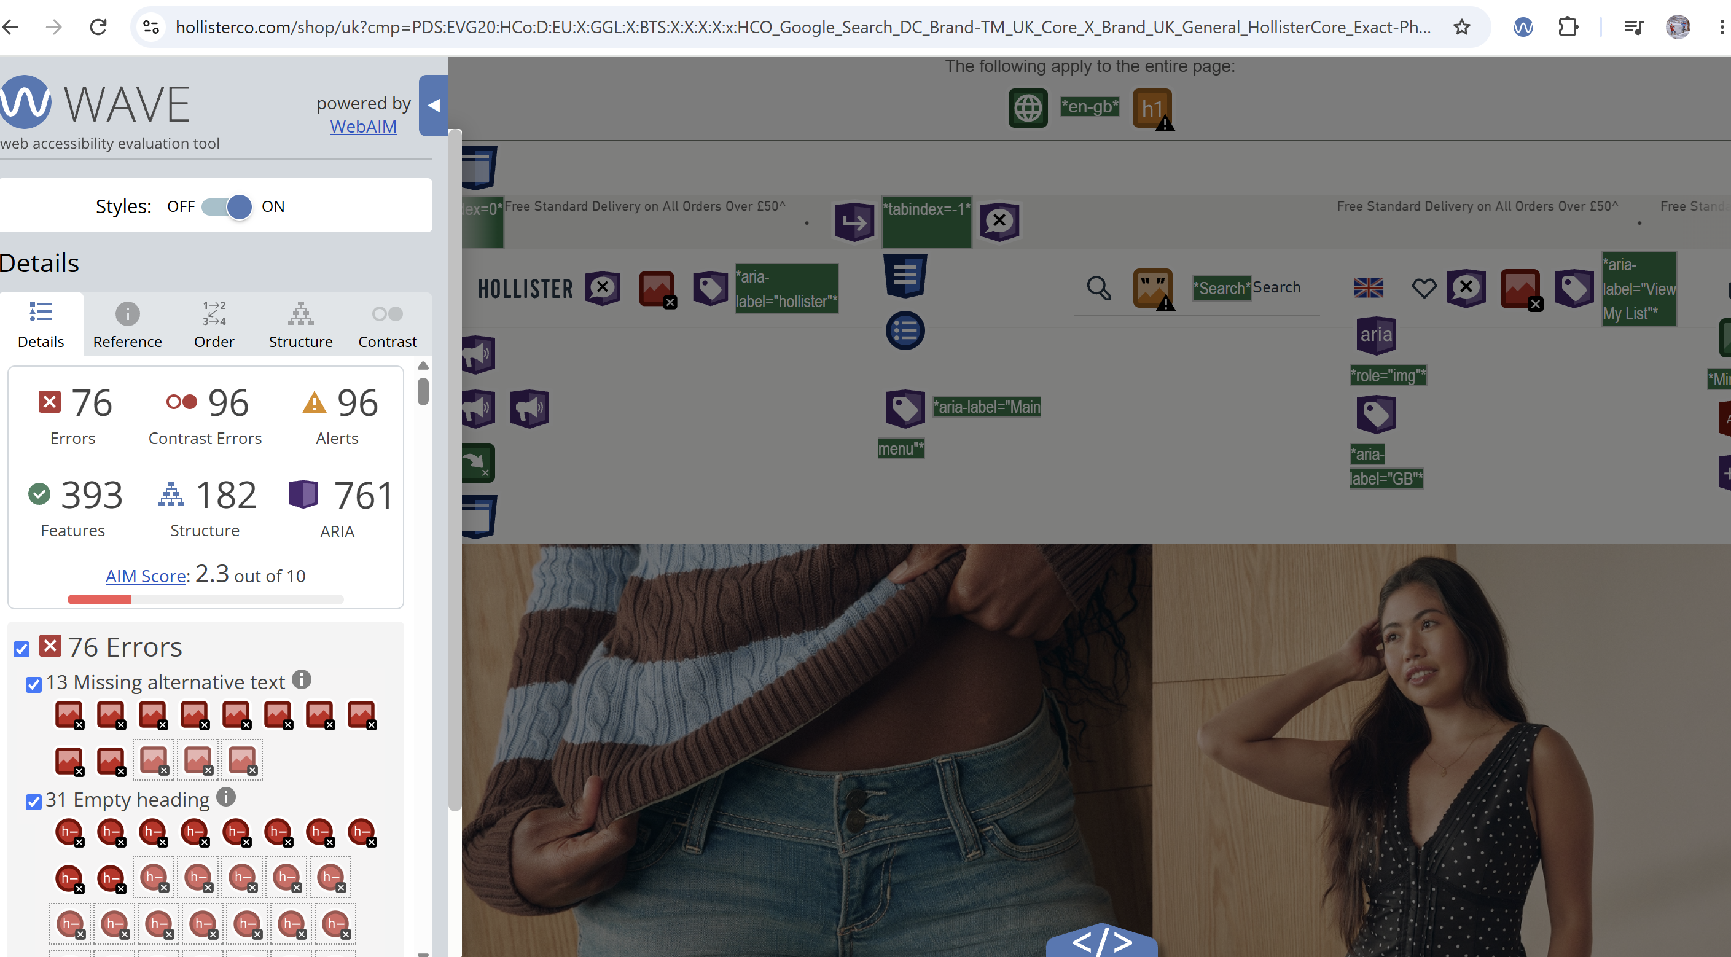

figure 24 Hollister h1 result
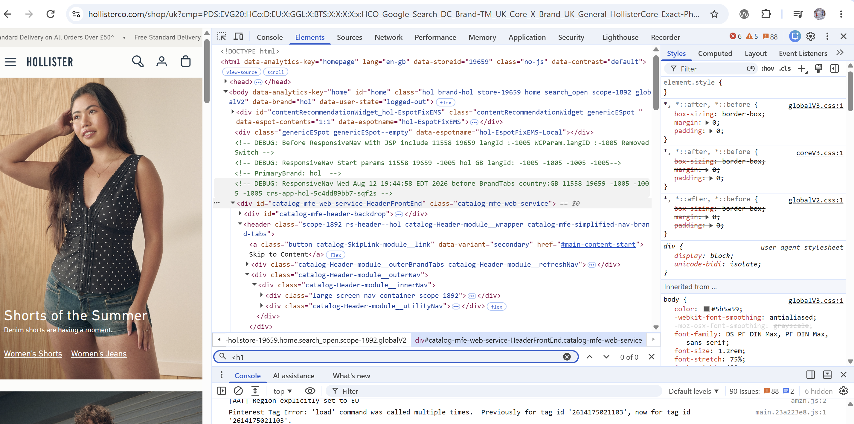

figure 25 Hollister H2 result
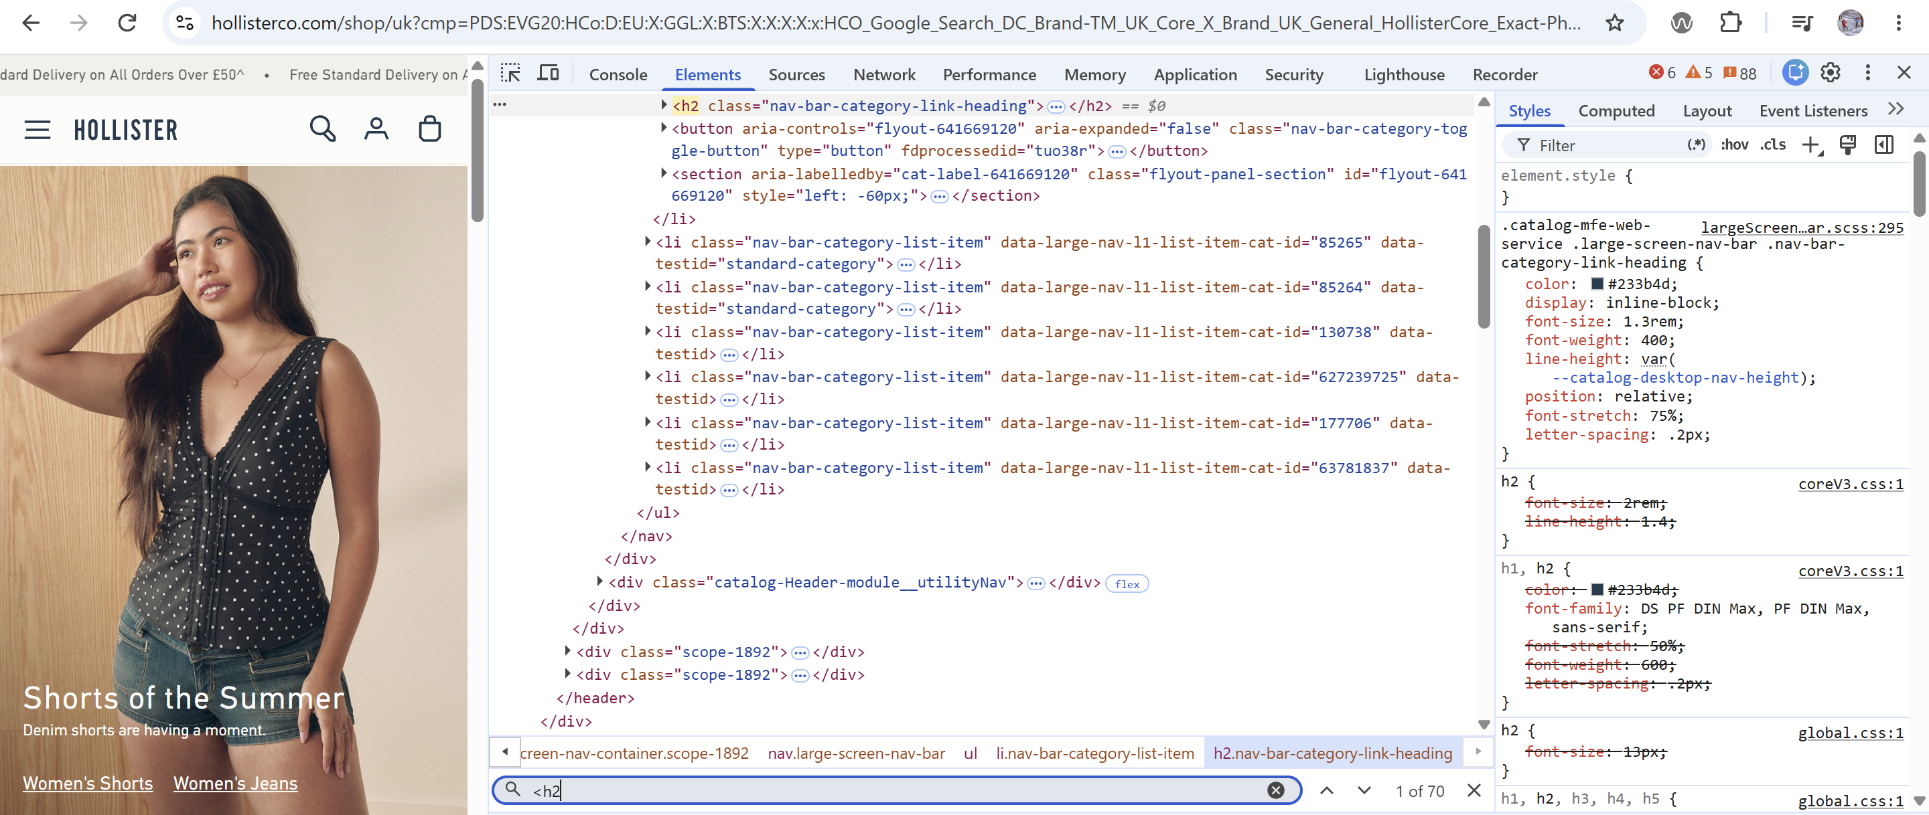

figure 26 Hollister ALT result
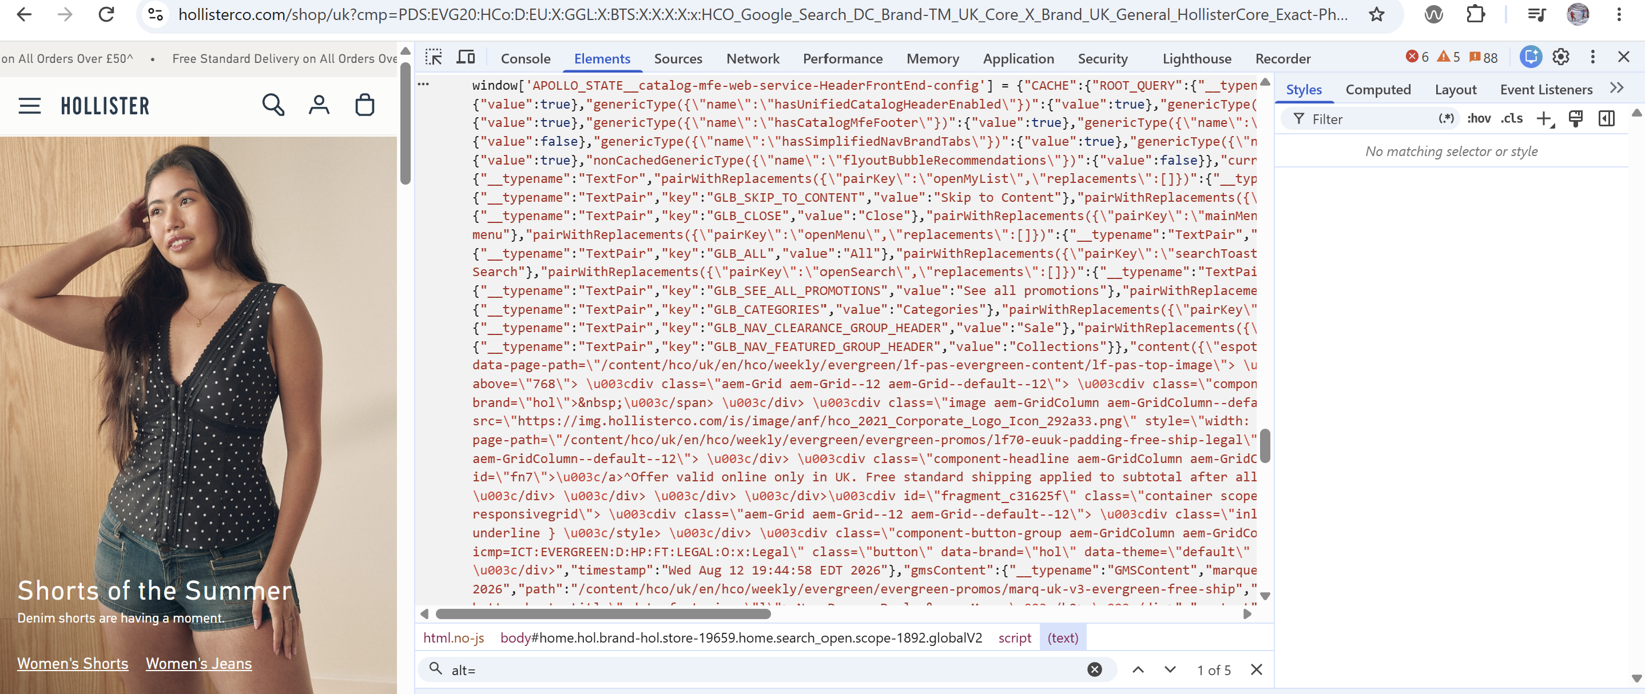

figure 27 Karen Millen WAVE result
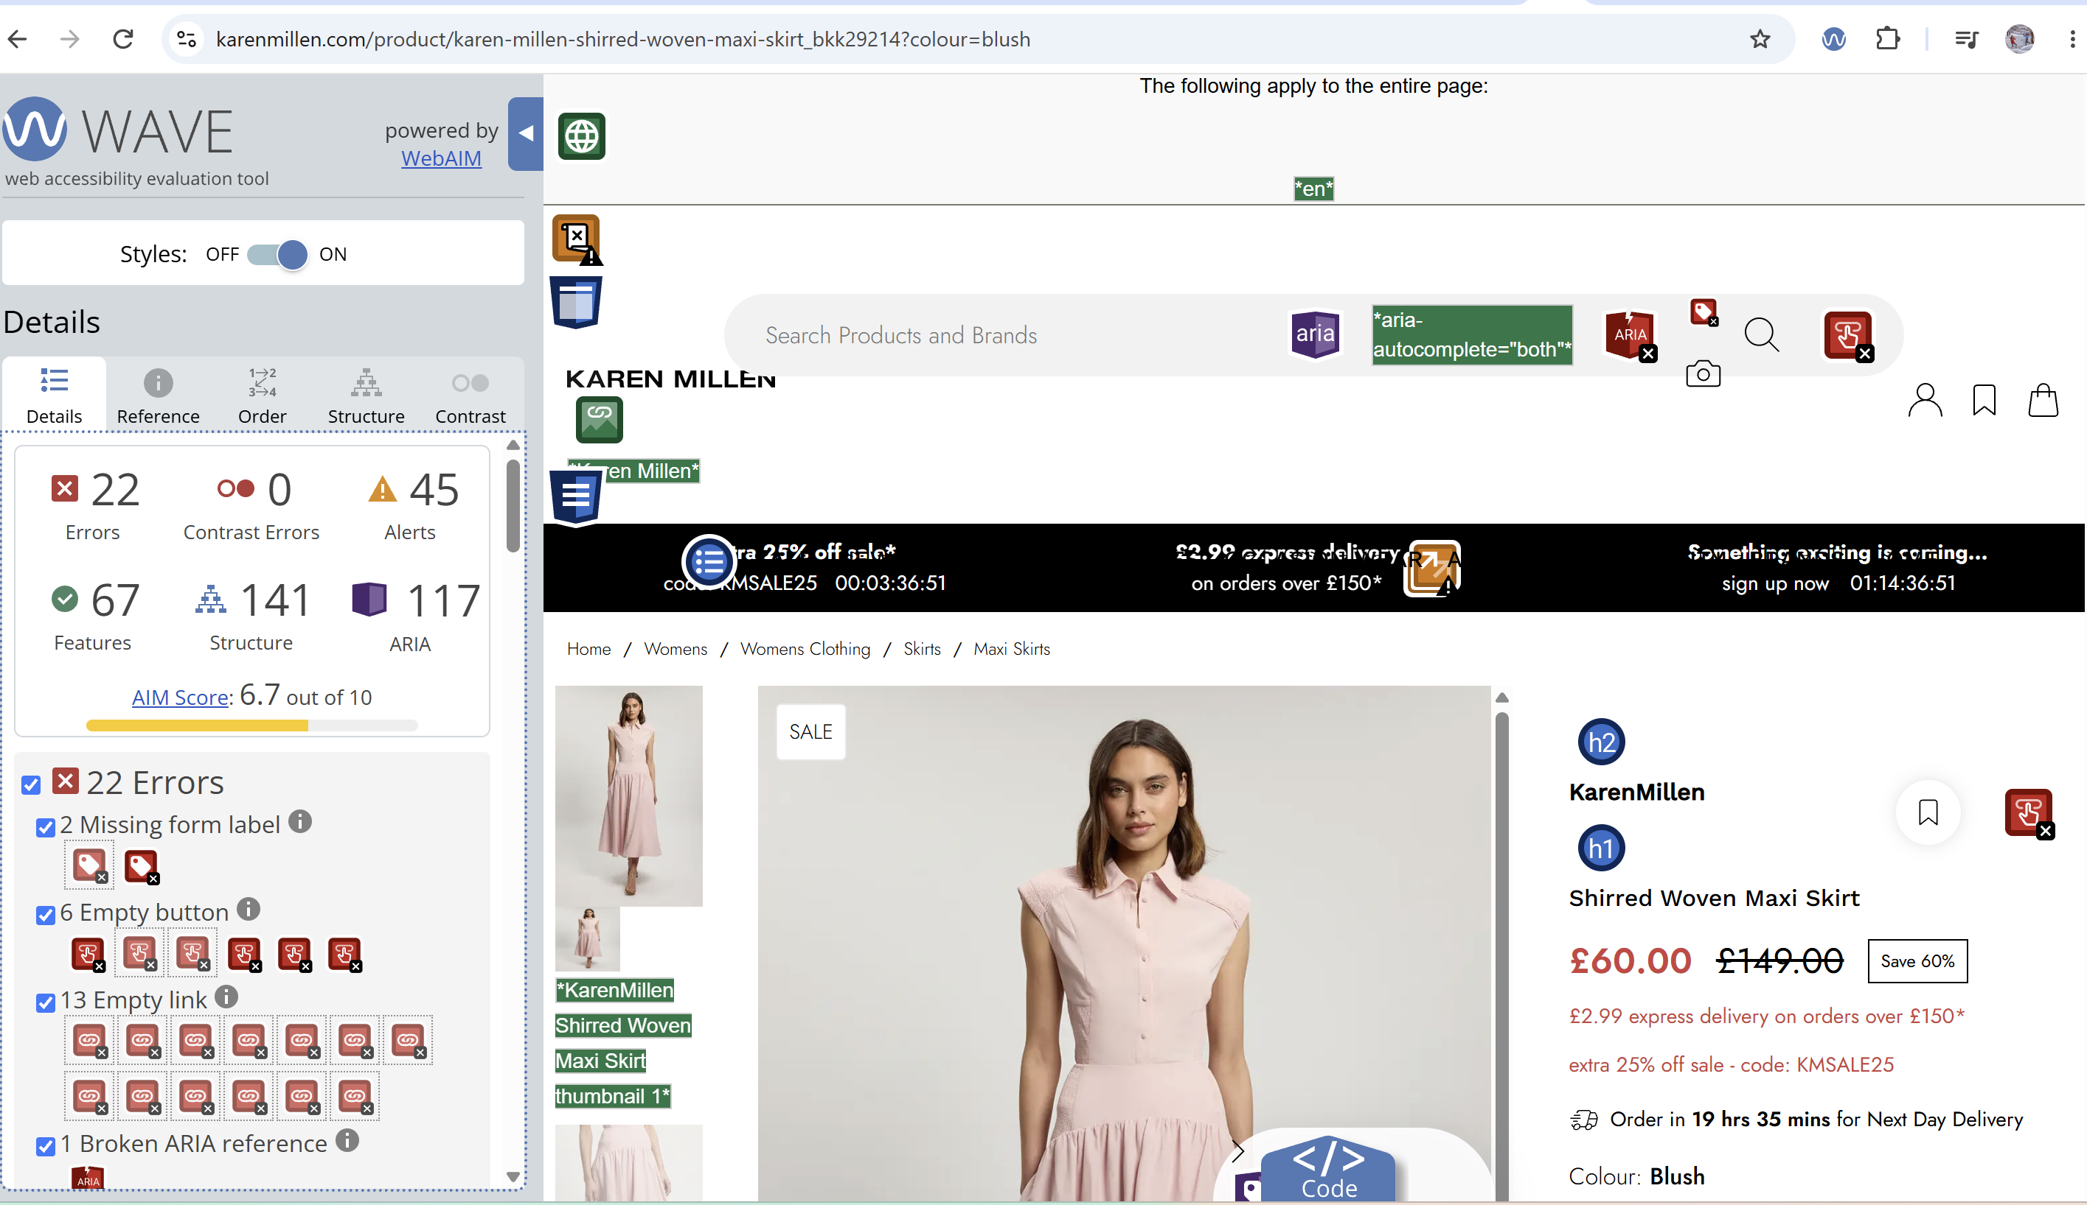

figure 28 Karen Millen H1 result
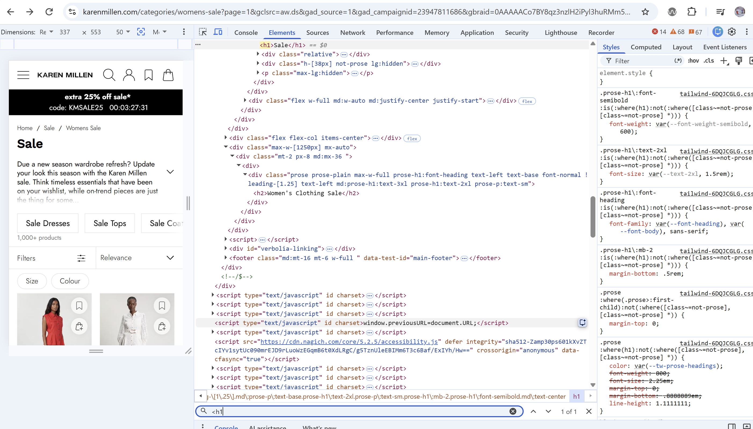
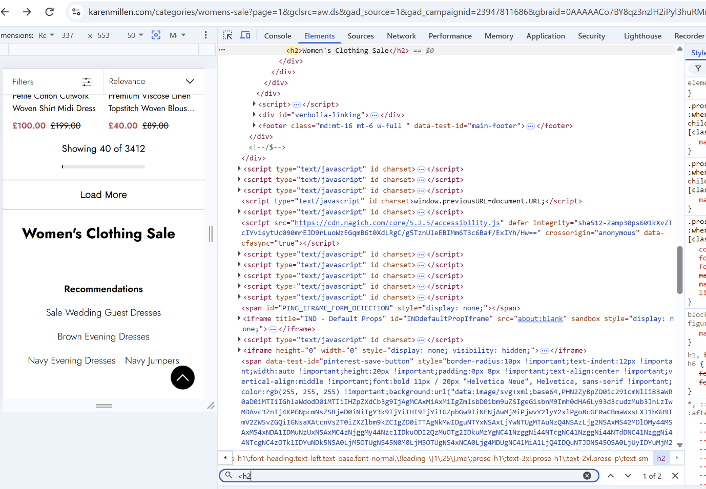
figure 29 Karen Millen h2 result
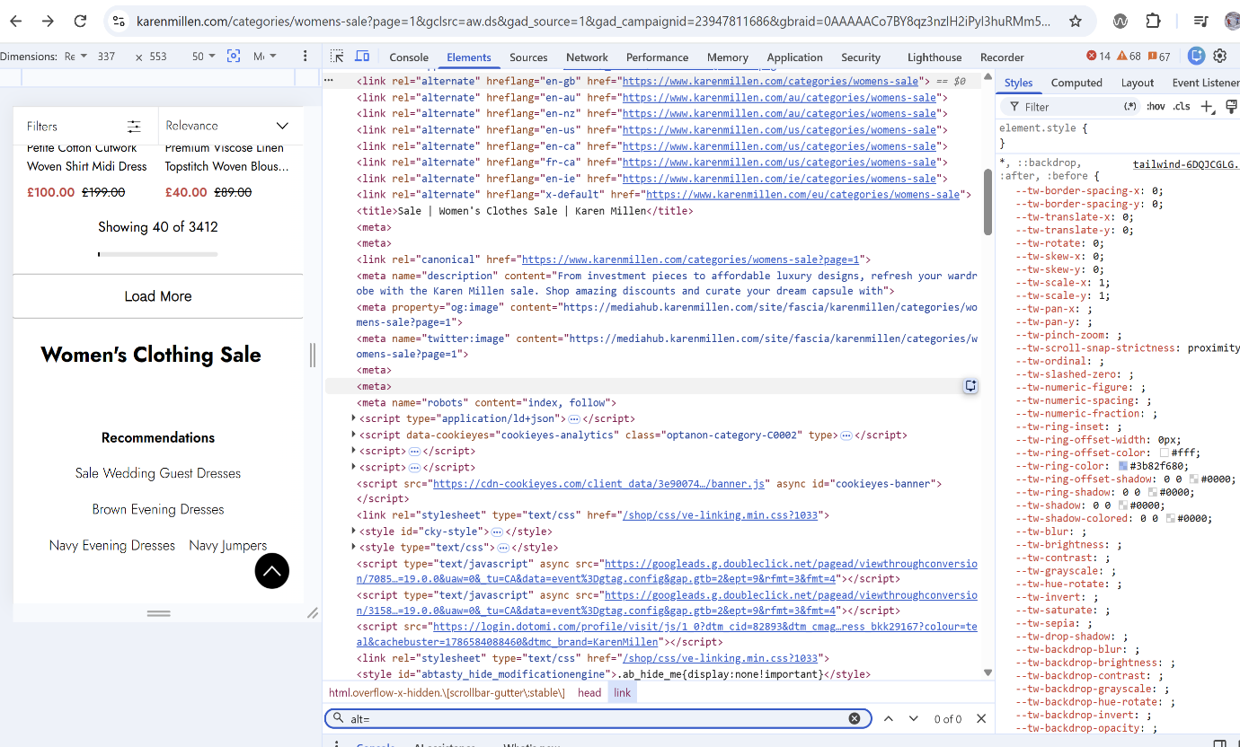
figure 30 Karen Millen ALT result



