Introduction to Web Development Report
  - Name
James Edward Millns

Student No
1708455

Email
1708455@student.uwtsd.ac.uk

Course
BSC (Hons) Software Engineering

Module Name
Introduction to Web Development
Module Code
ACCA4003
Lecturer
Kemi Ademoye

Table of Contents

1. Introduction 1
2. Requirements 1
2.1 Overview 1
2.2 Site Map 2
2.3 Schematics 3
3. Implementation 5
3.1 Screen Shots 5
3.2 Validation 10
3.2.1 HTML 10
3.2.2 CSS 13
3.2.3 Autoprefixer 13
4. Evaluation 14
4.1 Accessibility 14
4.2 Website Evaluation 16
4.3 Improvements 17
5. Conclusion 18
6. References 19

Introduction
This report will be following the development and implementation of the website “Cinema Student” created for the Introduction to Web development module. A section on the requirements of the website will outline its purpose and target audience. The stages of development on how the website was designed will be detailed, showing how the webpages link together in a site map, and the design development will be showcased in a wireframe.
The completed website will be showcased in multiple screenshots, with a section showing how the code behind the website has been validated to be compliant to web standards.
Finally an evaluation will be given detailing how the website offers accessibility to audiences from a wide range of backgrounds as advised by the WCAG 2.0 guidelines. A section will discuss the strong points of the websites, outlining the design, functionality and content of the website, with a further section detailing what improvements could be made.

Requirements

Overview
Cinema Student is a website designed for an imaginary student society who have received permission from the university to use the lecture halls during the weekends to host showings of DVD and Blue-Ray films. It is primarily aimed at university students attending the University of Wales Trinity Saint David.
The website needs to include a home page which will give a brief description and location to where the film showings are hosted. A page showcasing the films that are scheduled to be showing that weekend with times and descriptions for the specific films also needs to be provided with video content giving the students a view at the trailers for the films.
An additional page which will host events that are occurring within the society also needs to be created. This page will advise the students when a specific event which they may have an interest in will be taking place. These events may include Film marathons, E-sport streams or comedy events.
Further from that, the website should include a page where a student can request to have their own film showcased. Additionally a page which showcases new releases in legitimate cinema venues can be included, this page can be used to allow students to find out if there will be a group who intend to gather to watch a new release.

Site Map
For the website to be functional, each page needs to link to each other page in one form or another. The inclusion on a navigation bar allows the pages to link with one another while offering accessibility to any user.
Figure 1 shows how each page within the website links to one another. The errors indicated are due to the software that was used to create the site map not recognising the style sheet as a web page.
The website contains 16 web pages, 5 of them are main pages titled Home, What’s on, Events, BYOF and New releases, respectively. Each of these main pages have a dedicated link within the navigation bar. The remaining pages are essentially sub-pages which are a part of the What’s on page and the Events page. These two main pages contain links to each of these sub-pages, and each of these sub-pages have links to each other sub-page.
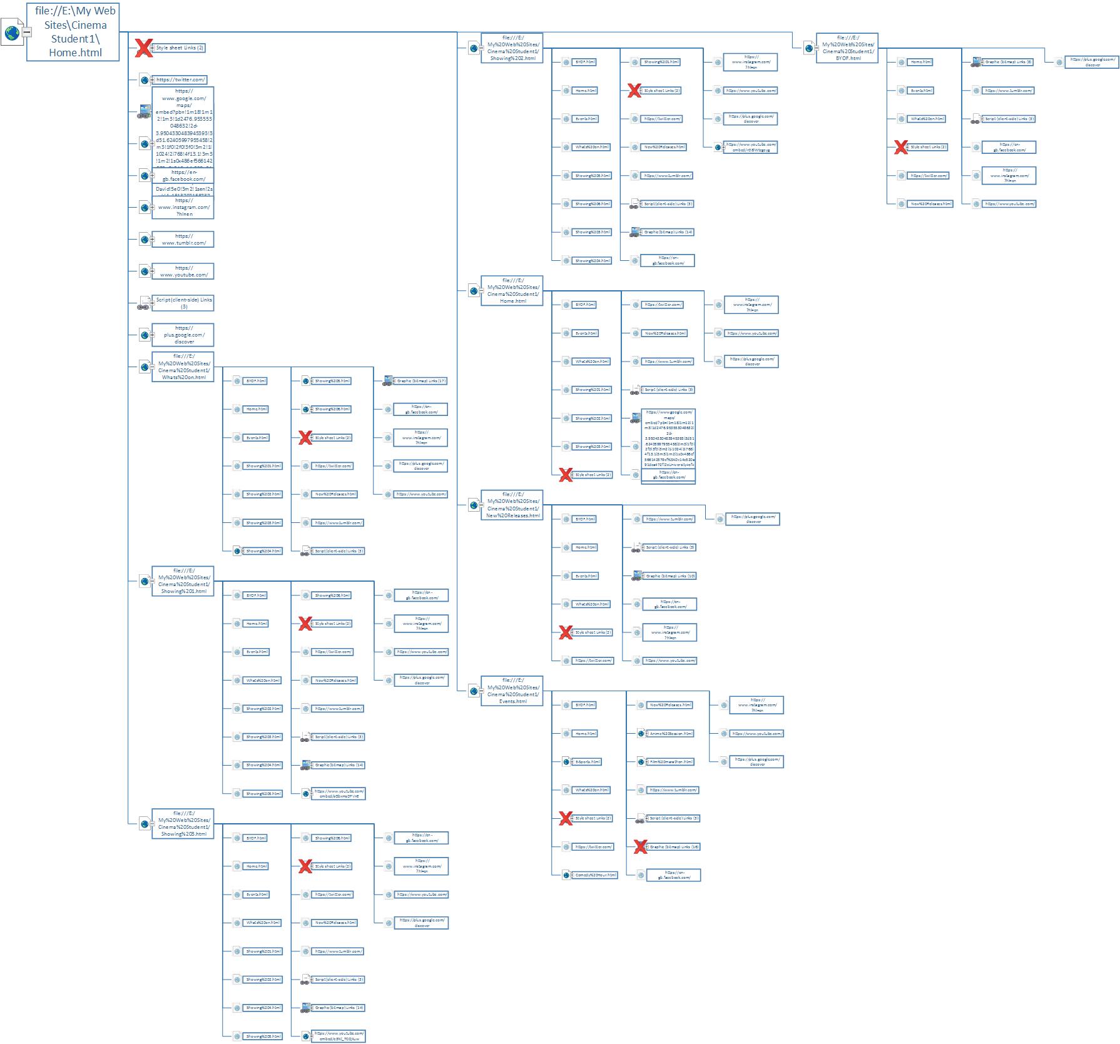
Figure 1: Site map of Cinema Student website.

Schematics
During development of Cinema Student, Adobe Photoshop was used to design the wireframe design of each page that would be in the website. While producing the website, it was decided to use the grid layout offered by Bootstrap. Bootstrap is a publicly available style standard which uses selectors with predefined attributes to assist in the layout design of a website. One of the main advantages of using Bootstrap is the use of rows and columns. Bootstrap allows the main body of the page to be divided into 12 columns with set widths and gutters [1].
Figure 2 shows the wireframe of the home page. Within the header of the page lies the navigation bar which spans the full 12 columns. At the beginning of the main body, a slideshow that spanning the whole width of the browser page has been added, which would be larger than the 12 column structure offered by Bootstrap. Following the slideshow, there would be a brief introduction to the website, outlining its purpose and what it had to offer to students visiting the page. Finally, there is a section that would give location details with an interactive map the students could use to plan out direction routes.
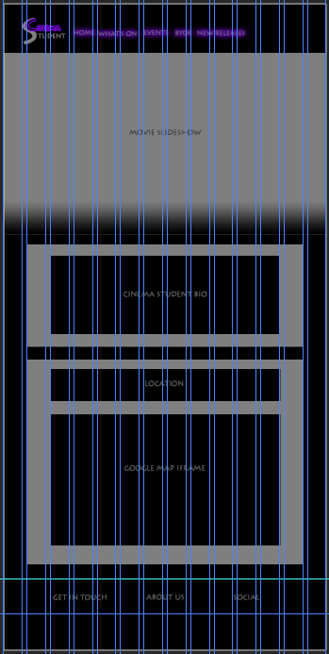
Figure 2: Wireframe of home page for Cinema Student.

Implementation

Screen Shots
The following figures showcase the overall design of the finished website. Due to the nature of the website, being primarily a cinema website, many images for films were used. All images, videos and sourced text used in the website are referenced here: Showcase slideshow [2] [3] [4]. Footer logos [5] [6] [7] [8] [9] [10]. Film Posters and descriptions [11]. Film trailers [12] [13] [14] [15] [16] [17]. Event posters [18] [19] [20] [21].
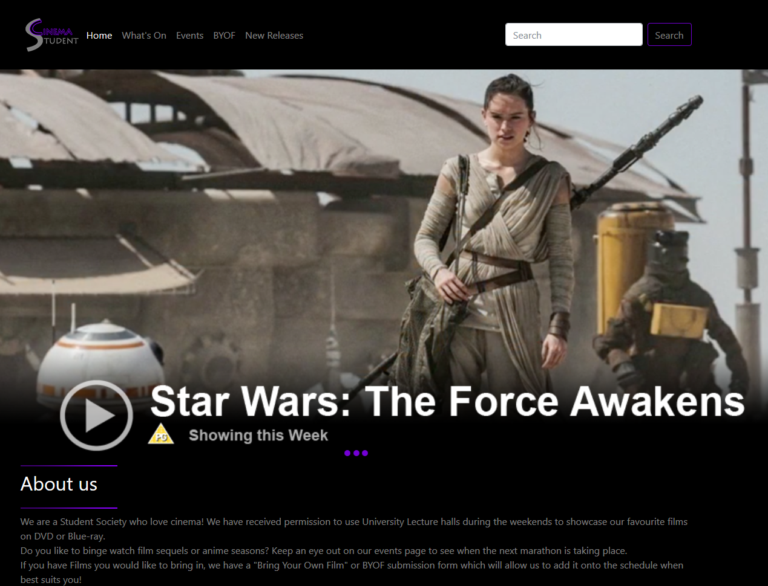
Figure 3: Home Page of website.

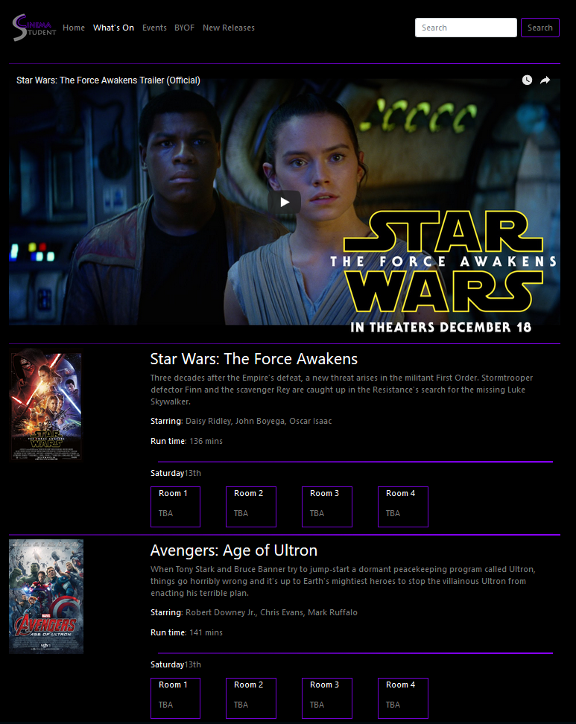
Figure 4: What's on page of website.

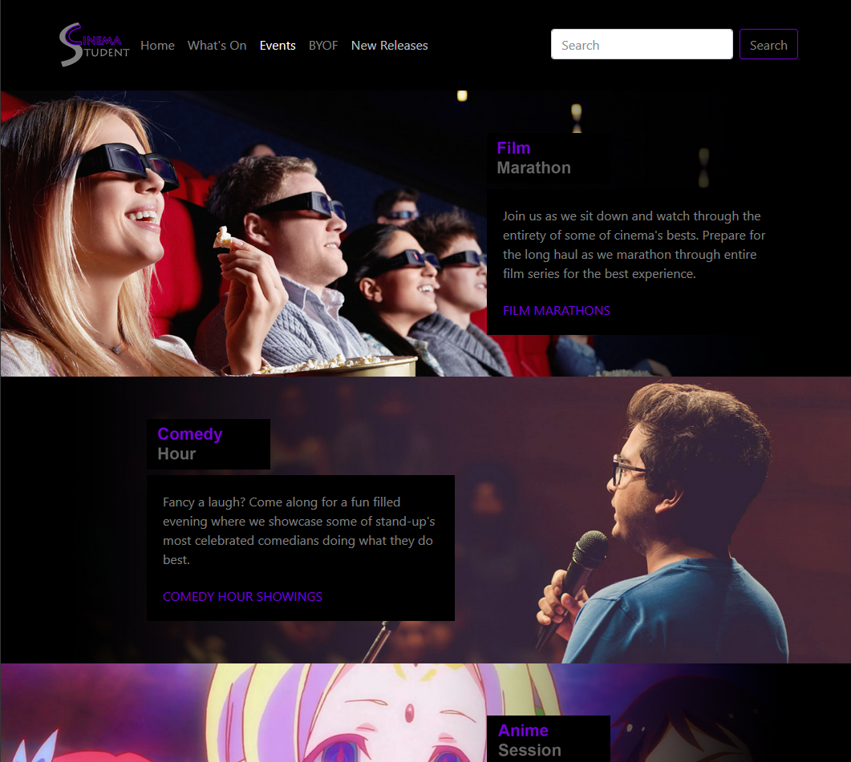
Figure 5: Events page of website

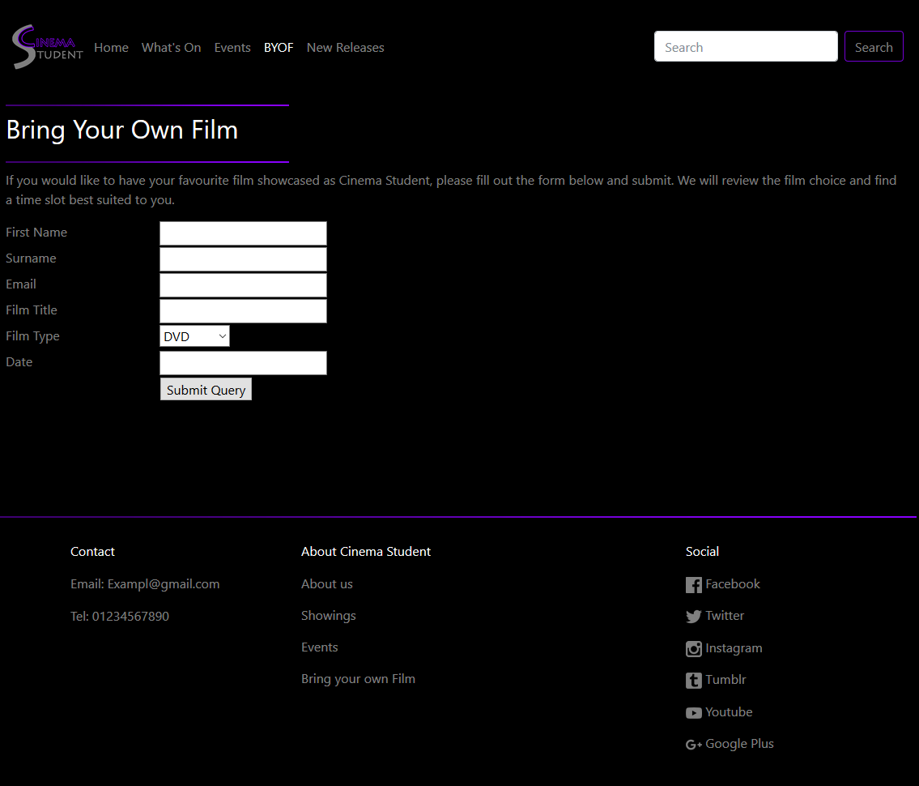
Figure 6: Bring your own film page of website.

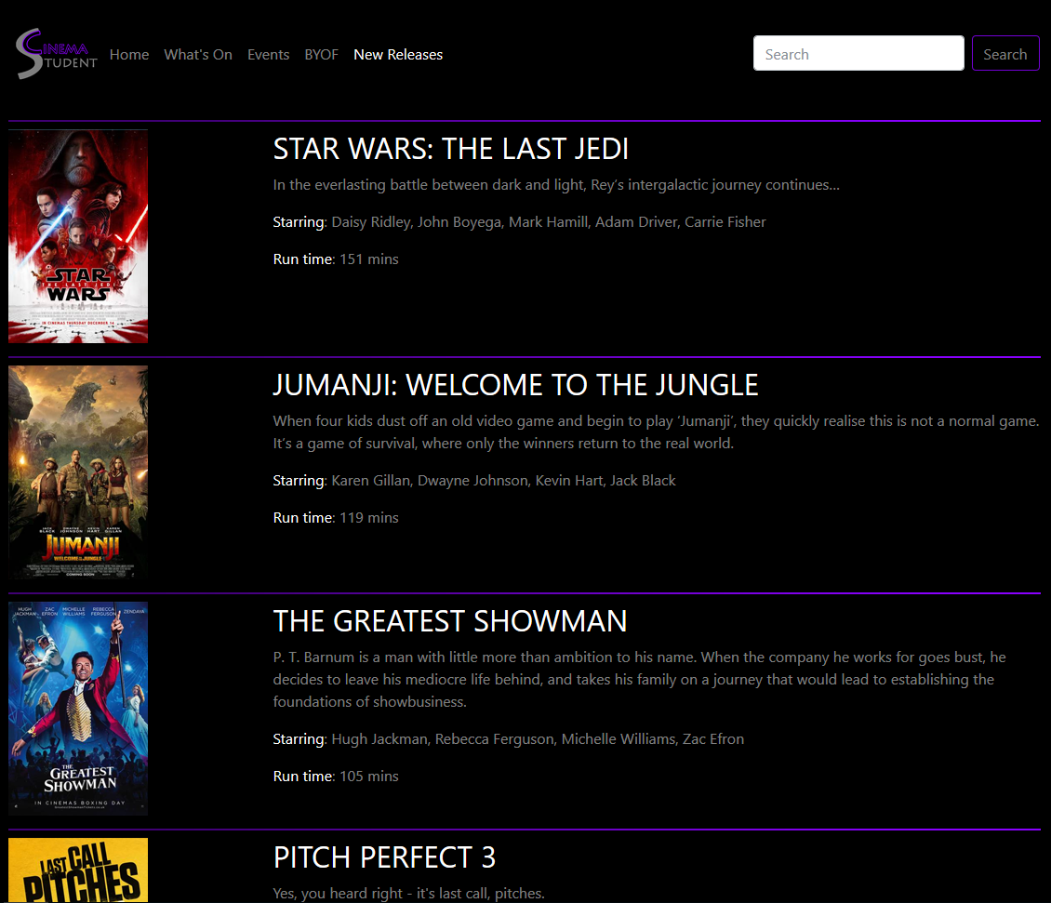
Figure 7: New Releases page of website

Validation

HTML
In order for a website to be valid, the HTML and CSS code needs to be checked. There are many code validators available on the internet. The following figures are screenshots of errors flagged by the validator provided by W3C [22].

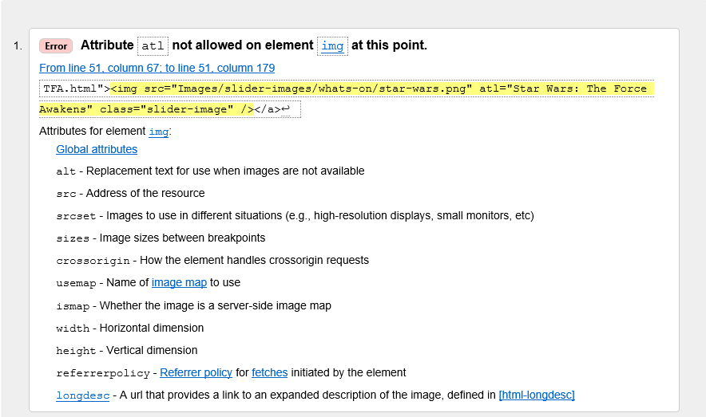
Figure 8: Error one of HTML Validation [22].

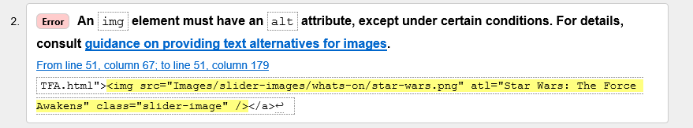
Figure 9: Error two of HTML Validation [22].

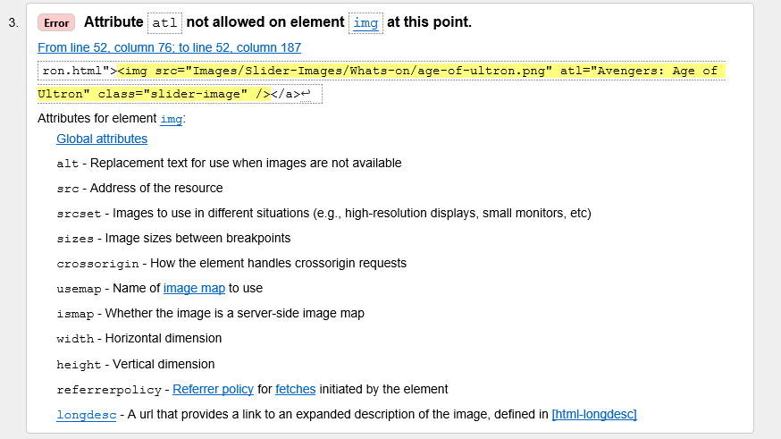
Figure 10: Error three of HTML Validation [22].

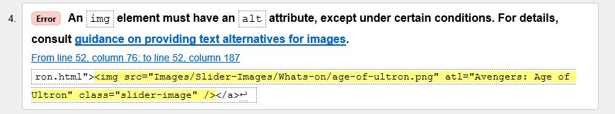
Figure 11: Error four of HTML Validation [22].

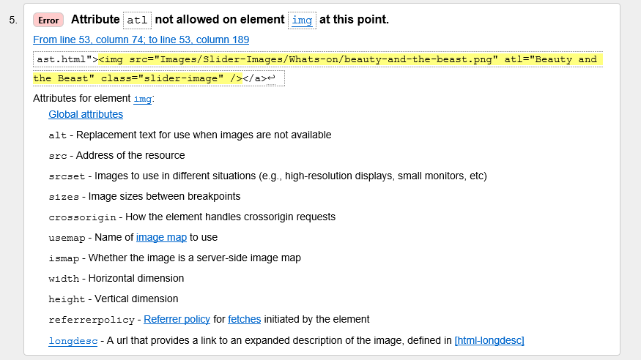
Figure 12.Error five of HTML Validation [22].

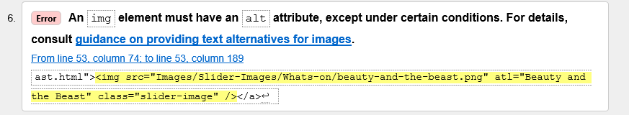
Figure 13: Error six of HTML Validation [22].

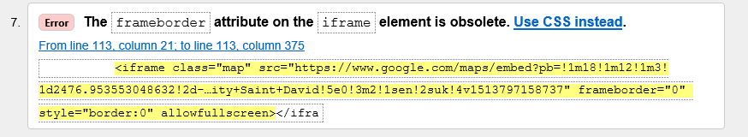
Figure 14: Error seven of HTML Validation [22].
The majority of errors flagged by the HTML validator were the misspelling of the “alt” attribute. Once these errors had been identified, amendments could be made to ensure the website was valid. Figure 15 shows the validation after the errors were amended [22].
Figure 15: Final check after amending errors [22].

CSS
Similar to the HTML validation, the CSS style sheet also needs to be validated to ensure it is acceptable. W3C also provides a CSS validator.
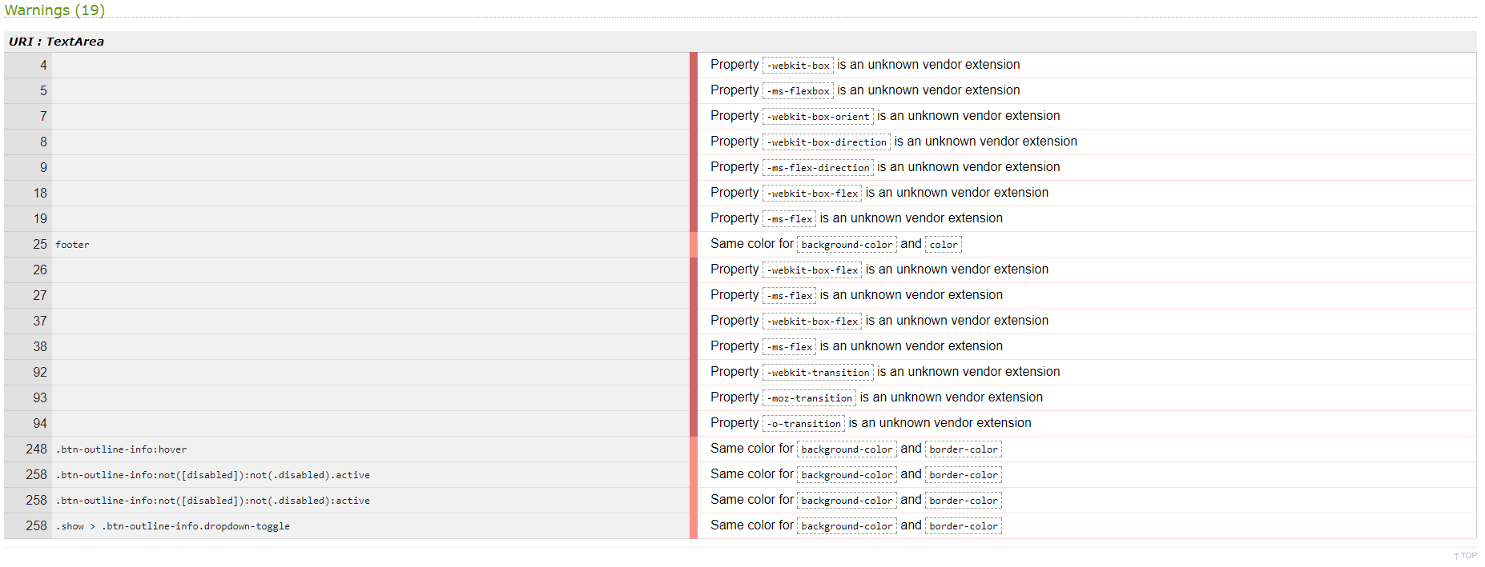
Figure 16: Errors from CSS Validation [23].
The results from the CSS validator show some errors in relation to properties that are required to allow flexboxes to function across all platforms. Some errors flagged indicated that the colour properties of the text and background in some sections were identical. This was done intentionally to prevent the bullet points generated by the “ul” and “li” elements being visible on the web page [23].

Autoprefixer
Autoprefixer is an online service that allows web creators make their HTML and CSS code compatible across all web browsers such as Google Chrome, FireFox and internet explorer. It is designed primarily to make flexboxes function correctly. Flexbox layouts are used to effectively implement a layout which is flexible across all window sizes [24].
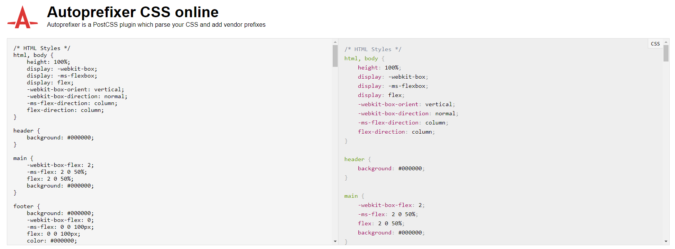
Figure 17: Alterations for CSS code provided by Autoprefixer CSS online [25].

Evaluation

Accessibility
In order to make websites that are accessible to a wider range of people who suffer with disabilities such as colour blindness, hearing loss or learning difficulties, web developers refer to the recommendations made by the Web Content Accessibility Guidelines (WCAG) 2.0. This guideline document outlines how to implement content that is user friendly for all audiences [26].
Section 1.4 of the WCAG 2.0 document details the use of colour. It advises to use a high colour contrast between text and background to allow the content to be easily eligible for all audiences. It recommends a colour contrast of 4.5:1 as a minimum contrast ratio for text to be readable across a wide range of text sizes [26].
The following figures show how the colours used on the website designed for this assignment score on the contrast scale. Two websites were used to conduct these tests, Contrast Checker and Luminosity contrast ratio analyser [27] [28].

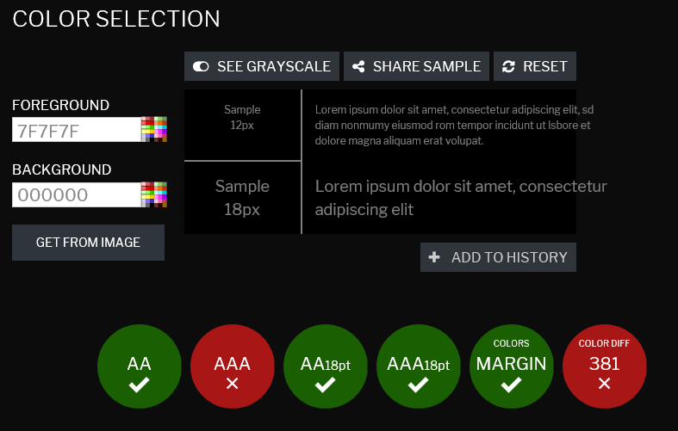
Figure 18: Contrast Results for grey on black [27].

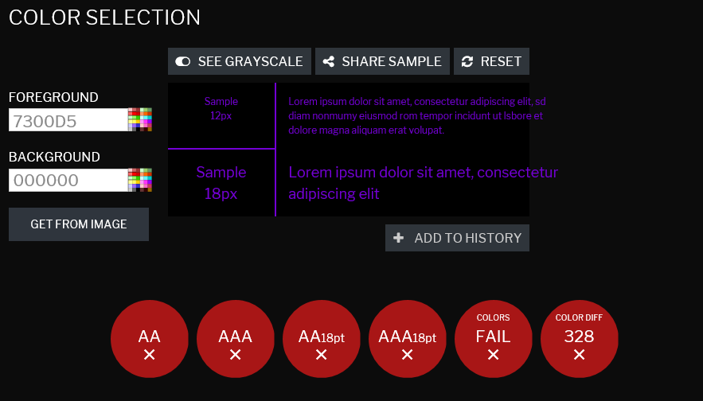
Figure 19: Contrast results for purple on black [27].

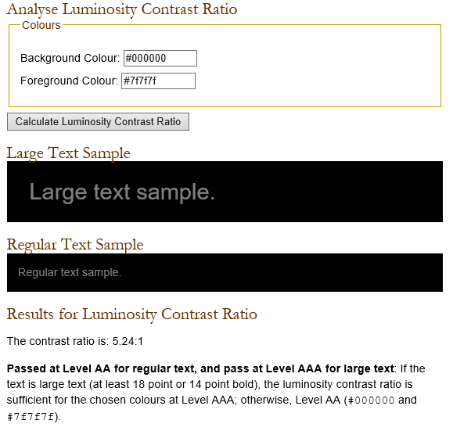
Figure 20: Contrast Ratio results for grey on black [28].

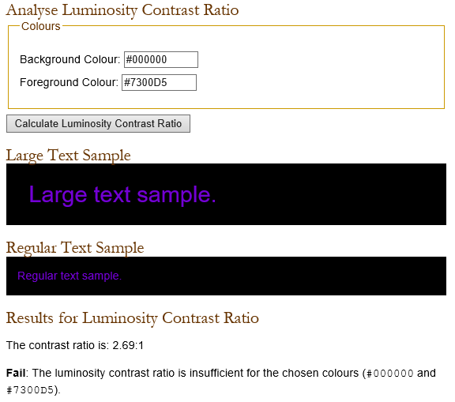
Figure 21: Contrast ratio results for purple on black [28].
The results show that the main colours used in the website (Grey and Black) are high contrast enough to be readable on medium to large fonts, but may prove difficult to read on smaller font sizes [27] [28]. This is remedied by the default font size of the website being set to 18pt.
On the other hand, the accent colour used (Purple) does not offer enough contrast for the text to be readable, even on larger font sizes [27] [28]. Being aware of this potential issue, the website was designed in a way where this accent colour was primarily used for graphics on the website, and was avoided as a text colour due to the limited contrast.

Website Evaluation
Design: The overall design of the website takes inspiration from existing cinema booking websites such as Vue, Odeon and Cineworld [29] [30] [31]. The website attempts to imitate the atmospheric setting of a cinema with its use of dark background and text. The placement of images and text allow for an easy browsing experience with the organised and structured layout. The inclusion of distinct break lines between blocks of content eliminates the possibility for confusion. The viewer is able to easily keep track of what they are looking at without becoming confused on where one section starts and the other ends.
Functionality: The website offers a high level of functionality with its use of integrated links between webpages, responsive navigation bar and use of data input fields. The use of integrated links allows for a pleasant browsing experience for users, as it gives the opportunity to reach any page included within the website with a maximum of only two link clicks.
As outlined in section 2.4 and 3.2 of the WCAG 2.0 [26], including a responsive and consistent navigation bar reduces the possibility for users to become confused or lost within the website. It recommends a repeated navigation bar amongst all webpages, which has been included in the design of Cinema Student.
Content: The content used in the website is consistently relevant. The inclusion of interactive media offers a form of entertainment to the user which is beneficial to the overall success of the website, as users would be inclined to revisit the website at a later date.
The use of images is beneficial to the website as a whole. Having visual representations of films the website is showcasing allows the users to relate to the content, while also making navigation more intuitive as the human eye latches onto patterns. Having images shown in specific patterns allows the user to better recognise the pages they have visited. Only having text content on the website would not offer this same level of recognition.
The text content within the website follows the recommendations made in section 3.1 of WCAG 2.0 [26] by avoiding unusual words, abbreviations where possible and implementing text that is understandable by users with a lower reading level. The only area where this recommendation is not followed is the inclusion of the “BYOF” abbreviation. A clarification of this abbreviation is given in the home page on the about section and at the top of the “BYOF” page where it clearly shows “Bring your own Film”.

Improvements
Design: The use of higher contrasting colours could be used to better improve the readability of the website. A lighter shade of grey or purple could be used against the black background for example.
A background image with a soft gradient from black to grey could be used to add an extra dimension the overall feel of the website.
Functionality: The inclusion of more interactive content like overlaying video trailers, or a “back to top” button which is stationary at the bottom right corner of the browser window would allow for a more functional website.
The use of responsive design could greatly improve the functionality across multiple platforms such as tablets and smart phones which have varying screen sizes.
Content: A more robust image slider which functions on different screen sizes would allow for a more immersive experience. The image slider currently on the website does not function properly on screen sizes that are larger or smaller than 1920x1080p as the images do not sit within a set container.
Within the “New Releases” page, an option could be added which would allow the users to search for groups who were interested in viewing the showings at the legitimate cinemas.

Conclusion
Cinema Student’s overall purpose was intended to serve as a platform for an imaginary student society who loves film. The website offers an intuitive layout which allows for easy navigation through its pages. The website was validated by industry standards proposed by W3C, where it also scored high on the colour contrast checkers which suggest its accessibility abides with the recommendations proposed by WCAG 2.0.
To further improve the website the inclusion of responsive design could be further implemented, along with a more efficient use of overlays and image sliders.
The website’s content offers users an entertaining experience with its use of interactive media, relevant information and images, and intuitive functionality while staying true to its target audience and purpose as a cinema platform.

References

[1] | “Bootstrap,” [Online]. Available: https://getbootstrap.com/. [Accessed 12 2017].
[2] | “Star Wars: The Force Awakens Ending and the Once and Future Jedi,” Den of Geek, 28 12 2015. [Online]. Available: http://www.denofgeek.com/us/movies/star-wars/251464/star-wars-the-force-awakens-ending-and-the-once-and-future-jedi. [Accessed 12 2017].
[3] | “Avengers: Age of Ultron image,” Youtube, [Online]. Available: https://i.ytimg.com/vi/zi4VAPVYFA4/maxresdefault.jpg. [Accessed 12 2017].
[4] | “What critics are saying about the new 'Beauty and the Beast',” Rappler, 17 03 2017. [Online]. Available: https://www.rappler.com/entertainment/movies/164472-beauty-and-the-beast-critics. [Accessed 12 2017].
[5] | “Facebook Logo,” Facebook, [Online]. Available: https://www.facebook.com/. [Accessed 12 2017].
[6] | “Twitter Logo,” Twitter, [Online]. Available: https://twitter.com/Twitter?ref_src=twsrc%5Egoogle%7Ctwcamp%5Eserp%7Ctwgr%5Eauthor. [Accessed 12 2017].
[7] | “Instagram Logo,” Instagram, [Online]. Available: https://www.instagram.com/. [Accessed 12 2017].
[8] | “Youtube Logo,” Youtube, [Online]. Available: https://www.youtube.com/. [Accessed 12 2017].
[9] | “Tumblr Logo,” Tumblr, [Online]. Available: https://www.tumblr.com/. [Accessed 12 2017].
[10] | “Google Plus Logo,” Google Plus, [Online]. Available: https://plus.google.com/discover. [Accessed 12 2017].
[11] | “Film Library,” IMDb, [Online]. Available: http://www.imdb.com/. [Accessed 12 2017].
[12] | “Star Wars: The Force Awakens Trailer (Official),” Yotube, 19 10 2015. [Online]. Available: https://www.youtube.com/watch?v=sGbxmsDFVnE. [Accessed 12 2017].
[13] | “Avengers: Age of Ultron Official Extended Trailer (2015) - Avengers Sequel Movie HD,” Youtube, 14 11 2014. [Online]. Available: https://www.youtube.com/watch?v=rD8lWtcgeyg. [Accessed 12 2017].
[14] | “Beauty and the Beast – US Official Final Trailer,” Yotube, 30 01 2017. [Online]. Available: https://www.youtube.com/watch?v=e3Nl_TCQXuw. [Accessed 12 2017].
[15] | “21 Movie Trailer - First Look,” Youtube, 07 01 2008. [Online]. Available: https://www.youtube.com/watch?v=PsK1c9ZBpuw. [Accessed 12 2017].
[16] | “Now You See Me Official Trailer #2 (2013) - Mark Ruffalo, Morgan Freeman Movie HD,” Youtube, 10 04 2013. [Online]. Available: https://www.youtube.com/watch?v=KzJNYYkkhzc. [Accessed 12 2017].
[17] | “Moana Official Trailer,” Youtube, 15 09 2016. [Online]. Available: https://www.youtube.com/watch?v=LKFuXETZUsI. [Accessed 12 2017].
[18] | “Cinema Image,” Oldreptheatre, [Online]. Available: http://www.oldreptheatre.org.uk/wp-content/uploads/2016/07/Cinema.jpg. [Accessed 12 2017].
[19] | “Standup comedy image,” Just Dial, [Online]. Available: https://www.justdial.com/entertainment/movies/Mumbai. [Accessed 12 2017].
[20] | “Feel asked to leave.jpg,” No Game No Life Wiki, [Online]. Available: http://no-game-no-life.wikia.com/wiki/File:Feel_asked_to_leave.jpg. [Accessed 12 2017].
[21] | “Earn millions play video games, the Esports revolution is here!,” Games Grabr, 07 07 2015. [Online]. Available: http://www.gamesgrabr.com/blog/2015/07/07/earn-millions-play-video-games-the-esports-revolution-is-here/. [Accessed 12 2017].
[22] | “HTML Markup Validation Service,” W3C, [Online]. Available: http://validator.w3.org/. [Accessed 12 2017].
[23] | “CSS Validation Service,” W3C, [Online]. Available: http://jigsaw.w3.org/css-validator/. [Accessed 12 2017].
[24] | C. Coyier, “A Complete Guide to Flexbox,” 12 11 2017. [Online]. Available: https://css-tricks.com/snippets/css/a-guide-to-flexbox/. [Accessed 12 2017].
[25] | “Autoprefixer CSS online,” Autoprefixer, [Online]. Available: https://autoprefixer.github.io/. [Accessed 12 2017].
[26] | B. Caldwell, M. Cooper, L. G. Reid and G. Vanderheiden, “Web Content Accessibility Guidelines (WCAG) 2.0,” 2008. [Online]. Available: https://www.w3.org/TR/WCAG20/. [Accessed 12 2017].
[27] | “CONTRAST CHECKER,” Acart Communications, [Online]. Available: https://contrastchecker.com/. [Accessed 12 2017].
[28] | “Luminosity Colour Contrast Ratio Analyser,” Juicy Studio, [Online]. Available: http://juicystudio.com/services/luminositycontrastratio.php. [Accessed 12 2017].
[29] | “MyVue,” Vue Cinema, [Online]. Available: https://www.myvue.com/. [Accessed 12 2017].
[30] | “Odeon,” OdeonCinema, [Online]. Available: http://www.odeon.co.uk/. [Accessed 12 2017].
[31] | “Cineworld,” Cineworld Cinema, [Online]. Available: https://www.cineworld.co.uk/. [Accessed 12 2017].
[32] | “League of Legends image,” [Online]. Available: https://news-a.akamaihd.net/public/images/misc/GameBox.jpg. [Accessed 12 2017].
[33] | “Hearthstone card back image,” [Online]. Available: http://media-hearth.cursecdn.com/attachments/39/664/cardback_0.png. [Accessed 12 2017].
[34] | “Overwatch Image,” [Online]. Available: https://blznav.akamaized.net/img/games/cards/card-overwatch-7eff92e1257149aa.jpg. [Accessed 12 2017].

marking criteria and Student FEEDBACK

This section details the assessment criteria. The extent to which these are demonstrated by you determines your mark. The marks available for each criterion are shown. Lecturers will use the space provided to comment on the achievement of the task(s), including those areas in which you have performed well and areas that would benefit from development/improvement.

Common Assessment Criteria Applied (Assignment 1) | Marks available | Marks  awarded
1. Research-informed Literature
Extent of research and/or own reading, selection of credible sources, application of appropriate referencing conventions.
Demonstrates a good level of research. Although an extensive list of references, the main research exercise activity for the assignment is on the weak side - see comments under Analysis. (Grade mark: 60.00%) | 5 | 3
2. Knowledge and Understanding of Subject
Extent of knowledge and understanding of concepts and underlying principles associated with the discipline.
Demonstrates an excellent understanding of the standards to design and implement a website. The website has been implemented using a variety of concepts. A few things to note: be careful with your choice of colours - see comments below and your use of relative URLs. Some of your links on your Events page were broken. See your report for further explanation and additional comments. (Grade mark: 85.00%) | 20 | 17
3. Analysis
Analysis, evaluation and synthesis; logic, argument and judgement; analytical reflection; organisation of ideas and evidence
A very good evaluation of the implemented website has been provided and the suggested improvements are relevant. The accessibility evaluation, however, is weak and mainly focuses on just one area - colours. You were given a list of features to review with respect to your implemented website and were also required to research the WCAG guidelines and use the guidelines to review the accessibility of your website. (Grade mark: 55.00%) | 20 | 11
4. Practical Application and Deployment
Deployment of methods, materials, tools and techniques; application of concepts; formulation of innovative and creative solutions to solve problems.
An excellent attempt featuring a well-thought-out website and it is evident that you have put a lot of effort into the content of the website. Well done. I know you have given some justification for the dark colours used on your website, however, the colour combinations means there is a low contrast between the text and background of the website. This is even more of an issue as there is quite a significant amount of text for the user to read. Also note that it is good practice to name the home page of a website as either index.html or default.html. See your report for additional comments. (Grade mark: 86.00%) | 50 | 43
5. Skills for Professional Practice
Attributes in professional practice: individual and collaborative working; deployment of appropriate media; presentation and organisation.
The report is well-written and presented. (Grade mark: 90.00%) | 5 | 4.5

Assignment Mark (Assessment marks are subject to ratification at the Exam Board. These comments and marks are to give feedback on module work and are for guidance only until they are confirmed. ) | Late Submission Penalties (tick if appropriate) |  | 78.5%
 | Up to one week late |  | 78.5%
 | 1st/2nd/3rd attempt? |  | 78.5%

