UNIVERSITY OF WALES: TRINITY SAINT DAVID PRIFYSGOL CYMRU: Y DRINDOD DEWI SANT

Unit Code: LCBB4002
Community Engagement
VODAFONE GROUP PLC


Student: 2008573
Ionut-Adrian Voinea
Dated: 08th of February 2021
Words: xxxx

Contents
Executive summary 2
Introduction 3
Macro business environment 5
PESTEL 5
Organization microenvironment 5
Porter Five Forces 5
Conclusion 5
References 5
Appendices 6

Executive summary
Current report aims to provide an analysis on one of the top 100 UK companies, Vodafone Group PLC, starting with details related to he sector it operates, goals, mission and values, followed by information related to company customers and their expectations from the organization. The discussion will continue with insights related to training and development and their importance for the organization, discussion supported by the presentation of a specific role form Vodafone, as organization. The skills and knowledge needed for the selected role will be investigated and the final part will conclude the findings related to Vodafone PLC.

Introduction
Vodafone Group PLC, one of the larger telecommunication companies worldwide (Statista, 2021) operates in one of the most competitive industries nowadays, telecom industry, managing the business on two regional platforms from geographical perspective, Europe, and Africa (Vodafone, 2020). As detailed in Appendix 1, the most of controlled operations are located in Europe, covering 77% out of the group revenue (with Germany, UK, Italy, Spain as locations with leading contribution to the group revenue) (Vodafone Annual Report, 2020). Africa contribute to the group revenue with 16%, leading locations being South Africa and Egypt. The rest of the 7% of the group revenue are ensured by other regions and partners. A short history of the company is presented in Appendix 2.
With the headquarters in London, the services provided by Vodafone covers 43 partner markets, being also recognized as one of the most valuable brands in UK, being estimated at 19.12 bn USD (Statista, 2021).
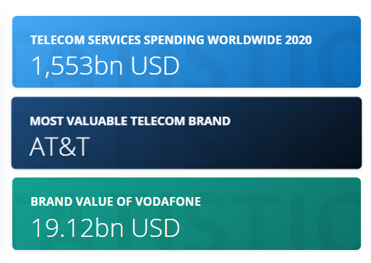
Figure 1: Vodafone brand value (Statista, 2021)
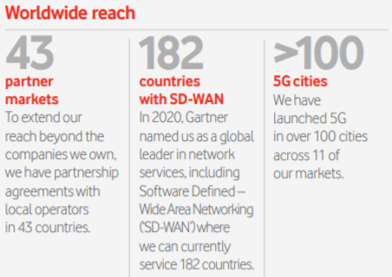
Figure 2: Vodafone worldwide coverage (Vodafone Annual Report, 2020)

Vodafone name comes from 3 words: voice, data and fone, providing a favor of the mobile services offered by the organization.
In terms of employees, Vodafone is employer of more than 92 000 people in 2020, with a slightly decrease since 2018, as detailed in Appendix 3. The main areas covered by the Vodafone staff includes customer service, sales, distribution, operations, and administration, 14% of Vodafone staff being located in Germany (Statista, 2021).
In terms of services, Vodafone provides mobile services, fixed broadband TV services and money transfer services towards consumer and business customers, as detailed in Appendix 4 (Vodafone Annual report, 2020). Most part of the services revenues (52%) are coming from consumer clients, followed by business consumer (28%), the rest of the revenue percentages coming from money transfer services (12%) and other services (8%), provided both to business and consumer clients (Vodafone Annual Report, 2020).
As stated by the company, Vodafone objective is to “connect for a better future”, endorsed by a strategy that aims to demonstrate a strong progress on the 4 strategic priorities:
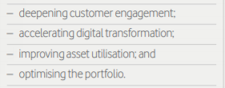
Figure 3: Vodafone strategic priorities (Vodafone Annual Report, 2020)

Principal Competitors: British Telecommunications PLC; Deutsch e Telekom AG; France Telecom Group; AT&T Corp

Macro business environment

PESTEL

Organization microenvironment

Porter Five Forces

Conclusion

References
Reference for Business (2021), Vodafone Group Plc - Company Profile, Information, Business Description, History, Background Information on Vodafone Group Plc, [online], Available at: https://www.referenceforbusiness.com/history2/98/Vodafone-Group-Plc.html Accessed 27th of January 2021
Vodafone official website (2021), Annual report 2020, [online], Available at: https://www.vodafone.com/content/dam/vodcom/files/vdf_files_2020/pdfs/vodafone-annual-report-2020.pdf Accessed 27th of January 2021

Appendices
Appendix 1 – Vodafone operating locations
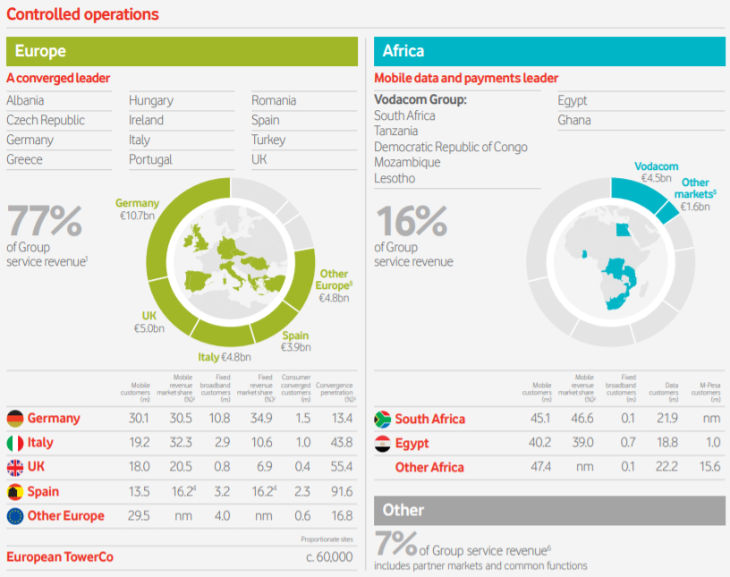
Source: Vodafone Annual Report (2020)

Appendix 2 – Vodafone Key dates
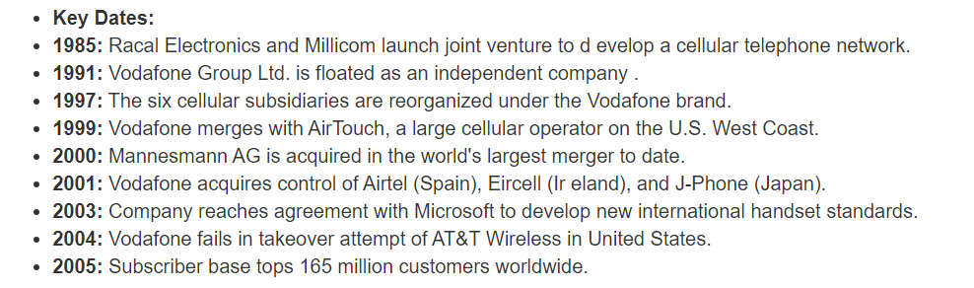
Source: Reference for Business (2021)
Appendix 3 – Number of employees, Vodafone

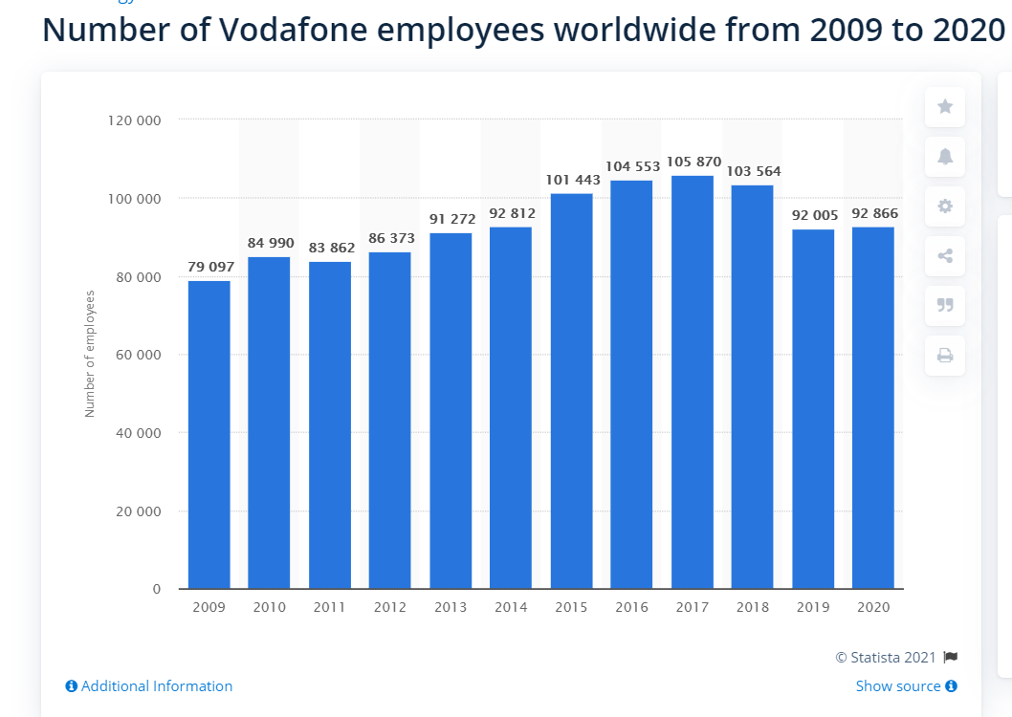
Source: Statista, 2021
Appendix 4 – Vodafone consumers and services
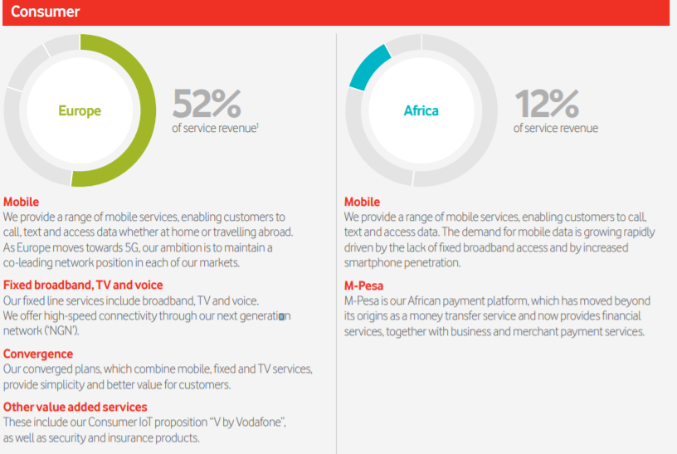
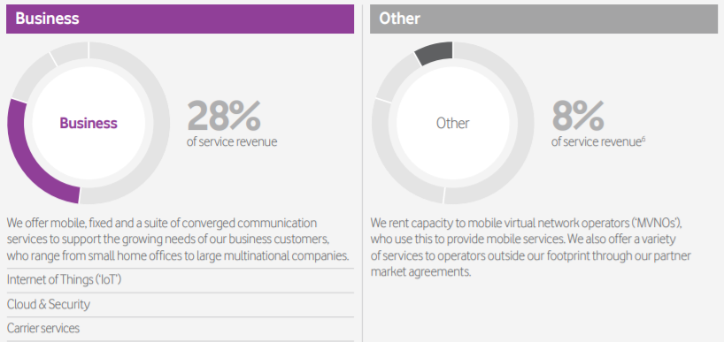
Source: Vodafone Annual report, 2020

