Task 1: Locating Sources
Identify and locate three different sources (a report, a journal article, and a website) related to the question
“What employability skills do business graduates need to succeed in the modern workplace?”
Show how you used keywords, search terms, and Boolean operators to find them, and explain how you know which type of source each one is and why it is appropriate for the research question.

Source Type & Why It Is Appropriate | URL/DOI | What search engine did you use? Google/Online Library/Library AI Assistant | Keywords/Boolean Operators Used
Article – It shows the review of employability and specifically tells students employability skills for workplaces. | Link Attachment | Online Library | Employability and Workplace
Article – It is for educational use for students to study specifically on skills to get ready for employability | Link Attachment | Online Library | Employability, Workplace and Skills

Task 2: Evaluating Information (CRAAP Test)
Your colleague has forwarded you a source from a peer reviewed journal, and they are not sure whether it is appropriate to use and has asked for your help. Your task is to evaluate the source by using the CRAAP Test to assess its appropriateness.
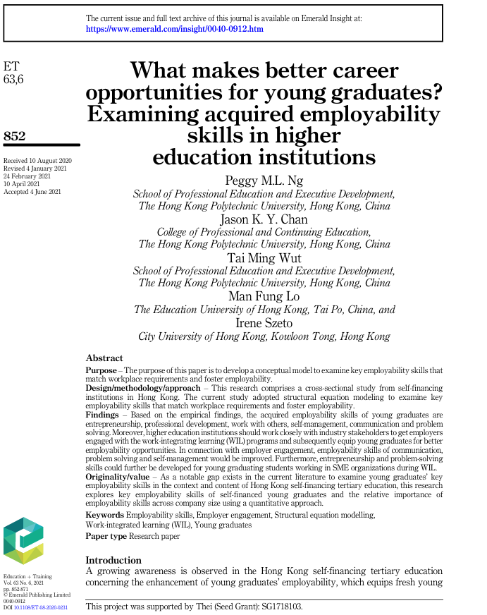

CRAAP Test
Currency | This article was received on 10th August 2020, it has been checked on 4th February 2021, 24th February 2021 and 10th April 2021. It has been accepted on 4th June 2021
Relevance | This fits in for every student for educational needs to stay well prepared for employability skills, this will gain knowledge in education wise and to stay steady for career wise in the future going into any industry of workplaces.
Authority | There are couple authors onto this source first author is Peggy M.L. Ng who was school professional education and executive in Hong Kong University at Hong Kong and second author Jason K.Y Chan who was college professional at Hong Kong University at Hong Kong.
Accuracy | This is reliable for education use for the future careers at any workplace and also can check elsewhere to confirm online if the sources matches with the same definition of knowledge and online, this is for students to understand in general.
Purpose | This exist for students because it is for understanding on this specific topic to gain skills to make weaknesses into strengths for their future careers they will be getting into the workplace.

Task 3: Source Analysis
Your manager has provided you with a short extract from a source and has asked you to analyse the source by Identifying one strength, one weakness, and providing a brief explanation of the strength and weakness identified.
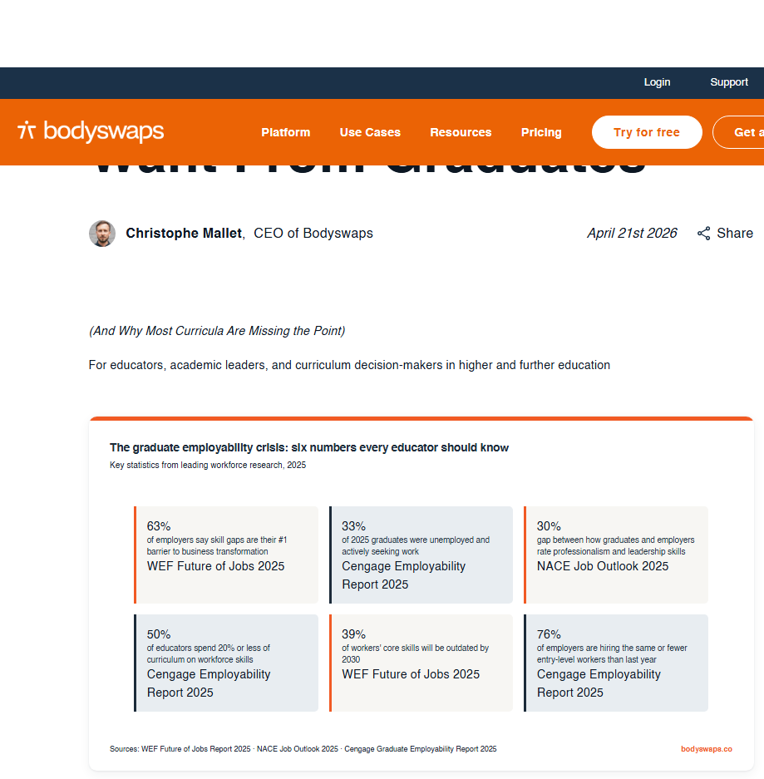
.

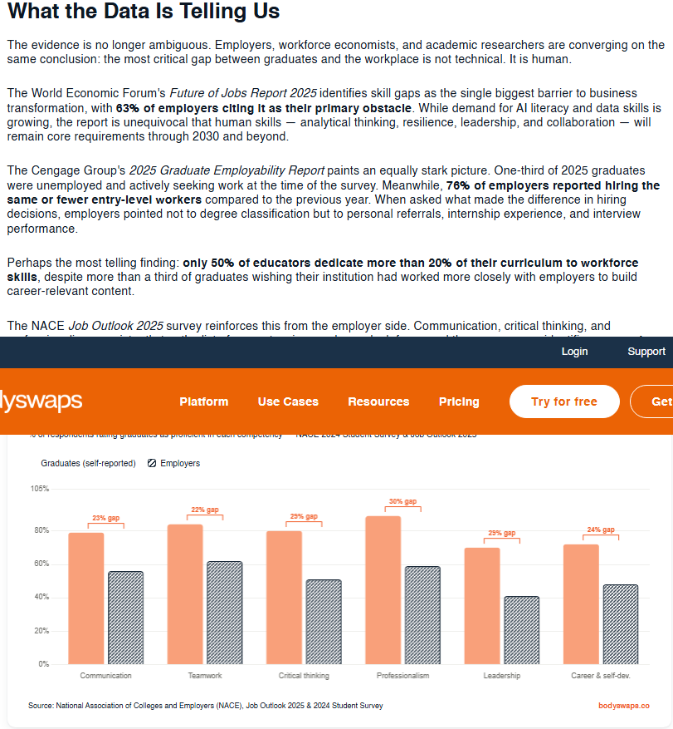

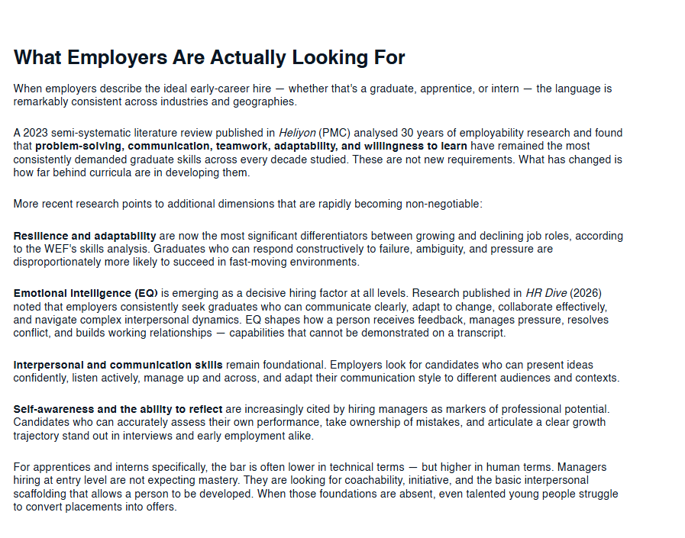

Please click the link, if you wish to read the article online.
What Employers Actually Want From Graduates

Strength of the Source:
This source tells us about everything we need to know, and it breaks down every detail such as showing the graphs on specific skills on where it is at currently and what it can be prove onto the next step.

It explains specifically in details what the employability looks for and what skills are needed to improve on, this will help in the future to gain weaknesses into strengths and gaining knowledge of understanding for students in educational wise.

Weakness of the Source:
Break it down what they could do to improve onto the next time for the future students that will come into education to study by getting to know their weaknesses and different ways to improve to make it into strengths.

