
An investigation into how Online business has been boosted by the changing of customer behaviour during the Pandemic

A Dissertation submitted for the
Master of Business Administration (MBA) 2023

Submitted 09/01/2024

Student: Arcangelo Ferrigno
Student Number: 1917529
Supervisor: Anthony Burns

DECLARATION
This work has not previously been accepted in substance for any degree and is not being concurrently submitted in candidature for any degree.
Signed: Arcangelo Ferrigno (candidate)
Date: 09/01/2024

STATEMENT 1
This work is the result of my own investigations, except where otherwise stated.
Other sources are acknowledged by footnotes giving explicit references. A bibliography is appended.
Signed: Arcangelo Ferrigno (candidate)
Date: 09/01/2024

STATEMENT 2
I hereby give consent for my work, if accepted, to be available for photocopying and for inter-library loan, and for the title and summary to be made available to outside organisations.
Signed: Arcangelo Ferrigno (candidate)
Date: 09/01/2024

Acknowledgements

First, I want to thank my wife and family for their patience and support throughout this journey.
Furthermore, I would like to thank my dissertation supervisor, Mr. Antony Burns, for kindly guiding me to the conclusion of this work.
Thank you very much!

Abstract

Following the COVID-19 pandemic, lockdowns and social distancing have forced people to change their daily behaviours radically. Consumers began to buy differently, reconsidering what was essential and swapping checkout lines for online shopping (JP Morgan, 2020).
The research will focus on the end consumer's point of view towards adopting online business, which includes not only e-commerce but, in a broader sense, also other areas such as smart working, e-learning, food delivery and home streaming.
It will analyse how customer behaviour has changed since the pre-COVID period and how the pandemic has boosted online businesses and "In-home" services.
This work is a qualitative research study that aims to analyse data obtained from semi-structured interviews to better understand the long-term impacts of the pandemic.
Initially, consumers moved online out of necessity. However, this trend has been maintained and strengthened thanks to a greater awareness of digital platforms' potential, flexibility, and convenience. Because of their regular usage, consumers have acquired new skills and confidence in online shopping, which has normalised and integrated into daily life.
While some sectors have seen a decline in online commerce since the end of pandemic-related restrictions, overall online activity continues to be significantly more robust than before the pandemic. Today, the trend traces a possible hybrid future, where new preferences merge with pre-pandemic habits.

Contents Page
Acknowledgements 2
Abstract 3
Chapter 1 – Introduction 5
1.1 Opening Section 6
1.2 Background 6
1.3 Research Problem 8
1.4 Aim, Objectives and Questions 9
1.5 The Significance 10
1.6 Limitations 10
1.7 E-commerce and new retail: Evolution and Business models 11
1.8 E-commerce and New retail: Market Size and Structure 13
1.9 Other Types of Online Business 16
1.10 Research Structure 23
Chapter 2 – Literature Review 24
2.1 Shopping behaviours during the COVID-19 pandemic 24
2.2 Consumer Spending Trends After COVID-19 Restrictions 27
2.3 The Long-Term Impact of the Pandemic on Consumer Behaviour 34
2.4 Chapter Conclusion 39
Chapter 3 – Methodology 40
3.1 Introduction 40
3.2 Research Philosophy 41
3.3 Research Approach 42
3.4 Methodological Choice 43
3.5 Research Strategy 44
3.6 Time Horizon 45
3.7 Techniques & Procedures 45
3.8 Limitations of the study 47
3.9 Ethical Considerations 47
3.10 Chapter Conclusion 48
Chapter 4 – Analysis of Results 50
4.1 Introduction 50
4.2 Demographics of the Participants 51
4.3 Theme 1 – There has been a significant transition towards online shopping since the beginning of the Pandemic 55
4.4 Theme 2 – The format in which Online Shopping has taken shape post the removal of Covid restrictions and reasons for its Continuation 57
4.5 Theme 3 – The importance of the Consumers’ Trust and enhanced Online Security in adopting Online Shopping 60
4.6 Theme 4 - Post-Pandemic Today's trend traces a possible hybrid future, where new preferences merge and rebalance with pre-pandemic habits. 61
4.7 Theme 5 – Observed Fluctuations in online streaming usage and subscriptions 63
4.8 Theme 6 – The Hybrid Work Model as the New preferred Standard 64
4.9 Theme 7 - Recommendations from Consumers 66
Chapter 5 – Discussions, Conclusions and Recommendations 69
5.1 Introduction 69
5.2 Discussion of the Findings 69
• Theme 1 – There has been a significant transition towards online shopping since the beginning of the Pandemic. 69
• Theme 2 – The format in which Online Shopping has taken shape post the removal of Covid restrictions and reasons for its Continuation. 70
• Theme 3 – The importance of the Consumers’ Trust and enhanced Online Security in adopting Online Shopping. 71
• Theme 4 - Post-Pandemic Today's trend traces a possible hybrid future, where new preferences merge and rebalance with pre-pandemic habits. 71
• Theme 5 – Observed Fluctuations in online streaming usage and subscriptions. 72
• Theme 6 – The Hybrid Work Model as the New preferred Standard 73
• Theme 7 - Recommendations from Consumers. 74
5.3 Conclusions 74
5.4 Recommendations 77
References 79
Appendices 87
Appendix 1 - Interview Consent Form 87
Appendix 2 - Essential Demographic Questions 90
Appendix 3 - Interview Questions 91
Appendix 4 - Analysis of Emergent Themes 93

Chapter 1 – Introduction

1.1 Opening Section

The digital revolution, which began in the second half of the last century, continues to produce its effects, modifying and renewing how consumers reach and satisfy their needs.
This flow of innovation and technological improvement has redesigned how companies do their business, allowing them to experiment with new sales and customer relationship channels. Mainly thanks to the driving force of the Internet and e-commerce.
Electronic commerce (e-commerce) is ‘‘the process of buying and selling products or services using electronic data transmission via the Internet and the World Wide Web” (Grandon and Pearson, 2004).
Since December 2019, the outbreak of the COVID-19 pandemic has had an influential impact on consumer behaviours not just in the UK but around the world.

1.2 Background

As a result of the COVID-19 pandemic, lockdowns and social distancing have forced people to change their daily behaviours radically. Consumers began to shop differently by reconsidering what is essential and swapping the checkout line with online shopping (JP Morgan, 2020).
The daily routine has, therefore, necessarily moved more vigorously from offline to online.
This shift has disrupted the retail sector, with many stores forced to close at the height of the lockdown, accelerating the trend towards electronic commerce as consumers shifted their spending to online (Guthrie et al., 2021).
According to Sheth (2020), people under the lockdown condition have discovered and learned new habits that will be maintained even after the end of the pandemic. This is because the adoption of digital technology is likely to cause people to change their existing habits (Sheth, 2020).
The inability to shop at the supermarket or go to work, school, restaurant, or the cinema has accelerated the spread of "In-home" services such as food delivery, home streaming, e-commerce, smart working, and distance learning. At the same time, there has been an exponential increase in the use of social networks as an alternative solution for social life, allowing users to interact and debate with each other (Trevisan et al., 2021).
According to Gu et al. (2021), the COVID-19 pandemic has also affected the lifestyles and priorities of online consumers, benefiting some industrial sectors at the expense of others. For instance, there has been a surge in the requests for health and safety devices, medical supplies, children’s products, sporting items, and entertainment goods. On the contrary, there has been a substantial budget reduction on holiday travel purchases. However, the essential purchase criteria such as price, availability and convenience have remained unchanged (Gu et al., 2021).
While the vast majority of these behavioural changes are not permanent, some of them are going to last permanently. Therefore, this pandemic scenario has mainly been characterized by two aspects: one is a change in customer behaviours that avoids crowded public gatherings, and the second is a greater propensity for digital adoption (Shashidhar,2020, cited in Sharma and Jhamb, 2020).
At the same time, the rapid migration to digital technologies has pushed companies to react, accelerating their digital transformation (Klein and Todesco, 2021). Recent data shows that a five-year leap in digital adoption by consumers and businesses has been made in about eight weeks due to the pandemic (Baig, Hall, Jenkins, Lamarre and McCarthy, 2020).
According to McKinsey research (2020), 75% of people who use digital channels for the first time will continue to use them when things return "normal." Hence, companies must ensure that their digital channels are on par or better than those of their competition to be successful in this new environment (Baig, Hall, Jenkins, Lamarre and McCarthy, 2020).

1.3 Research Problem

The pandemic of COVID-19 has had a significant impact on all commercial operations and consumer activity. While its impact on the digital transformation of organizations has been studied, more academic attention needs to be paid to the impact of COVID-19 on consumers and their behaviour (Kim, 2020; Verma and Gustafsson, 2020).
Industry reports and consumer surveys show that the post-lockdown period may have been too short to detect adaptive behaviours. These were principally focused on the immediate impact on consumer behaviours. “Further studies could observe online purchasing behaviours over a longer period” (Guthrie et al., 2021).
Covid-19 has increased the use of social media such as Facebook, Instagram, WhatsApp, Twitter and Zoom. Especially during the lockdown, comments expressing concern, such as anxiety and inhibition, have increased, thus influencing consumer decisions. Considering this, an analysis of online purchasing behaviours over a more extended period would also allow us to understand how consumers' attention has moved away from healthcare products and whether new behaviours have further changed with the impact of the post-COVID economic crisis and soaring inflation due to rising energy prices as consequence of the start of the war between Russia and Ukraine.

1.4 Aim, Objectives and Questions

This study aims to determine and describe how consumer behaviour has changed and evolved during such stressful life events as COVID-19 and how this latter played a role as the accelerator of the structural change in consumption and the digital transformation of the marketplace (Kim, 2020).
The Specific objectives addressed by this research are:
- To critically review the relevant literature regarding the shift to the online business due to a change in customers behaviour.
- To conduct semi-structured interviews with consumers to determine how the pandemic has changed the way they use online business services.
- To make recommendations on how businesses should shape their online business models to accommodate the new “normal”.
This work also aims to answer the following research questions:
- How has people’s spending changed since the end of coronavirus?
- Will the old habits return or die? Has the pandemic changed consumer behaviour forever?
- Will Online shopping be falling back towards the pre-pandemic trend?
- The pandemic has had a significant impact on where our money goes. Will the abrupt shift to online shopping last longer for some industries?
- Does increased experience and maturity in using online business affect customer behaviour in purchasing decisions?

1.5 The Significance

The research study will focus on the point of view of the final consumer towards the adoption of online business, which includes not only e-commerce but, in a broader sense, also other areas such as smart working, e-learning, food delivery and home streaming.
It will analyse the change in customers' behaviour since the pre-COVID period, highlighting the driving force the pandemic has given in adopting online businesses and "In-home" services.
This work is a qualitative research study that aims to analyse the data obtained from semi-structured interviews in order to better understand the long-term impacts of the pandemic, such as psychological, economic, regional disparities, generational changes and acceptance of technology.

1.6 Limitations

This study work, while dealing with the various facets of the impacts of the pandemic on consumer behaviour towards online business, cannot draw general conclusions. The limitations mainly concern the number and origin of the people interviewed, as they mainly come from the Northwest of England. This implies that the results of this research will only partially reflect trends across the UK.
Furthermore, the results are based on the opinions of surveyed consumers over a specific period of time and in a rapidly changing environment, consumer behaviours and priorities also tend to change.

1.7 E-commerce and new retail: Evolution and Business models

The birth of e-commerce dates back to the 1960s. Initially, however, electronic commerce was intended simply as the facilitation of commercial transactions electronically, using Electronic Data Interchange (EDI) as a means to facilitate this process, i.e., a data interchange system that replaced sending of documents by mail and fax (Walton et al., 1999).
Subsequently, the introduction of a technology called Electronic Funds Transfer (EFT) gave a further boost to the spread of electronic commerce as it solved the problem relating to payments, which until then were limited to the use of cash (Panurach, P., 1996).
However, it was only thanks to the spread of computers and telecommunications networks, which entered consumers' homes at the end of the 1990s, and following the introduction of electronic mail and web applications, that e-commerce finally began to take the shape of what we know today.
According to Tsai and Cheng (2011), today e-commerce can be defined as a "combination of innovative approaches, virtual applications and Internet business operations into a single and innovative enterprise solution. These interactions can lead to online shopping, order processing, transaction management, payment processing, manufacturing, inventory and customer support." (Tsai and Cheng, 2011, p.127).
Figure 1 shows the most popular business models of e-commerce.
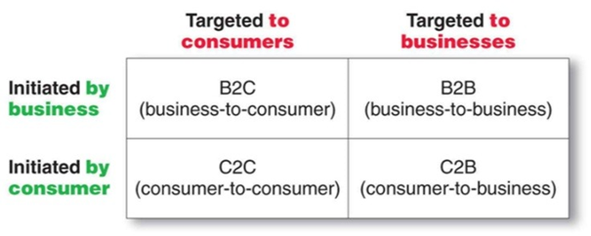 Figure 1 – Most popular types of E-commerce – Source: www.frachtbox.com

- B2B - Business to Business. It refers to transactions that take place between two companies to order goods and/or services, which exchange updated information on price lists and products online and for which payments are made electronically (Tian and Stewart, 2006).
- C2C - Consumer to Consumer. It is a type of e-commerce in which consumers, enabled by C2C platforms, buy and sell products and services to each other online without the need for companies to act as intermediaries (Investopedia.com, 2022).
In this model, the website is the mediator of trade. As an example, eBay and Alibaba are among the best-known C2C platforms.
- C2B - Consumer to Business. It is a type of e-commerce in which individuals present their products or services to companies, and these latter make the payment (Nemat, 2011). For example, the editors of websites or blogs sell their work to companies like Amazon, earning membership revenue for successful sales.
- B2C - Business to Consumer. It is the most popular e-commerce model as it represents the retail part of e-commerce on the Internet (Investopedia.com, 2022). Here, the sale transaction is directly carried out between the company and the end consumer. The latter can compare and choose its product through multimedial and interactive catalogues.
Concerning the methods of shipping the product, a distinction can be made between direct and indirect electronic commerce. In the first case, the products that the final customer buys are physical goods that are shipped via a courier. In the second case, the products are in digital format. Consequently, the courier's presence is unnecessary as the goods are delivered and transmitted directly via the Internet (Investopedia.com, 2022).

1.8 E-commerce and New retail: Market Size and Structure

Figure 2 shows the US trend in e-commerce retail sales by US Census Bureau date. The percentage of total US e-commerce sales to total sales has steadily increased since 1999, peaking at more than 16% in 2020 during the pandemic.
Regarding 2022, the percentage is slightly down compared to the peaks of 2020, reaching around 14%, which, in any case, is several higher than the pre-pandemic levels.
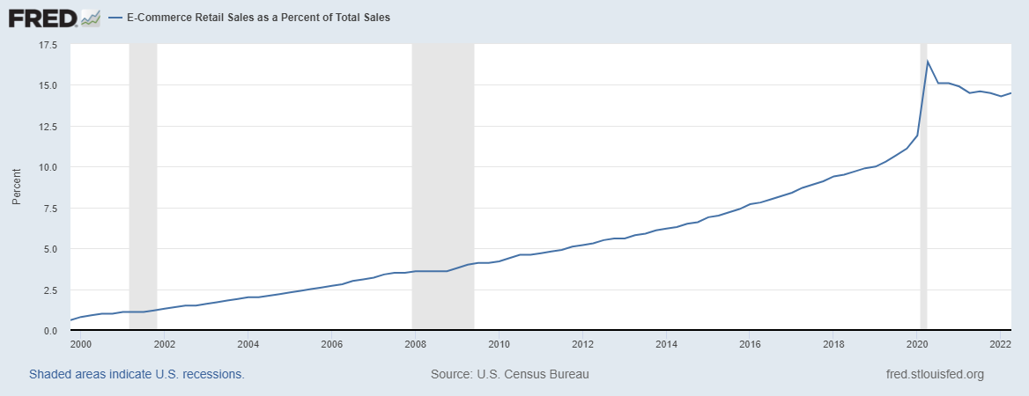
Figure 2 – E-Commerce Retail Sales as a Percent of Total Sales in US – Source: US Census Bureau
An even more de-marked trend was seen in the UK market, as shown in Figure 3. Here, we can see that a peak of 37% was reached during the 2020 lockdown periods.

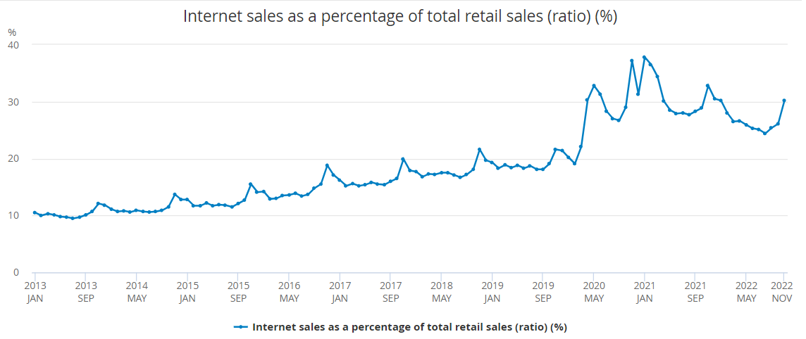
Figure 3 – E-Commerce Retail Sales as a Percentage of Total Retail Sales in Great Britain from January 2013 to November 2022 - Source: CENSUS for UK Office for National Statistics
Regarding 2022, again, the percentage is slightly down compared to the peaks in 2020. However, it is about 10% higher than the pre-pandemic levels.
As a result, the UK e-commerce revenues also saw a remarkable acceleration from £75bn in 2019 to £129bn at the end of 2021 [Figure 4].

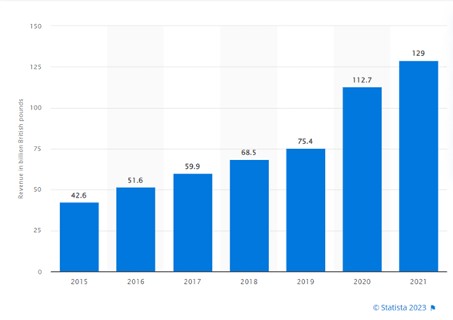Figure 4 – E-commerce revenue in the United Kingdom (UK) from 2015 to 2021 (in billion British pounds) - Source: Statista.com 2023

Figure 5 shows the Top 10 stores in terms of net sales generated in the UK in 2021.
At number one in the ranking, we find Amazon.co.uk, the largest online store in the United Kingdom, with a net turnover of 12,413.9 million pounds in 2021 (+5% compared to 2020). In second place is Tesco.com, with a net turnover in 2021 of 5,563.9 million pounds (-6% compared to 2020). In third place, we have Sainsbury.co.uk with 5,491.8 million pounds (+17% compared to 2020).
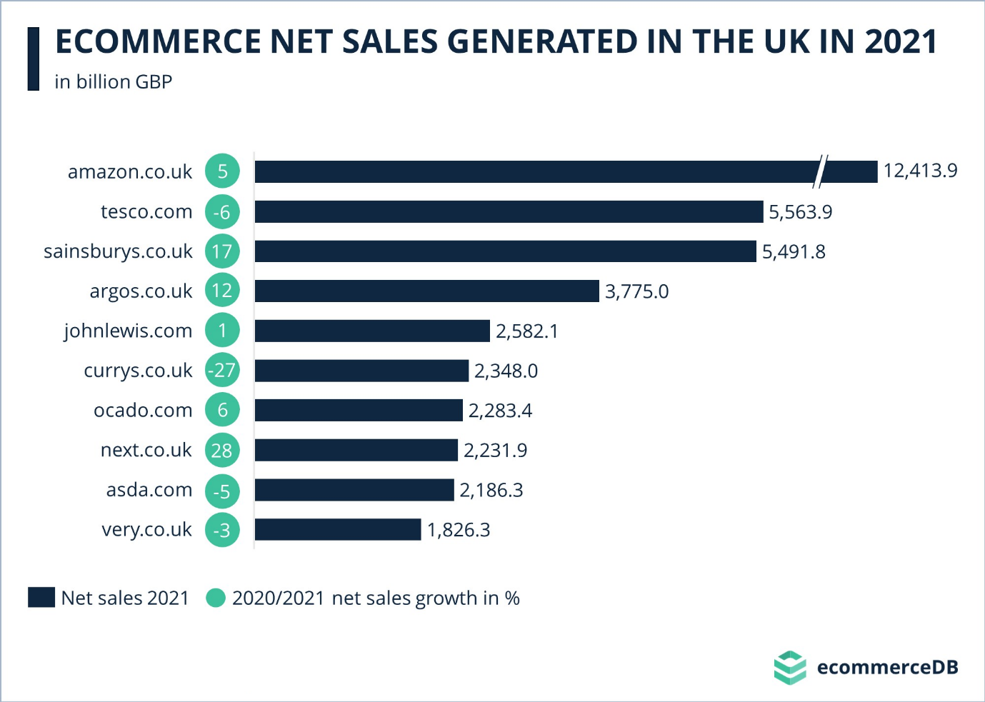
Figure 5 – Top online stores in the United Kingdom in 2021, by e-commerce net sales (in million British pounds) - Source: e-commerceDB 2023

1.9 Other Types of Online Business

So far, we have focused only on Online Businesses intended as E-commerce and New retail. However, other types of online businesses have seen a substantial acceleration in their volumes since the beginning of the pandemic. Therefore, this section aims to introduce what are also known as "In-home" services.

- Home Streaming

Home streaming is based on the technology also known as “Over the top” or simply “OTT”, which refers to film and television contents provided via a high-speed Internet connection rather than a cable or satellite provider (Oracle.com, 2023).
The three main OTT models are:

- AVOD (Ad-Based Video on Demand). With this model, consumers can watch videos for free as the businesses generate revenue with ads. The most famous example of an AVOD business is the non-premium version of YouTube (Mazsystems.com, 2020).

- SVOD (Subscription Video on Demand). With this model, users pay a monthly fee in exchange for instant access to a streaming library consisting of movies, TV shows, and other media content. Netflix, Disney+ and Amazon Prime Video are some examples of SVOD Business (Statista.com, 2023).

- TVOD (Transactional Video on Demand). Customers buy or rent videos one at a time. TVOD is also sometimes known as pay-per-view (PPV). Rakuten TV is a famous example (Mazsystems.com, 2020).

Figure 6 shows the SVOD penetration of UK households. As we can see, the overall SVOD penetration has significantly boosted since the beginning of the pandemic (2019), going from around 40% to a peak of 68% in 2022 (Ofcom, 2022).

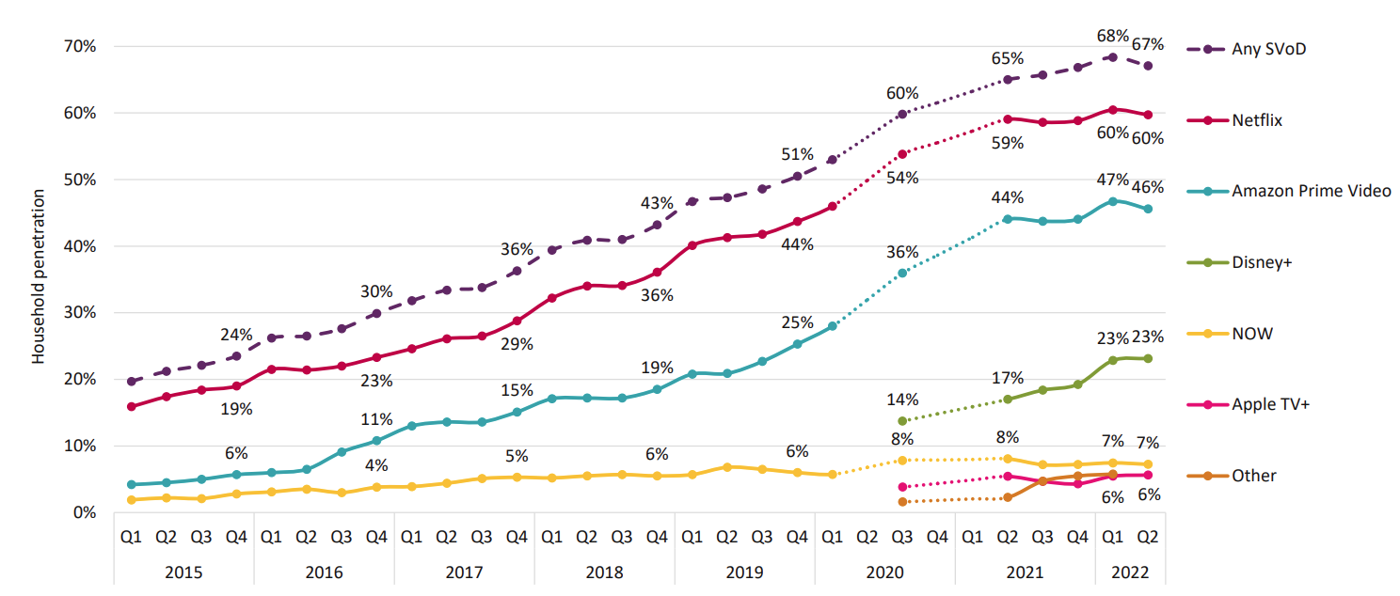
Figure 6: SVOD penetration of UK households, by provider: Q1 2015 – Q2 2022 - Source: Ofcom 2022
Note: According to Ofcom (2022), In Q2 2022, the total number of UK subscription TV and free-to-air households was 28.6 million.
According to the Ofcom UK Media Nation report of 2022, Netflix is the largest SVoD provider in the UK, with 17.1 million households (60%) subscribing, followed by Amazon Prime Video (46%) and Disney+ (23%).
Figure 7 shows that the % of households accessing two or more services was 46% in Q1 2022, equal to 13.2 million households. Also, the average number of SVOD subscriptions per SVOD home rose to 2 in Q1 2022, up from 1.6 two years earlier, before the Covid-19-related lockdowns (Ofcom, 2022).

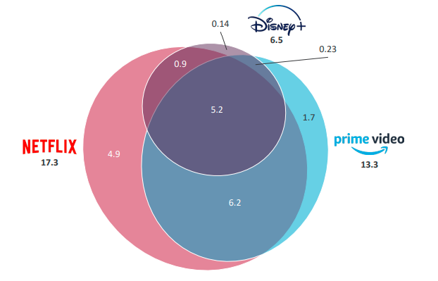
Figure 7: Households subscribing to one or more of Netflix, Amazon Prime Video and Disney+, and overlaps between them (millions) - Source: Ofcom 2022

Furthermore, we can see that 5.2 million households have signed up for all three of the most popular services, confirming a shift in consumer behaviours and how people increasingly use digital streaming platforms. The majority of Disney+ subscribers (80%) use the service in combination with both Netflix and Amazon Prime Video, with only 2% using it without either of those two services. (Ofcom, 2022).

- Food Delivery

The way the world eats is changing dramatically. According to McKinsey & Company (2021), “Just under two decades ago, restaurant meal delivery was still mostly limited to foods like pizza and Chinese. Today, food delivery has grown into a global market worth more than $150 billion, having more than tripled since 2017” (Ahuja et al., 2021).
The advent of engaging and easy-to-use apps, combined with the changing expectations of consumers, made food delivery service an essential category. This has been further boosted by physical-distancing requirements and lockdowns during the pandemic's peak, as under those circumstances, it represented the only hope of survival for the catering sector (Ahuja et al., 2021).
Led by platform-to-consumer services, such as Deliveroo, Just Eat, and Uber Eats, food delivery has expanded from takeaways to “anything and everything”, adding billions of dollars in potential revenue (D. Curry, 2023).
Figure 8 shows how the food delivery business has increased, mainly since the pandemic-related lockdowns began in March 2020.
The pre-pandemic growth rate of the US market was 3-4% per year, compared to the 7-8% growth seen since the pandemic's beginning (McKinsey & Company, 2021).
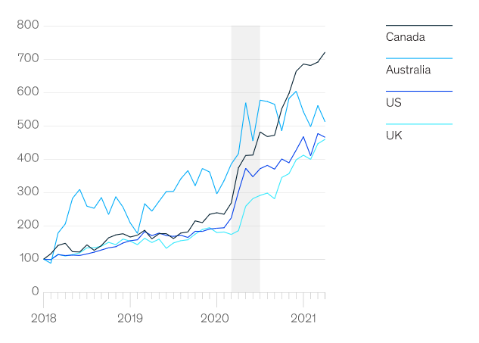
Figure 8: Normalized delivery-platform sales growth, index (Jan 2018 = 100) - Source: Edison Trends for McKinsey & Company (2021)

- E-Learning

According to the Oxford Learning College (2023), “E-learning is a learning experience or structured educational course delivered digitally or electronically. This learning method can include text, video, audio, and interactive content which provides educational material to users”.
Since the onset of the COVID-19 pandemic in 2020, digital education has become even more critical, enabling students to access essential learning materials and allowing companies to train employees remotely.
Nowadays, online education has become one of the most popular ways to learn in the UK, with 21% of British people using it (Oxford Learning College, 2023).

- Smart Working

The advance of digitization and the transition to a more knowledge-based economy have opened up the possibility of remote work and hybrid work (a mixed model working both in a central office and at remote locations) for employers and employees.
Before the outbreak of the coronavirus (COVID-19) in 2020, working from home was considered a luxury. Nevertheless, since then, the ability to work remotely has become crucial for employment decisions (Statista.com, 2022).

Figure 9 shows the share of the three ways of working for adult workers in the UK. As we can see from the easing of COVID-19 restrictions (beginning of 2021), even though we have a rebound in the percentage of people who travel for work, they are now firmly under 50% of the total. Furthermore, hybrid working has overtaken “full-time” working from home (Office for National Statistics, 2022).

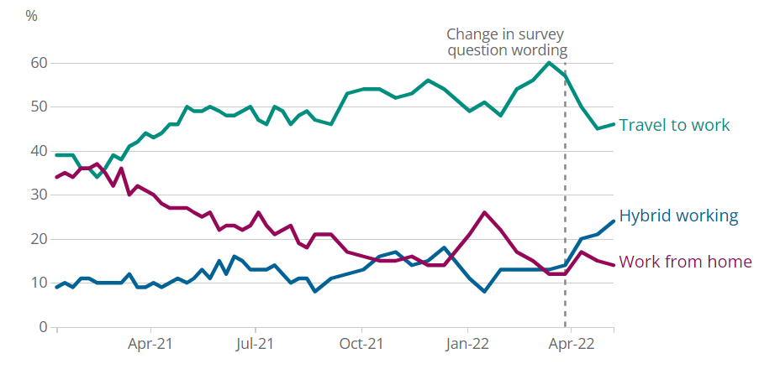
Figure 9: Percentage of working adults travelling to work, Great Britain, January 2021 to May 2022 – Source: Office for National Statistics (2022)

1.10 Research Structure

Chapter One: This first chapter is the introduction, which paves the way to present the subject matter. This chapter outlined the aims, objectives and rationale of this research.
Chapter Two: This chapter will make a literature review of the research topic. The secondary research will be mainly consisting of textbooks, journal articles, websites and newspapers.
Chapter Three: This chapter is focused on the research methodology, which will offer detailed instructions on how the study should be carried out from beginning to end. In addition, it seeks to add validity and reliability to the research findings, ensuring that the study can be critically assessed and, if necessary, replicated by future researchers.
Chapter Four: This Chapter will analyse data collected using the method described in Chapter 3. The main research findings will be based on ten semi-structured interviews.
Chapter Five: This final chapter synthesises all the findings to draw conclusions. This section connects back to the aims and objectives discussed in Chapter One and also addresses the implications of the outcomes, the study's limitations, and future research recommendations.

Chapter 2 – Literature Review

2.1 Shopping behaviours during the COVID-19 pandemic

The current literature on shopping behaviours during the COVID-19 pandemic has mainly focused on the factors influencing customers' online purchasing decisions. Their findings pointed to primary factors, including the benefits of online shopping, pandemic fears, media and subjective norms:

- Moon et al. (2021) show that when circumstances are severe and vulnerable, as with COVID-19, it is more likely that consumption through offline distribution channels will decrease. (Moon et al., 2021).

- Showrav et al. (2021) provided a summary of the inefficiencies of in-store shopping during the pandemic period and how retail brands have responded to the lockdown situation by adopting some sort of online shopping convenience for their target customers. In fact, consumers have increasingly started asking for contactless payment, home delivery, virtual consultations, and the availability of basic necessities within the product line of online businesses (Showrav et al., 2021).

- Prasad and Srivastava (2021) analysed customer switching behaviour during the peak of the COVID-19 outbreak based on two characteristics: the perceived risks of infectious diseases and the benefits of online shopping as an alternative saviour continuity of life. Findings suggested that the change in risk perception led to a change in marketing policies focused on building awareness. Furthermore, the study concluded that the new behaviours would continue even after the pandemic (Prasad and Srivastava, 2021).

- Eger et Al. (2021) demonstrated a correlation between changes in customer behaviour and fear, especially fear of health and worsening economic conditions. Results reveal considerable differences and similarities in consumer behaviour across generations. In general, restrictions mainly affect the shopping behaviour of the oldest generation (Eger et Al., 2021).

- According to Chen (2021), the significant factors affecting online shopping in an everyday social environment, such as service quality, commodity prices and online shopping experience, were insignificant in this pandemic. This is because the public panic triggered by the pandemic became a key factor affecting online shopping.

- Alhaimer (2022) found that the penalties imposed during the pandemic on those who broke the restrictions introduced with the lockdown have had a direct and positive influence on consumer behaviour towards online purchases. He also showed that the factors influencing users' attitudes and behaviours towards online shopping in "normal" non-emergency times vary from during emergencies.

- Truong et al. (2022) identified three primary shopping modes: Online purchases, Curbside pickup, and In-store shopping. That study examines how customers' buying behaviours have changed during the pandemic, identifying that health concerns and concerns about financial conditions have played a significant role in the changes in buying behaviour.
As the pandemic progressed with new variants, people adjusted their risk-based buying behaviours, depending on whether they received the vaccine or faced financial hardship.
The research findings indicate that people who had previously contracted the virus were less likely to buy groceries in-store or even pick them up curbside than people who never contracted the virus. This is due to the more fears for health from their experience with the virus. On the other hand, people who lost their jobs tended to buy regardless of shopping mode, because they had more free time and greater stress of being home too much during the pandemic. Thus, both fears about health and financial conditions influenced consumer behaviour in a dynamic rather than one-sided correlation (Truong et Al., 2022).

Since the early stages of the pandemic, people have switched to online and at-home activities such as shopping, entertainment, and catering. This has led to decreased personal transportation to the benefit of cargo handling associated with online shopping deliveries.
Additionally, we assisted in a shift towards more spending on improving homes and investing in home offices (Unnikrishnan and Figliozzi, 2021).
Regarding “in-person” spending, although higher-income households have spent more on “in-person” shopping during the pandemic than low-income households, their ability to shop “in-person” has declined during the pandemic compared to the previous period (Brough, Freedman and Phillips, 2021). This could be due to more flexibility in lifestyle and remote working by higher-income households (Badger and Parlapiano, 2020).
Additionally, Ecola et al. (2020) reported that households with children are more likely to shop online than households without children.

2.2 Consumer Spending Trends After COVID-19 Restrictions

Researchers have been examining changes in spending patterns since the post-pandemic era. This specific section aims to analyse the present literature on exactly how consumer spending patterns have changed after the end of the pandemic restrictions.

- Digital Payments

A recent study by Nguyen et Al. (2021) found that the pandemic has considerably accelerated the use of e-commerce and digital payment methods because of health and safety issues. Additionally, this trend is still going strong as the world gradually returns to normality. People still favour online shopping and contactless transactions because of the convenience and effectiveness of digital channels. Consequently, online and offline consumer spending habits have been considerably influenced by this new payment method (Kannan & Kulkarni, 2022).
Based on Rolfe (2023), digital payments are rising in e-commerce and physical shop landscapes. By 2027, they are likely to surpass USD 15 trillion with a CAGR (Compound Annual Growth Rate) of 16.3 % over the period 2017-2027 (Statista.com, 2022) [Figure 10].
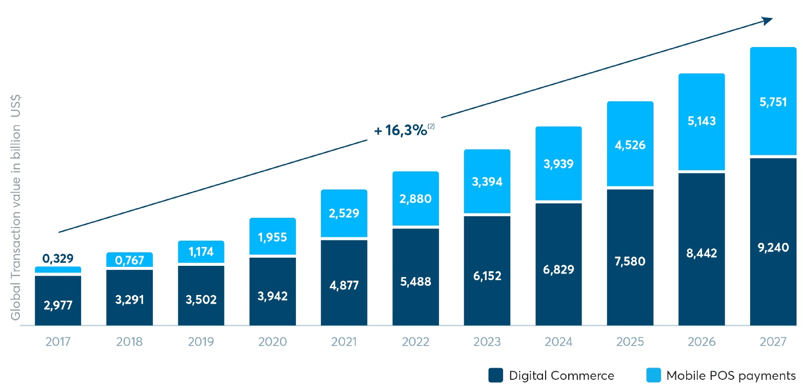
Figure 10: Digital Payments transaction trend, 2017 to 2027 – Source: (Statista.com, 2022)

- Shifts in Spending Categories

Research by Wani and Priyanka (2022) highlights that since the inception of the first lockdown, we have seen a notable shift from discretionary spending on travel and restaurants to essential items such as household expenses, groceries, cleaning products, health products, home office equipment and home entertainment.
Chen et al. (2022) highlighted a substantial shift in consumer spending categories since the conclusion of the pandemic. As restrictions eased, consumers gradually increased spending on experiences and services such as dining out, travel, entertainment, and luxury goods. Additionally, even with many workers returning to offices, there is sustained interest in creating comfortable home environments (Mukherjee and Narang, 2023).

- E-commerce

As we have seen in previous sections of this chapter, the pandemic has accelerated the adoption of E-commerce and digital payment methods, mainly due to health and safety concerns. Therefore, E-commerce sectors have expanded, mainly into groceries, home entertainment and physical fitness equipment (Walcott, 2023).
This trend has continued beyond the pandemic, with consumers preferring online shopping for the convenience and efficiency offered by digital channels (Tymkiw, 2022).
According to Investopedia.com (2022), after the lockdown, many consumers wanted to return to physical stores, both for the in-person shopping experience and social interaction. This has led to a temporary resurgence in the trend of traditional retail towards online shopping. However, in the vast majority of the industries, physical retail has never returned to pre-pandemic levels (Tymkiw, 2022).
Therefore, while some industries have seen a decline in online shopping, the overall growth of e-commerce during the pandemic has set new standards. That is because consumers who first adopted online shopping during the pandemic continued to use it, albeit at different frequencies depending on the industry (Investopedia, 2022).
A study by the IBM Institute for Business Value (2022), in association with the National Retail Federation (NRF), found that consumers have begun to adopt a hybrid approach to shopping, combining online and offline purchases. This new “hybrid approach” consists of online searches with in-store purchases or online purchases and in-store pickup.
The study also suggested that this trend could represent the future of retail as today, more than a third of Generation Z has already opted for hybrid purchases. This particular segment of consumers also tends to buy from brands aligned with their values like transparency, social responsibility, and ethical practices. (IBM-IBV, 2022).
With the proliferation of online shopping, consumer expectations of digital experiences have increased. According to Popa, Barbu, and Ionașcu (2023), consumers have developed “Enhanced Digital Expectations” and, therefore, now demand intuitive user interfaces, personalized shopping experiences, efficient customer service, and fast shipping. Features that were once considered luxuries have now become standard.
In short, consumers want companies to come to them, and they want to shop where a better experience is offered (Popa, Barbu, and Ionașcu, 2023).
In response to these new needs and because of increased awareness of the growing acceptance of technology by consumers, companies in the commerce sector have significantly increased their investments in IT infrastructures (IBM-IBV, 2022).
Furthermore, many retailers have faced logistical challenges, which have meant that optimizing supply chains and better managing shipments have become critical priorities (Hammi, Zeadally, and Nebhen, 2023).
Customer reviews have become crucial in online shopping. According to a survey by BrightLocal (2023), more than 90% of consumers said they read reviews of local businesses. This data makes us understand the importance and centrality that reputation management has achieved through online reviews. For this reason, companies in the commerce sector are massively increasing their efforts in online reputation management. Furthermore, reviews are not only the starting point for buyers during the research phase but also an additional source of information on customers and competitors, which can provide important insights for companies (Forbes, 2022).
As online interactions have increased, so have concerns about privacy and data security. Consumers have become more choosy when disclosing personal information and have begun to prefer and prioritise using online platforms and services that have adopted robust data privacy mechanisms (Alzaidi and Agag, 2022).
According to Paraschiv et Al. (2022), the use of mobile devices for online purchases has seen significant growth since the beginning of the pandemic to the point that today, the majority of online purchases are made via smartphone. For this reason, nowadays, we tend to talk about Mobile Commerce or simply M-commerce.
Figure 11 shows M-commerce as a share of total online retail by region in 2022; as we can see, over 65% of the E-Commerce transactions Worldwide are conducted over mobile devices like smartphones or tablets, with Asia-Pacific as the leading region with almost 80% (Statista.com, 2023).

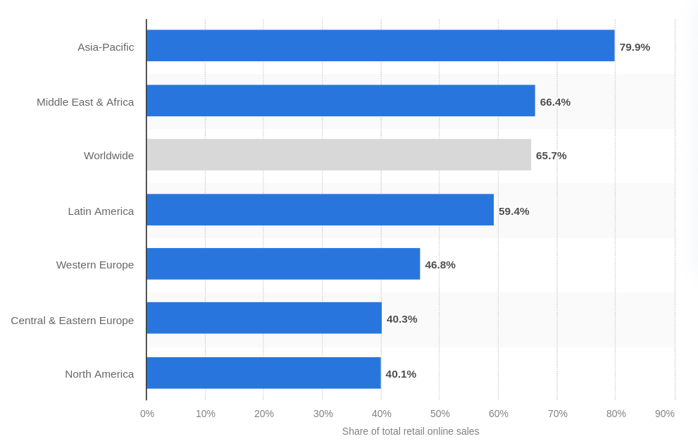
Figure 11: Retail M-commerce as a percentage of total retail E-commerce sales worldwide in 2022, by region – Source: (Statista.com, 2023)

A significant driving force for the expansion of M-commerce was the growth in the range of devices capable of carrying out mobile commerce (Investopedia, 2022).
Furthermore, introducing digital wallets such as Apple Pay and Google Pay has been fundamental, allowing customers to purchase without using physical payment cards. Last but not least, mobile commerce has proliferated thanks to resolving security problems (Investopedia, 2022).

- Dining and Restaurants

According to the Kantar Group (2023), online orders and delivery in the food service business have continued to rise throughout the lockdowns. Then, when restrictions were eased and restaurants reopened, many consumers started eating out again, resulting in a physiological decrease in online meal orders. Nevertheless, the adoption as well as usage of internet food ordering apps remain higher than before the pandemic.
Take-away and delivery services have considerably influenced consumer habits because of their convenience and low-contact nature. However, the human desire for interaction and social experiences will ensure that outdoor and indoor dining will remain essential in the restaurant business. Therefore, the post-COVID era points to a more balanced mixture of these trends (Wang et Al., 2022).

- Tourism and Travel

Online bookings for hotels, flights and other travel-related services have considerably decreased during the pandemic. Nevertheless, despite some hesitancy following the relaxation of restrictions, travel spending has substantially recovered, mainly due to increased consumer confidence, with domestic tourism growing faster than international tourism (Jin, Bao and Tang, 2022).
Moreover, it has been found that many clients have started preferring booking directly through physical travel agencies to have more guarantees and flexibility in case of trip cancellation (Sharma et al., 2022).

- Entertainment

During and after the COVID-19 pandemic, digital streaming platforms experienced a significant growth and transformation. With people worldwide confined to their homes due to lockdowns and social distancing measures, digital entertainment has emerged as a primary source of relaxation and entertainment (BBC, 2020).
At the beginning of the post-pandemic period, with the reopening of cinemas, theatres and entertainment venues, this trend recorded a slowdown, which never translated into a reversal of the trend (Ofcom, 2022).
According to Arts Professional (2023), the arts industry is undergoing a permanent shift in release strategies and attendance habits. While live participation is gradually returning, the sports industry has recognised the value of digital enhancements for remote audiences. Although live concerts will return gradually, the success of virtual events suggests that they will continue to be a complementary channel for artists to reach global audiences (Arts Professional, 2023).

- Health

According to McKinsey & Company (2022), healthcare products, fitness memberships, and wellness services have increased since the pandemic, indicating that people are becoming more health conscious.
In 2023, people appear to compensate for physical isolation by returning to the gym more significantly than before the pandemic (The Washington Post, 2023).
Furthermore, thanks to telemedicine, people seem to prefer home healthcare, for which, despite a decrease in the first half of 2022, its use is still double pre-pandemic levels (The Washington Post, 2023).

2.3 The Long-Term Impact of the Pandemic on Consumer Behaviour

The COVID-19 pandemic has resulted in unprecedented shifts in consumer behaviour, but questions remain on whether these changes will last or not. This section aims to analyse the current academic literature to study the pandemic's long-term impact to understand better the nature of these behavioural changes on consumers and the permanence of these newly acquired habits.
An overview of the main areas affected will therefore be carried out.

- Psychological Impacts and Factors

According to the World Health Organization (2022), a large number of people have reported psychological distress and symptoms of depression, anxiety or post-traumatic stress due to the impact of the pandemic. The fear for the virus has been an unprecedented stressor on the mental health of many individuals (WHO, 2022).
The pandemic's impact on mental health heavily influenced spending behaviours (Di Crosta et Al., 2021).
According to Das, Sarkar and Debroy (2022), the psychological impact of the pandemic on consumers could lead to lasting changes. For example, concerns about hygiene and health awareness will likely persist for a long time, driving preferences for contactless services and cleaner environments (Das et Al., 2022).
The study by Park et al. (2022) identified two different types of purchasing behaviours generated by the pandemic: “Panic Buying”, which consists of purchasing large quantities of “Basic” necessity goods, and “Revenge Spending”, which consists of purchasing expensive goods such as way to relieve negative emotions through this type of purchases.
However, distressing situations such as anxiety and uncertainty generally impact luxury spending and lead to sustained frugality (Park et Al., 2022).

- Economics Impacts and Factors

The lockdown, implemented with the intention of stemming the spread of the virus, has however had a negative effect on the global economy of various countries, generating a global economic recession, with some sectors affected more than others (Roy, S., 2020). In particular travel, tourism and hospitality (Singh, Jamal, and Ahmad, 2021).
The economic recession has generated unprecedented levels of unemployment and therefore governments around the world have launched stimulus packages and fiscal incentives to mitigate the economic impact (Roy, S., 2020).
Economic factors like unemployment rates, inflation, and the overall health of the economy had a consistent impact on consumer behaviours, including spending patterns and confidence in future planning (Loxton et Al., 2020).
Instead, in a diametrically opposite way, the Lockdowns have favoured greater savings for those who have been able to continue their work, due to limited spending opportunities (Niculaescu, Sangiorgi and Bell, 2023).
After the pandemic, the economic recovery once again influenced consumer behaviour and while many resumed spending, others remained cautious, prioritizing savings and investments. In this regard, there has been a notable increase in investments like stocks, cryptocurrencies, and real estate (Niculaescu, Sangiorgi and Bell, 2023).

- Generational Shifts

According to Min, Kim, and Yang (2021), generational differences have played an essential role in how consumers have adapted to pandemic changes, and these generational differences could influence the trajectory of behavioural changes.
While younger generations, such as GenZ (which includes people born between 1996 and 2010), have shown more excellent receptiveness to digital alternatives than older generations, including Gen Y (which includes people born between 1981 and 1995), Gen Z members were found to be less resilient (Harari, Sela, and Bareket-Bojmel, 2022). In fact, during the pandemic, Generation Z suffered the most from mental health issues, showing higher rates of depression and anxiety and, therefore, needed more emotional support (Schroth, 2019).
This is because Generation Z was deeply concerned about uncertainty in the future and was particularly vulnerable to job loss (Min, Kim, and Yang, 2021).
According to Harari, Sela and Bareket-Bojmel (2022), members of Gen Z showed higher levels of openness to change and self-improvement than Generation X (Gen X). However, both generations are positive about hybrid and remote ways of working.

- Regional Disparities

At the height of the pandemic, people living in urban areas with high population density suffered a lower level of healthcare availability and greater difficulties in accessing healthcare due to overcrowding in clinical facilities (Bourdin and Levratto, 2023).
According to Park (2023), political decisions and vaccination rates have played a crucial role in creating disparities between different areas and regions. It was found that the economic recovery was much more immediate in those states where the vaccination plans were more successful, with high percentages of inoculations among the population.
Furthermore, it was found that vaccination plans were more effective in areas where more rigorous social distancing measures were implemented, as here, the population was less reluctant to receive the COVID-19 vaccine (Park, 2023).
According to S&P Global (2021), consumer spending recovered faster in countries that handled the pandemic better.

- Technological Adoption

The COVID-19 pandemic has given impetus to the rapid adoption of many technological solutions by people. Just think of contact tracing apps, Telemedicine, online shopping, digital payment methods, video conferencing tools and remote working technologies (Moneta and Sinclair, 2020).
According to Clipper (2020), the adoption of technology was primarily facilitated by the desire to adopt solutions to reduce the risk/fear associated with the virus, by state incentives, by the reduction of regulatory barriers and by the excellent and satisfactory results of new treatment systems at home like the Telemedicine.
Among the technologies that have sparked the most debate due to data privacy concerns are “Contact Tracing Apps”. These apps can help slow the spread of COVID-19 only if their adoption exceeds a particular utilisation threshold among the population (Horvath, Banducci and James, 2022). However, privacy concerns have generated a certain reluctance among some of the population to download and use these apps, even when concerns about the pandemic were high (Chan and Saqib, 2021).
As we have seen in the previous section of this chapter (section 2.2), adopting technologies for online shopping and digital payments has been very important in boosting the entire E-Commerce industry. Moreover, new technologies have changed consumers' interaction practices with companies through using social media sites (Company and McKinsey, 2022).
During lockdowns, we saw a surge in demand for virtual events and online platforms as they became the only viable alternative to in-person meetings. According to Forbes (2022), these event types are destined to stay long after the pandemic. Even as in-person events are retaking place, the virtual event space is actually likely to expand by 21.4 % from 2022 to 2030.
Furthermore, hybrid events are also becoming increasingly popular, requiring a virtual event platform that allows guests to interact with each other in person and online (Forbes, 2022).
Lastly, the advancement of digitalization has made Remote and Hybrid working (a mixed model of working in a central office and at remote locations) possible for employers and workers. Working at home was considered a luxury before the COVID-19 outbreak in 2020. However, since then the possibility of working remotely has become increasingly important in career choices (Statista.com, 2022). Nowadays, "hybrid" working has overcome "full-time" working from home mode and it is now the most prevalent flexible working mode (Office for National Statistics, 2022).

2.4 Chapter Conclusion

The COVID-19 pandemic has significantly changed consumer spending behaviours, increasing e-commerce adoption.
Initially, consumers shifted towards online driven by necessity. Nevertheless, this trend has been maintained as well as boosted because of a much better awareness of digital platforms' potential, flexibility, and convenience. Even though some sectors have noticed a decline in internet business post pandemic, overall online activity remains considerably greater than prior to the pandemic.
Today the trend traces a possible hybrid future, where new preferences merge with pre-pandemic habits.
Therefore, brands and retailers will have to face the challenge and be able to intercept and adapt to these new trends, leveraging some key points such as strengthening consumer trust and providing enriched digital experiences.

Chapter 3 – Methodology

3.1 Introduction

This chapter outlines the research methodology adopted to investigate changes in behaviour since the beginning of the Covid-19 pandemic. The section will examine the justification of the chosen method, the resources that will be used with this method, the rationale of the methodology, and the influential factors surrounding the choice.
Through qualitative interviews, this research seeks to uncover in-depth personal experiences, insights, and reflections.
As we have seen in Chapter 1, the Specific objectives addressed by this research are:
- Critically evaluate the shift to the online business due to a change in customers’ behaviour.
- Conduct semi-structured interviews with consumers to determine how the Pandemic has changed how they use online business services.
- To make recommendations on how businesses should shape their online business models to accommodate the new “normal”.
The research method discussed in the following sections of this chapter was developed using the "Research Onion Model” made by Saunders et al. (Figure 12), which depicts the stages and levels of the research development process.

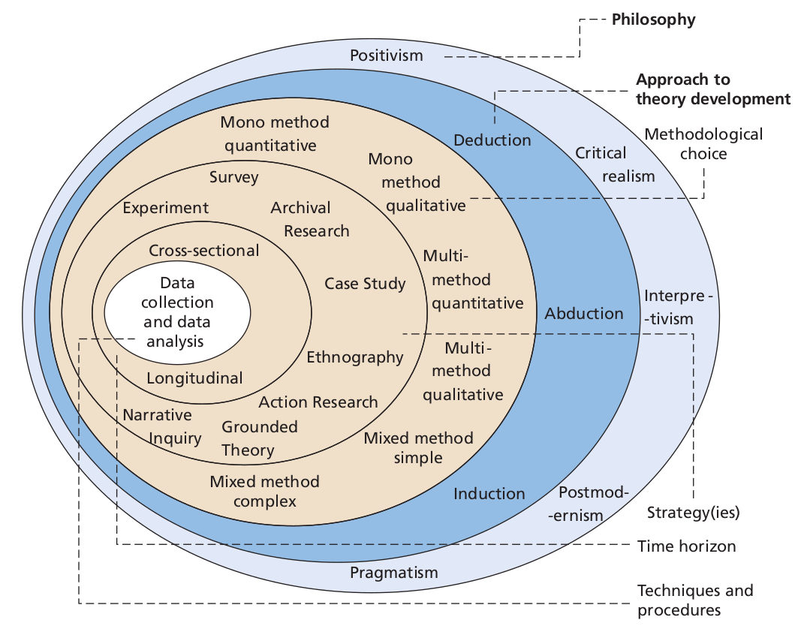

Figure 12: The “Research Onion” - Source: (Mark Saunders, Philip Lewis and Adrian Thornhill, 2019).

3.2 Research Philosophy

Research philosophy is the outer layer of the Saunders research onion which points to three research paradigms: Positivist, Pragmatist and Interpretivist (Saunders et al., 2019).
Research philosophy is linked to a set of beliefs about the nature of the investigation of reality and can be described from both an Ontological and Epistemological point of view (Bryman and Bell, 2011, p. 27, cited in Mayer, 2015).
According to Ejnavarzala (2019), “Epistemology is concerned with theories of knowledge and thus with questions such as what knowledge is, what counts as knowledge, how knowledge claims are justified, and the nature of explanations”.
Instead, according to Smith (2012), ‘Ontology’, often used by philosophers
as a synonym of ‘metaphysics’, is “the science of ‘what is’, of the kinds and structures of objects, properties, events, processes and relations in every area of reality” (Smith, 2012, p. 47). In other words, it deals with existential conditions linked to material, social, cultural and political contexts (Ejnavarzala, 2019).
For this research work, an interpretivist philosophy approach was adopted due to its flexibility and ability to dig deep in order to interpret and understand how the research participants experienced and reacted to this changing environment due to the pandemic.
"Interpretivism, also known as interpretivist, requires researchers to interpret aspects of their research. It is founded on a naturalistic data collecting approach, such as interviews and observations" (Research-Methodology.net, 2023). It is a qualitative research method, and therefore, its data is expressed through words and themes rather than numerically, as is the case with quantitative research (Bengtsson, 2016, p. 10).

3.3 Research Approach

In the direction of the centre of Saunders' research model, we locate the "Research Approach" layer, where three main approaches are available for selection: abductive, inductive, and deductive (Saunders et al., 2019):

- Deductive Approach: This method begins with a theory before turning to the data. Usually, research starts with a theory or hypothesis and seeks to test it using actual data. Deductive reasoning is primarily concerned with testing an established theory; the outcome may support or contradict the theory (Okoli, 2023).
- Inductive Approach: This method progresses from detailed observations to more general hypotheses and generalisations. Typically, data collection is the first step, and an overall theory or understanding is then developed using the data. The exploratory nature of the inductive approach makes it appropriate when there is a lack of prior theory on the subject in question (Gioia, Corley and Hamilton, 2013).
- Abductive Approach: This method incorporates parts of inductive and deductive reasoning. It alternates between theory and observations, improving and refining both along the process. Essentially, with this method the researcher makes observations and seek the hypothesis that would best fit or explain those observations (Dubois and Gadde, 2002).

In this research work, inductive reasoning was used. We initially gathered bias-free and unfiltered row data through semi-structured interviews where individuals answered a mix of structured questions followed by explorations based on answers. This data was later examined for patterns, themes and concepts.

3.4 Methodological Choice

According to Saunders et al (2019), there are three methodological choices outlined in the research:

- Mono Method which can use either qualitative or quantitative data;
- Mixed Method which combines both qualitative or quantitative methods to create a single dataset;
- Multi Method which combines qualitative or quantitative methods to create two independent datasets; with this method the research is divided into segments.

While quantitative research aims to quantify data, measure relationships, and derive statistically significant results, qualitative research delves into understanding the depth, context, and intricacies of human experiences and social realities (Creswell, 2003).

For what was mentioned above, the methodological choice for this research work is the "Mono method" by using semi-structured interviews (qualitative research). This is because the chosen technique enables the researcher to dig deeper into the participants 'experiences, perceptions and views without the distraction of managing another method, thus maintaining the research focus on the central questions (Kelle, 2006 and Creswell, 2003).

3.5 Research Strategy

Within the "Research Strategy" layer, among the various strategies that can be employed, Grounded Theory is the chosen approach for this study.
Grounded Theory is a research methodology that involves the construction of theory through the systematic collection and analysis of data. It was first introduced by sociologists Barney Glaser and Anselm Strauss in the 1960s (Jørgensen, 2001). According to Charman (2014), it refers to a set of systematic inductive techniques for conducting qualitative research with the primary goal of theory construction based on the actual data (Charman, 2014).
Denscombe (2017) emphasized the importance of researchers being adaptable and open as they must adopt a "continuous comparative strategy", which means continuously comparing data to discover new insights. This frequently leads to more profound questions as well as deeper analysis of the data. This method, however, can be complicated because it can produce misleading or unclear results. As such, it is best to limit the number of people questioned to no more than 15 in order to maintain the research's manageability (Cottrell, 2017).

3.6 Time Horizon

Customer interviews will be conducted as part of the study using a cross-sectional time horizon. According to Saunders et al. (2019), this particular kind of approach takes a "snapshot", which means that information is only collected just once in a short time, which is in contrast to longitudinal studies, which collect information from the same subjects at different points, enabling the analysis to be changed and developed over the time (Kumar, 2018).
This choice is in line with the purpose of the research question, which is not to examine how participants' perspectives change over time; therefore, data analysis over an extended period will not be required.
The interviewing process will last eight weeks, occurring in October and November of 2023.

3.7 Techniques & Procedures

In this qualitative study, primary data collection will take place through semi-structured interviews. Dumay and Qu (2011) pointed out the value of interviews by saying that if performed with care and a meticulously planned approach, interviews provide a vast collection of information to evaluate. In grounded theory research, Charmaz and Belgrave (2012) emphasised their importance and popularity because interviews tend to be the starting point for a constructivist grounded theory. According to Warren (2012), the key objective of interviews is to comprehend other people's opinions, which is consistent with the objective of this study, which is to acquire consumer opinions in order to answer research questions.
The use of semi-structured interviews allows for a flexible dialogue, enabling the conversation to evolve based on both the participant's insights and the researcher's interests, thereby facilitating the emergence of unforeseen themes (Roberts, 2020). Vanderstoep and Johnston (2008) argue that this semi-structured format mitigates issues related to data variability seen in informal interviews, and it avoids stifling the spontaneous discovery of information, a problem that can occur with structured interviews.
For this research work, the expectation in using semi-structured interviews is that these will generate a considerable amount of data since including open-ended questions will enable participants to freely express their thoughts and feelings about the research topic. This approach will likely facilitate a natural flow of conversation and open up new paths for investigation.
Purposive sampling technique has been employed to select ten individuals who had experienced relevant changes during the pandemic, whether personally, professionally, or socially. The selected sample consist of individuals diverse in age, profession, and geographic location in order to ensure a breadth of experiences. Additionally, Interviews were conducted via video conferencing platforms, considering the safety protocols and social distancing measures. Each interview lasts between 45 to 60 minutes, and data will be analysed using a "thematic analysis process", which has been recognised for its proficiency in managing extensive datasets (Clarke and Braun, 2006). This method is favoured in qualitative research for its capability to discover, scrutinise, and interpret patterns or "themes" within the data (Clarke and Braun, 2017). Acknowledged for its flexibility across various epistemological frameworks and research methodologies, such flexibility in analysis facilitates a reflective, inductive method, enabling patterns to emerge during the data analysis (Clarke and Braun, 2006). Moreover, a reflexive thematic analysis is adequate because codes can be modified in response to thematic changes (Byrne, 2022).

3.8 Limitations of the study

While addressing the various facets of the impact of the pandemic on consumer behaviour towards online business, this study work cannot draw general conclusions. The limitations relate mainly to the number and origin of the people interviewed, as they predominantly come from the Northwest of England. This means that the results of this research will only partially reflect UK trends.
Moreover, results are based on the opinions of surveyed online consumers over a specific time frame. However, in a rapidly changing environment, consumer behaviours and priorities also tend to change.

3.9 Ethical Considerations

Before commencing the dissertation research activity, an Ethics Form detailing the research proposal was carefully completed, reviewed by the dissertation supervisor and approved by the University of Wales Trinity Saint David, to ensure compliance with the guidelines outlined in the "University's Research Ethics" and "Integrity Code of Practice".
Each one-to-one interview will be transcribed word for word in real-time without the need for any audio/video recording, and data will be kept in password-protected cloud storage on the University Office 365 system, which will not be shared. Any USB sticks used to store or transfer data will be password protected.
Each participant will be assigned a unique identifier to guarantee confidentiality, and this list will be kept securely in a password-protected folder in compliance with the University's Research Data Management Policy.
This research activity has no sensitive, embarrassing, or upsetting topics. All participants were informed about the research's purpose and their rights prior to the interviews. Informed consent was obtained, and participants were made aware that they could withdraw at any time without consequence. The "Interview Consent Form" is included in Appendix 1.
Participants will also receive an email contact with which they can contact the principal researcher to request further information or details.
The aims and objectives of the project do not require data concerning children or vulnerable adults, and for this reason there is no need to carry out ethical assessments in relation to these groups.

3.10 Chapter Conclusion

This chapter highlighted the research methodology used to examine behaviour changes since the onset of the Covid-19 pandemic. The chapter described how the research was conducted, its limitations and how the study can be evaluated and, if necessary, repeated by future researchers.
The methodological choice was the "Mono method", using semi-structured interviews as the primary data collection technique (qualitative research), which allows the researcher to explore participant experiences and perceptions.
Interviews will be performed within a cross-sectional time horizon, as the research aims not to explore precisely how participants 'perspectives change over time; thus, data analysis over a prolonged period is unnecessary.
Moreover, an inductive approach and a grounded theory strategy within a qualitative framework have justified the research decisions in line with research objectives and questions.
As we have seen in the previous section of this chapter, the research has been developed using the "Research Onion" model made by Saunders et al., and below is a summary of the search choices made for each level of the model:
- Layer section - Qualitative Approach
- Layer one - Interpretivism
- Layer two - Inductive
- Layer three - Grounded theory
- Layer four - Mono Method
- Layer five – Cross Sectional

Chapter 4 – Analysis of Results

4.1 Introduction

This chapter is the core of our research, where we will analyse the data collected through the conducted primary research, consisting of ten semi-structured interviews.
Despite the small scale of the study, the very detailed responses to the sixteen open-ended questions provided a large amount of data to analyse.
Through the methodical application of "Thematic Analysis", this chapter systematically identifies and interprets themes that align with the research objectives.
This analysis has been conducted to be objective and critical and to ensure the reliability of the results. Furthermore, each interpretation has been carefully balanced with the study's limitations.
After a general overview of the demographic data of the research participants, the seven themes that emerged from the analysis of the responses transcribed during the interviews will be presented and critically discussed.

4.2 Demographics of the Participants

This section details the participants' demographic background to give more context to their responses and better understand the environment from which they are derived.
In fact, according to Sage (2023), questions regarding demographic data enable researchers to acquire critical information about their research topics. Such kinds of investigations provide a framework for survey data, assisting researchers in characterising their participants and facilitating the interpretation of their findings (Sage Research Methods, 2023).
Later in this chapter, when analysing the themes that emerged during the interviews, we will use demographic data to make further considerations.
Table 1 displays the demographic data collected from each participant before the interview through an "Essential Demographic Questionnaire", distributed along with the "Interview Consent Form".
A copy of the questionnaire is available in Appendix 2.
In order to ensure anonymity in compliance with the ethical constraints outlined in Chapter 3 (refer to Section 3.8), a participant identifier have been assigned to each interviewee, as indicated in the first column of Table 1.

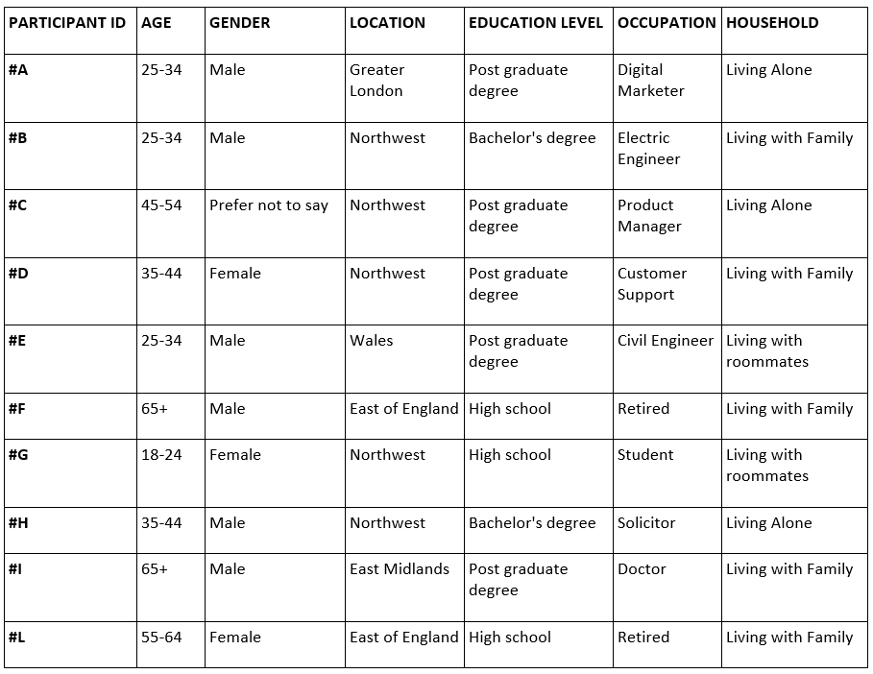

As we can see in Table 2 and its pie chart representation, the sample broadly covers all age groups.
Moreover, 60 percent of the interviewed are within the broader age range of 18-44, while the remaining 40 percent are in the 45+ age group.

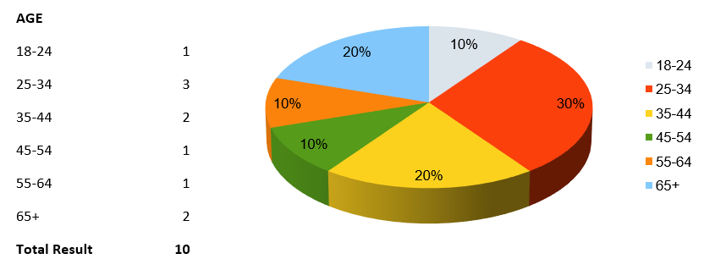

In terms of qualifications of the sample analysed (see Table 3), 50 percent have a postgraduate or master's degree. If we add 20 percent with a Bachelor's degree, seven out of ten participants have an University education.

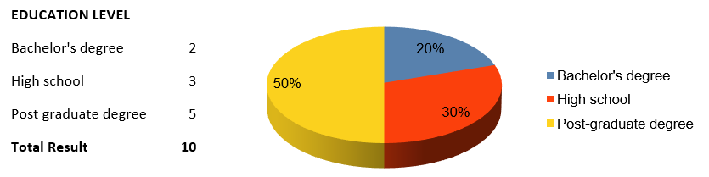

In Table 4, we can find a breakdown of the residential areas of the interviewed participants. Notably, 50 percent of the interviewees originate from the Northwest of England. This finding may pose a limitation, suggesting that the research results may only partially represent trends across the entire UK.
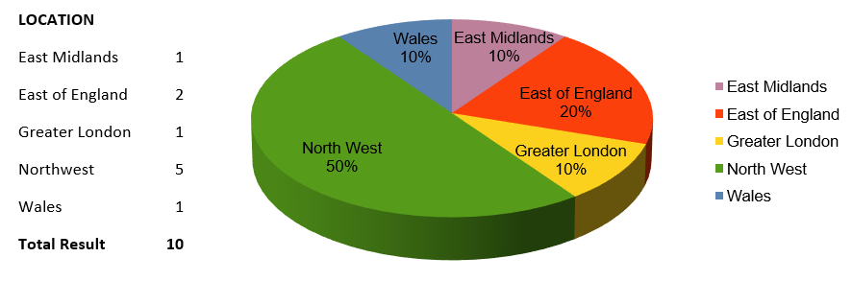

Table 5 provides us with the details of the families, where we can see that 50 percent of the interviewees live with their families. Despite this, the sample appears rather heterogeneous as it also covers different scenarios.

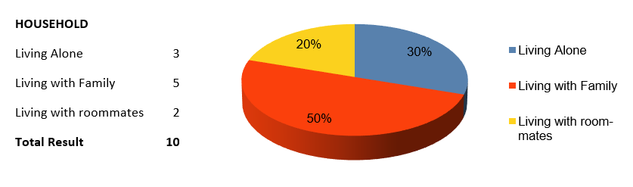

To complete the presentation of the demographic data of the sample interviewed, Table 6 reports the gender details, in which we can observe that 60% of the participants and, therefore, the majority of the sample identify as male.
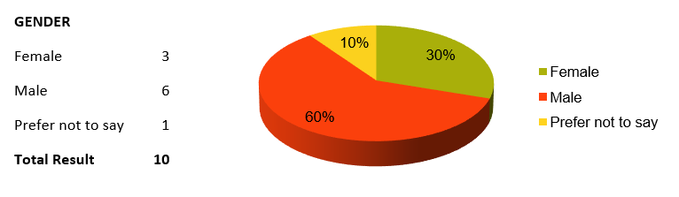

4.3 Theme 1 – There has been a significant transition towards online shopping since the beginning of the Pandemic

This theme arose from the answers to the following questions:

Q1. What general shopping habits did you have before the COVID-19 pandemic?
Q2. How did your shopping behaviour change during the pandemic? Please give some examples.

Responses to the above questions showed that online shopping has evolved around these three pillars or sub-themes.

- Sub-theme 1 – Change in Consumer Perception of E-commerce
Interviewees who had never purchased or had made very few purchases before COVID-19 stated that the main reason was scepticism toward this type of shopping, as evidenced by the following statements.
“Before COVID-19, I rarely used the Internet for shopping. I thought it was an unreliable platform, but little by little, during the coronavirus, I started making some purchases due to the needs arising from the pandemic, and I was positively surprised by this type of solution” (Participant F)
“Before COVID-19, I bought everything in stores because I did not trust e-commerce” (Participant L).
It is worth mentioning that Participants L and F are 55-64 and 65+ years old, respectively.
Moreover, from the response of Participant F, we can see that the demands associated with the pandemic meant that the initial scepticism was overcome, resulting in a pleasant experience. This latter point will be seen in depth as Sub-theme 2.
- Sub-theme 2 – The Role of Pandemic Restrictions in E-commerce Adoption to Overcome Preconceptions
Furthermore, it has emerged that pandemic-related restrictions were critical in overcoming scepticism and preconceptions among those unfamiliar with online shopping.
“Before COVID-19, I did not even have an Amazon Prime subscription as I preferred to shop at physical stores because I thought it was more reliable buying a product by seeing it in person rather than on a web page” (Participant B)
“In my case, COVID-19 has normalized e-commerce, breaking down my prejudices and making me gain trust in it” (Participant F)
“Since COVID-19, my online shopping has increased significantly, and I do so regularly. To make you understand, I did not even have an Amazon account before the pandemic. So, it is as if this new condition gave me the push I needed” (Participant H).
Interestingly, participants B and H, who fall into the 25-34 and 35-44 age groups, respectively, also needed that "push" generated by the pandemic restrictions to get in touch with online shopping.
- Sub-theme 3 – Pandemic-Induced Exploration, Adaptation and Appreciation
After starting using and exploring online shopping, people began to adapt and appreciate the benefits, as we can see from the following statements.
“During the pandemic, I began using Amazon and other internet retailers for convenience, simply because it was easier to obtain products online compared to visiting the physical store” (Participant E)
“As COVID-19 progressed, I realized that buying online is convenient. Especially, I feel protected by the excellent return policies” (Participant L)
“Before COVID-19, I generally liked buying goods at physical stores. Then, unable to go to stores any longer as it had become difficult and dangerous, I began shopping online, particularly for clothing. I also started doing a lot more grocery shopping online" (Participant D).

4.4 Theme 2 – The format in which Online Shopping has taken shape post the removal of Covid restrictions and reasons for its Continuation

This theme emerged with the answers to the following questions:

Q3. Have you noticed any significant changes in your spending patterns or priorities since the end of the coronavirus restrictions?
Q6. How often did you engage in online shopping before the pandemic, during the pandemic, and now?
Q7. Did you try any new online retailers/platforms during the pandemic? If so, what motivated you to try them?
Q9. Have you returned to in-store shopping for any products or services that you had shifted online for during the pandemic? If so, which ones?

The analysis of the responses to the above questions has found two sub-themes that explain the reason behind the will to continue using online shopping even after the end of the pandemic-related restrictions.
- Sub-theme 1 - Convenience and Economic Benefits of Online Shopping
One reason people continue to shop online today, even though mobility restrictions implemented during the pandemic are no longer in place, is economical. In fact, most participants have stated that significantly lower prices can be found online compared to purchasing the same product in-store. See some examples below.
“Today, but already since the pandemic, I have continued to shop online because the lower prices compared to physical stores help me cope with the current crisis and inflation caused by the conflict in Ukraine” (Participant B)
“I shop online to help save cash and also, consequently, to manage the present increase in the cost of living. I feel the recession as well as inflation, instead of decreasing internet purchases, will result in a decline in in-store shopping while increasing online transactions because of their cost-effectiveness” (Participant I)
“I have actually not gone back to shopping in physical stores for two good reasons. The first is economical; the second is that it is convenient to get the products shipped to your house. Moreover, I like online purchases' return policies better than in-store purchases" (Participant F).
From the answer of Participant F, we also can see other benefits of this particular kind of shopping: products delivered to your house and better return policies than in-store purchases.
Consequently, the majority of interviewees have incorporated online shopping into their everyday lives due to the convenience as well as financial benefits. They are likely to never return to conventional shopping.
“Today, I continue to shop online since I normally find better prices with the benefit that the items are sent straight to my home” (Participant C)
“I will not go back to my old habits, as when you try and see the comfort of internet shopping, it is difficult to return” (Participant A)
“Today, I can say I make the majority of my purchases online, which was unthinkable for me a couple of years ago!” (Participant L).
- Sub-theme 2 - Online Shopping as a Learning Process
It is important to underline how the necessity of the pandemic has led to the adoption and normalization of online purchasing behaviours:
“Before the pandemic, I practically did not use to shop online. Then, during the pandemic, I started doing it due to the needs that arose with the lockdown, and now it has become an integral part of my routine” (Participant E).
Furthermore, as we can see in the statement below, the pandemic represented for some participants a forced introduction to online shopping, which then often led to its appreciation and thus continued use:
“The pandemic forced me to open up to a world where I had very little confidence before. With this particular push, I got immersed in the new situation and also have been taught to make use of this new tool. These days, I continue using online shopping as it is convenient for personal reasons as I am a mum of two children, so I have little time to go to the stores physically” (Participant D).
Hence, we might compare the adoption of online shopping to an actual learning process in which the interviewees reported gaining new skills that made them more comfortable in this new shopping mode:
“Online shopping has turned into a habit and I have learned much more skills via experience” (Participant G)
“Now I know how to find exactly the same product in different online stores and compare its features in order to buy the best item at the best price.” (Participant H)
“I feel more confident now! I have learned more about exploring websites, platforms and products and also looking at prices as well as features” (Participant F).

4.5 Theme 3 – The importance of the Consumers’ Trust and enhanced Online Security in adopting Online Shopping

This theme emerged with the answers to the following questions:

Q2. How did your shopping behaviour change during the pandemic? Please give some examples.
Q10. How would you describe your comfort level and proficiency with online shopping platforms before the pandemic and now?
Q11. Do you believe your increased familiarity with online platforms has affected your purchasing decisions? If so, in what ways?

Analysing the answers to the above-mentioned questions, we can understand that gaining trust in online shopping and guaranteeing that their transactions are secure was essential in changing the minds of individuals who had previously been doubtful and sceptical:
“I was worried that I may be a victim of a scam, particularly because some individuals I know have complained about items delivered that were not as promised and not as described. However, both during the pandemic and now, I have personally seen the excellent level of security and reliability that these platforms offer when shopping online, especially when it comes to the most used platforms” (Participant F)
“Today, I can state I feel safer and also have gained trust in this particular kind of purchase ” (Participant H)
“Now I feel at ease and also make purchases of a greater value than in the past” (Participant E).
As you we able to observe through the response of Participant E, this increased trust implies that people are beginning make use of online shopping also for higher value products.
Furthermore, as we can see from the statements below, other factors have emerged, such as the speed of deliveries, return policies and greater security and simplification of payment methods, which have contributed to increasing the convenience and confidence of consumers for and towards online purchases:
“Important has been the simplified payment process, the speed of delivery, and the return/refund policies which safeguard the buyer" (Participant B).
“Once you have made a few successful purchases from the same online store, and they have your credit card information securely stored, and you have experienced no issues, you are more likely to continue shopping there in the future” (Participant C).
Last but not least, another relevant topic is the reliance on reviews for online purchases as most of those interviewed said they read reviews of websites and products before purchasing. Thus, reviews hold significant power in guiding consumer trust towards or away from a particular website or product.
“Now, I feel more at ease and relaxed; therefore, I make purchases without overthinking because I am sure everything will go smoothly. Of course, before purchasing, always look at the reviews, as they are the only tool that can help me understand if I am purchasing the product I need or if the site is reliable” (Participant G)
“I always look at reviews before making any purchase” (Participant B)
“Of course, for unfamiliar online shopping platforms, I rely heavily on reviews” (Participant D).

4.6 Theme 4 - Post-Pandemic Today's trend traces a possible hybrid future, where new preferences merge and rebalance with pre-pandemic habits.

This theme emerged with the answers to the following questions:

Q4. Are there products or services you started buying online during the pandemic that you had not considered buying online before?
Q5. Has the pandemic altered your purchasing habits and if so, do you believe you are going to ever return to shopping habits of previous times?
Q13. Which industries or sectors do you believe will continue to benefit from the shift to online shopping post-pandemic? And which ones do you think might see a decline in online shopping?

The analysis of the answers to the questions above has highlighted a rebalancing trend between Food Delivery and Dining at Restaurant that has begun since the restrictions on people's mobility were eliminated:
“I have decreased my usage of food delivery services, but I have increased the number of times I dine out at restaurants. I assume the balance is now 50-50” (Participant H)
“Nowadays, I alternate between buying food delivery and dining out” (Participant G).
Likewise, selective returns to in-person shopping have been noted for particular product categories, such as clothing and groceries items:
“As for food delivery and clothing shopping, I shop less online than during lockdown since I have balanced out in-store shopping more. Nevertheless, my internet shopping for these things is still substantially higher than before the pandemic” (Participant H)
“In terms of clothes, I prefer to purchase everyday and less costly items online. For the more expensive ones, I prefer to go to the store because it is easier to try on the clothes” (Participant F).
From the response of participant F, reported above, the reason behind the preference to purchase clothes in stores is the greater speed and convenience of trying on clothing directly in shops. Instead, the responses below indicate that some interviewees shop at grocery stores as they can buy the freshest products with the lengthiest expiration dates. Nevertheless, they still prefer to purchase recurring items online, like water bottles, soft drinks, detergents, etc.
“Regarding grocery shopping, there are items such as meat and fish that I would rather go and select in-person to choose items with lengthier expiration dates and make the best choices” (Participant E)
“When it comes to items like cheese, vegetables, fish, and meat, I like to go and select them in-store. Although online shopping continues to be beneficial, it is also true that they occasionally give you products nearing their expiration date. Therefore, if you select them yourself, you prioritize quality” (Participant C)
“Essentially, as the COVID-related restrictions have ended, I do online grocery shopping for recurring things in which the item's freshness does not matter, like bottled water or items I am currently knowledgeable about. "However, regarding fish, meat, vegetables and deli items, I would like to see them first-hand before I purchase them” (Participant G).

4.7 Theme 5 – Observed Fluctuations in online streaming usage and subscriptions

This theme emerged in responses to the following questions:

Q4. Are there products or services you started buying online during the pandemic that you had not considered buying online before?
Q5. Has the pandemic modified your shopping habits, and if so, do you believe you will ever go back to those of the past?

The analysis of the answers to the above questions has confirmed that since the pandemic, there has been a surge in the usage of streaming services:
“During the pandemic, I subscribed to Netflix, and I continue using it” (Participant F)
“During the lockdown, I subscribed to Netflix, and I continue using it with enjoyment as it will make my nights enjoyable because I am not an individual who goes out very much at night” (Participant L).
The above-reported response of Participant L suggests that streaming services are actively used by individuals who prefer to spend more time at home rather than getting out.
Additionally, some Participants have decreased their time-of-service use but still have active subscriptions:
“I started watching films in addition to TV series on Amazon Prime Video, Netflix and Disney Plus during the lockdown, and I still use those streaming services today. Nevertheless, although I carry on and keep my subscriptions active, I devote less time to using these services. I have also lately rediscovered the joy of visiting the cinema, so I go much more often ” (Participant C).
“I still have Netflix and Disney Plus but have halved my use. This is also because these services have exhausted their ‘novelty effect’, and I start to find the plots of the series similar and standardized" (Participant G).
The following assertions show that online video streaming subscribers’ trend very likely have two drivers: changes to pandemic restrictions and increasing subscription fees:
“I subscribed to all these streaming services like Netflix, Prime Video and Disney Plus. Honestly, I would never have considered buying these services before the COVID-19 pandemic. However, since the end of the lockdown, I have cut back on hours of usage, and I will cancel at least one of them (Participant B).” (Participant B)
“After the reduction of pandemic-related restrictions, I cancelled Netflix because I go out more and have less time to stay at home” (Participant H)
“I recently cancelled all my streaming platform subscriptions because these services have consistently increased their prices over the years” (Participant I).

4.8 Theme 6 – The Hybrid Work Model as the New preferred Standard

This last theme has emerged in responses to the following questions:

Q15. Prior to the pandemic, did you have the opportunity to work remotely or utilize a "smart working" approach? How did your work setup change during the pandemic, and how has it affected your daily routine and work-life balance?
Q16. Today, a large number of companies are exploring hybrid working models, a mix of remote and in-office working; what is your preference in this regard? Does a hybrid type have more benefits than fully office-based or fully remote work setup? Why?

The analysis of the answers to the above questions has found a preference among participants for the hybrid work model due to its flexibility:
“I believe that a 50-50 hybrid work model, where some of the work is done in person and some remotely, is often extremely effective, particularly once the nature of the job permits it. This approach offers flexibility as well as adaptability to various situations and needs and can be an ideal solution for most people, enhancing the work-life balance” (Participant F).

From the above answer, the flexibility of a hybrid working style results in a better work-life balance. Moreover, among the advantages of this working mode is that it enables employees to concentrate more, especially on some activities they choose to do at home, as the open space of the office could be chaotic sometimes:
“A hybrid working model where you can choose days based on your needs could be the right compromise. Working from home nowadays gives you the opportunity to focus better on certain tasks and work more peacefully, as working in an open space in the office can be chaotic at times” (Participant C).
Moreover, the benefits of social interactions in the workplace were mentioned mainly as reasons for preferring a hybrid working model:
“Working entirely from home removes direct contact with people, and with this approach, there is much more difficulty in sharing information, so you do not arrive at a solution immediately as you do when you are in person. Therefore, I think hybrid working is the best solution” (Participant D)
“I left the company I was working for because they required working solely from the office. I believe that the 50-50 hybrid model is the best compromise. This is because having some human contact is always beneficial. The risk of working from home isolates oneself, and it may take longer to seek quick advice since communication is less immediate. Additionally, I find it enjoyable to have face-to-face conversations with colleagues” (Participant E).
Last but not least, among the advantages that emerged from applying the working model are economic savings and reduced commuting time:
“I am one of those in favour of the 50-50 hybrid working model because, at least for my type of work, developing trust among colleagues or those who work for or with you is crucial. With this formula, I have improved my work-life balance because I save an hour of my time for commuting, making it less stressful. I also save on petrol commuting costs, so definitely from that perspective, it has been an improvement” (Participant B)
“Hybrid working has the advantage of allowing you to travel less during the week, reducing stress significantly” (Participant A).

4.9 Theme 7 - Recommendations from Consumers

This theme emerged with the answers to the following question:

Q14. What advice or suggestions would you give to businesses that aim to improve their online services, based on your experience?

The most recursive recommendation from the majority of those interviewed was the desire for a more present and, above all, more human customer service:
“Today, I would say that online services should be more human. This means having more accessible customer service, a person who answers the phone, understands your needs, and resolves the issue promptly” (Participant C)
“I do not like interacting with chatbots when I am trying to reach customer service” (Participant I)
“It is better to interface with a person than with a chatbot in case of issues” (Participant D)
“I prefer a more present but more easily accessible customer service without going through a chatbot, which is usually unable to resolve the issue” (Participant B).
The answers above indicate that most interviewees are against interfacing with chatbots as it would appear that the latter currently have limited problem-solving capabilities, not yet comparable to those of human technical support.
Another recurring recommendation was for free and increasingly faster deliveries especially in rural areas:
“I would like to see Delivery as fast as possible, even in rural areas” (Participant I)
“I would like faster shipping with zero delivery costs without necessarily having to reach a minimum order value” (Participant D).
Going ahead with the recommendations, there is a growing desire to see more secure payment methods available even on less well-known websites:
“Even greater security in payments is never bad, especially when buying from less well-known websites” (Participant F).
Finally, some interviewees suggested improving the feedback system and enriching the online catalogues to have a variety of products comparable to those in physical stores, as reported below:
“They should provide a WhatsApp number with direct access to a person operator, making the company appear friendly and accessible online 24 hours a day, seven days a week. Additionally, they should enhance the feedback system based on customer testimonials who have purchased the product” (Participant A)
“Sometimes I noticed that some well-known brands with physical stores offer fewer products online than what is available in their physical stores” (Participant G).

Chapter 5 – Discussions, Conclusions and Recommendations

5.1 Introduction

In this final Chapter, we will list, discuss, and compare the results of the Primary Research presented in Chapter 4 with those of the literature review seen in Chapter 2 of this thesis and how they relate to the research aims and questions discussed in Chapter 1.
Finally, the Chapter will conclude by addressing the limitations of this study and making recommendations regarding future research.

5.2 Discussion of the Findings

Theme 1 – There has been a significant transition towards online shopping since the beginning of the Pandemic.

The application of restrictions related to the COVID-19 pandemic was a determining factor in the adoption of online business by those who had never wanted to interact with this new method of making purchases. The limitations have forced this category of people to enter the world of online shopping as it was the only way to purchase essential goods, which is in line with what was stated by Guthrie et al., 2021.
The main reasons why some consumers have never tried e-commerce are mainly related to their scepticism and preconceptions regarding online purchases. So, the restrictions meant consumers overcame these preconceptions and started buying online. Therefore, the consumer found himself exploring this new world and adapting to this tool mainly thanks to the appreciation of the convenience and efficiency that e-commerce offers, in line with the findings of Tymkiw, 2022.

Theme 2 – The format in which Online Shopping has taken shape post the removal of Covid restrictions and reasons for its Continuation.

The needs related to the pandemic have led not only to the adoption of online shopping but also to its normalization and, therefore, to making it a habit. This is mainly for three reasons:
- The first is that the consumer feels more comfortable purchasing online because now it is more skilled and prepared to use this tool. In fact, the adoption of e-commerce can be compared to an actual learning path of new skills based on experiences built with daily usage, in line with the study of Sheth, 2020.
- The second reason is purely economic. In fact, most participants have stated that significantly lower prices can be found online compared to purchasing the same product in-store. Therefore, e-commerce is helping consumers cope with the impact of the post-COVID economic crisis and soaring inflation due to rising energy prices as a consequence of the start of the war between Russia and Ukraine. This point is in line with Eger et al. (2021), who demonstrated a correlation between changes in customer behaviour and worsening economic conditions and Loxton et al. (2020), who stated that Economic factors like unemployment rates and inflation have a consistent impact on consumer behaviours.
- The third reason is the Convenience of this shopping mode as products are delivered to the Customer’s house with better return policies than in-store purchases, in accordance with Showrav et al. (2021), who have stressed the importance of businesses providing some online Convenience for their customers.

Theme 3 – The importance of the Consumers’ Trust and enhanced Online Security in adopting Online Shopping.

The crucial factor that changed consumers' minds and helped them overcome their initial scepticism about online shopping was the acquisition of trust. In fact, the main concern expressed by the interviewees of this study was linked to the risk of being scammed; therefore, gaining consumer trust thanks to a positive purchasing experience was fundamental for e-commerce and its continuous use.
Nevertheless, to be successful, e-commerce has focused on increasing the security of transactions, simplifying payments, and ensuring the reliability of shipments and return/refund policies (Alzaidi and Agag, 2022).
Furthermore, the importance of feedback emerged as a tool consumers use to gain Trust in a particular store or product, which is in line with the survey by BrightLocal (2023), where more than 90% of consumers said they read reviews, explaining the reason why companies in the commerce sector are massively increasing their efforts in online reputation management.

Theme 4 - Post-Pandemic Today's trend traces a possible hybrid future, where new preferences merge and rebalance with pre-pandemic habits.

Since eliminating the restrictions linked to the pandemic, a selective return to in-person shopping has been observed for particular product categories, such as clothing (for the convenience of trying on clothes directly in stores) and groceries (to buy the freshest products). However, consumers still want to consult the store's website before purchasing at the physical store. Likewise, they still prefer to purchase recurring grocery items online, like water bottles, soft drinks, detergents, etc.
This behaviour aligns with the study by the IBM Institute for Business Value (2022) in collaboration with the National Retail Federation (NRF), which found that consumers have begun to adopt a "hybrid approach" to shopping, combining online and offline purchases.
Similarly, a rebalancing trend between Food Delivery and Dining at Restaurants was also noted in line with the findings of the Kantar Group (2023). In fact, with the easing of restrictions and the reopening of restaurants, many consumers have started eating out again, resulting in a physiological decrease in online meal orders. Despite this, the adoption of online food ordering apps remains higher than before the pandemic.

Theme 5 – Observed Fluctuations in online streaming usage and subscriptions.

Since the pandemic, there has been a surge in the usage of video streaming services driven by mobility restrictions (Trevisan et al., 2021).
The Primary Research suggests that nowadays, but in general, since the restrictions have ended, streaming services are actively used by individuals who prefer to spend more time at home rather than getting out. For all the others, however, there was a substantial reduction in the use of the service while keeping subscriptions active, at least for the moment.
Nevertheless, the constant increase in subscription prices complained of by those interviewed, combined with the reduction mentioned above in usage, could negatively impact the number of subscribers in line with the trend that was taking place in Q1-Q2 of 2022, as displayed in Figure 6 of Chapter 1 (SVOD penetration of UK households Q1 2015 – Q2 2022, Ofcom 2022).

Theme 6 – The Hybrid Work Model as the New preferred Standard

Before the coronavirus outbreak in 2020, working from home was considered a luxury. The advancement of digitalization has made remote and hybrid working (a mixed model of working in a central office and remote locations) possible for employers and workers.
This Primary research found a preference among participants for the hybrid working model due to its flexibility and adaptability to various situations, making it an ideal solution for most people to improve their work-life balance.
One of the advantages of this type of work is that it allows employees to concentrate more, especially on some activities that they choose to carry out at home, since the open space of the office can sometimes be chaotic. However, at the same time, it also offers the advantages of social interactions in the workplace, allowing workers to discuss and interact with colleagues. Furthermore, hybrid working allows both economic savings related to petrol and commuting costs but also the reduced commuting time reduces people's stress by improving their work-life balance.
The reasons cited above confirm and explain why nowadays, "hybrid" working has overcome "full-time" working from home mode, and it is now the most prevalent flexible working mode (Office for National Statistics, 2022).

Theme 7 - Recommendations from Consumers.

This last theme has the scope of helping address one of the objectives of this research, which is making recommendations on how businesses should shape their online business models to accommodate the new “normal”.
Below are listed the most recurring recommendations that emerged during the interviews:
- Respondents expressed a desire to have a “more human” customer service that can be contacted by telephone as it would appear that chatbots currently have limited problem-solving capabilities, not yet comparable to those of human customer care;
- Another recurring recommendation was to always have free and increasingly faster deliveries, especially in rural areas.
- There is a growing demand to have more secure payment methods available, even on lesser-known sites;
- Lastly, some interviewees suggested improving the feedback system and enriching the online catalogues to have a variety of products comparable to that of physical stores.

5.3 Conclusions

According to Guthrie et al. (2021), academic and industry reports showed that the post-lockdown period may have been too short to detect adaptive behaviours as these studies mainly focused on the immediate impact on consumer behaviours. Therefore, this research work proposes to observe online purchasing behaviours for a more extended period to understand whether new behaviours have further changed with the impact of the post-COVID economic crisis and the surge in inflation due to the increase in energy prices as a consequence of the start of the war between Russia and Ukraine.
Therefore, this study aimed to determine and describe how consumer behaviour has changed and evolved during such stressful life events as COVID-19 and how this latter played a role as the accelerator of the structural change in consumption and the digital transformation of the marketplace (Kim, 2020).
The Specific objectives addressed by this research are:
- To critically review the relevant literature regarding the shift to the online business due to a change in customers behaviour.
- To conduct semi-structured interviews with consumers to determine how the pandemic has changed the way they use online business services.
- To make recommendations on how businesses should shape their online business models to accommodate the new “normal”.
At this point, in light of the analyses and considerations made so far, the time has come to conclude the study by answering the research questions presented in Chapter One:

Q1: How has people’s spending changed since the end of coronavirus?
A1: There has been a normalization of the use of online shopping by consumers. Spending needs have been rebalanced, and consequently, there has been a reduction in purchasing health and safety devices and an increase in spending on travel and recreational activities.
Q2: Will the old habits return or die? Has the pandemic changed consumer behaviour forever?
A2: Most respondents have incorporated online shopping into their daily lives due to the convenience and financial benefits and will likely never abandon it to return entirely to conventional shopping.
Q3: Will Online shopping be falling back towards the pre-pandemic trend?
A3: In line with the above-reported A2, a return to pre-pandemic levels of online shopping appears improbable today. However, new hybrid trends, meant as a balanced mix between online and offline shopping, are emerging primarily for some specific products or services.
Q4: The pandemic has had a significant impact on where our money goes. Will the abrupt shift to online shopping last longer for some industries?
A4: During the pandemic, some sectors benefited most from the boost related to health concerns, such as health and safety devices. Furthermore, lockdowns have accelerated the spread of services such as food delivery and home streaming more than others. Therefore, a decline in these sectors is considered physiological once the reasons that accelerated the trend no longer exist.
Q5: Does increased experience and maturity in using online business affect customer behaviour in purchasing decisions?
A5: Consumers have learned new skills based on experiences built with daily usage. This has meant they have gained greater confidence in online shopping, leading to its normalization and adoption in their routine. Therefore, today, before making an online purchase, the consumer searches for the same product in different online stores and compares its characteristics to obtain the best item at the best price, also making use of feedback to determine the choice.
The limitations of this study mainly concern the number and origin of the people interviewed, as they mainly come from the Northwest of England. This implies that the results of this research partially reflect trends across the UK. Furthermore, the results are based on the opinions of surveyed consumers over a specific period of time and in a rapidly changing environment, consumer behaviours and priorities also tend to change.

5.4 Recommendations

In this section, for each of the themes that emerged in this research, the following recommendations for future investigations will be provided:
- Theme 1 – “There has been a significant transition towards online shopping since the beginning of the Pandemic”. It would be interesting to analyse the impact of the pandemic on those who were already using e-commerce, such as the younger generations.
- Theme 2 – “The format in which Online Shopping has taken shape post the removal of Covid restrictions and reasons for its Continuation”. It would be interesting to delve deeper into the topic by interviewing people with diametrically opposed income brackets and, in the case of a general improvement in economic conditions.
- Theme 3 – “The importance of the Consumers’ Trust and enhanced Online Security in adopting Online Shopping”. It would also be interesting to study the entire part relating to the advertising and feedback system in which companies invest to highlight their products in order to position them at the top of the search results for specific keywords.
- Theme 4 – “Post-Pandemic Today's trend traces a possible hybrid future, where new preferences merge and rebalance with pre-pandemic habits”. It will be intriguing to understand whether, with the advent of the metaverse, online shopping will change further, leading to the suppression of the need for physical stores.
- Theme 5 – “Observed Fluctuations in online streaming usage and subscriptions”. Expanding the scope and delving deeper into other areas of the Streaming Services, such as Gaming and Music Streaming, could also be interesting.
- Theme 6 – “The Hybrid Work Model as the New preferred Standard”. It would be interesting to understand how the reduced number of people working in the office impacts the transport sector and the catering services surrounding the offices.
- Theme 7 – “Recommendations from Consumers”. Based on the desire of the interviewees in this research to have a "more human" customer service, it would be interesting to delve deeper into the new technologies applicable in customer service like Artificial Intelligence (AI), Internet of Things (IoT), Virtual Reality (VR) and Augmented Reality (AR), to make this kind of service more "Empathetic".
Moreover, and in line with the limitations mentioned at the end of the previous section, a broader scope and a more significant number of interviewees would allow us to make more generalized considerations that better reflect the trend across the UK. However, increasing the number of interviewees using only a Qualitative Mono-Method and semi-structured interviews could make the research unmanageable. In this regard, a Mixed-Method strategy combining qualitative and quantitative methods would be worth considering. Therefore, it would be intriguing to conduct the study again in the future and compare the outcomes, considering how quickly the environment is changing.

References

Adiguzel, Zafer. (2019). “Examination-of-Effects-of-Competitive-Strategies-on-the-E-Commerce-Companies-in-Terms-of-Achieving-Sustainable-Competitive-Advantage”. 10.4018/978-1-7998-0035-4.ch014.
Ahuja, Chandra, Lord, and Peens, (2021), “Ordering in: The rapid evolution of food delivery”. McKinsey & Company. Available at: https://www.mckinsey.com/industries/technology-media-and-telecommunications/our-insights/ordering-in-the-rapid-evolution-of-food-delivery (Accessed: 25th Jan 2023).
Alex Rolfe, (2023), “Digital and alternative payment trends worldwide”. Available at: https://www.paymentscardsandmobile.com/digital-and-alternative-payment-trends-worldwide/#_ftn1 (Accessed:28th Aug 2023).
Alfonso, V., Boar, C., Frost, J., Gambacorta, L. and Liu, J., 2021. E-commerce in the pandemic and beyond. BIS Bulletin, 36(9).
Alhaimer, R. (2022). “Fluctuating attitudes and behaviors of customers toward online shopping in times of emergency: The case of Kuwait during the COVID-19 pandemic”. Journal of Internet Commerce, 21(1), 26-50.
Alzaidi, M. S., & Agag, G. (2022). “The role of trust and privacy concerns in using social media for e-retail services: The moderating role of COVID-19”. Journal of Retailing and Consumer Services, 68, 103042.
Anam, Sayedul & Golam Yazdani Showrav, Dewan & Hassan, Md Arif & Chakrabarty, Anuz. (2021). “Factors influencing the rapid growth of online shopping during covid-19 pandemic time in Dhaka City, Bangladesh”. 20. 1-13.
Armando, R.L.C., 2021. Disruption in the consumer decision-making? Critical analysis of the consumer's decision making and its possible change by the COVID-19. Turkish Journal of Computer and Mathematics Education (TURCOMAT), 12(4), pp.1468-1480.
Arts Professional, (2023), “Increase in post-pandemic arts attendance slows down”. Available at: https://www.artsprofessional.co.uk/news/increase-post-pandemic-arts-attendance-slows-down (Accessed: 1st Sept 2023).
Badger and Parlapiano, 2020. “The Rich Cut Their Spending. That Has Hurt All the Workers Who Count on It”. New York Times. Available at: https://www.nytimes.com/2020/06/17/upshot/coronavirus-spending-rich-poor.html (Accessed: 27th Aug 2023).
Baig, A., Hall, B., Jenkins, P., Lamarre, E. and McCarthy, B., 2020. The COVID-19 recovery will be digital: A plan for the first 90 days. McKinsey Digital, 14.
BBC, (2020), “TV watching and online streaming surge during lockdown”. Available at: https://www.bbc.co.uk/news/entertainment-arts-53637305 (Accessed: 1st Sept 2023).
Bengtsson, M. (2016). “How to plan and perform a qualitative study using content analysis”. NursingPlus open, 2, 8-14.
Bourdin, S., & Levratto, N. (2023). Regional Implications of COVID-19. International Regional Science Review, 01600176231189433. https://doi.org/10.1177/01600176231189433
Braun, V., & Clarke, V. (2006). Using thematic analysis in psychology. Qualitative research in psychology, 3(2), 77-101.
Brightlocal.com, (2023), “Local Consumer Review Survey 2023”. Available at: https://www.brightlocal.com/research/local-consumer-review-survey/ (Accessed:30th Aug 2023).
Brough, R., Freedman, M. and Phillips, D.C., (2021). Understanding socioeconomic disparities in travel behaviour during the COVID‐19 pandemic. Journal of Regional Science, 61(4), pp.753-774.
Byrne, D. (2022). A worked example of Braun and Clarke’s approach to reflexive thematic analysis. Quality & quantity, 56(3), 1391-1412.
Catherine Tymkiw, (2022). “How Shopping Habits Changed Due to COVID-19”, Investopedia. Available at:https://www.investopedia.com/how-shopping-habits-changed-due-to-covid-5186278 (Accessed:28th Aug 2023).
Chan, E. Y., & Saqib, N. U. (2021). “Privacy concerns can explain unwillingness to download and use contact tracing apps when COVID-19 concerns are high”. Computers in Human Behavior, 119, 106718.
Charmaz, K. (2014). Constructing grounded theory. Sage.
Charmaz, K., & Belgrave, L. (2012). Qualitative interviewing and grounded theory analysis. The SAGE handbook of interview research: The complexity of the craft, 2, 347-365.
Chen, (2021). “Factors affecting the consumers online shopping during the COVID-19 pandemic in China”. Revista argentina de clínica psicológica., 30(1). Available at: https://doi.org/10.24205/03276716.2020.2081.
Chen, Y. F., Ren, L., Yan, K. K., & Law, R. (2022). Fighting to lose less when closure is not an option: three-R strategies of fine-dining restaurants during the COVID-19 pandemic. Tourism Recreation Research, 1-18.
Clarke, V., & Braun, V. (2017). Commentary: Thematic analysis. Journal of Positive Psychology, 12(3), 297-298.
Clipper, B. (2020). The influence of the COVID-19 pandemic on technology: Adoption in health care. Nurse leader, 18(5), 500-503.
Cottrell, S. (2017). Dissertations and Project Reports: A step by step guide. Bloomsbury Publishing.
Creswell, J. W. (2003). Qualitative, quantitative, and mixed methods approaches.
Das, D., Sarkar, A., & Debroy, A. (2022). “Impact of COVID-19 on changing consumer behaviour: Lessons from an emerging economy”. International journal of consumer studies, 46(3), 692–715. https://doi.org/10.1111/ijcs.12786
David Curry, (2023), “Food Delivery App Revenue and Usage Statistics 2023”, Available at: https://www.businessofapps.com/data/food-delivery-app-market/#:~:text=The%20food%20delivery%20market%20has,dollars%20in%20potential%20revenue%20capture (Accessed: 25th Jan 2023).
Denscombe, M. (2017). EBOOK: The good research guide: For small-scale social research projects. McGraw-Hill Education (UK).
Di Crosta, A., Ceccato, I., Marchetti, D., La Malva, P., Maiella, R., Cannito, L., Cipi, M., Mammarella, N., Palumbo, R., Verrocchio, M. C., Palumbo, R., & Di Domenico, A. (2021). “Psychological factors and consumer behavior during the COVID-19 pandemic”. PloS one, 16(8), e0256095. https://doi.org/10.1371/journal.pone.0256095
Dubois, A. and Gadde, L.E., 2002. Systematic combining: an abductive approach to case research. Journal of business research, 55(7), pp.553-560.
Ecola Liisa, Hui Lu, and Charlene Rohr, (2020). “How Is COVID-19 Changing Americans' Online Shopping Habits?“.Santa Monica, CA: RAND Corporation, 2020. Available at: https://www.rand.org/pubs/research_reports/RRA308-6.html (Accessed: 27th Aug 2023).
EcommerceDB.com, (2023), “Top 10 online stores in the United Kingdom in 2021”. Available at: https://ecommercedb.com/news/top-10-online-stores-in-the-united-kingdom-in-2021/3899 (Accessed: 3rd Jan 2023).
Eger, L., Komárková, L., Egerová, D., & Mičík, M. (2021). “The effect of COVID-19 on consumer shopping behaviour: Generational cohort perspective”. Journal of Retailing and consumer services, 61, 102542.
Ejnavarzala, H. (2019). Epistemology–Ontology Relations in Social Research: A Review. Sociological Bulletin, 68(1), 94-104. https://doi.org/10.1177/0038022918819369
Figliozzi M, Unnikrishnan A. Home-deliveries before-during COVID-19 lockdown: Accessibility, environmental justice, equity, and policy implications. Transp Res D Transp Environ. 2021 Apr;93:102760. doi: 10.1016/j.trd.2021.102760. Epub 2021 Feb 25. PMID: 33649701; PMCID: PMC7904472.
Forbes, (2022), “Online Reviews And Their Impact On The Bottom Line”. Available at: https://www.forbes.com/sites/forbesagencycouncil/2019/01/15/online-reviews-and-their-impact-on-the-bottom-line/?sh=6d7952945bde (Accessed:30th Aug 2023).
Forbes, (2022), “Online Reviews: The Customer Reference That Never Sleeps”. Available at: https://www.forbes.com/sites/forbestechcouncil/2022/08/16/online-reviews-the-customer-reference-that-never-sleeps/?sh=636586332921 (Accessed:30th Aug 2023).
Forbes, (2022), “Virtual And Hybrid Events Are More Than Just A Covid-Era Fix”. Available at: https://www.forbes.com/sites/forbesbusinesscouncil/2022/12/20/virtual-and-hybrid-events-are-more-than-just-a-covid-era-fix/ (Accessed: 16th Sept 2023).
Gioia, D.A., Corley, K.G. and Hamilton, A.L., 2013. Seeking qualitative rigor in inductive research: Notes on the Gioia methodology. Organizational research methods, 16(1), pp.15-31.
Grandon, E.E. and Pearson, J.M., 2004. Electronic commerce adoption: an empirical study of small and medium US businesses. Information & management, 42(1), pp.197-216.
Gu, S., Ślusarczyk, B., Hajizada, S., Kovalyova, I. and Sakhbieva, A., 2021. Impact of the covid-19 pandemic on online consumer purchasing behavior. Journal of Theoretical and Applied Electronic Commerce Research, 16(6), pp.2263-2281.
Guo, W., & Luo, Q. (2023). Investigating the impact of intelligent personal assistants on the purchase intentions of Generation Z consumers: The moderating role of brand credibility. Journal of Retailing and Consumer Services, 73, 103353
Guthrie, C., Fosso-Wamba, S. and Arnaud, J.B., 2021. Online consumer resilience during a pandemic: An exploratory study of e-commerce behavior before, during and after a COVID-19 lockdown. Journal of Retailing and Consumer Services, 61, p.102570.
Hammi, B., Zeadally, S. and Nebhen, J., 2023. Security threats, countermeasures, and challenges of digital supply chains. ACM Computing Surveys.
Harari, T. T., Sela, Y., & Bareket-Bojmel, L. (2022). Gen Z during the COVID-19 crisis: a comparative analysis of the differences between Gen Z and Gen X in resilience, values and attitudes. Current psychology (New Brunswick, N.J.), 1–10. Advance online publication. https://doi.org/10.1007/s12144-022-03501-4
Horvath, L., Banducci, S., & James, O. (2022). Citizens’ attitudes to contact tracing apps. Journal of Experimental Political Science, 9(1), 118-130.
IBM Institute for Business Value (2022). "Consumers want it all". Available at: https://www.ibm.com/thought-leadership/institute-business-value/en-us/report/2022-consumer-study (Accessed:30th Aug 2023).
Investopedia.com, (2022), “Compound Annual Growth Rate: What You Should Know”. Available at: https://www.investopedia.com/investing/compound-annual-growth-rate-what-you-should-know/ (Accessed: 27th Aug 2023).
Investopedia.com, (2022), “Ecommerce Defined: Types, History, and Examples”. Available at: https://www.investopedia.com/terms/e/ecommerce.asp (Accessed: 16th Sept 2022).
Investopedia.com, (2022), “How Uber Makes Money”. Available at: https://www.investopedia.com/ask/answers/013015/how-do-ridesharing-companies-uber-make-money.asp (Accessed: 26th Jan 2023).
Investopedia.com, (2022), “Mobile Commerce: Definition, Benefits, Examples, and Trends”. https://www.investopedia.com/terms/m/mobile-commerce.asp (Accessed:31st Aug 2023).
Janusz Moneta, Lucy Sinclair (2020). “COVID-19 has accelerated digital adoption - the time to transform is now”. Available at: https://www.thinkwithgoogle.com/intl/en-gb/future-of-marketing/digital-transformation/covid-accelerated-digital-adoption/ (Accessed: 5th Sept 2023).
Jin, X., Bao, J., & Tang, C. (2022). Profiling and evaluating Chinese consumers regarding post-COVID-19 travel. Current Issues in Tourism, 25(5), 745-763.
JP Morgan (2020), “How COVID–19 has transformed consumer spending habits”. Available at: https://www.jpmorgan.com/insights/global-research/retail/covid-spending-habits (Accessed: 7th Sept 2023).
Jørgensen, U. (2001). Grounded theory: Methodology and theory construction. International encyclopedia of the social & behavioral sciences, 1, 6396-6399.
Kannan, P. K., & Kulkarni, G. (2022). The impact of Covid-19 on customer journeys: implications for interactive marketing. Journal of Research in Interactive Marketing, 16(1), 22-36.
Kantar Group (2023), “Restaurants rebound while food delivery becomes a post-pandemic norm”. Available at: https://www.kantar.com/company-news/restaurants-rebound-while-food-delivery-becomes-a-post-pandemic-norm (Accessed:31st Aug 2023).
Kelle, U. (2006). Combining qualitative and quantitative methods in research practice: purposes and advantages. Qualitative research in psychology, 3(4), 293-311.
Kim, R.Y., 2020. The impact of COVID-19 on consumers: Preparing for digital sales. IEEE Engineering Management Review, 48(3), pp.212-218.
Klein, V.B. and Todesco, J.L., 2021. COVID‐19 crisis and SMEs responses: The role of digital transformation. Knowledge and Process Management, 28(2), pp.117-133.
Kumar, R. (2018). Research methodology: A step-by-step guide for beginners. Research methodology, 1-528.
Lo, A., Duffy, E., & Ng, S. W. (2021). “Who’s grocery shopping online and why: Cross-sectional analysis of a nationally-representative sample since the pandemic”. Current Developments in Nutrition, 5, 5140231.
Loxton, M., Truskett, R., Scarf, B., Sindone, L., Baldry, G., & Zhao, Y. (2020). “Consumer behaviour during crises: Preliminary research on how coronavirus has manifested consumer panic buying, herd mentality, changing discretionary spending and the role of the media in influencing behaviour”. Journal of risk and financial management, 13(8), 166.
Mayer, I. (2015). “Qualitative research with a focus on qualitative data analysis”. International Journal of Sales, Retailing & Marketing, 4(9), 53-67.
Mazsystems.com, (2020), OTT Business Models: A Full Breakdown on Making Revenue in OTT. Available at: https://www.mazsystems.com/en/blog/types-of-ott-business-models (Accessed: 23rd Jan 2023).
McKinsey & Company, (2022), “Social commerce: The future of how consumers interact with brands”. Available at: https://www.mckinsey.com/capabilities/growth-marketing-and-sales/our-insights/social-commerce-the-future-of-how-consumers-interact-with-brands (Accessed: 16th Sept 2023).
McKinsey & Company, (2022), “Still feeling good: The US wellness market continues to boom”. Available at: https://www.mckinsey.com/industries/consumer-packaged-goods/our-insights/still-feeling-good-the-us-wellness-market-continues-to-boom#/ (Accessed: 4th Sept 2023).
Min, J., Kim, J., & Yang, K. (2021). How generations differ in coping with a pandemic: The case of restaurant industry. Journal of Hospitality and Tourism Management, 48, 280–288. https://doi.org/10.1016/j.jhtm.2021.06.017
Moon, J., Choe, Y., & Song, H. (2021). “Determinants of consumers’ online/offline shopping behaviours during the COVID-19 pandemic”. International journal of environmental research and public health, 18(4), 1593 (Accessed: 6th Jun 2023).
Mukherjee, S., & Narang, D. (2023). Digital economy and work-from-home: The rise of home offices amidst the COVID-19 outbreak in India. Journal of the Knowledge Economy, 14(2), 924-945.
Nemat, R. (2011). “Taking a look at different types of e-commerce”. World Applied Programming, 1(2), 100-104.
Nguyen, J., Le, Q. V., & Ha, J. T. (2021). Impacts of health and safety concerns on e-commerce and service reconfiguration during the COVID-19 pandemic: insights from an emerging economy. Service Science, 13(4), 227-242.
Niculaescu, C. E., Sangiorgi, I., & Bell, A. R. (2023). “Does personal experience with COVID-19 impact investment decisions? Evidence from a survey of US retail investors”. International Review of Financial Analysis, 102703.
Ofcom, (2023), Media Nations 2022 – UK Report. Available at: https://www.ofcom.org.uk/__data/assets/pdf_file/0016/242701/media-nations-report-2022.pdf (Accessed: 23rd Jan 2023).
Office for National Statistics, (2022), “Internet sales as a percentage of total retail sales (%ratio)”. Available at: https://www.ons.gov.uk/businessindustryandtrade/retailindustry/timeseries/j4mc/drsi (Accessed: 26th Dec 2022).
Office for National Statistics, (2022), “Is hybrid working here to stay?”. Available at: https://www.ons.gov.uk/employmentandlabourmarket/peopleinwork/employmentandemployeetypes/articles/ishybridworkingheretostay/2022-05-23#:~:text=Around%20one%20in%20seven%20working,home%20and%20travelled%20to%20work (Accessed: 6th Feb 2023).
Okoli, C. (2023). Inductive, abductive and deductive theorising. International Journal of Management Concepts and Philosophy, 16(3), 302-316.
Oracle.com (2023), “What is connected TV (CTV)?”. Available at: https://www.oracle.com/uk/cx/advertising/measurement/ctv-vs-ott/ (Accessed: 23rd Jan 2023).
Oxford Learning College, (2023), “Online Education & E-Learning Statistics UK”. Available at: https://www.oxfordcollege.ac/news/online-education-statistics/ (Accessed: 4th Feb 2023).
Panurach, P., 1996. Money in electronic commerce: Digital cash, electronic fund transfer, and ecash. Communications of the ACM, 39(6), pp.45-50 (Accessed: 13th Sept 2022).
Paraschiv, D. M., ȚIțan, E., Manea, D. I., Ionescu, C. D., Mihai, M., & Șerban, O. (2022). “The change in e-commerce in the context of the Coronavirus pandemic”. Management & Marketing, 17(2), 220-233.
Park, I., Lee, J., Lee, D., Lee, C., & Chung, W. Y. (2022). “Changes in consumption patterns during the COVID-19 pandemic: Analyzing the revenge spending motivations of different emotional groups”. Journal of Retailing and Consumer Services, 65, 102874.
Park, J. (2023). Regional Disparities in COVID-19 Vaccine Hesitancy: The Moderating Role of Social Distancing and Vaccine Rollout in the U.S. International Regional Science Review, 46(5–6), 577–612. https://doi.org/10.1177/01600176221132231
Popa, A., Barbu, C. A., & Ionașcu, A. E. (2023). The New Paradigm of Online Marketing: A Study of Generation Z Consumers’ Behaviour and Their Attitude Towards Brands.
Prasad, R. K., & Srivastava, M. K. (2021). “Switching behavior toward online shopping: coercion or choice during Covid-19 pandemic”. Academy of marketing studies journal, 25, 1-15.
Qu, S. Q., & Dumay, J. (2011). The qualitative research interview. Qualitative research in accounting & management, 8(3), 238-264.
Research-Methodology.net, (2023), “Interpretivism (interpretivist) Research Philosophy”. Available at: https://research-methodology.net/research-philosophy/interpretivism/ (Accessed: 14th Sept 2023).
Roberts, R. E. (2020). Qualitative Interview Questions: Guidance for Novice Researchers. Qualitative Report, 25(9).
Roy, S. (2020). “Economic impact of Covid-19 pandemic”. A preprint, 1, 29.
S&P Global, (2021), “China’s consumer market recovery under the Covid-19 pandemic”. Available at: https://www.spglobal.com/marketintelligence/en/mi/research-analysis/chinas-consumer-market-recovery-under-covid19-pandemic.html (Accessed: 16th Sept 2023).
Sage Research Methods, (2023), “Survey: Demographic Questions”. Available at https://methods.sagepub.com/reference/the-sage-encyclopedia-of-communication-research-methods/i14203.xml (Accessed: 26th Nov 2023).
Said, M., Tahlyan, D., Stathopoulos, A., Mahmassani, H., Walker, J. and Shaheen, S., 2023. In-person, pick up or delivery? Evolving patterns of household spending behavior through the early reopening phase of the COVID-19 pandemic. Travel Behaviour and Society, 31, pp.295-311.
Saunders, M., Lewis, P. and Thornhill, A. (2019) “Research methods for business students”. Chapter 4: Understanding research philosophy and approaches to theory development. 8th ed. New York: Pearson. pp. 128-170. Available at: https://www.researchgate.net/publication/330760964_Research_Methods_for_Business_Students_Chapter_4_Understanding_research_philosophy_and_approaches_to_theory_development (Accessed: 4th Oct 2023).
Schroth H. Are you ready for Gen Z in the workplace? California Management Review. 2019;61(3):5–18. doi: 10.1177/0008125619841006.
Sharma, A. and Jhamb, D., 2020. Changing consumer behaviours towards online shopping-an impact of Covid 19. Academy of Marketing Studies Journal, 24(3), pp.1-10.
Sharma, M., Antony, R., Sehrawat, R., Cruz, A. C., & Daim, T. U. (2022). “Exploring post-adoption behaviors of e-service users: Evidence from the hospitality sector/online travel services”. Technology in Society, 68, 101781. (Accessed: 1st Sept 2023).
Sheth, J. (2020) ‘Impact of Covid-19 on consumer behaviour: Will the old habits return or die?’, Journal of business research, 117, pp. 280–283. doi:10.1016/j.jbusres.2020.05.059.
Singh, A. L., Jamal, S., & Ahmad, W. S. (2021). Impact assessment of lockdown amid COVID-19 pandemic on tourism industry of Kashmir Valley, India. Research in Globalization, 3, 100053.
Smith, B. (2012). Ontology. In The furniture of the world (pp. 47-68). Brill. Available at: https://doi.org/10.1163/9789401207799_005.
Statista (2022), “FinTech - In-depth Market Insights & Data Analysis”. Available at: https://www.statista.com/study/45600/in-depth-report-fintech/ (Accessed: 28th Aug 2023).
Statista (2022), “Hybrid work - statistics & facts”. Available at: https://www.statista.com/topics/7560/hybrid-work/#topicOverview (Accessed: 6th Feb 2023).
Statista (2022), “Market value of foodservice delivery in the United Kingdom (UK) in 2021, with forecasts for 2022 and 2025”. Available at: https://www.statista.com/statistics/1110682/uk-takeaway-delivery-market-value/ (Accessed: 4th Feb 2023).
Statista (2022), “Online Food Delivery – Worldwide”. Available at: https://www.statista.com/outlook/dmo/online-food-delivery/worldwide (Accessed: 26th Jan 2023).
Statista (2022), “Restaurant delivery and takeaway in the United Kingdom - statistics & facts”. Available at: https://www.statista.com/topics/4679/food-delivery-and-takeaway-market-in-the-united-kingdom-uk/#topicOverview (Accessed: 27th Jan 2023).
Statista (2022), “Work from home & remote work - Statistics & Facts”. Available at: https://www.statista.com/topics/6565/work-from-home-and-remote-work/#topicOverview (Accessed: 5th Feb 2023).
Statista (2023), “E-commerce revenue in the United Kingdom (UK) from 2015 to 2021”. Available at: https://www.statista.com/statistics/282162/e-commerce-annual-sales-in-the-united-kingdom-uk/ (Accessed: 3rd Jan 2023).
Statista (2023), “Retail m-commerce as percentage of total retail e-commerce sales worldwide in 2022, by region”. Available at: https://www.statista.com/statistics/806323/mobile-commerce-share-total-worldwide-region/ (Accessed:31st Aug 2023).
The Washington Post, (2023), “Gyms, pets and takeout: How the pandemic has shifted daily life”. Available at: https://www.washingtonpost.com/wellness/interactive/2023/pandemic-changes-daily-life/ (Accessed: 4th Sept 2023).
Tian, Y. and Stewart, C., 2006. History of e-commerce. In Encyclopedia of e-commerce, e-government, and mobile commerce (pp. 559-564). IGI Global.
Trevisan, M., Vassio, L. and Giordano, D., 2021. Debate on online social networks at the time of COVID-19: An Italian case study. Online Social Networks and Media, 23, p.100136.
Truong, D. and Truong, M.D., 2022. “How do customers change their purchasing behaviors during the COVID-19 pandemic?”. Journal of Retailing and Consumer Services, 67, p.102963.
Tsai, Y.C. and Cheng, Y.T., 2012. Analyzing key performance indicators (KPIs) for E-commerce and Internet marketing of elderly products: A review. Archives of gerontology and geriatrics, 55(1), pp.126-132 (Accessed: 16th Sept 2022).
U.S. Census Bureau, (2022), “E-Commerce Retail Sales as a Percent of Total Sales”, [ECOMPCTSA], retrieved from FRED, Federal Reserve Bank of St. Louis; https://fred.stlouisfed.org/series/ECOMPCTSA, November 12, 2022.
Unnikrishnan, Avinash & Figliozzi, Miguel. (2021). Exploratory analysis of factors affecting levels of home deliveries before, during, and post- COVID-19. Transportation Research Interdisciplinary Perspectives. 10. 100402. 10.1016/j.trip.2021.100402.
Vanderstoep, S. W., & Johnson, D. D. (2008). Research methods for everyday life: Blending qualitative and quantitative approaches. John Wiley & Sons.
Walcott, P. A. (2023). COVID-19: A Catalyst for E-Commerce in the Food and Beverage Service Industry Food and Beverage Service Industry in Barbados?. In Interdisciplinary Perspectives on Covid-19 and the Caribbean, Volume 1: The State, Economy and Health (pp. 293-320). Cham: Springer International Publishing.
WALTON, S.V. and GUPTA, J.N.D., 1999. Electronic data interchange for process change in an integrated supply chain. International Journal of Operations & Production Management, 19(4), pp. 372-388 (Accessed: 13th Sept 2022).
Wang, B., Williams, M., Duarte, F., & Zheng, S. (2022). “Demand for social interactions: Evidence from the restaurant industry during the COVID‐19 pandemic”. Journal of Regional Science, 62(3), 830-857.
Wani and Priyanka, (2022), “Changing Consumer Buying Patterns in the Wake of Covid-19: A Comparison of FMCG Sector in India and Belgium”. AIMS JOURNAL OF MANAGEMENT, 1.
Warren, C. A. (2002). Qualitative interviewing. Handbook of interview research: Context and method, 839101, 103-116.
WHO, (2022), "The impact of COVID-19 on mental health cannot be made light of". Available at: https://www.who.int/news-room/feature-stories/detail/the-impact-of-covid-19-on-mental-health-cannot-be-made-light-of (Accessed: 4th Sept 2023).

Appendices

Appendix 1 - Interview Consent Form



Carmarthen Business School

Interview Consent Form

Dissertation research project title: “An investigation into how Online business has been boosted by the changing of customer behaviour during the Pandemic”.
Research course:
Research investigator:
Research Participants’ name:

Dear Participant,

Thank you for agreeing to be interviewed as part of the above research project. Attached to this letter are the interview questions that I have developed, which will assess the “investigation into how Online business has been boosted by the changing of customer behaviour during the Pandemic”, museums and archives through the answers you provide to the questions posed. There are no right, or wrong answers and your opinion will be valuable to knowledge building around income generation activity in the cultural sector.

The interview should take approximately 45 minutes but there is no time constraint. Interviews will be conducted in a private meeting space and answers will remain confidential. Information recorded will contain nothing of a personal nature that would identify you, and you will not be expected to provide any personal information such as income bracket, home address, date of birth, etc. You are free to withdraw from the interview process at any time.

Academic research undertaken at UK universities require adherence to ethical procedures, which includes seeking explicit agreement from participants to being interviewed and how the information contained in their interview will be used. The following information outlines the conditions of your participation and the purpose of your involvement. I would be grateful if you would read through this, then sign the consent form to certify that you approve the following:

- the interview will be recorded, and a transcript will be produced
- All answers will be anonymised, and no identifiable information will be requested from the interviewee
- the transcript of the interview will be analysed by Arcangelo Ferrigno as research investigator
- access to the interview transcript will be limited to the research investigator and dissertation tutor
- any direct quotations from the interview, or summary content, that are made available through academic publication or other academic outlets will be anonymized and care will be taken to ensure that no identifiable information will be made public
- the interview will be recorded on a personal device, accessible only to the research investigator. The recording will be deleted as soon as the interview has been transcribed
- The transcript of the interview will be stored on the research investigator’s personal OneDrive. The transcript will be deleted on completion of the dissertation
- The storage of information will comply with UWTSD’s data protection regulations, in line with national GDPR guidance

By signing this form, I agree that:

- I am voluntarily taking part in this project. I understand that I don’t have to take part, and I can stop the interview at any time
- The transcribed interview or extracts from it may be used as described above
- I have read the Information sheet
- I do not expect to receive any benefit or payment for my participation
- I am comfortable with the arrangements outlined, and I understand that I am able to contact the researcher with any questions I may have in the future

_________________________
Printed Name

_________________________ _______________
Participant Signature Date

_________________________ _______________
Researcher Signature Date

If you would like me to share details of my findings on completion of the research, please let me know.

I thank you for your time and participation. If any questions do arise, feel free to contact me at your convenience.

Researcher Name: Arcangelo Ferrigno
Tel: +447481010586
Email: 1917529@student.uwtsd.ac.uk

Appendix 2 - Essential Demographic Questions
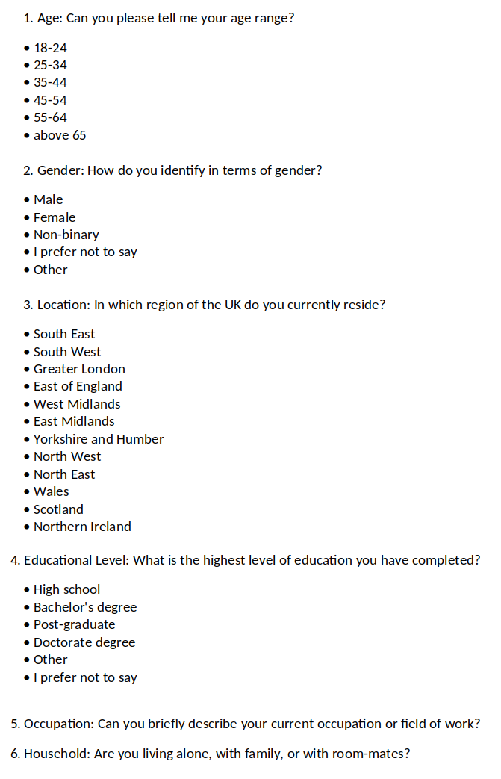

Appendix 3 - Interview Questions
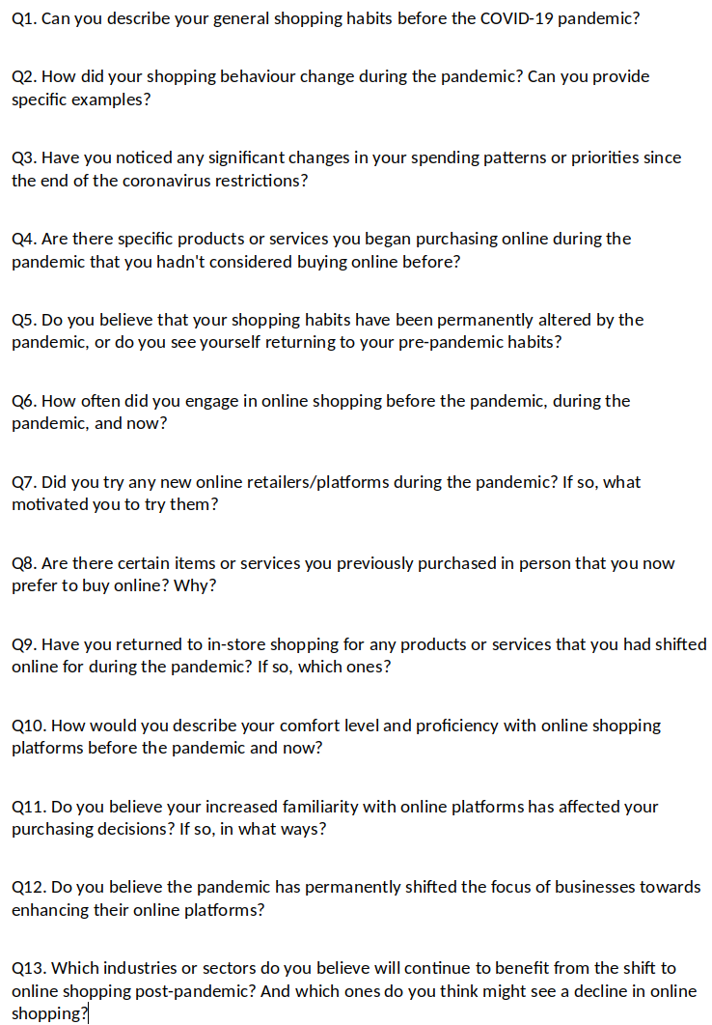
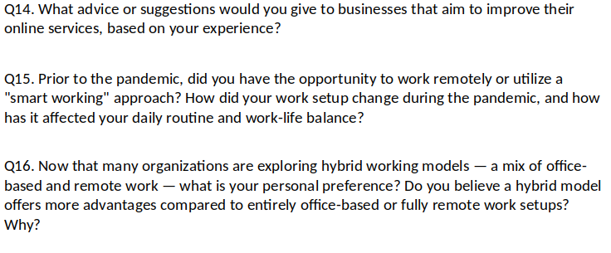

Appendix 4 - Analysis of Emergent Themes

Voices of the participants grouped (Interviewee) | Meaning Interpretation (Researcher) | Concepts/Themes identified
Before the COVID-19, I rarely used the Internet for shopping. I thought it was an unreliable platform, but little by little, during the coronavirus, I started making some purchases due to the needs arising from the pandemic, and I was positively surprised by this type of solution. (F)  Before COVID-19, I bought everything in stores because I didn't trust e-commerce. (L)  Before COVID-19, I did not even have an Amazon Prime subscription as I preferred to shop in physical stores because I thought buying a product by seeing it in person rather than on a web page was more reliable. (B)  In my case, COVID-19 has normalized e-commerce, breaking down my prejudices and making me gain trust in it (F).  Since COVID-19, my online shopping has increased significantly, and I continue to do so regularly. To make you understand, before COVID-19, I did not even have an Amazon account. So COVID-19 gave me the push I needed. (H)  During the pandemic I began using Amazon and other internet retailers for convenience, simply because it was easier to obtain products online compared to visiting the physical store. (E)  As COVID-19 progressed, I realized that buying online is convenient. Especially, I feel protected by the excellent return policies. (L)  Before COVID-19, I generally went and liked buying goods in physical stores. Then, unable to go to stores any longer as it had become difficult and dangerous, I began shopping online, particularly for clothing. Additionally, I started also doing a lot more grocery shopping online. (D) | Pre-pandemic online shopping scepticism.  Pandemic necessity leading to positive e-commerce experiences.  Breaking of preconceived notions.  Increased reliance on online shopping, initiation into e-commerce platforms due to the pandemic.  Transition to online shopping due to severe pandemic restrictions and for its convenience. | (1) Main Theme: There has been a significant transition towards online shopping since the beginning of the Pandemic.  (Sub1) Change in Consumer Perception of E-commerce.  (Sub2) The Role of Pandemic Restrictions in E-commerce Adoption to Overcome Preconceptions.  (Sub3) Pandemic-Induced Exploration, Adaptation and Appreciation.
Today, but already since the pandemic, I have continued to shop online because the lower prices compared to physical stores help me cope with the current crisis and inflation caused by the conflict in Ukraine. (B)  I have actually not gone back to shopping in physical stores for two good reasons. The first is economical; the second is that it is convenient to get the products shipped to your house. Moreover, I like online purchases' return policies better than in-store purchases. (F)  I shop online to help save cash and also, consequently, to manage the present increase in the cost of living. I feel the recession as well as inflation, instead of decreasing internet purchases, will result in a decline in in-store shopping while increasing online transactions because of their cost-effectiveness. (I)  I will not go back to my old habits, as when you try and see the comfort of internet shopping, it is difficult to return. (A)  Today, I can say I make the majority of my purchases online, which was impossible for me a couple of years ago! (L)  Today, I continue to shop online since I normally find better prices with the benefit that the items are sent straight to my home. (C)  Before the pandemic, I practically did not use to shop online. Then, during the pandemic, I started doing it due to the needs that arose with the lockdown, and now it has become an integral part of my routine. (E)  The pandemic forced me to open up to a world where I had very little confidence before. With this particular push, I got immersed in the new situation and also have been taught to make use of this new tool. These days, I continue using online shopping as it is convenient for personal reasons as I am a mum of two children, so I have little time to go to the stores physically. (D)  Online shopping has turned into a habit, and I have learned much more skills via experience. (G)  Now I know how to find exactly the same product in different online stores and compare its features in order to buy the best item at the best price. (H)  I feel more confident now! I have learned more about exploring websites, platforms and products and also looking at prices as well as features. (F) | Shift to online shopping due to lower prices, economic factors and convenience.  Routine integration of online shopping.  The necessity of the pandemic has led to the adoption and normalization of online shopping behaviours.  The pandemic served as a forced introduction to online shopping for some, leading to a greater appreciation and continued use of e-commerce.  Enhanced online shopping skills. | (2) Main Theme: The format in which Online Shopping has taken shape post the removal of Covid restrictions and reasons for its Continuance.  (Sub1) Convenience and Economic Benefits of Online Shopping.  (Sub2) Online Shopping as a Learning Process.
I was worried that I may be a victim of a scam, particularly because some individuals I know have complained about items delivered that were not as promised and that were not as described. However, both during the pandemic and now, I have personally seen the excellent level of security and reliability that these platforms offer when shopping online, especially when it comes to the most used platforms. (F)  Today, I can state I feel safer and also have gained trust in this particular kind of purchase. (H)  Now I feel at ease and also make purchases of a greater value than in the past. (E)  Important has been the simplified payment process, the speed of delivery, and the return/refund policies which safeguard the buyer. (B)  Once you've made a few successful purchases from the same online store, and they have your credit card information securely stored, and you've experienced no issues, you are more likely to continue shopping there in the future. (C)  Now, I feel more at ease and relaxed; therefore, I make purchases without overthinking because I am sure everything will go smoothly. Of course, before purchasing, always look at the reviews, as they are the only tool that can help me understand if I am purchasing the product I need or if the site is reliable. (G)  I always look at reviews before making any purchase. (B)  Of course, for unfamiliar online shopping platforms, I rely heavily on reviews. (D) | Improved trust in online platforms.  Significance of payment simplicity, delivery speed, and return policies.  The convenience of saved payment information leading to easier repeat purchases.  Reliance on Reviews for Online Purchasing. | (3) The importance of the Consumers’ Trust and enhanced Online Security in the adoption of Online Shopping.
I have decreased my usage of food delivery services, but I have increased the number of times I dine out at restaurants. I assume the balance is now 50-50 (H).  Nowadays, I alternate between buying food delivery and dining out. (G)  As for food delivery and clothing shopping, I shop less online than during lockdown since I have balanced out in-store shopping more. Nevertheless, my internet shopping for these things is still substantially higher than before the pandemic. (H)  In terms of clothes, I prefer to purchase every day and less costly items online. For the more expensive ones, I prefer to go to the store because it is easier to try on the clothes. (F)  Regarding grocery shopping, there are items such as meat and fish that I would rather go and select in person to choose items with lengthier expiration dates and make the best choices.(E)  When it comes to items like cheese, vegetables, fish, and meat, I like to go and select them in-store. Although online shopping continues to be beneficial, it is also true that they occasionally give you products nearing their expiration date. Therefore, if you select them yourself, you prioritize quality. (C)  Essentially, as the COVID-related restrictions have ended, I do online grocery shopping for recurring things in which the item's freshness does not matter, like bottled water or items I am currently knowledgeable about. "However, regarding fish, meat, vegetables and deli items, I would like to see them first-hand before I purchase them. (G) | Re-balancing Food Delivery and Restaurant Dining as pandemic restrictions change.  Selective return to in-person shopping for certain product categories like grocery shopping and clothes.  Return to in-store shopping for food prioritizing fresh products. | (4) Post-Pandemic Today's trend traces a possible hybrid future, where new preferences merge and rebalance with pre-pandemic habits.
Even greater security in payments is never a bad thing, especially when buying from less well-known websites. (F)  Delivery as fast as possible even in rural areas. (I)  I would like faster shipping with zero delivery costs without necessarily having to meet a minimum order value. (D)  Today, I would say that online services should be more human. This means having more accessible customer service, a person who answers the phone, understands your needs, and resolves the issue promptly. (C)  I don't like interacting with chatbots when I'm trying to reach customer service. (I)  It's better to interface with a person than with a chatbot in case of issues. (D)  I would prefer a more present but also more easily accessible customer service without the need to go through a chatbot that most of the time is unable to resolve the issue. (B)  They should provide a WhatsApp number with direct contact to a human operator, making the company feel friendly and available 24/7 online. Additionally, they could enhance the feedback system based on customer testimonials who have purchased the product. (A)  Sometimes I noticed that some well-known brands with physical stores offer fewer products online compared to what's available in their physical stores. (G) | Desire for increased payment security on less well-known sites.  Desire for free and faster deliveries.  Desire for Human Interaction in Customer Service  Desire for better feedback system based on customer testimonials.  Less variety compared to the physical store. | (5) Recommendations from Consumers.
During the pandemic, I subscribed to Netflix, and I continue using it. (F)  During the lockdown, I subscribed to Netflix, and I continue using it with enjoyment as it will make my nights enjoyable because I am not an individual who goes out very much at night. (L)  I started watching films in addition to TV series on Amazon Prime Video, Netflix and Disney Plus during the lockdown, and I still use those streaming services today. Nevertheless, although I carry on and keep my subscriptions active, I devote less time to making use of these services. I have also lately rediscovered the joy of visiting the cinema, so I go much more often. (C)  I still have Netflix and Disney Plus but have halved my use. This is also because these services have exhausted their "novelty effect," and I start to find the plots of the series similar and standardized. (G)  I subscribed to all these streaming services like Netflix, Prime Video and Disney Plus. Honestly, I would never have considered buying these services before the COVID-19 pandemic. However, since the end of the lockdown, I have cut back on hours of usage, and I will cancel at least one of them. (B)  After the reduction of pandemic-related restrictions, I cancelled Netflix because I go out more and have less time to stay at home. (H)  I recently cancelled all my streaming platform subscriptions because these services have consistently increased their prices over the years. (I) | Increase in the use of streaming services since the pandemic and maintained by people that spend more time at home.  Reduction in the utilization of streaming service while maintaining subscriptions.  Fluctuations in online streaming subscriptions as pandemic restrictions change.  Fluctuations in online streaming subscriptions due to increased prices. | (6) Observed Fluctuations in online streaming usage and subscriptions
I believe that a 50-50 hybrid work model, where some of the work is done in person and some remotely, is often extremely effective, particularly once the nature of the job permits it. This approach offers flexibility as well as adaptability to various situations and needs and can be an ideal solution for most people, enhancing the work-life balance. (F)  A hybrid working model where you can choose days based on your needs could be the right compromise. Working from home nowadays gives you the opportunity to focus better on certain tasks and work more peacefully, as working in an open space in the office can be chaotic at times (C).  Working entirely from home removes direct contact with people, and with this approach, there is much more difficulty in sharing information, so you don't arrive at a solution immediately as you do when you are in-person. Therefore, I think hybrid working is the best solution. (D)  I left the company I was working for because they required working solely from the office. Personally, I believe that the 50-50 hybrid model is the best compromise. This is because having some human contact is always beneficial. The risk of working from home is isolating oneself, and it may take more time to seek quick advice since communication is less immediate. Additionally, I find it enjoyable to have face-to-face conversations with colleagues . (E)  I'm one of those who are in favour of the 50-50 hybrid working model because, at least for my type of work, developing trust among colleagues or those who work for or with you is crucial. With this formula, I have improved my work-life balance, certainly because you save an hour of your time for commuting, making it less stressful. You also save on petrol, commuting costs, so definitely from that perspective, it has been an improvement. (B)  Hybrid working has the advantage of allowing you to travel less during the week, reducing stress significantly. (A) | Preference for hybrid work models post-pandemic due to its flexibility.  Hybrid working to allow to be more focused on certain task as open space in the office can be chaotic at times.  Preference for a hybrid work model, recognizing the benefits of social interactions at the workplace.  Preference for a hybrid work model as a way to save money and reduce the stress. | (7) The Hybrid Work Model as the New preferred Standard

