Workplace Culture and its impact on Organizational Efficiency (Domino’s Company)

Student name / id: Abel Paul Sandu 1911041

Lecturer name: Uju Ugochukwu

Program name: -BA-Management and Leadership - Skills for the workplace

Module name /code: Workplace culture and its impact on organizational efficiency BMSW5105

Assignment title: Individual report (Domino’s Company)

Date: 17.07.2021

Table of Contents
Table of Contents 2
1. Introduction 3
2. Main Body 4
2.1 Application of PESTLE and Competitiveness for Dominos and identification of key drivers for changes 4
.2 Detailed Analysis based on cultural web model regarding the culture of Dominos (appendix 1) 9
2.3 Explaining the term Ethical Dilemma and identification of two ethical dilemmas that are needed to be resolved 12
3. Conclusion and Recommendation 15
Reference 16
Appendices 18
Appendix 1 (Interview Questions based on 4 managers in Dominos in the UK) 18

1. Introduction
Workplace culture is defined as the fundamental beliefs, attitudes, assumptions, values, and behaviors of organizational members. It is essential to build workplace culture to obtain higher organizational efficiency along with possessing distinctive values, attributes, beliefs, and behaviors patterns. As stated by Cohen (2020, p. 183), effective organizational culture includes all the values, practices, codes of behavior that reflect on the mission and vision of statements of the organization. As per the case study, Dominos is the second-largest concatenation along with 60 international markets. In the UK also the company has a strong brand image which has enhanced the customer base. Regarding its organizational culture Dominos is a multicultural workplace and employees of the organization are from diverse cultures that impact workplace efficiency positively as they share their views to improve the work culture. To reach the organizational business goal Dominos train their workers about professional morals, societal morals as well as individual morals. However, the present assessments ascertain the detailed analysis of the cultural web model as well as application of Porter's five forces and Pestle analysis based on Domino's workplace culture.

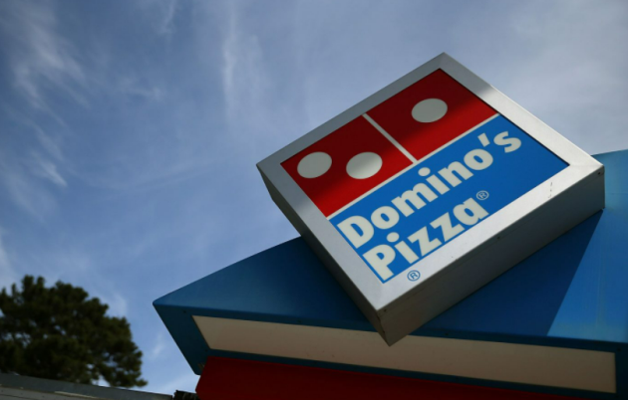
Figure: 1 Domino’s Logo
(Source: Dominos.com. 2021)

2. Main Body

2.1 Application of PESTLE and Competitiveness for Dominos and identification of key drivers for changes

PESTLE

Factors | Impacts
Political Factor | In around 85 countries Dominos operates as a multinational pizza restaurant and adjusts itself based on the political environment of respective countries (Domino's Pizza. 2021). The regulations on food quality, hygiene, wages vary from country to country that impacts their costs. In the service sector industry safety regulations, wage legislation, and intellectual property protection are under political factors that determine the price of products and services of Dominos. As an example, the UK is a politically stable country and there are fixed rules in pricing regulation, as a result, the restaurants provide good wages to employees and the best services to the customers.
Economic Factor | Unemployment- the economic factors such as inflation, unemployment rate, deflation wage policies affect the business performance as well as conditions of economic growth (Stirati, and Meloni, 2018, p. 495). From the beginning of the pandemic, Dominos has been suffering from a lack of employees and work labor, and their economy gradually falls. The unemployment issue is gradually increasing in the UK market, and this is an opportunity for the management of Dominos to reduce the unemployment rate.
Social Factor | Cultural Diversity- the culture of different societies and methods of doing things impact the organizational culture (Meng, and Berger, 2019, p. 65). Based on demographic trends, structural power of the social impact both marketing as well as operational aspects of Dominos. The organization understands the value of customers’ lifestyles, beliefs, and attitudes of the diverse cultures. Thus, they focus on the innovation their products accordingly. The social status distribution of the population is important to Dominos and considering this Dominos would not be able to launch a premium product to the general customers. It would go for niche marketing regarding most of the population of the place.
Technological Factor | Contactless delivery at the front door- As a global enterprise Dominos provides contactless food delivery at customers’ front door through the mobile application. The digital channels of the company take online orders and serve the consumers at their homes. With the partnership of Nuro, Dominos explores its business innovation to introduce autonomous pizza delivery. The company focuses on customers’ safety and hygiene aspects with the help of mobile applications.
Legal Factor | Data protection and privacy legislation- the government institutions and legal framework vary from country to country (Baldini et al., 2018, p. 80). In the UK Dominos maintains the data protection act 1998 such that Dominos group keeps their privacy of employees’ data or any confidential information. The company also updates its laws and regulations based on anti-bribery policy such that employees would not involve any corruption within the workplace.
Environmental factor | Waste Recycling- Dominos highlights the standards and environmental trends in different markets that increase the profitability of the organization. Regarding environmental concerns, Dominos knows the consumers’ activism and uses environment-friendly packages that easily enter the recycling stream. The pizza boxes are technically recyclable that reduces the waste in the environment. Based on environmental policy Dominos enables it to adhere to waste management in different countries.

Competitiveness of Domino’s

Competitive Elements of the Market | The impact of the Competitor’s
Competitive rivalry in an existing firm (High) | In the food manufacturing industry, the number of competitors is increasing day by day (Simensen et al., 2018, p. 50). In the existing firm KFC, PizzaHut is the strongest competitor of Dominos that makes a stronger force within the industry. Regarding the competition, Dominos operates with fixed costs products and services to the customers. Every year Dominos expects to continue by launching new products to beat the competition that makes a stronger force in the industry.
The threat of new entrants for Domino’s (moderate to low) | In order to achieve the business value in the industry, the economies of scale are difficult in which Dominos operates. Producing large capacitates makes it easier to have a cost advantage as well as production costlier for new products that identify as a weaker force of new entrants. The distribution networks can easily set up their channels for new entrants that make a powerful force for the business. However, Dominos focuses on innovation and builds brand identification on spending in marketing.
The threat of substitute products or services (High) | In the market, there are lots of substitute products that are easily available to the customers that make a stronger force of the substitute products and services (Palapa et al., 2020, p. 1747). Therefore, some substitutes are having high quality and more expensive comparatively Domino's products that make a weaker force of substitute products. However, to tackle the threats Dominos provides greater quality with reasonable price to attract the most customers and offers the best services as well.

Key Drivers for changes
From the overall assessment, it has been seen that the important key drivers such as technological factors, the threat of substitutes, and competitive rivalry need to be updated based on the present trend of the market. Within the fast-food industry, there are so many substitute products that increase the competition in the market (Shams et al., 2021, p.9). Regarding these Dominos focuses on the quality of the products such that customers can differentiate from other products. The company also maintains hygiene in food manufacturing by using advanced technology that produces food without manual interaction. Over the past decade, Dominos found more innovative ways to offer their services such as touch-free services at the doorstep of the consumers. In the mobile application, Dominos utilizes a GPS driver to track the order place and deliver the products at one click.
Not only the company adapts GPS drivers but also implements voice automation that makes unique brand value in the competitive market. Among the existing firms’ Domino's pizza focuses on marketing strategies such that it could retain customers as well as make a strong customer base. In order to beat the competition, the company conducts market analysis to make out the supply-demand situation and prevent overproduction within the industry. However, the research team of the company also must identify the social culture such as customers’ attitudes, lifestyles, demands, and views such that they can cope with the customers’ trends and it helps to increase more customers in the market. To enhance the customers’ satisfaction Dominos would focus on Robot delivery systems implementing voice learning systems that would help to place orders in the right location. Though there are several organizations including Pizza Hut, Mcdonald, Subway leading pizza manufacturer, Dominos focus on new consumers providing unique quality products to minimize the rivalry effect in the industry.

.2 Detailed Analysis based on cultural web model regarding the culture of Dominos (appendix 1)
Throughout the globe, Domino's pizza builds a mega-brand crossing 85 countries in the world. They have employed more than 165,000 employees and generated 2,4 GBP annually (Dominos.com.2021). As per the interviewees, it could have been mentioned that Dominos follows a multicultural organization where employees are from diverse cultures, and they have individual morals. Dominos is a customer-focused company that is mentioned by one of the interviewees and it has a brand culture along with innovation in delivery systems. Thus, adapting to diverse cultures helps the company to achieve the desired results. As per the cultural web model, various actions and behaviors are acceptable in the organization. The organizations provide training to the employees that understand the expectations and constitute normal behavior that helps the employees to stay productive. However, Domino's organization prepares its employees by following the professional and social ethics that are mentioned in the interview session.

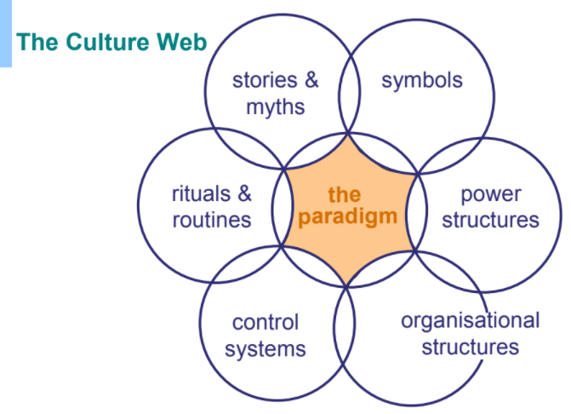
Figure: 2 Cultural Web model
Source (Hajli et al., 2018, p. 30)

The company Dominos maintains a hierarchical structure that includes the president, chief financial officer, manager of human resources, and manager of several departments that have been said by the interviewees. In the structure, the president is in the highest position and supervises the production of the company. The highest positions also look after the intersectional section; however, the chief financial officer is responsible for the cost of production and manages the financial departments including the outcomes and earnings of the company. According to the cultural web model, the organization describes working responsibilities into several departments that encourage employees to perform their best services. As per the two interviewees, the human resource managers look after the growth of the production systems and the post is also responsible for the improvement of human resources departments and they also mentioned that the behavior of HR managers is quite boorish that the employees could not express their views within the organization. In addition, the managers of several departments keep an eye on the food quality and food production as well.

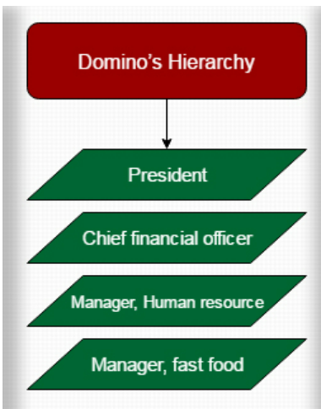
Figure: 3 Organizational structures of Dominos
Source (Domino's Pizza. 2021)

All over the world, Dominos is a successful business that adapts to diverse cultures in order to expand its business. According to the participants in the interview session, Dominos determines the cultural differences based on various countries that help to explore its stores and increase the revenues. Adapting different cultures’ attitudes, values can satisfy the existing customers and build brand value improving the customers’ base in the market. As per the cultural web model, different rituals and routines are acceptable by the company that enhances the daily activity of the company, and they understand the company expectations and feel a part of corporate culture within the company. Dominos also analyzes the needs and demands of the customers to maintain its reputation in the market that was evaluated by the interviewees. The company also develops a collaborative communication strategy such that employees share their relevant experiences and improves interpersonal communication systems within the company. According to the participants, the in-house team of Dominos operates the social sharing tools to share their posts and photos on social media.

According to the participants, the organizational goal of the Dominos is to provide food services to the potential customers in the market by following business development policy. The executive teams of the Dominos committed to providing speedy services by implementing mobile applications. As per the cultural web model control systems evaluates the performance management system and the symbols influence the organization branding along with the advertisements. Regarding this Dominos updates their organizational policy to adapt to diverse cultures such that they can provide services to all people in the business market. The company would take the policy of rewarding systems that encourage the employees to perform their individual tasks. Pulling the new clients, the company develops its marketing strategies to increase revenues in the competitive market. However, the company adapts health and safety policy to feel the employees secure in the company environment.

2.3 Explaining the term Ethical Dilemma and identification of two ethical dilemmas that are needed to be resolved

Ethical Dilemma and identifying two ethical dilemmas
As opined by Mirnig, and Meschtscherjakov(2019, p. 5), a moral dilemma or ethical dilemma refers to a problem in the decision-making process between two viable options. Human beings face different ethical problems in their lives including racism, caste and in most cases, the solutions are straightforward i.e., separation from each other. Therefore, ethical dilemmas cannot be solved because they are extremely complicated challenges to find solutions (Morris et al., 2018, p. 548). In business, organizations maintain codes of conduct to handle ethical dilemmas within the organizations. Regarding the ethical norms, companies should develop ethical standards for their workers, co-workers, clients, management, and business partners. However, some ethical issues are covered by the laws within an organization such that the company can keep its reputation in the market.

Discrimination
The 21st-century business world is affecting by the biggest ethical issues discrimination. Lacking a diverse workforce many organizations have come under fire in the last few months. As per the view of Galeazzo et al., (2019, p. 281), dissemination happens in any size organization that affects the employees’ performance because of unequal treatment. Based on gender, race, age, religion, disability employees can be discriminated within the organizational environment. The other instance of discrimination is firing employees and giving fewer promotions to the workers of ethnic minorities. Discrimination is not only unethical but also illegal that affects employees’ professional rights. In the case of many services, women are rejected based on the unethical assumption that women are not able to understand machinery (Dhanani et al., 2018, p. 148). Even they are deprived of a supervisory position though they have the ability to tackle the designation in the company. However, several instances of discrimination must be resolved in the organization which is required for the proper running of the operations of an organization.

Health and safety
The ethical identity of health and safety are protected by the law. Organizations may cut the corners to minimize costs and perform tasks faster. Lack of autonomy, job insecurity, injuries can cause work-related stress in between the workers. From the point of view of Moyce, and Schenker, (2018, p. 352), the ethical component of safety and health is an emerging discipline that should be transparent. The organizations must follow the health and safety act to support the employees and enhance the safety profession that builds accountability within the organization. However, companies should set measurable health and safety plans to enhance the employees’ performance.

Action Plan

Ethical Dilemmas | Strategies of overcoming Dilemmas
Discrimination | In order to tackle the discrimination dominos, observe the employee’s performance growth and reward them for better performance (Dominos.com, 2021). The company also develops action plans to monitor the workers’ activities. The managers and executive team enlist the outside experts to make important decisions and they also collect feedback from the employees such that they do not feel unequal in the organization. Hiring the experts’ team in Dominos, they gather data of employees’ population and make recommendations for incremental changes. The company should also follow the open forum to tackle the misunderstanding among the companies and cultivate cultural diversity such that employees who are from different social statuses would realize the individual value in between the organization. By providing proper training to the employees the organization sets the core values and builds a better, healthier, and stronger working environment, and establishes healthy relationships among employees and clients as well.
Health and safety | In the workplace, health and safety ethical aspects include the prevention of diseases, work-related incidents, or injuries. In order to maintain hygiene Dominos, set their health and safety agenda for the employees. They also provide training on how to run the food manufacturing machines and maintain safe work procedures within the company. In the food manufacturing industry hygiene is the most principal factor because customers, as well as employees’ safe health, depend on it. Considering safety rules, the effective team inspect the working place and check all equipment and tools that are used to produce foods. Regarding the pandemic, the Dominos stores maintain safe food delivery to the customers. Based on health rules all stores are using frequent sanitation of dominos counters, hot bags, and food preparation areas. The employees and delivery boys wash their hands before and after every delivery run.

3. Conclusion and Recommendation
In the modern business world, organizational cultures connect the members and develop the cultural value of the company in the market. From the assessment, it can be analyzed that friendly organizational cultures enhance the employees’ efficiency that also increases the company’s growth. The assignment also evaluates the business innovation of Dominos with the analysis of Pestle and Competitive elements of the market as well as demonstrates the ethical dilemmas. Therefore, it also evaluates the strategies to tackle the ethical dilemmas within the organization. Indeed, the cultural web model analyzes organizational culture with the development strategies. However, it can be recommended that the collective attitudes of the workers within a company can enhance the company’s performance as well as brand value in the competitive business market.

Reference
Baldini, M., Dal Maso, L., Liberatore, G., Mazzi, F. and Terzani, S., 2018. Role of country-and firm-level determinants in environmental, social, and governance disclosure. Journal of Business Ethics, 150(1), pp.79-98.
Cohen, D.V., 2020. Ethics and crime in business firms: Organizational culture and the impact of anomie. In The legacy of anomie theory (pp. 183-206). Routledge.
Dhanani, L.Y., Beus, J.M. and Joseph, D.L., 2018. Workplace discrimination: A meta‐analytic extension, critique, and future research agenda. Personnel Psychology, 71(2), pp.147-179.
Domino's Pizza. 2021. Management | Domino's Pizza. Available at: <https://dominos.gcs-web.com/corporate-governance/management> [Accessed 30 June 2021].
Dominos.com. 2021. Domino's Home Page - Domino's Pizza, Order Pizza Online for Delivery - Dominos.com. Available at: <https://www.dominos.com/en/> [Accessed 30 June 2021].
Furlan, A., Galeazzo, A. and Paggiaro, A., 2019. Organizational and perceived learning in the workplace: a multilevel perspective on employees’ problem solving. Organization Science, 30(2), pp.280-297.
Heir, E., Møretrø, T., Simensen, A. and Langsrud, S., 2018. Listeria monocytogenes strains show large variations in competitive growth in mixed culture biofilms and suspensions with bacteria from food processing environments. International journal of food microbiology, 275, pp.46-55.
Hifza, J., Palapa, A. and Maskur, A., 2020. The Strategic Foundation for Competitive Excellent Development in Integrated Islamic Primary Schools in Indonesia. Int. J. Adv. Sci. Technol, 29, pp.1747-1753.
Kipperman, B., Morris, P. and Rollin, B., 2018. Ethical dilemmas encountered by small animal veterinarians: characterisation, responses, consequences, and beliefs regarding euthanasia. Veterinary Record, 182(19), pp.548-548.
Li, Y., Wang, X., Lin, X. and Hajli, M., 2018. Seeking and sharing health information on social media: A net valence model and cross-cultural comparison. Technological Forecasting and Social Change, 126, pp.28-40.
Meng, J., and Berger, B.K., 2019. The impact of organizational culture and leadership performance on PR professionals’ job satisfaction: Testing the joint mediating effects of engagement and trust. Public Relations Review, 45(1), pp.64-75.
Mirnig, A.G. and Meschtscherjakov, A., 2019, May. Trolled by the trolley problem: on what matters for ethical decision making in automated vehicles. In Proceedings of the 2019 CHI Conference on Human Factors in Computing Systems (pp. 1-10).
Moyce, S.C. and Schenker, M., 2018. Migrant workers and their occupational health and safety. Annual review of public health, 39, pp.351-365.
Shams, S.R., Vrontis, D., Weber, Y., Tsoukatos, E. and Santoro, G., 2021. 1 The Relevance of Business Model in the Current Era. In Business Model Innovation: New Frontiers and Perspectives (pp. 1-10). Taylor and Francis Inc...
Stirati, A. and Meloni, W.P., 2018. A short story of the Phillips curve: from Phillips to Friedman… and back? Review of Keynesian Economics, 6(4), pp.493-516.

Appendices

Appendix 1 (Interview Questions based on 4 managers in Dominos in the UK)

1. Do you think the organizational culture in Dominos is effective throughout the globe?

2. Do you think the organizational structure is effectively maintained by Dominos?

3. Can you explain the cultural development strategies in Dominos?

4. Can you explain the policy through which cultural development helps the company to achieve organizational goals?

