Assignment - The Blog

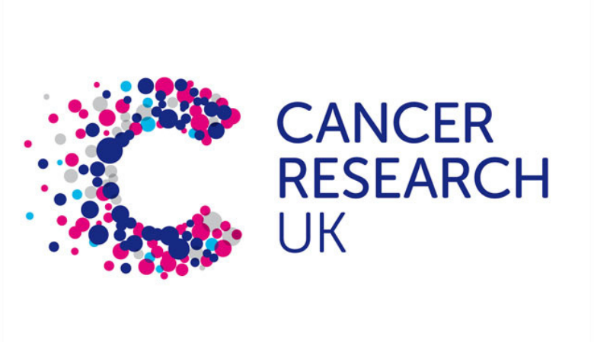

Cancer Research UK- The Funding
Cancer Research UK is a charity that is well known and are fighting the fight against cancer which ales a variety of different people but to combat this grave illness they need funding! Cancer research raises funding by doing donations which could be in the event of the death of a person who may leave a clause in their will which they say they will donate a certain amount to the charity, this is a big contributor to funding for Cancer research UK.

Fund raising is a big part of Cancer Research UK as it makes a massive difference with how they research and conduct their efforts, one of the main types of fund raising is events such as runs, cycling, hiking, swims, triathlons and plenty more these are important to the charity because it is a massive form of their funds to research and try and cure cancer.

Cancer Research UK also gets funding from the government which is one of the largest contributors to funding for Cancer Research UK as they give approximately £112 million pounds for the charity to Research and study cancer cells and cancer growth and progression.
There are a wide variety of individuals who do these runs according to Patrick who ran in the Cancer Research run he said that "I decided to give it a go for a great cause”. They also get funding from their shops as they have “a retail chain of over 600 shops”.
When Cancer Research UK have an event such as a race for life, they get sponsors that help raise money such as in the case of Stevenage Race for Life as they raised £85,000 for Cancer Research UK, during this race “up to 1000 people took part”. An attendee who ran the race for life, Louise stated that she had been “receiving treatment” and she had “chemotherapy and radiation” for “18 months” and that the end of the run for life make the end of her treatment! She also said that she was “overwhelmed that so many people came out to support me”.
Cancer research UK has many used for the funding that they receive as their goals and objectives that I mention in my next blog tell you all about their goals which we need a lot of funding for as there will be a heavy need for research as we intend to research and create new treatment and cure for this killer disease, we also need funding as we are planning to try and increase the survival rates of the patients who survive the surgery form cancer by another10 years by 2034 and to do this funding will be a massive requirement as it will help massively in the progression in the name of curing cancer.

Cancer Research UK- Goals and Objectivise



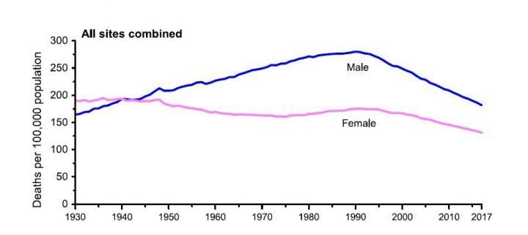

Cancer Research UK goals and objectives
Cancer Research UK main goal to accomplish is to one day prevent all types of cancer and cure it so nobody has to suffer from this type of disease again! Cancer Research UK have said that their vision is “our vision is to bring forward the day when all cancers are cured.” This is a positive goal to strive for and Cancer Research UK have been doing the upmost to research and try and find a cure for this deadly disease by providing money to researchers to find a cure to the illness faster so that more deaths are prevented by the efforts of Cancer Research UK.
While cancer isn’t preventable yet! Cancer research UK are finding ways to at least minimize the effect of the disease by developing new treatments and trying to diagnose it sooner to save more lives and as a result the cancer death rate declined by 29% from 1991 to 2017 (as you can see from the graph above) this is because there have been new treatments developed and we have become better at diagnosing the illness before it spreads to far causing it to become deadly! One of the best forms of cancer reduction is chemotherapy as it causes the tumours caused by the cancer cells to shrink allowing specialists to operate and remove the deadly tumours this is a big advancement caused by the goals and objectives that Cancer Research strives for.
Cancer Research UK goals are numerous as they have a lot that we want to accomplish for example we want to see three quarters of people diagnosed with cancer survive their disease for 10 or more years by 2034. This would be a huge achievement as it will be extending patients’ lives and their futures by a drastic amount of time in just a short 10 years, we hope to see a change in the mortality rate and the extension of life for all cancer patients and survivors, this will not only benefit the patients and their families but it will be a drastic bound forward in the field of research and progression in the case of cancer research. There are many specialists and researchers involved with cancer research as it is a massive issue and project but with the determination and the efforts of the people associated with Cancer Research UK the goals and objectives will be met eventually as we all strive for the same goal which is curing this so called “uncurable disease”

Evaluation

I have been writing 2 blogs about Cancer Research UK the aspects I have been focusing on are the funding that we get and the charities goals and objectives, I have done an in depth look at the funding and the goals which is why I believe that blogs that I have written help with the marketing of the charity as it will help the charity get recognition and hep the achieve more donations as I have not only provided the readers with key and valuable information I have also given them an understanding on what the charity does to make their funding and what the charities main goals and values are so I think that my blogs help with the overall marketing and attention that the charity will receive as they are giving people.
The first blog that I composed consisted of how the charity got their funding when writing this blog, I included multiple sources on where they got their funding from and how. They got some of their funding from the government but a massive part of the funding that they receive is from donations such as a donation in peoples will and just donation monthly I believe that this is helping the charity with marketing as I wrote about a numerous of different ways to donate and help them get funds another way they get funds is through charity related events such as fun runs help the charity get donations by having people run and get sponsored for them, in my blog I mentioned a run that happened in Stevenage race for life as they raised a whopping £85,000 for the charity. I think this is a way that my blog is helping the charity gain awareness and recognition as it is directly telling people how to make money for the charity and what to do in order to help get donations.
The second blog that I did was about what the charities main goals and objectives where I talked about how the charities main goals where to extend their patients who recovered from cancer by 10 years by 2034 and how they are constantly looking for new and better treatments to help cure the disease. I believe that my blog heled with the marketing of the charity because I explained what their goals and objectives where and how they intended to reach the, I think that this helped with the marketing because it helped get their intention out there to more people so they would see the intention of the charity and want to help by doing things mentioned in my first blog such as charity fun runs or even leaving s condition in their will about donation a certain amount to the charity to help them achieve the goals and objectives that I mentioned in my blog.

If you would like to read more about this then please go to websites below:
https://www.blogger.com/blog/post/edit/7454017022606769074/1361759155203898494?hl=en-GB
https://www.blogger.com/blog/post/edit/7454017022606769074/6417534410658607016?hl=en-GB

Reference list:
Cancer Research UK
https://www.cancerresearchuk.org/get-involved/volunteer/about-cancer-research-uk#:~:text=We%20raise%20funds%20through%20donations,chain%20of%20over%20600%20shops.
Date published: April 13 2021

Stevenage Race for Life raises £85k
https://www.thecomet.net/news/23646126.stevenage-race-life-raises-85k-cancer-research-uk/

Date published:11 July 2023

