

Cultural Awareness

November 27

.
Report by: SYED AHMED (2107824)

Executive Summary
This report will discuss country and the cultural differences to provide the handbook for staff to be successful in the hotel service delivery.

Culture reflects the mission of the company, which ultimately affects the experience of workforces and clients. That is why it is important to be deliberate about educating a specific culture that celebrates diversity.

Introduction

Hofstede’s Cultural Dimensions Theory

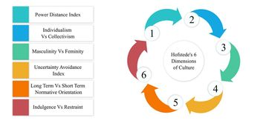

Hofstede's Cultural Dimensions Theory, created by Geert Hofstede, is a framework used to recognise the differences in culture across countries.

Hofstede’s based it on six key dimensions which are the following; power distance, masculinity-femininity uncertainty avoidance, individualism-collectivism and short vs. long-term orientation. Later on, researchers added restraint vs indulgence to the Cultural Dimensions.

Hofstede’s cultural dimensions are used by many to understand etiquette and help communication across cultures, in areas ranging from business to mediation.

This report will focus on the application of Hofstede model on cultural differences by applying the model to different countries and exploring what their cultural differences are.

United Kingdom (Hotel Location)

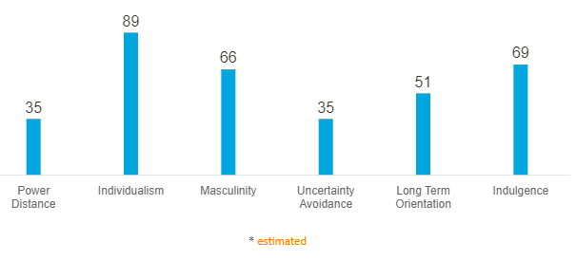

Power Distance is defined as the extent to which the less powerful members of establishments and administrations within a country think and accept that power is distributed unequally.
- At 35 Britain sits in the lower rankings of PDI – i.e., a society that believes that inequalities amongst people should be minimized.

Individualism. The fundamental issue addressed by this dimension is the degree of interdependency a society preserves among its members.
- At a score of 89 the UK is amongst the top of the Individualist scores. The British are a very Maverick and private people. Kids are taught from young to think and look out for themselves, also to find out what their purpose in life is and how they can make a unique impact to society. The British route to happiness is through personal fulfillment.

Indulgence. This dimension is defined as the extent to which people try to control their wishes and urges, based on the way they were raised.
- Score of 69 shows that the British culture is one that is classed as Indulgent. To be scored in Indulgence generally exhibit a willingness to realise their wishes and urges with regard to loving life and having a good time. The British possess a positive attitude and have a tendency towards being confident.

Japan (Guests Location)

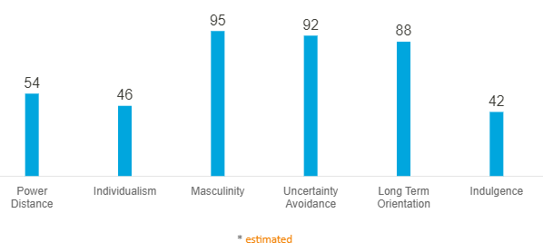

Power Distance
- At a score of 54, Japan is unclear of hierarchical society. Japanese are always aware of their ranked position in any social setting and act accordingly. Many people experience Japan as very hierarchical because of their business experience of extremely slow decision-making process. This is because all the decisions must be ok’d by each hierarchical layer and eventually by the final management.

Individualism
- Japan scores 46 on the Individualism dimension. Undoubtedly Japanese society shows many of the characteristics of a collectivist society: such as putting agreement of group above the expression of individual thoughts and people have a sense of shame for losing face. The Japanese are more private and reserved than most other Asians.

The dimension Uncertainty Avoidance is to do through the way that a society deals with the fact that the future will never be known. Uncertainty creates anxiety and different cultures have educated to deal with this anxiety in different ways.
- At 92 Japan is one of the highest uncertainty avoiding countries. This is mainly due to the fact that Japan is constantly threatened by natural disasters such as tsunamis.

Country Analysis

No eating or drinking on-the-go
If part of your daily routine is grabbing a coffee to-go to start your day, this is a habit you shouldn’t expect to keep while in Japan. The Japanese find it rude to eat or drink while walking or using public transportation.
The Japanese consider a meal that requires adequate time and comfort. The Japanese are prepared to wait to enjoy food and drink properly.

Hygiene
Cultural conceptions of cleanliness provide some of the starkest contrasts when traveling abroad. And in such a densely-populated country where space is so precious, hygiene customs are incredibly important. Moist towelettes will be provided at most public places.

Punctuality
Seeing a businessman in a suit with a briefcase sprinting down the street is not something you see very often in the United Kingdom, but this is rather common in Japan. Punctuality is crucial in Japan, and showing up even a few seconds late can be interpreted as very disrespectful.

Hotel Handbook
The table below is a handbook for training purposes in understanding cultural behavior and delivering the appropriate service to guests of each country.

 | United Kingdom | Japan
Meeting and greeting | A handshake is the most used greeting, and should be firm yet not too strong.  When greeting each other, close friends may hug or kiss one on the cheek, while others may simply offer a nod. | The Japanese handshake is limp and with little or no eye contact.  Some Japanese bow and shake hands. The bow is a greeting to show respect and is appreciated by the Japanese.
Cooperate Culture | In Great Britain, punctuality is important for business meetings. Be on time.  Brits prefer a friendly business relationship, but like to get straight to business after a few moments. | Punctuality is crucial in all business and social meetings.  Any amount of knowledge of Japanese culture is greatly appreciated.
Body Language | The British like a certain amount of personal space. Do not stand too close to another person.  Staring is considered rude. | Nodding is very important. When listening to Japanese speak, you should nod to show you are listening and understanding the speaker.  Do not stand close to a Japanese person. Avoid touching.
Gifts | When invited to someone's home, always bring a small gift. Present the gift upon arrival.  Gifts are opened upon receiving. | The ritual of gift giving is more important than the value of the gift.  Correct wrapping is very important. Appearance counts for as much or more than the contents.
Extra’s | Never try to sound British or mimic their accent.  Men should open doors for women and stand when a woman enters a room. | The Japanese do not express opinions and desires openly. What they say and what they mean may be very different.  Do not expect a Japanese person to say "no." "Maybe" generally means "no."

Conclusion

Cultural awareness helps us break down cultural barriers, build cultural bridges, and learn how to appreciate and understand those different from us. We can relate better to people with cultural differences and create relationships as we begin to understand ourselves better. This results in more cultural connection and less conflict.

Culture refers to the symbols, language, views, principles, and artifacts that are part of any society. Because culture influences people's beliefs and behaviors, culture is a key concept to the sociological viewpoint.

