 Development Emotional Intelligence Skill
Module Code: LCLM5006
Lecturer Name: Nishi Ramsurron
Student Name: Rahmia Kamil
Student ID: 2335591

Table of Contents
Introduction………………………………………………………………………..........................................1
Emotional Intelligence Models……………………………………………………………………………………2
Goleman’s Emotional Intelligence Model……………………………………………………………………3
Emotional Intelligence Improves Communication and Collaboration………………………….4
How Emotional Intelligence Supports Employee Well-being……………………………………….5
Critical Evaluation of Emotional Intelligence Models………………………………………………….6
Critical analysis of application of theories to the workplace ……….……………………………..7
Conclusion………………………………………………………………………………………………………………….8
Reference……………………………………………………………………………….....................................9

Introduction
Traditional approaches to management that focus primarily on technical competence and operational performance are no longer sufficient to meet the demands of modern organisations. Today's workplaces are characterised by rapid technological change, diverse workforces, increased collaboration, and greater awareness of employee wellbeing. As a result, organisations require leaders who can not only achieve business objectives but also build positive relationships, manage conflict effectively, communicate with empathy, and create supportive working environments. Consequently, emotional intelligence (EI) and mindfulness have become increasingly important in leadership development and organisational management because they enable employees and managers to understand emotions, improve interpersonal relationships, and make more balanced decisions. Following a recent organisational climate survey, senior leadership identified significant improvements in team morale, communication, employee engagement, and conflict resolution within one department. These improvements were largely attributed to the successful application of mindfulness practices and emotional intelligence principles during leadership interactions, team meetings, and workplace problem-solving activities. Employees reported feeling more respected, listened to, and supported, while managers demonstrated greater empathy, self-awareness, and emotional regulation when responding to workplace challenges. These positive outcomes indicate that integrating mindfulness and emotional intelligence into leadership practices can contribute to higher levels of organisational effectiveness and employee wellbeing. Mindfulness supports individuals by encouraging present-moment awareness, focused attention, and non-judgemental reflection, enabling employees to regulate emotions more effectively and respond thoughtfully rather than react impulsively.
Emotional intelligence complements mindfulness by helping individuals recognise, understand, and manage their own emotions while also understanding the emotions of others. Together, these capabilities strengthen communication, collaboration, resilience, conflict management, and leadership effectiveness, creating psychologically safe workplaces where employees feel confident expressing ideas, raising concerns, and contributing to organisational success.
The purpose of this report is to provide the Senior Management Team (SMT) with a critical analysis of how mindfulness and emotional intelligence can enhance employee performance, leadership capability, and organisational culture. The report examines the major models of emotional intelligence, evaluates their strengths and limitations, analyses their application within workplace settings, and explores how emotional intelligence contributes to employee wellbeing, inclusive leadership, psychological safety, and effective communication. Finally, the report provides recommendations to support future decisions relating to leadership development, employee training, recruitment, and organisational development strategies
Emotional Intelligence Models
Emotional intelligence (EI) refers to the ability to recognise, understand, manage, and use emotions effectively in oneself and others. Since the concept gained prominence during the 1990s, several theoretical models have been developed to explain how emotional intelligence influences behaviour, decision-making, relationships, and workplace performance. Although these models differ in their underlying assumptions and areas of focus, they all emphasise that emotional awareness and regulation are essential for effective leadership, teamwork, communication, and organisational success. The three most influential models are the Mayer and Salovey Ability Model, Goleman's Emotional Intelligence Competency Model, and Bar-On's Emotional–Social Intelligence Model.
Mayer and Salovey Ability Model
The Mayer and Salovey Ability Model views emotional intelligence as a form of cognitive intelligence that enables individuals to process emotional information effectively. Unlike models that include personality traits or behavioural competencies, this approach argues that emotional intelligence consists of specific mental abilities that can be developed and applied in different situations. The model is structured around four interconnected branches: perceiving emotions, using emotions to facilitate thinking, understanding emotions, and managing emotions.
The first branch, perceiving emotions, involves accurately recognising emotions in oneself and others through facial expressions, body language, tone of voice, and other non-verbal cues. This ability enables individuals to interpret emotional signals before responding to situations.
The second branch, using emotions, refers to the ability to use emotions to support thinking, creativity, decision-making, and problem-solving. For example, positive emotions may encourage creative thinking, while more cautious emotional states can promote careful analysis when making important decisions.
The third branch, understanding emotions, involves recognising the causes of emotions, understanding how emotions develop over time, and predicting how emotional reactions may change in different situations. Employees who understand emotional patterns are better equipped to anticipate conflict and respond appropriately before problems escalate.
The fourth branch, managing emotions, focuses on regulating emotions effectively in both personal and professional situations. Individuals with strong emotional management skills remain calm under pressure, respond constructively to criticism, and maintain positive relationships even during challenging circumstances.
This model provides a strong theoretical foundation for understanding emotional intelligence because it treats emotions as valuable information that influences judgement and behaviour. Within organisations, leaders who demonstrate these abilities can make more balanced decisions, manage conflict effectively, and support employees experiencing workplace pressures.
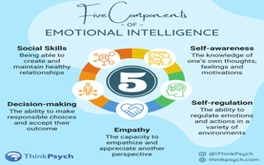
Goleman’s Emotional Intelligence Model
Daniel Goleman's Emotional Intelligence (EI) Model is one of the most influential and widely applied frameworks in organisational behaviour and leadership studies. Unlike Mayer and Salovey's Ability Model, which views emotional intelligence as a cognitive ability, Goleman defines EI as a collection of personal and social competencies that influence how individuals manage themselves and their relationships with others. He argues that emotional intelligence is just as important as technical expertise and cognitive intelligence in determining leadership effectiveness, employee performance, and organisational success. The model is particularly relevant to modern workplaces because it focuses on practical behaviours that can be developed through training, coaching, and workplace experience.
Goleman's model consists of five core components: self-awareness, self-management, motivation, empathy, and social skills.
Self-awareness is the ability to recognise and understand one's own emotions, strengths, weaknesses, values, and the effect these have on others. Individuals with high self-awareness are more likely to make balanced decisions because they understand how emotions influence their behaviour and judgement. In the workplace, self-aware managers can identify when stress or frustration may affect their decision-making and take appropriate action to respond professionally.
Self-management, sometimes referred to as self-regulation, involves controlling emotional reactions, remaining calm under pressure, adapting to changing situations, and behaving ethically. Employees with strong self-management skills are less likely to react impulsively during conflict or stressful situations. Instead, they remain composed, think rationally, and respond in ways that support positive workplace relationships. This competency is particularly valuable during organisational change, where resilience and adaptability are essential.
Motivation refers to an individual's internal drive to achieve goals beyond external rewards such as salary or promotion. Emotionally intelligent employees are often committed to continuous improvement, maintain optimism when facing challenges, and demonstrate resilience following setbacks. Their intrinsic motivation contributes to higher levels of productivity, innovation, and commitment to organisational objectives.
Empathy is the ability to understand and appreciate the emotions, perspectives, and experiences of other people. Empathetic leaders actively listen to employees, recognise when colleagues require support, and consider individual needs when making decisions. This competency strengthens trust, improves communication, and promotes inclusive leadership by ensuring that employees feel respected and valued regardless of their background or experience. The final component,
social skills, refers to the ability to build and maintain effective relationships through communication, teamwork, influence, collaboration, and conflict resolution. Leaders with strong social skills can inspire others, manage disagreements constructively, negotiate solutions, and encourage cooperation across teams. These abilities contribute to a positive organisational culture where employees feel psychologically safe to share ideas and work collaboratively.
Goleman's model has become highly influential because it demonstrates how emotional intelligence contributes directly to leadership effectiveness, employee engagement, customer relationships, and organisational performance. Many organisations incorporate its principles into leadership development programmes, performance management systems, coaching, and employee training. How Employees Can Use Emotional Intelligence to Improve Performance
Emotional intelligence (EI) plays an important role in improving employee performance by helping individuals understand their emotions, manage workplace challenges, and develop positive relationships. One key element of EI is self-awareness, which enables employees to recognise their own strengths, weaknesses, emotions, and behaviours. By understanding their abilities, employees can identify areas for improvement and seek opportunities for professional development. For example, an employee who recognises that they struggle with public speaking may attend training sessions to build confidence and improve communication skills. 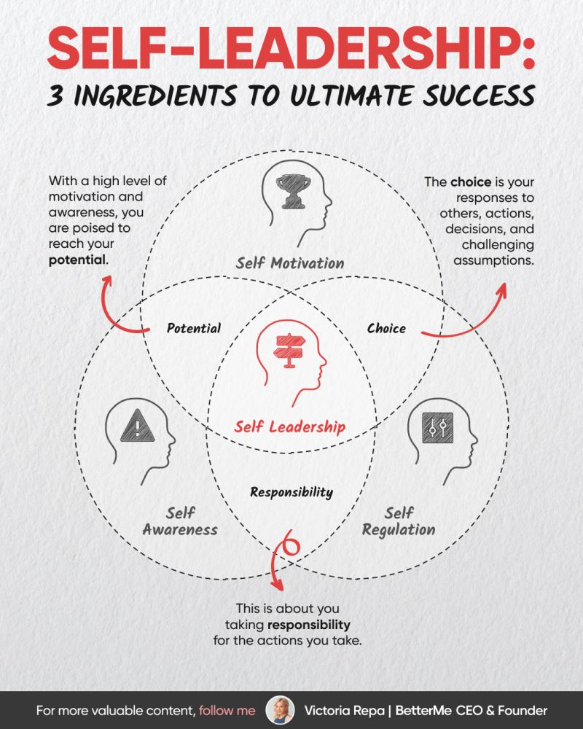
Another important aspect of EI is self-regulation, which involves controlling emotional reactions and remaining calm during challenging situations. Employees with strong self-regulation skills are better able to manage stress, avoid impulsive responses, and make rational decisions. For instance, when receiving critical feedback from a manager, an emotionally intelligent employee can remain open-minded, reflect on the feedback, and use it to improve performance rather than reacting defensively.
Motivation is also a significant component of EI that supports productivity and goal achievement. Emotionally intelligent employees can set personal goals, maintain commitment, and remain focused despite obstacles. For example, a sales employee who is internally motivated may continue working towards performance targets even after experiencing setbacks, using challenges as opportunities for g improves employee performance by strengthening self-management, resilience, communication, teamwork, and problem-solving abilities. Employees who develop EI are better prepared to manage workplace challenges, build effective relationships, and contribute positively to organisational success. Therefore, organisations should encourage emotional intelligence development through training, coaching, and supportive leadership practices to enhance both individual performance and overall workplace effectiveness. growth.

Emotional Intelligence Improves Communication and Collaboration
Emotional Intelligence Improves Communication and C intelligence (EI) plays a vital role in improving workplace communication and collaboration by helping employees understand emotions, develop stronger relationships, and respond effectively to different situations. One important element of EI is empty, which enables employees to recognise and understand the feelings, perspectives, and experiences of others. By demonstrating empathy, employees can communicate more respectfully and respond appropriately to colleagues’ needs and concerns. For example, a manager who notices that an employee is experiencing stress can offer support and adjust workloads rather than ignoring the situation.
Social skills are another key aspect of EI that contribute to effective teamwork and relationship building. Employees with strong social skills can communicate clearly, listen actively, provide constructive feedback, and build trust with colleagues. These abilities encourage cooperation and create a positive team environment where individuals feel valued and motivated to contribute. For instance, team members who use effective communication skills can share ideas openly and work together to solve problems more efficiently.
EI also helps employees manage workplace conflicts by encouraging emotional control, understanding, and constructive discussions. Instead of reacting negatively during disagreements, emotionally intelligent employees can remain calm, consider different viewpoints, and focus on finding solutions. For example, when two colleagues have opposing opinions about a project approach, EI allows them to discuss their differences respectfully and reach a compromise.
Furthermore, EI strengthens collaboration by developing trust and psychological safety within teams. When employees feel comfortable expressing their opinions, asking questions, and sharing concerns without fear of negative consequences, they are more likely to contribute innovative ideas and participate actively in decision-making. Emotionally intelligent leaders encourage open communication by demonstrating fairness, empathy, and respect towards all team member

How Emotional Intelligence Supports Employee Well-being
Emotional intelligence (EI) plays a vital role in improving workplace communication and collaboration by helping employees understand emotions, develop stronger relationships, and respond effectively to different situations. One important element of EI is empathy, which enables employees to recognise and understand the feelings, perspectives, and experiences of others. By demonstrating empathy, employees can communicate more respectfully and respond appropriately to colleagues’ needs and concerns. For example, a manager who notices that an employee is experiencing stress can offer support and adjust workloads rather than ignoring the situation. 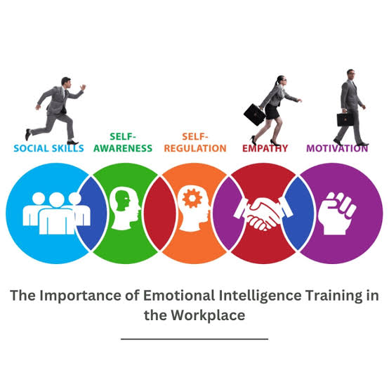
Social skills are another key aspect of EI that contribute to effective teamwork and relationship building. Employees with strong social skills can communicate clearly, listen actively, provide constructive feedback, and build trust with colleagues. These abilities encourage cooperation and create a positive team environment where individuals feel valued and motivated to contribute. For instance, team members who use effective communication skills can share ideas openly and work together to solve problems more efficiently.
EI also helps employees manage workplace conflicts by encouraging emotional control, understanding, and constructive discussions. Instead of reacting negatively during disagreements, emotionally intelligent employees can remain calm, consider different viewpoints, and focus on finding solutions. For example, when two colleagues have opposing opinions about a project approach, EI allows them to discuss their differences respectfully and reach a compromise.
Overall, EI strengthens communication, improves teamwork, and supports healthier workplace relationships by promoting empathy, cooperation, and effective conflict resolution.

Critical Evaluation of Emotional Intelligence Models
Emotional intelligence (EI) has become an influential concept in understanding workplace behaviour, leadership effectiveness, and employee well-being. However, while EI models provide valuable insights into how individuals recognise and manage emotions, their effectiveness and limitations require critical consideration. The Mayer and Salovey Ability Model is one of the strongest theoretical approaches because it defines EI as a form of mental ability involving the perception, understanding, and regulation of emotions. This model is supported by research suggesting that emotional abilities can influence social functioning and decision-making (Mayer, Salovey and Caruso, 2004). However, a limitation is that measuring EI as an ability can be challenging because emotional skills are difficult to assess objectively and may overlap with general intelligence and personality traits.
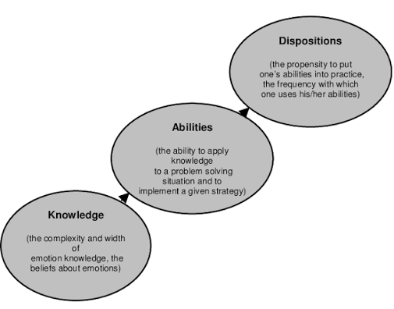
Goleman’s Emotional Intelligence Model has been widely applied in organisational settings because it connects EI with leadership, performance, motivation, and relationship management. Its strength is its practical relevance, as many organisations use its components, such as self-awareness and empathy, in leadership development programmes. However, critics argue that Goleman’s model is overly broad because it combines emotional abilities with personality characteristics and social competencies. This creates difficulties in clearly defining EI as a separate psychological construct (Mayer, Roberts and Barmade 2008)
The Bar-On Emotional–Social Intelligence Model provides a broader perspective by including adaptability, stress management, and general well-being. Its strength is that it recognises the importance of emotional skills in coping with workplace challenges. However, similar to Goleman’s model, it has been criticised for including many non-emotional traits, which may reduce its theoretical clarity.
Although EI is generally associated with positive outcomes such as improved communication, leadership effectiveness, and employee relationships, it does not always guarantee success. High EI can potentially be misused if individuals use their understanding of emotions to manipulate others or influence situations unfairly. Furthermore,

Critical analysis of application of theories to the workplace
The application of emotional intelligence (EI) theories in the workplace has become increasingly important as organisations recognise the relationship between employee emotions, leadership effectiveness, and organisational performance. The theories developed by Mayer and Salovey, Goleman, and Bar-On provide useful frameworks for understanding how employees and leaders can manage emotions, improve communication, and develop stronger workplace relationships. However, the practical application of these theories requires critical consideration because EI does not automatically guarantee improved performance or positive organisational outcomes.
. 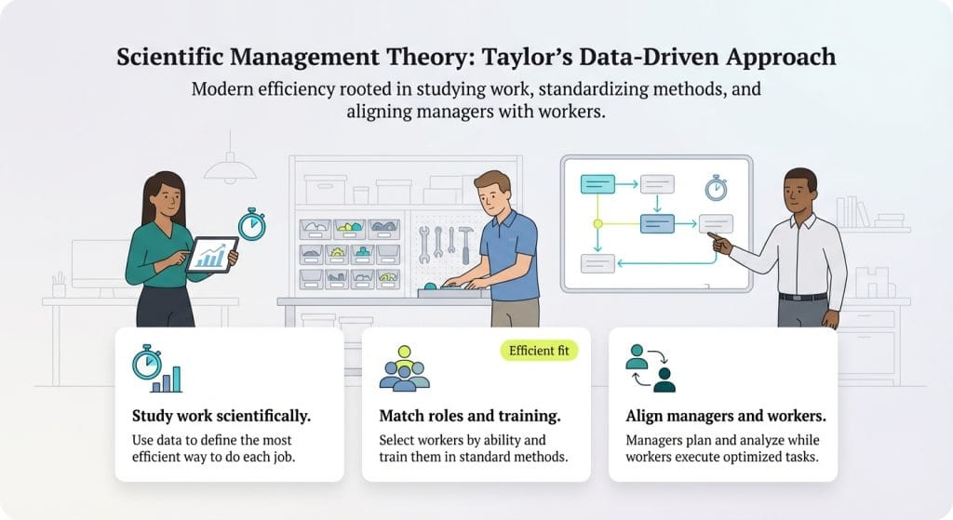

Bar-On’s Emotional–Social Intelligence Model contributes to workplace applications by emphasising resilience, adaptability, stress management, and wellbeing. This is particularly valuable in modern organisations where employees face uncertainty and continuous change. Nevertheless, including factors such as optimism and general mood may make the model less focused on emotional intelligence itself.
Overall, EI theories provide valuable guidance for improving workplace behaviour, leadership capability, and psychological safety. However, EI should not be viewed as a universal solution to organisational problems. High emotional intelligence can produce negative outcomes if individuals use emotional understanding to manipulate others or avoid necessary workplace decisions. Furthermore, EI development programmes are unlikely to succeed without supportive leadership, inclusive cultures, and effective organisational policies. Therefore, EI theories are most effective when integrated with broader approaches to employee development and organisational improvement.

Conclusion
Emotional intelligence (EI) and mindfulness have become increasingly important factors in improving individual and organisational effectiveness within modern workplaces. This report has demonstrated that traditional approaches focusing only on technical skills and operational performance are no longer sufficient for achieving sustainable organisational success. Organisations require employees and leaders who can understand emotions, communicate effectively, manage workplace challenges, and develop positive relationships. EI provides a valuable framework for achieving these outcomes by supporting self-awareness, emotional regulation, empathy, motivation, and effective relationship management.
The analysis of the major emotional intelligence models highlights different perspectives on how emotional capabilities influence workplace behaviour. The Mayer and Salovey Ability Model provides a theoretical foundation by explaining EI as the ability to perceive, understand, and manage emotional information. Goleman's Emotional Intelligence Model highlights the practical application of EI within leadership and organisational settings through competencies such as self-awareness, self-management, empathy, and social skills. Bar-On's Emotional–Social Intelligence Model expands the concept by emphasising resilience, adaptability, stress management, and emotional wellbeing. Although each model has limitations, together they provide valuable approaches for understanding and developing emotional intelligence in employees and leaders.
The report also demonstrates that emotional intelligence contributes significantly to employee performance, communication, collaboration, and workplace wellbeing. Employees with strong EI are better able to manage stress, respond constructively to feedback, resolve conflicts, and maintain effective working relationships. Similarly, emotionally intelligent leaders are more capable of creating psychologically safe environments where employees feel respected, supported, and confident in expressing their ideas and concerns.
However, emotional intelligence should not be considered a single solution to organisational challenges. Its effectiveness depends on ethical application, supportive leadership, inclusive workplace policies, and a culture that encourages continuous learning and development. Organisations should therefore integrate EI and mindfulness practices into wider strategies for leadership development, recruitment, employee wellbeing, and organisational improvement.

References
Huang, L., Zhang, Y. and Chen, J. (2024) ‘Emotional intelligence, workplace wellbeing and employee engagement: The mediating role of psychological safety’, BMC Psychology, 12, pp. 1–15.
Piispanen, J.R. and Rouse, R. (2024) ‘Emotion AI in workplace environments: A case study’, arrive. Available at: https://arxiv.org/abs/2412.09251
Rahaman, M.M. and Hossain, M.A. (2025) ‘The link between mindfulness and workplace outcomes: Does work–life balance matter?’, International Journal of Organizational Analysis. doi:10.1108/IJOA-03-2025-5338.
Zheng, J., Hong, H., Wang, N., Sun, J. and Xu, X. (2025) ‘Impact of mindfulness, emotional intelligence, and employee well-being on mental healthcare of workers’ effectiveness: The mediating role of employee satisfaction and the moderating effect of digital leadership’, Journal of Behavioural Health Services & Research. doi:10.1007/s10728-025-00523-4.
Zhang, X., Zhao, R., Li, Y., Wu, S., Xiao, T. and Wang, W. (2025) ‘The mediating and moderating effects of mindfulness and emotional intelligence on the emotional labour strategies and career resilience of tourism employees’, Scientific Reports, 15, Article 24268. doi:10.1038/s41598-025-07078-3.
Quy, N.L.D. (2025) ‘Mindfulness practice and work performance: The mediating role of emotional intelligence and psychological capital’, Brain and Behaviour. doi:10.1002/brb3.70291.
A baker, M., Noureddin, A., Abdullaah, M. and Fakfak, A. (2025) ‘Mindfulness and work engagement: How emotional intelligence bridges the gap’, Journal of Management World. doi:10.53935/jam. v2024i4.928.
Muni Andy, M., Mohd Som, H. and Mahmood, R. (2025) ‘The role of mindfulness, emotional intelligence, trust, and leadership self-efficacy in enhancing leadership effectiveness in electronic manufacturing firms: A conceptual analysis’, Social Science and Humanities Research Bulletin, 2(5), pp. 160–163. doi:10.55677/SSHRB/2025-3050-0504.

