

ASSESMENT TITLE

Component 2: Assignment (Report)

Name: Anderson Villanueva Suarez
Student ID: 2337296
Module Name: Changemakers: Creativity and Value Creation
Module code: BMHP5014
Lecturer: Dr Laila Surani

I acknowledge that this portfolio is mine, and I have use Microsoft Editor for Spelling and grammar
POSTER
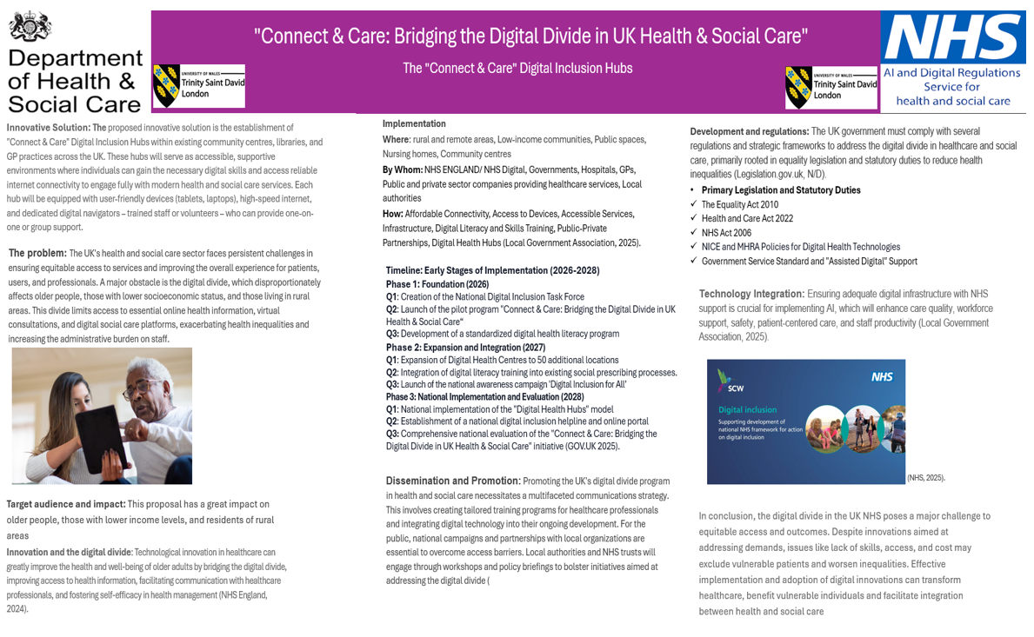
Pitch
Digital Divide in UK Health & Social Care
Currently, older people are greatly impacted by the digital divide in the UK healthcare system, which poses considerable challenges to their access to essential services and information. As healthcare services move more and more into the digital sphere, this growing exclusion is especially worrisome. The difference between people who have access to digital technology like computers and the internet and those who do not is known as the "digital divide." This discrepancy is particularly noticeable in the context of UK healthcare for older people, making it more difficult for them to get appointments, health advice, and other essential services (NHS England, 2024).
Various factors have led to the digital marginalization of older individuals in the UK healthcare system. For instance, many older adults lack the digital skills and self-assurance necessary to navigate the online environment; they often haven't had the chance to acquire the skills needed to engage with technology, resulting in decreased confidence and motivation to learn new tools. Economic challenges are also a significant factor, as the financial burden of internet access and digital devices can be overwhelming for seniors, particularly those living on fixed incomes. A considerable number of households in the UK still do not have internet access at home, while others have terminated their broadband subscriptions due to escalating expenses. Additionally, there are challenges related to accessibility. Health issues, physical disabilities, or age-related impairments can complicate the use of digital devices. Most digital platforms were not created with older users' needs in mind, highlighting a potential bias or lack of consideration for the digital capabilities and requirements of this demographic (Mohan, R. et al. 2024).
Giving people access to digital resources makes it possible for senior citizens to use telehealth services, understand medical conditions, and conduct online research. This is particularly crucial for people who live in remote areas or have limited mobility since digital tools can close the gap in healthcare access caused by distance. There are many benefits for everyone if the digital divide is closed, particularly in terms of social justice, economic growth, and improved public services (NHS, 2020).
Implementation
By encouraging cooperation between government agencies, NHS entities, academic institutions, industry stakeholders, and community organisations, the project to close the digital divide in the UK healthcare sector can be carried out at the national, regional, and local levels. Increasing access to devices and internet connectivity, enhancing digital skills and competencies, developing user-focused and accessible solutions, building trust, and encouraging effective leadership and teamwork should be the top priorities of this program (NHS England, N/D).
Within the UK healthcare environment, innovation projects to close the digital divide must be implemented at several organisational and geographic levels. On a national level, the Department of Health and Social Care and the National Health Service (NHS) in England play a major role in developing strong national funding sources, policies, and plans. Furthermore, national initiatives for digital inclusion are supported by the Department of Science, Innovation, and Technology. Integrated Care Boards and Health Innovation Networks are essential for coordinating these efforts at the regional level. At the local or community level: Community and social entrepreneurship-focused organisations are essential for interacting directly with those who do not have access to the internet (UK Parliament, 2024).
Dissemination
A variety of strategies, including national policies, community-led initiatives, strategic partnerships between volunteers and the NHS, and the use of traditional media like television, local radio, and promotional leaflets, can support this advancement, which aims to close the digital divide for older people within the UK healthcare system (Health Innovation Network, 2023).
Examples
A scalable approach for the NHS that changes over time—every three, five, or ten years, for example—promotes the transition from analogue to digital while establishing the NHS App as the main hub for healthcare and utilising artificial intelligence (AI) to provide more individualised community support. Another example would be a Department for Science, Innovation, and Technology-backed digital inclusion action plan that seeks to improve inclusion through a number of strategies or projects, including fostering user skills, removing service barriers, addressing device upgrades, and fostering trust with senior citizens
Libraries, pharmacies, community centres, and digital health hubs can all function as dependable physical venues that promote inclusion by emphasising a number of factors, including skill development. It is crucial to address device and data poverty, remove service barriers, and cultivate user trust
Other effective advertising and communications strategies
A multichannel approach that combines simple digital displays with printed materials like posters and pamphlets at community centres and medical offices to provide accessibility for all. putting in place a volunteer program to act as key contacts to promote community trust. Creating a more user-friendly NHS app that makes things like scheduling appointments, managing medications, communicating with doctors, and getting crucial information easier with its clear graphics, succinct videos, and intuitive touch materials. In order to prioritise their well-being, this strategy should also take into account the preferences of older people who want to use non-digital methods, making sure they are not pressured to give up their dependable options while encouraging the continued availability of traditional resources, like regular phone lines.

Conclusion
In summary, the digital divide in UK healthcare represents a major issue where socioeconomic factors like income, age, and geographic location worsen health disparities, as millions are without the necessary skills, devices, or internet access to utilize digital services, putting them at risk of exclusion despite the NHS's attempts to promote inclusivity. To address this, it is essential to implement innovative solutions and promote diverse strategies to guarantee that older adults can benefit.

REFERENCES
GOV.UK (2025) Policy paper, Digital Inclusion Action Plan: First Steps. Available at: https://www.gov.uk/government/publications/digital-inclusion-action-plan-first-steps/digital-inclusion-action-plan-first-steps (Accessed on 16 December 2025).
Health Innovation Network (2023) Bridging the Digital Divide in NHS Transformation: Ensuring Inclusivity and Equity. Available at: https://healthinnovationnetwork.com/insight/bridging-the-digital-divide-in-nhs-transformation-ensuring-inclusivity-and-equity/?cn-reloaded=1 (Accessed on 16 December 2025)
Legislation.gov.uk (N/D) Understanding legislation. Available at: https://www.legislation.gov.uk/understanding-legislation (Accessed on 16 December 2025).
Local Government Association (2025) Digital Inclusion Programme. Available at: https://www.local.gov.uk/our-support/cyber-digital-and-technology/digital-inclusion-programme (Accessed on 16 December 2025).
Local Government Association (2025) Local government and digital inclusion. Available at: https://www.local.gov.uk/our-support/cyber-digital-and-technology/inclusion/local-government-and-digital-inclusion (Accessed on 16 December 2025).
Mohan, R. et al. (2024) ‘Ensuring Sustainable Digital Inclusion among the Elderly: A Comprehensive Analysis’, Sustainability, 16(17), p. 7485. Available at: https://doi.org/10.3390/su16177485.
NHS (2020) Improving Digital Health Inclusion: evidence scan. Available at: https://www.strategyunitwm.nhs.uk/sites/default/files/2021-04/Digital%20Inclusion%20evidence%20scan.pdf (Accessed on 16 December 2025).
NHS England (N/D) Digital and Technology. Available at: https://www.england.nhs.uk/mat-transformation/matrons-handbook/digital-and-technology/#:~:text=The%20matron's%20role%20in%20technology,of%20health%20and%20care%20services. (Accessed on 16 December 2025).
NHS England (2024) Inclusive digital healthcare: a framework for NHS action on digital inclusion. Available at: https://www.england.nhs.uk/long-read/inclusive-digital-healthcare-a-framework-for-nhs-action-on-digital-inclusion/ (Accessed on 16 December 2025).
UK Parliament (2024) Digital exclusion in the UK: Communications and Digital Committee. Available at: https://lordslibrary.parliament.uk/digital-exclusion-in-the-uk-communications-and-digital-committee-report/ (Accessed on 17 December 2025).

