ASSESSMENT 2

COMMUNITY ENGAGEMENT
LCBB4002

LECTURER: RULA ALOUSI
STUDENT: DENISA-ANDREEA MATEI
Table of Contents
Introduction 3
Personal experience related to the outcome of previously discussed business 3
Conclusion 8
References 9

Introduction
Reflective writing about a particular topic helps in expressing the view of one's own related to a particular topic in an accurate way. It is also helpful in the process of gaining a comprehensive idea about the research topic. In this study, I will explain my personal experience related to the outcome of the previously discussed business. I want to mention the importance of various types of employability skills. I will include which employability skills have been improved due to the completion of the study. I will use the importance of models as well as theory. Based on the process and outcome of the business, I want to mention that in the future I want to conduct the study in a different way. The way it will be conducted in the near future this will also be elaborated in this study.

Personal experience related to the outcome of previously discussed business
In order to conduct the previous report, I have gathered much information related to community engagement as well as stakeholder participation. At the first time, I was very confused about which information I should take with respect to the company and which not. I want to mention that I did not have the idea that the authenticity of the source needs to be checked in that context. After checking authenticity, I eliminated some of the sources. The rest of the sources were appropriate to conduct the study. In that context, I want to mention the skills of self-management. This is due to the fact that it is really a tough factor to choose proper information among various sources (Freeks, 2021, p.9). Apart from that, I want to mention the arrangement of the information. Considering all I want to mention the importance of self-management.
After conducting the study, I could understand that it is one of my strengths. Based on the outcome of the report, I want to mention my planning as well as organizing skills. This is because I did not get much time for completing the whole task. In the meantime, completing tasks in a proper manner was really a tough job (Brooman and Stirk, 2020, p.80). I gained a lot of lessons from the study. Before the study, I did not have any sort of idea about community engagement. I had very little idea about the importance of stakeholder participation in business. However, after conducting the study, I could understand the way different kinds of stakeholders can influence the process of best practice with respect to an organization. I could understand that various kinds of skills are required to conduct business activities in a proper way.
I want to mention that after completing the study, I was able to bring improvement to some of my skills which are also required for business. I can understand the importance of team working from the community engagement of Unilever. However, I want to mention that when a lot of people are associated with any particular task, the possibility of having conflict remains high along with getting various kinds of advantages (Baruah et al. 2017, p.17). I did not get any elaborate idea about the way the possibility of conflict can be reduced. It is an area which I want to consider as a limitation in the process of completing my study.
Learning is also an employability skill that I must mention in that context. I completed this study on the basis of a company. From that context, I want to mention that I can understand the way community engagement works in the company and the benefits of it. In this way, an overall idea about community engagement has developed within me. I can understand the different ways through which different stakeholders can contribute to the best practices of the business enterprise. I think the learning of this outcome will help me in the near future if I think to start a business. I think it can also help me in my professional development as well.
However, I give much importance to communication skills but I do not think that this particular skill has improved after compiling this task. Communications are of two kinds and these are written communication as well as oral communication (Rowe and Zegwaard, 2017). Considering these two, I want to mention that my written communication has developed to a certain extent but this is not applicable for oral communication. Therefore I want to bring improvement on this particular skill. I think giving a presentation on this kind of subject will help me to achieve it.
In order to complete the task, I got various kinds of obstacles at the initial stage. The help of my professor is a useful factor that I want to mention in this context. The teaching style of my professor was absolutely addable and it worked as a motivation (Husam and Abraham, 2019, p.40). Considering this fact, I want to mention that this is one of the most important employability skills that I want to use in my future. I think it will be very much helpful for me on the path of career development. I have already mentioned that I had to complete the overall task under the proper time and in this way, the ability to work under pressure has increased. However, I think I should be focused more on time management. This is because I took some additional time for completing the overall task.
I want to mention the importance of theories and models related to community engagement. This is due to the fact that the theory, as well as the model, is helping to make the understanding more clear (MacCallu and Casey, 2017, p.12). Theory of change and nine-step model of community engagement can be mentioned in that context and the elaborations are as follows
Theory of change
Theory of change is important to evaluate community engagement. I can understand that the theory is helpful on the ground of community development as well. Theory of change denotes that proper education is very much important for community engagement (Thornton et al. 2017, p.141). From that context, I can say that the theory will be helpful in the process of mitigating conflict when a lot of people are engaged in a particular community. The following figure can be considered in order to understand the way of working of the theory.
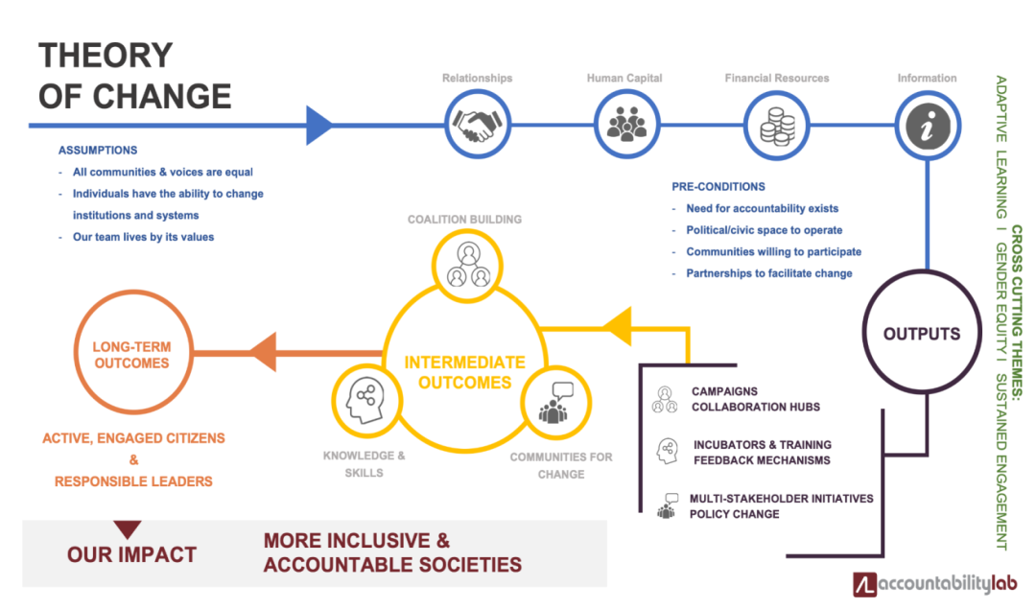
Figure 1: Theory of change
(Source: accountabilitylab.org)
Based on the above figure, it can be said that the theory follows a proper process and therefore evaluation of community engagement becomes much easier. The figure also indicates that for community engagement, it is important to incorporate several campaigns (Brooman and Stirk, 2020, p.80). I think the figure is much helpful to understand the way long-term positive outcomes can be incorporated with respect to an organization.
Nine step model of community engagement
“Nine step model of community engagement” is a model which helps in understanding community engagement in a proper way. In order to understand the fact, the following figure needs to be considered.
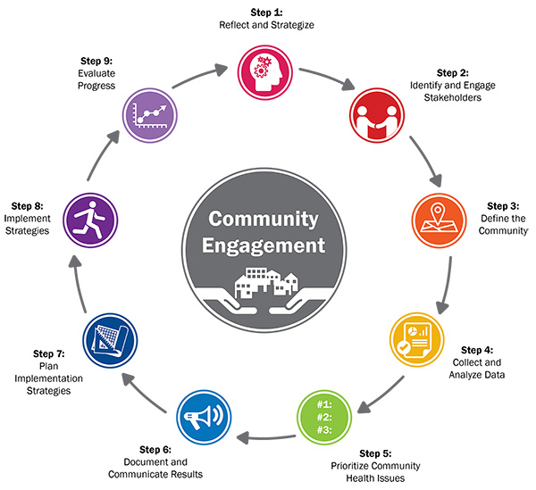
Figure 2: Nine step model of community engagement
(Source:healthycommunities.org, 2021)
I want to mention that the problem that Unilever may face related to community engagement, can be solved by the model in an easier way. This is because the model follows several steps and these are re; action and making strategies, identification of stakeholders, the definition of community, collection and analysis of data, prioritizing the issues related to community, documentation of result, implementation of strategies as well as evaluation of progress. Following all the processes, it will be much easier to deal with all kinds of issues related to community engagement and it will be helpful in the development process as well (Mutiso et al. 2018, p.12).
Personal development plan
Based on the above discussion, I can say that there are some areas in which I need to bring improvement and therefore I need to incorporate this particular personal; development plan. This is as follows.
Objective | Task | Success criteria | Time frame | Resources
Improvement in time management | It will provide some work to me and also provide some time for completing the work | If I am able to complete the work within the specific time period, I can that I am improving related to time management. If it takes a little more time, in that case also I will consider it as an achievement (Barton and Ryan, 2020, p.15). | (3-4) week | Books on time management and the online resources like articles as well as videos are helpful resources (Rowe and Zegwaard, 2017)
Development in communication skill | I want to involve my friends in order to check whether my communication skill is improving or not. | If my friend is satisfied with my communication, I will consider that my communication skill is improving. | (4-5) week | Self-practice is the best resource. However, the way practice should be followed needs to be known. From that context, the significance of both online and offline sources can be adopted (Rowe and Zegwaard, 2017).
Improvement in problem-solving skill | I will choose some situation which will have complex problems and I will try to figure out the probable solutions | Finding out the solution to the problem will be considered as a success. If I cannot find the solution which is suitable, I have to practice more to bring improvement in this particular skill. | (5-6) week | Models and theories related to problem-solving are some of the important sources that I want to follow

Table 1: Personal development plan
(Source: Created by self)
In that context, I want to mention that in the future I want to conduct the study in a different way. This is because I want to increase my employability skills. From this discussion, I want to say that there are some employability skills on which I need to give focus. However, in the latter study, I want to overcome this particular problem. I may develop basic ideas about community engagement. After that, I will search for information that indicates the community engagement with respect to the company. I think it will help me to develop all my learning skills more. In the future, I want to focus on time management. More specifically I want to mention that for gathering, arranging as well as putting data under different categories, I want to allot time and do it accordingly. I think this particular study helped me to understand my strength as well as weakness. In the future when the same topic will be conducted in a different way, I will try to overcome my weakness. I try to convert all the weaknesses into strengths. I am hopeful that I will be able to conduct the study in a different way which will be helpful for my career development within a short span of time.

Conclusion
From the above discussion, I can conclude that personal experience related to the conduction of the previous study helped me to understand that I have developed some of the employability skills. However, there are several factors on which I should give sufficient focus. In order to overcome the weakness, I will take the help of a personal development plan. The way it will help me can be understood from the above discussion. In the process of conducting the study, I can understand both my strength as well as weakness. Based on this I want to mention that in the future I want to conduct the study once but I want to do it in a different way. I think it will help me to enrich my knowledge more associated with the topic. I have used models and theory in order to increase my understanding of community engagement. I think the incorporation of this model, as well as theory, will be helpful for the chosen company. I could be aware of a variety of employability skills and these skills are very important for development in professional life. I want to improve myself on the skills on which I have weaknesses.

References
accountabilitylab.org, 2021. What we learned while updating our Theory of Change - Accountability Lab. [online] Accountability Lab. Available at: <https://accountabilitylab.org/what-we-learned-while-updating-our-theory-of-change/)> [Accessed 30 April 2021].
Barton, G. M., and Ryan, M. (2020). What does reflection look and feel like for international students? An exploration of reflective thinking, reflexivity and employability. Journal of International Students, 10(S2), 1-16.
Baruah, B., Ward, T., and Jackson, N. (2017, July). Is reflective writing an effective Peer Assessment tool for students in Higher Education?. In 2017 16th International Conference on Information Technology Based Higher Education and Training (ITHET) (pp. 1-6). IEEE.
Brooman, S., and Stirk, S. (2020). Who am I?: Using reflective practice and self-determination to redefine ‘employability’in legal education. Liverpool Law Review, 41(1), 79-98.
Freeks, F. E. (2021). The impact of a Biblical Fatherhood Programme for faith communities in the Christiana district: A reflective and community engagement strategy. In die Skriflig/In Luce Verbi, 55(1), 9.
healthycommunities.org, 2021. Community Health Assessment Toolkit | ACHI. [online] ACHI. Available at: <https://www.healthycommunities.org/resources/community-health-assessment-toolkit> [Accessed 30 April 2021].
Husam, H. A., and Abraham, P. (2019). Employability skills development through assessment in higher education: Students’ voices on reflective assessments. Glob Acad J Econ Buss, 1, 36-42.
MacCallum, J., and Casey, S. C. (2017). Enhancing skills development and reflective practise in students during their programme of study. New Directions in the Teaching of Physical Sciences, (12).
Mutiso, V. N., Gitonga, I., Musau, A., Musyimi, C. W., Nandoya, E., Rebello, T. J., ... and Ndetei, D. M. (2018). A step-wise community engagement and capacity building model prior to implementation of mhGAP-IG in a low-and middle-income country: a case study of Makueni County, Kenya. International journal of mental health systems, 12(1), 1-13.
Rowe, A. D., and Zegwaard, K. E. (2017). Developing graduate employability skills and attributes: Curriculum enhancement through work-integrated learning.
Thornton, P. K., Schuetz, T., Förch, W., Cramer, L., Abreu, D., Vermeulen, S., and Campbell, B. M. (2017). Responding to global change: A theory of change approach to making agricultural research for development outcome-based. Agricultural Systems, 152, 145-153.
uprisevsi.co.uk, 2021. Roles for Volunteers | NHS Volunteer Responders. [online] NHS Volunteer Responders. Available at: <https://nhsvolunteerresponders.org.uk/i-want-to-volunteer/volunteer-roles?utm_source=googleandamp;utm_medium=paid-searchandamp;utm_campaign=nhsvrandamp;gclid=Cj0KCQjwvYSEBhDjARIsAJMn0lhgAxDRtFMHqlDG6eGK8x2cEPnq4X_bMJ7SWEh5oUy5fHPfSNYBG5gaAg-wEALw_wcB> [Accessed 30 April 2021].

