Reflective practice

The purpose of this briefing paper is to support practitioners in developing an understanding in reflective practice and the significance of reflective practice in the early years workforce.

What is reflection and reflective practice?
Reflection is seen to be an essential skill for practitioners working in early years. D. Schön (1983 quoted in K. Aubrey and A. Riley. 2019, P.192) states that reflection is a process of obtaining an understanding and taking steps to examine an individual’s own behaviours, characteristics, experiences, and interactions. D. Schön identified two types of reflection, reflection-in-action which is reflecting on experiences that have already happened and consider what could be done differently. While the second type of reflection is reflection-on-action which is reflecting during an experience which allows a person time to rethink their decisions and do things differently moving forward. However, University of Cambridge (No date) believes that reflection is a highly subjective concept, and different people will describe it differently. They state that it's crucial to note that there's no one-size-fits-all approach to defining what reflection is and how it should be done because so much depends on an individual’s personal circumstances. The University of Cambridges theory is fairly different to D. Schöns as D. Shön believes that there are 2 types of reflection while the University of Cambridge believes that reflection looks different to each individual person.
Pacey (2016, P.4) states that reflective practice is the act of thinking and analysing an individual’s own practise in order to challenge, develop, and strengthen it. This should be a never-ending cycle of improvement and reflection. To be a reflective practitioner, individuals must be able to take a balanced view of their work, recognising and celebrating their strengths and what works well while also acknowledging what could be better. Evaluating an individual’s own practise will assist them in identifying their professional development requirements and will help them to gain confidence in their practise over time. Reflective practice allows practitioners to improve their practice which will in turn benefit all those who are involved in the service. It also allows practitioners to reflect on feedback they have received from their service and strengthen a part of their practice that they may not have realised themselves needed strengthening. P. Tarrant (2013, P.4) believes that reflective practice entails thinking of the individual’s self, the individual’s inner world, the individual’s actions, and the individual’s impact. As a result, reflective practice must take into account far more than just performance. The individual should examine their views and values in light of their profession. The autonomy aspect of professionalism can only be addressed if they can take a break and reflect on their work. P. Tarrant has very similar views to University of Cambridge as the University of Cambridge believes that refection looks different to each person while P. Tarrant suggests that reflective practice is different for each individual as it’s more than their professional practice their views and values also contributes, and every individual has different views and values.

Theorists
There are many theorists who support reflective practice, the University of Southampton (no date) believes that John Dewey is the father of reflection due to its similarities with personal learning. Dewey believed that reflection might be extremely helpful in making sense of complex or difficult-to-explain situations or experiences. He proposed that reflective practice entails recalling an experience and then asking questions to figure out why things went the way they did and what could have resulted in a different conclusion. The University of Cambridge also discusses the theorists Donald Schön, they state how D. Schön expanded on Dewey’s ideas by tying reflection more closely to professional development and practice. D. Schön believed that practitioners could obtain clear knowledge by using reflective practice. The University of Hull (2022) discusses the theorist David Kolb and his take on reflection. Kolb created the cycle of reflective practice; the reflective practice cycle is a strategy for people to learn from their experiences. It can be used to organise an individual’s thinking or as a foundation for reflective writing. Kolb’s model is divided into four stages which are concrete experience, reflective observation, abstract conceptualization and active experimentation. D. Boud is a theorist who wrote the book ‘Reflection: turning experiences into learning’ in this book written by D. Boud, R. Keogh and D. Walker (1985) we learn that Boud believed that to successfully reflect on an experience the individual must consider the emotions and feelings they felt at the time. Boud believed that this was an essential part of reflection as he thought that emotions played a big role in how an individual remembers an experience.

Reflection during professional practice
Reflection during professional practice is required to ensure that practitioners are constantly improving their service and reflecting on what they can do better. Many theorists have created models to guide practitioners with their reflective practice. The University of Cambridge (no date) shared many models of reflection by different theorists. The first one being The ERA Cycle (Jasper, 2013), this model is a simple 3 step guide to reflection. The first step is experience, the second step is reflection, and the last step is action. The cycle demonstrates that the individual will begin with an experience, either one that they have had before or one that is totally new to them. This experience might be favourable or negative. After they have experienced something, they will begin to reflect on it. This will allow them to reflect on the event and analyse their feelings about it, which will then determine their future moves. This leads to the cycle's last step: taking action. Although depending on the individual, what they do as a result of an experience will be different for everyone. Depending on the individuals learning styles the ERA cycle may not work for everyone therefore they may find a different model that’s easier to follow for them for example Driscoll’s what model which is based around an individual asking themselves 3 simple questions What? So what? And now what? The what question allows the individual to analyse and think about their experience. The second question so what? Is to understand ‘so what was learnt from the experience?’ The final question now what? is to conclude what was learnt from the experience and was has been taken away, for example would anything be done differently next time? Theorists believe that there are pros and cons to models of reflection. The pros of using models of reflection could be that it gives individuals a structure to their reflection, and secondly it offers a starting point for individuals who maybe be starting to learn how to reflect. L. Page and J. Hargreaves (2013) believes that cons to using models of reflection could be that the individual could get so carried away with ensuring they complete the model they may be distracted from the actual task to reflect on their experience, L. Page and J. Hargreaves also suggests that another limitation could be a lack of resources or a lack of time for example some models require you to take notes during the experience which may be difficult to do while working in the early years setting. A well as using Models there are many other ways a practitioner can improve their reflective practice, Tarrant (2013, P.26) believes that professional practitioners can improve their reflection by working with peers, this could be two practitioners working together or possibly a practitioner allowing children to work together and develop their reflection skills. This allows individuals to gain experience with planning and teamwork while also including them in a learning community in which they have a purpose. Where they can learn from each other by collaborating to reflect on the experience together as well as coming up with ideas as a team on what could be done differently in the future.

Bristol CBT (no date) Bristol CBT (no date)

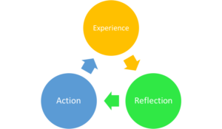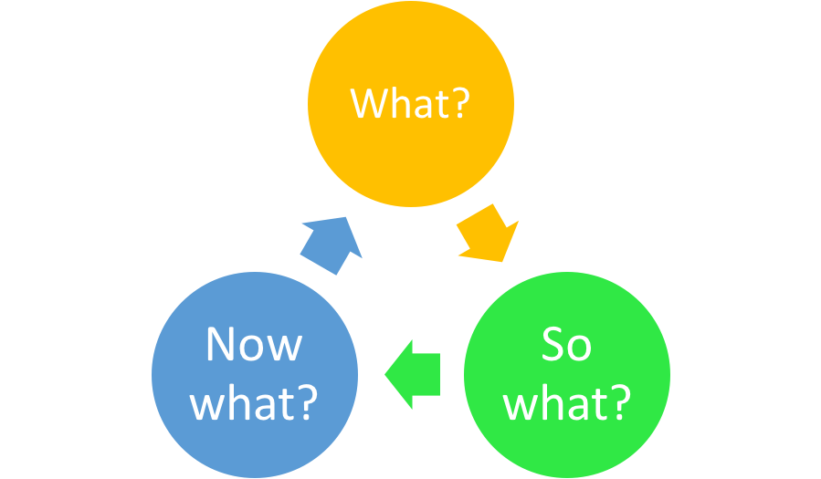

Reflection within early years settings
“There is an emerging importance for early years practitioners to be reflective in the continuously changing environment within the early years sector, particularly in regard to integrated working, which requires a reflective and sensitive approach to developing new ways for multi-professional working” Paige-Smith and Craft (2011 quoted in E. Hallet, 2013. P.25) Reflective practice has become an essential part of being an early year’s practitioner, not only is it important for practitioners to be reflective but it’s also a skill that should be exposed to the children too. A. Paige-Smith (2011, P. 23) stated that according to a recent study, Early Year children do best when they are engaged in activities that encourage deep thought (Siraj-Blatchford et al. 2002). REPEY (Researching Effective Pedagogy in the Early Years) found that circumstances that encouraged sustained shared thinking' between adults and children generated the most linguistic, social, behavioural, and cognitive progression in children. This suggest that exposing children to reflection and allowing them to reflect on their own experiences while guiding them to think about what they could do next time may help them developmentally in different areas. Practitioners could encourage reflection withing the early years setting by recording reflective account forms, a reflective account form allows the individual to put into writing the experience that happened, it then asks what the individual learnt from the experience which makes them recall the experience in more detail and also may allow the individual to see the experience in a different light for example sometimes during a negative experience it’s difficult to think about what the individual has learnt as the individual may be too caught up in their emotions. Next the form asks the individual how they could change or improve their practice as a result of this experience, this offers the practitioner a chance to write a solution to their possible problem and change their practice for the better. Pacey (2016, P. 04) believes that practitioners can practice reflection within the early years settings by asking for the view of others. Other people's thoughts about the setting might be a useful tool for reflective practise. The individual will have a greater knowledge of what works well and what could be done better by considering the perspectives of parents and carers, children, and other professionals. The children's parents for example will feel more engaged and valued if you ask them for feedback. Parents may also feel more inclined to encourage reflective practice at home with their own children if the practitioner is modelling good reflective practice to the parents. J. A-Moon (1999 P.166) suggests the importance of the learning environment when encouraging reflective practice. Individuals should consider time and space as learners require time to reflect, as well as time and opportunities to learn to reflect. Children should also feel comfortable and confident to express their feelings and thoughts during reflection in their learning environment. Finally, the environment should have a supportive practitioner who appreciates the need of reflection and the benefits it can have in self-development. Practitioners should work together in the early years setting to provide the best possible practice. To be able to provide this group reflection may be necessary, as through the sharing of ideas and expertise, this type of reflection allows practitioners to come together and build collective wisdom. An individual can share their reflections with others and learn from a larger group of individuals by participating in group reflection. It can also give individuals an insight into the experiences of others on the team, allowing them to consider how their work affects each member of the group positively or adversely. When dealing with challenges that may stretch across multiple departments or organisations, this technique might be beneficial as stated by Health & Care professions council (HCPC) (2021).

Conclusion
In conclusion reflection has proven to have many benefits to professional practice. Although models of reflection may have limitations it is likely that practitioners who also consider Bouds theory that reflection and emotions come hand in hand and also remember to ask for the view of others, as well as all the resources that are available for example the reflective accounts form, should be able to successfully reflect on their practice with or without using reflective models.

REFRENCE LIST

A, Paige-Smith, Developing reflective practice in early years, 2nd ed, Open university press, 2011, P.23

Bristol CBT (no date) Driscoll’s what model [Online Image] Available:
https://www.bristolcbt.co.uk/on-reflection-part-3-reflection-as-a-skill/ [Accessed 08.05.2022]

Bristol CBT (no date) The ERA cycle [Online Image] Available: https://www.bristolcbt.co.uk/on-reflection-part-3-reflection-as-a-skill/ [Accessed 08.05.2022]

D. Boud, R. Keogh and D. Walker, Reflection: Turing experience into learning, Oxon: Routledge, 1985.

E. Hallet. The Reflective Early Years Practitioner. London: SAGE Publications Ltd, 2013, P.25

Health & Care professions council, “Types of reflective practice”, HCPC, 2021. [Online] Available: https://www.hcpc-uk.org/standards/meeting-our-standards/reflective-practice/types-of-reflective-practice/ [Accessed 08.05.2022]

J. A-Moon, Reflection in learning & professional development: theory & practice, Oxon: Routledge, 1999, P. 166 – 169.

K. Aubrey, A. Riley, Understanding & using educational theories, 2nd ed., London: SAGE publications Ltd, 2019, p.192

L. Page, J, Hargreaves, Reflective practice, Cambridge: Polity Press, 2013, P.22.

Pacey.org.uk, “Developing self-reflective practice, Professional association for childcare and early years”, Pacey, 2016. [Online] Available: https://www.pacey.org.uk/Pacey/media/Website-files/PACEY%20member%20practice%20guides%20(PDFs)/PG04-self-reflective-practice.pdf [Accessed 04.05.2022]

Pacey.org.uk, “Supporting members to provide the highest standards of care and learning for children”, Pacey, 2016 [Online] Available at: https://www.pacey.org.uk/Pacey/media/Website-files/PACEY%20member%20practice%20guides%20(PDFs)/PG04-self-reflective-practice.pdf [Accessed 08.05.2022]

P. Tarrant, Reflective practice and professional development, London: SAGE publications Ltd, 2013, P.4.

P. Tarrant, Reflective practice and professional development, London: SAGE publications Ltd 2013, P.26.

University of Cambridge, “Models of Reflection”, Libguides, [Online] Available at: https://libguides.cam.ac.uk/reflectivepracticetoolkit/models [Accessed 06.05.2022]

University of Cambridge, “What is reflective practice?”, Libguides, [Online] Available at: https://libguides.cam.ac.uk/reflectivepracticetoolkit/whatisreflectivepractice [Accessed 04.05.2022]

University of Hull, “Reflective writing: Kolb”, Libguides, [Online] Available at: https://libguides.hull.ac.uk/reflectivewriting/kolb [Accessed 08.05.2022]

University of Southampton, “Reflective learning theories” EdShare, [Online] Available at: http://edshare.soton.ac.uk/11124/1/index.htm [Accessed 08.05.2022]

