COMPUTER

STUDENT NAME …………………….. MAGDY BKHEET
STUDENT ID…………………………….. 2007446
LECTURE NAME ………………………JAMES WILLIAMS
MODULE ………………. COMPUTER ARCHITECTURE
ASSIGNMENT TITEL…………. OPERATING SYSTEM

OPERATING SYSTEM (OS)
ASSIGNMENT
Table of Contents
Introduction 3
Task 1: key functions of general Operating Systems. 4
What is an operating system? 4
Key functions of an OS include: 4
• Memory Management and Processes: 4
• File & Directory Management: 6
• Device Management (I/O devices) 6
• User Interface provision (GUI & CLI) 7
• Networking capabilities: 7
• Security and Access Control: 8
TASK 2 8
Task 3 12
What is Linux? 12
Task 5 19
Demonstrate the use of each key aspect of the Bash script syntax: 19
Variables 19
User Input 19
if statement 19
A Loop (one type) 19
Array 19
Case statement 19
Function 19
References 23
MY LINUX COURSE SCREEN SHOT 25

Introduction
An operating system (OS) is the program that, after being initially loaded into the computer by a boot program, manages all of the other application programs in a computer. The application programs make use of the operating system by making requests for services through a defined application program interface (APL). In addition, users can interact directly with the operating system through a user interface, such as a command-line interface (CLI) or a graphical UI (GUI).

Task 1: key functions of general Operating Systems.

What is an operating system?
An operating system brings powerful benefits to computer software and software development. Without an operating system, every application would need to include its own UI, as well as the comprehensive code needed to handle all low-level functionality of the underlying computer, such as disk storage, network interfaces and so on. Considering the vast array of underlying hardware available, this would vastly bloat the size of every application and make software development impractical.
Instead, many common tasks, such as sending a network packet or displaying text on a standard output device, such as a display, can be offloaded to system software that serves as an intermediary between the applications and the hardware. The system software provides a consistent and repeatable way for applications to interact with the hardware without the applications needing to know any details about the hardware.
As long as each application accesses the same resources and services in the same way, that system software -- the operating system -- can service almost any number of applications. This vastly reduces the amount of time and coding required to develop and debug an application, while ensuring that users can control, configure, and manage the system hardware through a common and well-understood interface.

Key functions of an OS include:

Memory Management and Processes:
Process management is a systematic approach to ensuring that the business process operates efficiently and effectively. It's a methodology for aligning business processes with strategy goals.
[1] https://kissflow.com/workflow/bpm/what-is-process-management/#:~:text=Process%20management%20is%20a%20systematic,business%20processes%20with%20strategic%20goals.
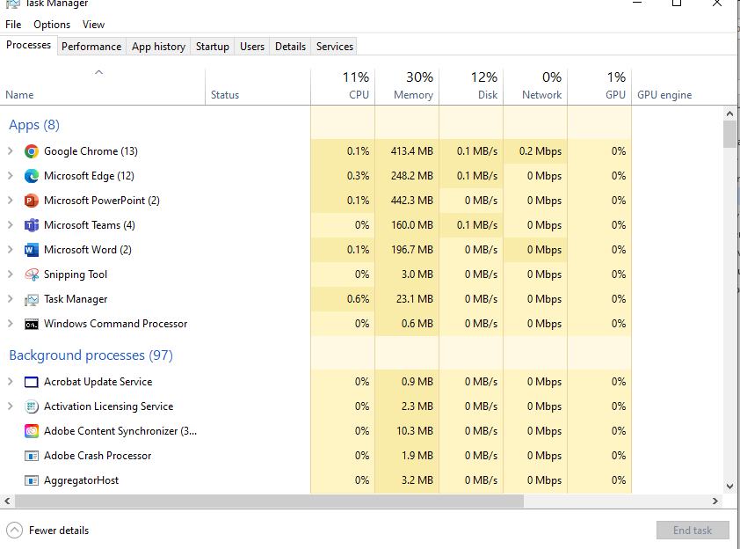
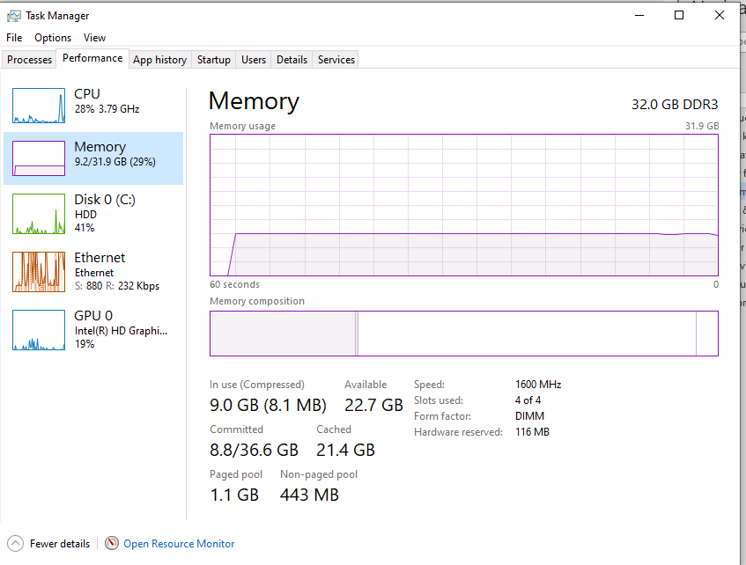

File & Directory Management:

File management: The process and operation of creating an organized structure to store information so that it is easy to retrieve. Drive: A drive is a device for storing information on a computer. For file storage, it's a top-level location or "Root" directory. [3]
[3]https://www.tutorialspoint.com/computer_concepts/computer_concepts_file_directory_management.htm
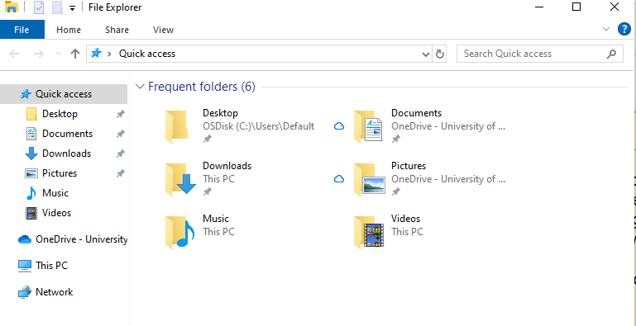

Device Management (I/O devices)
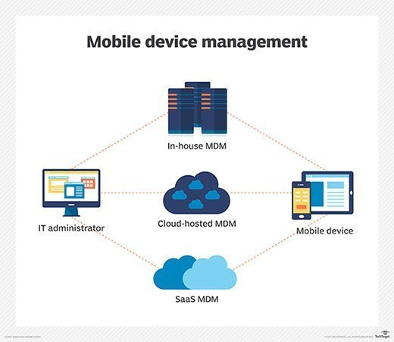
Device management in an operating system means controlling the Input/Output devices like disk, microphone, keyboard, printer, magnetic tape, USB ports, camcorder, scanner, other accessories, and supporting units like supporting units’ control channels [4]https://www.javatpoint.com/device-management-in-operating-system#:~:text=Device%20management%20in%20an%20operating,like%20supporting%20units%20control%20channels.
[5]https://www.javatpoint.com/device-management-in-operating-system#:~:text=Device%20management%20in%20an%20operating,like%20supporting%20units%20control%20channels.

User Interface provision (GUI & CLI)
The CLI operates based on commands a user inputs in the terminal. The GUI operates through visual elements such as icons, buttons, windows, dialog boxes, etc. The CLI is more efficient and faster than GUI since all the processing power is directed at completing the required task.
s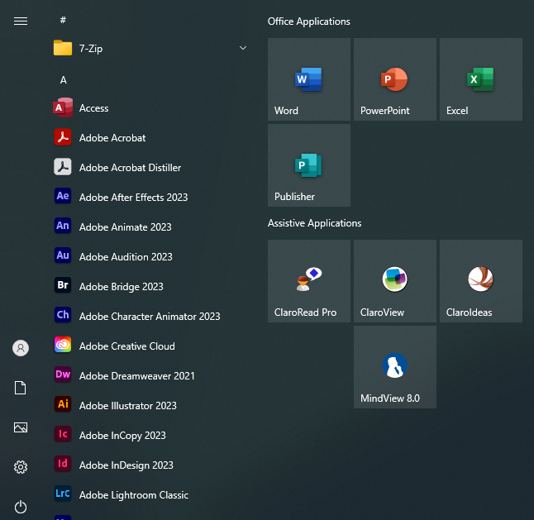

Networking capabilities:

Network capabilities refer to short-term authorizations that a sender obtains from a receiver and stamps on its packets to the receiver.
[6]https://www.ciena.com/insights/articles/3-network-capabilities-that-agencies-need-to-keep-up-with-cyberthreats.html
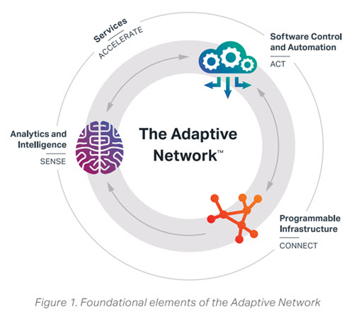

Security and Access Control:

TASK 2
In computing, dir (directory) is a command in various computer operating systems used for computer file and directory listing. It is one of the basic commands to help navigate the file system.
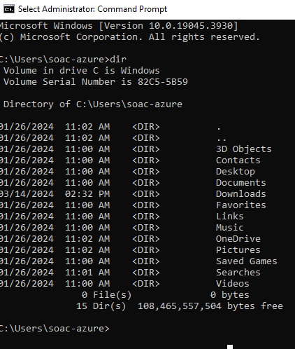
[7]https://www.lifewire.com/dir-command-4050018
[8]https://www.google.com/search?q=dir+in+cmd&rlz=1C1GCEA_enGB1106&oq=dir+in+c&gs_lcrp=EgZjaHJvbWUqBwgBEAAYgAQyBwgAEAAYgAQyBwgBEAAYgAQyBwgCEAAYgAQyBwgDEAAYgAQyBwgEEAAYgAQyBggFEEUYPDIGCAYQRRg8MgYIBxBFGDzSAQkx

dir /?. /? Can be used to see help information and other switches.
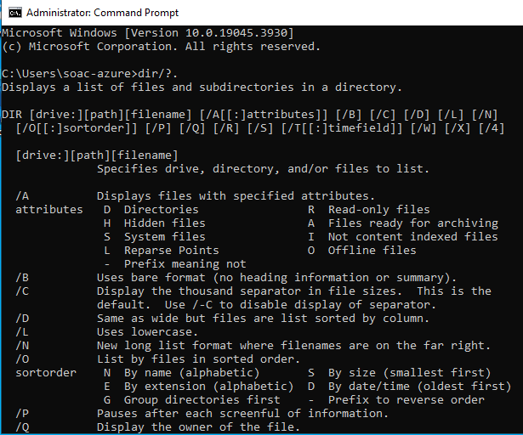

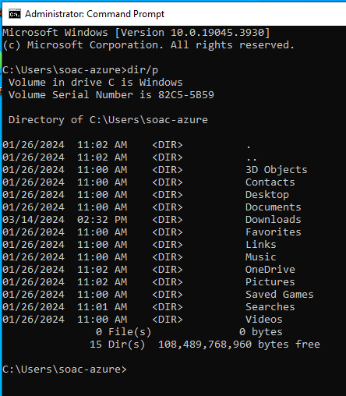 dir /p displays the directory one screen/page at a time
[9] /P - Pauses when the screen is full. Press any key to display another screen full of data. /W - Displays only filenames and directory names (without the added information about each file) in a five-wide display format.
[10] https://support.intermedia.com/app/articles/detail/a_id/27175/~/how-do-i-use-ipconfig-in-the-command-prompt-or-terminal%3F#:~:text=The%20ipconfig%20command%20is%20used,Subnet%20Mask%2C%20and%20default%20gateway.
ipconfig (standing for "Internet Protocol configuration") is a console application program of some computer operating systems that displays all current TCP/IP network configuration values and refreshes Dynamic Host Configuration Protocol (DHCP) and Domain Name System (DNS) settings. ipconfig
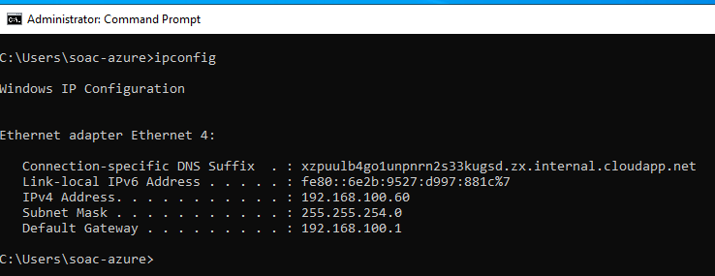
In computing, echo is a command that outputs the strings that are passed to it as arguments. It is a command available in various operating system shells and typically used in shell scripts and batch files to output status text to the screen or a computer file, or as a source part of a pipeline.
[11] https://www.geeksforgeeks.org/echo-command-in-linux-with-examples/
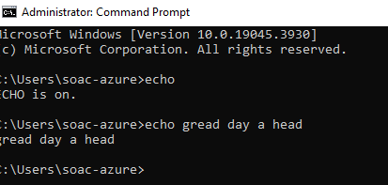

Description. The rmdir command removes the directory, specified by the Directory parameter, from the system. The directory must be empty before you can remove it, and you must have written permission in its parent directory. Use the ls -al command to check whether the directory is empty.
[12]https://www.geeksforgeeks.org/rmdir-command-in-linux-with-examples/
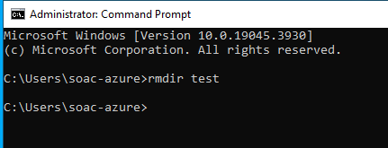

Task 3

What is Linux?
Just like Windows, iOS, and Mac OS, Linux is an operating system. In fact, one of the most popular platforms on the planet, Android, is powered by the Linux operating system. An operating system is software that manages all of the hardware resources associated with your desktop or laptop. To put it simply, the operating system manages the communication between your software and your hardware. Without the operating system (OS), the software wouldn’t function.
The Linux operating system comprises several different pieces:
- Bootloader – The software that manages the boot process of your computer. For most users, this will simply be a splash screen that pops up and eventually goes away to boot into the operating system.
- Kernel – This is the one piece of the whole that is called ‘Linux’. The kernel is the core of the system and manages the CPU, memory, and peripheral devices. The kernel is the lowest level of the OS.
- Init system – This is a sub-system that bootstraps the user space and is charged with controlling daemons. One of the most widely used in it systems is system, which also happens to be one of the most controversial. It is the in it system that manages the boot process, once the initial booting is handed over from the bootloader (i.e., GRUB or Grand Unified Bootloader).
- Daemons – These are background services (printing, sound, scheduling, etc.) that either start up during boot or after you log into the desktop.
- Graphical server – This is the sub-system that displays the graphics on your monitor. It is commonly referred to as the X server or just X.
- Desktop environment – This is the piece that the users interact with. There are many desktop environments to choose from (GNOME, Cinnamon, Mate, Pantheon, Enlightenment, KDE, Xfce, etc.). Each desktop environment includes built-in applications (such as file managers, configuration tools, web browsers, and games).
- Applications – Desktop environments do not offer the full array of apps. Just like Windows and macOS, Linux offers thousands upon thousands of high-quality software titles that can be easily found and installed. Most modern Linux distributions (more on this below) include App Store-like tools that centralize and simplify application installation. For example, Ubuntu Linux has the Ubuntu Software Center (a rebrand of GNOME Software) which allows you to quickly search among the thousands of apps and install them from one centralized location.

((Print Working Directory) A Unix/Linux command that displays the full path to the current directory (folder). The equivalent in DOS/Windows is the cd command without any parameter. [13]https://www.pcmag.com/encyclopedia/term/pwd#:~:text=(Print%20Working%20Directory)%20A%20Unix,cd%20command%20without%20any%20parameter.
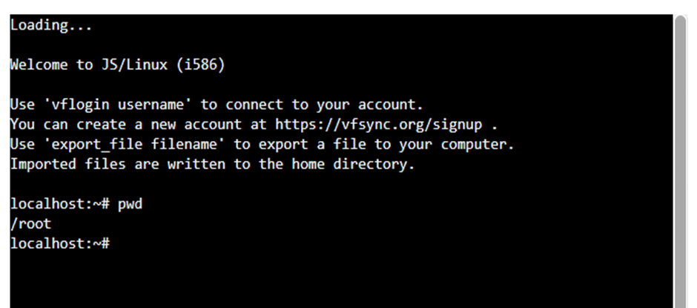

The ls command is one of the more basic commands in Linux. It is designed to list the names and features of files and directories. It can be used for a single file or as many as all files and folders in a selected set of directories. Command: ls [14]https://www.inmotionhosting.com/support/server/linux/ls-command/#:~:text=The%20ls%20command%20is%20one,Command%3A%20ls
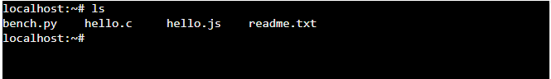
The “mkdir” command is used to generate a folder. Replace "testdir" with your desired directory name.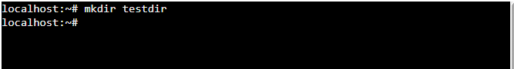
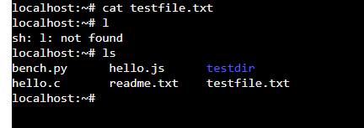

The touch command in Linux is used to create a new empty file and to change the timestamps of existing files. You can use it with the syntax: touch myfile. txt . In this example, we use the touch command to create a new file named 'myfile. https://www.geeksforgeeks.org/touch-[15] command-in-linux-with-examples/
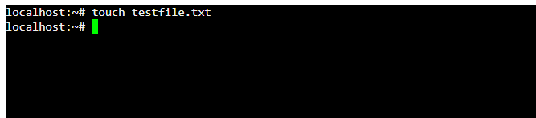
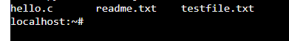

The cat command (short for “concatenate “) is one of the most frequently used command in Linux/Unix, Apple Mac OS X operating systems. cat command allows us to create single or multiple files,
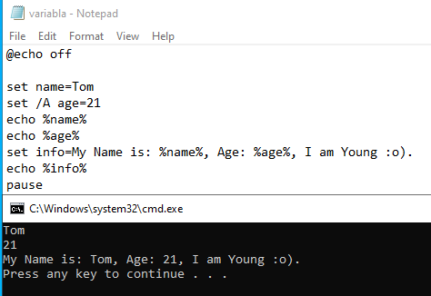
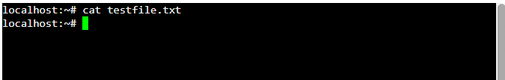

TASK 4
[16] https://stackoverflow.com/questions/29378566/i-just-assigned-a-variable-but-echo-variable-shows-something-else
Environment variables are mainly used within batch files, they can be created, modified and deleted for a session using the SET command. To make permanent changes, use SETX. Variables can be displayed using either SET or ECHO. Variables have a percent sign on both sides:

[17] https://stackoverflow.com/questions/29378566/i-just-assigned-a-variable-but-echo-variable-shows-something-else
Environment variables are mainly used within batch files, they can be created, modified and deleted for a session using the SET command. To make permanent changes, use SETX. Variables can be displayed using either SET or ECHO. Variables have a percent sign on both sides:
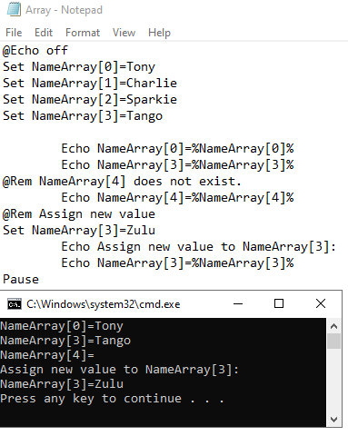

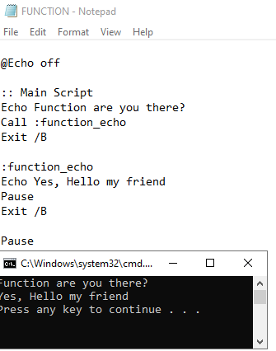

Task 5

Demonstrate the use of each key aspect of the Bash script syntax:

Variables

User Input

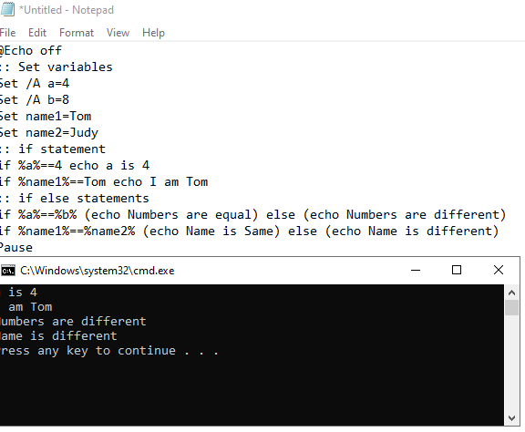
if statement

A Loop (one type)

Array

Case statement

Function

[18]
https://learnxinyminutes.com/docs/bash/
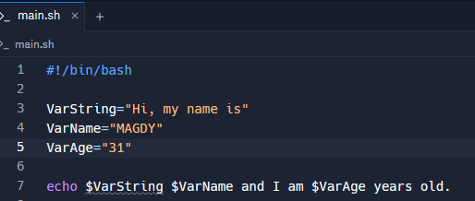
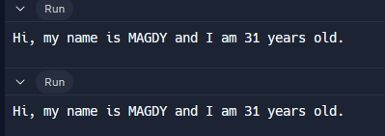

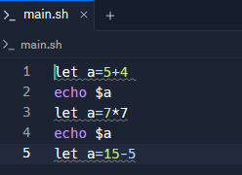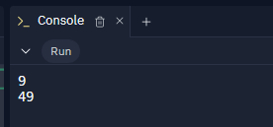

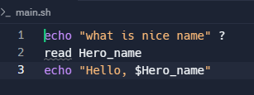

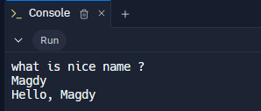

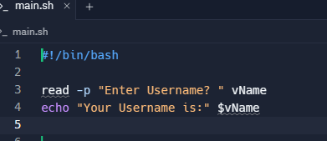
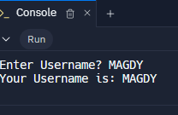

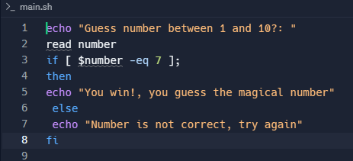
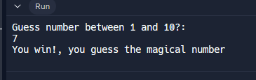

Conclusion
I have been done my report I in operation system I used learned windows command and I learned Linux batch and command and I learned how to use variable , if statement , function and Array in {echo} and I learned how to deal with the operating system I learned how PC processor performance working , in general I am so happy for what is I learned from this Report.

References
[1] https://kissflow.com/workflow/bpm/what-is-process-management/#:~:text=Process%20management%20is%20a%20systematic,business%20processes%20with%20strategic%20goals.

[2] https://superuser.com/questions/1364800/cpu-usage-at-100-but-tasks-using-it-are-not-showing
[3]https://www.tutorialspoint.com/computer_concepts/computer_concepts_file_directory_management.htm
[4]https://www.javatpoint.com/device-management-in-operating-system#:~:text=Device%20management%20in%20an%20operating,like%20supporting%20units%20control%20channels.
[5]https://www.javatpoint.com/device-management-in-operating-system#:~:text=Device%20management%20in%20an%20operating,like%20supporting%20units%20control%20channels
[6]https://www.ciena.com/insights/articles/3-network-capabilities-that-agencies-need-to-keep-up-with-cyberthreats.html
[7] https://www.lifewire.com/dir-command-4050018
[8]https://www.google.com/search?q=dir+in+cmd&rlz=1C1GCEA_enGB1106&oq=dir+in+c&gs_lcrp=EgZjaHJvbWUqBwgBEAAYgAQyBwgAEAAYgAQyBwgBEAAYgAQyBwgCEAAYgAQyBwgDEAAYgAQyBwgEEAAYgAQyBggFEEUYPDIGCAYQRRg8MgYIBxBFGDzSAQkx
[9]https://www.google.com/search?sca_esv=09379ecd0b6efd91&sca_upv=1&rlz=1C1GCEA_enGB1106GB1106&q=dir/p+command&sa=X&ved=2ahUKEwij1Imx7s6FAxV4UUEAHQr_DNYQ1QJ6BAg1EAE&biw=1920&bih=953&dpr=1
[10] https://support.intermedia.com/app/articles/detail/a_id/27175/~/how-do-i-use-ipconfig-in-the-command-prompt-or-terminal%3F#:~:text=The%20ipconfig%20command%20is%20used,Subnet%20Mask%2C%20and%20default%20gateway.
[11] https://www.geeksforgeeks.org/echo-command-in-linux-with-examples/
[12]https://www.geeksforgeeks.org/rmdir-command-in-linux-with-examples/
[13]https://www.pcmag.com/encyclopedia/term/pwd#:~:text=(Print%20Working%20Directory)%20A%20Unix,cd%20command%20without%20any%20parameter.
[14]https://www.inmotionhosting.com/support/server/linux/ls-command/#:~:text=The%20ls%20command%20is%20one,Command%3A%20ls
[15] https://www.geeksforgeeks.org/touch
[16] https://stackoverflow.com/questions/29378566/i-just-assigned-a-variable-but-echo-variable-shows-something-else
[17] https://stackoverflow.com/questions/29378566/i-just-assigned-a-variable-but-echo-variable-shows-something-else
[18]
https://learnxinyminutes.com/docs/bash/

MY LINUX COURSE SCREEN SHOT


