Advance Cybersecurity Assignment Student number: P147535
Module Code: ACCA6000
Module Tutor: Dr Carlene Campbell

Cloud-based services security issues & the future trends in Cybersecurity
Abstract—This paper looks into two issues that are critical in the field of information technology. The first issue addressed is the future trends in cybersecurity. Cybersecurity has grown tremendously over the years, as a result of increased use of the internet and technology. There are various cybersecurity trends that are likely to be witnessed in the future, such as an increase in cybersecurity threats. As mobile technology and the Internet of Things use increases, there is also likely to be an increase in the cyber threats which need to be combated. Nevertheless, artificial intelligence (AI) presents a viable solution to cybersecurity threats. Furthermore, blockchain may present a possible solution to cybersecurity threats and bring an end to the use of passwords, as the main method used in safeguarding data and systems. Moreover, a growth and demand for cybersecurity professionals and education is likely to be witnessed as demand for professionals to deal with the ever increasing cyber threats increases. Additionally, as governments and large corporations become the targets of cyber-attacks, governments are likely to come up with policies aimed at protecting them against cyber threats. Security issues around cloud based services are also discussed. The main security issues in cloud computing stem from the service providers not wanting to engage in regulatory compliance, trust by the consumer and the identification of security threats. Furthermore, privacy and confidentiality of information stored on the cloud is also a major security issue in services that are cloud based. Additionally, the accessibility and reliability of information stored in the cloud is also a security concern.

Introduction
The paper looks into two topics of future trends in cybersecurity and security issues related to services that are cloud based. The issues were chosen owing to the significant role that they play in the current world and in the future. There has been a heavy reliance in recent times on the internet, devices and things connected to the internet, as well as cloud computing. With this increased reliance, there has been an increase in cyber-attacks and therefore the need to look into the future of cybersecurity. Furthermore, cloud computing, despite its popularity has various security risks to its users, which are discussed in this paper. Furthermore, throughout the Lab analysis, the design and simulation of the IQ UWTSD “smart campus”, the author will try to combine between the understanding established from the research section and the Ethical hacking skills learned during this module to plan few real life hacking scenarios on the design network topology. Throughout these attacking scenarios, many potential risks and threats could be discovered and mitigated.

Related Work

Future trends in cybersecurity

Increased security threats
With the increased use of technology for personal and business purposes, there has been an ever increasing need for cybersecurity, as the potential threats have also increased. Cyber criminals are increasing coming up with new ways in which to gain unauthorised access to devices and information [1]. This section looks into the trends that are likely to be seen in the future in the field of cybersecurity.
The increase in cyber threats has mainly been promoted by poor security practises. Nevertheless, there has also been an increased awareness of threats that exist among the general public and organisations. In addition, there has been a need for sophisticated tools, which are capable of dealing with the ever growing sophisticated levels of attackers.
Ransomware attacks are likely to be on the increase in the future, more so, those targeting corporate networks. The rise of crypto currencies allows for cybercriminals to profit directly from the use of malware. There is therefore likely to be an increase in ransomware that is more sophisticated and personalised to the target organisation. In addition, social engineering makes it easier for cybercriminals to gain access to organisations.
Attacks on supply chains are also likely to be witnessed in the future, as companies share information with suppliers, distributors and retailers with the goal of increasing efficiency [3]. In addition, supply chains are usually in direct contact with the consumers and are therefore a way in which hackers can gain access to multiple systems. In supply chains, cyber threats can be disguised as software packages, which can then be used to gain access to an entire supply chain.

Blockchain security
One of trends that is currently on the increase and which is expected to be seen more in the future is the use of blockchain security [2]. Investments on the technology are currently underway and block chain technology is deemed as the future of cybersecurity. Nevertheless, blockchain has been widely applied to crypto currencies. The use of blockchain technology is likely to results in the death of passwords and offer encryption that is very advanced. In addition, blockchain technology will establish infrastructure that cannot be tampered with. Furthermore, blockchain security is secured through cryptography, eliminates the need for third party and stores data in a format that is distributed.
In the future, passwords are likely to be ditched by individuals and organisations, owing to the vulnerabilities that are present in passwords, such as users setting passwords that can be easily cracked and standards are complex.

AI and IoT
AI is likely to be utilised to a greater extent in the future. AI can, for example, leverage live security owing to its high speed in computing and features, such as self-learning which allow the AI to react in accordance to previous experiences to combat security breaches [2]. Despite cybersecurity not being an area of concentration of AI, it has the potential to be a game changer in cybersecurity [4].
Additionally, there has been a growth of threats related to IoT, as more and more people, as well as devices are being plugged into the internet. Most of the IoT in the market are deemed to have serious vulnerabilities, in regard to their security, which opens them to cyber-attacks [5]. Insecure web interfaces and transfer of data over these interfaces leave users who are connected to multiple devices vulnerable. This results in one breach resulting in the breach of several devices. IoT devices which have a poor design may present vulnerabilities that expose the user’s data leaving data unprotected. In the future there is therefore expected to be an increase in cyber threats related to IoT, as people are becoming more and more reliant on IoT systems for a variety of services.

Cybersecurity profession and education
There is expected to be an increase in demand for Cybersecurity professionals to keep data in organisations, as well as personal data, secure [6]. There is therefore likely to be an increase in training on cybersecurity and an increase in career paths for cybersecurity professionals [2]. Education on cyber security is likely to grow exponentially in the US, owing to public-private partnerships [7]. In addition, the US regime is also appealing to organisations, the academic world, as well as the industry to work together so as to defend cyberspace.

Mobile devices, platforms and cloud computing
One of the trends that are likely to continue into the future in cybersecurity is the exponential growth of mobile devices and applications, which in turn result in a growth in security risks [8]. A new device provides a window for a cyber-attack, an access point to networks through the exploitation of vulnerabilities. Additionally, new platforms, as well as devices will emerge in the future and will present opportunities for cybercriminals. Mobile devices and the platforms they run on will be a new avenue for cyber-attacks, as their increased use grows. This is evidenced by the ever growing number of malicious applications and spyware on the Android and Apple platforms.
Additionally, cloud computing is a trend that is likely to continue growing, well into the future as more and more firms embrace it, owing to cost savings and efficiencies [9]. Nevertheless, the increased utilisation of cloud computing by firms presents a set of vulnerabilities to cybersecurity. This is evidenced in the fact that studies and reports point out that the significant role of safety and due diligence in cloud computing by companies is being underestimated, as companies fail to vet the providers of cloud computing services [8].

Governments and cybersecurity
Additionally, cybersecurity is likely to become a prominent agenda in the national security policies of countries, owing to an increase in the number of attacks that target prominent businesses and governments. Owing to the highly publicised and sophisticated nature of cyber-attacks, such as the computer worm Stuxnet which allows for sabotage, cybersecurity is increasingly being termed as a concern that is strategic and military [10]. Cyber threats to countries national and economic security, as well as health and safety of the public are likely to be more undefined and frequent [11]. In addition, more than 10 million US residents have been victimised through theft of their identity in 2009. Cybersecurity is likely to become a concern for countries, as depicted by the Stuxnet worm incident, which wiped out 60 percent of computer networks in Iran [12]. In addition, the Stuxnet worm demonstrates that nation-states are susceptible to the cyber actions from other nations, as well as private entities. In addition, cybersecurity is also likely to become a global concern with the goal of mitigating risks of similar attacks. Furthermore, as knowledge on the Stuxnet worm become more public, countries and organisations are likely to engage in cyber wars, where copies of the Stuxnet worm are used by public and private enterprises.
Cybersecurity has become increasingly important as governmental organisations, private companies and the military have shifted the activities on the internet [13]. This will in future result in the development a comprehensive cybersecurity policy, which will be based upon government documents on the topic of cyberspace.

Cloud based services security issues
There has been an increase in storage of data in the cloud owing to scalability and savings in terms of costs and easy accessibility. The increased use of cloud services presents a new avenue for attacks. Cloud computing has several security risks [14]. There has been a change in the world of computation from centralised to distributed systems and an increase in virtual centralisation, that is the cloud computing is currently being witnessed [15].
One of the chief concerns in the use of cloud computing is that services and data preservation is undertaken by a third party and this leaves the client uninformed of the processes that are being run on the information, as well as where the data is being stored [16]. There is therefore a need for service providers to offer consumers assurance through service level agreements. Nevertheless, it is difficult to guarantee security and confidentiality of company data in the cloud owing to diverse services offered, such as: Software as a Service, Infrastructure as a Service and Platform as a Service. Every one of these services has their own security issues, which makes a service level agreement necessary.

Services in cloud computing
Infrastructure as a Service (IaaS) is a model of cloud computing that offers clients control over applications used in deployment, operating systems and offers a possibility of limited control in the selection of components for networking. Platform as a Service (PaaS) on the other hand, offers consumers the ability for the deployment of the cloud infrastructure, applications acquired or created by the consumers, which are created utilising tools and programming languages, which are sustained by the providers. Service as a Software (SaaS) offers clients the capacity to utilise the applications of the providers, which are operating on cloud infrastructure [17]. The applications can be contacted via client devices through a client interface, such as a web browser.
One of the security issues that are evident with the use of cloud based services has to do with privileged user access. This is especially the case when sensitive data is processed outside an organisation, as services that are outsourced tend to by-pass controls pertaining to personnel, physical and logistical issues which organisations have in programs that are in-house [18]. This makes it necessary for users of cloud based services to ask questions about the hiring of personnel and privilege afforded to administrators.

Regulatory compliance
Another security issue associated with the use of cloud based services is the regulatory compliance of companies offering these services. Customers using cloud based services are accountable for the safety and integrity of their information. Providers of cloud computing services are not subjected to as much scrutiny as traditional service providers, which is a cause of concern to customers regarding the security of their data.

Trust and security identification of threats
Trust is one of the chief safety issues in cloud-based services and has to do with trust in regard to access and security controls of the computer networks, reliability of the systems and rules pertaining to decision making under ambiguity. Trust in cloud based services relies on the operation model that is chosen, as the control of applications and data is outsourced and handed over, out of the owner’s strict control [19].
Another security issue in the use of cloud-based services has to do with the security identification of threats. In order to secure information systems, the threats and challenges facing the system must be identified, so as to allow for the implementation of the necessary countermeasures. Cloud computing, owing to its architectural design and features, offers various security benefits but also presents a new set of security issues. The features of cloud computing need to be assessment in terms of their risks in areas such as: reliability, availability, integrity of the data, privacy, ability for the data to be recovered, as well as auditing. In cloud based services, emphasis on security is in terms of the confidentiality, integrity, as well as availability. These three issues are paramount in the design of systems that are secure.

Privacy and confidentiality
Confidentiality and privacy in cloud based systems are important for services that are cloud based. Confidentiality refers to access to protected data, only being accessed by parties who are authorised. Cloud based services have an increased threat of data being compromised, owing to the amplified quantity of applications, parties and devices, which results in an augmentation in the quantity of points of entry. Additionally, the risk of information being compromised comes from data being delegated to the cloud, since the information is reachable to an amplified number of parties.
Multitenancy feature of cloud based services refers to the sharing of resources. The resources that are shared are data, memory, networks and programs. Cloud computing business model entails the sharing of resources at the application, network as well as host levels. Multitenant architecture means that the software application is designed in a manner that data and configuration are virtually partitioned, so that each client organisation works with a virtual application in each case that is customised. Infrastructure on the cloud often entails the reusability of objects, which means that the objects must be controlled in a careful manner, so as to safeguard the entire system from serious vulnerabilities.
Confidentiality of data may also be compromised as a result data remanence, which is a security issues in cloud-based systems. Data remanence refers to the lingering depiction of information that has been technically removed or erased. Owing to the virtual division of logical drives and lack of partition of hardware linking several users who are on a one infrastructure, data remanence has the ability to lead to the unintended revelation of confidential data.
Figure 1 - Tracing the attacker’s email

Data integrity and availability
Another security issue in cloud-based services is the integrity of data, which refers to the protection of data from unauthorised fabrication, deletion and modification. A provider of cloud based services is trusted with the task of maintaining the accuracy and integrity of data. The cloud model presents threats which are not limited to attacks from sophisticated insiders [20]. In addition, cloud based services’ security relies on the security of interfaces, which are utilised by clients to manage and interact with the cloud services. However, if the interfaces are not secure, an unauthorised person can gain access to the data and interfere with its integrity.
Availability security issue are faced cloud based services, owing to the fact that cloud based services rely at all times on the availability of networks and resource infrastructures all the times. Availability refers to the nature of a system of being easy to get to and used on require by an individual who is authorised [17]. Cloud based services need to be available even when a breach occurs, so as to cater to the needs of the customers. This requires that data, hardware and software is available to users who are authorised on demand.

Lab exercises analysis

Lab1: Footprinting & Reconnaissance

However robust the network security of any company is, attackers always persist in trying everything to find loopholes and weaknesses to exploit or create one by targeting the employees through email attacks. Classic email attacks intended to inject viruses and malicious programmes can bring an entire network down if not dealt with properly. It is the author’s belief that raising awareness of cybersecurity among employees and providing regular workshops on the subject can improve the overhaul network security of any company. To counter-attack this type of email attacks it is important to conduct Footprinting & Reconnaissance counter-attacks against these hackers by collecting their information using emails tracing.
As an ethical hacker, we will be performing footprinting & reconnaissance against the sender of the suspicious email. In this lab we will be using the eMailTrackerPro tool to produce a full footprinting report using two methods:
The first method is tracking a specific email address emulating an attacker:
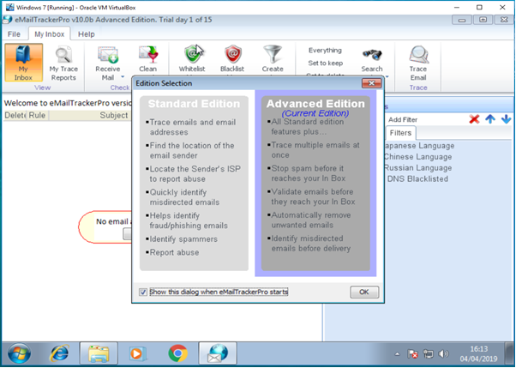
- Installing the eMailTrackerPro software on the virtual machine.
Figure 2- Installing eMailTrackerPro
- Tracing the email using Trace address of a real life scenario: in this lab we are using a real spam email that the author has received from the alleged Mr Peter Chin in the UAE, trying to convince victims to invest money in an Oil/Gas company, etc., using the email address mail@mail.com
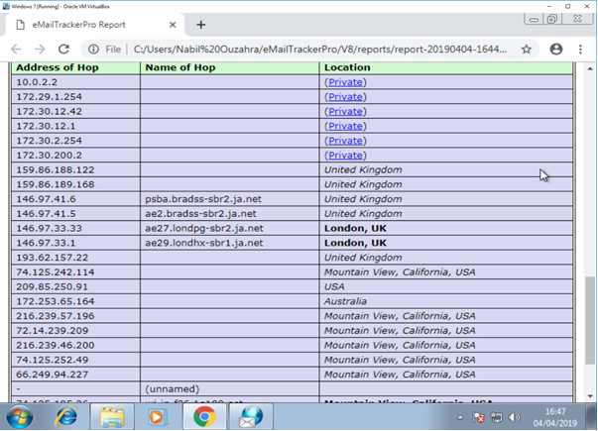
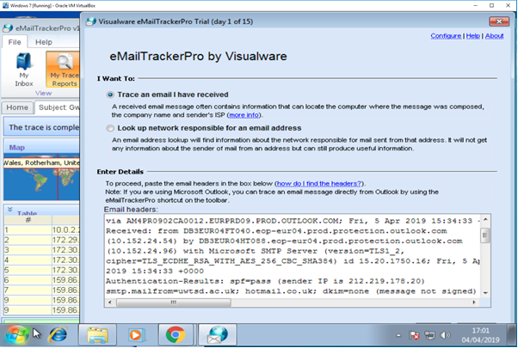
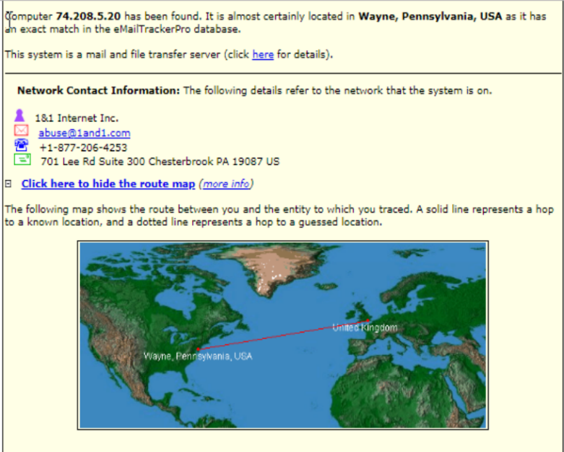
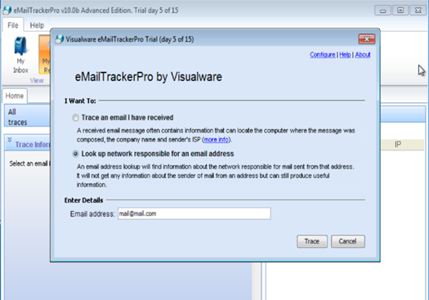
- As predicted, the results show that the email was a true spam as it was sent from a network belonging to a registered IP address 74.208.5.20 located in Wayne, Pennsylvania, USA.
Figure 6 - IP hop address to the source of the email server
Figure 5 - Tracing using email header
Figure 3 - Location Report
Figure 2 - Tracing the attacker’s email

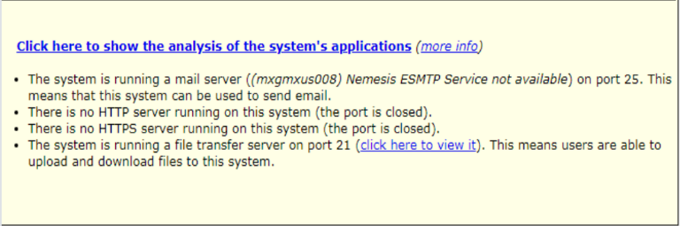
- The report gives more detail about the attacker’s system: running a mail server (mxgmxus008), no HTTP/HTTPS running (both ports closed). However, it is worth noting that his system is running an FTP server with port 21 open.
Figure 4 – Attacker’s system report
Figure 7 - Map results with both Hotmail and msn servers across continents

The second method is tracing the email header of an attacker.
In this part, we have used the email header from a Hotmail email address created for the purpose of this lab only. The results where conclusive as shown in figures 5-6-7.
Although attackers can use different technics to deceive their victims and hide the email source, the information within the header can always be used to perform a successful trace.
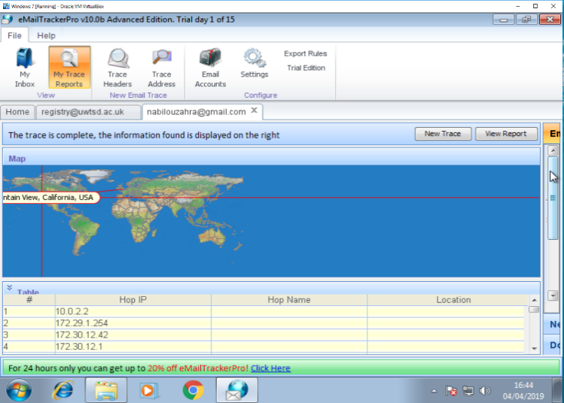

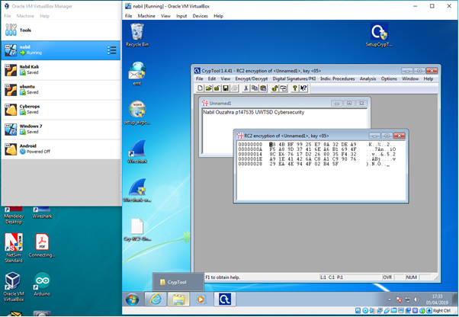
Lab 2: Cryptography

This lab highlights the importance and role of cryptography when it comes to protecting data information and communication throughout, especially with regard to valuable and sensitive data from individuals, companies or even governments. Cryptography is the science of using mathematical algorithms to decrypt or cipher the data using different types of keys. Symmetric and asymmetric algorithms such as AES, DES, RSA, DH, etc. are used to generate different types of keys. No matter what level of network security one has, data can always get compromised through internal individuals. Therefore, data encryption is always an extra security buffer to prevent data from being hacked and compromised.
In this lab, we have used a cryptography tool called “CrypTool”, which is one of the top freeware software that helped us to apply real examples, analyse the outcomes and have a real feel of how powerful Cryptography can be.
Figure 10 - Data decrypted using RC2 algorithm
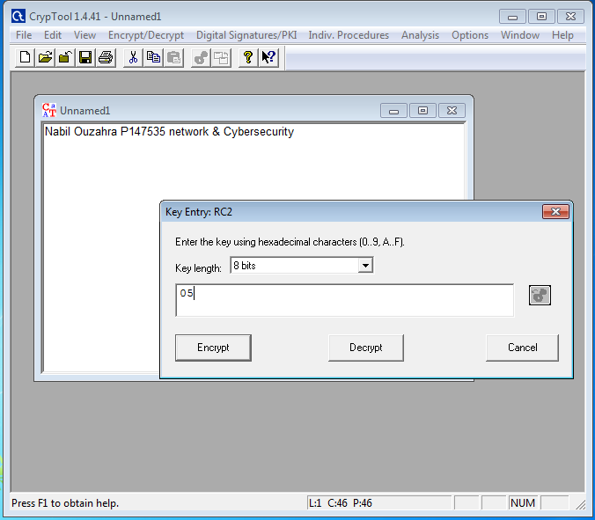
As shown in the figures below, we have successfully encrypted and decrypted the author’s university details as if it were stored on a registry server. The data was encrypted using a symmetric algorithm with RC2 8 bites key. The results show how complex the data is when it gets encrypted and how complex decrypting it can be without the correct key, especially if it was done with an RSA 2048-bits key.
Figure 8 - Encrypting the data using RC2 with 8 bites key
Figure 10 - Data Decrypted using RC2 algorithm
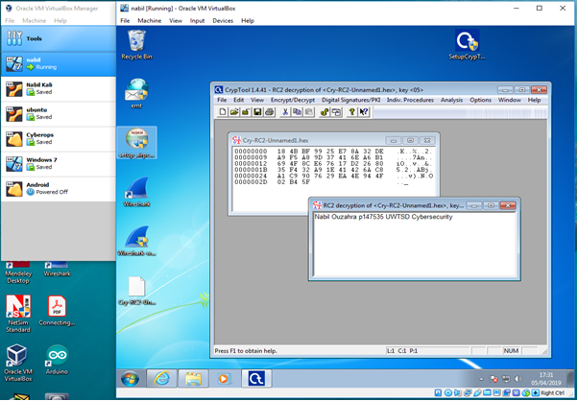
Figure 9 - Data encrypted using RC2 algorithm

Lab 3: Social engineering

Social engineering has become one of the effective ways to attack corporate and individuals’ information systems. It has emerged as a severe threat among virtual communities. Together with the growing trend of BYOD policies, the growing use of different communication tools such as IM, Skype, Dropbox, emails, etc., to collaborate between teams and business partners in different geographical locations has aggravated the level and the variety of social engineering attacks seen recently.
Evolutionary technics which have been developed by hackers, combined with zero-day exploit [21]have seriously damaged organisations and companies such as Sony, The New York Times and RSA.
Throughout this lab, we will have a real feel of how easy and efficient it is to create a social engineering attack against an individual’s Facebook account. It could be even more damaging if the aim was to target their bank account, PayPal account, business email account, etc.
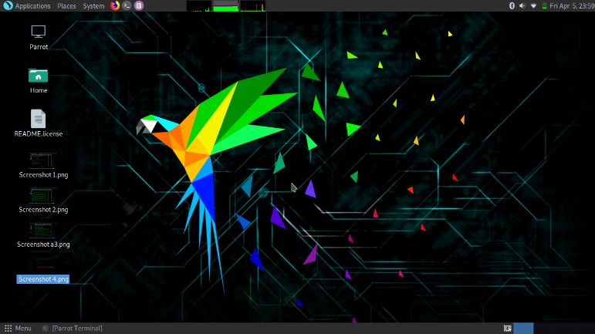
The first step is installing the Parrot OS system instead of Kali Linux (preferred choice) [22].
Figure 11 - Installing Parrot IOS system
The second step is navigating the applications menu to clone the website of Facebook and link it to the attacker’s IP address so that the compromised data of the victim gets directed to the attacker’s machine (as shown in figures 12 -13).
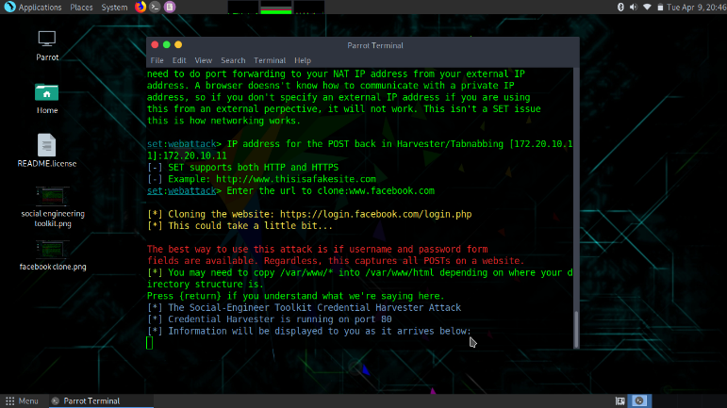
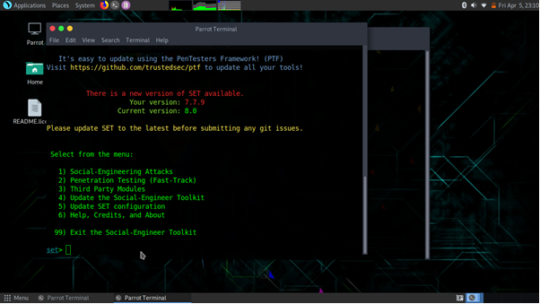
Figure 13 - Cloning the Facebook page
Figure 12 - Navigating through the social engineering attacking tools
Figure 13 - Cloning Facebook page
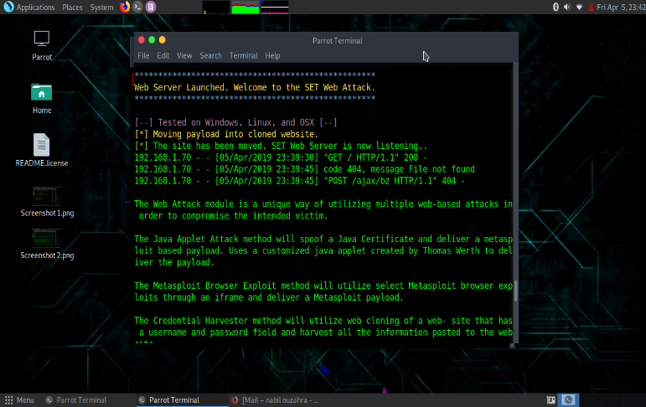
The third step is sending an email to the victim with a fake link to the Facebook login page http:www.facebook.com after forging the IP address of this web page using the attacker’s machine IP address instead (as shown in figure – 14).
Figure 14 - Web attacking server listening to the network traffic
The fourth step is following the link sent to the testing email created for this purpose, which would be the action that any individual unaware of cybersecurity would take.
The last step is waiting for the compromised data to be redirected to the attacker’s machine as soon as the victim
attempts to log-in with their username and password on the fake web page (please see figures 15.1 – 15.2).
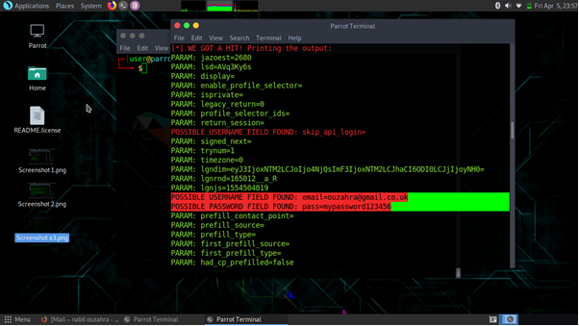
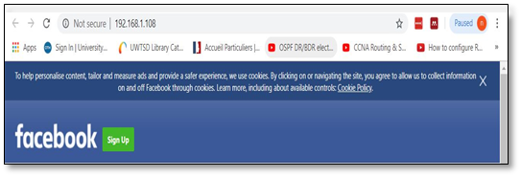
Figure 15.2 – The username and password of the victim have been captured in plain text
Figure 15.1 - Fake Facebook login

Lab 4: Scanning Networks – Anonymous Browsing using Parrot OS

This lab was done using a more advanced and easier tool available on the Parrot OS system similar to the CyberGhost proposed in Lab 2. The purpose of this lab could also be achieved using the Kali Linux proxy chain or the TOR proxy [23]. As an ethical hacker or penetration tester scanning the network of a company with a view to gathering information about their system weaknesses, port, running servers, etc., it is essential that our access to web content be unlimited. Therefore, being able to surf anonymously would give an ethical hacker the same advantage as any black hat.
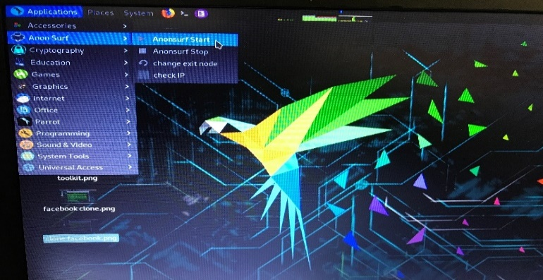
The Parrot security project team has developed an integrated script that can help the user to set a proxy chain by a simple click on the application menu.
Figure 16 - Launching Anonymous surf on Parrot OS

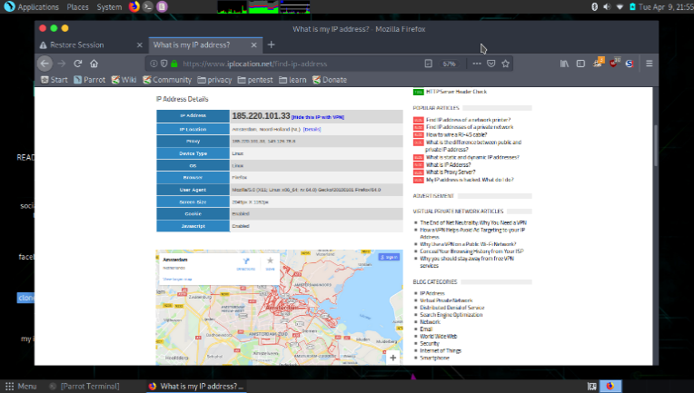
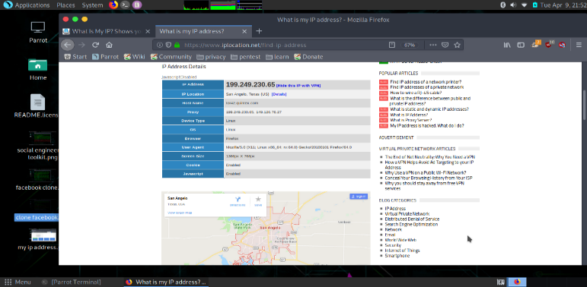
After launching the anonymous surf, the IP address location and has been checked successfully. Every time the service was launched, a new IP address has been assigned to the machine as illustrated in the figures 17-18.
Figure 18 - New IP address located in Amsterdam, Holland
Figure 17 - New IP address located in California USA
Figure 16 - Launching the Anonymous surf in Parrot OS

The author also checked for any DNS leaks to crosscheck the total anonymity of the user when browsing the web. The figures below show that every time we launched the anonymous surf, a new DNS address was assigned to our system (1st time was in Sweden and 2nd time Denmark)
Figure 22 - Network Design Model
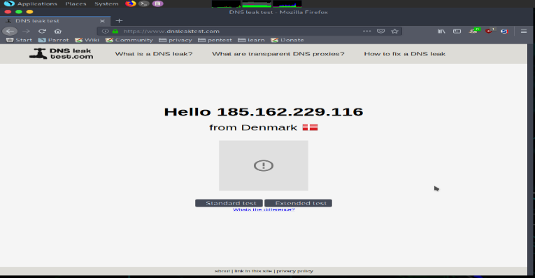
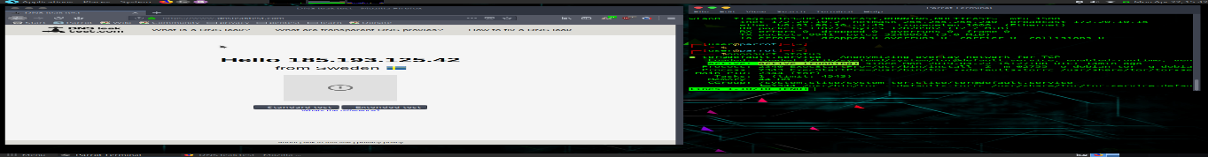
Figure 20 - DNS leak test showing DNS IP in Denmark
Figure 19- DNS leak test showing DNS IP in Sweden

design of a solution to a potential real life scenario

Simulation design of IQ building “Smart Campus”.

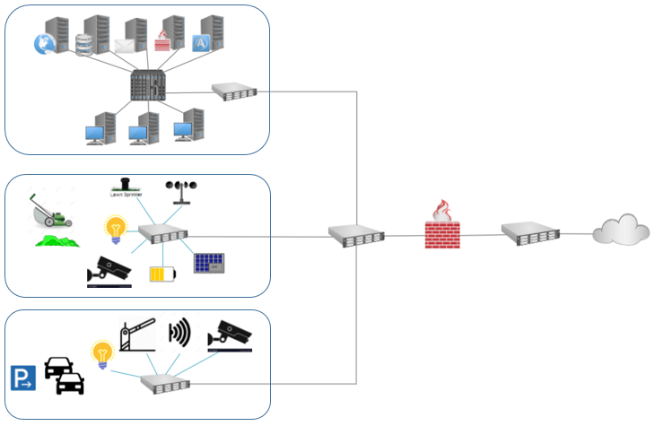
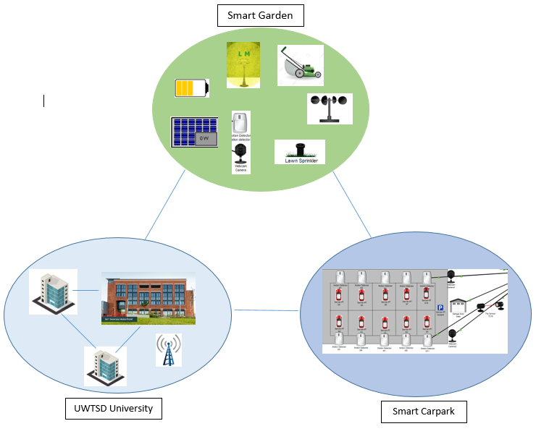
In this section, we will cover a discussion about the design aspect of the university smart campus. Within this design, the author will provide a technical discussion for each section created and an illustration of the overall design architecture.
Figure 21 - University Design Model

Implementation of the “UWTSD” smart campus

A functional network design was developed using Packet Tracer to simulate the entire sections of the new IQ smart campus. Various factors have been taken into consideration: support of IoT and BYOD policy across the campus; efficient hierarchical network design to support all the services running; sharing resources with collaborative partners securely using VPN; use of IoT sensors across the campus to develop a smart garden, a smart car park and a smart class room management system. There were many aspects to the security of this network, including:
- an ASA firewall was implemented in this design to stop unauthorised access and unwanted traffic to the network.
- a concept of honey pot was configured in the DMZ area to deceive any potential attackers.
- Network Behaviour Analysis software was deployed to alert the network administrator in real-time of any ongoing attack.
- an Intrusion Prevention System (IPS) host server was included to complement the role of the firewall to identify any dangerous incoming packets to the network that violate the specific rules and network policies.
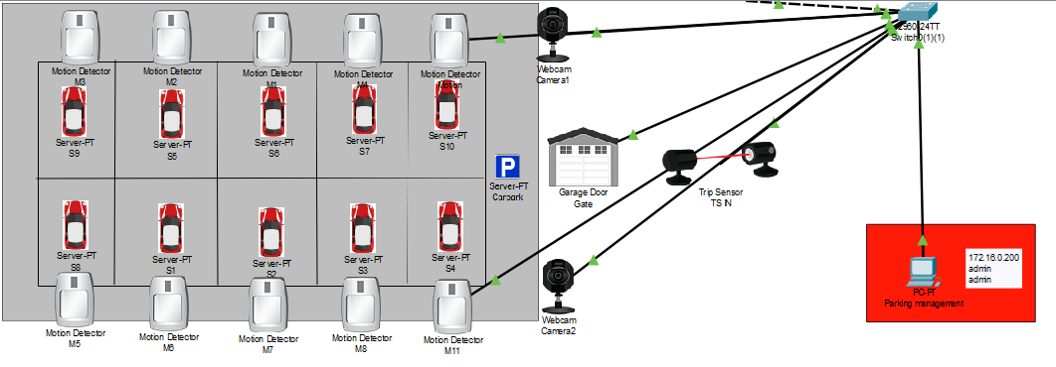
- an Intrusion Detection System (IDS) host server was added to analyse a copy of the live traffic out of band (offline) looking for any log violation so that alerts could be sent to the network administrator.
- a LAN remote access using ssh only to manage all the network components.
- a strong password to the wireless access point was configured to eliminate any chance of brute force password attack [24].
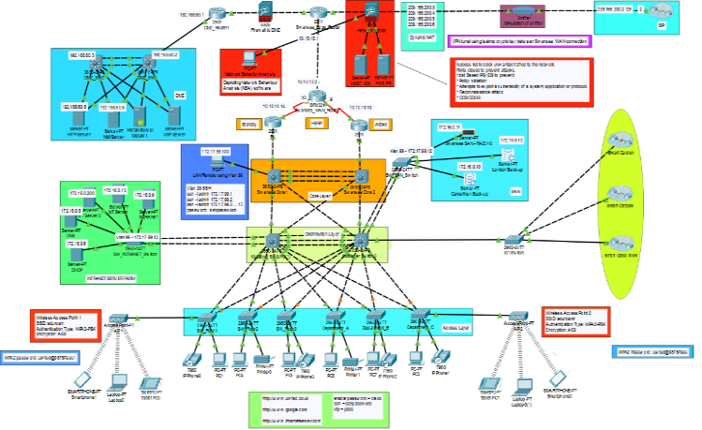
- a VPN tunnel was configured to the WAN, so that all the traffic between the main Swansea campus and other partners is encrypted.
Figure 25 - Smart Car Park
Figure 23 - Overall network topology
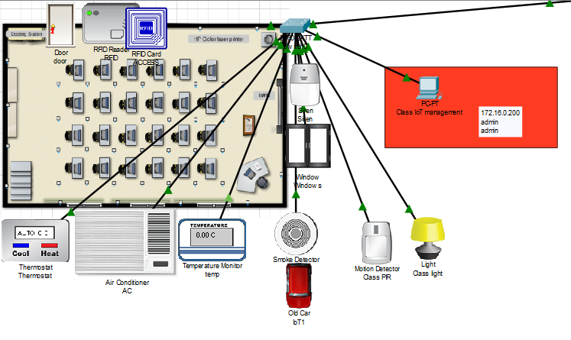
The author assumes that all the configurations and security features listed above are fully functional though it is not possible to implement and simulate all of them using Packet Tracer.
Smart Garden
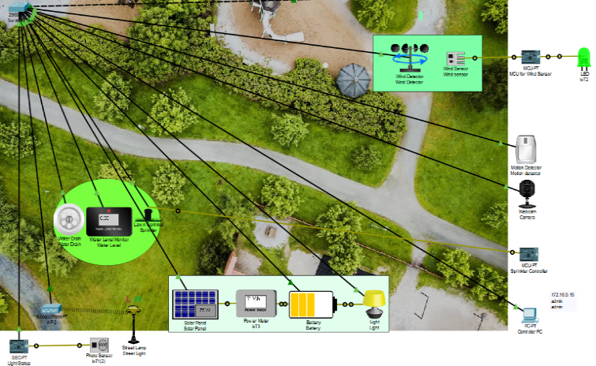
This design includes the development of a smart garden management system using IoT sensors as part of the overall network structure. This was done through the configuration of an IoT server within the Intranet server farm (please see figure - 24).
Figure 26 - Smart Class Room
Figure 24 - Smart Garden

Smart Car Park
A suitable smart car park was designed as part of this implementation, as shown in figure - 25, to illustrate a good understanding of IoT sensors interaction and the concept of modern smart car park.

Smart Class room
We also conveyed to demonstrate an illustration of a smart class room where many systems have been integrated into a single management system.
As shown in figure - 26, we have included a CO2 alarm system, an automated lighting system, an environment control system and an access control in this design.

Simulation and analysis of all potential risks, threats and attacks

The potential risks and threats to the recommended network design can be classified into two major groups: internal threats and external threats.
The potential risks to the network security are:
- BYOD policy implementation.
- Cloud computing risks.
- IoT botnet exploitation.
- Network exploitation through third party (partners and collaborators).
- Employees’ lack of knowledge about cybersecurity.
- Employees’ errors and behaviour.
- Lack of IT security management.
- Lack of defence in-depth knowledge.

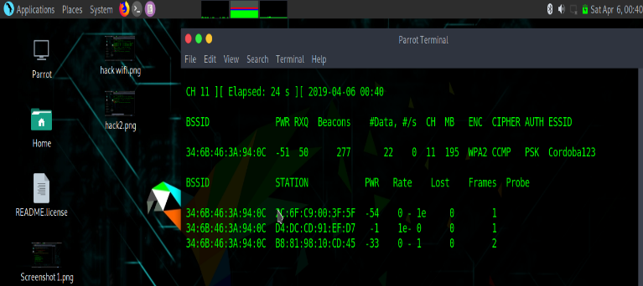
- Abuse of network policy and user account privilege.
Figure 27 - 1st step using airmon-ng
- Physical security and access control to the network infrastructure.
- Storing unencrypted data.
- Firewall misconfiguration (only trusted traffic should be permitted to the LAN and VPN).
- Remote management using telnet.
- Setting weak passwords.
- Devices loss and theft.
- Outdated software.

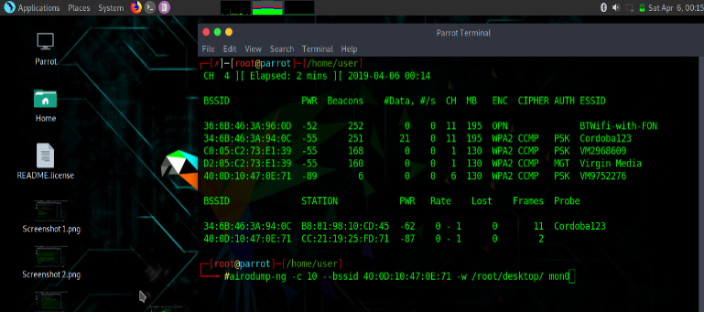
Unpatched security vulnerabilities and bugs.
Figure 28 - 2nd step using airodump-ng

The major possible attacks to this network are:
- Denial-of-Service (DoS) and Distributed Denial-of-Service (DDoS) attacks [25].
- Malware attacks
- Social engineering attacks.
- Phishing and spear fishing attacks.
- Password attacks.
- SQL injection attacks.
- WPA2 handshake vulnerability.
- Reconnaissance attacks.
- Exploit attacks.
- Passive attacks.
- Active attacks.
- Insiders attacks.

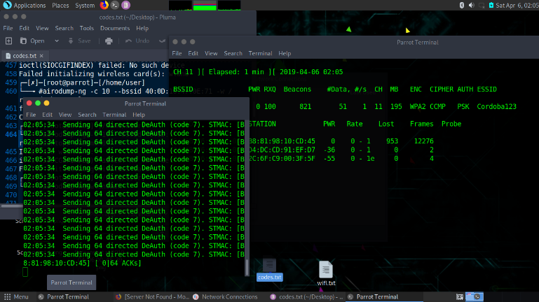
The potential risks and threats to the network design proposed for the new UWTSD smart campus will always be present. The author believes that the risks of successful attacks will always exist despite all the security layers, features, network policies and the engineers’ ingenuity. This can be explained by human errors and behaviour which always expose and weaken the security of networks. Indeed, statistics show that 93% of cyberattacks were due to human errors [26], which is why the cybersecurity insurance sector has risen sharply in the last few years: it was estimated at $500 billion in 2017 only and is expected to quadruple by 2019 [27].
Figure 29 - 3rd step using aireplay-ng
To conclude this report, the author has chosen four lab attack simulations targeting the university’s new smart campus using different offensive tools and each lab will identify certain risks. At the end of each lab, some recommendations will be given in order to mitigate those risks. It is worth noting that all these attacks were carried out in an ethical fashion using educational resources.
Figure 30 - 4th step using aircrack-ng
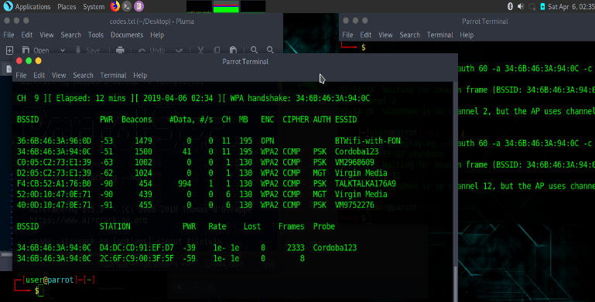
Attack 1: Exploiting WPA2 handshake vulnerability.
Using a home wireless access point and the “aircrack-ng” Kali Linux attacking tool, the author has managed to capture the handshake packet that contained the password key encryption and which was later put into a brute force password attack using a preloaded world-list file to crack the password. However, due to the strength and length of the password used, it proved impossible to crack after 5 hours, which emphasises the importance of using strong passwords. It would take a few months if not years to crack strong passwords using this method (please see figures – 27 to 31).
Figure 31 - Handshake WPA2 packet captured

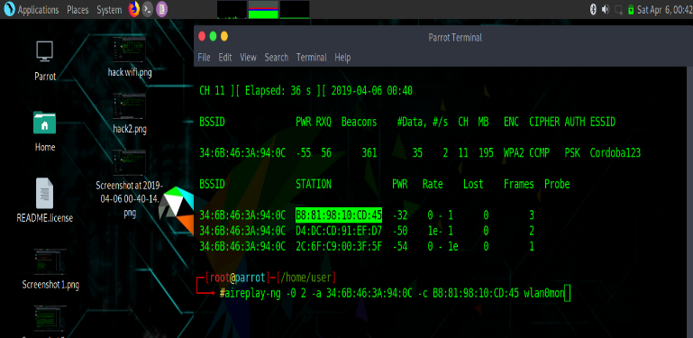
Figure 28 - 2nd step using airodump-ng
Attack 2: Exploiting Telnet traffic.
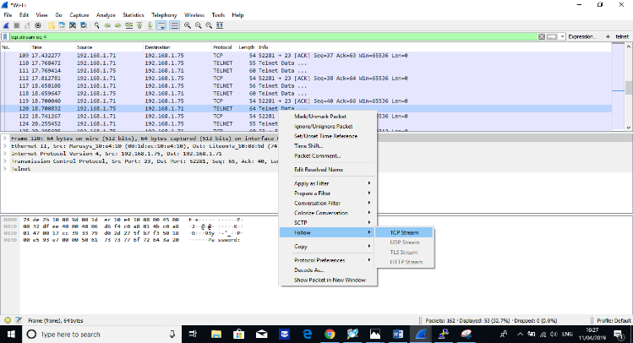
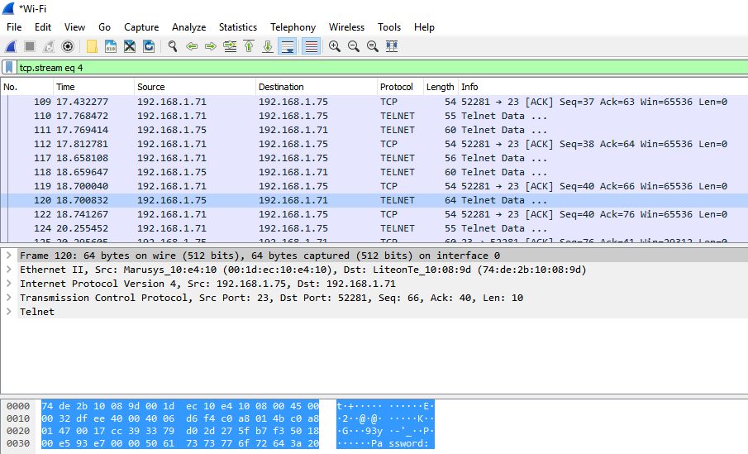
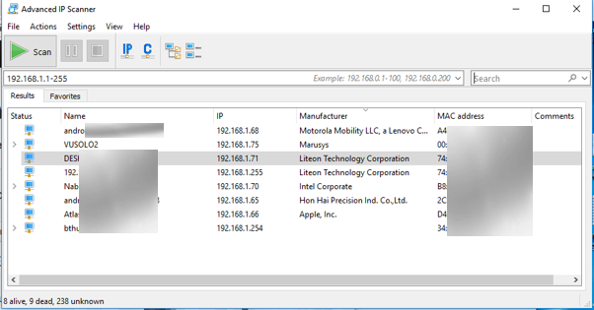
Using Wireshark and Putty software to telnet into a home media player, the author tried to simulate a remote management to a network device such as switch or router. After login to the machine using telnet, Wireshark was used to filter telnet traffic and gather the “TCP stream” of the data exchanged between the victim’s IP address and the gateway IP to compromise the username and password in plain text (please see figures 32-35).
Figure 33 - Telnet data being captured using Wireshark
Figure 32 - Scanning for the target device IP address
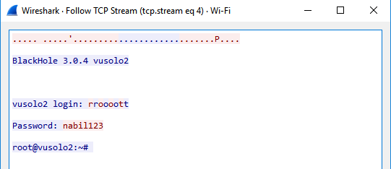
Figure 38 - Results from Nmap
Figure 35 - Username and password being compromised
Figure 34 - Following the stream of the telnet data

Attack 3: Web server reconnaissance attack.
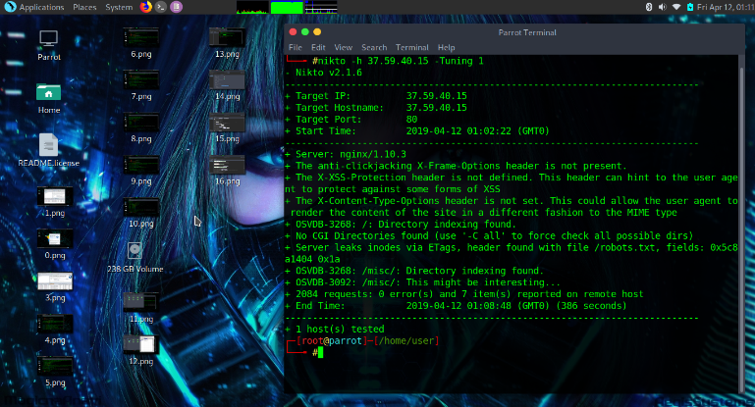
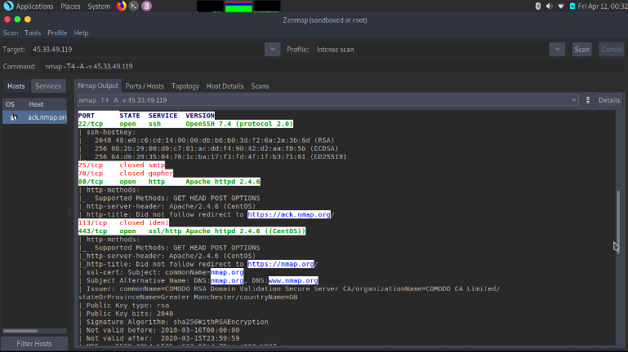
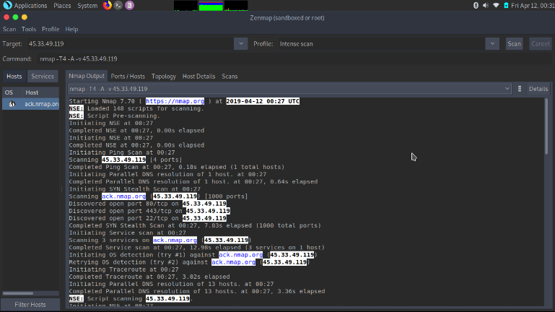
In this lab, the author used the Parrot OS and “Nikto” offensive tools to launch a reconnaissance attack on a webserver (https://hack.me/) using its sandbox IP. This powerful tool has underlined two major vulnerabilities. The code given shows that this web server database can be exploited and edited, which could be a major risk if attackers were able to tamper with its SQL data and, for example, increment loyalty points, balance credit, etc. Also, the author demonstrated a network reconnaissance attack using Nmap on our target https://scanme.nmap.org, the information’s gathered through this advance scanning tools could provide any attacker with an opportunity to exploit this vulnerabilities (please see figures – 36 to 38).
Figure 36 – Reconnaissance attack using “Nikto” tool
Figure 37 – Reconnaissance attack using Nmap tool

Attack 4: Exploiting web server through SQL injection.
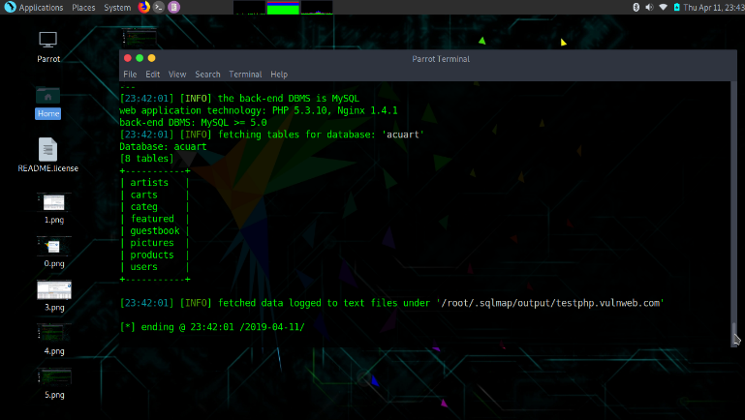
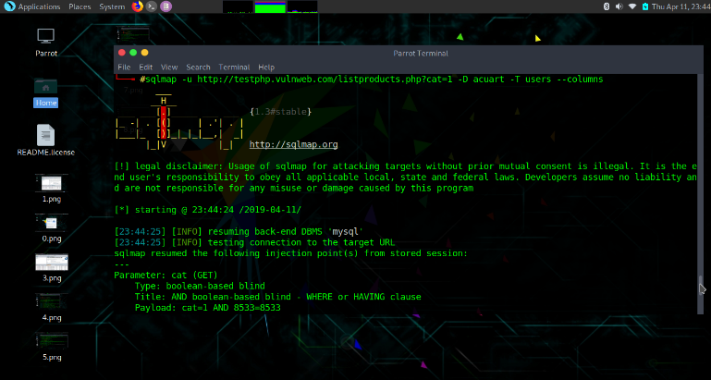
In this lab, the author has managed to exploit the entire database of a website named http://www.testphp.vulnweb.com using sqlmap in Parrot OS. After launching two reconnaissance attacks, the author managed to compromise the content of its “dbs” file. The entire database was compromised, including emails, users and passwords (please see figures – 39 to 42).
Figure 39 – SQL attack using "sqlmap" tools
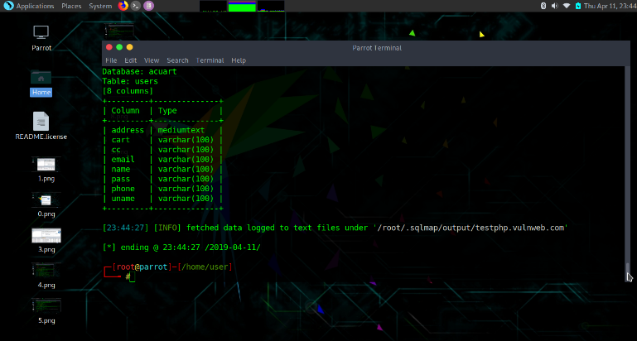
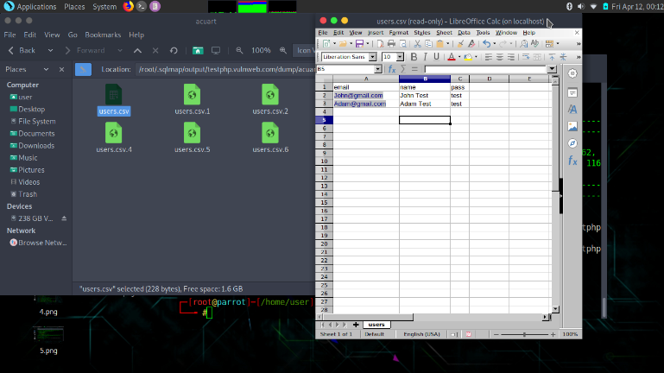
Figure 41 - Entire database being compromised
Figure 40 - Parent database being compromised
Figure 42 - SQL data being stored on the attacker’s machine

Security measures to protect the “Smart Campus” resources and services.

Throughout the labs exercises and the attacks designed, the author demonstrated that certain measures should be implemented to stop those risks:
- the network device management should only be carried out using ssh.
- strong passwords should be used throughout the entire campus and all the default logins to the IoT devices should be changed and managed carefully.
- all the data stored in SANs and servers should be encrypted using strong encryption methods such as triple DES (168 bits) or RSA 2048, for example.
- all the servers should be configured to support only secure certificate protocols such as TLS 1.0/1.1/1.2/1.3 and never support SSL 2 or SSL 3. These actions will ensure no one becomes a victim of downgrade attacks, poodle attacks, beast attacks, etc. [28].
- all the servers should only support secure cipher suits and authenticated encryption.
- the use of a well-configured firewall and the combination of IPS/IDS should block any reconnaissance attack in progress and shut down the connection in time [29].
- SQL injection attacks required great attention from both software developers and network admin to prevent them; a strong firewall, disabling dynamic queries, patching and update, defining appropriate access privileges and continuous monitoring of all SQL statements should help to reduce these threats [30].

Conclusion
The future of cybersecurity is likely to witness an increase in threats targeting both traditional computers and new devices. However, there is likely to be progress in education, training and professions in the field of cybersecurity, which will be critical in combating cyber threats. Furthermore, the government is likely to play a more prominent role in cybersecurity. Security threats in cloud-based services have to do mainly with the reliability, privacy and accessibility of information, and customers are therefore obliged to demand more from their providers of cloud-based services. The author believes that conducting regular penetration tests through the expertise and skills of ethical hackers can substantially reduce these sophisticated cyber-attacks and cyber threats.
Future work: The exponential increase of cyber-attacks that most businesses are facing is alarming. However, the reality is that the cybersecurity industry is far from being ready to deal with the overwhelming level of attacks it faces every day.
The future of cybersecurity relies on the implementation of AI systems as this could be considered as a turning point for the entire industry. More research could be done on AIs, AIs algorithm effectiveness and limitations and the role of Machine Learning in fighting cyber-attacks in the future.

References
[1] A, Bendovschi, “Cyber-Attacks-Trends, Patterns and Security Countermeasures”, Procedia Economics and Finance, vol. 28, pp. 24-31, 2015.
[2] Enterprise Security magazine, “Future Trends in Cybersecurity”, enterprisesecuritymag.com. Jan 11, 2019. Available: https://www.enterprisesecuritymag.com/news/future-trends-in-cybersecurity-industry-nid-808-cid-21.html [Accessed on April 15 2019].
[3] H, Boyes, “Cybersecurity and Cyber-Resilient Supply Chains”, Technology Innovation Management Review, pp. 1-46, April 2015.
[4] B, Morel, Artificial Intelligence and the future of Cybersecurity, AISeC ’11 Proceedings of the 4th ACM Workshop on Security and Artificial Intelligence, 2011.
[5] A, Arabo & B, Pranggono, Mobile malware and Smart Device Security: Trends, Challenges and Solutions, 2013 19th International Conference on Control Systems and Computer Science, IEEE.
[6] F, Schneider, “Cybersecurity education in universities”, IEEE Security & Privacy, vol. 11, no. 4, pp.3-4, 2013.
[7] E, McDuffie & V, Piotrowski, “The future of Cybersecurity Education”, Computer, vol. 47, pp. 67-69, Aug 2014.
[8] R, Sharma, “The Study of Latest Emerging Trends on Cyber Security and its Challenges to society”, International Journal of Scientific & Engineering Research, vol. 3, no. 6, pp. 1-4, June 2012.
[9] R. Krutz and R. Vines, Cloud security: A comprehensive Guide to Secure Cloud Computing, Wiley Publishing, 2010.
[10] M, Cavelty, The Militarisation of Cyber Security as a source of Global Tension, Center for Security Studies, 2012.
[11] W, Sharp Sr, “The past, present and Future of Cybersecurity”, Nat’l Sec. L. & Pol’y, vol. 13, 2010
[12] I, Lachow, “The Stuxnet Enigma: Implications for the future of cybersecurity”, Geo. J. Int’l Aff. Vol. 118. 2010-2011.
[13] R, Harknett & J, Stever, “The New Policy World of Cybersecurity”, Public Administration Review, vol. 71, no.3, pp. 455-460, May/June 2011.
[14] J, Brodkin, “Gartner: Seven Cloud-Computing Security Risks”, Network world. July 02, 2008. [Online]. Available: https://s3.amazonaws.com/academia.edu.documents/34194686/consumer_risk.pdf?AWSAccessKeyId=AKIAIWOWYYGZ2Y53UL3A&Expires=1555315687&Signature=QBtV9j%2B51t1bMMsMovoypyxxY9E%3D&response-content-disposition=inline%3B%20filename%3DGartner_Seven_cloud-computing_security_r.pdf [Accessed on April 15, 2019].
[15] B, Kandukuri, R, Paturi and A, Rakshit, Cloud Security Issues, 2009 IEEE International Conference on Service Computing.
[16] L, Kaufman, “Data Security in the World of Cloud Computing”, IEEE Security & Privacy, vol. 7, no.4, 2009. [Abstract]. Available: https://ieeexplore.ieee.org/abstract/document/5189563/references#references [Accessed April 15, 2019]
[17] S. Tabassam, “Security and Privacy Issues in Cloud Computing Environment”, Journal of Information Technology & Software Engineering, vol. 7, no.5, pp. 216, 2005 [Online Serial] Available: https://www.omicsonline.org/open-access/security-and-privacy-issues-in-cloud-computing-environment-2165-7866-1000216-96442.html [Accessed April 15, 2019].
[18] McAfee, “Cloud Computing Security Issues and Solution”, mcafee.com. n.d. [Online]. Available: https://www.mcafee.com/enterprise/en-us/security-awareness/cloud/security-issues-in-cloud-computing.html [Accessed April 14, 2019]
[19] D, Zissis & D, Lekkas, “Addressing cloud computing security issues”, Future Generation Computer Systems, vol. 28, no. 3, pp. 583-592, March 2012, [Online Serial]. Available: https://www.sciencedirect.com/science/article/pii/S0167739X10002554#br000095 [Accessed April 15, 2019]
[20] J. Ma, “Top 10 security concerns for Cloud-Based Services”, impreva. Dec 14, 2015. [Online]. Available: https://www.imperva.com/blog/top-10-cloud-security-concerns/ [Accessed April 15, 2019].
[21] R. Heartfield, G. Loukas, and D. Gan, “An eye for deception: A case study in utilizing the human-as-a-security-sensor paradigm to detect zero-day semantic social engineering attacks,” Proc. - 2017 15th IEEE/ACIS Int. Conf. Softw. Eng. Res. Manag. Appl. SERA 2017, pp. 371–378, 2017.
[22] Parrot Security Project, “Parrot Linux - The best choice for security experts, developers and crypto-addicted people.,” 2019. [Online]. Available: https://www.parrotsec.org/. [Accessed: 15-Apr-2019].
[23] S. Chakravarty, A. Stavrou, and A. D. Keromytis, “Identifying proxy nodes in a tor anonymization circuit,” SITIS 2008 - Proc. 4th Int. Conf. Signal Image Technol. Internet Based Syst., pp. 633–639, 2008.
[24] Y. B. Choi, J. Muller, C. V. Kopek, and J. M. Makarsky, “Corporate wireless LAN security: threats and an effective security assessment framework for wireless information assurance,” Int. J. Mob. Commun., vol. 4, no. 3, p. 266, 2015.
[25] C. C. Chen, Y. R. Chen, W. C. Lu, S. C. Tsai, and M. C. Yang, “Detecting amplification attacks with Software Defined Networking,” 2017 IEEE Conf. Dependable Secur. Comput., pp. 195–201, 2017.
[26] B. D. Sawyer and P. A. Hancock, “Hacking the Human: The Prevalence Paradox in Cybersecurity,” Hum. Factors, vol. 60, no. 5, pp. 597–609, 2018.
[27] M. Evans, L. A. Maglaras, Y. He, and H. Janicke, “Human behaviour as an aspect of cybersecurity assurance,” Secur. Commun. Networks, vol. 9, no. 17, pp. 4667–4679, 2016.
[28] C. Brubaker, S. Jana, B. Ray, S. Khurshid, and V. Shmatikov, “Using frankencerts for automated adversarial testing of certificate validation in SSL/TLS implementations,” Proc. - IEEE Symp. Secur. Priv., pp. 114–129, 2014.
[29] O. Torkul, I. H. Cedimoglu, and M. R. Cesur, “an Intelligent Firewall Agent Design Against,” no. December, pp. 6–10, 2016.
[30] C. Ping, “A second-order SQL injection detection method,” Proc. 2017 IEEE 2nd Inf. Technol. Networking, Electron. Autom. Control Conf. ITNEC 2017, vol. 2018–January, pp. 1792–1796, 2018.

marking criteria and Student FEEDBACK

This section details the assessment criteria. The extent to which these are demonstrated by you determines your mark. The marks available for each criterion are shown. Lecturers will use the space provided to comment on the achievement of the task(s), including those areas in which you have performed well and areas that would benefit from development/improvement.

Common Assessment Criteria Applied (Assignment 1) | Marks available | Marks  awarded
1. Research-informed Literature
Extent of research and/or own reading, selection of credible sources, application of appropriate referencing conventions.
Outstanding knowledge of research informed literature. Diversity of sources used with high level of referencing skills consistently applied. Some relevant key areas discussed such as block chain, AI, regulatory compliance etc. See report for more feedback. (Grade mark: 97.78%) | 45 | 44
2. Knowledge and Understanding of Subject
Extent of knowledge and understanding of concepts and underlying principles associated with the discipline.
3. Analysis
Analysis, evaluation and synthesis; logic, argument and judgement; analytical reflection; organisation of ideas and evidence
The lab exercises were excellently done but could relate more on how these can aid or assist organisation to be proactive against vulnerabilities, threats and attacks. You could also cross-reference your literature review. Overall, excellent job. (Grade mark: 91.11%) | 45 | 41
4. Practical Application and Deployment
Deployment of methods, materials, tools and techniques; application of concepts; formulation of innovative and creative solutions to solve problems.
5. Skills for Professional Practice
Attributes in professional practice: individual and collaborative working; deployment of appropriate media; presentation and organisation.
Can communicate with an exceptionally high level of professionalism. Just few minor errors, see report for more feedback. (Grade mark: 90.00%) | 10 | 9

Assignment Mark (Assessment marks are subject to ratification at the Exam Board. These comments and marks are to give feedback on module work and are for guidance only until they are confirmed. ) | Late Submission Penalties (tick if appropriate) |  | 94%
 | Up to four weeks late |  | 94%
 | First Attempt? |  | 94%

marking criteria and Student FEEDBACK

This section details the assessment criteria. The extent to which these are demonstrated by you determines your mark. The marks available for each criterion are shown. Lecturers will use the space provided to comment on the achievement of the task(s), including those areas in which you have performed well and areas that would benefit from development/improvement.

Common Assessment Criteria Applied (Assignment 2) | Marks available | Marks  awarded
1. Research-informed Literature
Extent of research and/or own reading, selection of credible sources, application of appropriate referencing conventions.
2. Knowledge and Understanding of Subject
Extent of knowledge and understanding of concepts and underlying principles associated with the discipline.
You have demonstrated the level of knowledge and understanding. You have excellently explain and analyse the scenarios you derived for the campus from your chosen research area(s) in a meaningful way. (Grade mark: 95.00%) | 20 | 19
3. Analysis
Analysis, evaluation and synthesis; logic, argument and judgement; analytical reflection; organisation of ideas and evidence
You have explain resources, devices used for your chosen design and critically analysis your chosen solution. You have discussed your simulation design, packet tracer implementation and simulation attacks beyond what was expected. Excellent conclusions with recommendations. (Grade mark: 100.00%) | 20 | 20
4. Practical Application and Deployment
Deployment of methods, materials, tools and techniques; application of concepts; formulation of innovative and creative solutions to solve problems.
A comprehensive implementation with excellent use of the crypto configuration. Most security measures such as firewall, IPS, etc. considered. Could be implement in a real world environment. Adding to your design implementation you had conducted penetration testing and made recommendations. (Grade mark: 100.00%) | 60 | 60
5. Skills for Professional Practice
Attributes in professional practice: individual and collaborative working; deployment of appropriate media; presentation and organisation.

Assignment Mark (Assessment marks are subject to ratification at the Exam Board. These comments and marks are to give feedback on module work and are for guidance only until they are confirmed. ) | Late Submission Penalties (tick if appropriate) |  | 99%
 | Up to four weeks late |  | 99%
 | First Attempt? |  | 99%

