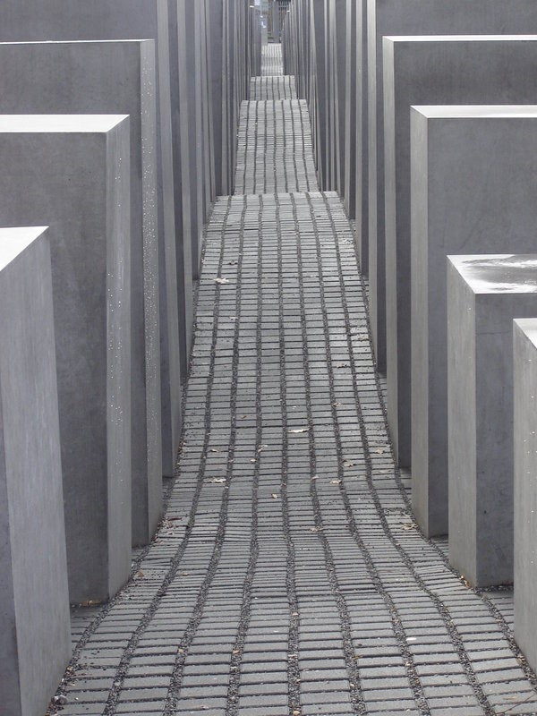
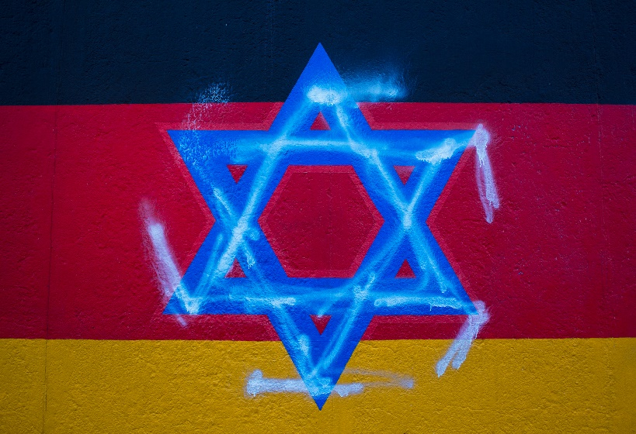
From Oppression to Remembrance

A Guide Book of Tourist Sights
that celebrate the Jewish Heritage of Berlin
This Guide Book aims to give a comprehensive description of Berlin’s most treasured sights that highlight and celebrate its Jewish Heritage.

As a result of the horror that was inflicted upon the Jewish people in the Holocaust, Berlin has been fervent in preserving those places of importance for Jews living and worshipping in the German Capital today and also for those who share in the appreciation and remembrance of all those who suffered at the hands of the Nazi Regime.

This Guide Book presents the three places of significance for those visitors who have come to Berlin in order to learn more about Berlinese Jews and their life both past and present. These three places are the New Synagogue, the Jewish Museum and the National Holocaust Memorial. These sights have been chosen for this Guide Book because of the contribution they provide in preserving and teaching about the Jewish heritage that is kay to understanding the history of Germany’s capital city. There is also information included in this Guide Book about further sights of interest that tourists may wish to visit if they wish to further their understanding of Berlin’s Jewish history; such as the Sachsenhausen Concentration Camp which is only a short train journey out of the city.

Looking forward, Berlin continues to invest in its support of the city’s Jewish population through the promotion of the ‘House of One’ Project which aims to build a combined place of worship for the Christian, Muslim and Jewish faith communities, thus encouraging ecumenical relations and denoting Berlin as a multi-cultural city. The conception of this project has marked Berlin as a city with a vision of inter-faith unity for the future; a stark contrast to the ideals of the past that were allowed to become established under the leadership of the Führer, Adolf Hitler and the Nazi Socialist Party.

Religious Judaism in Berlin
The New Synagogue

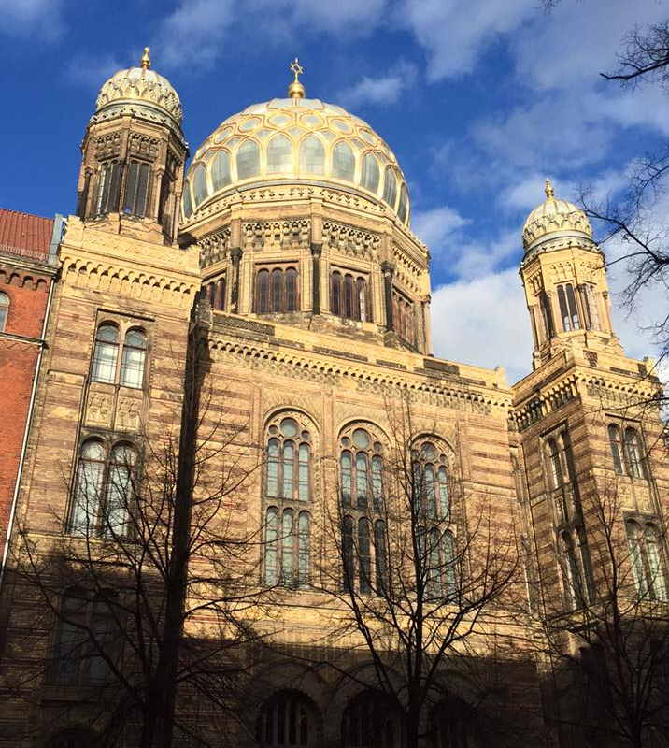
The dome of the New Synagogue (figure 1, left) stands prominently on the Berlin sky line with its gilded decoration visible for miles around. This impressive building is located on Oranienburger Straße and is one of the most vital historical landmarks for the Jewish community of Berlin. Having been built in 1866, the New Synagogue was once the focal point for Pre-Nazi Judaism when the population of Jewish Berliners was approximately 160,000 meaning that Berlin was the centre of Liberal Judaism.
Figure 1: The front façade of the New Synagogue

Nazism and the Jews:
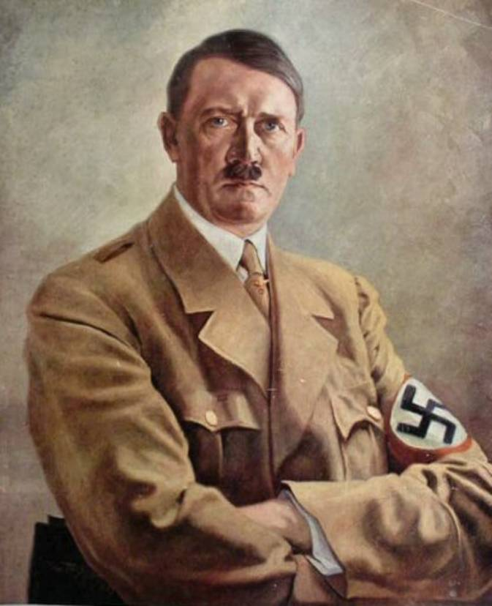
As a result of Hitler’s abhorrence of the Jewish ‘race’ and the initiation of the Nazi Holocaust, where approximately eleven million innocent people lost their lives, Berlin as the central place where contemporary Judaism had become established, was suddenly robbed of its identity and what replaced it was political turmoil, dictatorship and censorship. As a result of Hitler’s lust for power and desire to reassert Germany as a dominant power in the world after it suffered defeat in the First World War (1914-1918), Germany found itself plunged back into warfare with its familiar enemies: Britain, France and the United States of America.
Figure 2. A portrait of Adolf Hitler
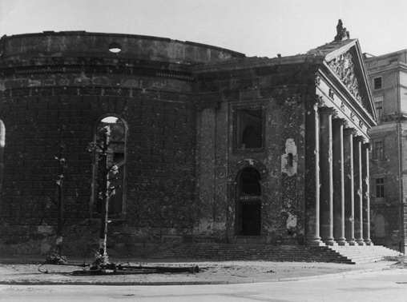
It was the belief of the Nazi Party leaders, that the Jewish members of German Society were responsible for Germany’s defeat at the close of the First World War and also for the subsequent financial and economic downturn that immediately followed as a result. To remedy the issue and to start the rebuilding of Germany in order for it to be a ‘great New Order in Europe,’ all those citizens of Jewish origin were placed in Concentration Camps where they were tortured, over-worked and eventually killed at the hands of the Nazi military forces. This meant that many businesses were left without proprietors, homes left derelict and a place of worship, like the New Synagogue, was left without a Rabbi or congregation. The New Synagogue was badly damaged by the bombs dropped by enemy aircraft in the strategically planned air raid bombings of Germany’s major cities by the British Royal Air Force. This battle, which occurred in the two penultimate years of the conflict (1943-1944), was responsible for the destruction of other notable landmarks in Berlin, the Roman Catholic Cathedral of Saint Hedwig (shown left after the damage) being only one structure out of many to experience bomb damage.
Figure 3
The New Synagogue Today:
When visiting the New Synagogue today, the façade of the building is as impressive as it would have been. Its gilded colonnades, towers and dome give the impression that the Synagogue does not have the history of destruction that it possesses, but inside is a different story.
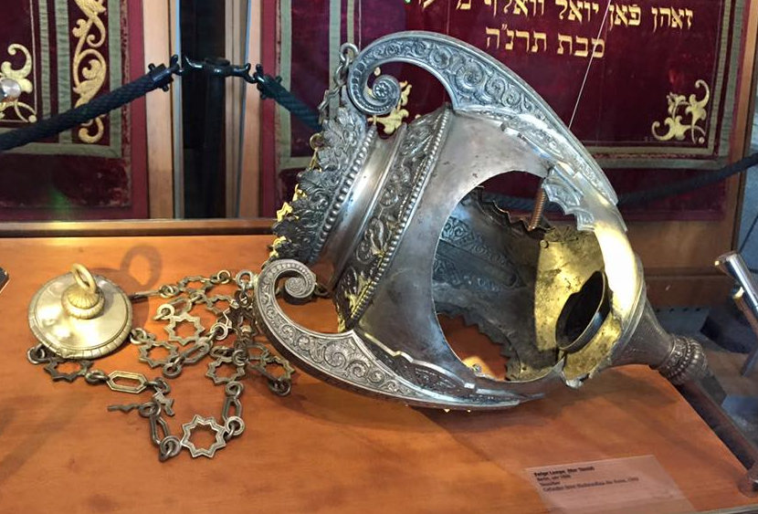
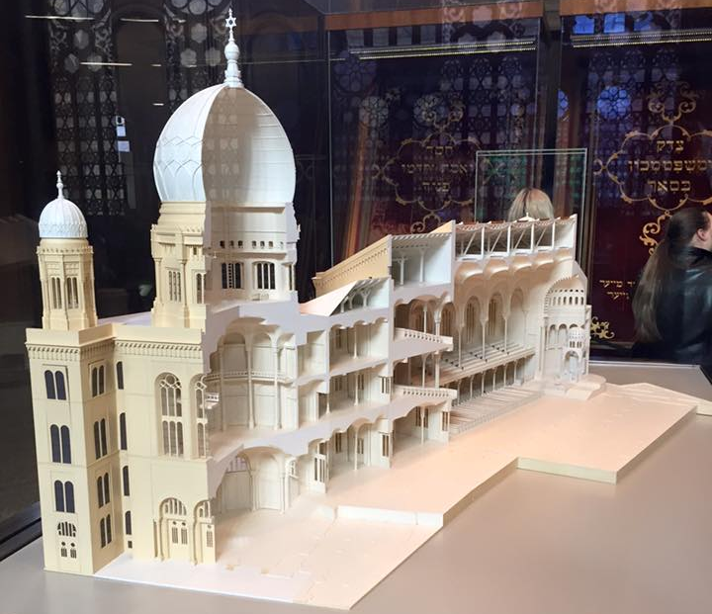
Upon entering the New Synagogue, the immediate space is the porch way that is situated before the entrance to the former main congregational space of the Synagogue. Today, the circular porch way displays some artefacts from before the Synagogue was damaged. Figure 5 shows an image of the former Sanctuary Lamp that would have hung above the Holy Table and the place from where the Torah would have been read. Shown in figure 4 is a model of the New Synagogue as it would have been before it suffered bomb damage in the Battle of Berlin and figure 6 is an image from a German newspaper that provides a glimpse of how the interior of the Synagogue would have looked when it was first built.
Figure 4
Figure 5

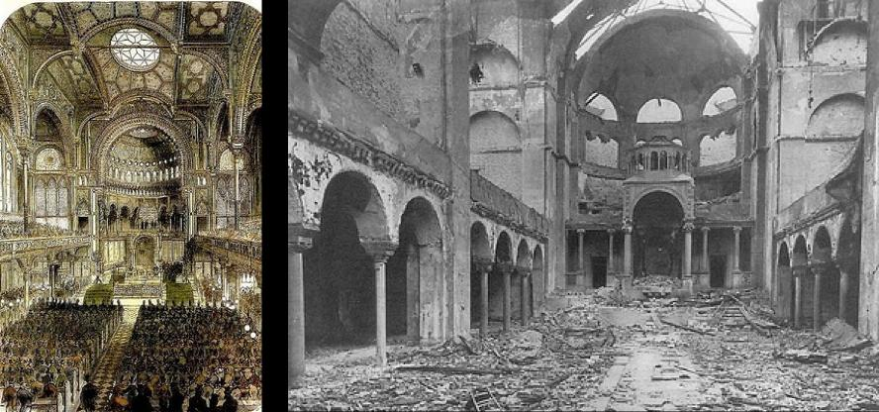

Figure 6

As a result of the bomb damage, the New Synagogue was reduced to more than half its original size with the entire Apse (the circular roof above the Torah Scrolls) and canopy, which covered the Arc containing the sacred Scripture scrolls of the Torah, being reduced to rubble. The windows were blown out and the lavish patterned wall murals that decorated the walls of the congregational prayer space were lost. The front façade of the building, the dome and the inner vestibule were undamaged and remained structurally sound.
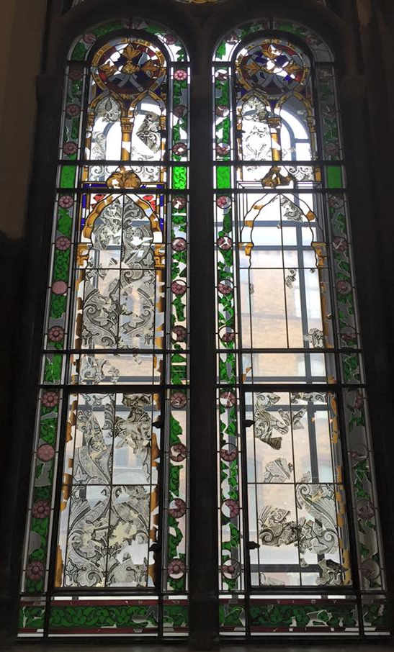
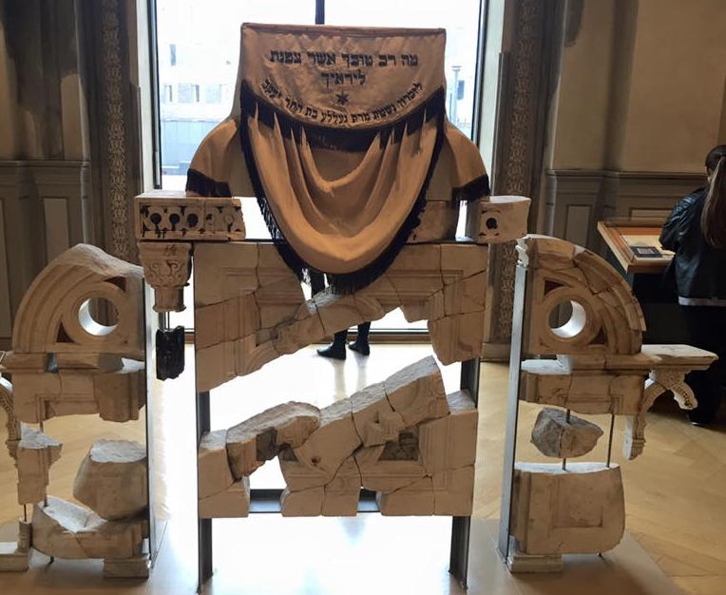
The first room after the initial porch way holds the remains of the Holy Table that would have resided at the east end of the Synagogue directly in front of the place where the scrolls were kept. The pieces of marble have been reconstructed from the rubble to show the structure of the Holy Table and the same has been done with the pieces of marble that originally formed the reading desk for the Torah scrolls (figure 7).The preservation of these important historical and theological pieces of the New Synagogue’s architecture allows visitors to appreciate the intricacy and aesthetic grandeur of the building that once stood as the beacon for all practising Jews who belonged to the citizenship of Berlin.
Figure 7

The preservation of the remains of the New Synagogue windows is also an important part of giving the visitor a glimpse into the past. In the structure that remains, there has been an effort made to reassemble the stained glass windows out of the blown out shards of glass recovered after the bomb attack. Today visitors can view the rearranged shards, which have been set into Perspex plastic, in order to offer a glimpse into the original design of the windows whilst consciously acknowledging the destruction caused by the warfare of the Second World War.
Figure 8
Figure 8
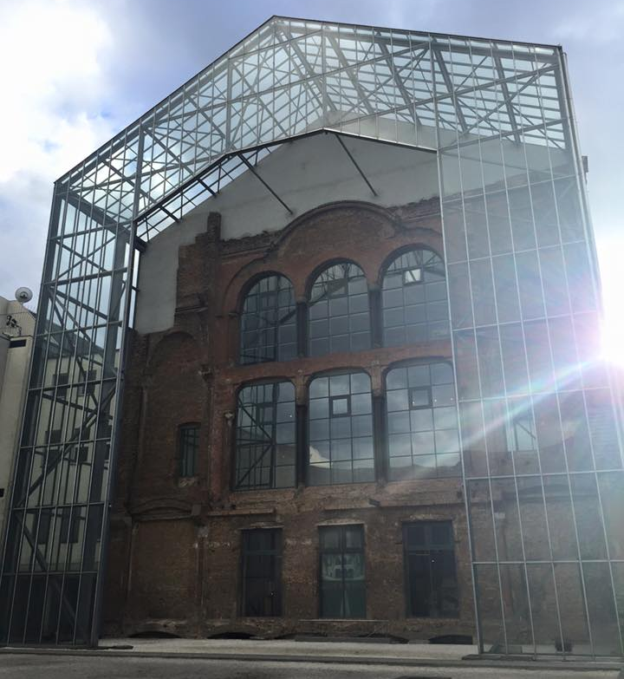
The current building is backed by a court yard at its rear where there are markings that show the area covered by the original construction. From inside the Synagogue building, there are images on the internal windows (those adjacent to the courtyard) depicting the view of the Synagogue before destruction thus giving a perspective to the visitor of the architectural scale of the original building. From outside, there is a visible metal and glass structure that supersedes the exposed brickwork of the older building. From here, the structural damage to the New Synagogue can be visualised. Looking east, there is a series of metal pillars that stand where the Arch and Apse above the Ark of the scriptures formerly stood. The area from the front entrance to the Synagogue to this point is vast, enforcing even more the extent of the damage caused by the carpet bomb attacks of the British Royal Air Force. These structures, along with the relics of the New Synagogue, serve as a reminder to the Jewish community of Berlin and to those who visit, the extent of the suffering of the Jewish people who lived in Germany and Berlin at that time.
Figure 9
Today, the New Synagogue is once again used as a place of worship for Berlinese Jews although those attending services meet in a room upstairs where services are conducted in the Conservative style of Jewish religious practise. The rest of the building is now used and occupied by the ‘Berlin Centrum Judaicum Foundation, an institution for the preservation of Jewish memory and tradition, a community congregation centre for study and teaching.’ Alongside the Museum artefacts, small book shop and the sacred prayer space in the upper half of the building, the New Synagogue has now become a memorial to times past with a secure future where it will be a place for the religious and academic instruction of Contempory Judaism.

Visitor Information:
Opening | Hours
 | Jan - Mar | Apr - Sep | Oct - Dec
Mon - Thu | 10 am - 6 pm | 10 am - 6 pm | 10 am - 6 pm
Fri | 10 am - 3 pm | 10 am - 6 pm | 10 am - 3 pm
Sat | closed | closed | closed
Sun | 10 am - 6 pm | 10 am - 7 pm | 10 am - 6 pm

Admission Costs:
Adult Admission - €5,
Concessions - €4
Dome Admission only - €3
Concessions - €2.50

Guided and Audio Tours are also provided for those visitors who would like to learn more about the New Synagogue and its history. There are also members of staff available to answer any questions. Please note that there will be a security check of bags and persons upon entering the Synagogue.

Historical Judaism in Berlin
The Jewish Museum
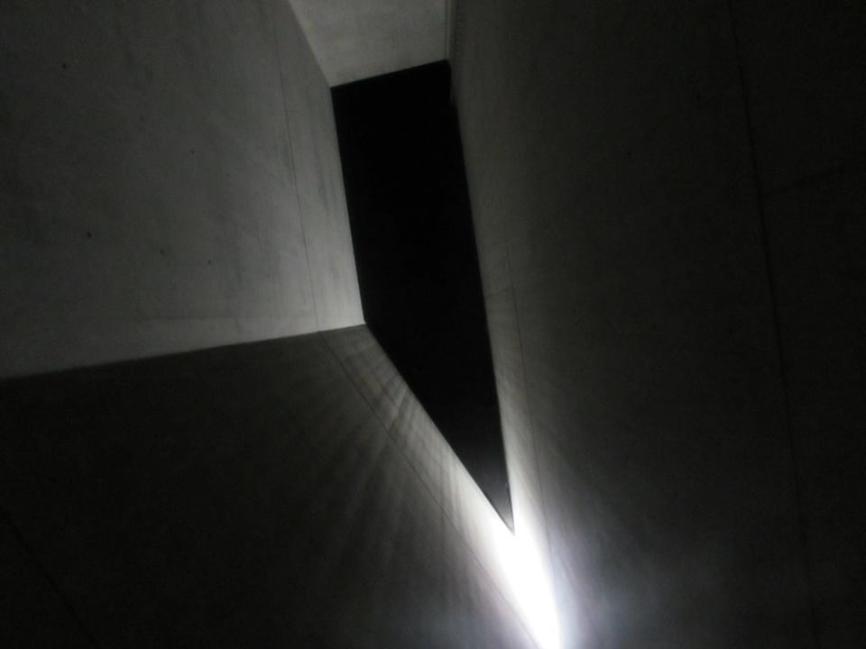
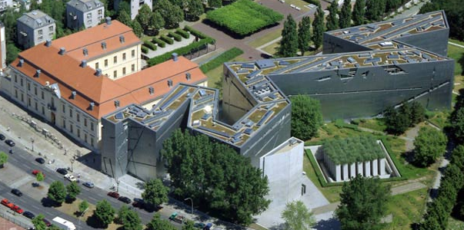
For those tourists who are interested in the more historical side of Berlin’s Jewish heritage, the Jewish Museum is a favorite attraction. Opened in 2001 and designed by Daniel Libeskind, this museum presents the span of the deep-rooted Jewish heritage that Berlin possesses.
The museum is attractive to visitors who are interested in history and also architecture. As shown in figure 8 above, the building is unique in its design. The museum possesses some definitive features such as the holocaust tower and the way in which the museum is presented and structured architecturally. When walking down the corridors of the museum, visitors can view the exhibitions that are placed in glass cases set into the museum walls. The architectural intent of Libeskind in his design of the building, was to give the visitor a sense of uneasiness and confusion as they walked down the corridors viewing the artefacts of the Jewish families who were lost in the Holocaust. Visitors will notice that the floors are slightly uneven and the ceilings are angled to give a sense of disorientation to those visiting the Holocaust Exhibition. The height of the experience for the visitor is to enter the Holocaust tower; a cold single room which sits in pitch darkness with no light apart from a minute chink of sunlight which appears from the top corner of the ceiling (figure 9). There is one door which serves as both the exit and entrance and the room is kept in silence. A ladder is the only addition to the bare black walls yet it is out of reach to those standing beneath it
Figure 10

Once again the architectural intent of the designer was to offer the visitors an experience, in a concentrated manner, of the loneliness and fear of those people trapped in the Nazi Concentration Camps. Visitors will feel isolated and exiled from the noise which can still be heard from the busy Linden Straße outside. This simple yet powerful activity means that the horror faced by the Holocaust sufferers in those Camps more than seventy years ago suddenly becomes tangible to the museum’s visitors in the moments they are in that space.
Figure 11

In addition to the Holocaust Memorial Exhibition, the Jewish Museum presents other permanent exhibitions of interest. These include Judaism and the Enlightenment, notable Jewish figures such as Moses Mendelssohn, Women and Judaism and also a comprehensive explorative guide to the thread of Jewish heritage that runs through the history of the German nation. This exhibition titled ‘Two Millennia of German Jewish History lets the visitor see the Germany of the past and present through the eyes of the Jewish minority. This point of view presents well-known historical events with a new focus and greater complexity alongside the fates of individuals and families.’

There are activities for younger members of visitor parties where they can interact with video and audio elements of the exhibitions and there are opportunities for children and school groups to research the lives of Holocaust victims and other prominent German Jewish citizens in the Rafael Roth computer suite which is situated in the center of the Holocaust exhibition. The Museum also has in its care portraits left by Jewish families of relatives who were either seized by the Nazis or who fled the country in order to escape the results of the Holocaust.

In addition to visiting the museum’s archive collection and exhibitions, visitors have the opportunity to participate in some of the museum’s extra events that happen both in and out of the museum opening times on a regular basis. These events consist of book readings, the showing of films relevant to a particular exhibition or topic, academic conferences and lectures and the occasional celebration of the Jewish arts through the medium of concerts and theatre performances. Most of the museum’s concerts and entertainment shows are performed at the weekend with the majority of the film-showings occurring during the week which allows visitors to view them as part of their entrance fee to the museum.
For those with a more academic scope, the Jewish Museum also offers academic programs that allow the museum to carry out the task of being a teaching institution as well as a place for maintaining Berlinese Jewish history. The W. Michael Blumenthal Academy has allowed the Jewish Museum in Berlin to:

address questions of migration and diversity as well as Jewish-Islamic relations. The Academy's multifaceted programs of lectures, conferences, workshops, and panel discussions provide a platform to discuss highly relevant, sociopolitical themes. In line with the Museum's mandate to engage with the history and culture of the Jewish minority in Germany, the Academy also seeks out new perspectives on other religious and ethnic minorities. In this way, the Academy both explores the relationships between minority groups and the majority society and promotes exchange and network-building among minorities.

To accompany the visitor and to further enhance their experience of the exhibitions, the museum has a wide range of informative reading material available for taking away or purchasing. The museum guide brochures are useful for providing a clear and concise summary of the exhibitions and the pieces of most importance included in them. These brochures provide a visitor with and historical, theological and educational companion. The guidebooks are available at the museum shop situated to the right at the front entrance.

The museum has refreshment facilities in the museum's Café Schmus where visitors can enjoy traditional Jewish meals. Alternatively, the café also allows visitors to enjoy a simple hot drink and offers a choice of traditional German pastries. Outside the cafe is the glass courtyard where seating is provided for all visitors. The space is light and airy allowing an appreciation of the beauty of the landscaped garden areas behind the glass courtyard which serves as a quiet, contemplative memorial space for those who have been moved or affected by the museum and its exhibitions. The garden is also used for events during the Summer months.

Visitor Information:

Admission Costs:
Opening | Hours
 | Jan - Mar | Apr - Sep | Oct - Dec
Mon | 10 am - 10 pm | 10 am - 10 pm | 10 am - 10 pm
Tues – Sun | 10 am - 8 pm | 10 am - 8 pm | 10 am - 8 pm

Museum ticket regular charge - €8
Museum ticket reduced charge - €3
Children under 6 years - free
Family (2 adults, 4 children) - €14

Guided Tours for large groups can be booked in advance. There will be an airport style security check of bags and visitors upon entering the museum. The use of cameras is permitted but the use of flash is contrary to the museum’s policy on cameras and video recordings as flash can be harmful to some of the museum’s artefacts. Audio headsets for guided tours can also be purchased and collected from the front desk.

Judaism Remembered in Berlin
The National Holocaust Memorial
Berlin's National Holocaust Memorial or the memorial to the murdered Jews of Europe as it is also known, is a public memorial to those Jews who lost their lives as a result of the Nazi Holocaust.

Situated on Cora-Berliner Straße in the centre of Berlin, The National Holocaust Memorial is situated near the Brandenburg gate and the Reichstag building. Designed by Peter Eisenman and built between 2003-2004, the memorial became part of Berlin's commemorative places of interest for those interested in learning about the Holocaust and its victims. There are two levels to the memorial; the first being the field of concrete blocks on the ground level and the second being the museum exhibition which sits beneath.

The Concept and Meaning:
Figure 12

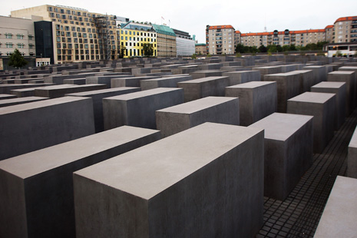
On an initial view of the memorial, it simply looks like a sea of different sized concrete blocks which are arranged in rows. Visitors can enter and walk through the landscape of blocks from any side and as they journey further into the memorial, the floor becomes increasingly uneven with a rise and fall design built into the pathways. Similar to Libeskind’s intentions with the design of the Jewish Museum, Eisenman’s vision was to create a piece of art that would be striking to the eye and disorientating to the senses which, when experienced together, would give visitors a feeling of isolation whilst they were in the midst of the forest of concrete towers. To enhance this feeling, Eisenman designed the concrete blocks without colour or decoration to really impress upon those who visit the memorial, the desolation and solitude experienced by those Jews who were herded unwillingly into the Concentration Camps.
The Exhibition:
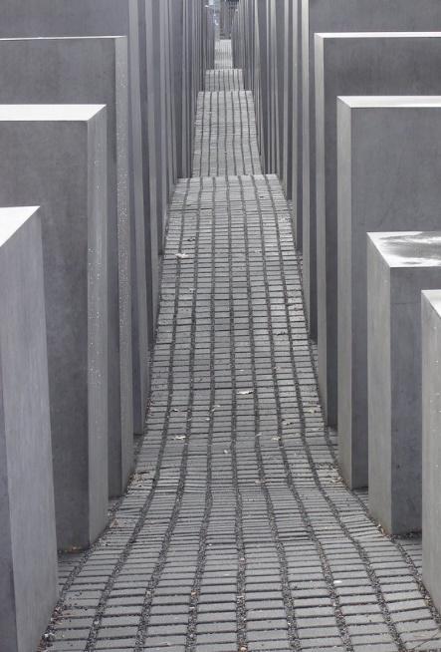
Underneath the field of concrete blocks is the permanent exhibition of the murdered Jews of Europe. The content of this exhibition is similar to that of the Jewish Museum, however visitors to the memorial are able to become more affiliated with individual personal accounts of people who were lost during the Holocaust. This exhibition takes the visitor on a journey through a variety of different rooms. These rooms are; the Room of Dimensions, the Room of Families, the Room of Names and the Room of Sights.
Figure 13

The Room of Dimensions presents letters of correspondence from and to those prisoners who were trapped in the Concentration Camps. Their stories and letters which detail the horror they encountered from Nazi officers can be read on illuminated screens, giving the reader a glimpse into the personal suffering of the innocent captives. The purpose behind showing these letters is to enforce to those reading them today, that the Jews of the Camps were real people who lived and suffered. A fact that Hitler and his Nazi Party refused to acknowledge.
The Room of Families comprises of accounts, images and artefacts that belonged to Jewish families before they were segregated and removed from society. The cases are filled with personal details and belongs of men, women and children and their stories are instrumental in providing the visitor with an accurate image of what life was like for German Jews before and during the time of the rule of the Nazi party and the Third Reich.
The Room of Names is the most interactive of the rooms in the memorials exhibition. The room is lit by the projections of names and faces of individual case-studies who were murdered in the Holocaust. The room is kept in silence, as those who visit listen to the biographies of sufferers and those considered missing. This room highlights the level of knowledge that is still unknown about a large majority of the Holocaust victims but the limited accounts of letters left behind have allowed for a representation and remembrance of individual people.
The Room of Sites provides the history of the Nazi occupation of Europe and how the ideas of the Nazi party took hold of almost a whole continent. This room also provides information about how the Nazis disposed of over 11 million Jewish people in their various Concentration Camps, gas vans and euthanasia programs. The images in the Room of Sites show the harrowing conditions of camps such as Auschwitz, Bergen-Belsen and Sachsenhausen as well as showing on large maps the extent to which Jews were taken and exterminated from across Europe.

This series of rooms provide an informative and personal journey through the cause, events and victims of the Holocaust meaning that the National Holocaust Memorial is a key place to visit for anyone who wishes to gain a better understanding of the personal effects of the Holocaust upon German and European Jews. However, because of the use of graphic and sobering images used, the memorial exhibition may not be wholly appropriate for younger children.
Visitor Information:
Opening | Hours
 | Apr - Sep | Oct - Mar
Mon | Closed | Closed
Tues – Sun | 10 am - 8 pm | 10 am - 7 pm
The Memorial on ground level is open 24 hours per day. Please find below the opening times of the underground exhibition.

Admission Costs:
Admission into the memorial and the exhibition is free. However, groups will have to book in advance so that the exhibition does not become over crowded.
The National Holocaust Memorial welcomes groups from academic institutions as well as tourists so queuing for the exhibition may be experienced. The use of Cameras is permitted in the exhibition but large bags and luggage are to left at the Information desk. There is disabled access in the form of a lift down to the exhibition and audio tours for the visually impaired are also available.
The three places of interest that this Guide Book provides information about, have been chosen because of their importance to Berlin and its acknowledgment of the Jewish heritage which so vital to its identity today. Each are educations; in their respective ways with all of them presenting different aspects of Berlin’s Jewish Heritage in different ways.
For tourists who want to learn more about Berlinese Jews or the treatment of Jewish people in the Holocaust, the Sachsenhausen Concentration Camp is only a 45-minute train journey away from the city. This Concentration Camp is a particular place of interest as it is where the officers of the Nazi military (the SS) were trained although it is not preserved on the same scale as other Camps such as Auschwitz.
Maps and Directions:
All directions provided in this guide book are calculated from the Central Station of Berlin using the underground train network. The Numbers refer to their placement on the map of Berlin Below:
- (1) The New Synagogue - 12 Minute Train Journey (Typically every 10 Minutes)
- (3) The Jewish Museum - 19 Minute Train Journey (Typically every 20 Minutes)
- (2) National Holocaust Memorial - 6 Minute Train Journey (Typically every 10 Minutes)
- Sachsenhausen Camp - 45 Minute Train Journey (Typically every 60 Minutes)
Useful Numbers:
Berlin Tourist Information: +49 (0)30 - 25 00 23 33

The National Holocaust Memorial Information Desk: +49 (0)30 – 26 39 43 – 0

The Jewish Museum Reception: + 49 (0)30 25 993 488
The New Synagogue Information Office: +49 (0)30 88028 300
  - 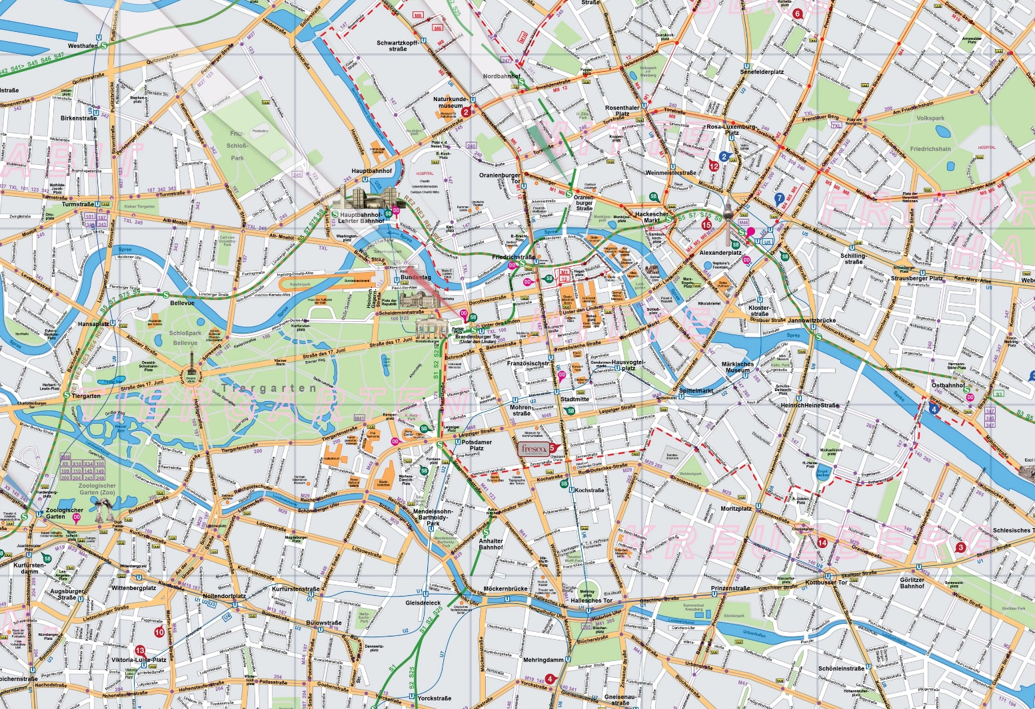
Figure 14
3
2
1
Bibliography
Andrews, Andy, ‘How Do You Kill 11 Million People? – Why the Truth matters more than you think’ (USA: Thomas Nelson Press, 2011)
Hitler, Adolf, ‘Hitler’s New World Order’ Unknown Date. http://ww2today.com/30th-january-1941-hitlers-new-world-order [Accessed: 23rd May 2016]
Unknown Author. ‘About the Museum’ Unknown Date. <http://www.jmberlin.de/main/EN/04-About-The-Museum/00-about-the-museum.php> [Accessed: 24th May 2016]
Unknown Author. ‘Academy Programmes’ Unknown Date. <http://www.jmberlin.de/main/EN/03b-Academy/04-Academy-Programs/00-academy-programs.php > [Accessed: 24th May 2016]
Unknown Author. ‘Exhibitions’ Unknown Date. <http://www.jmberlin.de/main/EN/01-Exhibitions/00-exhibitions.php> [Accessed: 24th May 2016]
Unknown Author. ‘New Synagogue’ 8th December 2015. <http://www.berlin.de/en/attractions-and-sights/3560461-3104052-new-synagogue.en.html > [Accessed: 22nd May 2016]

Image References

Unknown Author. ‘New Synagogue’ 8th December 2015. <http://www.berlin.de/en/attractions-and-sights/3560461-3104052-new-synagogue.en.html > [Accessed: 22nd May 2016]
Andy Andrews, ‘How Do You Kill 11 Million People? – Why the Truth matters more than you think’ (USA: Thomas Nelson Press, 2011)
Adolf Hitler. ‘Hitler’s New World Order’ Unknown Date. http://ww2today.com/30th-january-1941-hitlers-new-world-order [Accessed: 23rd May 2016]
Unknown Author. ‘New Synagogue’ 8th December 2015. <http://www.berlin.de/en/attractions-and-sights/3560461-3104052-new-synagogue.en.html > [Accessed: 22nd May 2016]
Unknown Author. ‘About the Museum’ Unknown Date. <http://www.jmberlin.de/main/EN/04-About-The-Museum/00-about-the-museum.php> [Accessed: 24th May 2016]
Unknown Author. ‘Exhibitions’ Unknown Date. <http://www.jmberlin.de/main/EN/01-Exhibitions/00-exhibitions.php> [Accessed: 24th May 2016]
Unknown Author. ‘Academy Programmes’ Unknown Date. <http://www.jmberlin.de/main/EN/03b-Academy/04-Academy-Programs/00-academy-programs.php > [Accessed: 24th May 2016]

