Module - Level 6 Manufacturing Systems and Simulation
B-Eng Applying Lean Techniques Assignment

Student - Paul Corry
Student Number - 0750389

Lecturer - Mr Andrew Thorn
Module Code - ACEA6002
Word Count - 3498



Contents

Table of Figures 3
Lean in the Workplace Introduction 4
Lean Theory 4
Continuous Improvement in the Workplace 5
Initial Steps to Removing Waste and Getting Lean 5
Value Stream Mapping 5
Kaizen 6
Five S 6
Job standardisation 7
Literature Review 7
Workplace Overview 8
Lean Project Summary Objectives 8
Lean Project Discussion 9
Typical Melt Planner 10
Area Identified for Reducing Waste 11
Standard Work Instruction (SOP) 12
Time and Motion Study 15
Current Planning Schedule 16
Suggested Planning Schedule 17
Project Savings of Project 18
Lean Project Summary/Evaluation 19
References 20
Web Sites Used 21

Table of Figures

Figure 1. Summary of Product Melt Data & Predicted Yield 10
Figure 2. Typical Melt Schedule 11
Figure 3. Typical Melt Schedule 12
Figure 4. Standard Operating Procedure (1 of 4) 13
Figure 5. Standard Operating Procedure (2 of 4) 14
Figure 6. Standard Operating Procedure (3 of 4) 14
Figure 7. Standard Operating Procedure (4 of 4) 15
Figure 8. Two Deck Low Energy Sieving Machine 16
Figure 9. Typical Month Melt Summary Schedule 17
Figure 10. Suggested Month Melt Summary Schedule 18
Figure 11. Projected/Potential Costs Savings of Suggested Project 19

Lean in the Workplace Introduction

Lean manufacturing can be considered as a methodology which, has a focus upon minimizing manufacturing waste within an organisation however, simultaneously with maximum productivity. Waste can be anything that does not particularly add value to the system. Therefore, lean manufacturing is a process that can make the manufacturing process much more efficient by the identification of a “value” creation and also whilst eradicating unnecessary stuff which, does not overall contribute. Once a waste has been identified, we can then begin to reduce until it has been finally eliminated which, in turn, makes the organization more efficient (Kumar, N., Hasan, et al, 2022).

Lean Theory

Ideologists over time have broken down waste into three types of categories, these can be denoted by the prefix “mu”:

- Mura - the unsteadiness or unevenness within a particular process.
- Muri - the “unreasonable” or overburden process conditions.
- Muda – something which, has zero value to a process.

According to Smith, S (2014), Muda, which is a classical waste whereby, anywhere in a particular process that does not any value. Muda can be divided into two other categories.
- As determined by the customer, does not add value however, still required therefore, cannot be fully eliminated from the process.
- May not add value which, determined by customer, however, is not necessary therefore can be eliminated from the process.

As stated by Smith, S (2014), Mura, can be determined as a process which, may be inconsistent and also unevenness. For example, a particular part of a production line whereby inventory “pile-up” in a part of a production line that in turn may create a large amount of inventory of used materials.

According to Pieńkowski, M, (2014), Muri suggests that an employee/employees may be overworked or even a piece of production machinery. Muri can also mean unreasonableness in the organisation with workers being overburden.
In relation to these concepts, they can be considered related as they help to eliminate each other although, individually they are based upon different concepts.

Continuous Improvement in the Workplace

Lean can be considered not a one-time type of process, in fact, the importance of continuous improvement as the name suggests, does not stop. It is never-ending process in which small improvements are made over time and this then in these increments have positive results on the organization therefore, this process continues so long as the organization. does so (Dieste, M., & Baseggio, A, et al, 2020).

Initial Steps to Removing Waste and Getting Lean

To remove waste and increase value in the workplace a few simplistic steps such as value stream mapping, kaizen five S can be considered to initially get going.

Value Stream Mapping
Value stream mapping can involve analysing what is currently done in the organization to determine which of these particular parts add some sort of value and which parts can be considered as waste. From this analysis an “ideal” map can then be created that would help minimise the waste which, was identified in the first instance.

Kaizen
This methodology according to Boca, G.D., (2011), suggests that kaizen means “change for the better”. Industries depends upon kaizen to stay competitive by trying to be better in regards, to improvements which, creates additional value whilst eliminating in many cases the majority of waste. The ideology of kaizen is the create incremental small improvement steps which, in turn will eventually lead to a combined large improvement. Employees are encouraged to make suggestions for continuous improvement by their line or operational managers. Once the culture of kaizen has been understood employees may become more engaged workers to aid the organisation to move forward.

Five S
5S can be considered as a method for creating a more organised and efficient workplace. According to Chapman, C.D., (2005), this then allows an organization to become more efficient by decreasing waste and increasing profit. Originally from a Japanese work process culture, 5S is a five-step process that includes safety which, now in a modern organization is quite common. This five-step process consists of five basic principle phases:

- Sort - Removing un-necessary items from the workplace which, are not needed in the particular process. These items can be tagged.

- Straighten - Once un-necessary items have been removed, everything which, is required for the process may be organised into their best location.

- Shine - The workplace and the items left for the process can be cleaned-up. “A cluttered desk is a cluttered mind !!!”

- Standardize - Once the work area is straightened-up and shined, a work culture may be created to keep it this way. Efficiency can be visible seen.

- Sustain – This final phase is to sustain the area and keep it going. However, the culture change is not easy although, a cleaner efficient area will be good for employee morale which, in turn brings even more efficiency. Employees involved all through this project will engage motivation.

Job standardisation

Job standardization is considered to be a process whereby, a single best way for an employee to perform a particular function has been developed and documented. Both employees and managers who undertake such tasks may develop their standardized methodologies of required tasks with each other. Senior management should not dictate, they should include rather than exclude shop floor employees as they know the tasks better. Employees will also engage more and participate in regards, to work standardization if they are included in the process methodology standardisation set-up.

Literature Review

To determine whether or not the process requires improvement, criteria may be considered which, can also be used in six sigma type systematically type projects. Any process which does not include effectiveness, adaptability and efficiency may be subject or considered for improvement. This particular literature review aims to improve the efficiency, effectiveness, and overall performance of the planning schedule. Scheduling according to Snyder, H., (2019), can play a crucial role in regards, to the quality of the material being produced in any organisation. The need for more efficient material alloy scheduling is becoming more vital due to the increasing possibility of cross contamination when producing complex compositions. Improved scheduling methods have resulted in organisations having increased profits due to reduced product defects. Identifying the issue in this study consist of excessive changeovers between complex compositions which contributes to the increased risk of possible cross contamination. This review will focus on exploring various strategies aimed at reducing changeovers. Changeovers or set-ups can be referred to the time required when switching from one product to another. Work published previously include lean principles on approaches in minimising changeover times which, in turn reduces costs by improving efficiency. This also highlights challenges in material scheduling for an optimized process. This review emphasises the importance of exploring innovative approaches of this particular topic. The conclusion from this literature review is that by optimising operations by reducing waste is key to any business. www.theleanway.net

Workplace Overview

LSN Diffusion specialise in the manufacture of thermal spray metallic powders with each having a spectrum of various particle size distribution and chemical composition. These powders are sold worldwide to many customers and industries for use in various applications such as general hard-surfacing, laser additive, brazing and much more. Metallic powders are predominantly of a nickel-based composition although, until recently, more cobalt, and iron-based are now being manufactured. Similar to food recipes, material is formulated using raw materials via chemical compositional modelling. Revert material (oversize and undersize) from previous material are also added to the composition equation. Alloys are then physically assembled and melted down into a homogeneously using induction coiled furnaces. Molten metal is then produced by water, hybrid or dry gas atomization technology depending on customers specification or application specific requirements.

Lean Project Summary Objectives

Operations management can be considered as a “key” aspect for many manufacturing organisations. Improvement and efficiency of productivity in our organisation can be achieved as mentioned in this report, by reducing waste and implementing lean-manufacturing principles www. This report presents a case study to reduce waste in regards, to the planning and execution of planned material from the point of input of customer orders through to the despatch of finished goods. An area has been identified within the planning and logistics department whereby, customer orders are being produced in bitesize pieces rather than the total order in one production run specifically on regular high runner alloys (non-be-spoke alloys). This has resulted on many unnecessary change-over processes identified when a SMED methodology is applied. Therefore, the purpose and ideology of this project is to reduce unnecessary costly changeover between products which, not only reduces waste, but also most importantly reduces the risk of contamination from the portfolio of alloys which are manufactured at any one time on the shopfloor could potentially save the organisation many £1000’s of pounds per calendar month.

Lean Project Discussion

Orders or even “tentative” orders are scheduled/planned to meet customers required delivery dates. When alloys are planned, they are generally scheduled initially as virgin melts (no previous revert added) on a newly rammed/lined induction furnace. For example, a simplistic NiBSi alloy whereby only three elements present. Alloys are then subsequently produced with more elements and with increasing percentages until a point when the furnace needs to be re-lined. This occurs when the furnace lining has been eroded from material produced that contains higher levels of Carbon, Chromium or Tungsten for example. These elements are responsible in exponentially furnace erosion when melted in air. (Aravind, N., Babu, S.P., et al., 2019).

As per the melts plan, a particular alloy has been and is often programmed twice within the melt order sequence. Idea for this is when the initial melts (N-580) have been produced, the revert post the sieving operation is returned for re-use as revert in the 2nd campaign. For this particular alloy, customer requires a minimum 1000 kg batch size!! However, it has been identified that by programming this alloy in this manner of schedule can create additional un-necessary change overs and laboratory inspection/QC costs.

N-580 is a high runner material which is manufactured for coating of pump shafts for the oil industry in North America. Summary of product is shown in (fig 1) as below including frequency of melts:

Figure 1. Summary of Product Melt Data & Predicted Yield
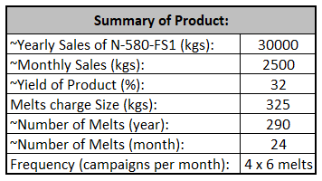

Typical Melt Planner

A typical melt schedule whereby the alloy N-580 is planned in this manner can be seen in both (fig 2 & 3) as below.

Figure 2. Typical Melt Schedule
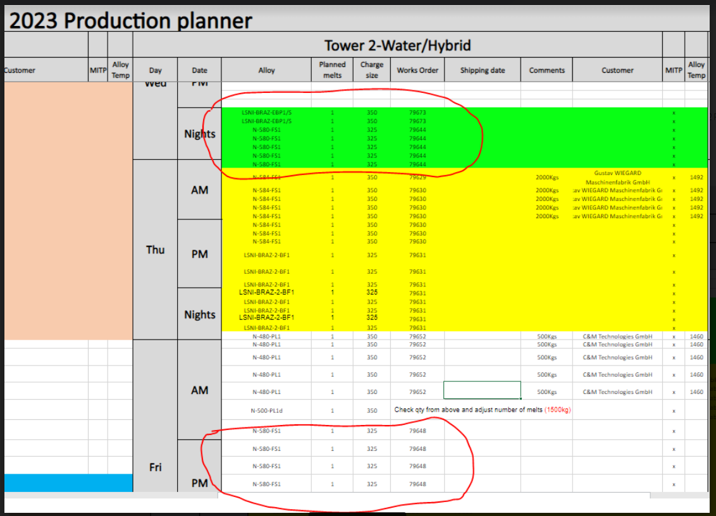

Figure 3. Typical Melt Schedule
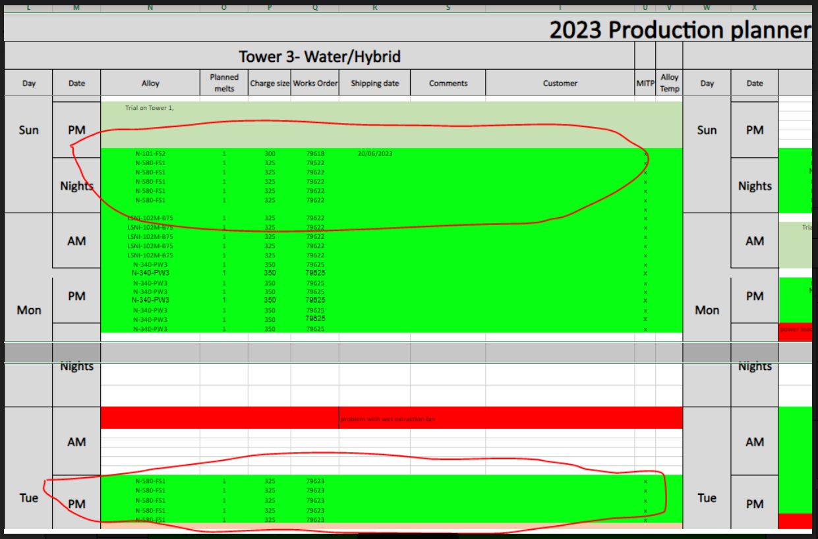

Area Identified for Reducing Waste

Several areas of waste within the process have been identified by producing this alloy in this manner:

- Equipment/hoppers - Prior and post each campaign, all equipment must be clinically cleaned (change over expense)
- Laboratory and QC testing - each of the campaigns need full qualified in regards, to composition and other physical testing (laboratory analysis costs)
- Post approval of material – Re-blending of product post the approval of the matrix lots.
- Laboratory and QC testing – Final inspection of finished saleable product.

The above shows the additional cost when producing material in bite-sized pieces. If material was manufactured as per 1000 kg lots then, the change-over times and laboratory analysis costs would be significantly reduced. It is also important to note however, that additional changeovers can heighten the risk of cross contamination if for example, equipment or indeed the powder hoppers themselves were not clinically cleaned!

Standard Work Instruction (SOP)

The work instruction procedures (SOP) for equipment clean downs, can be seen in (fig 4 to 7) below. As per work instruction, care and attention is key as this process relies heavily on the operator undertaking this task as there is no current automated system for this particular operation. This clean down process is complex and labour intensive therefore, will have significant costs associated to this process. As stated by Gough, J. and Hamrell, M., (2009), an SOP is a step-by-step detailed work instruction to aid operators to systematically carry out operations in the same manner each time.

Figure 4. Standard Operating Procedure (1 of 4)
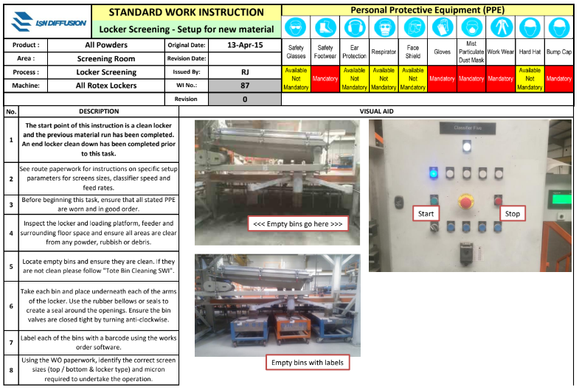
Figure 5. Standard Operating Procedure (2 of 4)
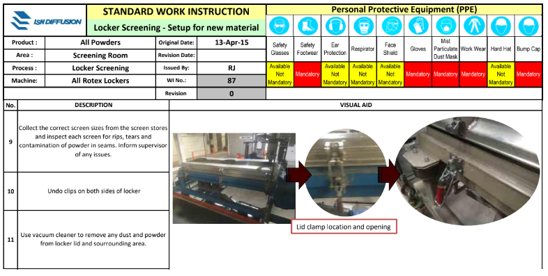

Figure 6. Standard Operating Procedure (3 of 4)
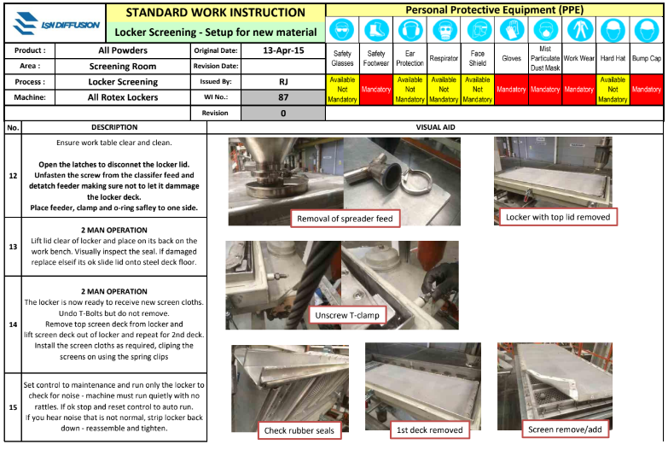

Figure 7. Standard Operating Procedure (4 of 4)
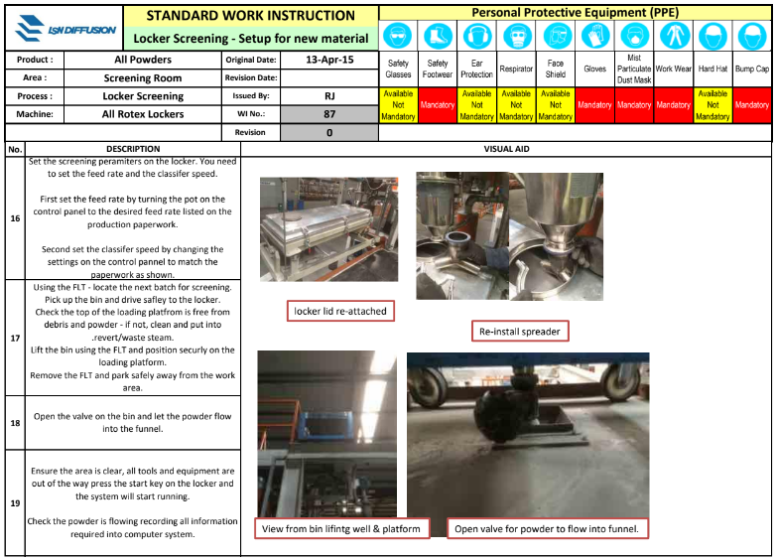

The standard operating procedure as per above is quite labour intensive. Powder that is screened contains particles that are less than 5µm. These superfine particles can stick to much of the surface areas in the system therefore, manual cleaning is much needed as all surface areas needs to be fully cleaned to prevent costly cross contamination. The SOP as detailed above is written step-by-step instruction from a “practical” perspective which, is aimed at the individuals who will act upon it. This makes the SOP therefore, successful. www.thefdgroup.com

Time and Motion Study

A time and motion study has been quantified in regards, to the clean down of the screening equipment and associated powder hoppers. A thorough change over of this particular equipment takes approximately 3 hours by at least two operators. Although, it’s difficult to quantify exact cost due to the complexity of tasks done on the shopfloor, is it estimated however, the cost of each changeover is in excess of £150 per piece of screening equipment. A time and motion study is a type of technique used in businesses to review individual work tasks which, identifies how “long” a specific task takes with what “physical” activity the task involves. This type of study can be applied to many types of organisations and not just physical shop floor activities. A rotary low energy screening sifter which, is used for sieving this material can be seen in (fig 8) below. www.britannica.com

Figure 8. Two Deck Low Energy Sieving Machine
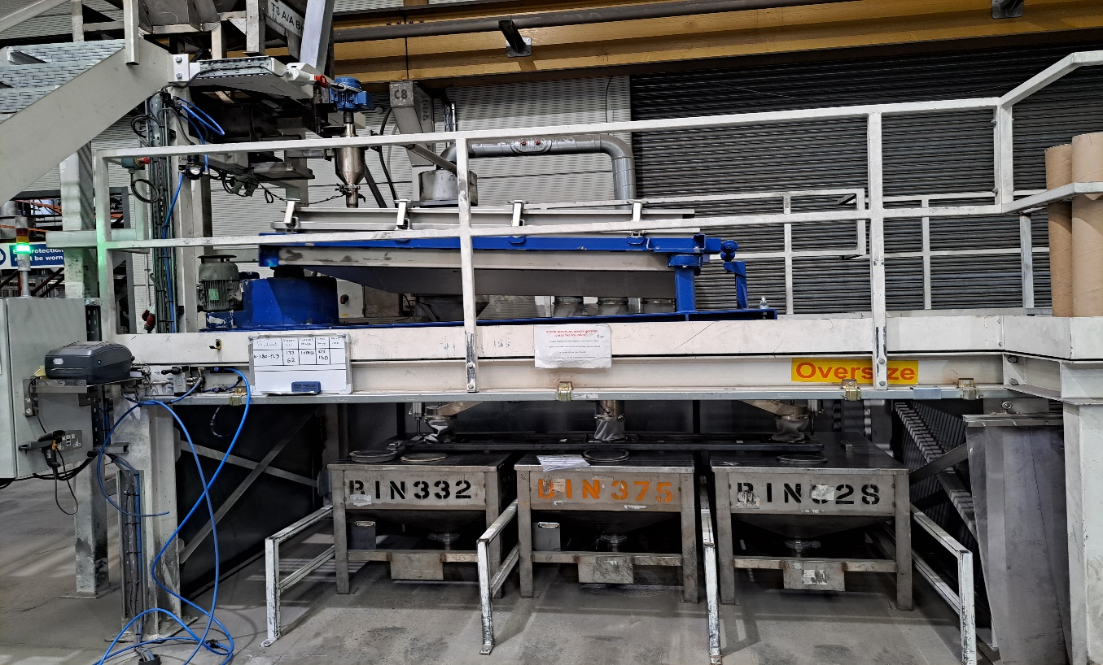

Current Planning Schedule

As mentioned, producing high runners in smaller batch sizes can create significant waste due to the additional changeovers downstream within the process. However, when demand is high many changeovers may be inevitable due to customer dictated delivery dates although, in many cases whereby product is produced in smaller campaigns there in no customer urgency or even when material is planned in an inconsistent manner (Mura). Therefore, these smaller campaigns do indeed cause unnecessary and costly additional waste as well as the increased risk of contamination when equipment is not cleaned as per work instructions (Muda). Additional laboratory costs are also contributed when producing material in smaller batch sizes. Material is also subject to double handling, again with added costs too. A typical monthly melt summary for this alloy can be seen below in (fig 9). This summary details number of melts required to produce customer required quantities.

Figure 9. Typical Month Melt Summary Schedule
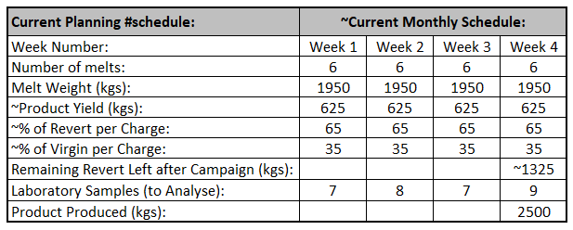

Melts are typically planned as above. Summary shows quantity of laboratory samples to be analysed to produce ~2500 kg of finished product after blending these smaller quantities into minimum 1000kg lots. Data also suggests that there are four total changeovers for this alloy alone.

Suggested Planning Schedule

To reduce costly equipment changeovers and samples for laboratory evaluation a newly proposed planning schedule for this particular alloy is shown in (fig 10). As detailed, this melt schedule aims to produce the same quantity of finished however, with half the number of changeovers and reduced laboratory samples submitted with no cost ramifications in regards, to increased inventory etc. The additional revert is compatible with other similar alloys therefore, this can be substituted as virgin material. There will also be potentially less double handling of material as the finished material samples submitted to the QC Department will represent actual shipping quantities. Therefore, reduced blends of smaller lots into master batches.

Figure 10. Suggested Month Melt Summary Schedule
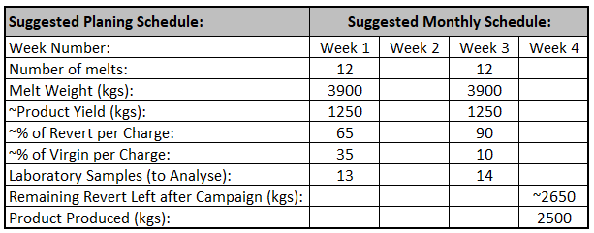

By moving to the suggested method of manufacturing this alloy which, can also be utilised on other similar types of material, many costly changeovers per year can be saved as well as the reduced risk of contamination which, to our type of organisation can be costly. The number of samples submitted to laboratory would also be reduced. Chemical analysis and all other physical testing have estimated costs of approximately £500 per sample. Over the course of a year, savings may run into many thousands of pounds. As stated by Armstrong, J.S., (1991), strategic planning improves manufacturing performance which, in turn helps the organization to become profitable.

Project Savings of Project

The potential savings as shown in (fig 11) below suggests that within a year, the organisation would benefit in excess of ~£30 k alone. However, due to the complexity of a batch-to-batch manufacturing company such as ours it would be extremely difficult to accurately identify true cost savings. Approximately 150 hours can be saved in man-hours whereby this labour may be used elsewhere in the plant. An additional saving although, difficult to quantify, would be the reduced risk of material contamination for this specific grade. After deep discussion with the material purchasing departmental manager in regards, to the changeover costs, and savings due to reduced laboratory samples it appears that the programming of material going forward will have considerations to these lean principles. According to Bhasin, S., (2012), Organizations are more successful when using lean principles.

Figure 11. Projected/Potential Costs Savings of Suggested Project
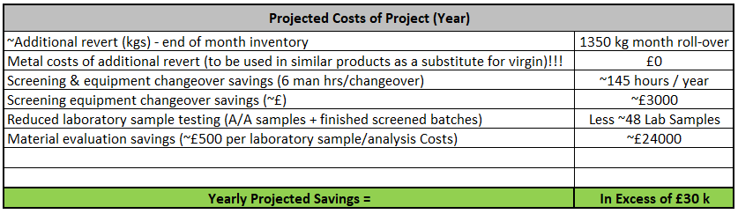

As detailed above, excess revert can be used easily in compatible material as this particular alloy is a standard hard facing alloy with not to dissimilar elements which, is a norm within the metal charge formulation department. The second phase of producing this alloy may contain 95% revert which, is the maximum limit for the use due to induction melting. Producing material with high levels of revert has no detriment to the quality of the finished material for this application.

Lean Project Summary/Evaluation

This particular project highlights aims to reduce waste in a dynamic work environment. As discussed, (SMED) can be an applied methodology in order, to reduce waste regardless of the insignificance of cost. SMED can enable streamlining by focussing on internal and external changeovers. According to Mali, Y.R. and Inamdar, K.H., (2012), SMED is now widely used and accepted methodology currently in manufacturing. Overall equipment effectiveness (OEE) which, is a key performance indicator may be used in the project to measure effectiveness of the process. OEE which, highlights the availability of the process was averaging ~65%. Although, this methodology on a similar product manufactured as suggested in larger batch sizes the OEE increased to around 75% within one month. Improvements can be seen in regards, to in labour recovery when producing larger batch sizes however, initial outlay for virgin material is higher in the first week the amount of revert used will be higher by the third week therefore, at month end, no additional material to the revert pool is increased.

This project highlights that large savings can be made when material is planned in batch sizes to what the customer orders. Any orders which, are produced in smaller batch sizes have increased changeover times and costly laboratory analysis costs that are considered as waste in the process. This particular method of manufacture aims to optimise the process in a batch-to-batch manufacturing organisation by using lean methodologies such as SMED. The planning department now made aware of these cost savings are on board with this methodology and not this concept is in its infancy however, due to customer delivery time constraints it has been difficult to roll this out as standard procedure although, will be something to work to.

In conclusion, this project can be seen in a number of ways whereby with the introduction and implementation of lean principles, the organization can become more economically viable and sustainable by being more effective and efficient. Lean principle is also about culture change with both management and shop-floor employees regardless of what the organization produces.

References

Aravind, N., Babu, S.P., Rajkumar, M. and Mahendran, R., 2019. High temperature erosion behavior of cast nickel base 73Ni–13Cr–4Sn–4Bi–Mo alloy. Materials Research Express (Online), 6(8).

Armstrong, J.S., 1991. Strategic planning improves manufacturing performance. Long Range Planning, 24(4), pp.127-129.

Bhasin, S., 2012. Performance of Lean in large organisations. Journal of Manufacturing systems, 31(3), pp.349-357.

Boca, G.D., 2011. Kaizen method in production management. In International scientific conference young scientists (pp. 13-20).

Chapman, C.D., 2005. Clean house with lean 5S. Quality progress, 38(6), pp.27-32.

Dieste, M., Baseggio, A., Panizzolo, R. and Biazzo, S., 2020. Lean Thinking and Workplace Safety: insights from two improvement projects. In roceedings of the International Conference on Industrial Engineering and Operations Management. Recuperado el (Vol. 19).

Gough, J. and Hamrell, M., 2009. Standard operating procedures (SOPs): Why companies must have them, and why they need them. Drug Information Journal, 43(1), pp.69-74.

Kumar, N., Hasan, S.S., Srivastava, K., Akhtar, R., Yadav, R.K. and Choubey, V.K., 2022. Lean manufacturing techniques and its implementation: A review. Materials Today: Proceedings.

Mali, Y.R. and Inamdar, K.H., 2012. Changeover time reduction using SMED technique of lean manufacturing. International Journal of Engineering Research and Applications, 2(3), pp.2441-2445.

Pieńkowski, M., 2014. Waste measurement techniques for lean companies. International Journal of Lean Thinking, 5(1), pp.9-24.

Smith, S., 2014. Muda, muri and mura. Lean & Six Sigma Review, 13(2), p.36.

Snyder, H., 2019. Literature review as a research methodology: An overview and guidelines. Journal of business research, 104, pp.333-339.

Web Sites Used:

https://www.britannica.com/topic/time-and-motion-study

https://www.thefdagroup.com/blog/a-basic-guide-to-writing-effective-standard-operating-procedures-sops

https://theleanway.net/The-Five-Principles-of-Lean

