Module Name: Academic Skills

Module Code: LCLM 4001_Lon
Task 3
Student Name: Mohammed Towhid Miah
Student ID: 2335330
Group: 5
Lecturer’s names: Mohammad Rahman

Table of Contents
Introduction 1
Gibb’s Reflective Cycle 1
Description 1
Feelings 2
Evaluation 2
Analysis 3
Conclusion 3
Action plan 4
Conclusion 4
References 5

Introduction
This reflective report emphasises exploring my learning in this module which has enhanced the three main academic skills such as note-taking skills, academic writing skills and research skills. The analysis of my experience and their influence will be evaluated leveraging Gibb’s reflective cycle.

Gibb’s Reflective Cycle

Description
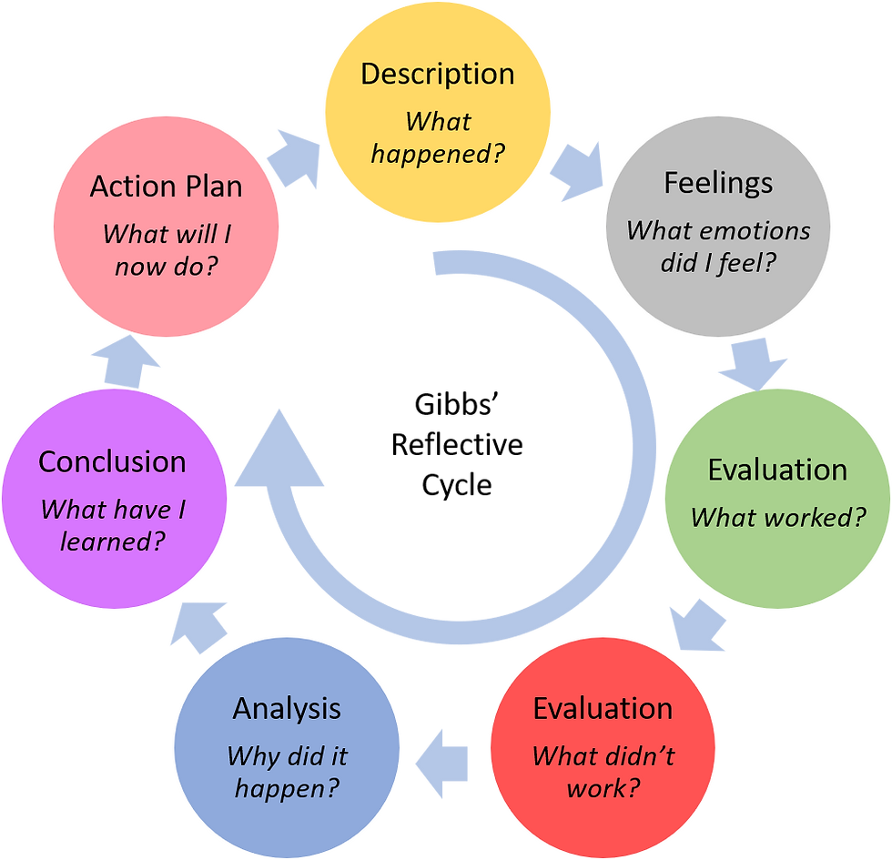
Figure 1: Gibb’s Reflective Cycle
(Source: Gökmen et al., 2024)
While competing in this middle I took part in various activities that have played a vital role in enhancing my academic skills. This process started with the exercise of academic writing that needed me to write an essay on a compound topic. This skill was developed by the task of essay writing in which we were empowered to write, receive feedback and review our work. Taking part in the peer review provides perception into various styles of writing that widen the understanding of efficient academic writing. The module introduces various techniques for note-taking skills like the Cornell Method (Gökmen et al., 2024). These skills were developed at the time of lectures and sessions of study in which I experimented with these methods modifying them to the type of content that is being presented. This helped me to capture and arrange the information effectively which made my session of study productive. This module also involved the session of the library in which the usage of journals and databases for finding the information was learned (George and Casey, 2020). My research skills were developed through the requirements of the assignment to locate, assess and in-text the academic sources strengthening the significance of authenticity in the research. This task increased my competency to provide high-quality information and amalgamate it into my work efficiently.

Feelings
In the early stage of the module, I was a little confident in my skills of Academic writing though I knew there was some improvement required. The idea of getting and providing feedback was daunting at first but required reprove (Aarts et al., 2020). Nevertheless, as I took part in the process I started to value feedback as a growth tool. I had a mixed feeling about the Note Taking Skills. I frequently felt submerged at the time of large lectures not sure of the best way to grasp the information. The creation of this technique of note-taking made me very concerned initially, as it needed me to come out of my comfort zone and immoderate my pertinent methods. At first, I felt concerned about my research skills because of the large volume of available resources and the complications of academic information. The main fear of choosing the not dependable sources or misunderstanding the information was a notable problem. Nevertheless, I adopted more experience with the tools of research I grew my confidence and I started to start tri look at the process as an easier and manageable task.

Evaluation
All the activities that were designed to enhance my academic writing skills were efficient. The repetitive drafting process and reviewing double the peer and instructor’s feedback notably increased my clarity and consistency in writing, the session of the peer review at first was very stressful although it was a valuable experience as it explored various perspectives and styles of writing that allowed me to enhance my approach. My experience in Note-taking Skills was a combination. I appreciated the innovative technique such as the Cornell Method it took a lot of time to search for methods that matched my style of learning. I struggled to modify and some of the techniques felt unmanageable, Nevertheless, I found a balance through continuous practices for integrating the elements from different methods to creating a tailored system of Note-taking that enhanced my arrangement of information and retention. The activities of research skills and finding the information were very hard yet rewarding (Campos et al., 2020). The session of the library was useful in understanding the process of research. I understood how to steer the academic datasets confidently and assess the sources that made my research projects meticulous and advocated, I found it difficult sometimes to navigate through a large amount of information.

Analysis
The main focus of the activities was to improve my academic writing skills which can be ascribed to the constructed approach of the module, the process of writing, getting feedback and reviewing helped me to recognise my weaknesses in writing and work on them. The session of the peer review was helpful particularly because it offered a double perception. I received feedback on my work and also learned by playing with the writing of others. This corresponding experience of learning enhanced my understanding of efficient academic writing. The combined outcome with the Note-taking skills emphasis on the significance of flexibility (Voyer et al., 2022). The creation of various techniques of Note-taking made me realise that not a single method is globally implementable. It took many tests and mistakes to discover that the mixed approach of amalgamating the linear notes with the visual component such as a mind map was a very efficient technique. This experience indicated the significance of personalising all the strategies of studying the preferences of personal learning and the material that is being learned. The main factor was the focus on assessment in the research skills. This module tries to find the sources and to value their authenticity. This approach to analysis changed my process of research by making it standard and efficient.

Conclusion
This module has influenced the development of my academic skills notably increasing my academic writing, research skills and note-taking, through the constructed task of writing and feedback I have achieved confidence in my writing emphasising analysis and clarity. My skills of note taking helped me to learn the significance of adaptability and modifying the technique of various contexts of learning, the process of my research skills has been specifically rewarded. I felt capable of locating, assessing and amalgamating target authentic sources into my work. These skills are invaluable for the existing academics and for the professional aspirations.

Action plan
I want to continue developing these skills through continuous practice and opportunities for learning. For the skill of academic writing, I will look for feedback on my writing from the instructor and peers in order to make sure of improvement. I also plan to examine the workshops for writing and online courses to enhance my understanding of the conventions of academic writing. I will continuously enhance my mixed system of note-taking modifying it as required for various subjects and content types. I planned to examine the tools for digital note-taking like the Notion that could increase the ability to arrange the information effectively. In order to increase my research skills I will continuously practice learning about academic datasets and stay updated on target friends of research. I also plan to take part in in-depth research assignments that will offer opportunities to implement these skills. To develop the abilities of critical thinking that are important for assessing the quality of the research materials.

Conclusion
Conclusively, this module has played a very crucial role in increasing my academic skills specifically in academic writing, research and note-taking skills. The process of reflection has indicated the significance of flexibility. I am dedicated to developing these skills to improve my academic journey.

References
Aarts, R., Kools, Q. and Schildwacht, R., 2020. Providing a good start. Concerns of beginning secondary school teachers and support provided. European Journal of Teacher Education, 43(2), pp.277-295.
Campos, V., Trott, A., Xiong, C., Socher, R., Giró-i-Nieto, X. and Torres, J., 2020, November. Explore, discover and learn: Unsupervised discovery of state-covering skills. In International Conference on Machine Learning (pp. 1317-1327). PMLR.
George, K.W. and Casey, A.M., 2020. Collaboration between library, faculty, and instructional design to increase all open educational resources for curriculum development and delivery. The Reference Librarian, 61(2), pp.97-112.
Gökmen, M.F., Akyol, M.M. and Sevinç, K., 2024. The Effects of Cornell Note-taking Method on High School Students’ Listening Skill. Giresun Üniversitesi Eğitim Fakültesi Dergisi, 1(1), pp.48-57.
Voyer, D., Ronis, S.T. and Byers, N., 2022. The effect of notetaking method on academic performance: A systematic review and meta-analysis. Contemporary Educational Psychology, 68, p.102025.

