Coexistent Perspectives(ADCD 7001)

Antonio Gaudi's concept of naturalistic design
Question 3 – Space & Place

Name：Haolin Cui
Student number：1915462
Submission Date: Wednesday, December. 14th, 2022 Word Count: 4160
1. Introduction
This essay will describe the bionics in the architectural design of Antonio Gaudi, take Sagrada Familia Cathedral and Parc Güell as cases to analyze the application of natural elements in Gaudi's two classic works in detail, and describe the influence of these two classic buildings on modern architectural design.

Since Pythagoras, people's design has gradually moved away from imitating nature and began to use two-dimensional points, lines, planes and three-dimensional geometric figures as the design basis. This school of designers believes that this simple geometry also exists in nature. This is also a process from the perceptual design concept to the rational design concept.

But the famous Spanish architect Antonio Gaudi （Zhu Chi,2001） argued that simple points, lines, surfaces and simple geometric shapes do not exist directly in nature. He formed his own unique design style by drawing inspiration directly from nature through his own observations, without reference to other design schools.
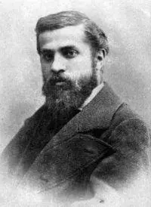
Figure 1 Antonio Gaudi

1.1 The influence of nature on Gaudi's architectural design
As a child, Gaudi was deeply influenced by nature. Gaudi was born into a family of blacksmiths, so he was born with a good sense of spatial deconstruction and sculpture. The most important reason was that Gaudi suffered from rheumatism when he was a child, which made it difficult for him to move and play with other children. In order to better enrich his life, Gaudi chose to observe nature, which laid a solid foundation for his future design road.

Gaudi took nature as his teacher, the ocean, the forest and the mountains as his teachers. From Gaudi's point of view, he believes that it is not only human beings in this world that have spirit, can talk, can think and can grow, but everything in nature, including seemingly lifeless stones, can be full of vitality. Therefore, in Gaudi's architectural design career, nature has provided him with many design inspirations, endless natural forms emerge in nature, including growing plants and living animals, which are the source of Gaudi's creative inspiration.

1.2 Nature in Gaudi's design
In all of Gaudi's architectural design works, we can see the breath of nature all the time. Someone once asked Gaudi about his favourite architectural design books which had the greatest influence on him. He looked at the tree outside and said that what influenced me was not books, but nature. Therefore, in Gaudi's architectural works, we can see a variety of natural elements such as forests, oceans, animals, and plants.

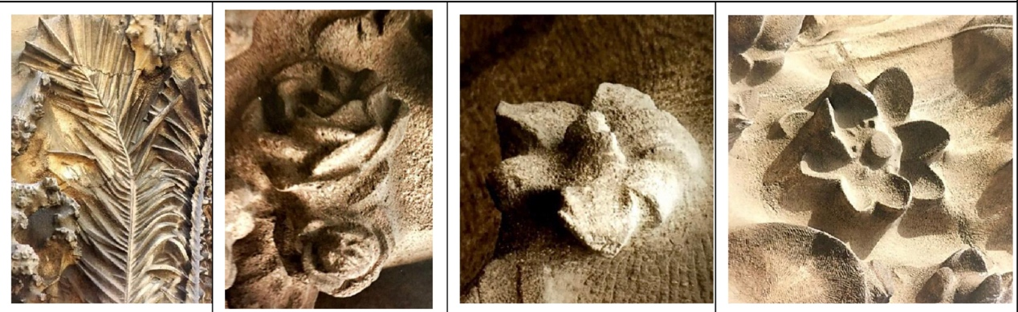
Figure 2 Plant sculptures in Gaudi's works
Take Gaudi's most famous work, the Sagrada Familia Cathedral. The western facade of the Sagrada Familia is decorated with more than 100 animal and plant figures. The staircase in the church was modelled after a conch. In addition, there are different designs related to nature in the church, such as trees, tree festivals, etc. （Li Han, 2017） Vincent House looks like a gorgeous tiled house, but it also contains many elements of nature. The shingles have been planted with African calendula flowers to add a little pizzazz to the cold house. In addition, there are many flowers, birds and plants decorated with tiles and walls, everywhere reflecting the atmosphere of nature. The CASA MILà is also a classic, with Gaudi moving the ocean into the building. But from the appearance, we can see the waves in the sea, and the chimney on the roof is like another form of conch.
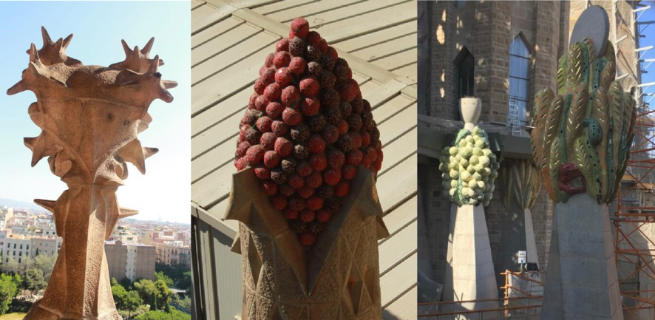
Figure 3 Top of Sagrada Familia Cathedral

2. Bionics in Gaudi Architecture
2.1 About bionics
Humans used to be an animal in nature, and is a part of nature, we strictly abide by the laws of nature and adapt to the natural harsh environment. But gradually human beings evolved into intelligent creatures, began to learn from and imitate nature, listen to the voice of nature, and follow the rules of nature, not only in order to survive, but also to use natural methods and principles to improve human lifestyle and living environment. This is inevitable because it has been proven for thousands or even tens of thousands of years that constructive forms of nature can be very good at creating comfortable environments. Over the past century or two, the world has gradually seen the emergence of architectural forms that resemble wild animals or plants, such as shells, flower petals, turtle shells, plant stems, even human figures and many other bionic forms. At present, "architectural bionics" is a systematic and purposeful study of the laws and principles of biomorphic generation replicated by wild animals and plants in architecture. Bionic architecture is different from bionic architecture because bionic architecture is only a part of bionic architecture. Its essence is to tell how to imitate natural form in the production of architectural form. Bionic architecture is a kind of architectural design based on the organization, structure and function principles of natural objects, forming a unique architectural style. (О I Vorobyeva,2018)

In essence, function and form are closely related and interdependent. The research results in the field of architectural bionics are of great significance to solving the problem of architectural form generation. If we need to really define the concept of form generation, it is the process of generating new forms and structures. In the practice of Russia and other countries, it is essential to find the generative capacity of new structural systems. Organic forms are driven by natural forms, such as terrestrial forms, animal forms, anthropomorphism, and the structural organizing principles of natural structures. At present, the concept of organic form generation is often combined with contextual and ecological methods, which means to achieve a balance between architecture, natural environment and people. These trends continue to focus on the expressiveness of the latest designs and technologies, indicating a growing interest in the bionic form of architecture. As this trend develops, humans have found unexpected gains, in emphasizing the similarities between architectural design and living organisms, a kind of "external skeleton" has been associated with animals in nature. Those designs based on fractal geometry can refer to the generation of truly organic forms. With the help of computer design, which has been implemented in a number of experimental projects today, it was developed by French scientist B. After a paper by Mandelbrot. B. Mandelbrot, who was the first to write about architectural fractals, mentioned the shape of the Paris Opera House. On the basis of the fractal, the reproduction of natural laws in the generation of architectural forms is indeed a classic representative of modern bionic architecture.

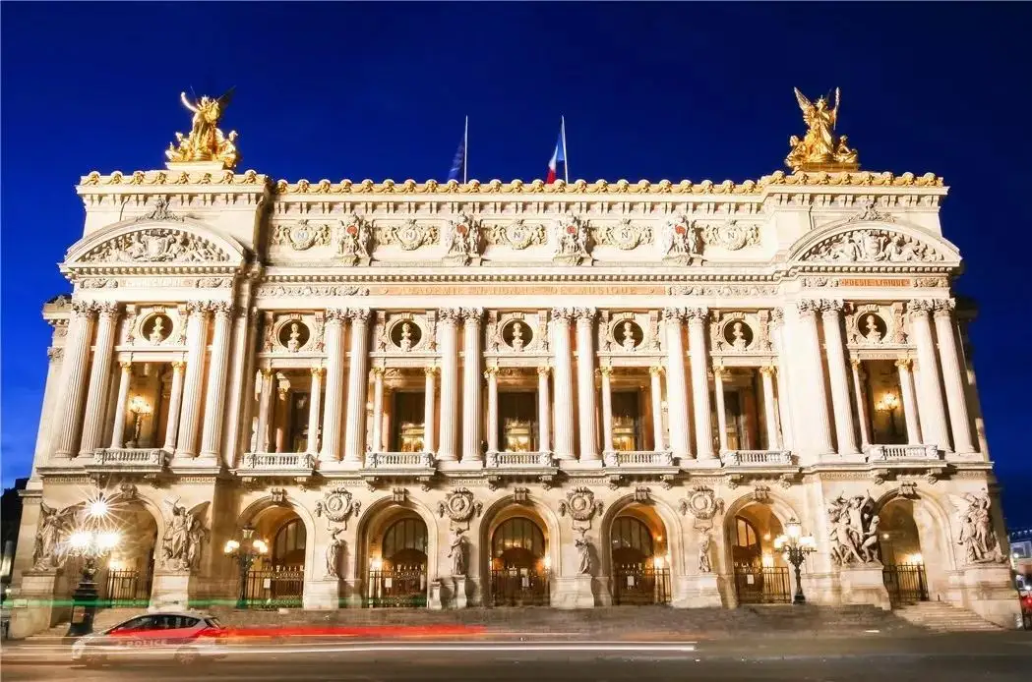
Figure 4 Paris Opera House

2.2 Antonio Gaudi's bionics
As an architect, Gaudi was very advanced in the application of bionics to architecture. This is of practical value and significance to the future development of architecture. He applied his research on the mechanics of bones, and the structural imitation of honeycomb ant nests and shells to the design of architectural structures. This is a great inspiration for future architects.
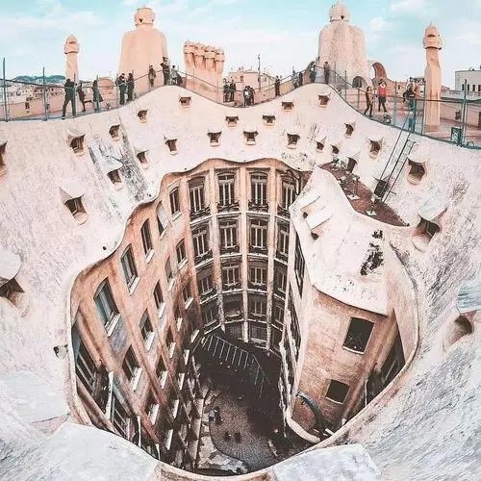
Figure 5 A Beehive-like Mira apartment

Gaudi's design of Sagrada Familia Cathedral takes bionics as the starting point of design ideas and logic in its structural functions. The term "bionics" was coined in the United States in 1960 by J.E. Sidil. "Bionics" was only proposed by J.E. Sidil in the United States in 1960, so in Gaudi's time, bionics has not been systematically explained. Gaudi can be regarded as the pioneer and guide in the field of bionic architecture. The meaning of bionics is to simulate the nature of life. Biomimetics comes from the Greek word "creature," meaning "life," "NIC," and "suffix." The nature of Bionics aims to learn, observe and imitate the characteristics of animals and plants, such as animal and plant structure, bone, texture, environment, and other characteristics, with these materials of science and technology to create new design concepts, design skills and the creative process of imitation science.
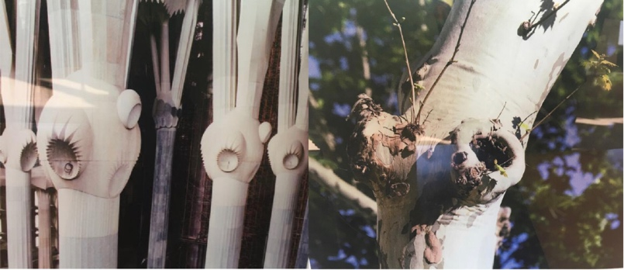
Figure 6 Pillars inside the Sagrada Familia Cathedral

Bionic architecture is based on the nature of plants and animals as the research object, exploring their characteristics, and learning the reasonable rules of composition, and through the application of these conclusions to enrich and improve the treatment of design works, which is conducive to the building appearance image and internal structure and internal plane and space and other elements of the derivation process. In some ways, this kind of building imitating biology also belongs to green buildings, and the method and technology of imitating biological characteristics also belong to the scope of green building technology.

In Gaudi's work, architectural talent and excellent ability to solve practical problems have always been derived from natural aesthetics. He uses SLATE, stone and sand as the original materials for architectural creation. The appearance and structure of his works are different from the traditional architectural structure, which is very novel, strange and amazing. He skillfully combined materials, colours and shapes organically, leaving behind many distinctive and innovative architectural works. He was like an inventor, reflecting extreme individualism and irrational tendencies. He uses the imagination of the sky to apply natural animals and plants to his architectural designs, making each building a vivid and vibrant artistic sense. In fact, during Gaudi's creation process, he often had some fantastic ideas of Heaven and sky, and these inspirations often built him a special style of architecture.

Bionics of architecture has two functions: analysis and application. It mainly analyzes how to integrate modern urban landscapes with nature and the ecological balance between nature and humans. In the process of the formation and development of human civilization, human beings have unconsciously "pushed" themselves out of nature and independently created a brand-new man-made environment. And this innovative bionic architecture happens to seek a way to let humans "return to nature", and peaceful coexistence with humans again. Architectural bionics will help people make their homes more comfortable, make cities brighter, cleaner, and more vibrant, and make the whole architectural world more beautiful and engaging.

3. The nature of Gaudi's architectural works
Gaudi argued that "straight lines are artificial, only curves are God-given." He thinks that nature is beautiful, it is effective beauty, practical beauty. Therefore, his buildings are full of natural curves, gorgeous colours and rich imagination. Gaudi applies natural elements and curved elements in the conception of the overall structure of the building and adopts curve modelling and imitation of natural forms in the facade and decoration of the building to express the "ecological nature" of the building. (Chen Shuwei, 2013) Gaudi tried his best to get rid of the traditional medieval Gothic church style, and integrated dynamic and streamlined lines into it, giving it a free and natural character. The facade and structure of the cathedral of the Holy Family are almost made up of curves, which, though still moving, trace the structural laws of natural life.

3.1 Nature in the Sagrada Familia Cathedral
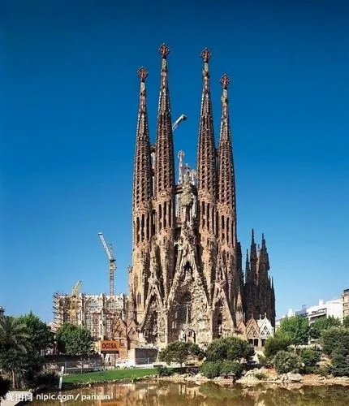
Figure 7 Sagrada Familia Cathedral
The design of Sagrada Familia Cathedral still adopts the Gothic style as the basic design concept. One of the obvious characteristics of Gothic architecture is the pursuit of height. In order to achieve a considerable height, it is usually necessary to add strong buttresses to the external walls to support the main structure of the building, which also leads to the appearance of not detailed and beautiful. Through the study of nature, Gaudi finally concluded that there was no need to add buttress support to the outside of the main structure, which was to design the internal columns into a tree-like structure, which was a very pioneering design. This innovative design method was called the "catenary arch structure". Gaudi wanted the piers of the Holy Family Cathedral to have the structure and beauty of a tree. Therefore, he abandoned the vertical piers of the traditional church and designed a group of piers that inclines slightly as the height climbs. The weight of the piers supporting the building is distributed from top to bottom by the tree-like columns with branches. Gaudi believed that the building itself would be subject to counteracting shear forces, which would allow for the creation of independent structures without the need for walls and parapet support. Gaudi was inspired by learning from nature, and the pillars mimic the way trees grow in a two-way spiral for maximum support. This revolutionary tree-like structure creates a light interior structure that allows light to flow through, transforming the interior of the Holy Family Cathedral into a fantasy forest of casting and spirituality.
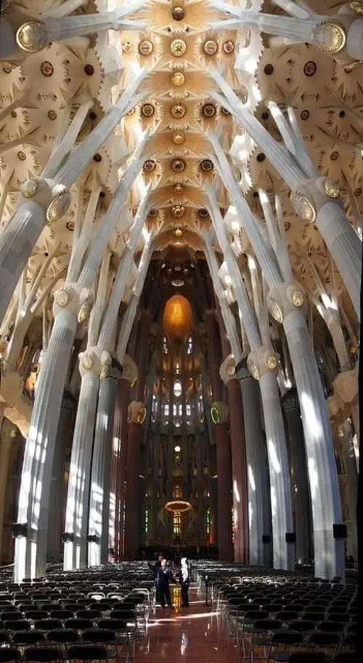
Figure 8 The interior columns are designed to form a tree structure

The tree-like columns with branching branches support the hyperboloid structure of the vault. The vault structure of the inner and side halls and the cross-shaped wing corridors present the evolution of Gaudi's artistic styles in different periods, from the early neo-Gothic architectural style to the hyperbolic paraboloid formed by the plane's curved surface. The simple and neat line structure enables natural light to freely shuttle through the church. (Roger Scruton, 2013) As for the design of the roof of the Cathedral of the Holy Family, Gaudi redesigned it on the basis of the vault with local characteristics in Catalonia. The traditional building material of the vault is solid brick, while the arch structure of the cathedral of the Holy Family is made of reinforced concrete, the vault of the side hall is shaped like a star, and the vault of the inner hall is decorated with tile collage as details. And arranged in a spiral like a palm leaf.

Gaudi designed two different decorative elements on the spire at the top of the large Windows in the nave and side nave of the Cathedral of the Holy Family. The first represents spring and summer with fruits that are abundant in different seasons, such as almonds, peaches, plums, cherries, etc. There is also representative of winter, such as: pomegranate, chestnut, apple, persimmon and so on. The second decorative element, ears of wheat and grapes, represents the Eucharist. In the apse of the semicircle, Gaudi boldly proposed decorating the church with real animal figures, which was controversial at the time. Gaudi decorated the outer walls of the apse with sculptures of reptiles and amphibians, such as frogs, conches, blue-spotted lizards, snakes, geckos, snails and chameleons. (Hu Peidong, 2019) In addition to being decorative, the animals symbolize that these evil creatures are confined to the door of the Sagrada Familia Cathedral by the mystical power of the cross at the top of the Tower of Jesus. The carved ornamentation of the apse's spire selects plants closely associated with the Christian faith, such as ears of wheat, palm branches, olive trees, and cedars, which represent the Eucharist. As a symbol of the sacrament of the Eucharist, the ear of wheat represents the bread given to believers by Jesus. Gaudi also used the wild grass growing around the Cathedral of the Holy Family with a very Mediterranean regional style as the decoration of the church spire, which also reflects Gaudi's sensitivity to nature.
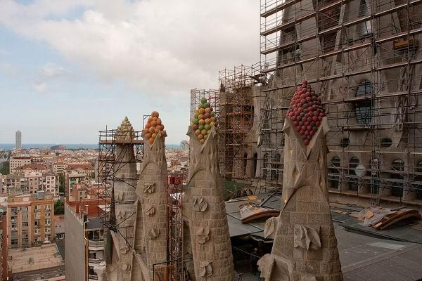
Figure 9 Different kinds of fruit tree tops

3.2 Nature in the CASA MILà
In CASA MILà, the most prominent design element is the curve.
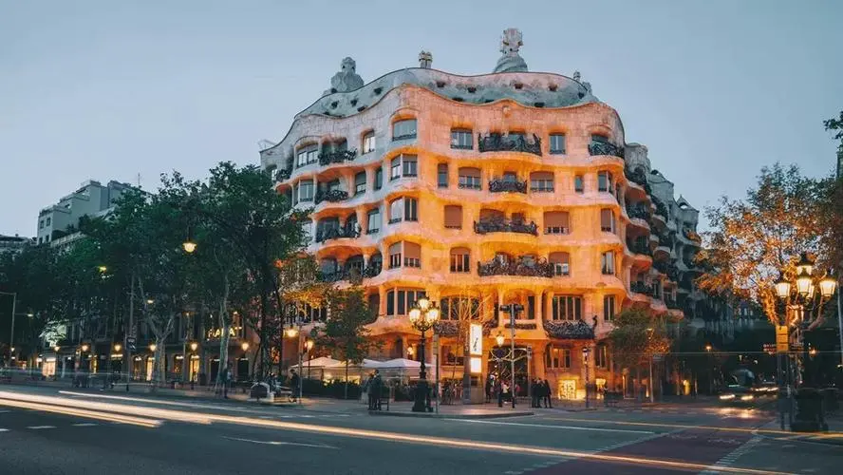
Figure 10 CASA MILà

As an architect, Gaudi seems to have forgotten the straight lines necessary for building structures and has boldly displayed an almost impulsive love of curves. If Botello Apartment is just the beginning, Gaudi tried to correct the original right Angle of the building as much as possible, so as to make the building present a curved form. At this time, Gaudi still had the limitations of the original building. At the CASA MILà, Gaudi was free to pursue his curvilinear revolution. At CASA MILà, Gaudi's use of curves is at its highest. The whole building presents an integrated circle, which is freely unfolded around a courtyard, with fluctuations and converging, flowing in continuity. All the intervals are organically bent or tilted in different directions and to different degrees, and the walls and the ground are continuously twisted into a whole. The curves combine the light sense and weight sense of colourful interfacing materials such as rubble stone, glass, terra-cotta brick and porcelain pieces. The organic shapes of Windows and doors are embedded in the walls as if they were natural: wrought iron is like spring plants overgrowing the balconies. CASA MILà is a vibrant organic architectural ensemble that, even with its furniture, pursues the twisted sculptural feel that characterizes his buildings. As a whole, the undulating surfaces are one and the same. All this is a harmonious dream song, a human whimsy, is a novel masterpiece of engineering.
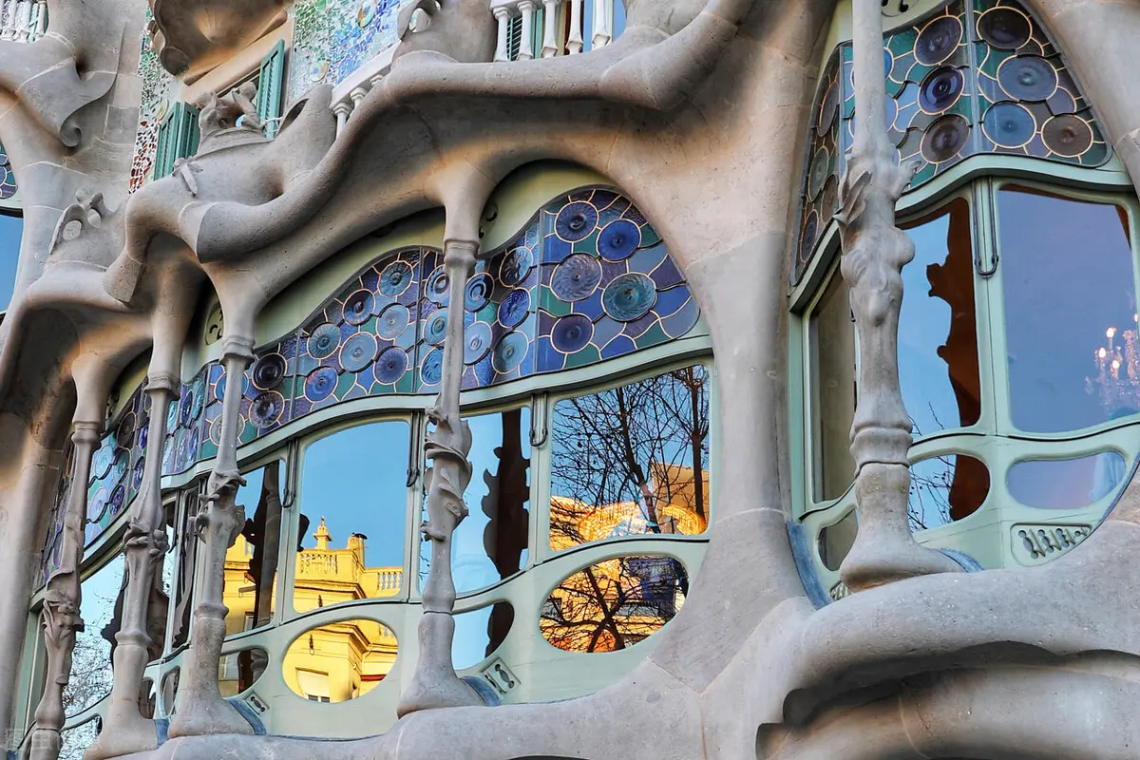
Figure 11 Details of CASA MILà’s window

Here, Gaudi seems to clearly "hate" straight lines. In the most practical field of architecture, even in today's mechanical, structural and material support with high technology, it is difficult to avoid straight lines. Gaudi's love of curves at that time was so thoroughly expressed that one can imagine that it took a great deal of effort. And the impulse to follow the curve revolution to the end clearly requires a kind of crazy belief as ideological support. As he and many others of his time believed, nature has no straight lines. Keep your architecture away from a straight line, that is, make your work closer to the natural form. Gaudi's curve impulse initially showed the naturalistic design thought.
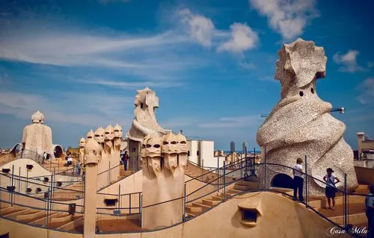
Figure12 The varied roofs of the CASA MILà

In terms of colour, Mira's apartments do not follow Gaudi's usual dense colour decoration, but directly expose the primary colour of the opalescent stone, giving the entire building a single opalescent colour. (Wu Shaojia, 2018) For Gaudi, colour is an essential element of architecture. According to Philippe Thiebaut, Gaudi once thought: "Architecture must not only lose colour but also use colour to steal form and make architecture give life." Colour is the supplement of form, and is the most vivid expression of vitality. (Thiebaut P, 2005) For example, in CASA MILà, Gaudi used his skilled porcelain shards to create a vivid palette of colourful facades that contrasted with the colours of the surrounding buildings. Gaudi ditches the dense, colourful decor here, making the appearance of CASA MILà closer to that of a rock that has been eroded by the sea and weathered out of its hole. In fact, it's just like the giant stones of SAN Miguel de Faye, 20km north of Barcelona. From this perspective, Gaudi's use of milk colour here is a reaction to his own past decorative traditions, but it is in keeping with his work's closer resemblance to the natural form of the hand. It is for this reason that the CASA MILà has earned the title "The Quarry".

Of course, on top of this milky stone, there is another colour, and that is brown. The brown colour comes from the delicate ironwork that adorns the balcony.（Sheng Enyang, 2009） The iron art on the balcony, first of all, is out of the need for safety, in the whole opalescent stone is a unique point rope. It is unique in that it is like a leafy plant growing on a balcony. This is obviously another use of curves.

In addition, Gaudi also featured one element -- the tower. The use of tower elements, mainly on the roof of CASA MILà. The towers were designed by Gaudi as grotesque projections that resembled conches on the beach, soldiers in full armour, mythological odiums, and church bells. In fact, this is a special form of pancetta and ventilation duct. The use of these strange forms of towers here makes the terrace of the CASA MILà very attractive, becoming a golden room with dreamlike colours.
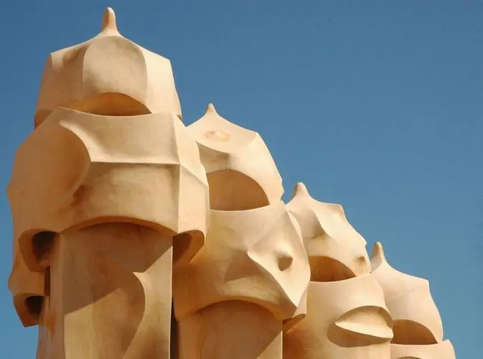
Figure 13 Sculpture on the roof of CASA MILà

It is Gaudi's combination of curves, colours (ivory and brown) and towers that make the Mira a soft, aspirational form that is both sensuous and expressive, giving off a unique flavour that represents a subversive architectural form.
If we look at Gaudi only from the perspective of style, then the CASA MILà and other buildings of Gaudi can only be regarded as wonders in the history of architecture. But obviously, Gaudi's influence and value lie not in the fact that he is just a miracle case, but in the continuation and promotion of a tradition. Therefore, when Le Corbusier declared Gaudi to be a great artist, Gaudi's design ideas, especially the naturalism highlighted by CASA MILà, began to greatly influence the research and practice of organic architecture.

It should be said that Gaudi's naturalistic design ideas come from a deep tradition. Curve, as early as the "Chinese style" deeply influenced by the Rococo era, has entered the vision of artists. So much so that William Hogarth, in The Analysis of Beauty, clearly states: "The serpentine line gives beauty its greatest charm. Note that in the most graceful form there are the fewest straight lines." (William Hogarth, 2002) However, the "picturesque" movement, which was popular in garden art in the 18th century, as well as the discussion on the concept of "picturesque" triggered by it, made Westerners begin to emphasize the handling of natural elements in a way that is almost "not an imposition but a dialogue", (Michelle Conan, 2006) thus impacting the previously popular concepts such as geometry, rules and symmetry, and making curves gradually become popular among people. The emphasis on natural scenery in the concept of "picturesque", of course, also has a more profound influence on the formation of naturalistic design ideas. What's more, in his angry denunciation of machines, Ruskin, while stressing that "forms that do not originate in nature are necessarily ugly," declared with greater fervour that "it is the signs of life that are most precious." He even explicitly reminds people: "How elegant architecture is made, just as we should think about how trees grow."

In 1933, seven years after Gaudi's death, Dali published an article in the Minogue in December of that year entitled "On the Astonishing Edible Beauty of Modern Architecture". Dali wrote of Gaudi's colonnade of CASA MILà: "One enters the cave through soft doors made of calf liver." （He Ning, 2009）

4. Antonio Gaudi's design thought and historical significance
As the most admired design master in the Catalan area of Barcelona, the leader of the Spanish Art Nouveau movement and the only important representative figure of the Spanish Art Nouveau movement, Antoni Gaudi's architectural art and design exploration fully embodies the design concept of "learning from nature".

As Ruskin said in The Seven Lights of Architecture, "All perfect shapes in the natural form must consist of curves". （John Ruskin, 2006） Gaudi's naturalistic design style is not only reflected in the direct reproduction of nature, but also in the curve style of abstraction, refinement and overview of the natural forms of flowers and trees. Gaudi famously said: "Straight lines belong to man, curves belong to God”. （ Wang Yuan, Zhang Wei,2014） Therefore, Gaudi regards curves as his favourite. He shows his exploration, pursuit and love for nature with various curves.

It can be said that, to some extent, the love for curves and the successful application of curve modelling have made Gaudi and the Art Nouveau movement's historical position in the history of design.

Now, from the perspective of the development of the whole design history, to review and analyze the design style of Antoni Gaudi and the Art Nouveau movement "learning from nature" in the history of western design, we should stand in the perspective of two aspects to make an objective judgment. There is no denying that Gaudi and his Art Nouveau movement's design exploration has certain limitations. They regard nature as the source of design inspiration, use curves to interpret their praise of nature and life, and use curves to reflect the true meaning of art. This decorative, naturalistic and handicraft mode of production is doomed to fail this movement.

The democratization of modern design, in the end, is still luxurious and extravagant design, still serving a small number of the aristocratic bourgeoisie. However, as the sleeve of the Art Nouveau movement in the history of western modern design, Antoni Gaudi's design exploration has important historical value and practical significance. In the new industrialization era, "learning from nature" is a new aesthetic principle, which fits in with people's spiritual orientation at that time. Its attention to naturalism and natural spirit can change people's lives and concepts. It can integrate humanistic care into the design practice which was completely immersed in industrialization and mechanization at that time, and show the concern for humanity and respect for the value of individual life. There may be philosophical and ethical values involved that go beyond the design movement itself. In a contemporary society with an increasingly severe environmental protection situation, the design field continues to promote green design, circular design, and ecological design. As a design style, a design concept, and a humanistic spirit, the sustainable development model followed by "learning from nature" is bound to produce new enlightenment for the development of contemporary design.

References
Websites
[1] Zhu Chi. Gaudi in Barcelona and his representative work -- Sagrada Cathedral [J]. China's Foreign Trade, 2001，（09）：60-61.
https://kns.cnki.net/kcms/detail/detail.aspx?dbcode=CJFD&dbname=CJFD2001&filename=ZKWM200109031&uniplatform=NZKPT&v=yArlCh6BWBBm3WXDr3Bt7gaV8xl-iYVYIUwgETEWGgqxJfJix4G0_x1LnV2dMcOz
[2] Li Han. Research on Antonio Gaudi's Architectural Works and His Creative Thoughts [D]. Xi 'an University of Architecture and Technology, 2017：70.
https://kns.cnki.net/kcms/detail/detail.aspx?dbcode=CMFD&dbname=CMFD201801&filename=1017736381.nh&uniplatform=NZKPT&v=sT6wjWJXoZ3g5KegJtsqY9FXgqmCz43aM-AnOnTMGzGYiAmDCO18xEZEDeUEVXMp
[3] О I Vorobyeva. Bionic architecture: back to the origins and a step forward[J]. South Ural State University, 2018.
https://iopscience.iop.org/article/10.1088/1757-899X/451/1/012145
[4] Chen Shuwei. On Gaudi's Naturalism [D]. Zhejiang University, 2005:1-48.
https://kns.cnki.net/kcms/detail/detail.aspx?dbcode=CMFD&dbname=CMFD0506&filename=2006043762.nh&uniplatform=NZKPT&v=hkasETKuivcKWQFaB8_9gDJlNUe1TVEWRhUkU0SREUj3xP6zgCsiZ1905F-_TJZ-
[5] Hu Peidong. Argument of Aesthetic and Naturalism of Architecture: Based on Sagrada Familia Designed by Antoni Gaudi [J]. Central China Architecture, 2019: 86-89.
https://kns.cnki.net/kcms/detail/detail.aspx?dbcode=CJFD&dbname=CJFDLAST2019&filename=HZJZ201903021&uniplatform=NZKPT&v=ZCfNonUv2du3XdvwPn_Mw2_pcSpmZSynm4-508xBRII0uedw54IfatL9cdOQpDha
[6] Wu Shaojia. Naturalism in Gaudi's works -- A case study of Mira House [J]. Art Education Research 2018 (19)：70-72.
https://kns.cnki.net/kcms/detail/detail.aspx?dbcode=CJFD&dbname=CJFDLAST2018&filename=MSJY201819050&uniplatform=NZKPT&v=Mc2-8_xgk5j0489yCgTO9B6eQ-CpObO5GtjdDWQW0BTK6oH5vJyJSgAbR7EFiHWG
[7] Sheng Enyang. Understand Gaudi’s Design idea from Casa Mila [J]. Space and Theory(194), 2009:123.
https://kns.cnki.net/kcms/detail/detail.aspx?dbcode=CJFD&dbname=CJFD2009&filename=ZSHI200906041&uniplatform=NZKPT&v=upa3nTMloHjpkuAp-OuFysfF-3Ad23xCXHk1qwxb7FImH4F9ZY7NcQF_Z6y8M7Ta
[8] He Ning. Art Nouveau Movement and Curves in Gaudi's works [J]. Art Design Research,2009,(04):74-77.
https://kns.cnki.net/kcms/detail/detail.aspx?dbcode=CJFD&dbname=CJFD2009&filename=SHIZ200904017&uniplatform=NZKPT&v=eHkB2CeFBlkxwaGvVdV6iKjQXbnmAu4cecL4xzWb4UWwuDv0jv3LlXZpmuSTDjB8
[9] Wang Yuan, Zhang Wei. From CASA MILà, PARC Quel to Sagrada Familia -- A Brief analysis of Gaudi's Works [J]. Chinese residential houses: 2014(06): 126-127.
https://kns.cnki.net/kcms/detail/detail.aspx?dbcode=CJFD&dbname=CJFD2014&filename=ZHMJ201406112&uniplatform=NZKPT&v=FHYuH9pQvwzwpVxSza8eev-3hi7O0-QTjdqOd3jscGPQTCs1y2FI4GJcTRgGChrh
Books
[10] Roger Scruton. The Aesthetics of Architecture[M]. China Architecture and Building Press，2013:118.
[11] Thiebaut P. Gaudi: Visionary architect [M]. Shanghai People's Publishing House,2005: 68.
[12] William Hogarth. Analysis of beauty [M]. Guangxi Normal University Press, 2002:91.
[13] Michelle Conan. Through the Rock Landscape -- Bernard Latsuz's landscape speech[M]. Hunan Science and Technology Press, 2006:17.
[14] John Ruskin. The seven lights of the building [M]. Shandong Pictorial Publishing House, 2006:91.

