

Applied Leadership and Management in the Workplace
Module Assignment Submission
Student Name: | Jennifer Parmenter
Student Number: | 2238431
Module No: | BMSK4014
Module Title: | Problem solving and decision making

Statement of Confirmation of Authenticity
By the act of making this submission, the student declares that this is the work of the student named above. The work has not, in whole or in part, been knowingly presented elsewhere for assessment, or where assessment has been built on a previous assessment, this has been identified. Where materials have been used from other sources it has been properly acknowledged. If this statement is untrue, the student acknowledges that an assessment offence has been committed.
Attention is drawn to the plagiarism and unfair practice policies of both the University and of ILM.

Contents
Introduction 2
Problem Identification, Scope, and Impact 3
Problem Analysis and Root Cause Analysis 4
Problem 4
Root Cause 4
Ishikawa analysis 5
Grid Analysis 6
Gantt Chart analysis 7
Stakeholders and Their Influence on Operations & Decision-Making 8
Stakeholder communication plan 9
References 11

Introduction

In today’s fast-paced, digitally driven world, running a business involves not only delivering quality services but also managing operational challenges effectively. This assignment focuses on problem-solving within the context of my salon business, specifically addressing the difficulty of managing appointment bookings across both traditional phone calls and social media platforms. As social media continues to dominate how people interact and make decisions, failing to keep up with these communication channels results in missed booking opportunities and negatively impacts customer service.
The objective of this assignment is to identify the root cause of this issue and evaluate its impact on the business. By applying various problem-solving techniques and methodologies, I aim to uncover practical solutions that will streamline our booking process, improve customer engagement, and ensure that we capture every potential appointment opportunity. This exploration will not only cover the direct impact of the problem on operations and customer satisfaction but also consider long-term implications for business growth and competitiveness in the salon industry.
Ultimately, this assignment seeks to demonstrate how effective problem-solving strategies can help overcome business challenges, optimise operations, and maintain high standards of customer service in a rapidly evolving industry.

Problem Identification, Scope, and Impact
The primary issue facing my salon business is the challenge of managing appointment bookings efficiently across multiple communication channels, particularly phone calls and social media platforms. While traditional phone booking remains important, the rise of social media as a preferred contact method for many clients has created a gap in our booking process. Currently, we struggle to keep up with messages and inquiries on platforms such as Instagram and Facebook, leading to delayed responses or missed bookings entirely.
The issue of managing appointment bookings across phone and social media channels affects several key areas of my salon business. Slow or missed responses can lead to dissatisfied clients, harming our reputation and reducing customer satisfaction. Without a streamlined system, handling multiple booking channels increases the administrative workload and decreases staff productivity. This inefficiency results in missed bookings, leading to revenue loss and limiting our ability to grow and expand our customer base. Additionally, in a highly competitive industry, failing to effectively use social media for bookings puts us at a disadvantage compared to competitors who offer seamless digital experiences. The impact is both immediate and long-term: in the short term, we face lost income and potential negative reviews, while in the long term, ongoing inefficiencies can damage our brand image, reduce customer loyalty, and hinder future business growth. Addressing this problem is crucial for improving our booking process, enhancing customer satisfaction, and ensuring the salon’s sustained success.

Problem Analysis and Root Cause Analysis

Problem
Problem analysis is the process of identifying and understanding the root cause of an issue to find effective solutions (Kokotovich, 2008). The primary issue affecting my salon is the inefficient management of appointment bookings. clients increasingly prefer these digital platforms for bookings, the lack of a streamlined system makes it difficult to track and respond to inquiries promptly. This has led to missed bookings, delayed responses, and a decline in customer satisfaction, resulting in revenue loss and a weaker competitive position. Several factors contribute to this issue: the high volume of inquiries overwhelms the manual booking process, there is no unified system to manage bookings across channels, staff are juggling daily operations with responding to messages, and limited social media training makes it harder to handle inquiries efficiently.

Root Cause
To gain a better understanding and identify the root cause of this problem, Im going to use the 5 Whys technique (Serrat, 2017):
- Why are bookings being missed?
Because inquiries from social media are not being responded to promptly.
- Why are responses delayed?
Because the staff is managing multiple communication channels manually.
- Why is the process manual?
Because there is no integrated booking system that consolidates phone and social media appointments.
- Why hasn’t an integrated system been implemented?
Because the current focus has been on traditional phone bookings, and the growing importance of social media bookings was underestimated.
- Why was social media underestimated?
Because there was a lack of understanding of its growing role in customer engagement and booking preferences.
The root cause of the problem is the absence of a streamlined, integrated booking system that can handle both phone and social media inquiries efficiently. This has led to fragmented communication, delayed responses, and missed opportunities, affecting both customer satisfaction and revenue.
By addressing this root cause, the salon can improve booking efficiency, enhance customer service, and maintain a strong competitive edge in the industry

Ishikawa analysis
An Ishikawa diagram, also known as a fishbone diagram, is a tool used to identify and analyse the causes of a problem (Society for Quality, 2024). It looks like the skeleton of a fish, with the "head" representing the main problem and the "bones" branching off to show the possible causes of that problem.
the Ishikawa diagram helps you move from a generalised problem (“missed bookings”) to specific, actionable insights, making it easier to create effective solutions that improve booking efficiency and customer smatisfaction in the salon.
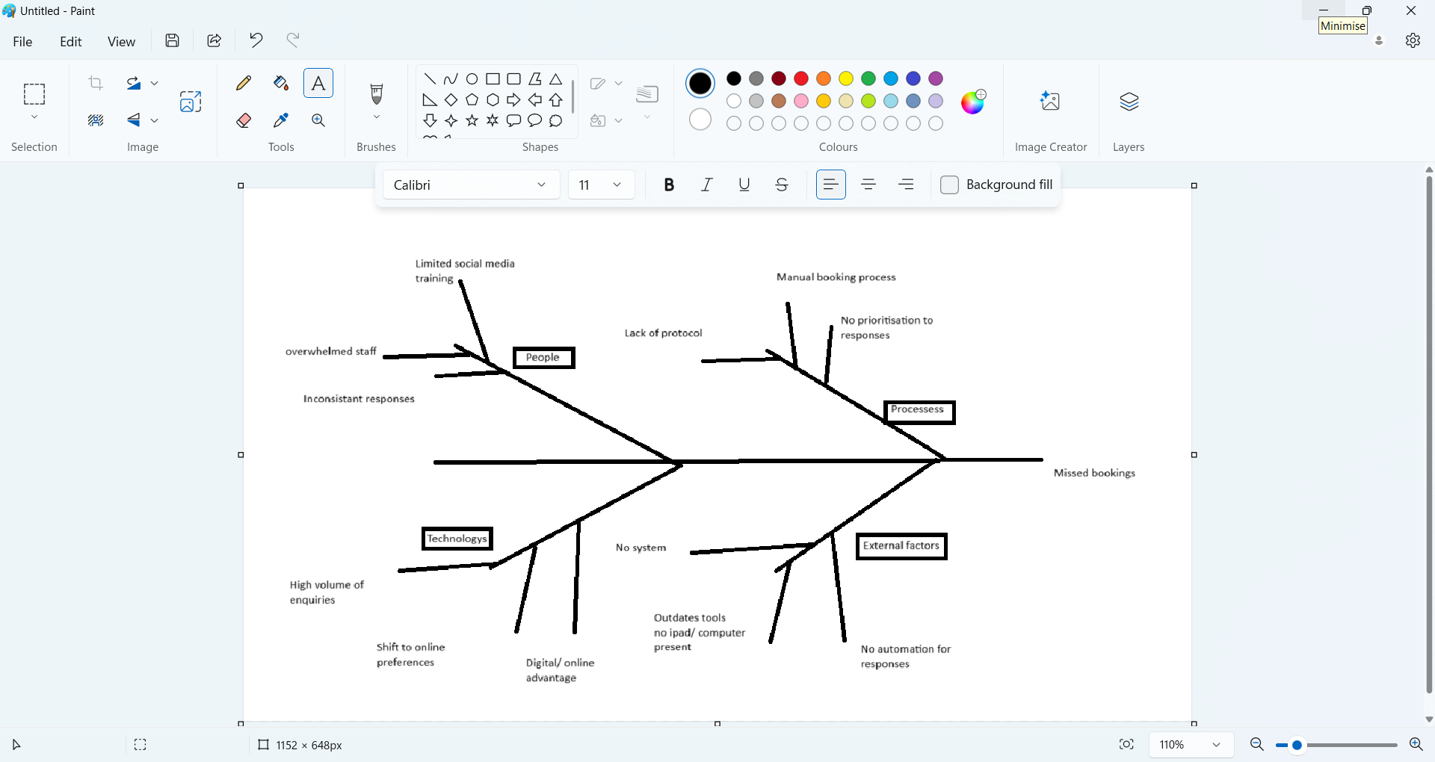
This diagram will categorise potential causes under key factors.

Here’s an Ishikawa (Fishbone) diagram illustrating the root causes of the inefficient booking system in my salon. It categorises potential issues under four main areas:
- People- Lack of social media training and overwhelmed staff.
- Processes- Manual, non-prioritised booking processes.
- Technology- Absence of an integrated system and outdated tools.
- External Factors- High inquiry volume and shifting client preferences to online channels.

Grid Analysis
A Grid Analysis is a decision-making tool used to evaluate and compare different options or solutions based on various criteria (admin-modernmeetingstandard, 2024). It helps businesses systematically assess the pros and cons of each option, prioritise them, and make informed decisions.
In a grid analysis, you can see the possible solutions or options listed in one column and the criteria for evaluation listed in another. Then, each option is scored or rated against each criterion to determine which solution best meets my needs.
A grid analysis can help me evaluate different solutions to the problem of managing appointment bookings across multiple channels (phone and social media). By comparing options based on clear criteria, you remove personal bias and make more objective, data-driven decisions. The grid analysis helps identify the most effective solutions, allowing me to allocate resources (time, money, effort) more efficiently. It also helps highlight which criteria are most important for the salon, such as customer satisfaction, ease of use, or cost, so i can choose the best solution that aligns with my priorities. This is also effective because it allows me to explore multiple options and weigh their potential impact, leading to better problem-solving and decision-making.

Criteria | Integrated Booking System | Additional Staff | Social Media Management Software
Cost | 3 | 2 | 4
Ease of Use | 4 | 3 | 4
Customer Satisfaction | 5 | 3 | 4
Impact on Revenue | 5 | 2 | 3
Time | 3 | 2 | 5
Scalability | 5 | 2 | 4
Total Score | 25 | 14 | 20

This a Grid/ Chart showing my results

By using a grid analysis, I can make an informed decision about how to improve my booking process, whether it's implementing new technology, adjusting workflows, or reallocating resources. This structured approach helps ensure im choosing the solution that will deliver the greatest benefit to my business.
The grid shows that the integrated booking system scores the highest in areas like customer satisfaction, revenue impact, and scalability, making it the best choice despite having a moderate implementation time and cost. In contrast, additional staff may be more expensive and less scalable, while social media management software may be quick to implement but less effective at improving overall customer satisfaction.

Gantt Chart analysis
A Gantt chart can be a powerful tool to help me plan, schedule, and manage projects related to improving the booking system or addressing other operational challenges (Grant, 2023).
A Gantt chart provides a clear visual timeline of your project, making it easy to see task deadlines and track progress. It breaks down large projects into smaller, manageable tasks with assigned timelines, ensuring nothing is missed. Tasks can be allocated to specific team members, improving workflow and efficiency. By monitoring progress in real-time, I can adjust schedules or reassign resources as needed. Additionally, it highlights task dependencies, helping me understand which tasks must be completed first to maintain a smooth project flow.

Task | Duration  (weeks) | Wk 1 | Wk  2 | Wk  3 | Wk  4 | Wk  5 | Wk  6 | Wk  7 | Wk  8 | Dependencies
Research booking systems | 2
Choose the best booking system | 1 |  |  |  |  |  |  |  |  | Research completed
Purchase & Install software | 1 |  |  |  |  |  |  |  |  | Choose system completed
Staff training | 2 |  |  |  |  |  |  |  |  | Purchase software completed
Test booking system | 1 |  |  |  |  |  |  |  |  | Staff training completed
Launch new system | 1 |  |  |  |  |  |  |  |  | Test completed

Above is a Gantt chart aimed at improving my salon’s booking system, which could include tasks like researching booking systems, training staff, and launching the new system.
In summary, a Gantt chart is an effective tool for managing projects in my salon, especially when implementing changes like a new booking system. It helps with planning, monitoring progress, and keeping tasks on schedule, ensuring that the business runs more efficiently.

Stakeholders and Their Influence on Operations & Decision-Making
Stakeholders are individuals or groups that have an interest in how the business operates and performs. They play a significant role in influencing decisions, shaping strategies, and ensuring smooth operations with in the Salon (Høgevold et al., 2016). I am going to explore how key stakeholders which are customers, suppliers, marketing, management, and finance wholey affect my business.
Customers play a crucial role in shaping the salon’s operations. Their feedback directly impacts the salon’s reputation and influences service improvements. If customers are satisfied, they boost the salon’s image, but dissatisfaction can harm it. Additionally, the growing demand for convenient booking options, such as using social media and online platforms, pushes the salon to adapt its booking process to stay competitive and meet customer expectations. From a customer’s perspective, they want easy booking options, quick responses, personalised services, and high-quality experiences. Their preferences influence important business decisions, such as adopting new booking systems, improving customer service, and introducing loyalty programs to meet their expectations and enhance their overall experience.
Suppliers play an important role in the salon’s operations by ensuring a steady supply of products, equipment, and essentials, which directly impacts service delivery. They also influence the cost and quality of products, affecting pricing and profit. From the supplier's perspective, they want consistent orders, timely payments, and clear communication. This influences the salon’s decisions when choosing suppliers, as factors like reliability, pricing, and product quality are essential for managing, maintaining service quality, and ensuring profitability.
The marketing team plays a key role in increasing the salon's brand visibility through social media, online ads, and promotions, helping the salon reach new customers. Their efforts also focus on gaining new clients and keeping existing ones through loyalty, special offers, and targeted content. From the marketing team's perspective, they need clear direction on the brand image, a budget, and data on customer behavior.
Management is responsible for setting the vision, goals, and policies that guide both the daily operations and long-term growth of the salon. Their decisions on staff training, workload distribution, and customer service standards directly affect staff performance and morale. From management's perspective, they want efficient operations, satisfied customers, and a motivated team to achieve business objectives. Their decisions on investments in technology, staff development, and improving customer service help enhance the overall efficiency and success of the salon.

The finance team plays a crucial role in managing the salon’s cash flow, allocating budgets, and controlling expenses, which ensures the business remains sustainable. They focus on revenue growth by managing costs, setting pricing strategies, and making investment decisions to maintain profitability. From the finance team’s perspective, they want clear financial reports, cost-effective operations, and a balance between investment and returns. Their input influences decisions on expanding services, purchasing new equipment, or hiring additional staff based on finances.

Stakeholders have a significant influence on the success of the salon. Customers drive innovation and demand for convenience, leading improvements. Suppliers ensure product quality, which impacts customer satisfaction. Marketing helps position the salon in a competitive market, while management ensures operations run smoothly and align with the salon’s goals. The finance team secures the salon’s financial health and guides important investment decisions. By involving all stakeholders in decision-making, the salon can achieve both short-term success and long-term growth.

Stakeholder communication plan
A stakeholder communication plan is a document that outlines how to effectively communicate with key stakeholders (Sanghera, 2018). It ensures that stakeholders are kept informed, engaged, and aligned with business goals and objectives.

Stakeholder | Objective | Message | Method/Channel | Frequency | Responsible
Customers | Keep them informed about new services and offers | Introduce new services, special offers, and updates on salon practices | Social media, Email newsletters, SMS | Weekly updates or as needed | Marketing team
Suppliers | Maintain good relationship and supply consistency | Order confirmations, inventory needs, and new product requests | Email, Phone calls, Meetings | Monthly check-ins | Salon manager
Marketing Team | Align on promotional strategies and brand image | Updates on current promotions, new campaigns, and brand direction | Meetings, Email, Reports | Bi-weekly | Business owner/Manager
Management | Ensure smooth operation and alignment on goals | Business goals, staff performance, budget updates, operational issues | Weekly team meetings, Reports | Weekly meetings | Salon owner/Manager
Finance Team | Keep financial health in check and on target | Budget updates, revenue reports, cost analysis | Reports, Email, Meetings | Monthly | Finance manager
This is a table of a plan ive put in place to make sure stakeholders are kept up to date. This plan includes details on who the stakeholders are, how often communication will take place, the preferred methods of communication, and the key messages to be conveyed.

References
admin-modernmeetingstandard (2024). Grid Analysis - Definition & Detailed Explanation - Meeting Decision Making Glossary - ModernMeetingStandard.com. [online] modernmeetingstandard.com. Available at: https://modernmeetingstandard.com/grid-analysis/.
American Society for Quality (2024). What Is a Fishbone diagram? Ishikawa Cause & Effect Diagram. [online] ASQ. Available at: https://asq.org/quality-resources/fishbone.
Grant, M. (2023). Understanding Gantt Charts. [online] Investopedia. Available at: https://www.investopedia.com/terms/g/gantt-chart.asp.
Høgevold, N.M., Svensson, G., Wagner, B., Varela, J.C.S., Ferro, C. and Padin, C. (2016). Influence of stakeholders and sources when implementing business sustainability practices. International Journal of Procurement Management, 9(2), p.146. doi:https://doi.org/10.1504/ijpm.2016.075261.
Kokotovich, V. (2008). Problem analysis and thinking tools: an empirical study of non-hierarchical mind mapping. Design Studies, 29(1), pp.49–69. doi:https://doi.org/10.1016/j.destud.2007.09.001.
Sanghera, P. (2018). Planning for Communication and Stakeholder Management. doi:https://doi.org/10.1007/978-1-4842-3910-0_8.
Serrat, O. (2017). The Five Whys Technique. Knowledge Solutions, [online] 1(1), pp.307–310. doi:https://doi.org/10.1007/978-981-10-0983-9_32.

