SKILLS FOR THE WORKPLACE ACADEMIC & EMPLOYABILITY SKILLS

NAME: Ana Maria Nastasa
STUDENT NUMBER: 1815910
MODULE TITLE: Academic&employability skills for the work place
MODULE LECTURER NAME:Timothy Hopkyns
Table of contents
Introduction 3
Background 3
Required skills for the job 3
A current skill that is present 4
Skills that would be required to be developed 6
Analysis of the skills and their practical implications 7
Mechanism of the development of the mentioned skills 8
Conclusion 10
Reference 11
Bibliography 13

Introduction
Workplace skills are defined as the attributes that an individual use for the execution of a particular type of task (Prince et al., 2015). This task could be in the academic as well as in the professional space. This means that the academic space could additionally be considered a working place. However, in the modern aspect of academics, skills acquired and developed during the academic segment are essentially used in the professional space in multiple forms. The aim of this study lies in the identification of the skills that would be required for the execution of a particular task of the professional task. The scope of this study additionally includes the identification of the mechanism that would be associated with the development of skills for a particular task.

Background
As a preferential career choice, I want to be a gym trainer in the professional space. Specifically, I would prefer to be a Kangoo Jumps gym trainer post the completion of my education obligations. The rationale for such a choice includes the presentation skills that I have acquired over the time coupled with the area of interest that I have in the segment of fitness and the expansion of the concept of modulated fitness. For the identification of this career choice, I have essentially multiple skills in the fitness segment as well as in the communication segment.

Required skills for the job
According to Brenner (2016), the skills required for the mentioned job includes the following:
- Identification of positive energy
- Development of social contact with the peers
- Modulated development of teamwork
- High quality of leadership
- The external motivation for improving the self-esteem of the peers and the customers to facilitate the duties of a gym trainer
Apart from the mentioned skills required for the execution of the duties associated with a gym trainer, additional skills would include the resistance training skills for an individual (Smith et al., 2016). For the development of physical strength, the resistance training skills are essentially required for a gym trainer. The resistance training exercises are defined as the exercises that enable the development of the physical body of an individual (Banks et al., 2016). Some of the examples include shoulder press, barbell squat, bent over row and others.
However, for gym trainers, apart from the physical skills and knowledge skills, mental and physiology skills are essentially required. The mental skills include the effective reading of the individual needs and understanding the requirements of each of the individual associated with the gym. The job of a trainer in a gym is essentially a multi-faceted one. This includes skills in the occupational regulation support coupled with providing cross-national support in the execution of the task provided by the mentioned organisation (Lloyd and Payne, 2018). Additionally, in the segment of leadership, as a trainer, transformational leadership skill is essentially required. The rationale behind the same includes the generation of a positive and communicative environment for conduction of fitness activities. This additionally would include the use of the current Kangoo boots as a modern way of executing high-intensity exercises.
Overall, the skills required for the execution of duties as gym trainer would include a basic idea about the nutrition content of an individual based on the physical appearance and the frequency of exhaustion during the conduction of exercises in both the light and the heavy domain.

A current skill that is present
Current skills could be identified and analysed based on the SWOT analysis model. The SWOT analysis model enables the identification of the skills that are present in the current scenario as well as the skills that could be developed in the long end.
Segment | Attributes
Strengths | - Effective communication  - Time management  - Resource management  - Intricacies of physical fitness  - The minor idea about the mental fitness and nutrition aspects associated with an individual
Weakness | - Limited transformational leadership skills  - Limited external motivation due to limited understanding of the requirement of the individuals in the fitness segment  - Limited self-practice in the use of Kangoo boots for individuals preferring a combination of controlled and intense fitness activities
Opportunities | - Potential development of transformational leadershipwith the use of communication skills and time management skills  - Increase in the segment of customer interaction shortly and the development of peer interaction in the current scenario of academic obligations
Threats | - The major threat includes the deviation from the central prospect of being a gym trainer due to the perceived skill development required in the nutritional segment  - The additional threat would include the potential aspect of conducting sales through membership increment and additional sales of consumable fitness product that might influence the tasks associated with a gym trainer
Table 1: SWOT analysis
(Source: Created by author)
Based on the above identifications, I think that I have currently the skills of communication, time management, and anthracites of physical fitness. This would enable me to project myself as a gym trainer as communication and time management with the clients would be an essential requirement during the professional working hours. Additionally, having an idea about physical fitness would enable me to guide the clients in the conduction of their physical activities. This would include managing the resistance training modules relative to each client. This modulation would vary upon the age and the requirement of the customers in the short end.
Similarly, I think that I have a high degree of resource management skill. This would include the effective use of the machinery available in the gym coupled with cross selling of the consumable products for the mutual benefit of the customer and the organisation.

Skills that would be required to be developed
The skills that would be required to be developed based on the SWOT model would include leadership skills. Transformational leadership is defined as the approach undertaken in which all of the recommendations provided by the peers and juniors are taken into consideration during the execution of a task (Banks et al., 2016). For the mentioned job profile, the following skills would be required to be developed:
- Transformational leadership
- Nutrition skills associated with physical fitness
- Customer interaction and sales skills in the long end
The mentioned skills could be developed into three domains. First, in the domain of development of transformational, the mentioned skill could be developed by the creation of a working environment in which the responsibility of a task would be shared with a supportive environment. Additionally, leadership skills could be developed by breaking the normal procedure associated with any task (Komives, 2016). For example, I could include the concept of shared responsibility during the execution of a group task. This would include the use of in-class exercise characterised by the active generation of trust coupled with admiration among the peers and with the professors. Second, in the domain of the development of customer interaction and sales skills, I could develop the same by providing multiple mock presentations to my peers. Additionally, I could execute multiple academic internships that would provide me with practical experience in dealing with customers. In the long end, this would enable me to focus on only providing training to the customers than managing the sales, registers associated with the organisation.

Analysis of the skills and their practical implications
The rationale for developing the mentioned skills could be analysed in two domains. First, in the commercial space, customer interaction and sales skills would enable the regular development of personal competencies as a trainer (Delcourt et al., 2017). In the long end, this would complement the leadership and motivational skills required in the direct dealing of customers in the fitness segment. Second, in the domain of the management skills, development of the transformational leadership skills would enable the effective management of the resources present in the gym and segmentation of the customer interest in a dynamic form.
Overall, the development of the nutritional skills would complement the execution of the tasks associated with a gym trainer. This includes providing initial and basic recommendations to the customers during the execution of training activities in the gym centres.
Post the identification of the required skills, it could be deduced that the second skill of knowing basic nutrition would be a product of the leadership and the sales skills. This would be because understanding and the implementation of the skill would enhance increased customer dealing.
Based on the mentioned weakness, the Kangoo boot weakness could be additionally improved by taking multiple classes associated with the same. This would include roping in external trainers and experienced trainers for training myself with the Kangoo boots. This would be because; the Kangoo boots technique is essentially a new approach in the fitness industry. Development of this skill would enable me to provide effective training to those individuals that prefer a regular workout without any weight training.
Hence, the major advantage associated with the current strengths would include the dual implementation of the same in the academic segment as well as the potential professional segment. This would be because; communication, resource management, and time management form the basic pillars of any task irrespective of the nature of the work.

Mechanism of the development of the mentioned skills
Relative to the mentioned discussion, I would be able to acquire the mentioned job in two ways.
First, I would be able to acquire the job with skills that I currently have. The undertaken organisation is one of the most appreciated organisations in the segment of fitness in the UK. Additionally, communication skills that I have along with the resource management skills would enable me to understand the need of the customers in the long end. Additionally, during the conduction of the interview for the designation, I would be able to present my preferential choice of career as a gym trainer to the interview panel. Similarly, the experience that I would acquire during the multiple internships in the fitness segment would alleviate my candidature in front of the interview panel. The major advantage associated with this mechanism would include the potential use of SWOT analysis in the identification of the customers’ needs and their capability. This would be because of two reasons. First, the SOWT analysis would enable the medical and physical limitations of the customers. This would help me to provide a high degree of the efficient recommendation of fitness activities. Second, the SWOT analysis would enable me to motivate fitness enthusiasts by presenting the potential development of their physical body in the long end.
Second, I would acquire this job through multiple recommendations from my peers as well as my professors. As mentioned before, the skills that I have could be implemented in both the segments of academics and professional space. Hence, the fitness activities that I have developed within the academic segment among the peers would complement my resume in front of the interview panel. Additionally, I could intern with the fitness department of my academic organisation and present it to the interview panel. As a result, I would get a direct preference to be a gym trainer in the mentioned organisation. Overall, the major advantage associated with this mechanism would include the projection of me as a recommended candidate that would be endorsed by the educational service provider.

Conclusion
The analysis conducted based on the mentioned study yielded two concluding statements. First, it could be concluded that the majority of the skill required landing a job as a gym trainer in the organisation of Kangoo includes the communication, resources management and knowledge about physical fitness. The rationale for the same includes the need to communicate with the customers on a real-time basis. Second, in the segment of the mechanism of skill development, it could be concluded that a direct approach in the development of the skills would result in the overall mitigation of the weakness identified coupled with the reduction in the segment of threats.
Overall, it could be concluded that the mentioned skills could be used in both the academic and the employment sector in a randomised manner. The randomised manner would include the development of a “one to many” function among the multiple skills so identified. The rationale for the same would include the regular use of such skills in the academic segment that are demanded by organisations of repute in an endorsed form.
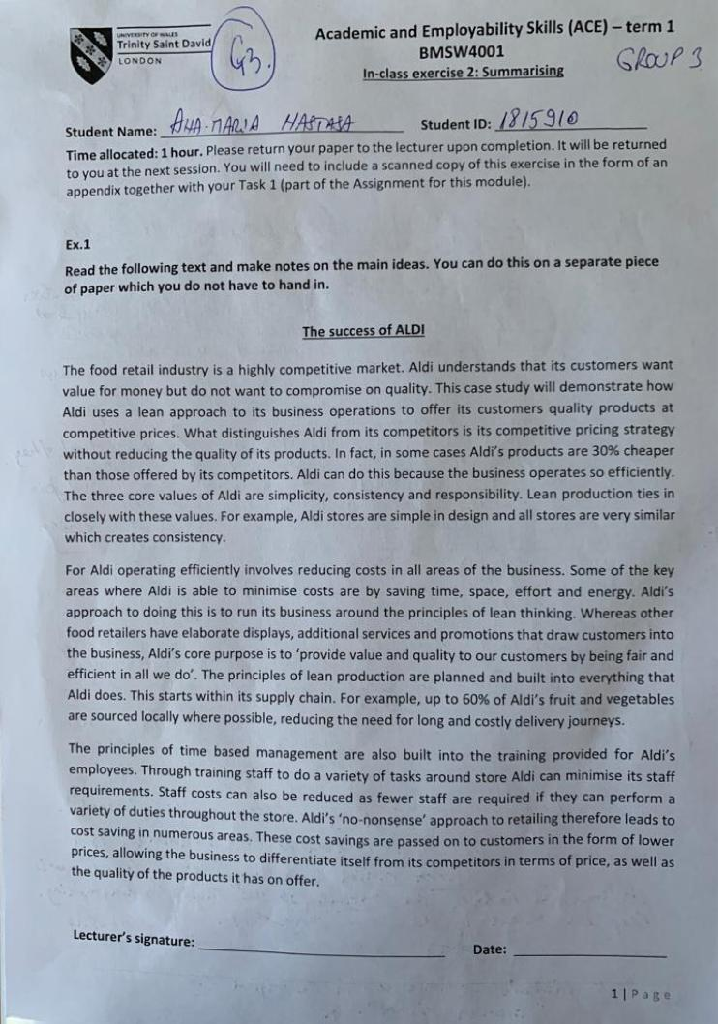
In class room exercises:
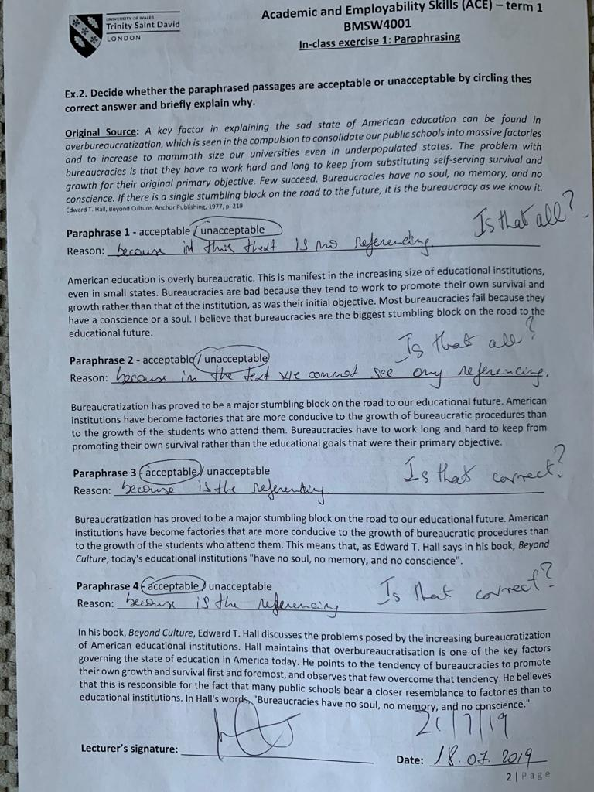
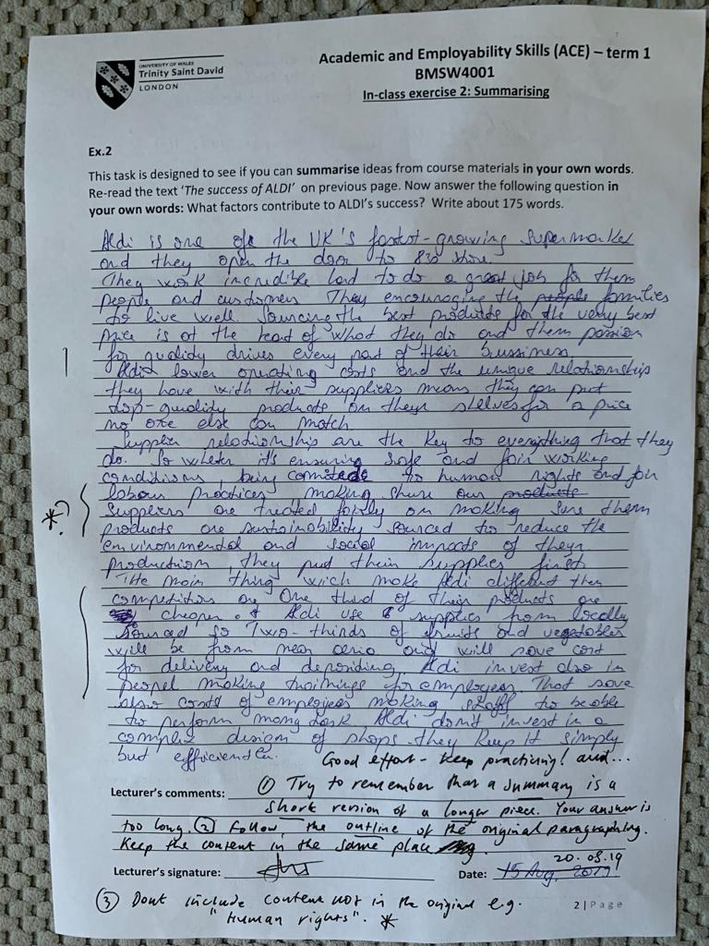

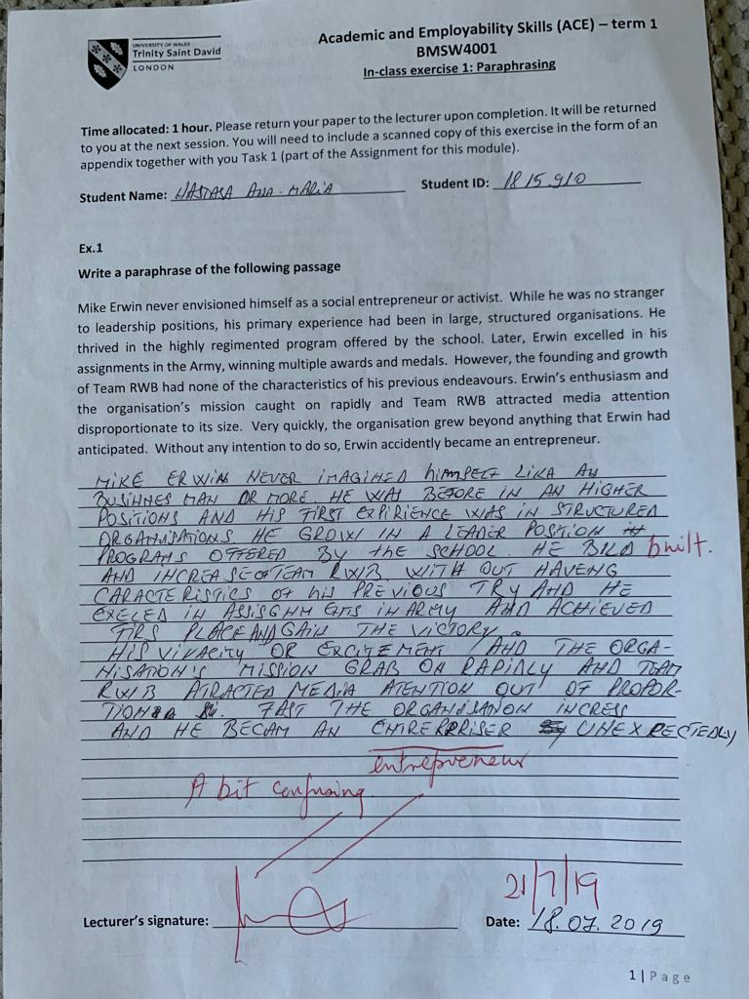
Reference
Banks, G.C., McCauley, K.D., Gardner, W.L. and Guler, C.E., 2016. A meta-analytic review of authentic and transformational leadership: A test for redundancy. The Leadership Quarterly, 27(4), pp.634-652.
Brenner, J.S., 2016. Sports specialization and intensive training in young athletes. Pediatrics, 138(3), p.e20162148. Available on: https://pediatrics.aappublications.org/content/pediatrics/138/3/e20162148.full.pdf
Delcourt, C., Gremler, D.D., De Zanet, F. and van Riel, A.C., 2017. An analysis of the interaction effect between employee technical and emotional competencies in emotionally charged service encounters. Journal of Service Management, 28(1), pp.85-106.
Komives, S.R., 2016. Leadership for a better world: Understanding the social change model of leadership development. John Wiley & Sons.
Lloyd, C. and Payne, J., 2018. Licensed to skill? The impact of occupational regulation on fitness instructors. European Journal of Industrial Relations, 24(1), pp.91-108. Available on: https://journals.sagepub.com/doi/pdf/10.1177/0959680117701016
Prince, M., Burns, D., Lu, X. and Winsor, R., 2015. Knowledge and skills transfer between MBA and workplace. Journal of workplace learning, 27(3), pp.207-225.
Smith, J.J., Morgan, P.J., Plotnikoff, R.C., Stodden, D.F. and Lubans, D.R., 2016. Mediating effects of resistance training skill competency on health-related fitness and physical activity: The ATLAS cluster randomised controlled trial. Journal of sports sciences, 34(8), pp.772-779. Available on: https://pdfs.semanticscholar.org/609c/bcfd7feab5bd4756a5d20199efefdbbe0b7a.pdf

Bibliography
Corfield, R. (2006) Successful Interview Skills: How to Present Yourself with Confidence (4th Ed) London: Kogan Page
Cottrell, S. (2008) The Study Skills Handbook 3rd edition. Hampshire: Palgrave MacMillan.
Cottrell, S. (2010) Skills for Success: Personal Development and Employability (2nd Ed) Basingstoke: Palgrave Macmillan
Cottrell, S. (2010) Skills for Success: Personal Development and Employability (Palgrave Study Skills) Hampshire: Palgrave MacMillan.
Gibbs, G. (1988) Learning by doing: A guide to teaching and learning methods. London: FEU.
Greetham, B. (2013) How to write better essays. Basingstoke: Palgrave Macmillan.
Leigh, J. (2004) CVs and Job Applications Oxford: Oxford University Press
Mackevic, V. (2014) From confusion to conclusion. How to write a First-Class essay.2nd edition. Edited by Tom Wild. United States: Createspace
Moon, J. (2006) Learning Journals: A Handbook for Reflective Practice and Professional Development (2nd Ed) New York: Routledge

