

BMIH4003
Foreign Languages & Cultural Awareness
Assignment one

Portfolio

Student Name: Adriana Mitran
Student Number: 1920087
Lecturer’s Name: Giulia Chifari
Word count: 2000

Contents
Component One-Professional Reflection 3
Component Two-Training Plan 4
Component Three-Student Self-Reflection 6
Component Four-Training Presentation 8
References 16

Component One-Professional Reflection

Scenario:
Maria, a dedicated food, and beverage employee at a luxury hotel, was excited to serve a diverse group of guests attending a conference at the hotel. One afternoon, while serving a group of guests at the hotel's restaurant, she noticed a gentleman named Mr. Lee, who seemed to be from East Asia, sitting alone at a table.
Maria smiled broadly as she walked up to Mr. Lee and said, "Hello! How are you feeling right now? Do you want to sample our daily special dish? But Mr. Lee seemed a little surprised by Maria's straightforward manner and excitement. Though he seemed reserved, he answered respectfully.
Unaware of the cultural differences in communication styles, Maria continued to engage Mr. Lee in conversation, asking him about his day and making recommendations from the menu. Mr. Lee, who preferred a more subtle and reserved interaction, felt uncomfortable with Maria's approach but did not want to offend her.
As Maria persisted in her efforts to make Mr. Lee feel welcomed, he began to feel uncomfortable and decided to finish his meal quickly to avoid further discomfort. After paying his bill, Mr. Lee left the restaurant earlier than he had planned, feeling slightly unsettled by the interaction.
Mr. Lee complained to the hotel manager later that day regarding his unpleasant dining experience. The management concluded that the guest had been uncomfortable due to Maria's unintentional cross-cultural interactions.
The manager immediately arranged a meeting with Maria to discuss the incident and provided cultural sensitivity training to help her understand the diverse backgrounds of the hotel's guests. Maria learned the importance of adapting her communication style to accommodate different cultural norms and preferences, ensuring that all guests feel respected and valued during their stay at the hotel. Moving forward, Maria made a conscious effort to approach interactions with guests with a greater awareness and sensitivity to cultural differences, creating a more inclusive and welcoming environment for all guests.
The previous example illustrates how crucial it is to recognise individual differences, particularly when actions or gestures that are seen as courteous in one culture are interpreted differently in another, cultural misunderstandings can happen in the hospitality sector. A simple thumbs-up, which is widely used in my culture to indicate approval, might, however, be considered offensive in certain Middle Eastern societies. Guests may become uncomfortable or offended because of this misperception. To deliver great service and guarantee a satisfying visitor experience, it is essential to understand these cultural differences.
Preventing cultural misunderstandings in the hospitality industry requires a range of skills that go beyond basic communication abilities. Cultural competence, emotional intelligence, adaptability, and awareness of diverse customs are essential for professionals in this field. By developing these abilities, workers in the hospitality industry may successfully manage interactions with visitors from different cultural backgrounds, creating a positive atmosphere and lasting partnerships.
Being culturally competent entails being aware of and considerate of the customs, beliefs, and conduct of visitors from various cultural backgrounds. With this ability, hospitality workers can adjust their interactions, communication style, and service to the cultural preferences of their clients (Shani & McKenna, 2017).
By assisting professionals in controlling their own emotions and understanding the viewpoints of others, emotional intelligence plays a critical role in averting cultural misunderstandings. According to Kim and Jogaratnam (2017), this ability enables workers in the hospitality industry to modify their communication style, settle disputes, and establish rapport with clients from a variety of cultural backgrounds.
In summary, in today's globalised industry sector, hospitality employees must develop these abilities in order to successfully navigate the complexities of cultural diversity and guarantee pleasant guest experiences.

Component Two-Training Plan

Training Plan: Cultural Competence in the Hospitality Industry
The ability to avoid cultural misunderstandings has become more and more important in today's globalised hospitality sector to guarantee outstanding guest experiences and cultivate healthy connections with clients from a variety of cultural backgrounds. To create a warm and inclusive environment, hospitality workers must be culturally competent to identify and honour the norms, values, and practices of their visitors. Organisations can prevent miscommunications that could cause guests to feel uncomfortable, offended, or dissatisfied by proactively addressing cultural differences and encouraging sensitivity and knowledge among staff. The objective of this training programme is to provide staff members with the abilities and information needed to successfully manage cultural differences, which will ultimately improve the calibre of services provided in the hospitality industry.

Objective: To provide staff members the abilities and information they need to avoid cultural misunderstandings and deliver exceptional service to guests from a variety of cultural backgrounds in the hospitality sector.

Duration: two-day training programme

Day 1:

Session 1: Understanding Cultural Differences

-Introduction to cultural competence in the hospitality industry
-Examining how cultural misinterpretations affect the experiences of guests
-Case studies and illustrations of how cultures differ in behaviour, communication, and traditions

Session 2: Cultural Awareness and Sensitivity

- Developing empathy and cultural awareness for visitors from other backgrounds
- Acknowledging and valuing traditions, beliefs, and cultural norms
- Interactive exercises to improve awareness of cultural differences

Day 2:

Session 3: Communication Strategies for Cultural Competence

- Effective communication technique for cross-cultural interactions
- Non-verbal communication and its significance in different cultures
- Role-playing exercises to practice culturally appropriate communication

Session 4: Emotional Intelligence and Adaptability

- Understanding the role of emotional intelligence in preventing cultural misunderstandings
- Developing adaptability skills to adjust behaviours and approaches based on cultural differences
- Strategies for managing cultural conflicts and resolving misunderstandings

The significance of preventing cultural misunderstandings in the hospitality industry cannot be overstated. A well-designed training program that focuses on enhancing cultural competence among employees is essential for creating a welcoming and inclusive environment for guests from diverse backgrounds. By equipping hospitality professionals with the necessary skills, knowledge, and awareness to navigate cultural differences effectively, organizations can enhance guest satisfaction, build stronger relationships, and ultimately improve the overall quality of service delivery. Embracing cultural diversity not only promotes respect and understanding but also contributes to a positive and memorable guest experience, setting the foundation for long-term success in the competitive hospitality sector.

Component Three-Student Self-Reflection

Self-Reflection Model: Gibbs’ Reflective Cycle
Description:
As part of my work in the hospitality sector, I have come across several scenarios when visitor encounters have benefited greatly from cultural sensitivity. One incident in particular stick out where I assumed that every guest desired a high degree of personal involvement and participation, resulting in a cultural mistake. This caused a misunderstanding with a foreign guest who preferred more formal, reserved service. I became aware of how my mistake had affected the guest's experience when I noticed that they seemed uncomfortable.
Feelings:
At first, I felt guilty and ashamed for not taking the guests' cultural preferences into account and causing them discomfort. I understood how crucial cultural sensitivity was to deliver a welcoming and inclusive guest experience. Through this experience, I realised how important it is to gain a deeper comprehension of various cultural conventions and communication styles to improve my relationships with visitors from a variety of backgrounds.
Evaluation:
Through this experience, I realized that cultural awareness goes beyond basic knowledge of customs; it requires empathy, adaptability, and a willingness to learn and respect diverse perspectives. Understanding the importance of cultural awareness in the hospitality industry is crucial for building trust, fostering positive relationships, and delivering exceptional service that meets the needs and expectations of all guests.
Analysis:
I have realised the value of ongoing education and improvement in cultural competency by critically analysing my behaviour and the effects of cultural misunderstandings on visitor experiences. Research (e.g., Kim & Jogaratnam, 2019; Okumus et al., 2019) supports the notion that cultural understanding positively improves client pleasure and loyalty in the hospitality sector.
Conclusion:
The significance of cultural sensitivity in the hospitality sector has been reaffirmed by this reflective process. It has brought to light the necessity of constant instruction, introspection, and receptivity to successfully negotiate cultural variety and avoid miscommunication. Hospitality professionals may improve visitor experiences, forge closer bonds with their clients, and help create a more inviting and inclusive atmosphere by adopting cultural awareness as a fundamental skill.
I can speak from personal experience when I say that it is crucial to identify and deal with cultural misunderstandings. Misunderstandings based on cultural differences can result in misinterpretation, disagreements, and obstacles to cooperation in social and professional contexts. If communication styles, attitudes, conventions, and beliefs between people from different cultural backgrounds are not effectively recognised and controlled, it can lead to confusion and stress when people engage.
A 2020 Journal of International Business Studies study by Leung, K. et al. is one source that highlights the value of cultural sensitivity. The study underlines how crucial cultural intelligence is for managing cross-cultural relationships and how cultural misunderstandings can obstruct efficient relationship-building, communication, and decision-making in a variety of contexts.
Experiencing cultural misunderstandings has, in my opinion, highlighted the importance of empathy, receptivity, and a readiness to comprehend and appreciate various cultural viewpoints. People may create inclusive workplaces that support the growth of varied abilities and viewpoints, bridge gaps, and promote mutual understanding by proactively attempting to understand and value cultural differences.
It takes constant work, education, and intercultural competency to address cultural misunderstandings. Individuals and organisations may benefit from the richness of cultural diversity to foster innovation, cooperation, and success in an increasingly interconnected world by appreciating diversity, exercising cultural sensitivity, and encouraging cross-cultural knowledge.

Component Four-Training Presentation


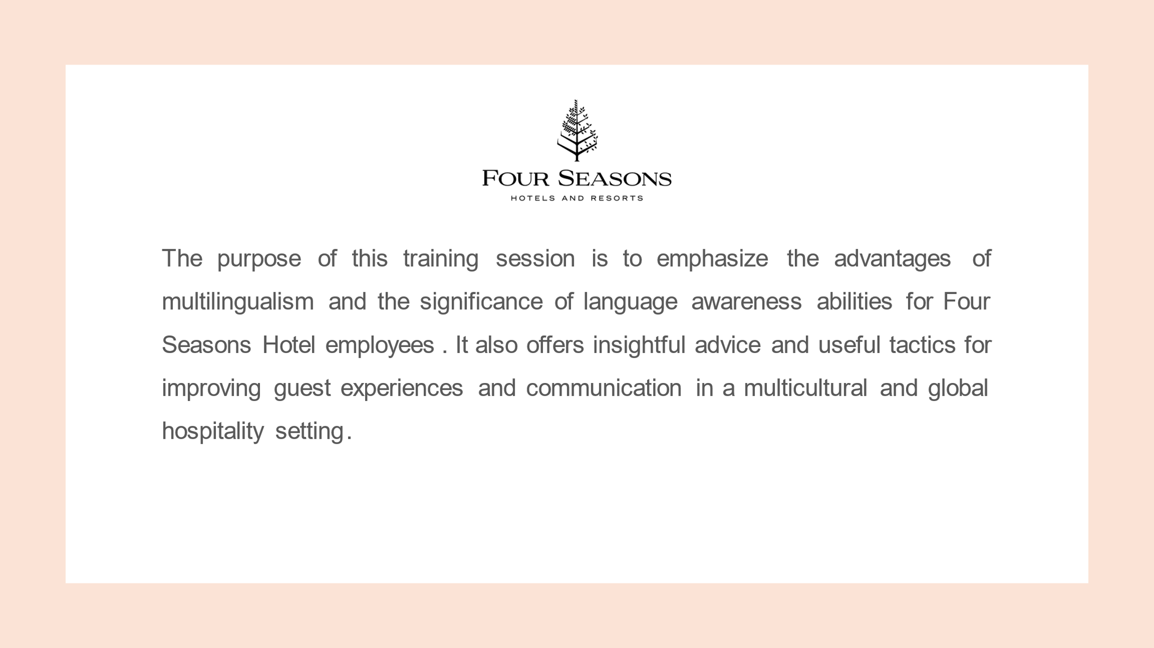



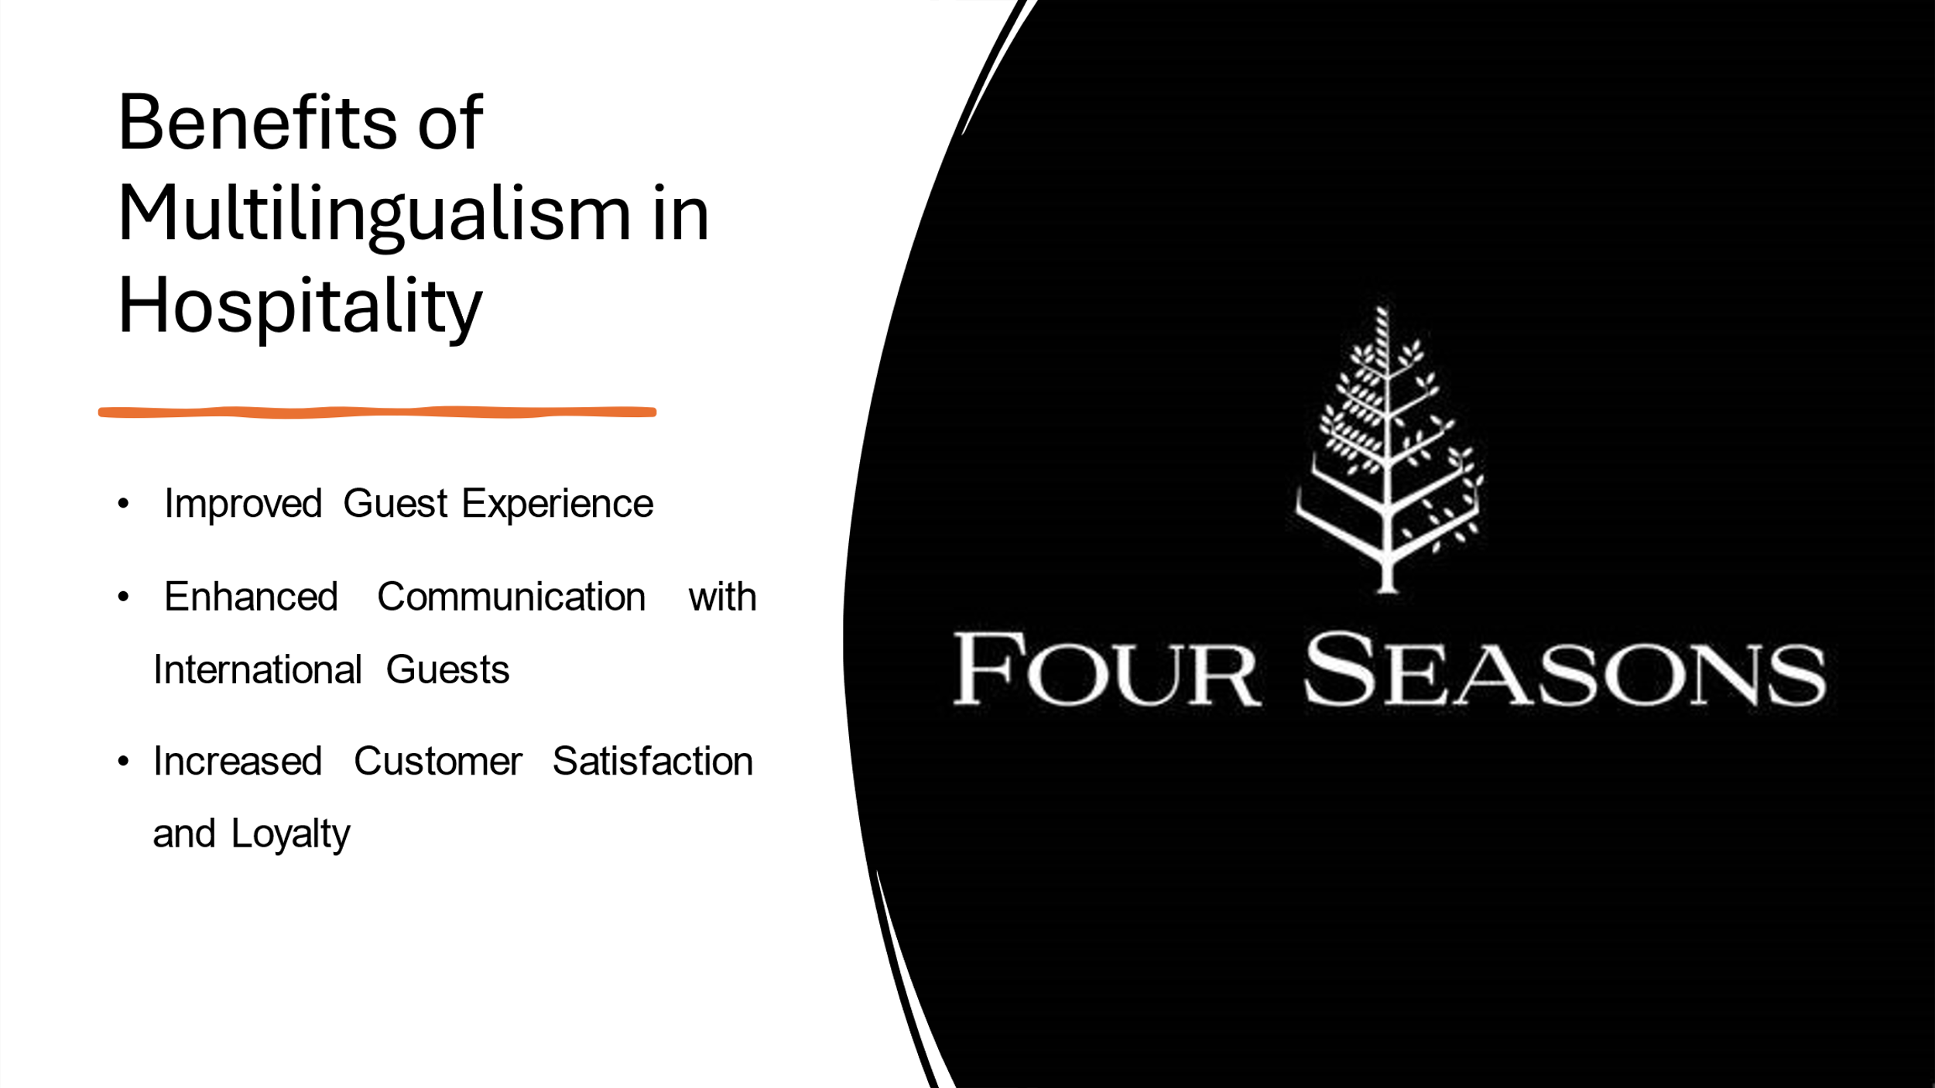

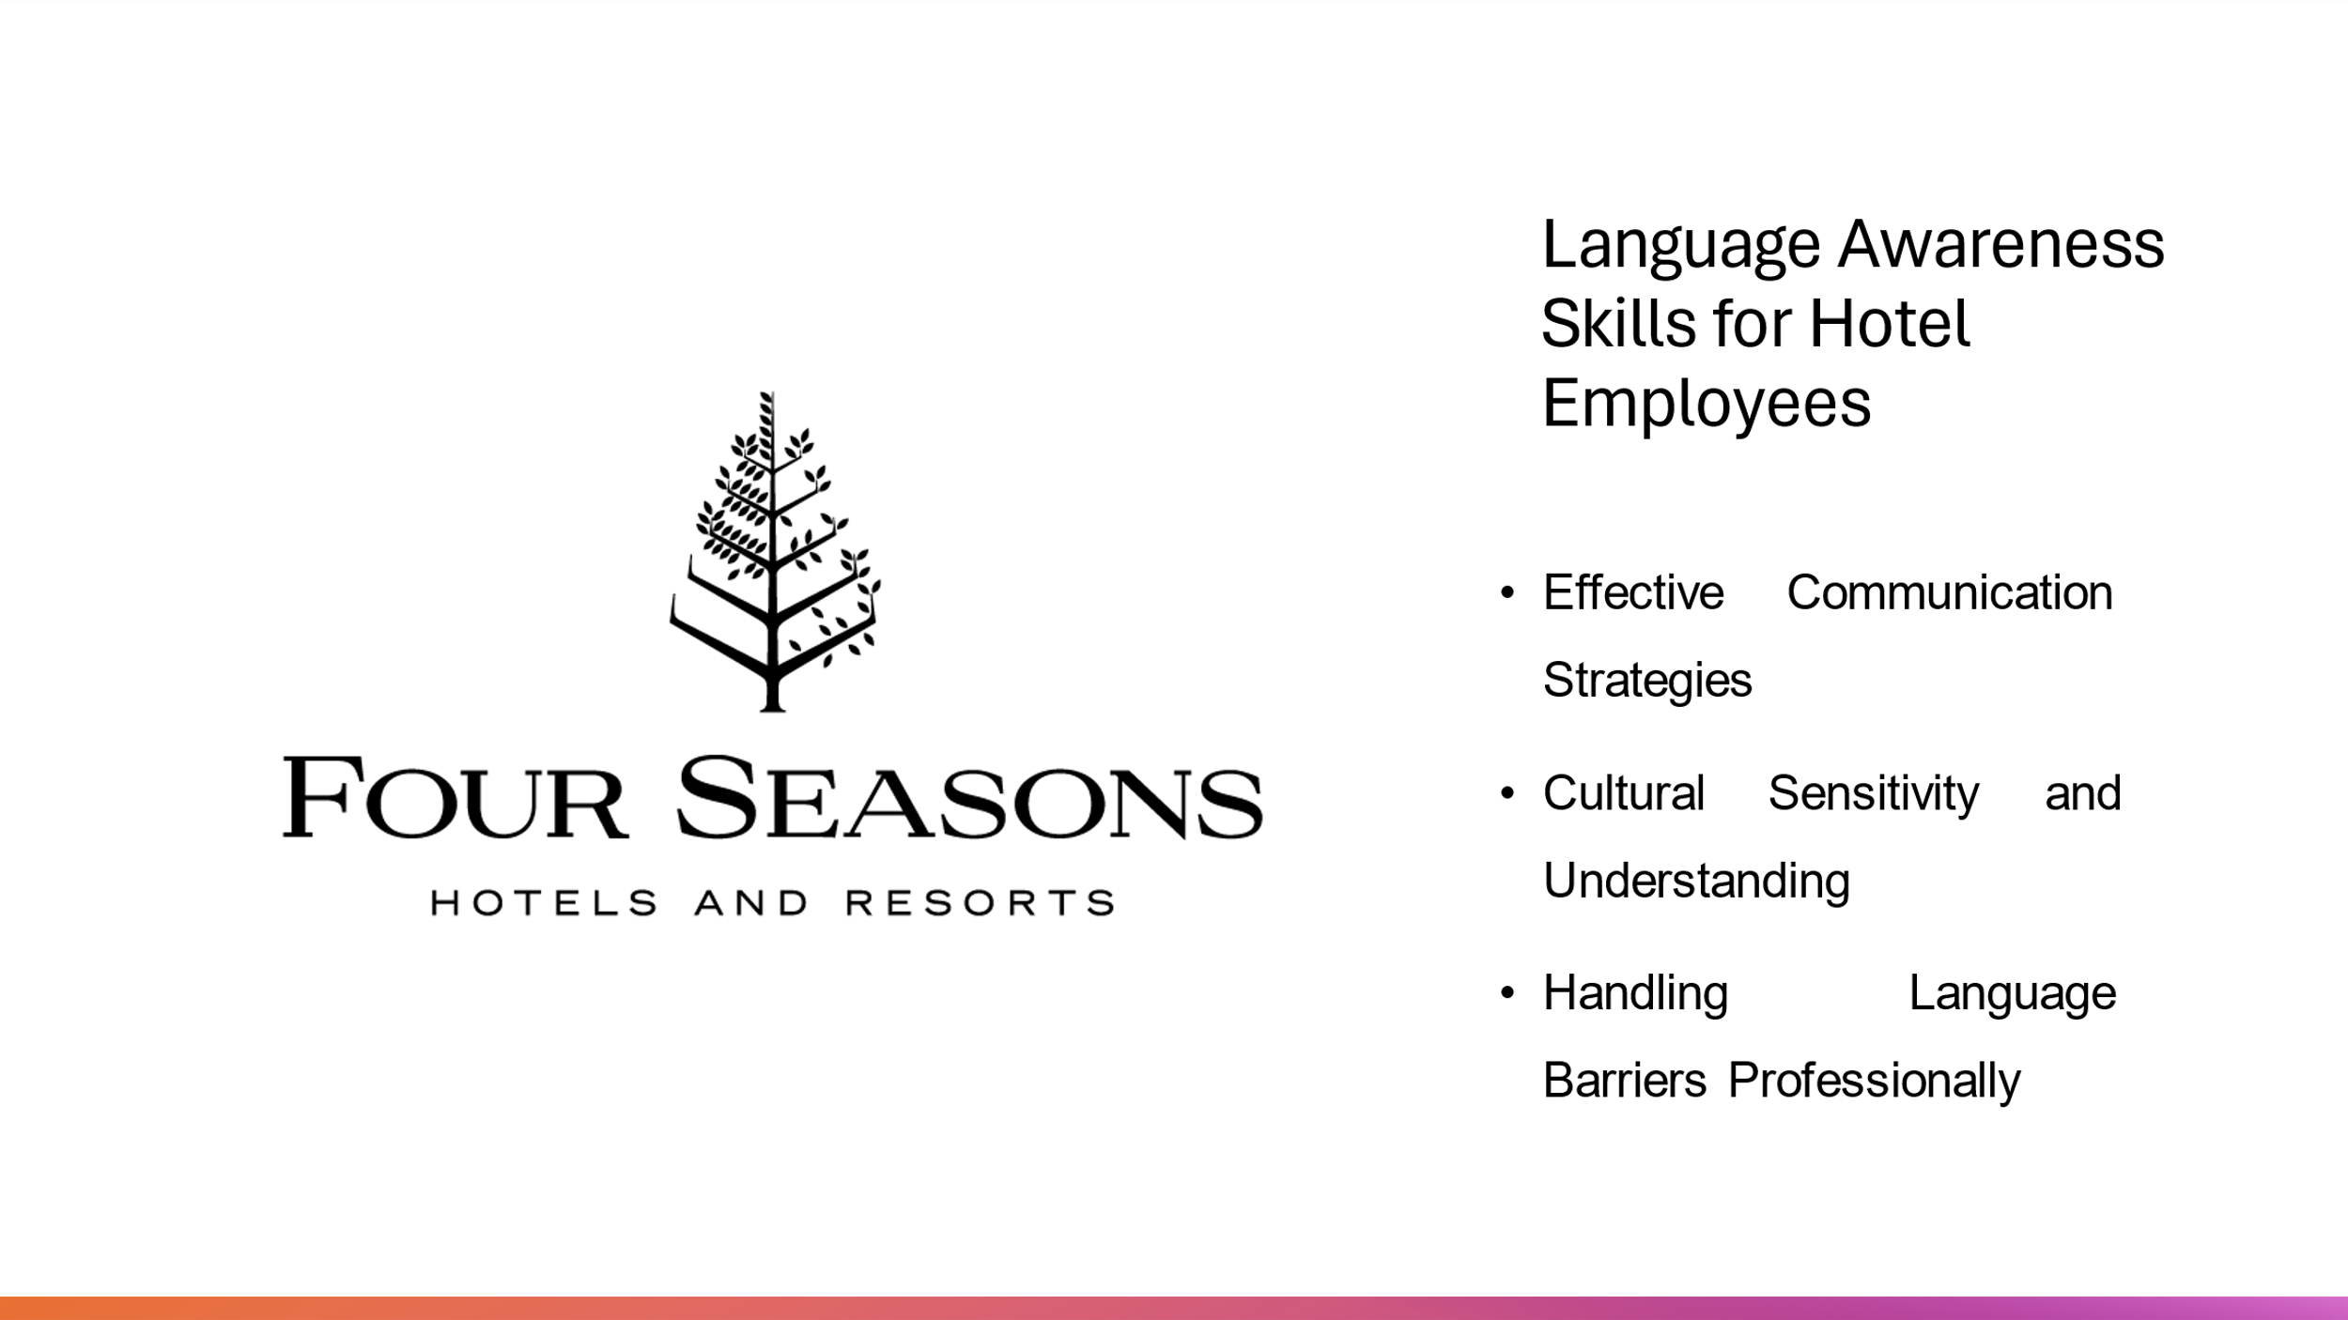



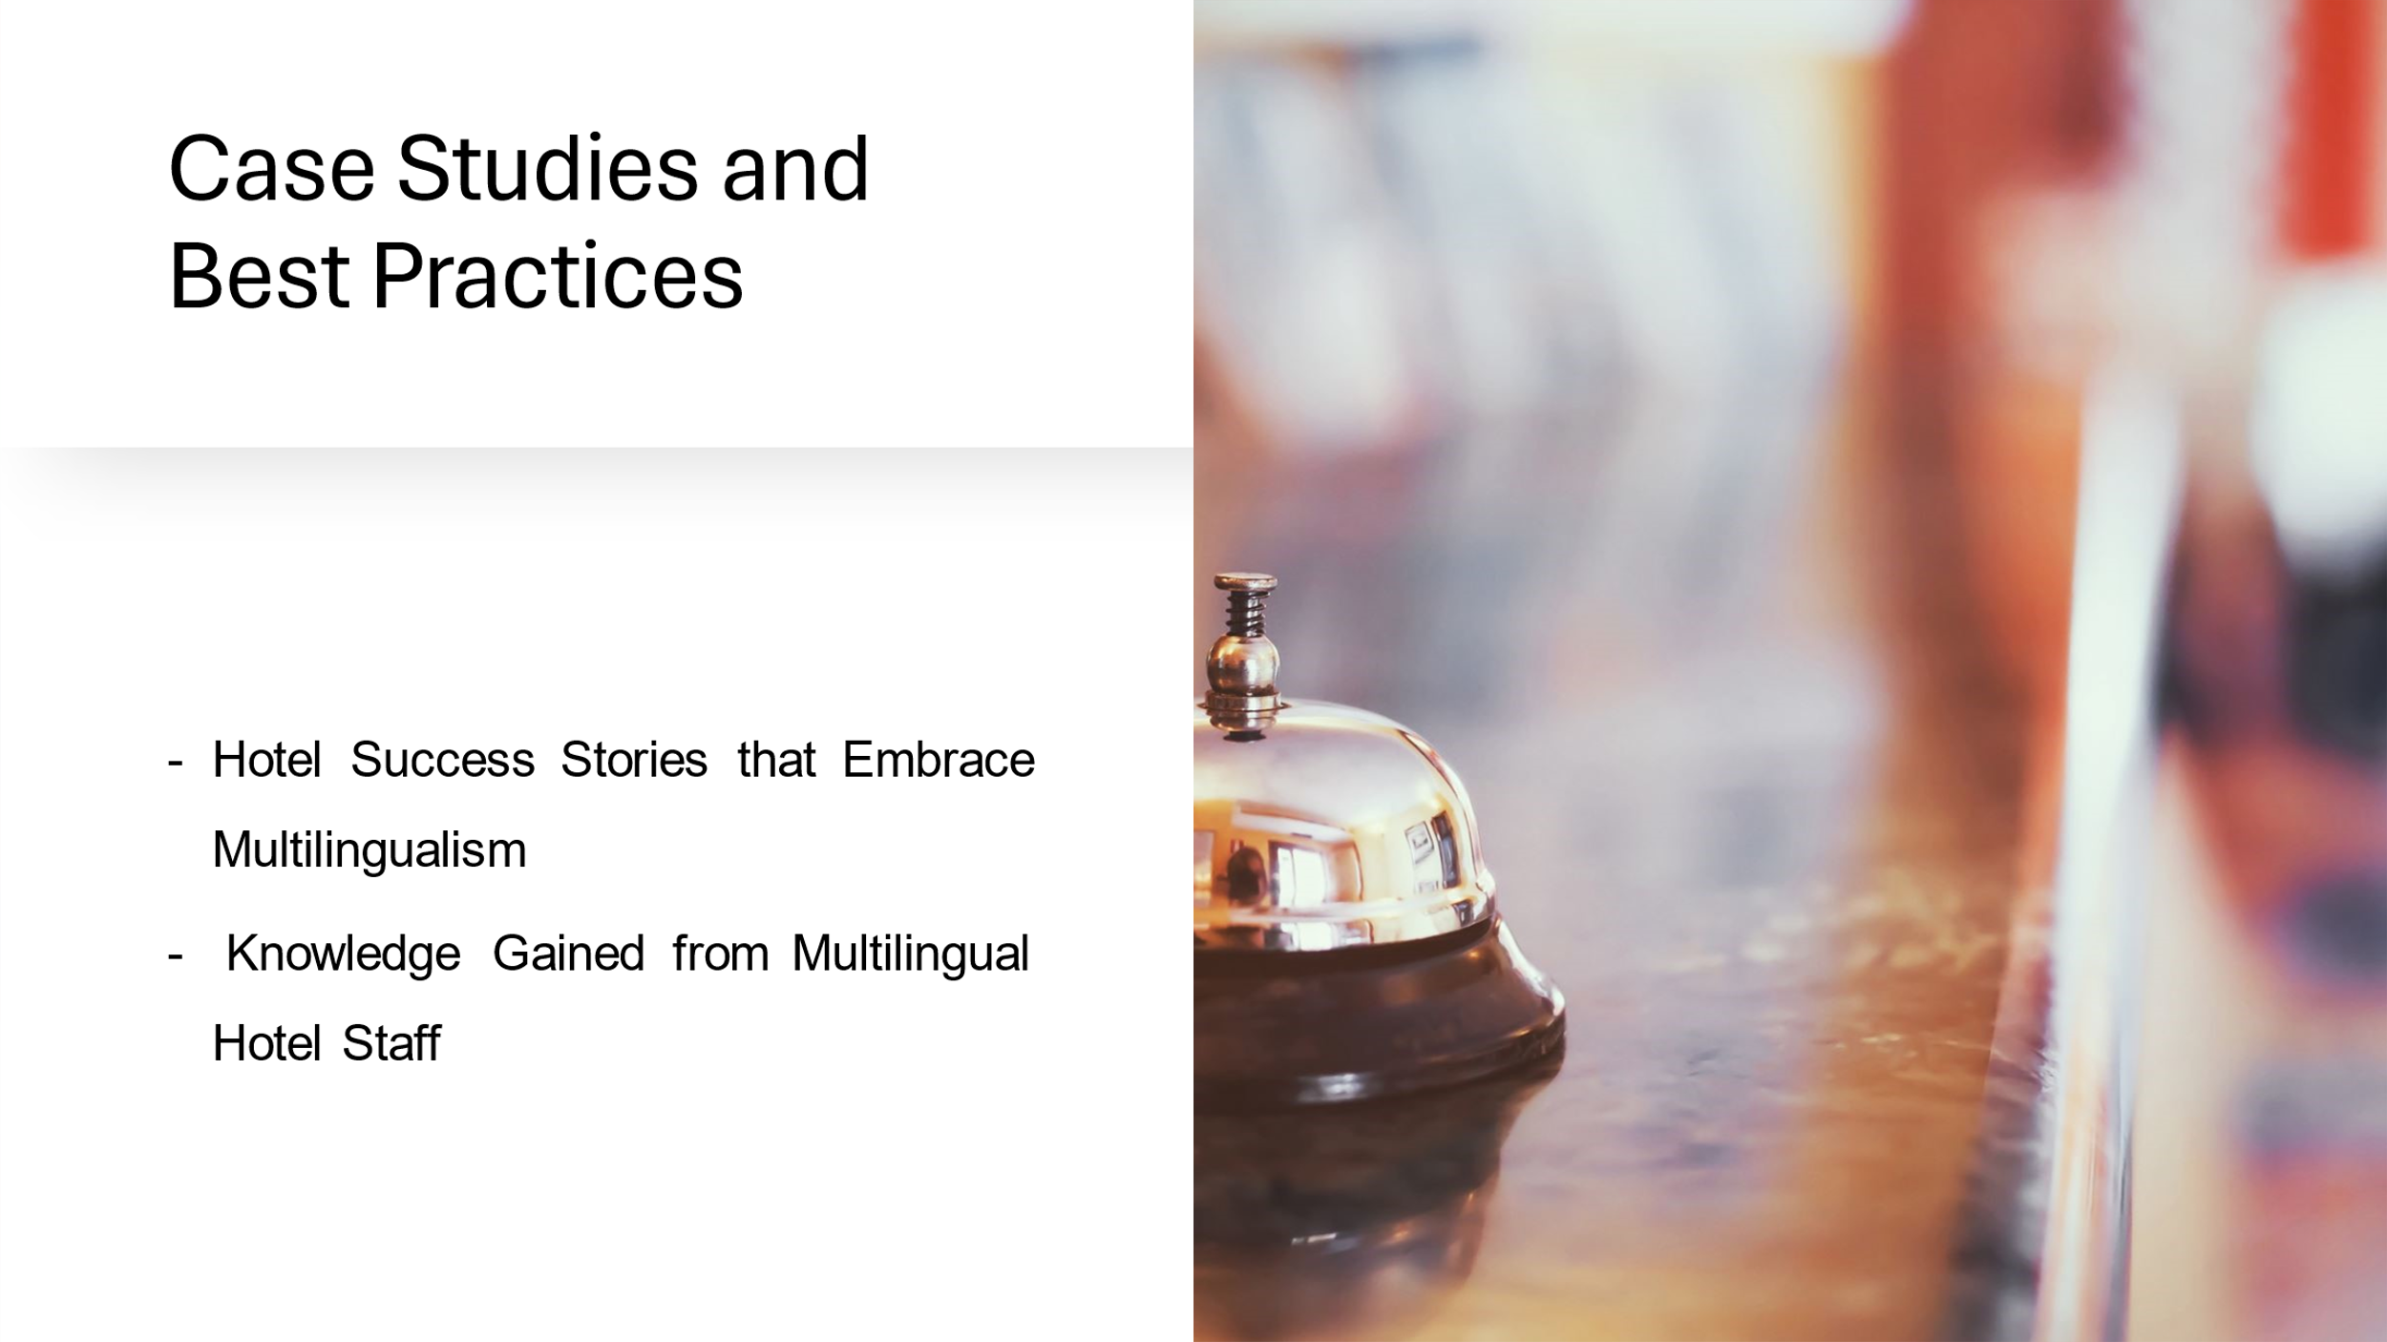

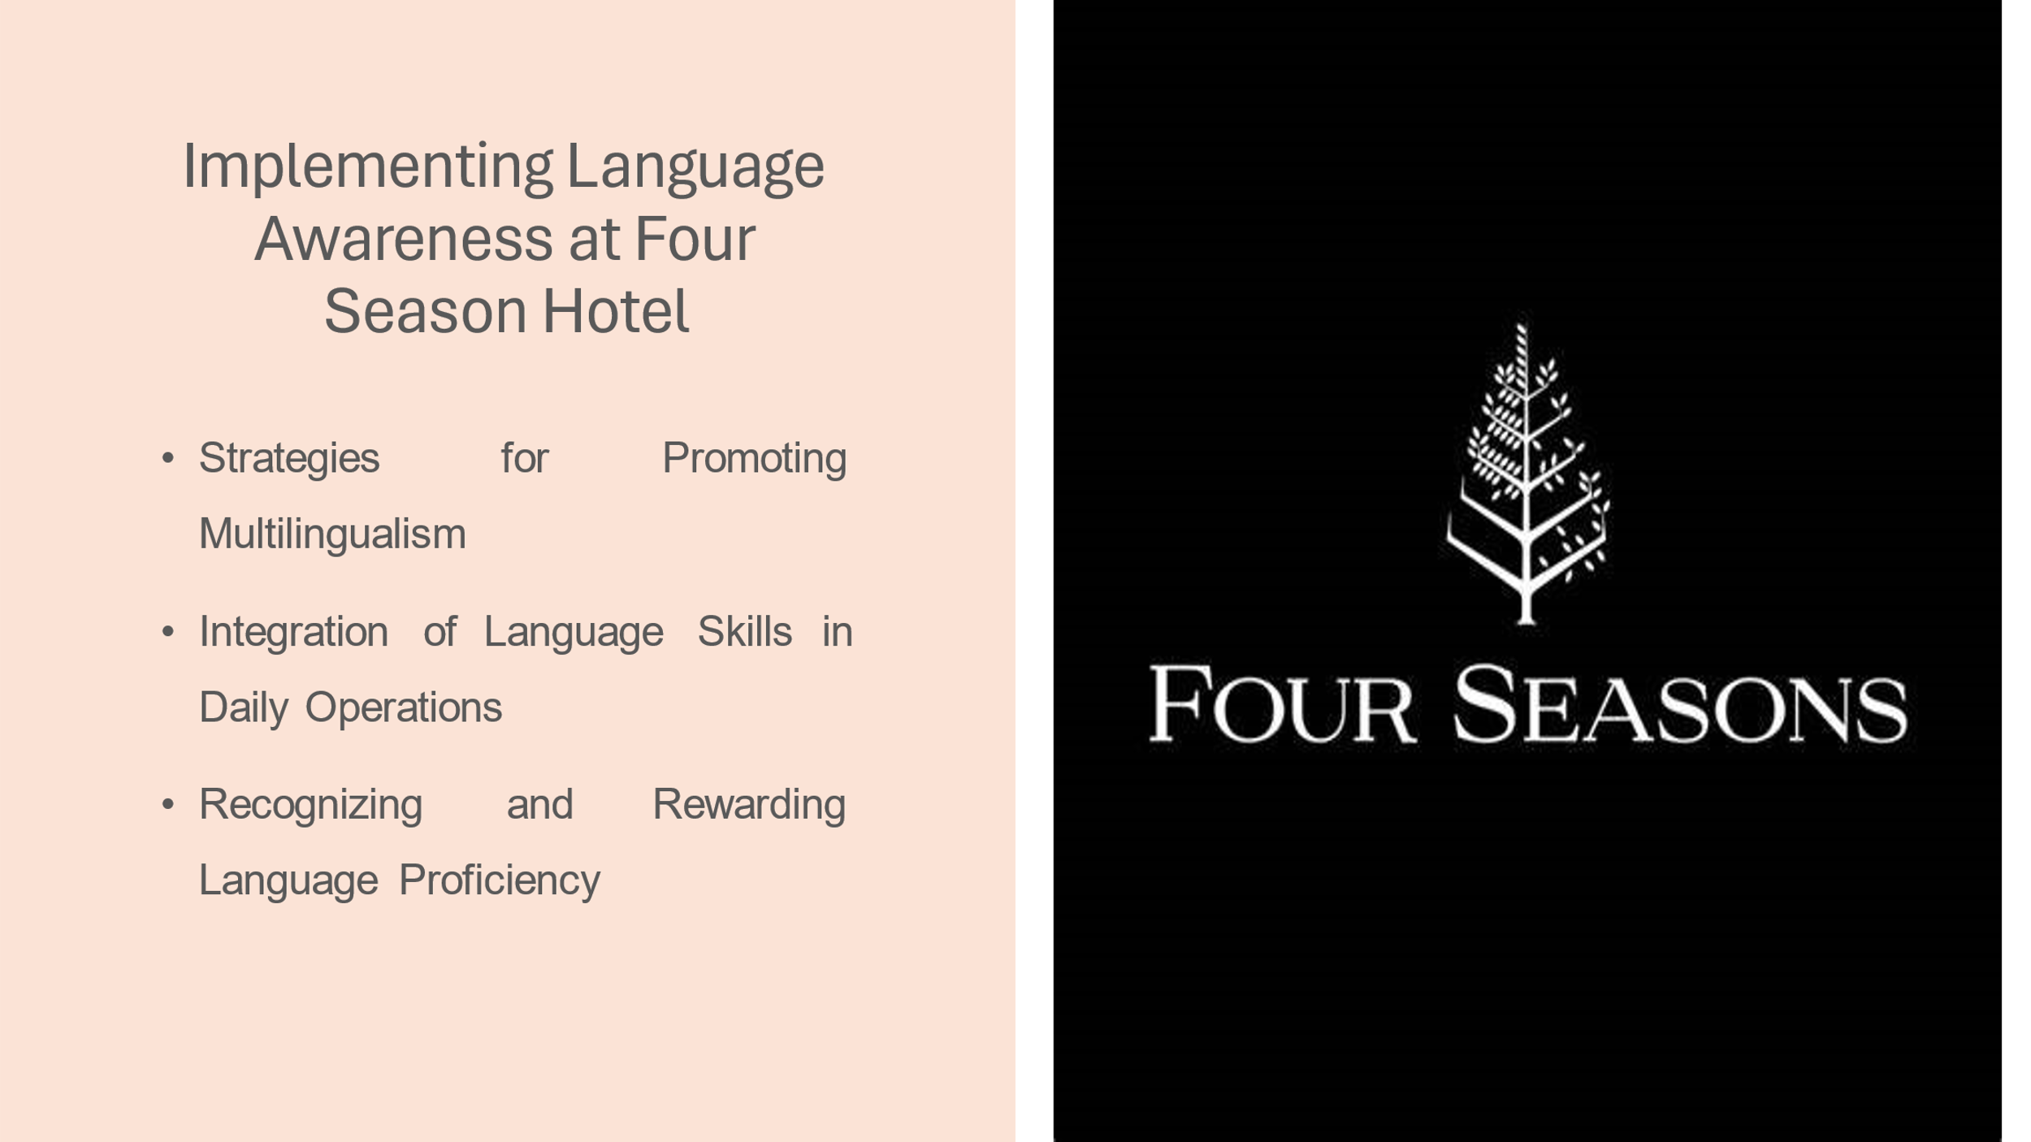

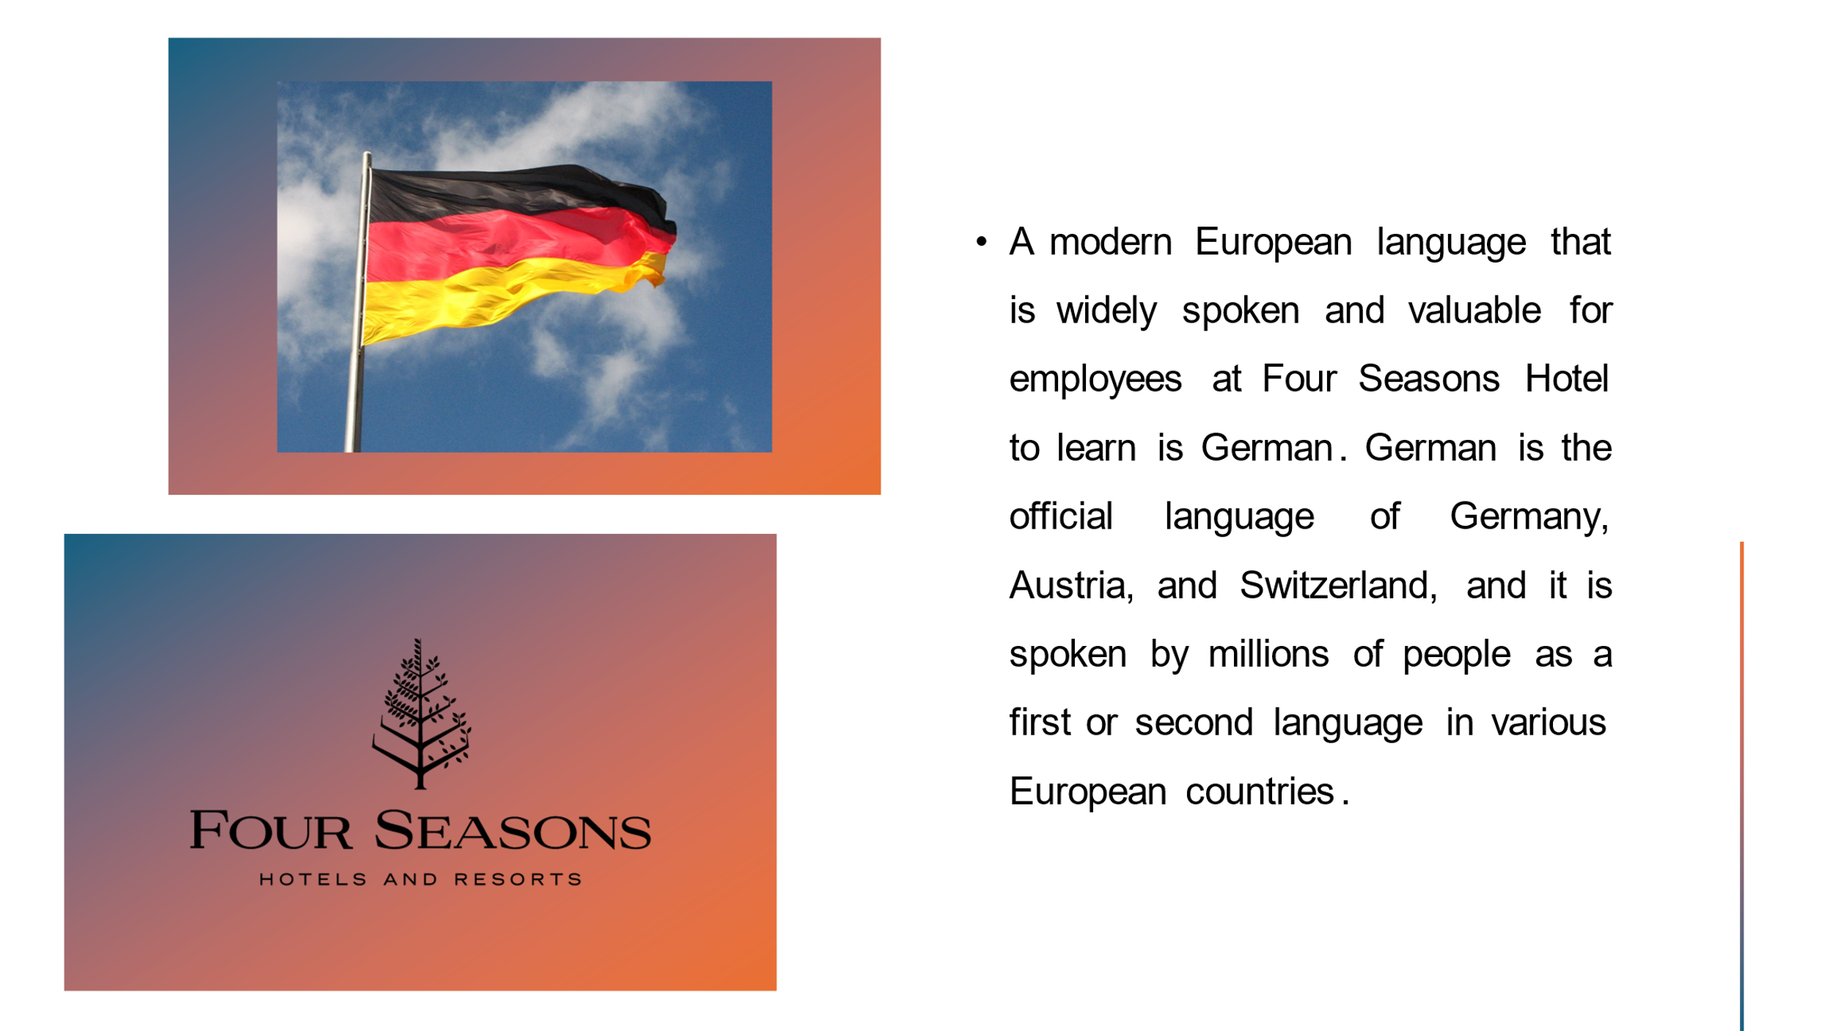

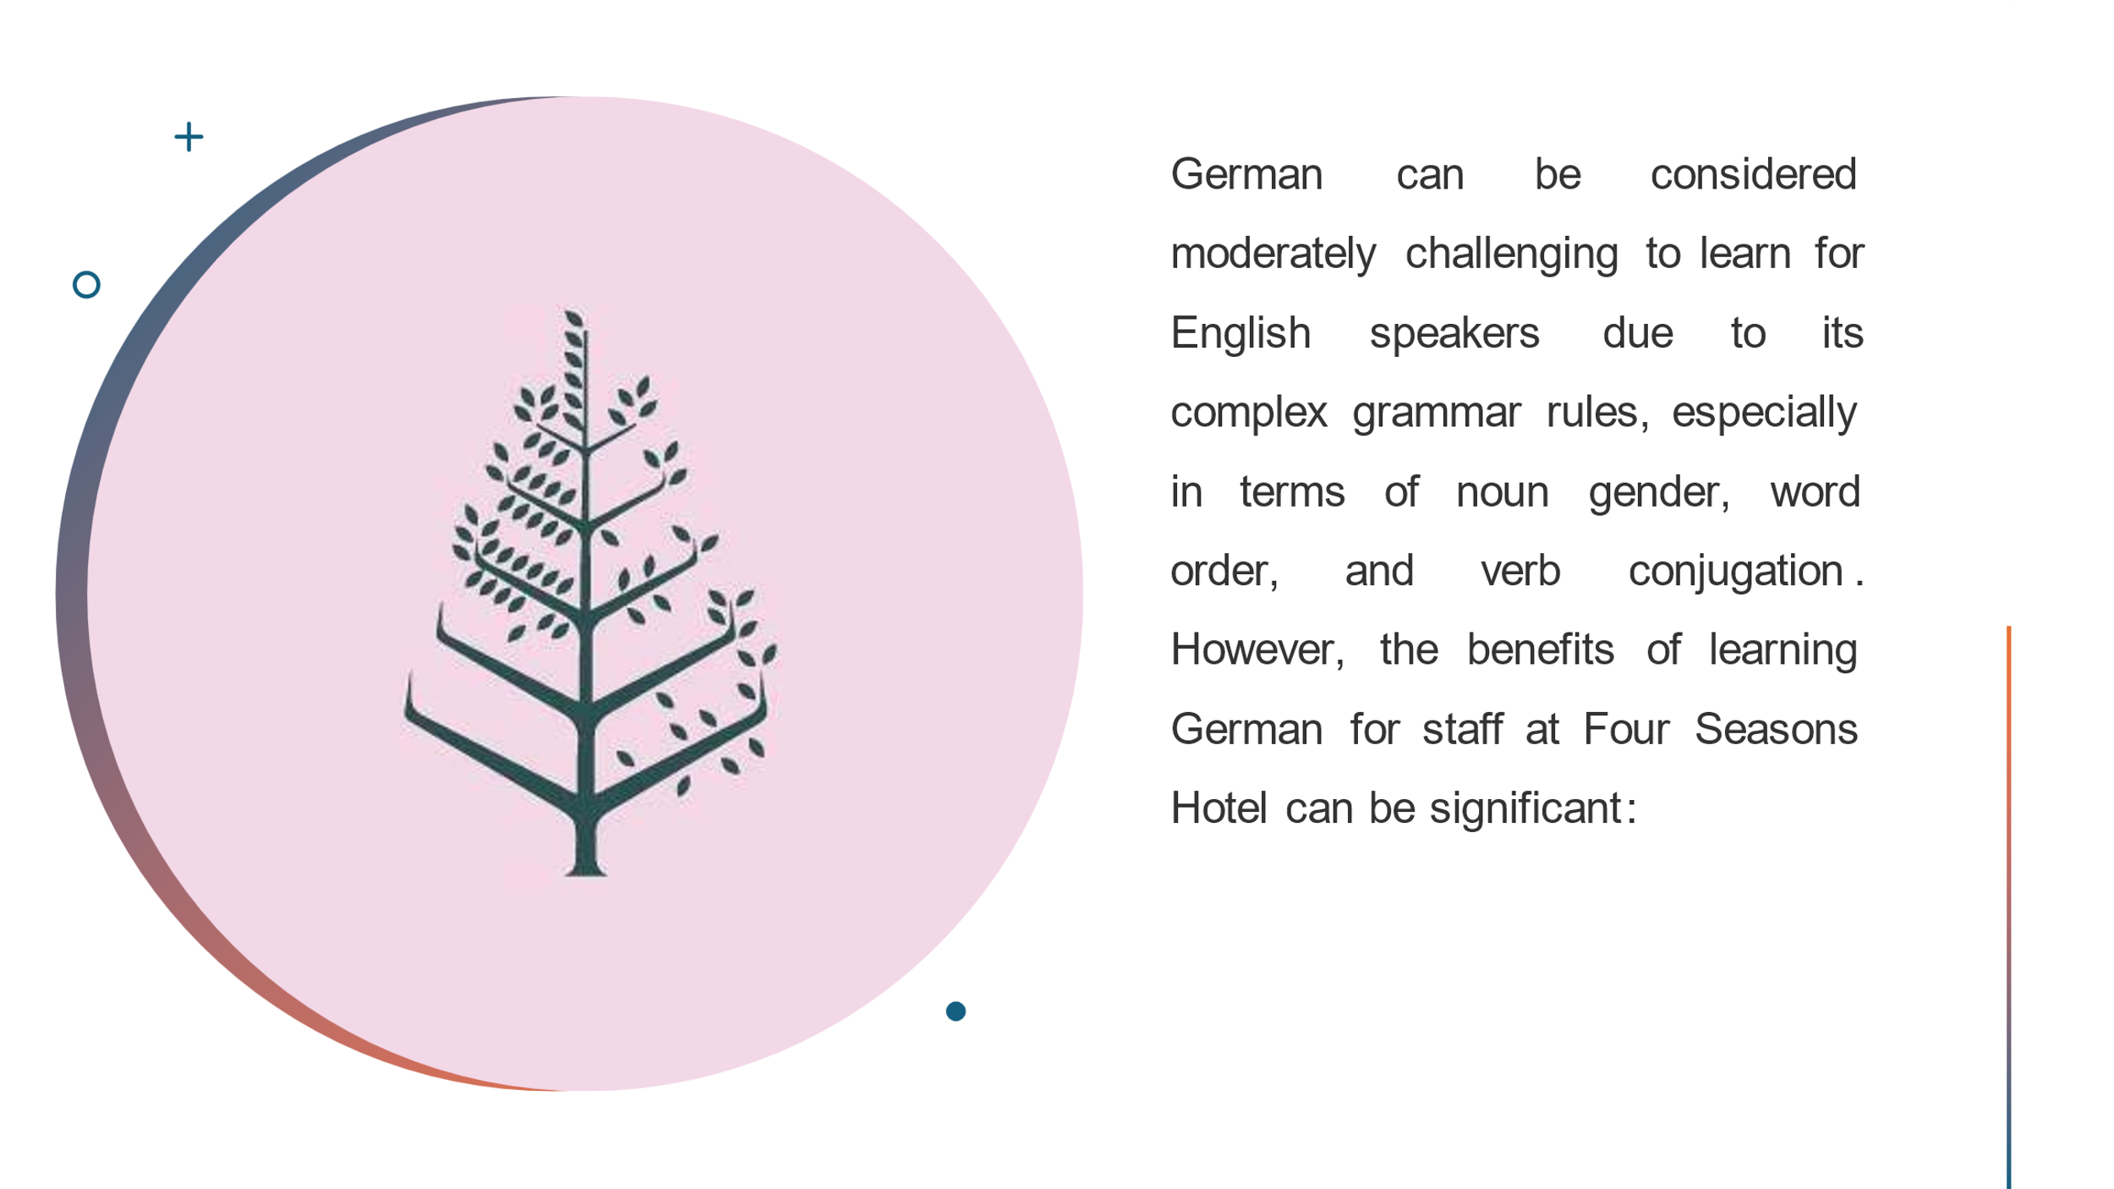

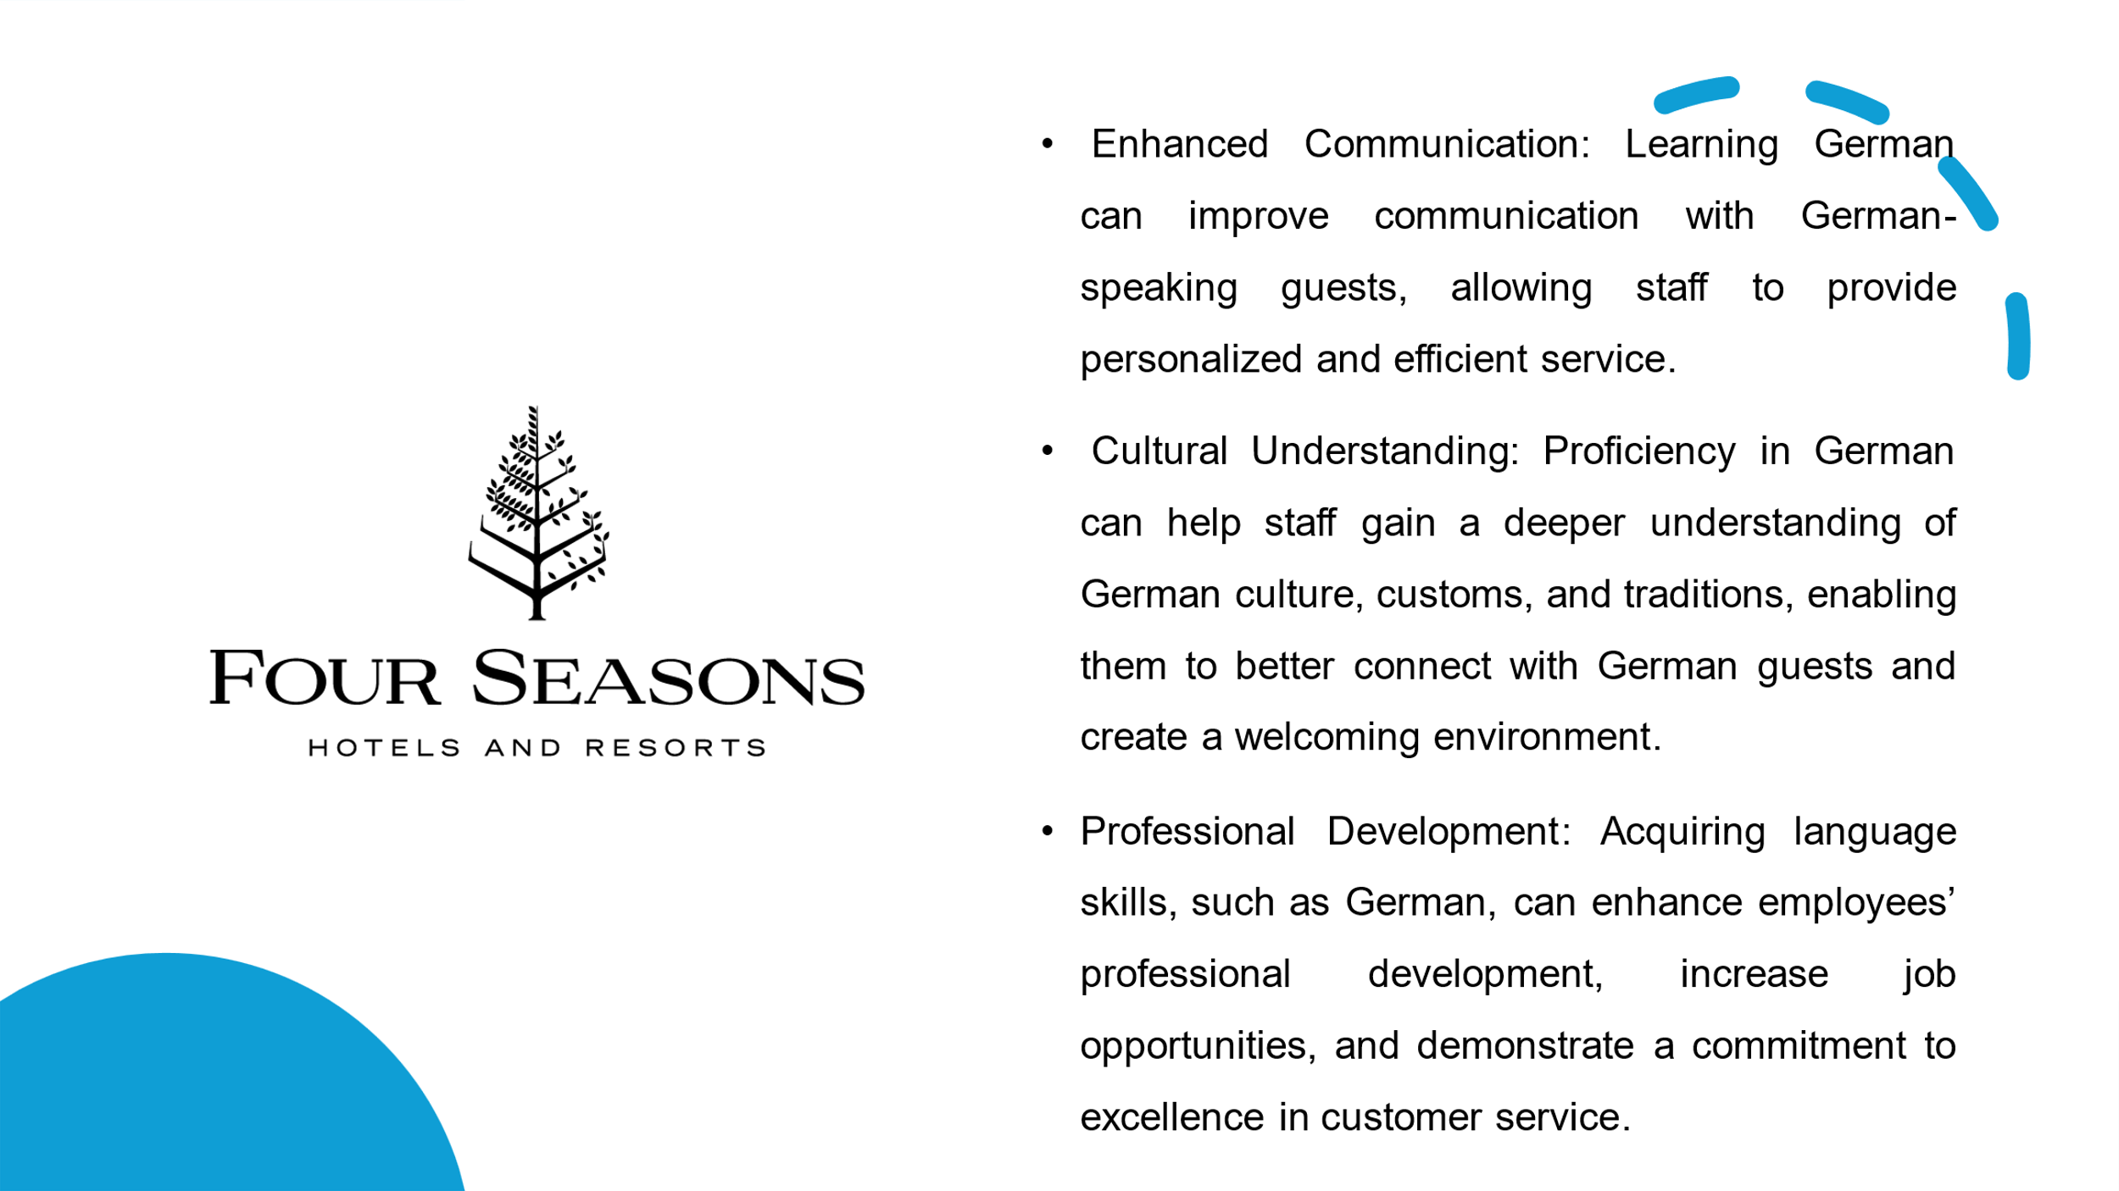

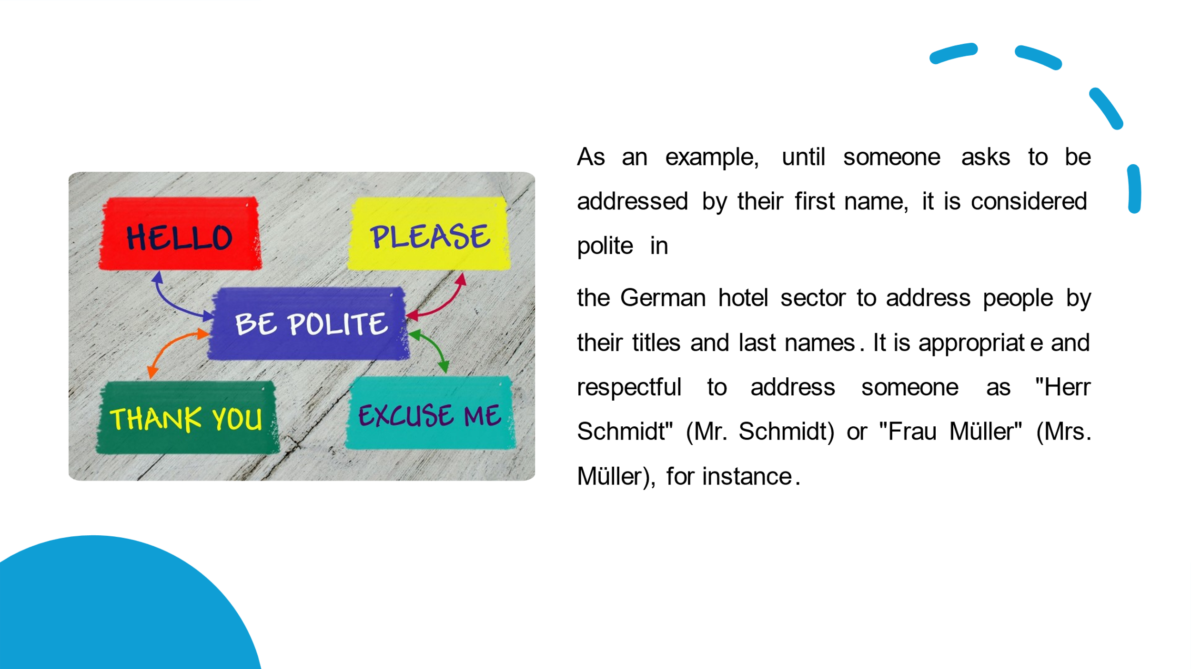

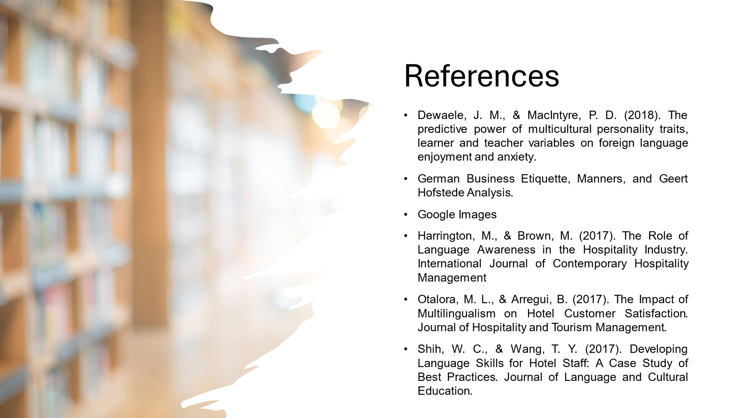

References

- Commisceo Global. German Business Etiquette, Manners, and Geert Hofstede Analysis.
- Dewaele, J. M., & MacIntyre, P. D. (2018). The predictive power of multicultural personality traits, learner and teacher variables on foreign language enjoyment and anxiety.
- Gibbs’ G. (1988). Learning by Doing: A Guide to Teaching and Learning Methods
- Google Images
- Harrington, M., & Brown, M. (2017). The Role of Language Awareness in the Hospitality Industry. International Journal of Contemporary Hospitality Management.
- Juwaheer, T. D. (2018). Assessing the impact of cultural differences on customer satisfaction in the hotel industry. International Journal of Contemporary Hospitality Management.
- Kim, H., & Jogaratnam, G. (2017). Cultural intelligence, emotional intelligence, and cross-cultural service encounters: A study of international hotel managers in the United States. International Journal of Hospitality Management
- Kim, H., & Jogaratnam, G. (2019). Cultural intelligence, emotional intelligence, and cross-cultural service encounters: A study of international hotel managers in the United States. International Journal of Hospitality Management
- Leung, K., Bhagat, R. S., Buchan, N. R., Erez, M., & Gibson, C. B. (2020). Culture and international business: Recent advances and their implications for future research. Journal of International Business Studies
- Li, X., Law, R., Vu, H. Q., & Rong, J. (2017). Examining the relationships between the service performance, satisfaction, and behavioural intentions of casino patrons: The mediating role of service quality. International Journal of Hospitality Management
- Okumus, F., Altinay, L., & Chathoth, P. (2019). Employee responses to cultural diversity: The role of knowledge sharing through social network relationships. International Journal of Hospitality Management
- Okumus, F., Altinay, L., & Chathoth, P. (2016). Employee responses to cultural diversity: The role of knowledge sharing through social network relationships. International Journal of Hospitality Management
- Otalora, M. L., & Arregui, B. (2017). The Impact of Multilingualism on Hotel Customer Satisfaction. Journal of Hospitality and Tourism Management
- Shani, A., & McKenna, S. (2017). Cultural competence in the hospitality industry. Worldwide Hospitality and Tourism Themes
- Shih, W. C., & Wang, T. Y. (2017). Developing Language Skills for Hotel Staff: A Case Study of Best Practices. Journal of Language and Cultural Education
- Wang, L., & King, B. E. M. (2020). The Impact of Multilingualism on Hotel Performance in a Global Context: A Conceptual Framework. Journal of Hospitality Marketing & Management

Component one-professional reflection

