The Feasibility for Lidl to Own Convenience Stores



FEBRUARY 2020

MODULE NAME: organisational consultancy (m6x01422)
Name: hongli shang
Student Number: 1904764

Table of Contents
1.0 Introduction 1
2.0 Project Justification 1
2.1 Aims and Objectives 1
2.2 Rational 2
3.0 Business Case and Project Approach 2
3.1 Benefits to Lidl 2
3.2 Background Literature 3
3.3 Potential Risks 5
4.0 Research Methodology 5
4.1 Primary research 5
4.2 Secondary research 6
5.0 Project Plan 8
Reference 9

1.0 Introduction
Established in 1930s, Lidl is an ambitious grocery retailer based in Germany which opened its first store in 1994 in the UK (Lidl, 2020). As such an industry that is closely relative to people’s daily lives, the competition in grocery retailing industry is intense (MarketLine, 2015). Represented by Lidl and Aldi, hard discounters are taking away the market shares of traditional ‘big four’ in the UK, relying on their low-price reputation and quick expansion (MarketLine, 2015).
Owning convenience stores is considered by several supermarkets as an advisable way to compete with these hard discounters considering those stores make it possible to achieve the satisfying growth under a low-cost path (MarketLine, 2015). These years not only have these convenience stores improved the convenience of shopping, but also boosted the financial growth of the organisations they belong to (Sainsbury’s, 2019; Tesco, 2019).
However, given that the average stores of Lidl are comparatively small compared with the traditional supermarkets (Lidl, 2020) and the potential possibility that prices of items in convenience stores are higher than that in the supermarkets (Mortimer, 2016), whether it is feasible for Lidl to own convenience stores is worthy to be studied and that is what this document focuses on.

2.0 Project Justification

2.1 Aims and Objectives
The overall aim of the project is to determine the feasibility of opening convenience stores for Lidl. To achieve that, there are three specific objectives:
- To provide an overview analysis of the market layout in the sector of supermarket in the UK including main competitors of Lidl.
- To analyse the advantages and disadvantages of owning convenience stores for Lidl and evaluate which side is more valuable.
- To provide targeted suggestions based on the result of the analysis to improve the performance of Lidl in its sector.

2.2 Rational
When it comes the project justification, there are two main fields of significance involved which can be divided into the internal and external reasons.
- Internal- Lidl’s ambition of quick expansion. Having owned 760 stores in the UK, one ambition of Lidl is to open in total of 1000 outlets by the 2023 (Chambers, 2019). Convenience stores are potentially in line with its goal given that with smaller store areas and lower cost, they can boost the expansion of Lidl.
- External- Behaviours of main competitors. Most of its competitors have devoted some parts of their energy to the sector of conveniences stores, for example, among 1428 stores of Sainsbury’s, there are 820 convenience stores and that proportion has been over 55% (Sainsbury’s, 2019). Moreover, one of competitive hard discounters, Aldi, which is also a grocery company based in Germany, has launched another brand called Aldi Local last year (Aldi, 2020). Although the manager denied its desire to expand its business to convenience stores, Aldi Local reflects its interest in increasing its exposure through that way.

3.0 Business Case and Project Approach

3.1 Benefits to Lidl
Lidl has been a growing power in the UK market for decades. With its efforts on efficient service and cheap quality produce, an awareness that low price is not necessarily related to inferior quality has been accepted by its customers gradually (MarketLine, 2015). To grow further, convenience format is expected to bring about the following main benefits to Lidl:
- Achieving the goal of quickly expanding. Given that the area of convenience stores is comparatively small than normal supermarkets and categories of items are limited, it is more convenient for Lidl to increase its exposure so that it can achieve its goal of opening 1000 stores in the UK by 2023 (Chambers, 2019). With a market share of approximately 5.9%, there is still space for Lidl to grow (Lidl, 2020).
- Attracting new customers. Relying on the strategy of cost leadership (Porter, 1985), Lidl is renowned as a low-price retailer. As a result, it is more attractive to frugal customers than other people (MarketLine, 2015). However, convenience stores could attract new groups of consumers such as commuters and those who seek to save shopping time (Gahinet and Cliquet, 2018). Those new customers could become potential opportunities for Lidl to grow sustainably.
- Connecting with more local suppliers. In terms of the whole value chain, the supplier is an indispensable part (Porter, 1985). The spread of convenience stores will allow Lidl to take advantage of the beneficial resources in different places. For example, through selecting the most advantageous suppliers, it could maintain its cost in a low position (Mortimer, 2016).

3.2 Background Literature
Convenience stores refer to relatively small retailing businesses that stock everyday items with longer opening time and shorter cashier lines than traditional supermarkets (Hervert-Escobar et al., 2017). To summarise, there are several main features of those stores:
- Location: The proper choice of location can become a competitive advantage of convenience stores (Wilbard et al., 2018). Proximity determines the frequency of patronage (Gahinet and Cliquet, 2018). As a result, most stores are close to densely populated communities, for example, three Aldi Locals are in Tooting, Kingston and Kilburn of London (Aldi, 2020) which is advantageous to attract potential customers.
- Items: Generally, most types of items in convenience stores belong to daily commodity, such as chilled food and food for tonight (Hervert-Escobar et al., 2017). For example, the sub-brand of Aldi, Aldi Local, does not provide those bulkier items that customers may have difficulty in transporting without a car (Aldi, 2020).
- Area: Given that there is relatively limited choice of items in those stores, they are always not as large as supermarkets. For instance, the average area of Sainsbury’s convenience stores is over 2300 square foot while that figure of its supermarket is approximate 35000 square foot (Sainsbury’s, 2019).
- Opening time: To improve the character of convenience, the opening time of convenience stores are quite long. Taking Tesco Express for example, its opening time is exceeding 16 hours (Tesco, 2020).
According to Association of Convenience Stores (2019), approximate 50,000 convenience stores contributed to over £8.8 billion in Gross Value Added over the last year, generating sales of exceeding £40.3 billion in the UK. With expanding both scale and importance, convenience stores have become an important sector in retailing industry in the UK (Rybaczewska and Sparks, 2020).
When it comes to reasons of prosperity in the convenience sector, socio-demographic factors are significant. For example, with an aging population and a shrinking scale of households, the consumption habits of customers are changing (Rybaczewska and Sparks, 2020). The proximity and time are important factors to accelerate the patronage (Gahinet and Cliquet, 2018). Relying on competitive locations and elaborately selected items, it does not take a long time for customers to find what they want. Moreover, the opening time is long enough to achieve a flexible shopping. Therefore, customers tend to decrease their purchase volumes but visit those stores more frequently (Gahinet and Cliquet, 2018).
The development of convenience stores not only brings about significant advantages to the organisation they belong to but also boosts the local economy. On the one hand, they generally allow the organisation to gain new market shares (Gahinet and Cliquet, 2018; Mortimer, 2016). Moreover, convenience format is capturing more potential customers. The essence of convenience stores is improving the convenience of shopping which is imperative for working people (Gahinet and Cliquet, 2018). Customers have become less sensible to price and the large out of town shop is being less attractive considering time consuming and indulgent trips (MarketLine, 2015) while convenience stores become more popular. On the other hand, it is reported that convenience stores created around 405000 jobs in mainland UK in 2019 and promoted the development of local economy powerfully (Association of Convenience Stores, 2019).
However, there are much pressure put on convenience format which constrains its development. For one thing, these kinds of pressure come from public concern and environmental issues. Given that many items in convenience stores are regarded as unhealthy, such as snack foods, candy and soft drinks (Hervert-Escobar et al., 2017), they are a notorious source of calories which contribute to the obesity especially child obesity that is concerned by public universally (Tran et al., 2019). Furthermore, the environment cost of convenience stores is another issue that cannot be ignored. For example, convenience stores generally have higher Energy Use Intensities (EUIs) than other buildings (Shen et al., 2019).
Correspondingly, increasing environment costs and health concern has brought about regulations in the convenience sector. In terms of public health, some suggests that convenience stores must post calorie information (Tran et al., 2019) while others advocate ‘promoting ready-to-eat fruits in corner stores to children as a price-neutral alternative to calorically dense snacks’ (DeWeese and Orhi-Vachaspati, 2017). Furthermore, the Environment Bill has been re-introduced to Parliament which is regarded as an operational challenge to local shops (Association of Convenience Stores, 2020). Given these potential extra pressure and costs, convenience format may be not so attractive to some retailing organisations to some extent.
For another, the internal costs cannot be ignored. Considering opening early in the morning and closing late at night (Association of Convenience Stores, 2019), the labour cost tends to increase. As a result, the price of items in convenience stores is even higher than that in the supermarket (MarketLine, 2015). Considering the reputation of low price of hard discounters, it is another factor that may influence the decision of owning convenience stores for Lidl.

3.3 Potential Risks
Considering the serious character of decision making and the requirement of adequate and thorough research as well as professional knowledge, there are three main potential risks that are considered in the project.
- Resource risk. It refers to the macro research such as market condition and its developing trend and the micro research, for instance, the performance of convenience format of its main competitors may be not thorough enough.
- Schedule risk. It is such a kind of risk that the schedule made before may be interrupted by potential unknown reasons so that the process of the project may have to be revised.
- Lack of representativeness. Given the limitation of time and location, the primary research could only be conducted in a limited range of communities which would bring about a potential risk of that the representativeness is not enough when it comes to the result of primary research.

4.0 Research Methodology

4.1 Primary research
Primary research usually refers to the involved information needs to be gathered by self-conducted research methodology which determines that it requires a relatively long time to carry out (Bradley, 2010). The primary research of this project will be mainly conducted by the way of questionnaire. The questionnaire will focus on three aspects.
- Public opinions about the most significant advantage when they decide to shop in Lidl. Given that there are several benefits of convenience stores such as proximity and time, this part of questions aims to find the most competitive advantage of Lidl’s potential convenience stores. Moreover, it is also a process of gaining a better understanding of the organisation itself.
- The test of potential failure. This part focuses on measuring the influence of potential disadvantages of convenience stores. For example, considering the price of items is a little higher than that in normal supermarkets, whether consumers would like to pay for a higher price could determine the impact of this factor.
- Public suggestions of an ideal convenience store. Some questions will be offered which aim to understand the expectation of consumers towards a satisfying convenience store, including the type of items, the opening time and the number of check-out machines.
Through analysing the result of recalled questionnaires, a better understanding of the feasibility for Lidl to own convenience stores will be expected to achieve.

4.2 Secondary research
The secondary research always provides basic knowledge on what pertain information had been already compiled by other researchers in the past. Considering there are numerous information, it requires the researcher to identify the relevant sources and apply them properly (Bradley, 2010).
As for this project, first, S.W.O.T Analysis which was developed by Humphrey in 1960s is an eligible tool to carry out an analysis of external and internal environment of Lidl (Madsen, 2016). They stand for strength, weakness, opportunity and threat. Fig. 4-1 displays a rough S.W.O.T Analysis of Lidl.
Second, when it comes to the explanation of advantages and disadvantages of this strategic decision, Porter’s Five- Forces Model and Porter’s Generic Strategies will be applied. The application of these models will be supported with appropriate research from published sources such as journals like Foodservice Research International and Journal of Retailing, organisation websites like Lidl, Aldi as well as other academic sources. Fig. 4-2 indicates the advantages and disadvantages that will be discussed.
Finally, several targeted recommendations according to the result of primary research and the analysis of secondary research will be given in order to promote a better market performance of Lidl.
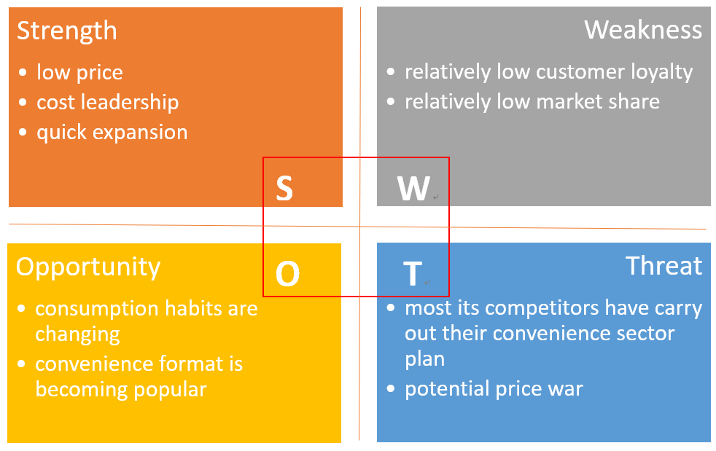
Fig. 4-1 S.W.O.T Analysis of Lidl
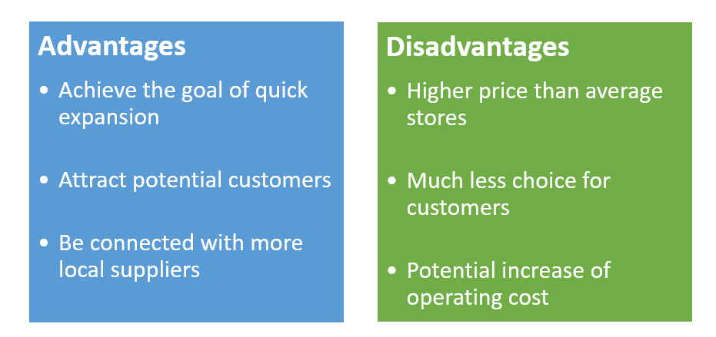
Fig. 4-2 Advantages and Disadvantages of Owning Convenience Stores

5.0 Project Plan
An initial project plan is demonstrated in the Fig.5-1. The plan is divided into three stages and the time span is from 29 January to 8 May.

Fig. 5-1 Initial Project Plan

Reference
Aldi (2020) About us. [Online] Available at: https://www.aldirecruitment.co.uk/about-us/ (Accessed: 21 February 2020).
Association of Convenience Stores (2019). The Local Shop Report 2019. https://www.acs.org.uk/sites/default/files/acs_local_shop_report_2019.pdf (Accessed: 21 February 2020).
Association of Convenience Stores (2020). ACS: Environment Bill Must Account for Local Shops and Communities. https://www.acs.org.uk/news/acs-environment-bill-must-account-local-shops-and-communities (Accessed: 21 February 2020).
Bradley N. (2010). Marketing research: tools & techniques 2nd ed., Oxford: Oxford University Press.
Chambers S. (2019) Lidl to open 230 stores in challenge to big four supermarkets - German discounter to accelerate the pace of expansion. The Times, 10 November [Online] Available at: https://www.thetimes.co.uk/article/lidl-to-open-230-stores-in-challenge-to-big-four-supermarkets-h9gqggwkv (Accessed: 20 February 2020).
DeWeese R. S. and Orhi-Vachaspati P. (2017). Cost of Children's Healthy vs Unhealthy Snacks Does Not Differ at Convenience Stores. Journal of Nutrition Education and Behavior. 49(3). pp. 241-243.e1
Gahinet M. and Cliquet G. (2018). Proximity and time in convenience store patronage: Kaïros more than chronos. Journal of Retailing and Consumer Services. 43(2018). pp.1-9.
Hervert-Escobar L., Esquivel-Flores O. A. and Ramirez-Velarde R. V. (2017). Optimal pricing model based on reduction dimension: A case of study for convenience stores. International Conference on Computational Science. 108(2017). pp.2079-2089.
Lidl (2020). About Us. [Online] Available at: https://www.lidl.co.uk/about-us (Accessed: 19 February 2020).
Madsen D. Ø. (2016) SWOT Analysis: A Management Fashion Perspective. International Journal of Business Research, 16(1), 39-56, 2016.
MarketLine (2015). The Big 6 UK Food Retailers - How supermarkets are responding to the discounter threat. Available at: https://advantage-marketline-com.ezproxy.uwtsd.ac.uk/Analysis/details/the-big-6-uk-food-retailers-how-supermarkets-are-responding-to-the-discounter-threat-29268 (Accessed 22 February 2020).
Mortimer (2016). Big retailers are realising the risk of moving into convenience stores. https://eprints.qut.edu.au/97896/2/97896.pdf (Accessed: 21 February 2020).
Porter M. (1985). Competitive advantage- Creating and Sustaining Superior Performance. Free Press, New York.
Rybaczewska M. and Sparks L. (2020). Locally-owned convenience stores and the local economy. Journal of Retailing and Consumer Services. 52(2020). pp.1-7.
Sainsbury’s (2019). Annual Report and Financial Statements 2019. [Online] Available at: https://www.about.sainsburys.co.uk/~/media/Files/S/Sainsburys/documents/reports-and-presentations/annual-reports/sainsburys-ar2019.pdf (Accessed: 20 February 2020).
Shen H., Xu K. and Freihaut J. (2019). A statistical study on energy performance of U.S. convenience stores: Investigation of factors and bench marking on store energy use. Energy and Buildings. 183(2019). pp.792-802.
Tesco (2019). Annual Report and Financial Statements 2019. [Online] Available at: https://www.tescoplc.com/media/476422/tesco_ara2019_full_report_web.pdf (Accessed: 20 February 2020).
Tesco (2020). Store Locator. [Online] Available at: https://www.tesco.com/store-locator/uk/ (Accessed: 21 February 2020).
Tran A., Moran A. and Bleich S. N. (2019). Calorie changes among food items sold in U.S. convenience stores and pizza restaurant chains from 2013 to 2017. Preventive Medicine Reports. 15(2019). pp.1-6.
Wilbard J. G., Mbilinyi B. D., Maliva N. S. and Mkwizu K. H. (2018). Is Location a competitive advantage on retail convenience shopping? International Journal of Research & Methodology in Social Science.4(2). pp.15-26.

