Discuss how Richard III as portrayed by Shakespeare and the Tudors, differs from his modern day portrayal.

Introduction
Richard III was considered to be the last Plantagenant king, born in 1452 and died at the battle of Bosworth in1485 after reigning as king for twenty six months. The English crown passed to Henry VII who was the first king of the Tudor dynasty. Richard was and still is widely thought to have murdered two of his nephews in The Tower of London (one of which was to be the next King )while he was their protector, in order to take the crown. This legend has passed down through the ages with the help of Shakespeare’s play The Tragedy of Richard III. which depicted him as a monstrous, deformed and wicked man. This myth continued for almost five hundred years until in 1924 the Richard III society was formed, stating that it believed that much of the traditional accounts of his character and career were not supported by sufficient evidence and that they aimed to promote research of his life and career. Since then there have been more sympathetic views published, first in 1951 was Josephine Tey’s Daughter of Time and then many other books from different authors followed. There have been documentatries, videos and court cases all trying to prove his innocence in regards to the killing of the princes and his profile was brought to the forefront when his bones were discovered under a carpark in Leicester and re-interred in the Cathedral in 2015.

Shakespeare’s Richard.
Sir William Shakespeare, playright, poet and actor, lived during the Tudor dynasty 1564-1616. He has been proclaimed as the greatest and most influential writer of the English language . Richard III and all three parts of Henry VI were his first recorded works probably written in 1590’s. He wrote nine plays about kings but it is believed he never intended for them to be accurate historical dramas . Richard III is based over a period of seven years as he moves from his role of Duke of Gloucester towards kingship and therefore is a compressed timeline with some invention of events. The play opens with a speech by Richard as Duke of Gloucester who ably sets the scene of what type of man he is.
‘I, that am rudely stamped ,and want love’s majesty To strut before a wanton ambling nymph; I, that am curtailed of this fair proportion, Cheated of feature by dissembling Nature, Deformed and unfinished, sent before my time Into this breathing world,scarce half made up, And that so lamely and unfashionable That dogs bark at me as I halt by them-‘
As can be read, he has described himself as a grotesque man and it was a known fact that anyboby who had a physical deformity in Tudor times were thought of as evil therefore from Shakespeare’s first page he is being depicted as unpleasant .
It is known that Shakespeare obtained his knowledge of history from the writings of historians such as Sir Thomas More and John Rous. Both lived during the reign of Richard Duke of York although More had only been seven when the Battle of Bosworth was fought. Rous had been known to write of Richard as a good lord during his reign but once Henry Tudor was on the throne he altered his stance, claiming that Richard had been in his mother’s womb for two years and had been born with a full set of teeth, hair to his shoulders , a humped back and rt shoulder higher than left ,These embellishments may have been partly true but were probably greatly exagerated over the years. The histories from Rous were full of double negatives therefore any positives about his character were lost in translation and More’s analysis was definitely biased against him. On writing his play, Shakespeare would have been aware that his sources were few but he was able to use his imagination to fill in the gaps while claiming not to be an historian, but a dramatist, wanting to amuse while moderately educating his audience .
During the play , Richard is blamed for facillitating the killing of Henry VI, Duke of Clarence (his brother),Edward of Lancaster, Anne his wife and Edward and Richard his nephews, the two princes. These accusations against Richard remained for over four hundred years with no-one in the first instance to put his case forward as nobody wanted to be seen to be supporting him which may have resulted in forfeiting of their lands and rights. Then as time went on, even though it was no longer used as a propaganda tool, the myth remained. In the meantime Shakespeare’s play became the people’s history with Richard being made the wicked humpbacked tyrant uncle who killed his innocent nephews in order to gain the crown .
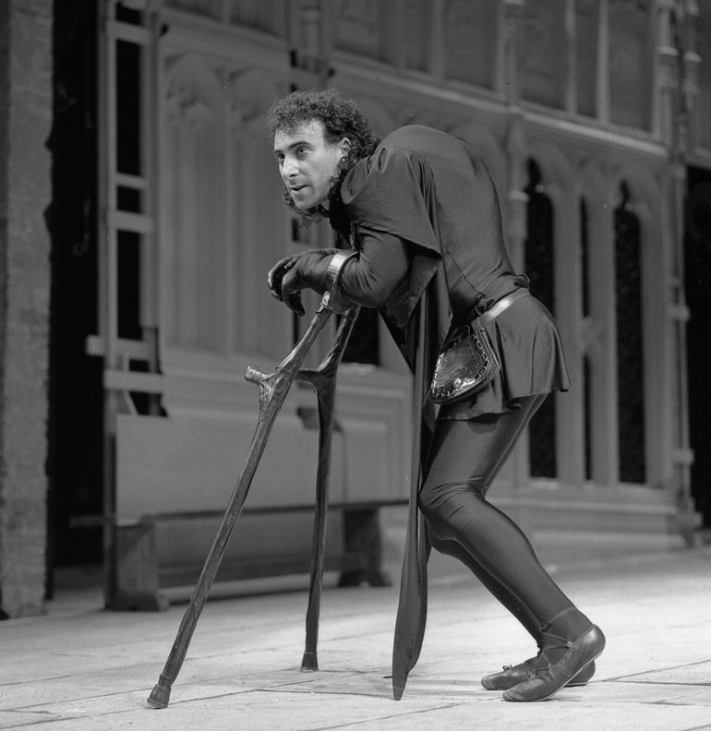
In

Anthony Sher as Richard III RSC 1984

T

202020

20th Century Richard.
In 1924, The fellowship of the White Boar was created which later became Richard iii Society. It was launched to promote research into his life, confident that it would reveal a different profile as that portrayed by the Tudors. There came to be a growing number of people who thought that there must be more to the myth of Richard III and members of the society came to be known as Ricardians. Two books,The Daughter of Time by Josephine Tey, written in 1951, a novel of an informal police investigation into the alleged murder of the Princes in the Tower, plus the biography of Richard III by Paul Murray Kendall in 1955 created a more sympathetic profile and thus started the ball rolling to bring him to a wider audience, becoming a household name and even developing into a romantic figure.
As more research was carried out, it came to light that Richard who had been Lord of the North while his brother Edward IV was on the throne, had been seen to work hard all his adult life courting popularity with charisma and a sharp wit. He was also considered to be courageous, daring and a good warrior which would have been difficult if he had been so severely handicapped as portrayed by Shakespeare. He was a successful governor championing equitable justice which continued during his kingship. He was capable of being sympathetic and generous and was reported to have refused expensive gifts from townsfolk while travelling. He was exceptionally loyal to his brother Edward who granted him commissions on nine counties and had been made Admiral and Constable of England in 1469. When Edward died unexpectedly in 1483 he was made Lord Protector of the twelve year old King Edward V and his younger brother Richard, his nephews. However, before Edward could be made king, Richard declared that he had been born illegitimate and that he could not become King, therefore Richard was to be crowned instead. Contrary to the myth created by the Tudors that Richard was a power crazy tyrant, it is thought that he was forced to take control and, like his brother in the past, act swiftly and boldly, to avoid control of the new king being taken by the Woodville family (the child’s maternal uncles). When the children who had been housed in the Tower of London were not seen again after Richards coronation in 1483, rumours that Richard had had them murdered commenced. It is thought that these may have been started in France as they were worried that Richard may invade them thus it was in their interest to cause trouble. After Richard was killed at the Battle of Bosworth in 1485 and Henry was made King, the rumours about the princes were allowed to run riot. There were no eyewitnesses to tell of their fate and because Richard’s reign had been so very short, there was very little contemporary history written. Henry VII never formally accused of him of having the princes murdered and merely made vague accusations. After battles, it is the victors that write the history and in fact it is stated that Richard was possibly the original victim of fake news.
Portraits of Richard that had been painted shortly after his death and showing him to have unequal shoulders, narrowed eyes and a thin cruel mouth , were examined in 1950 and again in 1973 and found to have been radically doctored from the original painting which was probably more normal looking. This again was thought to be evidence of Tudor propaganda especially as this picture and other copies would have been kept in the royal collections for all at court to view.
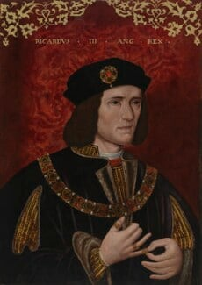Richard 3rd – artist unknown.

Of the six major crimes Richard was accused of by Shakespeare, four, namely the murders of Henry IV, Clarence, Anne and Edward of Lancaster, have definitely been found to be untrue, with the remaining two unable to be proved. In 1984, a televised trial was staged with a Judge, QC’s and jury- the subject being whether Richard III killed the princes in the tower. It was to be based on the probability of him being the murderer, but he was found to be not guilty.
In 2012 his profile again was raised when Philippa Langley. a Ricardian, instigated a quest to find his body which was to be discovered in a crude grave under a carpark in Leicester, formally part of a priory. After his bones were exhumed, extensively examined and analysed, it was confirmed beyond reasonable doubt that they belonged to Richard III, even demonstrating his scoliosis which rendered some of the early commentaries of him having one shoulder higher than another as possibly true although some say it would have been barely discernible. He was reinterred in Leicester Cathedral in 2015, his coffin having passed by 35,000 people and following a twenty one gun salute (highest honour rendered). Since then, there have been many films, documentaries and books written about him, again all showing him in a more positive light.
Another new project launched by Philippa Langley is The Missing Princes project which is looking at evidence into what happened to the princes after disappearing from sight in 1483. In 2023 a further documentary was made where new evidence came to light indicating that the princes were not murdered but were sent abroad and in fact both launched attacks to regain the crown with support from Richard’s sister in France. With all the research that has been and is being accomplished, the quest continues to try to improve Richard’s reputation and to clear his name.

Conclusion.
Richard III died in 1485 having only been on the throne for two years, giving him no time to prove whether he would have been a good king or not. He was beaten in battle by Henty VII who was the first king of the Tudor dynasty so it would not have been in his interest to have Richard painted in a good light. Shakespeare who wrote his plays during Queen Elizabeths reign, although taking his ideas from some historians, was more interested in the drama aspect rather than the true historical facts and in order to illustrate Richard as the ultimate deformed, murderous villain, he re-arranged the story to suit the plot. This version of Richard remained in the public domain with little questioning until the twentieth century, when more people started to question the authenticity of the story and started researching to find an alternative form although many historians still believe that Richard killed his nephews. There is evidence that he was a popular and effective Lord in the North and if he had been on the throne for longer, he may have been able to prove this in his kingship too. Discussion continues and, in the meantime, books are being written, documentaries are being filmed, and films are being made, maintaining his profile and thus continuing the search for the truth about Richard III.
BIBLIOGRAPHY

Channel 4 Documentaries, The Princes in The Tower: The New Evidence [video]. 2023 https://www.youtube.com/watch?v=1LaBPpxkb3k [accessed 03 January 2024].

Hicks, Michael, Richard III, The Self Made King, (New Haven and London: Yale University Press,2019).

Innes Paul and Katie James, ‘Temporal Compression In Shakespeare’s Richard III’, Literature, 2:4 (2022),315-328 <https://www. doi.org/10.3390/literature2040026 > [accessed 03 January 2024].
Jones Dan, The Hollow Crown, (London: Faber&Faber ,2014).

Kendall Paul Murray, Richard the Third, (London: Book Club Associates, 1973).

National Portrait Gallery https://www.npg.org.uk/collections/search/use-this-image/?mkey=mw05304, [Accessed 03 January 2024].

Norwich John Julius, Shakespeare’s Kings, (London: Faber&Faber Ltd, 2018).

‘Richard III’, (Radio programme), Moral Maze, (London: Radio 4, 25 March 2015).

Richard iii Society, About Us, (2024) https://www.richardiii.net/about/ [Accessed 01 January 2024].

Shakespeare William, Richard III, (London: Penguin Books Ltd,2005).

Shakespeare Birthplace Trust, Richard III ,https://www.shakespeare.org.uk/ richard-iii [accessed 03 January 2024].
Tey Josephine, The Daughter Of Time, (London: Arrow books,2009) .
Weir Alison, Richard III & The Princes In The Tower ,(London: Vintage, 2014).
Wikipedia, William Shakespeare,(2023)< https:// www.en.m.wikipedia.org/williamShakespeare> [accessed 04 January 2024].

Williams Graham C. (dir), The Trial Of Richard iii [DVD], London Weekend Television. (1984).

2

20

2

2

2
2
2
2
2
2
2
He”0th Century Richard2 belief that many features of the

traditional accounts of the character and

T

he belief that many features of the traditional accounts of the character and career of Richard III are neither supported by sufficient evidence nor reasonably tenable, the Society aims to promote, in every possible way, research into the life and times of Richard III, and to secure a reassessment of the material relating to this period, and raise of Richard belief that many features of the traditional accounts evidence nor reasonably tenable, the Society aims to promote, in every possible way, research into the life and times of Richard III, and to secure a reassessment of the material relating to this period, and raise awareness of the role in history of this monarch.

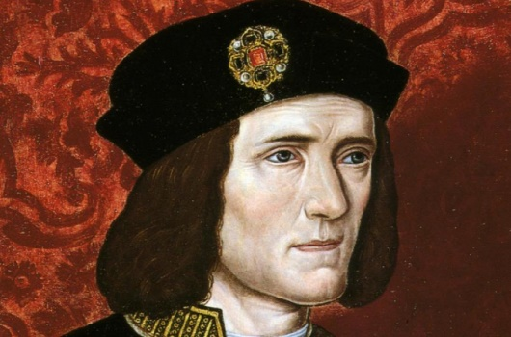
https://arstechnica.com/gaming/2021/02/historian-bolsters-case-that-richard-iii-murdered-the-princes-in-the-tower/
Late 16th century picture of Richard III
Anthony Sher as Richard III RSC 1984
https://www.shakespeare.org.uk/explore-shakespeare/shakespedia/shakespeares-plays/richard-iii/

2

Michael Hicks, Richard III, The Self Made King,(New Haven and London: Yale University Press,2019) p.1.
Richard iii Society, About Us, (2024) https://www.richardiii.net/about/ [Accessed 01 January 2024].
Wikipedia, William Shakespeare,(2023)< https:// www.en.m.wikipedia.org/williamShakespeare> [accessed 04 January 2024].
John Julius Norwich, Shakespeare’s Kings, (London: Faber&Faber Ltd, 2018) p.458.
Paul Innes;Katie James, ‘Temporal Compression In Shakespeare’s Richard III’, Literature, 2:4 (2022),315-328 (p.328) <https://www. doi.org/10.3390/literature2040026 > [accessed 03 January 2024].
William Shakespeare, Richard III, (London: Penguin Books Ltd,2005), p.5.
Alison Weir, Richard III & The Princes In The Tower ,(London: Vintage, 2014),p32.
Weir, Richard III, p. 28.
Hicks, Richard III, p.4.
Norwich, Shakespeare’s Kings , p.463.
Hicks, Richard III , p.8.
Shakespeare Birthplace Trust, Richard III ,https://www.shakespeare.org.uk/ richard-iii [accessed 03 January 2024].
Hicks, Richard III, p.9.
Weir, Richard III, p.30.
Ibid.
‘Richard III’, (Radio programme), Moral Maze, (London: Radio 4, 25 March 2015).
Dan Jones, The Hollow Crown, (London: Faber&Faber ,2014), p.311.
Paul Murray Kendall, Richard the Third, (London: Book Club Associates, 1973), p.50.
Jones, The Hollow Crown, p.294.
Moral Maze, 2015.
Hicks, Richard III, p.8.
Moral Maze, 2015.
Weir, Richard III, p.32.
National Portrait Gallery https://www.npg.org.uk/collections/search/use-this-image/?mkey=mw05304 ,[Accessed 03 January 2024].
Richard iii Society, 2024, [accessed 03 January 2024].
Graham C. Williams (dir), The Trial Of Richard iii [DVD], London Weekend Television. (1984)
Richard iii Society, 2024, [accessed 01 January 2024].
Moral Maze, 2015.
Channel 4 Documentaries, The Princes in The Tower: The New Evidence [video]. 2023 https://www.youtube.com/watch?v=1LaBPpxkb3k [accessed 03 January 2024].

