School of Sport, Health & Outdoor Education

Assessment Feedback Sheet

Student No./Name: 1802239/ Niall Claxton
Module: SHSS4078
Module Code: Adventure: A Risk Worth Taking

Personal Evaluation – to support your academic progress please complete the section below BEFORE submitting your work.
What do you consider to be the best aspects of this work?
Which aspects do you consider could have been improved in this piece of work?
What have you found most satisfying whilst undertaking this submission?
ASSESSMENT CRITERIA | Learning  Outcomes |  | GRADE
ASSESSMENT CRITERIA |  |  | Poor  0 – 25% | Unsatisfactory  26-39% |  | Satisfactory  40 – 49% | Good  50 – 59% | Very Good  60 – 69% | Excellent  70 – 85% |  | Exceptional  86– 100% | %
Complete logbook for each session | All |  |  |  |  |  |  |  |  |  |  | 15%
Provide a synopsis of a critical incident case study | All |  |  |  |  |  |  |  |  |  |  | 15%
Identify a specific significant hazard and the risk it poses to undertaking adventurous outdoor activities | 1,2,3,5 |  |  |  |  |  |  |  |  |  |  | 30%
Discuss a range of appropriate measures that might effectively control the identified hazard and consequent risks. | 1,2,3,5 |  |  |  |  |  |  |  |  |  |  | 30%
Appropriate references used and correctly formatted | All |  |  |  |  |  |  |  |  |  |  | 10%
It is expected that students will present work that is proof read, correctly referenced and adheres to the Assessment Checklist. Therefore a range of 0 – 10 marks will be deducted for non-completion of any of the points on the checklist below.
TUTOR COMMENTS:

Submission date:  via Turnitin |  | Return date:  (at least within 4 weeks) |  |  | Tutor: Denise Leonard |  |  |  |  | Mark:

Assignment Checklist

- Please complete the Personal Evaluation section of the Assessment Feedback sheet, add your name and details, and paste the whole of this assignment document into the front of your assignment

- Submission is a single word file, clearly labelled with your name and module code
- Font style - Times New Roman, size -12 for text and 14 for headings
- Ink colour – black only
- Line spacing – 1.5 line spacing and 2cm- 2.5cm page margins
- Quotations more than three lines to be indented 1 line spacing
- One line space between paragraphs, paragraphs must be left aligned
- Pagination (your assignment should have page numbers)
- All tables and figures are internally referenced and have a title
- Word count checked and written at end of text (before references and any appendix)
- Assignment is within 10% of the word limit (excluding references and any appendices)
- All references in the text are included in the reference list
- Correct referencing following the Harvard style, as described in the Palgrave study skills book ‘Cite them Right’.
- Correct spelling using UK English
- Correct use of punctuation
- Grammar and syntax correct- double check anything that has a green line under it
- I have read my assignment out loud to myself and it makes sense and is easy to read
- Somebody else has read my work and it makes sense to him or her!
- I have checked and I have not plagiarised
Failure to follow these guidelines will cost you marks!

Logbook
Climbing at Three Cliffs Bay

-Examine the generic risk assessment

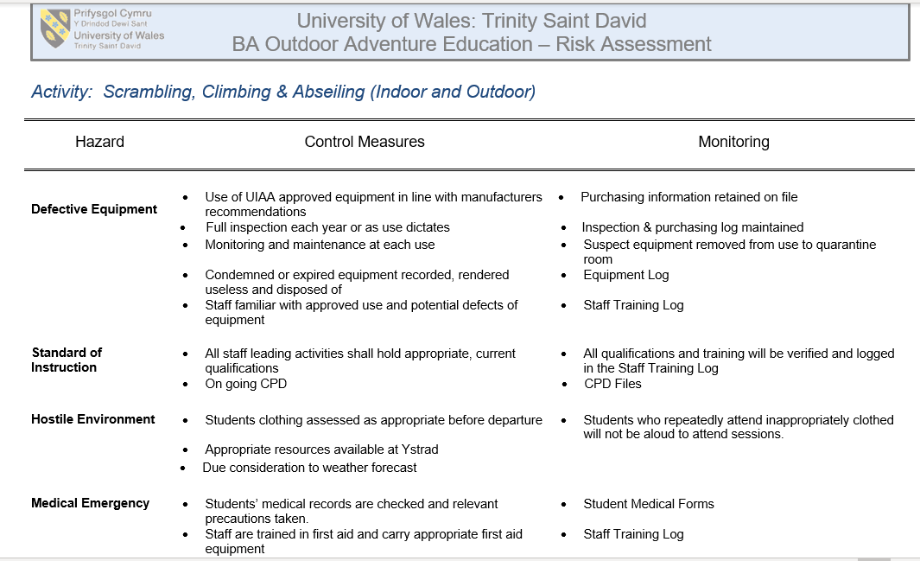

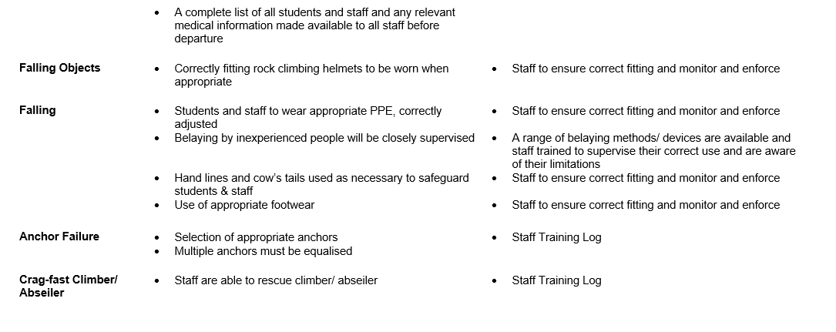
[Grab your reader’s attention with a great quote from the document or use this space to emphasize a key point. To place this text box anywhere on the page, just drag it.]

-Make notes towards or write a site-specific risk assessment
Hazard | Control measures
Tide | Go at a time when the beach is accessible
Strong wind and rain | Climb appropriate to the weather conditions
Rough and steep terrain | Wear correct PPE and footwear
Falling objects | Wear helmet at all times when near or below the cliff
Weather forecast (5th February 2019)
Time | Height (M)
00:31 | (LW) 4.7
06:45 | (HW) 11.9
12:51 | (LW) 4.5
19:02 | (HW) 11.8
Sunrise: 07:51
Sunset: 17:08
Note: the tidal information shown is for Mumbles in the Gower Peninsula, Wales. Please note that there is an approximate +20 minutes time addition required to the tide times for Llangennith versus those shown for mumbles.
-Have understood key technical terms (words and phrases) when given
UIAA - International Climbing and Mountaineering Federation
Half Hitch – the half hitch is a simple overhand knot. This is a reliable and versatile knot.
Belay- when climbing belaying is used to keep tension on a rope as a safety system.
Lock-off – this is a climbing technique, a static hold is used to retain extreme tension through the body allowing the climber to have good balance while moving from one hold to the other. The climber will first move upwards the hold they intent to use, then when the arm is in a bent position it is locked in position.
‘Static’ Rigging Rope – a static rope is designed not to stretch, this makes it useful for pulleys and rescues, however a static should under no circumstance be used to belay.
Dynamic Single Rope – a dynamic rope is designed to stretch in order to absorb the energy from a fall. Single ropes are best suited when used as only one length and can range usually from 9 to 11mm in diameter.
Single Pitch Venue – a single pitch can be completed without any intermediate stances. The climber should be able to walk away from the top of the climb safely without any safety ropes, they can also safely abseil to the bottom of the climb. A single pitch venue is the location of a climb that can be completed with one pitch.
Grade – the grade of a climb refers to the level of difficulty and skill level required. The over all difficulty is graded with numbers, the lower number given to the easier climb and technical ability progresses through the alphabet.
Jurassic Limestone – millions of years old limestone from the Jurassic period. As the fissures continued to develop in the Jurassic, when they then became infilled with mudstone and limestone which contained Jurassic fossils.
Carboniferous Limestone – this is a collective term for the limestone that is seen throughout Ireland and the UK. This limestone has been three for between 325 and 363 million years.
Tidal Range – this is the difference between the sea level in hight from high tide and low tide.
Rule Of The 12th's -
Three Cliffs Bay – this is the name of the site we used for our climbing session. The site is located on the south coast of the Gower Peninsula in the City and County of Swansea, Wales. Three Cliffs Bay gets its name from the three cliffs that are sitting just out on the bay. The site is well known and has National Trust car park nearby, another feacher of the bay is the very flat beach, meaning the tide comes in very fast.
Barnacle – this is a type of arthropod constituting the infraclass Cirripedia in the subphylum Crustacea, and is hence related to crabs and lobsters. Barnacles are exclusively marine, and tend to live in shallow and tidal waters, typically in erosive settings. When in an environment with barnacle, for example climbing or coasteering it is worth noting how sharp these are, however they do provider good grip.
Samphire – this is a plant associated with water bodies. Samphire is edible and has white flowers, usually find in salt water or marshes.

Have identified key activity specific skills to be developed (knot tying, weather, nature, etc)
The most basic skills for this activity, outdoor climbing, would be putting on and fitting the climbing harness, other basic skills would be tying into the belay rope using a re threaded figure of 8 knot with a stopper knot at the end. Being able to belay safely and confidently is also essential for this activity.
Be aware of issues relating to access and conservation/ environmental sustainability relating to the venue
The Three Cliffs Bay is a remote location and difficult to access. This site is more suited to serious enthusiasts or competent trekkers rather than those with young children. The easiest access to the bay is from the National trust car park at Southgate via the path, or alternatively a more challenging route from Parkmill via the woods following the signs for the beach. In 1956 The National Trust designated Gower as Britain's first "Area of Outstanding National Beauty" (AONB).
Be able to outline the potential benefits of each session
This session should be beneficial in gaining confidence in climbing in the outdoors, the chosen pitches aren’t too high, and most participants should be able to climb them. This is also a good change to do more belaying and improve on technique. The bay is very open and we will be exposed to the elements, therefore this is a good chance to find out what the best clothing is for outdoor climbing. Due to the site being remote and hard to access, all the gear will have to be carried down to the site, this will be a good way to see how all the kit should be organised and transported. When belaying a climber, good communication will have to be used between the climber and belayer.
Explore the health and safety history of the site/ activity
It is well known and stated on many websites that the Three Cliffs Bay has very strong rip currents, therefore it is advised that people do not swim there. Although there is lifeguards on duty at the site during summer and public holidays, several people have drowned. With the appropriate PPE such as a climbing helmet, the most common injury we will be exposed to while climbing is stain and sprains such as ankle sprains. Unless there is an equipment failure or an incompetent person belaying, this activity should be relatively safe.
During the session
Inspect relevant kit in accordance with the guidelines provided
- Climbing harness- Examine the belay loop, tie in area and the straps, inspecting the stitching and any signs if wear. Examine the buckles.
- Ropes- must know the history and inspect for signs of wear.
- Belay device – inspect for wear.
- Climbing helmet – Inspect for damage and cracks, check adjustments and buckle.
- Carabiner – Inspect for signs of wear, test the security mechanism e.g. screw gate.
- Nuts – Examine for signs of wear.

Keep a record of events and relevant observations throughout the day
The weather was colder than anticipated and it took some time to setup the climbing ropes and rigging, this meant that all the first-year students were standing on the beach waiting exposed to the cold wind. I was glad to have extra layers to put on and warm food to eat. Everyone in the group was at a different level of competency, only a few students attempted the third difficult climb and some students were still learning to belay. The bottom area of the first two climbs, where we were belaying from, was uneven and awkward to stand in. After everyone had an attempt at climbing, we dissembled the rigging system and took an alternative route back, this route was in the risk assessment and would have been used if the tide would have trapped us on the b each, however, this route involved a scramble. Everyone first made their way up the cliff; this was a free scramble. We gathered at a flat point before we started a steeper climb, we were all tied into a rope for this section. This took some time and I don’t think this would have been an option if we were in a hurry or if someone was injured.
Maintain a record of dynamic risk assessments/ considerations
I think it is worth noting the injury that could be caused by an incompetent belayer, if someone isn’t fully competent there should be someone holding the rope behind the belay device and ensuring that there isn’t too much slack in the rope.
Reflect on their own and others’ preparation for the activity
I think that everyone was relatively well prepared for this activity. Many people had their own kit, for example harnesses and shoes. I felt I had been very well prepared as I has extra layers to put on, I had hot food and drinks, my climbing harness and approach shoes (not including the stores gear). When we had to wait for the rigging to be set up, I was able to put on a down jacket, coat and hat and have warm food. I think my approach shoes were idea for this, however I did notice that some people had a poor choice of shoes for this activity.

After the session
Record any near misses or accidents
During this activity fortunately we had no near misses or accidents.
Reflect on the suitability of the generic and site-specific risk assessment for that day and update accordingly
I think the generic and site-specific risk assessments were good and went into detail covering most things. The only thing I would add to this would be human error, for example what I mentioned before, the greatest risk could be an incompetent belayer and although this is mentioned under ‘falling’ in the risk assessment I could add a section for human error.
Briefly outline specific learning outcomes from each session
This was our first session focusing on risk assessments, and although I am usually safety conscious, I think I learned a lot about spotting potential hazards. After this session I can see how important it would be to complete a risk assessment before taking a group here. As the site was relatively remote and if there was an injury and the tide came in this could cause a lot of problems if this wasn’t thought of beforehand.

Paddle sports at Llandysul
Examine the generic risk assessment
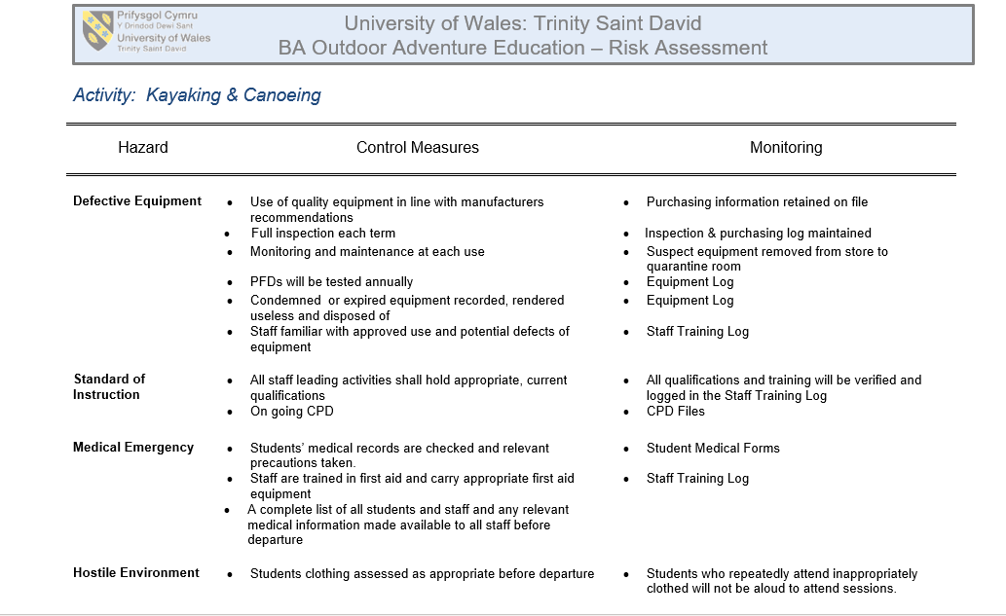

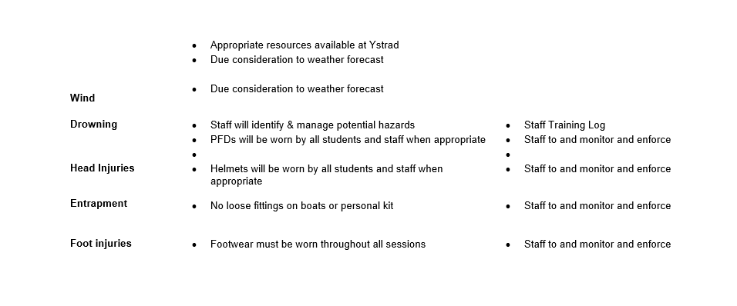

-Make notes towards or write a site-specific risk assessment

Hazard | Control measures
Bad corner on road between changing rooms and lake | Pay attention when crossing road
Overhanging branches along river | Wear a helmet
Objects under water level
Other users | Be aware of other users, giving space for paddle
Slippery lake bank | Wear appropriate footwear
Poor access to river in places | Be aware of where the river can be accessed and have spotters in place if necessary

-Be familiar with relevant legislation
By law, if you want to coach the public or run activities with the public, you will be required to have the relevant training with certificates and if you plan to be self employed you must be licenced ect.

-Understand the relevant NGB awards and their remits
The main National Governing Body (NGB) for paddle sports is the British Canoe Union (BCU). They provide a range of training from basic certificates that can be achieved in a few hors in the water such as 1 start BCU, right up to highly skilled and qualified coaches.

-Have understood key technical terms (words and phrases) when given
1. Kayak- A sit in craft that is propelled using a paddle held in the hand
2. Silurian Mudstone – a very old formation of mud that can be found in lakes, it wan be very sticky.
3. Eddy – this is a circular movement of water that creates a small whirl pool
4. Edge – the river bank
5. Breaking in and out – this refers to moving into and out of eddies. This is done by working with the flow of water and using it to you advantage.
6. CLAP – Communication, Line of sight, Avoidance, Position of most usefulness
7. Afon Teifi – the river Teifi is 73 miles long and is a well-known feature in Wales.
8. Grade – this is a system used to rate how severe a river is or just a particular section, the scale starts at 1 being the calmest and goes up to 6 for the most severe conditions.
9. Flow rate – this is the speed and amount of water flowing through a river, it can be measured and compared to other rivers.
10.Slalom – this is a way of moving, like ‘weaving’ between obstacles. This can e done water sports and would look similar to a skier.
11. Catchment Area – this is the area of the land that water will gather.
12. Sewin – this is also a type of fish, a Sea Trout
13. Salmon – Type of fish found in both fresh and salt water. Usually fast flowing rivers.
14. Japanese Knotweed – This is an invasive plant that is easily spread, it is important that we stay away from this plant to avoid spreading it further, for example on the bottom of a craft.
15. Appropriate Footwear – The footwear we should be using for the particular activity, mainly to enforce our safety for ankle support, from slipping and to avoid sharp objects penetrating the footwear into our feet. The appropriate footwear for this activity is shoe with a sole and sufficient grip, but also not too bulks as you should be able to get out of an enclosed kayak easily.

Have identified key activity specific skills to be developed (knot tying, weather, nature, etc)
the sessions will be taking place on the lake, this is a good chance to practice different paddle strokes and controlling the boat. The weather will make a difference as a light kayak will react very fast to little wind compared to other crafts.
Be aware of issues relating to access and conservation/ environmental sustainability relating to the venue
This sight is used by an outdoor centre, so therefor we don’t have to worry too much about the conservation, however we must keep the sight and more importantly the river clean. The access to the lake is easy although can be slippery at times. The river access is poor, and can only be accessed at a few points, this is something to be aware of.

Be able to outline the potential benefits of each session
This session should be beneficial to everyone, however the people who have less experience in the water should benefit more. This is a good opportunity to get some good quality water time as we have a good student to instructor ratio. We will be using a variety of crafts so this is a good chance to try out something new, we will ask me focusing on risk and looking at risk assessments, I am keen to hear a few opinions or what hazards there could be to some of the different kayaks and canoes etc..
Explore the health and safety history of the site/ activity
This activity has a history with a very well know tragedy, at Lyme Bay in 1993. We wont be in the sea so wont won’t face the problems that were experience during this tragedy, however it is a good reminder that when exposed to the environment we should always be aware of what we are doing.

During the session
Inspect relevant kit in accordance with the guidelines provided
All the kit was inspected following the correct legislation and procedures. I inspected my own PPE, which included my helmet; I checked the straps and buckle and made sure it was a good fit and in good condition. I also had a buoyancy aid; I made sure the foam was in good condition, I checked all the straps and buckles, ensuring they would tighten. I also had my water safety knife, a whistle, a wetsuit and appropriate footwear.

Keep a record of events and relevant observations throughout the day
After having a look at the weather as a class we talked about possible health and safety concerns for the activity, we then went to the stores and prepared kit, as well as two stand up paddle boards. On arrive at the sight we got changed and then had an in depth discussions about the crafts we would be using, pointing out some concerns, and the biggest hazard was the rings on the kayaks as we could catch out fingers in these, I was surprised about that. During this talk some people started to get cold as it was quite windy, as we were all in wetsuits there wasn’t much we could have done apart from move into the shed onsite. When choosing a kayak to use I didn’t put much thought into it as I have paddled quite a bit before and thought I would be fine, however I haven’t used a kayak since I was younger and have been using a sit on top, the difference was a lot more obvious that I thought and I didn’t like how enclosed the cockpit was. I paddled around a bit and tried to get used to it but I think I want to learn to roll a kayak first. I have plans for this with my local canoe club.

Maintain a record of dynamic risk assessments/ considerations
The rings on the side of the kayaks and sit o tops pose a risk as they are the right size to catch a finger in, the rings could be easily removed. Some kayaks had screws inside to hold the foot plates in place, if these were to catch shoe lace, the paddler could become entrapped. In strong wind the stand up paddle boards could pose a risk as they are light and have a large surface area, meaning they will catch the wind when trying to move them.
Reflect on their own and others’ preparation for the activity
Everyone arrived well prepared. I had everything I needed, including a change of clothes and food for after. Most students participated in this activity and put in a good effort.

After the session
Record any near misses or accidents
During this activity fortunately we had no near misses or accidents.
Reflect on the suitability of the generic and site-specific risk assessment for that day and update accordingly
The risk assessment was adequate.

Briefly outline specific learning outcomes from each session
Learn new paddle skills and how to spot potential risks to plan a risk assessment.

Mountain Biking
-Examine the generic risk assessment
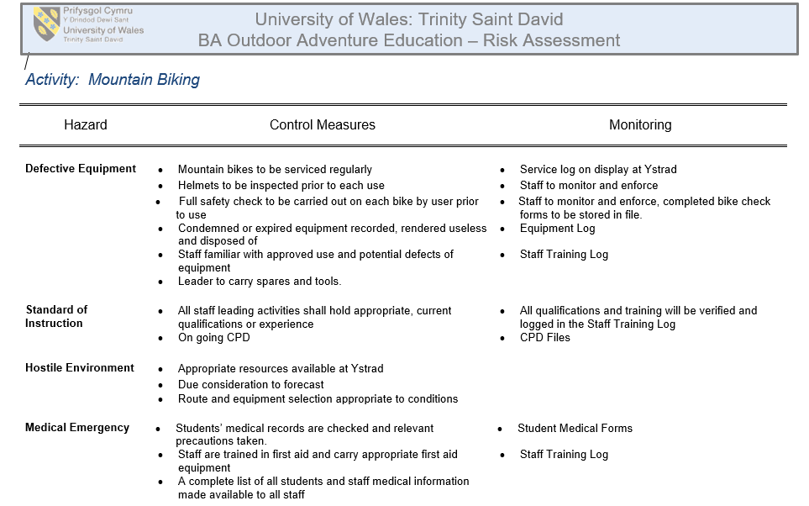

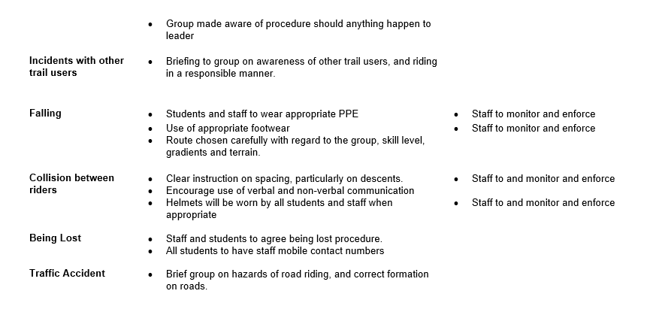

-Make notes towards or write a site-specific risk assessment
Hazard | Control
the site is very remote is areas at they cannot be accessed by vehicle | Do a site recce, taking notes of areas with difficult access and poor phone signal
Other users acting fooling | be aware of other users and let them pass if necessary
gates at end of trail sections | Warn cyclists of possible obstructions at the end of sections designed to slow them down
Steep river banks alongside trails | Cycle with your limits when along rivers or other steep drops

-Understand the relevant NGB awards and their remits
BMBLA – British Mountain Bike Leader Awards
MIAS – Mountain-bike Instructors Award Scheme
PMBI - Professional Mountain Bike Instructors Association

-Have understood key technical terms (words and phrases) when given
1. NRW – Natural Resources Wales.
2. Table Top – the top of a feature in a trail, this is the flat part of a feature with steep sides, this flat section can ether be jumped over of ridden
3. Crank – the mechanical part of a bike, this is the component that at attaches the peddles to the bottom bracket, the bearing housed in the frame.
4. Attack Position – a position used by a rider that can easily absorb bumps by bending the elbows and knees, this position is low and close to the bike therefore it also reduces drag, however this would not be a good position for peddling.
5. Drop Off – this is when biker leaves contact with the ground, it is important here that the rear wheel makes the first contact with the ground.
6. Brechfa Forest – a forest in Wales that is popular for mountain biers as it has good trails.
7. Ash Die Back – this is a serious disease that is effecting Ash trees across Europe.
8. Rose Bay Willow Herb – a common wild flower found in the area
9. Fire Track – these are the roads that are found in parks, they join the sections of bike trails and are suitable for vehicles, they are used by the forestry and other maintenance services. This makes they great for our safety as we can get help or medical treatment faster. The tracks get their name from their other use, as they help to prevent a forest fire from spreading through the entire forest and help to contain the fore into an area.
10. Grade – mountain bike trails are graded using colour. The grade represents the level of difficulty.
11. Berm – this is a technical feature in a trail, it is a corner which has been built up as part of the trail, by riding higher up in the trail, gravity will push us into the corner, allowing us to keep our speed rather than slowing down.
12. BMBLA – British Mountain Bike Leader Awards
13. MIAS – Mountain-bike Instructors Award Scheme
14. PMBI - Professional Mountain Bike Instructors Association
15. Cycling UK – a UK charity supporting cycling and bike use.
Have identified key activity specific skills to be developed (knot tying, weather, nature, etc)
learning the attach position was important for this session. Being able to control the bike and use our body weight to advantage is important. By pushing our body weight forward we can take the weight off the back wheel and if we lean back we can take the weight off the front of the bike, this is useful for getting the bike up small stones etc. being able to read the trail ahead is also a good habit to learn at the beginning. The biker should be looking forward to where they want to proceed to rather than down at the wheel.
Be aware of issues relating to access and conservation/ environmental sustainability relating to the venue
Mountain bikes can be very harsh on the environment. It is important that we are responsible bikers and stick to the trail. In forest parks we will also often come across unofficial trails, these have been made by the public, a responsible biker will not use these are they are damaging to the natural environment, they could also be dangerous.
Be able to outline the potential benefits of each session
Learn the basic bike skills while learning the practical and theory of risk assessing the activity. As an activity, group would benefit from physical exercise and fitness, also good mental well being as we are in the outdoors and exercising. Mountain biking is also a good activity to improve body co-ordination, team work skills and navigation.
Explore the health and safety history of the site/ activity
Mountain biking is a high risk activity. Even with the correct PPE, we can’t control all the risks. Mountain bike injuries usually result in shoulder, collarbone and finger injuries, this is became it is our natural reaction to put our hands out in front of us to break our fall and protect the head.

During the session
Inspect relevant kit in accordance with the guidelines provided
Before leaving Cynefin, the M check was conducted on all bikes, this is a full inspection of the bikes. I then chose a good fitting helmet and checked the straps and buckle. I didn’t use any other PPE, just gloves and appropriate footwear.
Keep a record of events and relevant observations throughout the day
On arrival at the site, we started with some very basic bike skills, just ensuing everyone could work the breaks and change gear. After this we done a few laps of the end of one of the trails practicing a few hill climbs and technical work. E started out on the forest road for about 15 minutes before reaching the first section of full trail we would ride. This was good as it took me this ling to warm up. Everyone got the hang of the bikes surprising fast. I found the trail very flowy and had some good features.

Maintain a record of dynamic risk assessments/ considerations
There was two things picked up today. One was the other user who was impatient with new riders and was not considerate when trying to pass. This could have caused an accident. The other thing I noticed was the gates at the end of trail section, these could also cause an accident.
Reflect on their own and others’ preparation for the activity
preparation for this day was good I thought, I had no issues. The tutors did point out that some people were wearing cotton t-shirts. We had spare tubes and tools.
After the session
Record any near misses or accidents
During this activity there was a few falls but this can be expected. No injuries for this session, however to be precautions, riders could wear elbow and knee pads.
Reflect on the suitability of the generic and site-specific risk assessment for that day and update accordingly
I think it was good, but have added two points.

Briefly outline specific learning outcomes from each session
Learned the basic bike skills, how to write and spot risks for a risk assessment and we learned a few technical terns, both technical bike terns and trail features.

Lyme Bay synopsis
The Lyme Bay incident happened in the South coast of England. This was a tragic incident that involved a group of eight school children, from the Southway Community College, Plymouth. The group was accompanied by a teacher, Norman Pointer, from the school and two instructors from the centre. The two instructors were nether competent or qualified for this activity with a group, Anthony Mann was the more experienced of the two, but his kayaking training only extended too a 1 star BCU (British Canoe Union) qualification, this award could be achieved after 6 quality hours in the water. The younger and less experienced instructor, Karen Gardiner, had the same 1 star BCU. The equipment used by the centre for this activity was inadequate, on this day life jackets were used instead of buoyancy aids, the school children were only given wetsuits because they had requested them and the choice of kayak that the teacher was in was for a more experienced kayaker. Only the instructors had cagoules and spray decks and none of the kayaks had been fitted with deck lines or supplementary buoyancy. On arrival at the site, after paddling a short distance it was clear that the teacher was having difficulty controlling the kayak as it capsized a number of times after leaving shore. It has been reported that the teacher requested to return to the shore several times, however, instructor Anthony Mann was persistent that they should continue and catch up with the group, who were in the distance now. The teacher also claimed to have tried to communicate with the group by shouting but was not heard, and as he was not given a whistle, he asked Anthony to make an attempt to get the attention of the group with his whistle, but the request was ignored. After the teacher still continued to capsize, the instructor made the decision to tow using a tow line, Norman Pointer became increasingly fatigued from the effort of climbing back into the raft and was sick in the water. Meanwhile, the rest of the group was with Karen Gardiner who was struggling to keep the group of eight children together, she made the decision to raft up to stay together, this was a poor choice for this environment as the waves began to fill the kayaks with water (this could have been avoided by the use of spray decks) until eventually capsizing them one by one. The children now in the water and stating to get cold fast, were instructed to climb onto the upright kayaks. This continued until most of the kayaker were in the water. They were then instructed to hold onto the remaining kayaks, although there was no deck lines so this could have contributed to the kayaks capsizing. When there was only one kayak remaining upright, Karen Gardiner make the decision to overturn it and use it as a raft. Neither instructor had any means of communication except for a whistle. There was no flares, personal trackers or even a mobile phone, it appears that the preparation for this activity concluded of a tow line and a first aid kit. The centre did not appear to have an appropriate off-site protocol in place. As soon as the group was overdue, there should have been contact made with the coast guard and a search and rescue should have been started. At 1443hrs a fishing vessel, Spanish Eyes, spotted a capsized kayak in the water and alerted the coastguard, however it was reported that this would not be an immediate cause for concern as this is not an unusual occurrence. The first people to be rescued was teacher Norman Pointer and instructor Antony Mann. Four hours after the first call was made to the cost guard, the final missing person, Emma Harley, was picked from the water. One student was found dead and another three died in intensive care. This tragic incident resulted in the death of four school children.

With reference to a critical incident case study that we have examined, identify one key contributing hazard. Evaluate your own personal logged experiences in different activities, of risk management in relation to this identified hazard.
The Lyme Bay tragedy that happened in 1993, resulted in the deaths of four school children. I will examine this incident and point out what I think was a key contributing hazard. I will then use my own experience to evaluate how this hazard could play a role in other activities and how we can control this hazard. I will be using my logged experience through semester two and using Kolb’s experiential learning cycle to review and reflect on my experiences. I will put focus on the competency of the centre and its staff, and this will include an in depth look at the equipment used this day, and also the lack of certain safety equipment. After pointing out the reasons I feel that incompetency was the key contributing hazard, I will then discuss the ways that this type of incident can be avoided.
The tragedy in Lyme Bay was a turning point for the outdoor education industry, after these events the industry has a lot more regulations to adhere to and centres are monitored more closely. After researching and reviewing the Lyme Bay incident, I think that a key contributing hazard was the competence of the instructors. The two instructors were neither qualified nor experienced enough to lead this activity, there was also an inadequate ratio of competent paddlers to beginners. Although I believe the key contributing hazard was the incompetence of the instructors, I think it’s important to discuss the incompetence of the centre as a whole first. The level of incompetence extends past the two instructors, as the centre managers should not have allowed these instructors to lead such a big group of paddlers alone. The centre also lacked a system to know what time everyone was expected back, the equipment that was supplied by the centre was of a poor choice, for example, the use of life jackets rather than buoyancy aids. The kayaks used were not fitted with deck lines or supplementary buoyancy and the safety kit consisted of a tow line and a first aid kit, it is worth noting here that Anthony Mann claimed that he supplied the tow line on the day. The report doesn’t mention the kit available at the centre, although we can assume that they either don’t have enough or even any buoyancy aids, it would be inappropriate to assume that the centre had spray decks available and it was the decision of the instructors to leave them behind. The two instructors also had no means of communication, but again the report does not mention if this was available or not, however, I would expect that if available the instructors would have used a means of communication. Two weeks prier to the disaster, both instructors, Anthony Mann and Karen Gardiner attended a basic paddle course which was the 1 star BCU (British Canoe Union), this would have by no means qualified them for leading this activity as it could be achieved in about 8 hours of quality water time, however this could have lead to the instructors feeling more confident in their ability, this may have been the case with Anthony Mann, as in court the paddle instructor Steve Gynes suggested that Mann may have had more confidence in his ability than was realistic.
When the group arrived at Lyme Bay that morning, before entering the water they were told by the instructors that the lifejackets would not need to be inflated, and in trying to do so, this could lead to over-inflation or the lifejacket being deflated. Joanna Willis gave evidence in court saying that she did not inflate her lifejacket as she was afraid what could happen. This was a very big factor in the disaster, the paddlers were basically entering the water without a floatation device as it was defective; each lifejacket uninflated could only support 6kg. Had the lifejackets been inflated fully they would have prevented the students from drowning. Would the group have been able to successfully complete the activity if the weather conditions were different? I don’t think the weather played a big role in the events of this day, the first issues were encountered in the shelter of the bay, when teacher Norman Pointer capsized several times and this would suggest that the issue was the poor choice of kayak which was a result of incompetence not the weather. After climbing back into the kayak several times, Pointer became fatigued and got sick in the water, this could have been avoided if the paddlers were shown how to correctly get back into the craft, a competent instructor would have shown this in the bay before proceeding. The choice made by Mann to tow the fatigued and inexperienced paddler into the open water shows a lack of experience as he would have been exhausting himself and the open water would have made the kayak even more difficult for Pointer to control. The decision to raft up by Gardiner was adequate, however due to not having spray decks or deck lines, the kayaks began to take on water, I think that at this point given the situation and having no means of communication (including flare etc), an experienced instructor would have made the decision to head back towards shore and meet the rest of the group. In the report it does not entail the exact detail of the four deaths, but the most likely cause was by drowning and the second would have been hypothermia. The choice of clothing worn by the paddlers on this day was inadequate, however they were wearing wetsuits but only after requesting them specifically. A cagoule would have provided a good barrier against the wind and helped to retain body heat, the use of a helmet would have also helped to keep body heat in, as we loose a lot of heat through our head, a helmet would have also made the paddlers more visible to rescuers. From my personal experience I have noticed that a helmet is a good means of retaining heat, especially when in the water and your hair gets wet a lot of heat can be lost quickly. I have also kayaked both with and without a cagoule, the difference is immense and I think this could have gave the kayakers the extra time they needed for help to arrive. The inexperienced kayaking instructors also made a bad choice when they put Pointer in a kayak that was suited for someone more experienced, I think this choice was also a key factor as it lead to the group being separated, which lead to the school children rafting up. From my experience the choice of kayak makes a big difference and a shorter and lighter kayak of lower volume will require more skill to control and is less stable, the Lazer II Three Fifty canoe fits this description, this was the craft paddled by Pointer on this day. During the court case it was pointed out that the coastguard had received a call from a ship, informing of a kayak in the water. The coastguard did not react to this with a formal search and rescue, claiming that this sort of sighting was not unusual and would usually be no cause for immediate alarm as this was quite a common occurrence. Although an immediate search and rescue at this point could have made a difference to the survival of the kayakers, it was not protocol at this point, also it was only by chance that the abandoned kayak was spotted, so this could have made little difference to the fate of the paddlers.
Since the Lyme Bay tragedy in 1993, there has been many regulations put in place as a means of stopping this from happening again. All outdoor instructors must now be qualified for everything they instruct, and this is monitored. Experience alone can no longer qualify a person to lead an activity, for example even the most competent and experienced kayaker can not lead an expedition without the required certificates. The employer also has a responsibility to be able to provide first aid, the 1981 health and safety regulation means employers must have adequate and appropriate equipment and staff who can provide first aid, failure to meet this standard can lead to prosecution by the Health and Safety Executive (HSE). Outdoor centres are also now subjected to monitoring by the Adventurous Activity Licencing Authority (AALA). If an activity is licensable the correct licence must be obtained by the centre or they could face prosecution, after an inspection the AALA has the authority to reject the appeal. Inspections are carried out by the Adventurous Activity Licencing Service (AALS) on behalf of the AALA, they can make spot checks on providers of adventurous activities. During these inspections all staff must have the relevant certificates or qualification to support the activities they are instructing. There has now been regulations as to how many persons one instructor can manage and depending on the activity and how severe it is, as well as the competence of the participants. From my experience in semester one and two, we have always had a good ratio of instructors and students, when one of the instructors was ill, the scheduled practical session was postponed as they though this would have been a safer option.

I feel the tragedy was solely due to incompetence, however this incompetence was not just the instructors on the day, but also the centre and their choice of kit and PPE. The group being inadequately clothed and using uninflated lifejackets was a major factor that lead to the four deaths. The management of the centre was incompetent in choosing what equipment to use, managing staff and their training and on the day of Lyme Bay tragedy, the centre failed to react in time which would suggest that the management staff had no procedure in place for this type of scenario. Although this event was tragic, it was the turning point for how centres are run and this could have saved many lives by now. Soon after the court case, the AALA was set up to enforce the safe running of adventurous activities. Although I believe that the events of this day were due to incompetence, I don’t think that it would be fair to hold the instructors responsible, and even thought the centre manager at the time was given a sentence of three years for manslaughter, I believe they can’t be fully blamed as there was no AALA at the time, this would mean that the way the activity was carried out on this day could have been common procedure at this time for many centres. Because of the Lyme Bay tragedy, most of the issue involving incompetent staff and instructors has already been highlighted and this was the reason for the HSE to introduce the AALA, this means that most areas of this hazard has already been covered and there is not much to be suggested at this point on how to improve the system, in fact, I think that health and safety can be too extreme in the current world as we have to have a licence, permit or certificate for everything we do.
Essay word count: 1867

