

Module Code: LCBB5000
Module Name: Data Handling & Bussiness Intelligence Assessment 1
Student Name: Pavel Bodushki
Student number: 2023711
Term 1 Group 2
Name of Lecturer: Anupam Mazumdar
Word count: 1,360
Date of submission: 10-05-2022

Table of Contents
Introduction 3
Big Data features 3
Critical analysis 3
Practical application 6
Conclusion 7
References 8

Introduction
The dynamism and competitiveness of the business environment requires especially from large business organisations improved responsiveness and flexibility in addressing various developing trends (Lim and Teoh, 2020). Business intelligence incorporates mechanisms for collecting and analysing large quantities of performance-related data, which are systematically reviewed and transformed into information, in order to support strategic and operational decisions (Lim and Teoh, 2020).

Big Data features
The strategic effectiveness of business intelligence largely depends on the availability of Big Data – the collection of large quantities of data, often real-time ones, supporting decision-making process at tactical and strategic level (Riahi and Riahi, 2018).
Accurate decision-making is a key outcome of the business intelligence process; hence, the collected data have to respond to three key criteria – volume, variety and velocity (Hadi et al., 2015). Respectively, business entities are required to develop the necessary infrastructure in order to be able to collect extensive quantity of data in order to avoid any gaps and respond to the volume criterion. Velocity expresses the frequency of the data collection process which may be a key factor for accurately detecting ongoing developing trends (Riahi and Riahi, 2018). Variety criterion emphasises on data diversity, so that all forms of valuable data are reflected accordingly as a part of the business intelligence process (Riahi and Riahi, 2018).

Critical analysis
The advantages of using Big Data in the process of business intelligence are numerous. Almeida (2017) proposes three key areas – technological, financial and competitive advantage (fig. 1). The technological domain relates to a more scalable data access, integration of various types of data, as well as improved data quantity and quality (Almeida, 2017). These are key ingredients for a more precise conduct of business intelligence in practice. The financial benefits are mainly associated with the ability to reduce costs and maximise sales which in turn improve the return on investment (Almeida, 2017). These are key areas of performance determining the success of a business entity.
Almeida (2017) identifies nine distinct areas of potential improvements, as shown below. The benefits are mainly related to consistent improvements in the marketing process via a better understanding of consumer behaviour, improved product/service development, data-driven marketing and others (Almeida, 2017).
Figure 1 – Benefits of big data
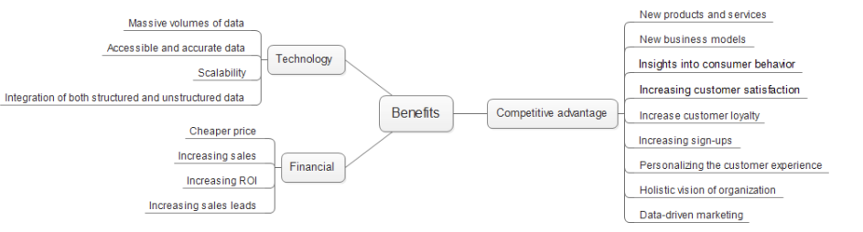
Source: Almeida (2017)
Considering these key benefits, business organisations extensively use the new technologies to collect actual user-based data – opinions and feedback on social media and other communication channels, as well as actual purchasing behaviour (Andrei et al., 2018). Similarly, Ke and Shi (2014) view Big Data as a way of improving organisational performance given the enhanced capability to identify development directions and existing weaknesses. In this light, the data-driven decision-making supports the achievement of the three main areas – business, environmental and social performance – as discussed by Lim and Teoh (2020).
There are also concerns related to data protection, ownership and especially security, as argued by Cole et al. (2015). Business organisations also have to ensure strict compliance with the data protection and privacy rules. In relation to security, the main issues are linked to practices, policies and protocols, whereas external security problems originate from structural risks and vulnerabilities (Cole et al., 2015).
Almeida (2017) recognises six main areas of challenges in the Big Data management process. As shown below, security of information, appearance, knowledge discovery, data storage and analysis, data visualisation and human resources appear to be among the most concerning areas which specific issues at each of them (Almeida, 2017). Thus, the use of wrong metrics or having data imperfections and gaps may considerably jeopardise the overall effectiveness of the business intelligence practice (Harvey, 2018).
Figure 2 - Challenges of big data
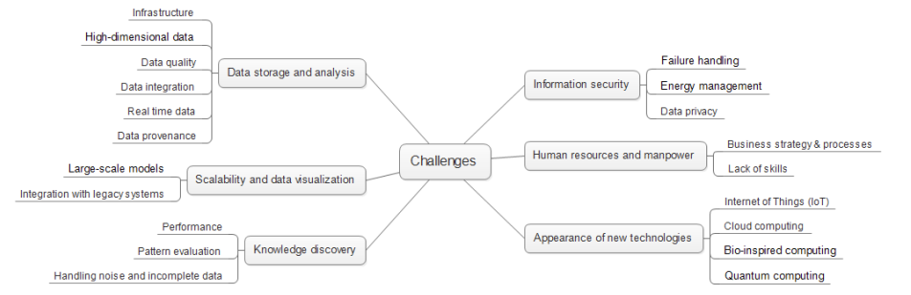
Source: Almeida (2017)
The existing issues clearly demonstrate the importance of developing an extensive infrastructure, which embodies the most advanced technological solutions for data collection and analysis, as well as security standards, as a key condition for coping with the potential challenges.
The role of the having highly-qualified workforce is also essential, as business intelligence process requires holistic technical, analytical and other skills (Harvey, 2018). Professionals in the field are also required to eliminate resistance to change, be flexible and adaptive to the dynamic changes and requirements for professional conduct in the field (Harvey, 2018). Due to the importance and sensitive of the process, high levels of integrity in the workplace are also necessary.

Practical application
Lim and Teoh (2020) the use of business intelligence and value of Big Data in three main domains: business, environmental and social, as previously mentioned. The evidence from practice confirms these observations.
The case of Tesco is quite indicative for the holistic value of business intelligence and Big Data application. Data from millions of different Club Card users are collected in real-time on the basis of realised purchases (Rijmenam, 2014). This information meets the volume, velocity and variety criteria by enabling the organisation apply accurate changes in the product and promotion offers, as well as better manage its inventory, so that optimisations are achieved (Rijmenam, 2014). In this way, the organisation achieves meaningful operational improvements and better serves its customers; thereby, realising competitive advantage in the marketing field. In the field of manufacturing, Big Data contributes to the better real-time management of the complex production and supply chain processes (IBM, 2013). Moreover, Big Data find a common application at product testing stage; thereby, supporting decision-makers as a part of the product development and innovation processes (IBM, 2013). These are key examples of business advantages.
In the domain of the environmental protection, Big Data could also be of help. Tesco uses temperature sensors aiming at optimising the temperature of the freezers, so that electricity consumption is at its most optimal level and food waste is minimised (Rijmenam, 2014). The investment in this data-driven management process not only strengthens the cost control of the retailer; thereby, delivering improved competitiveness, but also contributes to more sustainable policies in the key fields of energy efficiency and food waste reduction by saving £100 million per annum (Rijmenam, 2014).
The faster access to extensive information also strengths organisations’ responses to different trends related to key stakeholder groups, which have a profound effect in coping with various social issues which are suggested by Lim and Teoh (2020). In this light, the responsiveness to corporate social responsibility challenges could be of value, especially in the case of large public companies whose policies are impactful and visible to the public.
Considering the advances in the field, there are several key trends worth being explored in more details. Since the outbreak of the pandemic, business organisations has more extensively adopted new methods, especially cloud and SaaS platforms, as the latter are expected to account for 50% of all analytical tools by 2024 (Avidon, 2021). There are even mobile tools in the area of business intelligence which in turn facilitates the on-the-go analytics (Pereda, 2019). The accessibility of data also has also pushed organisations to be more literature and prepared to handle large quantity of data – a key driver for the development of a data-driven culture supporting the business intelligence process (McKinsey, 2018). Such culture also requires common values and appropriate behaviours at work, so that collaboration between different stakeholders is facilitated (McKinsey, 2018). Considering all, the increasing importance and quantity of data also poses certain risks from the privacy and security stand point. Therefore, business organisations face new challenges in the field where data governance should be considered as a main priority (Almeida, 2017).

Conclusion
The current journal review regarding Big Data application in the field of business intelligence critically evaluated the main advantages and risks of the technology. The discussion of the key characteristics and application in practice demonstrated the validity of the findings by Lim and Teoh (2020). The field of business intelligence provides numerous advantages in three critical areas of business intelligence by supporting the achievement of business advantage, environmental benefits and social achievements. Nevertheless, these benefits are not given, as they require consistent efforts, investments in new technologies and qualified workforce, changes in organisational culture, as well as advanced privacy and security measures. Moreover, the use of the technologies is not standardised, as it is required to address the unique goals and characteristics of every business entity.

References
Almeida, F. (2017) Benefits, Challenges and Tools for Big Data Management, Journal of Systems Integration, Vol. 8(4), pp. 12-20.
Andrei, G., Galmeanu, R. and Radu, F. (2018) Managerial Accounting – an Essential Component of the Information System, Valahian Journal of Economic Studies, Vol. 9(23), pp. 109-114.
Avidon, E. (2021) SaaS adoption, real-time BI among top analytics trends, [online] Available: https://www.techtarget.com/searchbusinessanalytics/feature/SaaS-adoption-real-time-BI-among-top-analytics-trends [Accessed: 7 May 2022]
Cole, D., Nelson, J. and McDaniel, B. (2015) Benefits and Risks of Big Data, [online] Available: https://core.ac.uk/download/pdf/301367945.pdf [Accessed: 17 April 2022]
Hadi, H., Shnain, A., Hadishaheed, S. and Ahmad, A. (2015) Big Data and Five V’s Characteristics, International Journal of Advances in Electronics and Computer Science, Vol. 2(1), pp. 16-23.
Harvey, C. (2018) Big Data Pros and Cons, [online] Available: https://www.datamation.com/big-data/big-data-pros-and-cons/ [Accessed: 18 April 2022]
IBM (2013) Analytics: The Real-world Use of Big Data in Manufacturing, [online] Available: https://www.ibm.com/downloads/cas/ONBGKB82 [Accessed: 18 April 2022]
Ke, M. and Shi, Y. (2014) Big Data, Big Change: in the Financial Management, Open Journal of Accounting, Vol. 3(4), pp. 77-82.
Lim, Y. and Teoh, A. (2020) Realizing the strategic impact of business intelligence utilization, Strategic Direction, Vol. 36(4), pp. 7-9.
McKinsey (2018) Why data culture matters, [online] Available: https://www.mckinsey.com/~/media/McKinsey/Business%20Functions/McKinsey%20Analytics/Our%20Insights/Why%20data%20culture%20matters/Why-data-culture-matters.ashx [Accessed: 8 May 2022]
Pereda, T. (2019) Oracle Business Intelligence Mobile: Reports on the Go, [online] Available: https://fwpr.com/oracle-business-intelligence-mobile-reports-on-the-go/ [Accessed: 8 May 2022]
Riahi, Y. and Riahi, S. (2018) Big Data and Big Data Analytics: Concepts, Types and Technologies, International Journal of Research and Engineering, Vol. 5(9), pp. 524-528.
Rijmenam, M. (2014) Tesco and Big Data Analytics, a Recipe for Success? [online] Available: https://datafloq.com/read/tesco-big-data-analytics-recipe-success/665 [Accessed: 18 April 2022]

