I confirm that I have not used any AI tools in the research and creation of this assignment. I confirm that I have not presented any AI generated materials as my own work. I confirm I have copies of my drafts, notes, and other resources I used, which I may be asked to provide in evidence

Field Journal
Over the two weeks we built up our understanding of archaeological field work practice, through taking part in practical.
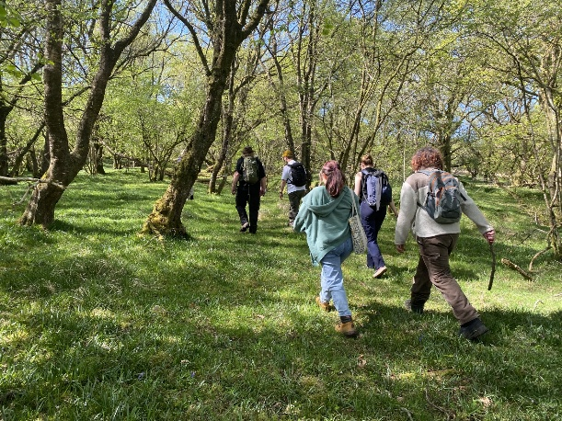
Students from UWTSD Lampeter undertook a two-week field trip to Strata Florida in May 2025, students travelled from the campus to the site daily, to practice and learn about archaeological field techniques. Strata Florida is the site is the Cistercian Abbey and is currently curated by Cadw. The site covers an area of 120 acres, and includes the ruins of the Abbey and monastery, a 70 hectare woodland, remnants of an old mine and farm, and a church.
Figure 1- Students walking in Abbey Wood Strata Florida, S. Green - 2025

Our team consisted of 20 students and a few staff members, the team was put together from students of different years at university and different skill levels so that the higher-skilled students could help guide those who were new to surveying. This really encouraged communication, confidence, and peer learning, which enhanced our ability to interpret results and conduct more effectively on-site.
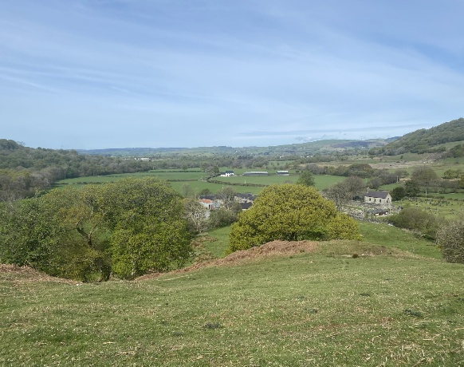
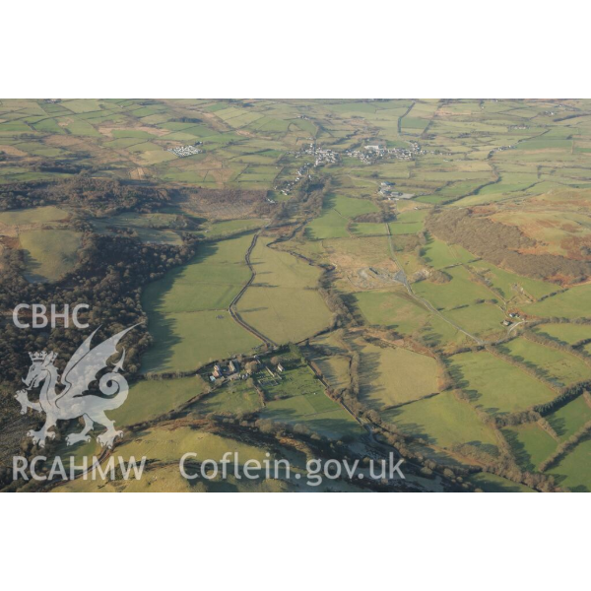
Strata Florida is considered one of the largest Cistercian abbeys, spanning potentially over 120 acres of land, within the Teifi valley floor(Administrator, 2013). The surroundings of Strata Florida in Ceredigion are conducive to archaeological exploration. It is situated in a wide, flat valley within the Cambrian Mountains, close to the River Teifi. This would have been a suitable place for the Cistercian monks, as the river would have provided water and the surrounding land would have provided arable land for farming. The openness and gentle slopes would have facilitated building and the growing of food. Forest and local hills offered natural protection and resources like wood. My observations of the area seem to suggest earlier field systems and tracks, which hint at previous land use. Overall, the topography shows how the physical landscape influenced where and how people worked and lived at Strata Florida.
Figure 2 – Aerial view of Teifi Valley, Driver, T.G - 2007
The first day Quentin spent with us, he took us around the abbey on foot and explained to us the defining features and periods that constitute the history of the abbey. The first and most important thing to include in discussion was the landscape itself. Below the statue of the pilgrim, we sat for about two hours discussing the landscape features. It is simple to see that at the end of the Ice Age, a glacier ran through the valley, flattening it down and widening the valley floor(Woodbury, 2012). At Strata Florida, glaciation created obvious U-shaped valley features and deposited glacial till, which affected later land use. The low-lying terrain surrounding the abbey would likely have been a factor in the location of the abbey, enabling a firm and pragmatic foundation to be achieved for construction, farming, and monastic life(Hambrey et al., 2001).
Figure 3 – View from hill of the Teifi Valley – S. Green - 2025
As we drew towards early afternoon, we wandered through the cemetery observing the peculiar alterations in the ground. The first observation we made was the mounds close to graves, and Quentin explained that these mounds were created by ant colonies; the ants colonize there because the soil is loose and disturbed, basically forming small mounds pushed against the tombstones. Something else that we observed was that there was a bank going through the graveyard. We waited there for a bit and observed that the bank was connecting the two trees that were present in the graveyard. This made us wonder if it had any sort of significance behind it, a purpose, or if it was a natural phenomenon. We took a hypothesis that perhaps it was intentional landscaping or some leftover ancient burial practices. Nevertheless, excavation of a cemetery cannot be done for ethical purposes. The cemetery further might be protected legislatively by provisions, for example, the Cultural Heritage Law depending on how long the graves have been there(Brown, Frisby and Prior, 2024)
More broadly, the day provided a chance to view a landscape from an archaeological perspective. It helped to make us think more critically about how we might respond to the environment we live in and reflect on human agency on the land. It also helped by allowing us, on later days, to be able to have such structured discussions which were more related to the archaeology of the landscape and broader cultural and historical contexts which might influence what we observe in the field.
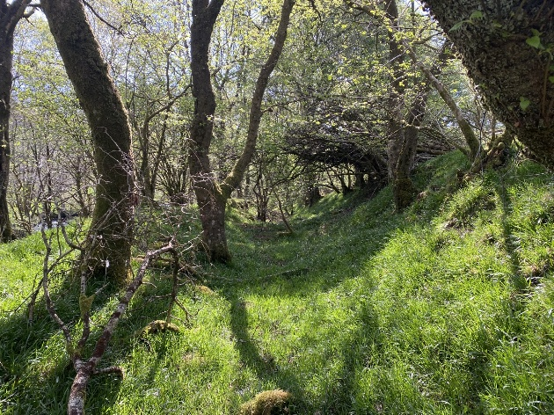
On Tuesday we walked around the Abbey Woods. The first things we noticed were earth bank structures and stone walls. These stone walls and earth banks would have been a road for horse and carriage to travel down for those people who were not visiting the abbey. This is because to travel through the abbey grounds you needed to pay a road toll fee. This is not strongly supported by evidence, but the fees would have likely been applicable in the 1800s and during the Rebecca Riot period (1839–1844), when there were rural places in Ceredigion and Carmarthenshire that imposed road tolls and charges (Rees, 2011). Although the original function of the wall and bank road would not have been to circumvent road tolls during the medieval era, they would have continued to be utilized in the 19th century as rural Wales did not develop as quickly, with older infrastructure proving still useful. The fact that such walls were built from local stone is indicative of a desire to clearly define routes, control the movement of livestock, and preserve boundaries through woodlands. Similarly, the earth banks, most likely built by heaping up topsoil excavated from adjacent ditches, moved the pathway upwards for better drainage and stability, especially in wetter environments(Hilling, 2018). Their existence indicates continued, even evolutionary, utilization during different eras of history, illustrating how medieval land use impacted the landscape beyond the medieval period.
Figure 4 – Picture of the wall and bank road in the Abbey Mines – S. Green - 2025
Along the return journey we encountered a split stream. At first, we did not pay much attention to the stream until we went further and came across an old water mill; this highly connects with the utilization of waterpower by the Cistercian monks to develop an independent economy. Water mills were required for grain grinding and performance of other field tasks, confirming the advanced expertise in hydraulic engineering possessed by the monks and their reliance upon effective, sustainable technology to power monastic life as well as outside community requirements(Butler, 2005).
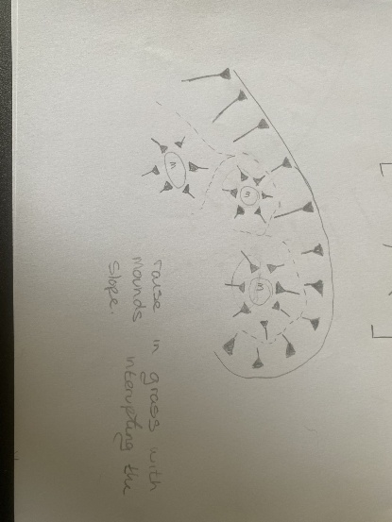
During the following few days, our attention turned to hachure surveys, a historic method of mapping landforms. Hachure maps employ short parallel lines known as hachures to portray shape and steepness in two dimensions ahead of the general use of contour lines (billboyheritagesurvey, 2014). It was created by Austrian military officer Johann Georg Lehmann in 1799 to assist the military in understanding battlefield terrain better. His system was earlier than modern European topographic mapping with more precise instruments.
Figure 5 – Hachure diagram of mound the bumpy field S. Green - 2025
Hachure surveys encourage a more intimate relationship with the landscape in that the surveyor observes and traces on paper what he or she is observing, in contrast to aerial photography, which tends to provide only a visual impression. The method is cheap and accessible, requiring no expensive equipment, but it is subjective surveys can be read differently by different surveyors. On the other hand, recent technologies like LiDAR have rich, objective height data at a high expense, requiring expert personnel to work with, and with the need for extensive processing of data. Hachure surveys are rapidly achievable at the field location without the use of high technology and are therefore effective for rapid field sketching and instruction where instant visual interpretation is needed (Schindling and Gibbes, 2014).
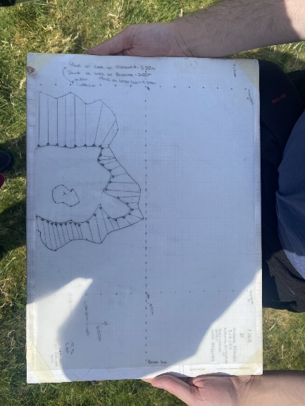
We hachured the rough field over several days. It was a nice place to begin, as it featured only small bumps, a tree, and a spoil heap from an old pit. We began by hachuring, then did a rapid measured survey. This involved having to select a temporary benchmark, something that won't alter, so that we could measure alterations in future surveys. We decided on a stone that was familiar to everyone, and Quentin marked it with an X. We began the measured survey on Wednesday of the second week, applying skills previously learned to record the landscape from an archaeological perspective.
Figure 6 – Rapid survey map from the first day – S. Green - 2025
I worked in a group of three, which was very beneficial to us as it allowed two to measure and one to plot the points on the grid. We started of setting up our grid on the ground, which consisted of us setting up three tape measures, a base line and two other tapes transecting that lane about 15m apart from each other, this created our axis. From that point we set the axis up on our paper and started plotting points. On the first day of doing this, we managed to get the outline of the tree measured and placed on the hachure survey lines, making the lines denser on the steeper areas.
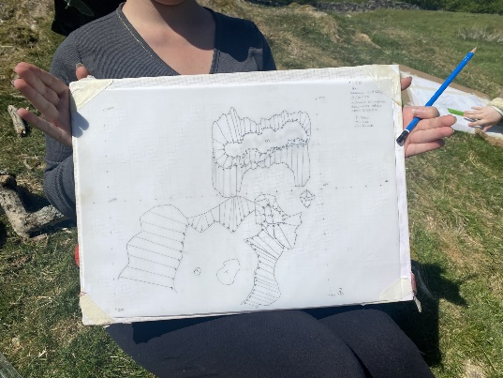
On the second day we managed to add a few mounds that could be identifiable around the tree that can be seen on figure 7. Once we got this down, we were able to start on the dumpy levels.
Figure 7 – Rapid survey map after we had finished the tree and mounds around it – S. Green - 2025
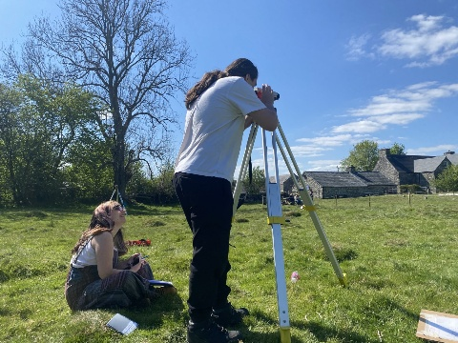
A dumpy level is a precise optical instrument used in archaeology to measure height differences and create accurate topographic profiles of a site. It helps archaeologists record the elevation of features, structures, and trenches during excavation. Using a tripod, levelling staff, and the instrument itself, the dumpy level ensures reliable horizontal readings, essential for mapping and understanding stratigraphy. Although newer digital tools exist, the dumpy level remains a trusted method in field archaeology due to its accuracy, simplicity, and ability to produce consistent data across a site(Dinsmoor, 1977).
Figure 8 – Leon using a dumpy level and Kip recording the measurements – S. Green - 2025
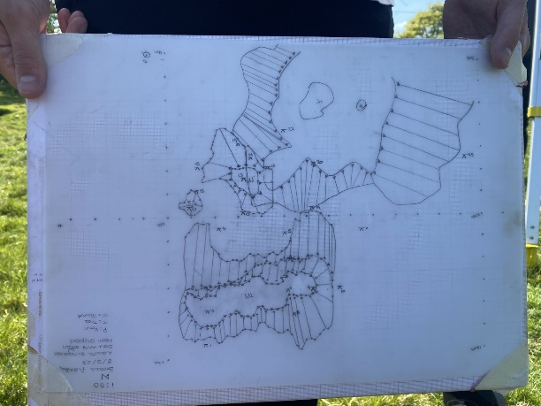
We took readings of the grounds between the mounds we had labelled on our graph with our dumpy level and tripod. We had labelled benchmark points that were labelled 1–25 on our graph, which showed variations in the ground level, and which indicated minor height variations that might be proof of human activity in the past or might reflect natural alterations in the landscape.
Figure 9 – Finished rapid survey map, with benchmarks on – S. Green - 2025
In general, the experience at Strata Florida increased my experiential knowledge of archaeological fieldwork hugely, in addition to increased appreciation for the ways in which landscapes evolve and present human occupation over time. Technical skill and interpretative consideration were built up in a blend of guided walks, communal practice in surveying, and practical techniques like hachure drawing and dumpy level operation. Working with students from mixed backgrounds assisted me in building confidence in gaining information through shared knowledge. The past context of the abbey as well as its local setting provided a strong background for implementing these methods, placing theory within everyday life. Moreover, working on different aspects of the site, ranging from glacial scenery to possible 19th-century routes, focused on intricate layering of people and nature processes that create heritage landscapes. Lastly, this fieldwork not only served as an educational exercise but also emphasized the necessity of critical observation and reflective practice in archaeological interpretation.

Bibliography
Administrator, walesonline (2013) Welsh History Month: Strata Florida abbey, Wales Online.
billboyheritagesurvey (2014) ‘The slippery slope: CAD hachures’, Billboyheritagesurvey’s Blog, 13 March. Available at: https://billboyheritagesurvey.wordpress.com/2014/03/13/the-slippery-slope-cad-hachures/ (Accessed: 13 May 2025).
Brown, D.T., Frisby, H. and Prior, S. (2024) ‘Grave communications: how an understanding of gravedigging practices informs post-medieval cemetery excavations and interpretations’, Post-Medieval Archaeology, 58(1), pp. 100–120. Available at: https://doi.org/10.1080/00794236.2024.2356653.
Butler, L. (2005) ‘Monastic Landscapes’, The Antiquaries Journal, 85, pp. 423–423. Available at: https://doi.org/10.1017/S0003581500074734.
Dinsmoor, W.B. (1977) ‘The Archaeological Field Staff: The Architect’, Journal of Field Archaeology, 4(3), pp. 309–328. Available at: https://doi.org/10.1179/009346977791490212.
Driver, T.G. (2007) AP_2007_4937 [Digital Photo]. Available at: https://rcahmw.ibase.media/en/view-item?i=65618&WINID=1747146832549.
Hambrey, M.J. et al. (2001) ‘Devensian glacigenic sedimentation and landscape evolution in the Cardigan area of southwest Wales’, Journal of Quaternary Science, 16(5), pp. 455–482. Available at: https://doi.org/10.1002/jqs.639.
Hilling, J.B. (2018) The Architecture of Wales: From the First to the Twenty-First Century. University of Wales Press.
Rees, L.A. (2011) ‘Paternalism and rural protest: the Rebecca riots and the landed interest of south-west Wales’, Agricultural History Review, 59(1), pp. 36–60.
Schindling, J. and Gibbes, C. (2014) ‘LiDAR as a tool for archaeological research: a case study’, Archaeological and Anthropological Sciences, 6(4), pp. 411–423. Available at: https://doi.org/10.1007/s12520-014-0178-3.
Woodbury, S. (2012) ‘Strata Florida Abbey’, 2 June. Available at: https://www.sarahwoodbury.com/strata-florida-abbey-1-june-2012/ (Accessed: 13 May 2025).

