BMIH 6001 Contemporary Themes in the Hotel and Hospitality Sector (Research paper)

Student Name: Mihaela Mirabela Martineac
Student ID: 2013903
Course: Contemporary Themes in the Hotel and Hospitality Sector
Table of Contents
1. Introduction 3
2. Overview of Literature 4
3. Application to the Hotel and Hospitality Sector 8
4. Recommendations and Future Policies to Implement 12
5. Conclusion 13
References 14

1. Introduction
As indicated by Statista Research Department (2023), there has been a huge upscale in global tourism in the last 70 years and tourism and hospitality industries are closely related. With the increase in this global tourism, certain issues arise as well, which aligns with the findings of Jamal and Budke (2020). One such issue is sustainability, which is selected as the theme for this report.
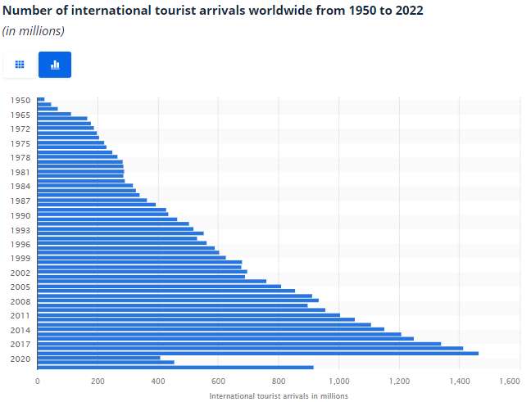
Figure 1: Statistics of International Tourist Arrivals from 1950 to 2022
(Source: Statista Research Department, 2023)
As indicated by Qadri et al. (2022), with the increase in environmental consciousness, the hospitality industry has stepped up and embraced sustainability as the fundamental principle. From luxurious resorts to boutique hotels, this evolving trend has revolutionised the way people travel, stay as well as indulge in memorable experiences. In the United Kingdom, sustainability has transformed a cornerstone of the hospitality activity and has shown a deep commitment to reducing the environmental impact as well as to conserving resources and supporting the local communities.
The paper focuses on the contemporary theme of sustainability in the hospitality sector and takes the example of Premier Inn to better show the practices done in the industry. The central company reviewed in the paper, Premier Inn, a well-named and established chain of hotels, provides the context for the research. By evaluating Premier Inn's approach to sustainability and its management response to this contemporary issue, the research aims to analyse the real impacts of sustainable practices within the hotel industry.

2. Overview of Literature
As indicated by Statista Research Department (2022), the increase in global tourism has led to the development of the hospitality sector as well because the tourism and hospitality industries are related, which is also opined by Meo et al. (2022). It has also been made clear by Jamal and Budke (2020) that the hospitality industry with this increase has faced several issues through the years. It has been made clear by Jones, Hillier and Comfort (2017) that sustainability is one such issue, which is selected as the contemporary theme of this report.
Sustainability has been a crucial area of focus for the hospitality industry because of the increasing global concerns over environmental degradation as well as for the need for responsible business practices. The scholars have extensively examined the sustainable practices within the industry so that effective strategies can be outlined for reducing environmental impacts, enhancing operational efficacy as well as for meeting the social norms set by the conscious customers. The inclusion criteria for this research paper's literature review are scholarly papers, journals, articles and any necessary and related company-specific data over the last 10 years, that is, from 2013 to 2023. The exclusion criteria for this research report are unverified papers, unpublished papers, articles, journals, scholarly papers or any other form of document past the 10 years’ time period set. The research will also provide references from only papers with open access or with a downloadable pdf available over the internet, also journals and research made by the hotel to improve the hospitality sector.
According to Raub and Martin-Rios (2019), sustainability in the hotel industry involves a range of initiatives aimed at minimising the ecological footprint, conserving resources, and promoting shared accountability. The Triple Bottom Line approach (TBL) is one such theory that can underpin sustainability efforts in the industry. The TBL approach was proposed by Elkington in 1994 (Elkington, 2013), which emphasises the simultaneous pursuit of economic prosperity, social well-being as well as environmental stewardship. It is indicated by Elkington in his paper that by adopting the TBL approach the hotels can have a sustainable development and would be able to balance the financial profitability, social equity as well as environmental conservation. Figure 2 explains the concept of the Triple Bottom Line. As shown, that figure, TBL framework revolves around 3 aspects of business, namely, profits, people, and the planet. The profits aspect helps retain the financial stability of the company, the people aspect represents the social aspect of the company, and the planet aspect revolves around the environmental sustainability of the company (Wallstreetmojo Team, 2023).
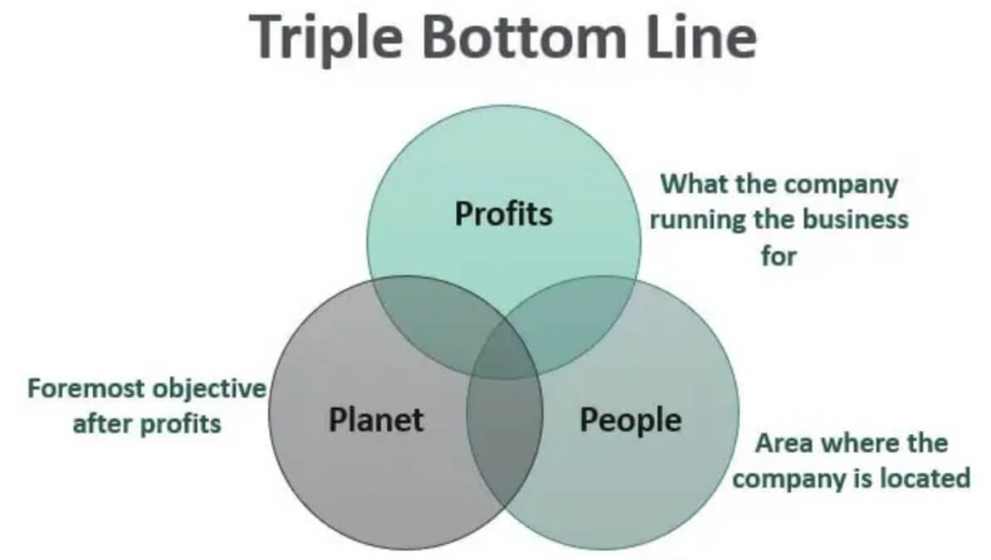
Figure 2: Triple Bottom Line by Elkington
(Source: Wallstreetmojo Team, 2023)
While in pursuit of sustainable practices in the hotel and hospitality industry, energy conservation has been a topic of discussion for many conscious people as well as many companies. It is opined by Gössling and Peeters (2015) that energy usage in hotels is one of the major contributors to a substantial part of the surrounding environmental impact. This issue can be addressed by implementing energy-efficient appliances. It is opined by Trotta (2018) that energy-saving appliances like smart lighting systems, energy-efficient appliances as well as occupancy sensors can help in reducing the energy consumption. This can also help in reducing the costs incurred by the hotels.

Table 1: Summary of Effective Practices Found in Literature Review
(Source: Created by Author)
Waste reduction and recycling have gained significant attention as part of sustainability efforts in the hospitality industry. Bortoleto (2014) has emphasised the importance of waste management practices in reducing environmental impacts, which aligned with the thoughts of Kucukvar, Egilmez and Tatari (2014). Hotels have implemented waste segregation programs, composting initiatives as well as partnerships with local recycling facilities to minimise circular economy and it aims to maximise resource efficiency by reusing and recycling materials throughout the value chain.
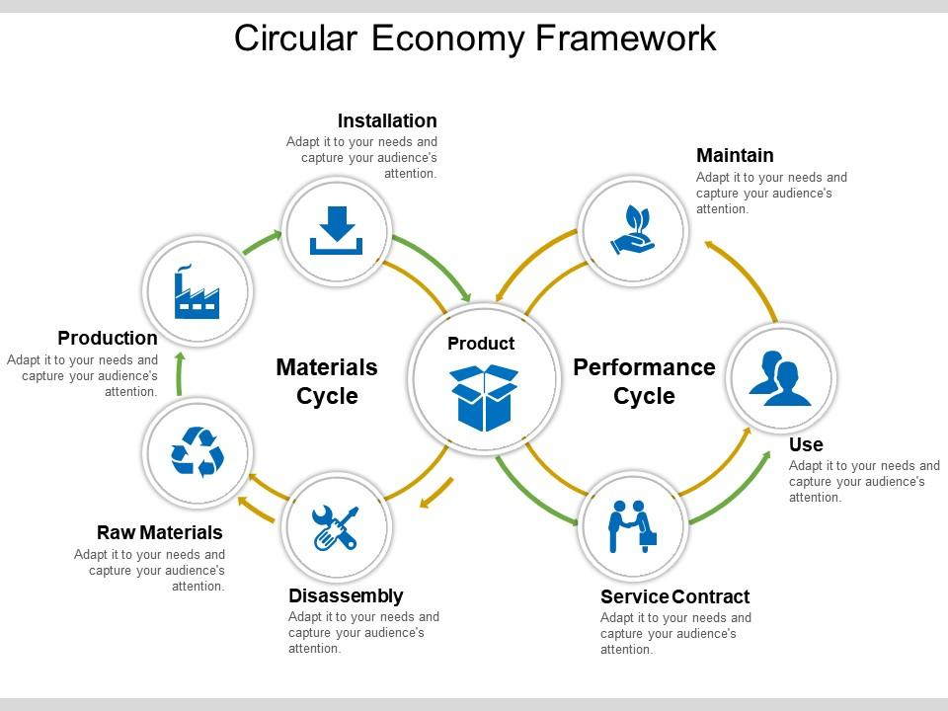
Figure 3: Circular Economy Framework
(Source: SlideTeam, 2023)
The circular economy is a business concept that tries to reduce waste and promote sustainability by reusing resources for as long as feasible (Xavier et al., 2021). It differs from the typical linear economy, which operates on a "take-make-dispose" model. Resources are continually exchanged in a circular economy, and their worth is maximised throughout their existence. It is indicated by Goyal, Esposito and Kapoor (2018) that the circular economy concept is based on natural ecosystems, in which waste from one creature becomes a useful resource for another. Similarly, items and materials in a circular economy are meant to be reused, mended, remanufactured, or recycled rather than thrown after use.

3. Application to the Hotel and Hospitality Sector
The application of sustainability in the hotel and hospitality sector will be explored with a specific attention on Premier Inn. The section will also examine Premier Inn's sustainability initiatives as well as provide an analysis of the real impacts of these sustainable practices within the industry. Premier Inn has demonstrated a strong commitment to implementing sustainable methods into its operations to reduce the carbon footprint of the company. According to Reuters (2021), the company has announced that it aims to achieve the goal of zero carbon emissions by the year 2040.
Premier Inn has a clear vision about achieving this sustainability goal and has focused on several areas for achieving this. One such area of focus for the company is energy efficiency. Premier Inn has invested in energy-efficient building designs and technologies, which include the use of LED lighting, smart thermostats as well as motion sensors so that the company can save not only the energy expended but also can reduce the cost. The company has developed a partnership with an energy firm named E.ON, which has also helped the company install lithium-ion batteries at the 200-room hotel to manage the energy efficiency of the hotel (Newsroom, 2019).
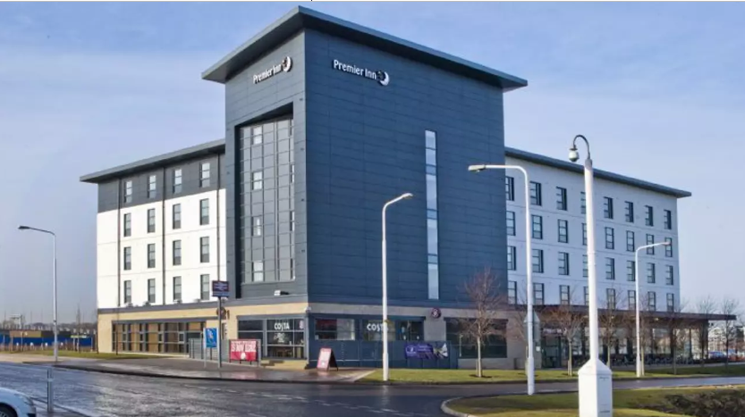
Figure 4: Premier Inn Lithium-Ion Battery-Powered Hotel
(Source: Newsroom, 2019)
Premier Inn has also embraced renewable energy sources, which helps the company power its operations. The company has installed solar panels and has partnered with other companies like E.ON to reach the levels of environmental sustainability promised by it (Newsroom, 2019). The mother company of Premier Inn, Whitbread has also completed the installation of more than 85 solar arrays at hotel locations across the UK, which was expected to deliver more than £280,000 in energy cost savings in one year (Saur News Bureau, 2016). The solar arrays installed will provide the company with an expected amount of 1,326,000 kWh of power, which in turn will help the company cut around 6,132 tons of Carbon emissions per year. This dedication to renewable energy has not only helped Premier Inn become more sustainable, but it has also assisted Premier Inn in mitigating the impact of variable energy prices.
Premier Inn has also focused a great deal on managing the waste produced by the company. This is another great initiative launched by the company to implement sustainable strategies into the company's core operations. Premier Inn has implemented various comprehensive recycling programmes, which will help the company achieve its target. According to Hospitality Net (2019), the company has vowed to eliminate all excessive objects and one time use plastics from all their hotels by the year 2025. This will help the company move a step closer to realising its target of zero carbon. The company has stated that they believe that this is one of the biggest commitments across the hotel industry and this will help shape the future by making it a sustainable one.
Premier Inn has wholeheartedly acknowledged the importance of employee engagement as well. The company has accepted the importance of employee engagement in implementing sustainable practices, for which the company offers training courses to its employees to help them uphold sustainability in the company operations. As indicated by Whitbread Plc (2021), the company provides training to its employees in such a way that they can be made industry ready and sustainability is a big part of the hotel and hospitality industry, which is agreed by the company. The company according to its ESG report of 2020 and 2021 stated that it is greatly concerned about the environment and thus always operates in a way that can be respectful towards the environment.
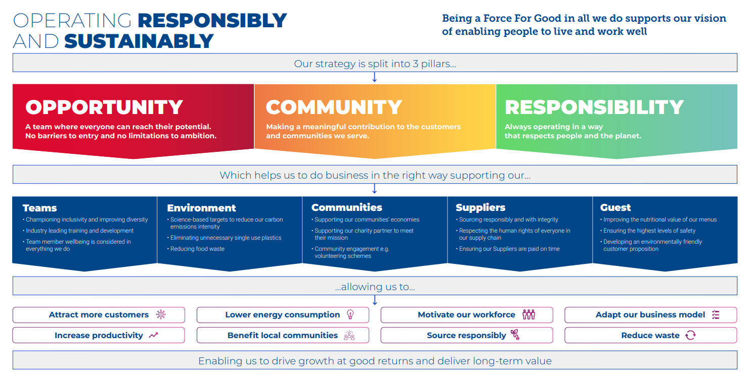
Figure 5: Whitbread Strategy
(Source: Whitbread Plc, 2021)
However, despite Premier Inn's admirable efforts, there are significant limitations and hurdles to implementing sustainability in the hotel sector. One of the most difficult difficulties is reconciling sustainability aims with financial concerns. Sustainable practices can necessitate large investments in infrastructure renovations, renewable energy installations, and personnel training (Lema et al., 2021). While these expenditures may result in long-term cost benefits, they can also bring immediate financial challenges, especially for smaller hotels with limited resources. Overcoming this obstacle necessitates a mental change towards viewing sustainability as a long-term investment rather than a short-term expenditure, which can be particularly difficult for smaller hotels.
The intricacy of supply chain management is another barrier. Hotels rely on a variety of suppliers for various products and services and hence it is critical that these suppliers follow sustainable practices (Dahlmann and Roehrich, 2019). Premier Inn has taken the initiative to engage with suppliers and encourage them to use sustainable buying practises. However, guaranteeing the overall sustainability of the supply chain continues to be a difficulty for the hotel sector.
It is critical to recognise that the effective adoption of sustainable practices in the hotel business is heavily reliant on the dedication and collaboration of numerous stakeholders. To encourage sustainability, Premier Inn has actively worked with guests, workers, local communities, and industry partners. Premier Inn's sustainability initiatives extend beyond its own operations and have a positive impact on its guests, employees, local communities, and industry partners. Premier Inn has made a beneficial environmental effect outside its own operations by promoting awareness among guests and encouraging their participation in sustainable activities. The firm has also worked on environmental initiatives with local communities, benefiting their well-being and establishing a positive brand image, having a good reputation that last for years.
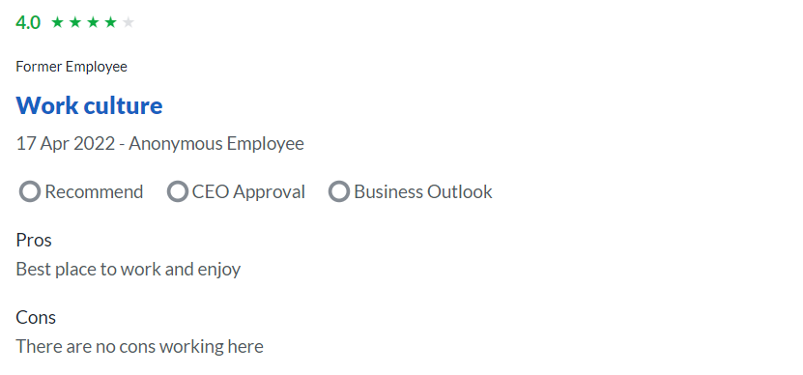
Figure 6: Review of Premier Inn Former Employee
(Source: Glassdoor, 2023)
The use of sustainable practises by Premier Inn within the hotel and hospitality sector acts as a paradigm for the industry. The employees of the company have also shared their personal feelings about the company and have stated that the company has no real cons. Figure 6 shows the response of a former employee of the company who stated that the company is the best place to work at, which aligns with the opinion of the present employee of Premier Inn as shown in Figure 7. Premier Inn has proved that sustainability can be integrated into all elements of hotel operations by focusing on energy efficiency, renewable energy adoption, trash management, and staff involvement. Despite hurdles such as budgetary constraints and supply chain complexity, Premier Inn's dedication to sustainability serves as a model for other hotels to emulate. By tackling these issues and encouraging stakeholder engagement, the hotel sector can move towards a more sustainable future in which environmental responsibility and commercial success coexist. The efforts of Premier Inn serve as an example to the whole hotel sector to embrace sustainability and make a good influence on the earth.
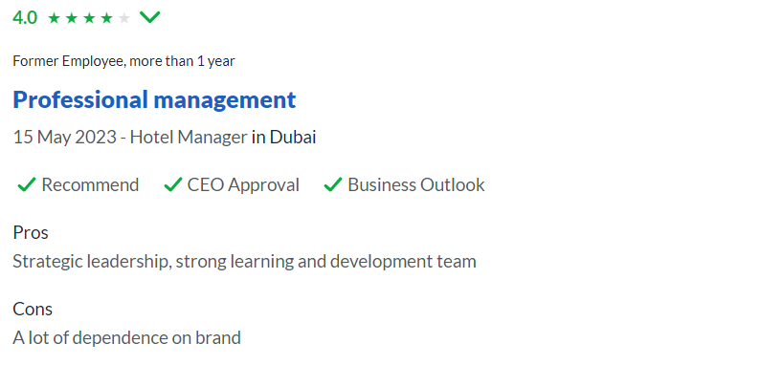
Figure 7: Review of Premier Inn Employee
(Source: Glassdoor, 2023)

4. Recommendations and Future Policies to Implement
In light of the evaluations conducted, numerous basic recommendations for the hotel sector to improve its sustainability performance emerge. Hotels that follow these ideas can help to create a more ecologically responsible future while also benefiting from significant cost savings and an enhanced reputation. The following recommendations are based on research findings in the context of Premier Inn as a case study.
To begin, hotels should prioritise the use of energy-saving devices (Ford and Sturman, 2018). Hotels may dramatically cut their energy use by incorporating smart lighting systems, occupancy sensors, and energy-efficient equipment. This not only improves the environment, but it also saves money in the long run by cutting power costs. A thorough energy audit may uncover areas for improvement and lead to the adoption of energy-saving solutions customised to each hotel's individual needs.
Water conservation methods should also be prioritised. It is indicated by Conrady and Buck (2007) that hotels can install low-flow equipment, such as aerated faucets and showerheads, to reduce water use while maintaining visitor comfort. Additionally, increasing visitor knowledge of the significance of water conservation through educational signs and digital communication channels may encourage responsible water consumption during their stay (Cooper and Hall, 2022). Engaging staff through training programmes to report and swiftly repair any water leaks can help to improve water management efficiency.
As part of a complete sustainability plan, waste reduction and recycling programmes should also be undertaken. Hotels can form alliances with local recycling facilities to guarantee that recyclable items such as paper, plastic, glass, and aluminium are properly disposed of (Tribe, 2009). Additionally, hotels can experiment with novel waste management strategies, such as composting organic garbage, to reduce the quantity of waste transported to landfills. Employee education and frequent communication campaigns can help to create a waste-reduction culture and good waste management practices throughout the organisation.

5. Conclusion
The report has presented a thorough examination of the modern issue of sustainability in the hotel and hospitality business, with Premier Inn serving as the key case study. By investigating the management reaction to sustainability and assessing its actual repercussions, useful insights into the practical implications of sustainable practise in the hotel sector have been achieved. The ideas are intended to help hotels improve their sustainability performance and contribute to a more ecologically responsible future.

References
Bortoleto, A.P., (2014). Waste prevention policy and behaviour: New approaches to reducing waste generation and its environmental impacts. Routledge.
Conrady, R. and Buck, M., (2007). Trends and Issues in Global Tourism... Berlin, Germany: Springer.
Cooper, C. and Hall, C.M., (2022). Contemporary tourism: An international approach. Goodfellow Publishers Ltd.
Dahlmann, F. and Roehrich, J.K., (2019). Sustainable supply chain management and partner engagement to manage climate change information. Business Strategy and the Environment, 28(8), pp.1632-1647.
Elkington, J., (2013). Enter the triple bottom line. In The triple bottom line: Does it all add up? (pp. 1-16). Routledge.
Ford, R.C. and Sturman, M.C., (2018). Managing hospitality organizations: Achieving excellence in the guest experience. SAGE Publications.
Glassdoor, (2023). Premier Inn Reviews. Premier Inn. [Online] Available at: https://www.glassdoor.co.in/Reviews/Premier-Inn-Reviews-E37496.htm [Accessed on: 13 May 2023]
Gössling, S. and Peeters, P., (2015). Assessing tourism's global environmental impact 1900–2050. Journal of Sustainable Tourism, 23(5), pp.639-659.
Goyal, S., Esposito, M. and Kapoor, A., (2018). Circular economy business models in developing economies: lessons from India on reduce, recycle, and reuse paradigms. Thunderbird International Business Review, 60(5), pp.729-740.
Hospitality Net, (2019). Premier Inn Is Removing All Unnecessary Single-Use Plastics From Their Hotels By 2025. [Online] Available at: https://www.hospitalitynet.org/news/4096032.html [Accessed on: 13 May 2023]
Jamal, T. and Budke, C., (2020). Tourism in a world with pandemics: local-global responsibility and action. Journal of tourism futures, 6(2), pp.181-188.
Jones, P., Hillier, D. and Comfort, D., (2017). The sustainable development goals and the tourism and hospitality industry. Athens Journal of Tourism, 4(1), pp.7-18.
Kucukvar, M., Egilmez, G. and Tatari, O., (2014). Evaluating environmental impacts of alternative construction waste management approaches using supply-chain-linked life-cycle analysis. Waste management & research, 32(6), pp.500-508.
Lema, R., Bhamidipati, P.L., Gregersen, C., Hansen, U.E. and Kirchherr, J., (2021). China’s investments in renewable energy in Africa: Creating co-benefits or just cashing-in?. World Development, 141, p.105365.
Meo, M.S., Kanwal, S., Ali, S., Karim, M.Z.A. and Kamboh, A.Z., (2022). The future and challenges of applying innovative technologies in the tourism and hospitality industry in Asia. In Handbook of Technology Application in Tourism in Asia (pp. 1287-1298). Singapore: Springer Nature Singapore.
Newsroom, E., (2019). Premier Inn installs UK’s first hotel-based energy storage unit. [Online] Available at: https://www.edie.net/premier-inn-installs-uks-first-hotel-based-energy-storage-unit/ [Accessed on: 13 May 2023]
Qadri, S.U., Bilal, M.A., Li, M., Ma, Z., Qadri, S., Ye, C. and Rauf, F., (2022). Work environment as a moderator linking green human resources management strategies with turnover intention of millennials: a study of Malaysian hotel industry. Sustainability, 14(12), p.7401.
Raub, S.P. and Martin-Rios, C., (2019). “Think sustainable, act local”–a stakeholder-filter-model for translating SDGs into sustainability initiatives with local impact. International Journal of Contemporary Hospitality Management, 31(6), pp.2428-2447.
Reuters, (2021). Premier-Inn owner vows to reach net zero carbon emissions by 2040. [Online] Available at: https://www.reuters.com/business/sustainable-business/premier-inn-owner-vows-reach-net-zero-carbon-emissions-by-2040-2021-04-21/#:~:text=Premier%2DInn%20owner%20vows%20to%20reach%20net%20zero%20carbon%20emissions%20by%202040,-Reuters [Accessed on: 13 May 2023]
Saur News Bureau, (2016). Whitbread completes installation of 88 solar arrays at Premier Inn sites across UK. [Online] Available at: https://www.saurenergy.com/solar-energy-news/whitbread-completes-installation-88-solar-arrays-premier-inn-sites-across-uk [Accessed on: 13 May 2023]
SlideTeam, (2023). Circular economy framework presentation pictures. [Online] Available at: https://www.slideteam.net/circular-economy-framework-presentation-pictures.html [Accessed on: 13 May 2023]
Statista Research Department, (2023). Number of international tourist arrivals worldwide from 1950 to 2022(in millions). [Online] Available at: https://www.statista.com/statistics/209334/total-number-of-international-tourist-arrivals/ [Accessed on: 13 May 2023]
Tribe, J. ed., (2009). Philosophical issues in tourism (Vol. 37). Channel view publications.
Trotta, G., (2018). Factors affecting energy-saving behaviours and energy efficiency investments in British households. Energy policy, 114, pp.529-539.
Wallstreetmojo Team, (2023). What is a Triple Bottom Line? Triple Bottom Line. [Online] Available at: https://www.wallstreetmojo.com/triple-bottom-line/ [Accessed on: 13 May 2023]
Whitbread Plc, (2021). MAKING A POSITIVE DIFFERENCE. [Online] Available at: https://www.premierinn.com/content/dam/pi/websites/desktop/why/force%20for%20good/final-esg-report-v3.pdf [Accessed on: 13 May 2023]
Xavier, L.H., Giese, E.C., Ribeiro-Duthie, A.C. and Lins, F.A.F., (2021). Sustainability and the circular economy: A theoretical approach focused on e-waste urban mining. Resources Policy, 74, p.101467.

