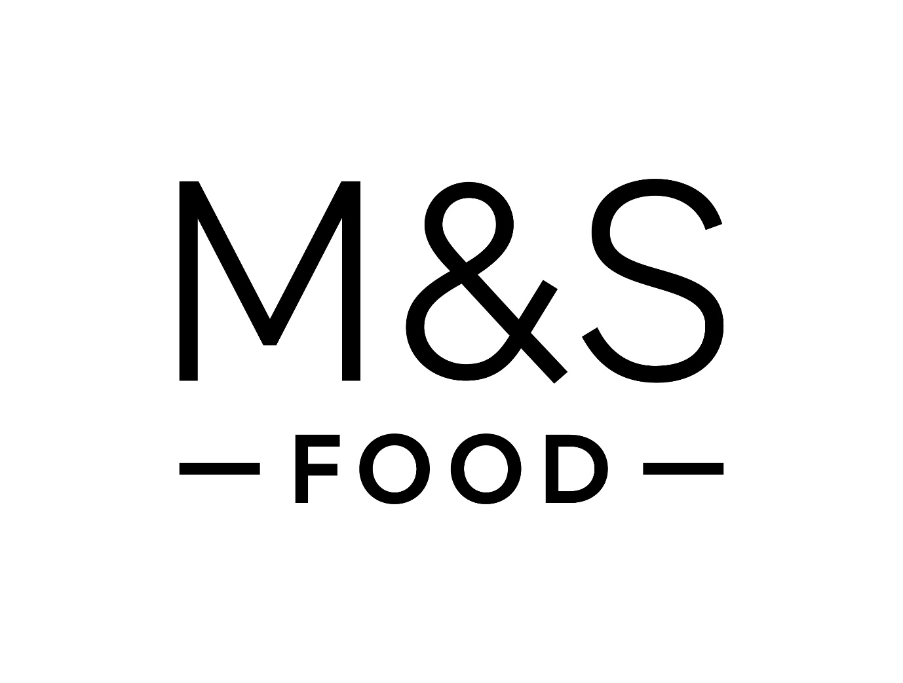

Building Sustainable Marketing Relationships at M&S Food
Author: Salma Farache
Student No.: 2408621
Module: BMSW5007 ‘Building a Sustainable Marketing Relationship’
Tutor: Gwyneth Jones
Date: 24 November 2025

Executive Summary:
The purpose of this report is to analyse how Marks & Spencer (M&S) Food builds and maintains customer relationships through Customer Relationship Management (CRM), Segmentation, Targeting, Positioning (STP), and the 7Ps marketing mix. The research involved a detailed review of academic theory, lecture materials, and industry reports to evaluate the effectiveness of M&S Food’s marketing strategies in creating sustainable customer relationships.
The report finds that M&S successfully combines its traditional image of quality and trust with digital innovation and sustainability. CRM and data analytics play a central role in enabling personalised marketing and improving customer loyalty, while the STP model and 7Ps marketing mix support clear customer value creation.
However, the analysis highlights several challenges, including affordability perceptions, staff turnover, and the need for deeper digital integration with Ocado. The report concludes that M&S should strengthen its customer data systems, enhance ethical transparency, and use artificial intelligence to deepen personalisation and sustain long-term competitive advantage.

Table of Contents

Building Sustainable Marketing Relationships at M&S Food 1
Executive Summary 2
Section 1-introduction 4
Section 2-Findings and Critical Analysis 5

2.1 M&S Food: Organisational Overview……………………………………………5
Section 3-Data and Customer Relationships……………………………………….6

3.1 Relationship Marketing and CRM………………………………………………6
Section 4-CRM Strategy Analysis…………………………………………………….7

4.1 Segmentation, Targeting, and Positioning (STP) 7
4.2 Marketing Mix (7Ps) ………………………………………………………………8
4.3 Ethics, and Sustainability…………………………………………………….…10

4.4 Customer Needs and the 4Cs Model………………………………………….11
4.5 Digital Marketing and Future Opportunities………………………………….12
Section 5-Conclusion and Recommendations……………………………………13
References list…………………………………………………………………………….14
Appendices……………………………………………………………………………….16

Section 1 - Introduction
This report has been prepared for the Marketing Manager of Marks & Spencer (M&S) Food to provide critical insights into how customer relationship marketing (CRM) strategies support sustainable growth, customer retention, and long-term loyalty. It evaluates how M&S Food builds and maintains customer relationships through marketing and relationship-based strategies. Relationship marketing emphasises emotional engagement and loyalty rather than purely transactional exchanges (Buttle and Maklan, 2019; Grönroos, 2017), which is essential in the competitive UK grocery sector.
The report draws on theories from BMSW5007 lectures (University of Wales Trinity Saint David, 2025) and key texts such as Kotler and Keller (2016), Jobber and Ellis-Chadwick (2020), Chaffey and Smith (2022), and Red & Yellow (2022). It also integrates market evidence from The Grocer (2025) and the M&S Annual Report (2025).
M&S Food is a premium British retailer known for quality, innovation, and customer trust. In 2025, its grocery market share reached 4.5%, supported by strong online sales through Ocado. The analysis examines CRM, STP, and the 7Ps marketing mix, alongside ethics, sustainability, and digital marketing, and provides recommendations for strengthening sustainable customer relationships.

Findings and Critical Analysis:

Section 2- Organisational Overview
Marks & Spencer (M&S) was founded in 1884 and has grown from a small market stall into one of the UK’s leading retailers. The Food division became a major strength in the 1970s, known for innovation, high-quality prepared meals, and ethical sourcing.
Its mission, “to make every moment special for customers, through quality, innovation and trust”, reflects a strong focus on customer care and responsible sourcing. These values align with relationship marketing because they aim to build loyalty through consistent quality and trust.
According to the 2025 Annual Report, M&S Food revenue rose by 13.2% in 2024/25, with 6.7% volume growth, showing the success of its customer-centric strategy and digital transformation (Marks & Spencer, 2025). The Grocer (2025) also reports that M&S reached a 4.5% market share, matching Waitrose for the first time, supported by significant online growth through Ocado. Appendix A (Figure 3) summarises its improving position in the UK grocery sector.
Although M&S benefits from premium positioning, it faces challenges such as perceptions of high pricing and limited international expansion. Overall, its development, mission, and performance reflect a strong customer-centric culture. Customer centrality refers to placing the customer at the centre of strategic and operational decisions to create long-term value for both the customer and the organisation (Payne and Frow, 2017). This forms a solid foundation for effective Customer Relationship Management (CRM).

Section 3 – Data and Customer Relationships
3.1- Relationship Marketing and CRM
Relationship marketing focuses on building long-term connections that deliver mutual value (Buttle and Maklan, 2019). Lecture 1 explains that strong relationships depend on trust, commitment, and satisfaction (University of Wales Trinity Saint David, 2025). M&S applies these principles through its Sparks loyalty programme and Ocado partnership, which collect first-party data across online and store channels. This supports personalised communication, such as vouchers based on previous purchases or birthdays, reflecting CRM as a process of creating and enhancing relationships with targeted customers (Buttle and Maklan, 2019).
Personalisation, however, brings data-privacy risks. Under GDPR, M&S must ensure clear consent, secure storage, and transparent use of data. Weak data governance can reduce trust (CIM, 2023), making strong ethical controls essential. A similar approach is seen in Arsenal Football Club’s CRM system, which created a single customer view to strengthen engagement (Inviqa, n.d.). M&S aims for the same emotional loyalty, but fragmented data between Sparks and Ocado limits full visibility of customer behaviour.
M&S also builds relationships through value-added content on Sparks, such as recipes and sustainability tips, supporting engagement beyond transactions (Sheridan, 2019). Effective CRM also requires a supportive culture; as Gummesson (2017) notes, relationship marketing involves the whole organisation. M&S would benefit from further employee training in digital empathy and personalised service.
Overall, CRM at M&S is effective in personalisation and loyalty building, but stronger system integration, predictive analytics, and a unified internal commitment to customer value are needed to enhance long-term relationships (Payne and Frow, 2017).

Section 4 – CRM Strategy Analysis
4.1 - Segmentation, Targeting, and Positioning (STP)
The STP model helps organisations identify and prioritise key customer groups (Kotler and Keller, 2016). Effective segmentation must be measurable, accessible, substantial, and actionable (Smart Insights, 2024). M&S applies demographic and behavioural segmentation to target premium quality seekers, health-conscious shoppers, and convenience-focused families. Through Ocado, it also reaches time-poor professionals who prefer online grocery shopping, strengthening relevance across both premium and convenience markets (Jobber and Ellis-Chadwick, 2020).
M&S positions itself through emotional appeal and sensory branding, supported by its slogan “This is not just food…”, which differentiates the brand through storytelling. Effective positioning must remain consistent and customer-centred (University of Wales Trinity Saint David, 2025). However, affordability limits market reach. The Grocer (2025) notes that M&S is often viewed as expensive, while Mintel (2025) reports that most UK shoppers now prioritise “value-for-quality.” McDonald and Dunbar (2018) emphasise the need to balance segmentation precision with cost efficiency, and Porter (2008) argues that sustainable differentiation depends on strong perceived value.
M&S could strengthen its strategy by using micro-segmentation to target ethical and health-driven consumers and by developing value-tier options without weakening its premium identity. Grönroos (2017) highlights that positioning must combine functional and emotional value, reinforcing the need for fair pricing alongside strong brand storytelling. Integrating Sparks and Ocado behavioural data would improve targeting accuracy and support more personalised offers (Chaffey and Smith, 2022).
Overall, M&S’s STP strategy builds emotional loyalty and brand differentiation but requires greater inclusivity, price adaptability, and enhanced digital segmentation to stay competitive.

4.2 – Marketing Mix (7Ps)
The 7Ps marketing mix (Product, Price, Place, Promotion, People, Process, and Physical Evidence) offers a holistic view of how M&S creates and delivers customer value (Red & Yellow, 2022). M&S follows Porter’s differentiation strategy, focusing on superior quality and innovation to stand out from competitors (Porter, 2008). The 7Ps framework supports this by reinforcing premium products, strong branding, and a consistent, high-quality customer experience

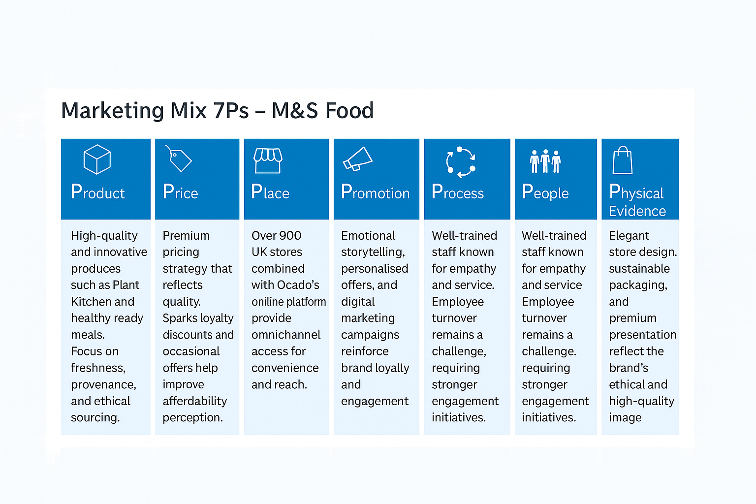
Figure 1: Marketing Mix (7Ps) – M&S Food (Adapted from Red & Yellow, 2022; The Grocer, 2025)
As illustrated in Figure 1, M&S integrates each marketing element to strengthen loyalty and ensure customer satisfaction. The company also targets specific customer groups through its product and pricing strategies. For example, the Plant Kitchen range appeals to health-conscious consumers, while the Remarksable Value line supports price-sensitive families. Through Ocado, M&S promotes convenient ready meals for busy shoppers. These targeted offerings help M&S meet diverse customer needs and build long-term loyalty (NielsenIQ, 2024).
Product: M&S focuses on innovation, freshness, and provenance. Examples include the Plant Kitchen range and healthy ready meals. However, M&S offers fewer low-cost alternatives than Tesco or Aldi. Expanding the Remarksable Value line could attract value-conscious shoppers without harming brand quality (NielsenIQ, 2024).
Price: M&S maintains a premium pricing strategy that supports its quality positioning but limits affordability. The Grocer (2025) reported that M&S’s basket price exceeds Tesco's. Payne and Frow (2017) recommend dynamic, CRM-driven pricing to strengthen loyalty among price-sensitive customers.
Place: M&S combines over 900 UK stores with Ocado’s online platform, creating an omnichannel presence. However, limited international reach restricts potential long-term growth (Kotler and Keller, 2016).
Promotion: M&S is known for emotional storytelling and data-driven promotion. Chaffey and Smith (2022) emphasise that personalised, interactive campaigns increase engagement. Expanding influencer partnerships and user-generated content could help reach younger consumers.
People: Staff empathy and engagement reinforce customer satisfaction, yet high turnover threatens consistency (Blythe, 2018). Investing in training and employee well-being could strengthen service quality (University of Wales Trinity Saint David, 2025).
Process: Efficient systems such as click-and-collect support convenience. Deloitte (2024) notes that using AI in logistics could reduce waste and improve operational speed.
Physical Evidence: Store aesthetics and recyclable packaging reflect M&S’s sustainability values. Aligning digital design with in-store ambience would ensure a consistent customer experience (UWTSD, 2025).

4.3 - Ethics and Sustainability
Ethical marketing and sustainability are central to long-term trust (Peattie and Crane, 2016). Ethical practices support customer expectations for transparency, safety, and responsible sourcing, which strengthens loyalty. Many M&S customers prefer brands that reflect their personal values, especially environmental responsibility and fair supply chains. However, competitors such as Tesco and Waitrose also invest in sustainability, so M&S must continue improving to retain ethically minded consumers (Mintel, 2025).
M&S’s Plan A initiative, “Because there is no Plan B for our planet,” demonstrates its commitment to social responsibility, and Lecture 5 highlighted that transparent ethics strengthen brand credibility. According to the M&S Annual Report (2025), the company has reaffirmed key Plan A goals, including achieving net-zero operations by 2040, signalling strong environmental and social accountability. Red & Yellow (2022) argue that sustainability supports loyalty, while CIM (2023) warns that weak communication can lead to perceptions of “greenwashing.”
M&S has progressed through 100% recyclable packaging and surplus-food redistribution, yet Deloitte (2024) reports that customers expect clearer sustainability metrics. Balancing ethics with profitability is challenging; Jobber and Ellis-Chadwick (2020) note that integrating ethical goals into strategy strengthens long-term competitiveness. M&S should enhance transparency through public dashboards and expand ethical training (Peattie and Crane, 2016). Strengthening partnerships with local and ethical suppliers would further reduce environmental impact and support communities, aligning with Elkington’s (1998) Triple Bottom Line of People, Planet, and Profit.
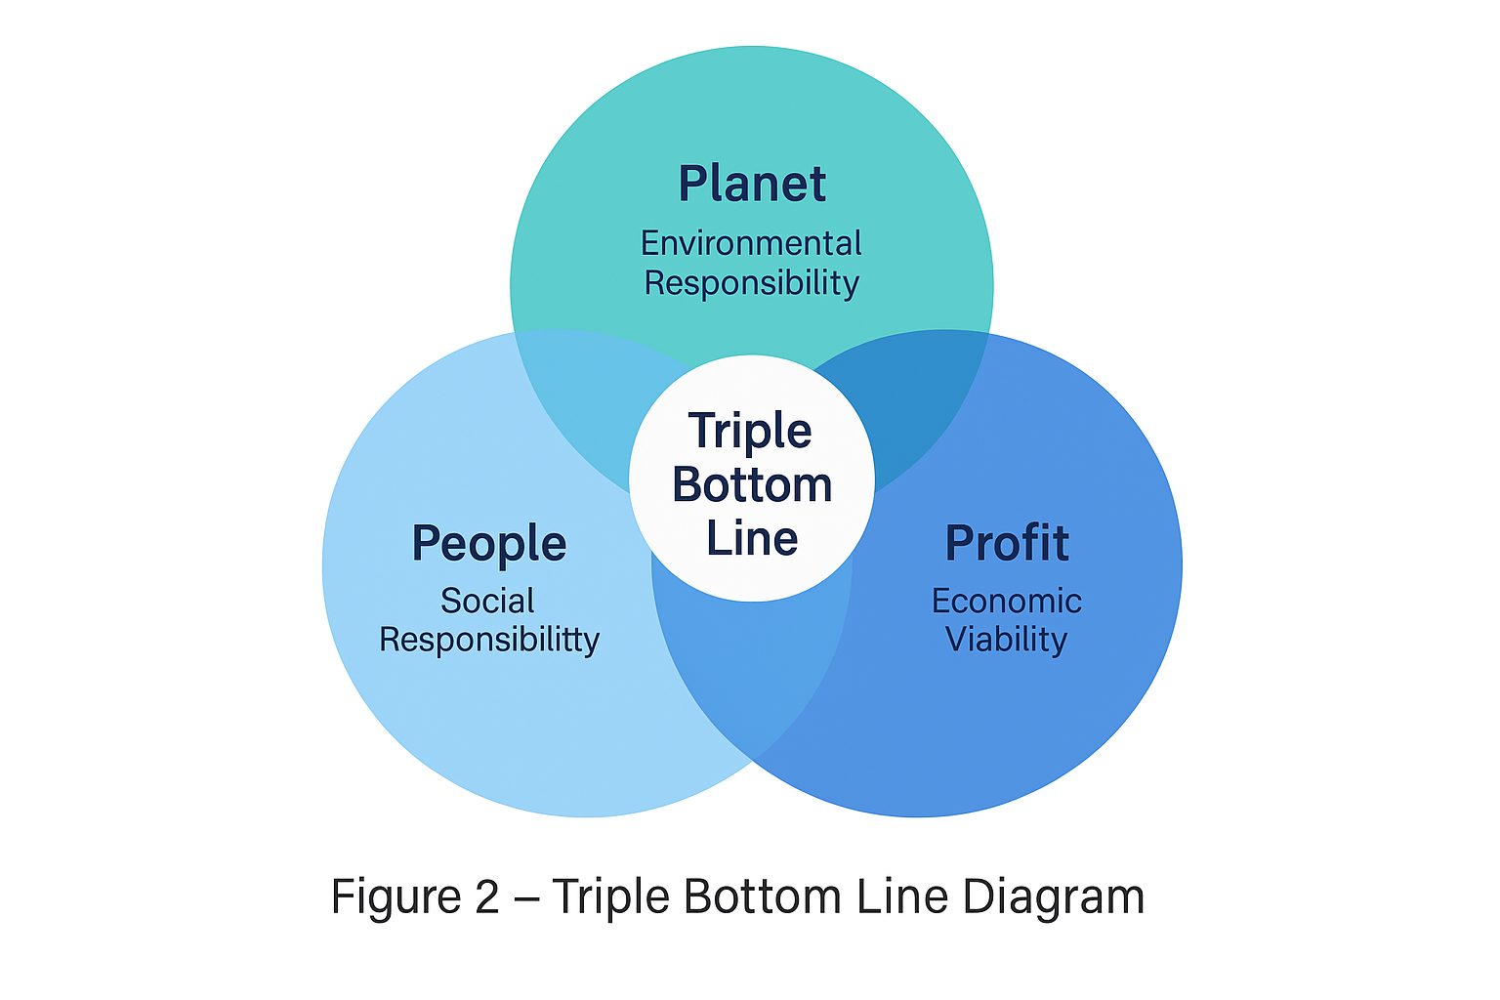
Figure 2: The Triple Bottom Line (People, Planet, Profit) – Applied to M&S Food (Adapted from Elkington, 1998)

As shown in Figure 2, M&S integrates all three sustainability pillars into its operations. Prioritising employee well-being, environmental care, and ethical profitability supports responsible growth and reinforces customer trust.

4.4 - Customer Needs and the 4Cs Model
The 4Cs model, which includes Customer Needs, Cost, Convenience, and Communication, offers a customer-centred alternative to the traditional marketing mix (Lauterborn, 1990). It helps organisations assess how effectively they meet customer expectations.
M&S meets Customer Needs by offering innovative, high-quality, and healthier food ranges that support changing lifestyles. In terms of Cost, the Sparks loyalty scheme provides discounts, although many customers still view M&S as more expensive than Tesco or Aldi. Convenience is supported through the Ocado partnership and click-and-collect services, which make shopping accessible and flexible. Communication is a strong area for M&S, as emotional advertising, personalised emails, and sustainability messages help build trust and engagement.
Overall, M&S applies the 4Cs model effectively but should continue improving affordability and strengthening two-way digital communication to maintain loyalty. Competitors such as Tesco and Aldi attract value-conscious shoppers with lower prices, which means M&S must balance premium quality with better value to support long-term customer relationships (Mintel, 2025).

4.5 - Digital Marketing and Future Opportunities
Digital marketing has transformed how customers engage with brands, and Lecture 6 highlighted that effective omnichannel integration strengthens engagement across all touchpoints (University of Wales Trinity Saint David, 2025). M&S uses its website, mobile app, and Sparks loyalty data to personalise offers. Chaffey and Smith (2022) note that analytics-driven targeting increases customer satisfaction. However, fragmented data and limited use of artificial intelligence still restrict performance.
Deloitte (2024) reported that retailers using predictive analytics achieve higher retention, suggesting that M&S would benefit from machine-learning tools to anticipate behaviour and refine campaigns. NielsenIQ (2024) found that most UK consumers prefer digital updates on sustainability, giving M&S opportunities to expand digital storytelling and eco-focused communication. Porter (2008) argues that lasting advantage depends on uniqueness, and technologies such as augmented reality, virtual experiences, and digital communities could help M&S differentiate its brand.
Digital marketing supports customer centrality by improving personalisation and engagement, but strong digital offerings from Tesco and Aldi mean customers can easily switch if expectations are not met. Without better data integration and stronger AI-driven personalisation, M&S risks losing loyalty. The Sparks app already boosts repeat purchasing through personalised offers, and the success of the Plant Kitchen range shows how targeted products can strengthen satisfaction and retention.

Section 5 - Conclusion and Recommendations
M&S Food has established a strong reputation for quality, trust and ethical values, supported by CRM, STP and the 7Ps marketing mix. These approaches help the company maintain long-term customer relationships and reinforce loyalty in a competitive market. However, the analysis also highlights areas that require improvement, including customer perceptions of high pricing, limited integration between Sparks and Ocado data, restricted international reach and challenges with staff motivation. Addressing these gaps is important for strengthening customer centrality.
To continue developing, M&S should align its marketing strategy more closely with the Triple Bottom Line. Supporting People through better staff training, well-being and consistent service will strengthen customer experience. Protecting the Planet by reducing waste, improving sustainable packaging and communicating environmental progress clearly will build trust. Enhancing Profit through AI-driven personalisation and more flexible pricing can support competitiveness while maintaining ethical values.
Balancing these three dimensions will help M&S achieve sustainable growth. By combining social responsibility, environmental care and data-driven innovation, M&S can deepen emotional loyalty and continue to position itself as a trusted and responsible food retailer (Elkington, 1998; Peattie and Crane, 2016).

Recommendations
- Data integration: Unify Sparks and Ocado databases for a single CRM view.
- Dynamic pricing: Use CRM analytics for flexible offers.
- Employee engagement: Introduce rewards and mental well-being initiatives.
- AI-driven marketing: Adopt predictive analytics for personalisation.
- Ethical transparency: Publish sustainability dashboards and progress reports.
References list:

Arsenal FC CRM Case Study. (n.d.) Inviqa. Available at: https://inviqa.com/case-studies/arsenal-fc (Accessed: 5 November 2025).
Blythe, J. (2018) Consumer Behaviour. 3rd edn. London: Sage Publications.
Buttle, F. and Maklan, S. (2019) Customer Relationship Management: Concepts and Technologies. 3rd edn. London: Routledge.
Chaffey, D. and Smith, P. R. (2022) Digital Marketing Excellence. 7th edn. London: Routledge.
Chartered Institute of Marketing (CIM). (2023) The Role of Digital Ethics in Marketing. London: CIM Publications.
Deloitte. (2024) Global Powers of Retailing 2024: Customer-Centric Innovation. London: Deloitte Insights.
Elkington, J. (1998) Cannibals with Forks: The Triple Bottom Line of 21st Century Business. Oxford: Capstone.
Grönroos, C. (2017) Service Management and Marketing. 5th edn. Chichester: Wiley.
Gummesson, E. (2017) Total Relationship Marketing. 4th edn. Oxford: Butterworth-Heinemann.
Jobber, D. and Ellis-Chadwick, F. (2020) Principles and Practice of Marketing. 9th edn. Maidenhead: McGraw-Hill Education.
Kotler, P. and Keller, K. L. (2016) Marketing Management. 15th edn. Harlow: Pearson Education.
Lauterborn, B. (1990) ‘New marketing litany: Four Ps passé; C-words take over.’ Advertising Age, 61(41), p. 26.

McDonald, M. and Dunbar, I. (2018) Market Segmentation. 5th edn. London: Goodfellow Publishers.
Mintel. (2025) UK Food Retailing Market Report. London: Mintel Group Ltd.
NielsenIQ. (2024) The Future of Grocery Retail. New York: NielsenIQ Reports.
Payne, A. and Frow, P. (2017) Strategic Customer Management. 2nd edn. Cambridge: Cambridge University Press.
Peattie, K. and Crane, A. (2016) ‘Green marketing: legend, myth, farce or prophesy?’ Qualitative Market Research, 19(2), pp. 234–253.
Porter, M. E. (2008) ‘The five competitive forces that shape strategy.’ Harvard Business Review, 86(1), pp. 78–93.
Red & Yellow Creative School of Business. (2022) eMarketing: The Essential Guide to Marketing in a Digital World. 7th edn. Cape Town: Red & Yellow.
Sheridan, M. (2019) They Ask, You Answer: A Revolutionary Approach to Inbound Sales, Content Marketing, and Today’s Digital Consumer. 2nd edn. Hoboken, NJ: Wiley.
Smart Insights. (2024) ‘Segmentation, targeting and positioning (STP marketing).’ Smart Insights. Available at: https://www.smartinsights.com/digital-marketing-strategy/ (Accessed: 7 November 2025).
University of Wales Trinity Saint David. (2025) Lectures 1–6: Building Sustainable Marketing Relationships (BMSW5007) [PowerPoint presentations].
Marks & Spencer. (2025) Annual Report and Financial Statements 2025. London: Marks and Spencer Group plc. Available at: https://corporate.marksandspencer.com/sites/marksandspencer/files/2025-05/Marks-and-Spencer-Group-plc-Annual-Report-and-Financial-Statements-2025_INTERACTIVE_FINAL.pdf (Accessed: 2 November 2025).
The Grocer. (2025) ‘M&S market share level with Waitrose as Ocado sales boom.’ The Grocer, 18 March. Available at: https://www.thegrocer.co.uk/news/mands-market-share-level-with-waitrose-as-ocado-sales-boom/709511.article (Accessed: 5 November 2025).

APPENDICES:
Figure 1: highlights how M&S maintains a balance between premium quality and accessibility across its marketing mix. This integration supports its brand differentiation and strengthens customer trust through consistency and innovation.

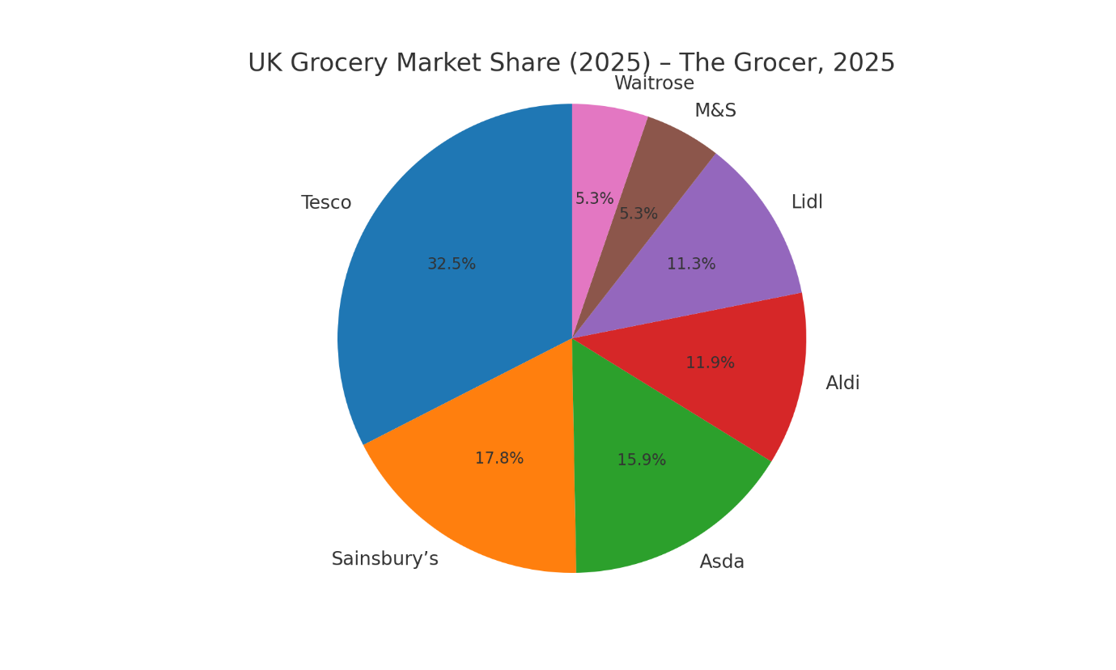
Figure 3: UK Grocery Market Share, 2025 (Source: The Grocer, 2025)

