The design of the building for public and private use, where the restaurant, ice cream parlor and managerial flats are to be located.
The site is located between County Hall and the Marriot Hotel. There are numerous soil highlights and low vegetation in the area. There are no protected plants in the area.
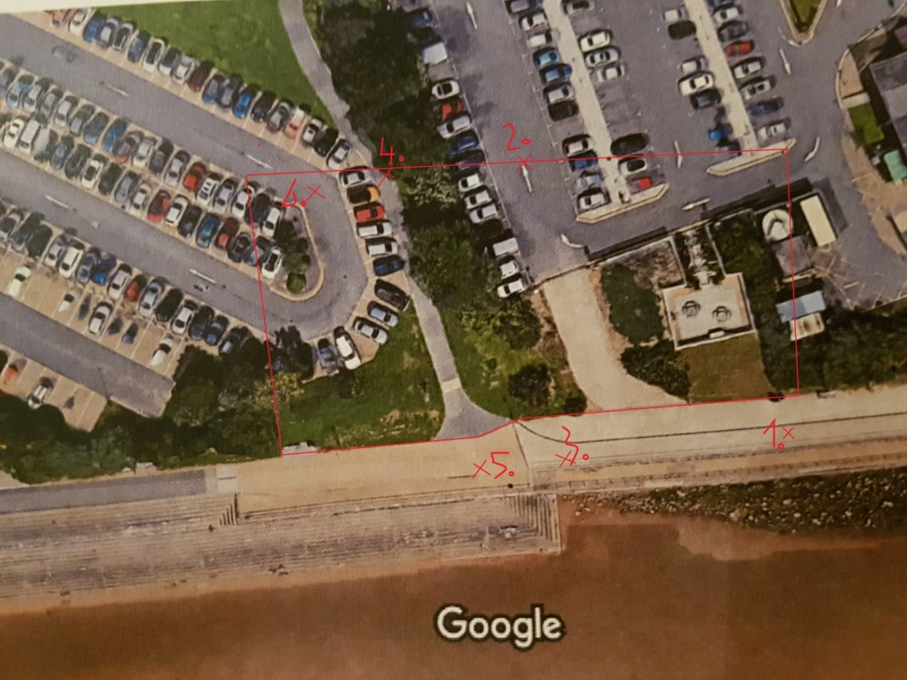
The exact locations of the photographs taken are marked on the map.
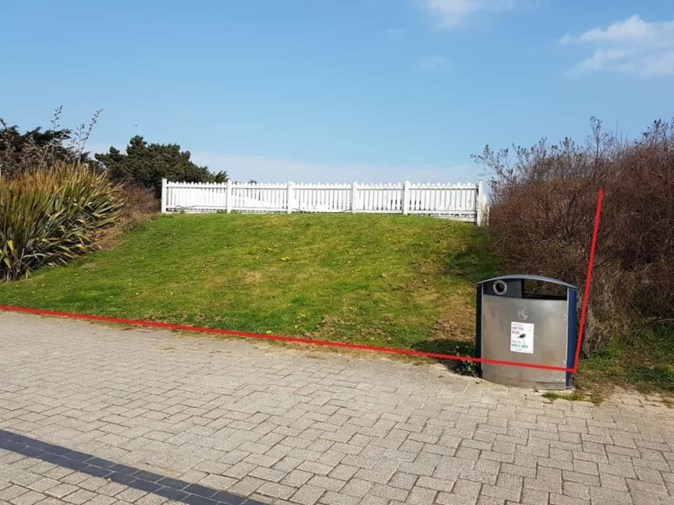
Photograph 1 the red line marks the place of the construction site. Hillocks, soil embosses.

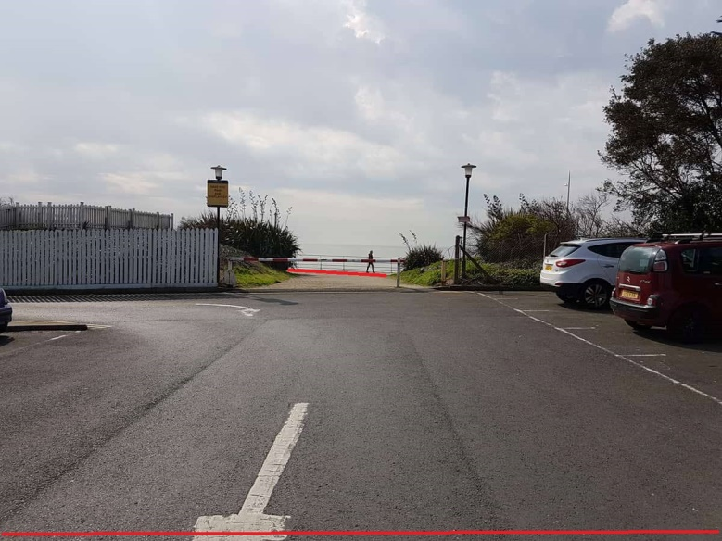
Photograph 2 Part of the car park from the Marriott Hotel.
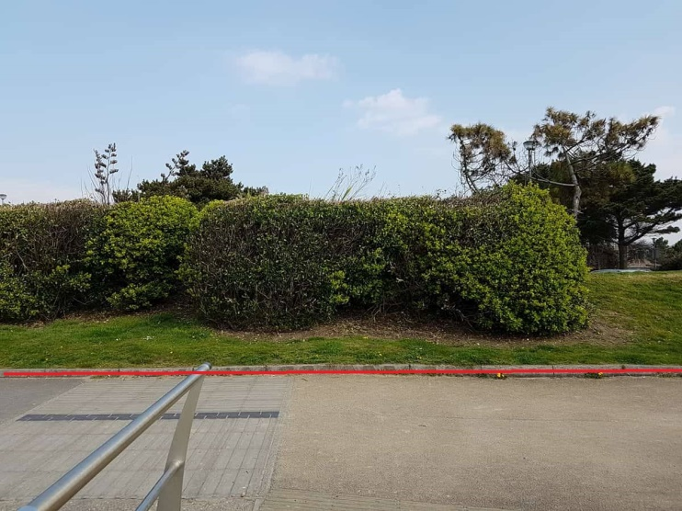
Photograph 3 Vegetation area and elevation of the area.
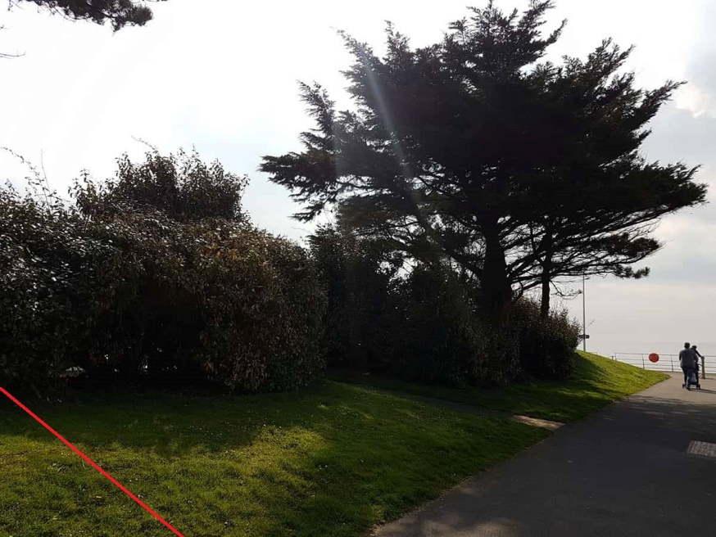
Photograph 4 High vegetation, trees embedded in the construction site.
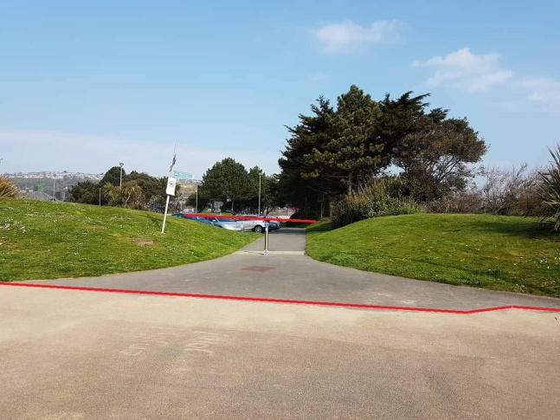
Photograph 5 Walkway for cyclists and pedestrians.
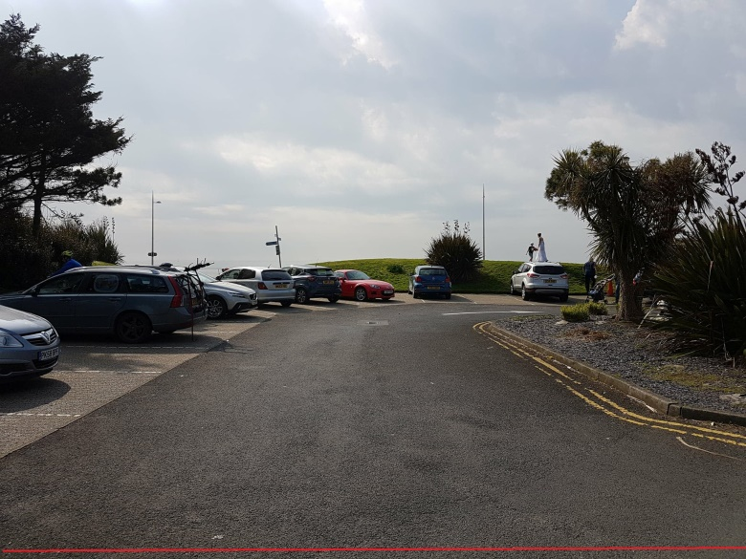
Photograph 6 Another car park

PART 1
SITE SURVEY AND OBSERVATIONS
Ground- water conditions
On the basis of the inspection, the ground substrate was determined as clayey sand. The building is designed with the assumption of a conventional freezing depth of 1m. The building is of a simple, repeatable construction, soil water conditions are defined as simple, groundwater level below the foundation level of the building.
SOIL TYPES IN SWANSEA
The Swansea series consists of very poorly drained organic soils. They formed in 40 to 130 centimeters of highly decomposed organic material over sandy mineral. These soils are in depressions or on flat level areas on uplands and outwash plains. Saturated hydraulic conductivity is moderately high or high in the organic material and very high in the substratum. The mean annual temperature is about 9 degrees Celsius and the mean annual precipitation is about 1143 millimeters.
TAXONOMIC CLASS:
Sandy or sandy-skeletal, mixed, dysic, mesic Terric Haplosaprists

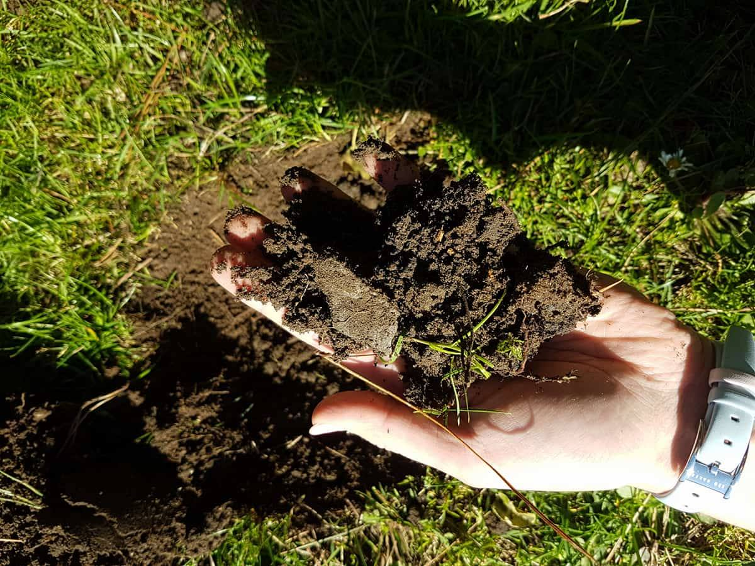
Photographs 1 & 2 of soil
Despite the sunny day, the soil is wet. There are roots and numerous stones in it. Black colour. The best way to get information on the soil is geotechnical investigations. We will learn from them about the composition of the soil, the level of groundwater and physicochemical properties. Geotechnical investigations are carried out by drilling and probing directly on the plot and measurement of soil samples (plasticity,compaction, chemical composition) in the laboratory. 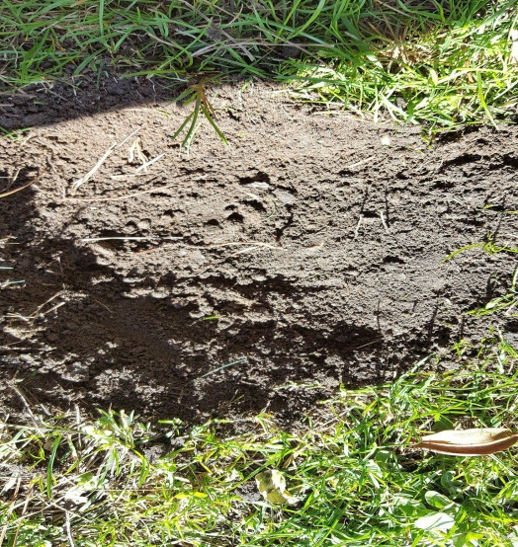
Photographs 3 of soil

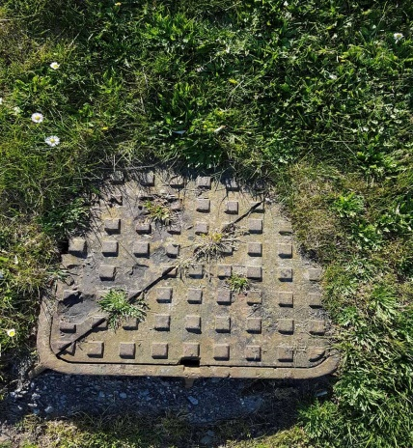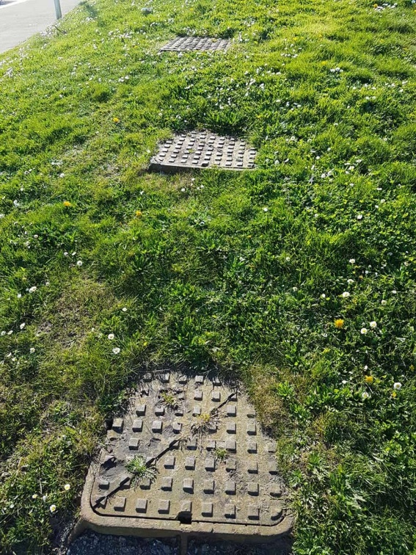
Photographs 4 & 5
I found sewer manholes in a given area. Presented in photographs 4 and 5
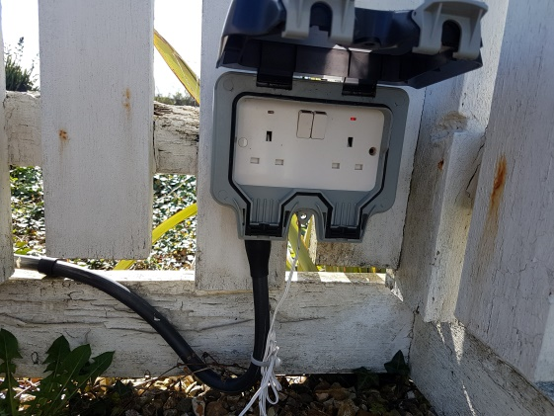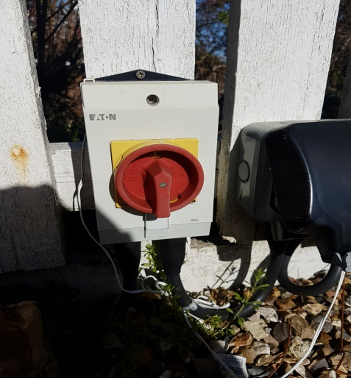
Photographs 6 & 7 External electrical connections

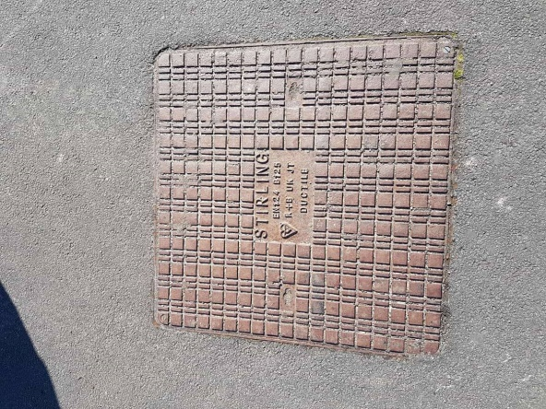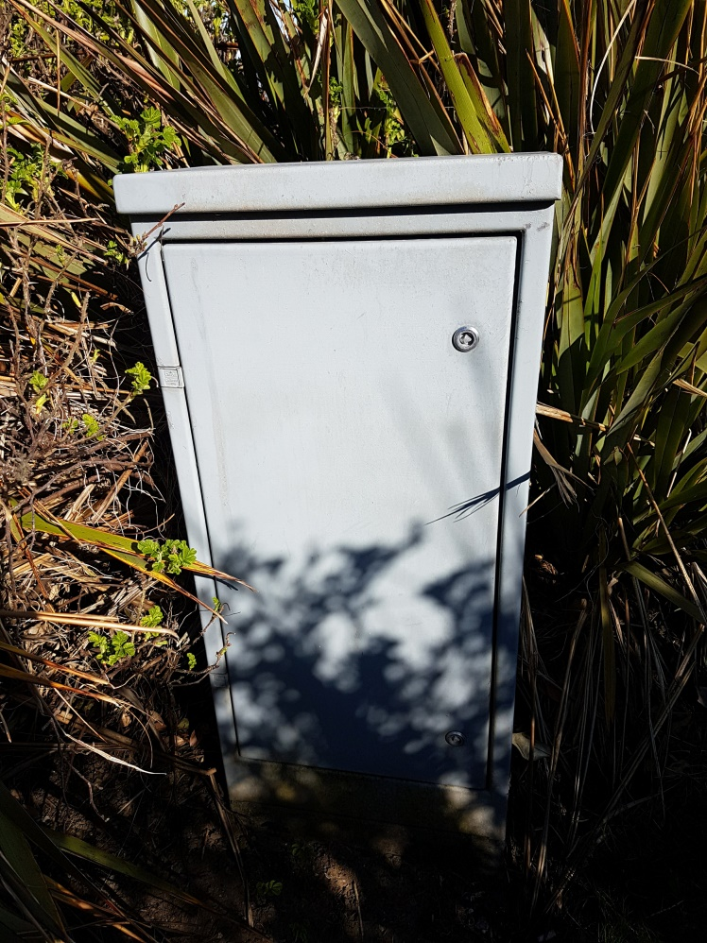
Photographs 8 & 9 Electrical point

PART 2
Classification soils can be classified in many ways, such as geological origin, physical properties, chemical composition and particle size. It was found that the particle size and physical properties of the soil are closely related and are therefore particularly important and interesting for the designer.
We can do a more detailed study of the area using machines that will accurately tell us what ground we have. I will give you some examples that we can use to check the ground.
Site soil Test these tests are designed to evaluate the density or shear strength of soil and are very valuable since they do not disturb the soil under test. Three such tests are the standard penetration test, the vane test and the unconfined compression test. Standard Penetration Test this test measures the resistance of a soil to the penetration of a split spoon or split barrel sampler driven into the bottom of a borehole. The sampler is driven into the soil to a depth of 150mm by a failing standard weight of 65 kg failing though a distance of 760mm. This test establishes the relative density of the soil. (attached is a drawing PART 2 Standard Penetration Test ). Vane Test this test measures the shear strength of soft cohesive soil. The steel vane is pushed into the soft clay soil and rotated by hand at a constant rate. The amount of torque necessary for rotation is measured and the soil shear strength calculated. (attached is a drawing PART 2 Vane Test )
The triaxial test data, it is possible to extract fundamental material parameters about the sample, including its angle of shearing resistance, apparent cohesion, and dilatancy angle. These parameters are then used in computer models to predict how the material will behave in a larger-scale engineering application. An example would be to predict the stability of the soil on a slope, whether the slope will collapse or whether the soil will support the shear stresses of the slope and remain in place. Triaxial tests are used along with other tests to make such engineering predictions.
We can also do a Laboratory Testing tests for identifying and classifying soils with regard to moisture content, liquid limit, plastic limit, particle size distribution and bulk density.
For my project I would do a laboratory test and use a minimally-invasive standard penetration test, additionally I would check the popular Triaxial Shear Test method, which will determine the soil's resistance to pressure.
PART 3
Due to the soil and water conditions, the building can not be built too shallow. Documentation of ground soil testing enables selection of decision making.
For our project, we should know the level of occurrence of groundwater, load-bearing soil, and the extent of the freezing zone. It will not be a cellar building and it will not adjoin another building.
The bottom of the foundation pit is at risk of persistent rainwater. Rainwater can cause the soil to become plasticized, thus losing its load-bearing capacity, which is why you should properly secure the trench.
The excavation should be performed just before foundation. The flowing water should go to the well, located at the lowest point of the excavation (a popular way is to bury the barrel there, in which water will collect).
The second way to drain rainwater is to leave about 20 centimeters of soil. This layer, which absorbs water, should be removed just before the construction of foundations begins.
The most common situation in which there are stratified varied permeable and impermeable soils. Deposition of impermeable soils in the foundation level and slightly deeper disturbs the rainwater soaking causing temporary water deposition around the footing and foundation wall. To prevent this phenomenon, it is worth using a drainage around the foundations.
We start construction of such a foundation from the excavation. The walls of the excavation require slope slopes. Depending on the type of soil, the inclination of slopes can be about 1: 1 or 1: 1.5 (that is, for every meter of the escarpment height, 1.5 meters of the deviation from the vertical). It is important that the escarpments are stable and do not fall to the bottom of the excavation.
(Attached is a drawing PART 3 Drainage around the Foundations)
For my project I used reinforced concrete footing because it can be made with much larger widths, in order to transfer large loads to a low load bearing ground. The dimensions of reinforced concrete footbridges (width and height) are adopted in accordance with the rules of reinforced concrete dimensioning and bearing conditions and use of the so-called load-bearing capacity of the foundation structure, the load-bearing capacity of the foundation foundation settlement and the building deflection in case of uneven settlement.
( Attached is a drawing PART 3 Reinforced Concrete Strip A) and B) )

FOUNDATIONS
Foundation footings: reinforced concrete made of gravel concrete class C16 / 20;
height: 35 cm; width: outer 60 cm, internal 70 cm, reinforced on
underside of Ø12 rods, 34GS mark, Ø 6 stirrups every 30 cm
Concrete thickness 10 cm, lean concrete C8 / 10;
Application PERI system shuttering
Foundation walls: concrete C16 / 20 25 cm thick

PART 4
I.
WALLS:
Brick- Flemish Cross Bond
formed by laying headers and stretchers alternately in each course. Not as strong as English bond but is considered to be aesthetically superior and uses less facing bricks ( 79 facing bricks per m squares)
- Exisiting External Wall
- Adhesive
- Insulation Board
- Fixing Anchors
- Reinforcing Mesh
- Render Basecost
- Render Finishing Coast

WINDOWS:
System of energy-saving wooden windows
Energy + Arte
FRAME 92 x 80
WINGS 92 x 80
WOOD made of properly selected glued timber in four layers
Glazing, double-chamber pane filled with Argon with a coefficient of Ug = 0.5 W / m2 * K
FACING Indoor hinges and Maco envelope fittings for stability and security
GASKET Two Q-lon seals
COLOR covering paint, color dark brown, providing ease of care and maintenance
DOOR:
Double Door
SG20
The SG20 is a versatile, slimline steel and glass door, with matching glazed screens and windows. When used as main entrance doors to public and commercial buildings, the SG20's welded steel construction is capable of withstanding very heavy use over many years. When used internally, the fire rated SG20 is often used in corridors, stairs or lift lobbys in multistory buildings.
Fire Rating
Our SG20 doorsets have been tested to BS 476 or BS EN 1634 and have achieved integrity ratings from 30/0 to 180/0, and integrity and insulation ratings from 30/30 to 90/90.
Technical details

Typical profile sizes 50mm x 50mm and 50mm x 70mm. Profile gauge in 1.5, 1.8 or 2.0mm steel. Weather seals to frame and door profiles. Removable steel glazing beads for easy glass replacement. Adjustable surface mounted hinges for single swing doors, or floor springs and pivots for double swing doors. Closers may be surface mounted or concealed. This glass door may be fire rated up to 180 minutes (3 hours) depending on configuration and size. Thermally broken, non fire rated profiles are also available.

II.
Ventilation.
Gravity ventilation should be used in rooms mechanical, consistent with the requirements of health and safety at work. Air flow ventilation between rooms should take place less than the room contaminated to a more polluted one. In non-mathematic rooms regardless of the air exchange, you should have constant (mechanical) air exchange not less than 0.5 times per hour. Mechanical ventilation should be provided in generally accessible areas (in the windows with the window and one cabin can be used gravitational or mechanical). Rooms with different levels of sanitary requirements can not be combined into one mechanical ventilation system. The ventilation openings should be mounted ventilation grilles made of stainless materials, easy to clean and possible disassembly. Above open devices from which smoke or steam should be emitted should be installed hoods with a mechanical hood. Ventilation and air-conditioning installations they should make it possible to meet the conditions for air exchange and cleanliness, and fire safety, as well as conditions regarding air exchange, room temperature and humidity.

The supply and exhaust ventilation system allows you to maintain full control over the air exchange. This is of great importance not only for the quality of the air but also for reducing heat loss through ventilation.
The mechanical supply and exhaust ventilation system makes it possible to recover a significant amount of heat from the air removed from the building. The central element of the system is a ventilation unit. The control panel consists of fans and a heat exchanger, it is popularly called a recuperator. Electrically powered recuperators allow you to recover on average 50-80% of heat from the air removed from the building.
Energy is recovered by heating the cool air drawn from outside by heat from the air removed from the room. As a result, the air supplied to the room does not cool it down too intensively, and thus less energy is needed to maintain the temperature.
( Attached is a drawing PART 4 II. Roof Ventilation Mechanism)
III.
Current practice is to make decks integral with the abutments. The objective is to avoid the use of joints over abutments and piers. Expansion joints are prone to leak and allow the ingress of de-icing salts into the bridge deck and substructure. In general all bridges are made continuous over intermediate supports, and decks under 60 metres long with skews not exceeding 30° are made integral with their abutments.
(Attachated is a drawing PART 4 III A. and B. )
IV.

-electrical safety
-fire safety
-Noise
-personal protection equipment
-work at heights
-gas safety
-pressure equipment
-work in closed spaces
-harmful substances
-machines, devices
-personal protection equipment
-mess huts
-drying rooms
-toilets
-first-aid rooms

Good workstation design can help reduce the incidence of injury or ill health in the workplace.
Employers should ensure that workstations are designed to help employees carry out their tasks with ease of access to controls on equipment. For example, if seating is required it should be suitable for the task and have:
support for the small of the back
fully adjustable height settings
footrests available if necessary

Bibliography:
- Third Edition 2002 Update “Advanced Construction Technology”, Roy Chudley Revised by Roger Greeno.
- Tenth edition “Bulding Construction Handbook”, Roy Chudley and Roger Greeno.
- Third Edition “Construction Technology2:Industrial & Commercial Bulding”, Mike Riley & Alison Cotgrave
- All my drawings delivered to the office. ( Attached is a drawing PART 2 Standard Penetration Test , attached is a drawing PART 2 Vane Test, Attached is a drawing PART 3 Drainage around the Foundations, Attached is a drawing PART 3 Reinforced Concrete Strip A) and B) , Attached is a drawing WALL, WINDOWS AND DOOR PART 4. I, Attached is a drawing PART 4 II. Roof Ventilation Mechanism, Attachated is a drawing PART 4 III A. and B. )

BLANKA GROBELNA
CONSTRUCTION TECHNOLOGY ONE
M4X01303

