

Doctorate of Business Administration
Module Code: HKBM7000
Professor: Dr. LUK Chung Leung

Progressing Financial Risk Management: Theoretical base study on the application of Machine Learning in Liquidity, Credit and Market Risk Management

Student: Terence L Creighton

Student ID: 1922498

Contact: +852 5239 1307

Email: creightonterence@gmail.com
Word Count:5497

TABLE OF CONTENTS
Contents
TABLE OF CONTENTS 2
TABLE OF FIGURES 4
CONTACT DETAILS 5
PROJECT TITLE 5
INTRODUCTION 6
RESEARCH PROBLEM AND OBJECTIVES 8
2.1 Company/Industry Background 8
2.2 Definition of Problems 9
2.3 Research Objectives 9
2.3.1 General Objectives 9
2.3.2 Specific Objectives 10
2.3.3 Research Questions 11
2.3.4 Delimitations of the Study 11
RESEARCH DESIGN 12
3.1 Introduction 12
3.2 Definition of Variables 12
3.3 Research Method 13
3.3.1 Acquisition and Selection of Data 15
3.3.2 Training of the Model 16
3.3.3 Evaluation and Training of the Model 19
3.3.4 Interpretation and Deploying of the solution 20
3.4 Sampling 22
DATA COLLECTION, ANALYSES AND REPORTING 24
4.1 Theoretical Framework 24
4.1.1 What process will be used to classify the various risk factors financial institutions face? 24
4.1.2 The application of risk analysis through machine learning and the different approaches reliable and available for this analysis? 26
4.1.3 What are the most appropriate metrics that can be used as a measure for machine learning and its effectiveness? 28
4.1.4 What factors will distinguish the implementation of machine learning in the administration of financial risk? 29
4.2 Proposed Data Collection and Processing 30
CONCLUSIONS 33
REFERENCES 34
APPENDICES 36
EXPECTED SCHEDULE 36

TABLE OF FIGURES
Figure 1: Rule, Non Rule Based Computation Approaches 14
Figure 2: Research Approach and Phases 15
Figure 3: Correction of the Problems Identified with Supervised Learning 18
Figure 4: Clustering and unsupervised learning methods 19
Figure 6: Data target population and sample size 23
Figure 7: Financial Risk categorisation, with emphasis on the categories covered in the study 25
Figure 8: A.I. Planning process considerations 26
Figure 9: Steps in Development and Deployment of the AI/ ML Solution 26
Figure 10: The Risk Management framework for the AI/ ML 29
Figure 11: Approach to Data collection per phase 30
Figure 12: Initial baseline creation 31
Figure 13: Liquidity, leverage, and capital deviation from the mean 32
Figure 14: Refined baseline creation 32

CONTACT DETAILS
Name: Terence Leslie Creighton
Degree: Doctorate of Business Administration (DBA)
Student ID: 1922498
Email Address: creightonterence@gmail.com
Contact Number: +852 5239 1307

PROJECT TITLE
“Progressing Financial Risk Management: Theoretical base study on the application of Machine Learning in Liquidity, Credit and Market Risk Management”

INTRODUCTION
Several factors were expected to mute financial results across the banking sector in Hong Kong due to the continuing market uncertainty being seen due to the USA and China tensions in trade with low-interest rates being the main driver. These factors have disrupted business in Hong Kong and have had an impact on investor confidence. The situation has further been compounded by the severe effects of the Corona Virus pandemic currently affecting the globe. Regulators and financial institutions are now facing new challenges in uncharted waters as they try to determine how to manage and maintain their liquidity and cash to realign their operations (Aziz and Dowling, 2019). Banks have to ensure availability of funds to their clients to support their clients both individuals and businesses without having liquidity issues themselves.
They have to recheck their current stress models that look at liquidity to ensure they have adequate capital for them to be able to raise it for new loan facilities. This means that they have to find new and innovative ways of raising money through access to new and existing markets, such as the introduction of virtual banks and offering new services to their clients within their reach such as by adding ban assurance services (Aziz and Dowling, 2019). They have to redo their expectations to cater for the uncertainty and the large scale of the effects of the pandemic. Banks and other financial institutions are likely to take heavy losses. Therefore, they need to rethink how they will be able to ensure liquidity by reducing certain expenditure in their books and rethink their traditional business models. Social distancing rules will mean that customer engagement will have to change, and new methods of dispensing cash and cash transactions will have to be redone such as cashless transactions through credit, debit and mobile money will have to be done. Other ways include wireless transfers and cash transfers to avoid the transfer of contact from one person to another (Aziz and Dowling, 2019). This means that a complex AI/ ML tool will have to be used to assess all these transactions as most employees have to work from home due to the lockdowns that have been instituted. The sustainability of these models has to be checked and rechecked to ensure that businesses can make a quick turn around and get back to profitability.
Related Work
As earlier identified, the main reason for the implementation of new strategies is the mitigation facing the various organisation and especially in the financial sector. Similar to the 2007-2008 financial crisis, the coronavirus pandemic has led the financial institutions into the consideration of a more reliable operating framework. Although the traditional structure was quite useful, the need for a more internet-based model is necessary, especially in the mitigation of situations like the one experienced during the pandemic (Aziz and Dowling, 2019). This approach is why machine learning is being considered to enable a better approach to risk mitigation.
The financial crisis of 2007-2008 had a similar impact to that of the coronavirus pandemic, especially in regard to excessive risk-taking by banks and increased lending rates by banks. The effect of this approach is that it results in poor performance and a failed banking model. The coronavirus pandemic has pushed most of the businesses out of operations which directly impacts on financial markets as well as activities of banks and financial institutions (Aziz and Dowling, 2019). This is due to increased levels of unemployment, the operational approach of the institutions and maintenance of liquidity with increased default among consumers. This is a direct hit to the institutions serving in the markets and illustrates the need for an active and working model to manage various risks in the financial sector.

RESEARCH PROBLEM AND OBJECTIVES

Company/Industry Background
The use of machine learning is ever growing and has been applied in many cases. An earlier form of machine learning was used in credit risk modelling, whose goals were to use available financial data to predict the default risk (Mayenberger, 2019). The significant risks associated with financial institutions and the market are those of credit, operational, exchange and liquidity risk.
The fact that financial institutions like banks are exposed to many risk factors highlights the need for institutions to have well-constructed risk management infrastructures.
This aspect is following the set-out government regulations that the institutions are required to follow. Risk management is vital for banks and financial institutions based on the rationale of banks being substantial in size and that the overexposure to risk can cause the banks to report failure and collapse of their operations. This may result in millions of people suffering from the destruction of the bank and a sudden rise in concern for the economy.
Therefore, it is essential to consider the role of machine learning in addressing most of the financial risk issues in the market (Mayenberger, 2019). By clearly understanding the aspect of risk and the challenges associated with banks and governments can set better regulations to encourage effective management and decision making for the achievement of better results. The ability of the management of most financial institutions to manage risks also affects the investor's decision-making process. Even with high profit margins and substantial revenues, banks can still record lower profits due to the lack of risk management that may be witnessed by the organisation. This paper, as such, evaluates the aspect of the use of ML in financial threats and its management.

Definition of Problems
The domain and focus of the study are related to the role of technology in Business and how it affects the activities and operations of the financial institutions. The purpose of the technology is Business continues to take centre stage, especially in ensuring the levelling up of the performance of the Business.
A notable aspect is that of engaging technology is solving most of the issues and problems affecting most of the financial institutions. Therefore, credit risk for most of the financial institutions is used as a measure of profitability and leverage. The understanding is that risk management allows a financial institution to absorb the impact of economic shocks. Part of the questions associated with risk management and especially in financial institutions, is how the institutions can better manage their financial risk.
Technology has made it more effective for Business to operate with the use of technology in providing a smooth transition into performance. Field experts in A.I. recommend the use of algorithms, especially in machine learning, as a way of production especially concerning managing financial data (Punniyamoorthy and Sridevi, 2016). Risk being a significant factor of consideration for many businesses and especially financial institutions, should be evaluated based on the effect of the performance. This approach will be because of the effectiveness of risk management for businesses.

Research Objectives

General Objectives
In response to the financial crisis of 2007/2008 the Basel Committee on Banking Supervision developed a set of internationally agreed set of measures with the aim to strengthen the regulation, supervision, and risk management of banks. These measures were rolled out in stages between 2010 and 2015 and required banks to:
- Hold increased levels of capital
- Adhere to minimum leverage ratios
- Include an additional two minimum liquidity ratios
- Report internally and externally on the banks position
In the extension of the regulations and measures that have been implemented the research aims to achieve the following:
- To develop a theoretical model for the application of machine learning in Liquidity, Credit and Market Risk within banking.
- Increase the number of data sources for the bank to enable a more accurate and real-time reporting with regards to external factors that affect market risk and to address the challenges that affecting financial institutions

Specific Objectives
- Understand the role of Artificial Intelligence and Machine Learning in operations of Financial Institutions
- The evaluation of risk management factors to provide clear guidelines for the study and expected results
- The effect of predictive AI on Financial Risk Management, Bank Liquidity, Banking Market, Bank Operations
- To understand the machine learning technique that will be utilised in the administration of liquidity, market, credit risk

Research Questions
A machine learning technique will be utilised to show how credit, bank liquidity and markets can be managed by classifying them by their characteristics. Another approach on how to evaluate the quality of these factors will be suggested. This will be done by addressing the following questions:
- How can credit risk be managed using artificial intelligence/ machine learning through regulation?
- How can new and existing markets be accessed using artificial intelligence/ machine learning and the existing risks be mitigated?
- How can bank liquidity be managed using artificial intelligence/ machine learning?

Delimitations of the Study
Due to the nature of the study being done, various limitations will be experienced in the scope of the research.
- The approach of the study will consider a theoretical framework rather than a practical aspect based on the lack of existing machine learning applications examples.
- Since the information provided is theoretical, not all aspects of the research will be accessible and as such broad research is needed.
- Limited time frame requires a broad scope of research and narrowing down of specific information.

RESEARCH DESIGN

Introduction
This work focuses on using machine learning methods and algorithms to evaluate how credit, bank liquidity and markets can be managed. Three issues will be resolved in this thesis document. First, the various types of risks will be classified and reviewed with the machine learning algorithm with access to the data provided for multiple components of risk factors (Aziz and Dowling, 2019). Second, the various AI/ML approaches to resolve these issues will be analysed and categorised. Third, the determination of the quality criteria will be determined. Lastly, limitations of each strategy will be highlighted adequately, and prospects of development and new studies will be given for further study areas.

Definition of Variables
The five variables involved in this study include 4 dependant variables and 1 independent variable these are:
- Dependant Variable
  - Variable 1: The risk factors affected by the machine learning and AI.
  - Variable 2: The Liquidity Coverage Ratio net reporting values affected by the machine learning and AI.
  - Variable 3: The Net Stable Funding Ratio net reporting values affected by the machine learning and AI.
  - Variable 4: The Capital requirements reporting values affected by the machine learning and AI.
The dependent variables can either increase or decrease depending on the effectiveness of machine learning is making a difference in the study.
- Independent Variable
  - The independent variable in the study is the use of machine learning in the study.
This variable seems to be consistent throughout the research

Research Method
This chapter will focus on the various steps that will be followed when creating the AI/ ML banking model with a focus on its ability to analyse risk. The following processes will be answered:
- How the data will be acquired and what selection criteria that will be used
- What method will be used to train the model
- The assessment and training of the model
- Interpretation and deploying of the solution
The main goal of the implementation of the A.I. in the organisational setting is to support the computers to be able to simulate human like intelligence through sensing, learning, thinking and acting with an aim of achieving analytical insights and automation. Machines have the ability to discern and perform relative to humans and the multiple user interfaces they implement. The essence of the A.I. is the ‘Think’ component e.g. making evaluations, projections, or recommendations (Gokul, 2018). The implementation of the A.I. will involve two computation approaches to effectively mimic human intelligence which are rule and non-rule based.
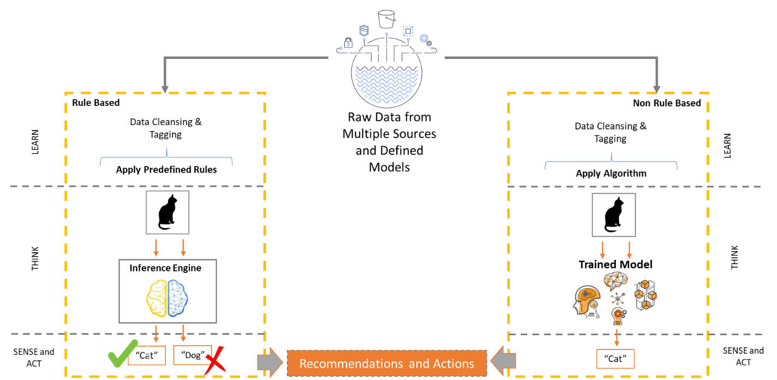
Figure 1: Rule, Non Rule Based Computation Approaches
The research of the implementation of the application of machine learning to financial risk management is a complex one. This necessitates that the research is advanced in phases, allowing the research to:
- Attain the specific data required for the phase as well as customise the approach for each phase
- Analyse the outputs from the previous phase and adjust the approach, identify the area that requires focus and to create new baselines.
The proposed approach that the research will follow will focus on four main phases:
- Discovery phase: This phase will look at the understanding the prescribed financial risk models applied in the institution, understand the regulatory reporting requirements and conduct a literature review.
- Definition phase: Focuses on the creation of expected results (initial baseline), defining the approach for the research and collecting the initial data required for the ML model.
- Development phase: This phase is important at the training and refinement of the model, creation of a refined baseline and extend the data processed through the model.
- Results phase: Analysis of the outputs of the trained model versus the baseline and the development of the recommendations.
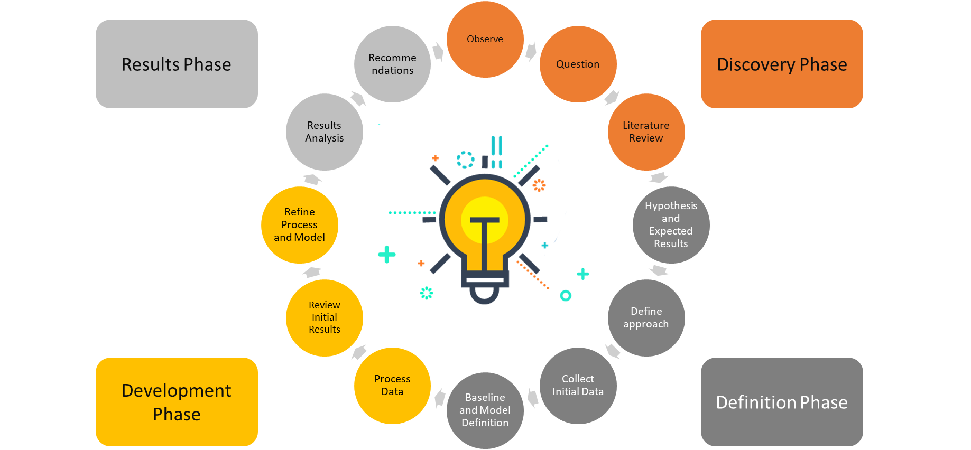
Figure 2: Research Approach and Phases

Acquisition and Selection of Data
Selection of Respondents
There are many financial institutions that utilise machine learning and A.I. in managing most of their operations. Furthermore, these organisations also apply the same technology to protect their resources. Therefore, in the selection of respondents for the qualitative data collection, the researcher will consider organisation that have a robust financial system and one that operates to enhance the performance of the organisation. The respondents of the research will as such be chosen based on their effectiveness in achieving results in regard to how effective their performance portfolio is in regards to service delivery in the financial system. The operations of the organisation are to evaluated based on the impact that machine learning has on the effectiveness of financial risk management. The selection of the respondents as such will consider financial institutions that serve a broader market with the use of A.I. as its primary security system. The research will also consider how effective the resources are in achieving decision making based on the effectiveness of the organisation.
Research Time Frame
For the achievement of reliable results, the organisation will consider implementation of sufficient results based on the impact this approach has on the financial institutions. Therefore, as described the research will be conducted in four phases. Discovery phase reliable time frame would be a period of two months which will allow for effective analysis of prescribed models, interview the SMEs and conduct the required literature reviews. It is challenging to accurately determine the time frame for the next phases but instead they will be weighted according to the importance of the phase and the work load required as follows, definition phase 30%, development phase 60% and results phase 10%.
It is important in establishing the foundation of the research and therefor time is not the measure for the research but instead will be in the reliable information provided on how the A.I. helps to reduce risks that may occur in the form of liquidity, market and operational risk.

Training of the Model
One of the ways of improving the intelligence core of an AI is by using no-based computation which is used mainly in machine based algorithms used in learning. This is because of how flexible it is to allow machines autonomous ability to be able to pick data sets of samples and use them to give a prediction without being given predetermined instructions. As earlier identified, there are four kinds of algorithms which are used in machine learning and they include those that supervise, unsupervised, semi-supervise and those that reinforce learning
The supervised learning algorithms: This kind of ML algorithms are guided by human beings who implement the relationships between each input variable of data and all other inputs of variables which are involved.
The unsupervised learning algorithms: in contrast, the patterns identify specific cluster of data that is unlabelled and does it automatically. These algorithms are only designed in a way which they can learn to determine if there are patterns in data or whether there are structures which exist.
Semi-supervised Learning: This type of ML is utilised in the case where the data sets are labelled partially. Semi-structured learning algorithms are used to combine both the supervised and the unsupervised algorithms to either check if there is a structure or pattern used in the input variable (Jacobs Jr, 2018). The approach also assists people to predict data that is unlabelled and input them back into the model to be used as data used for training the ML.
Reinforcement Learning: This is the last type of machine learning which determines the optimal behaviour of based on the response provided by the environment. The reinforcement learning models provide incentives for machines to optimise the behaviour of provision of positive feedback. This teaches the ML to learn to move towards a specific behaviour which is preferred.
Many of the traditional AML (Anti-money laundering) systems which are rule-based can identify a very big percentage of transactions which are deemed suspicious. A lot of human effort is used to determine which of the transactions are seem as suspicious but may not be so (Jacobs Jr, 2018). ML can be used to determine which transactions are false positives and save the human effort. This problem can be solved with ab effective implementation of the A.I. with labelled historical background in banking transactions that train data. Given the nature of supervised learning, continuous modelling of the new patterns that are not available with the existing data.
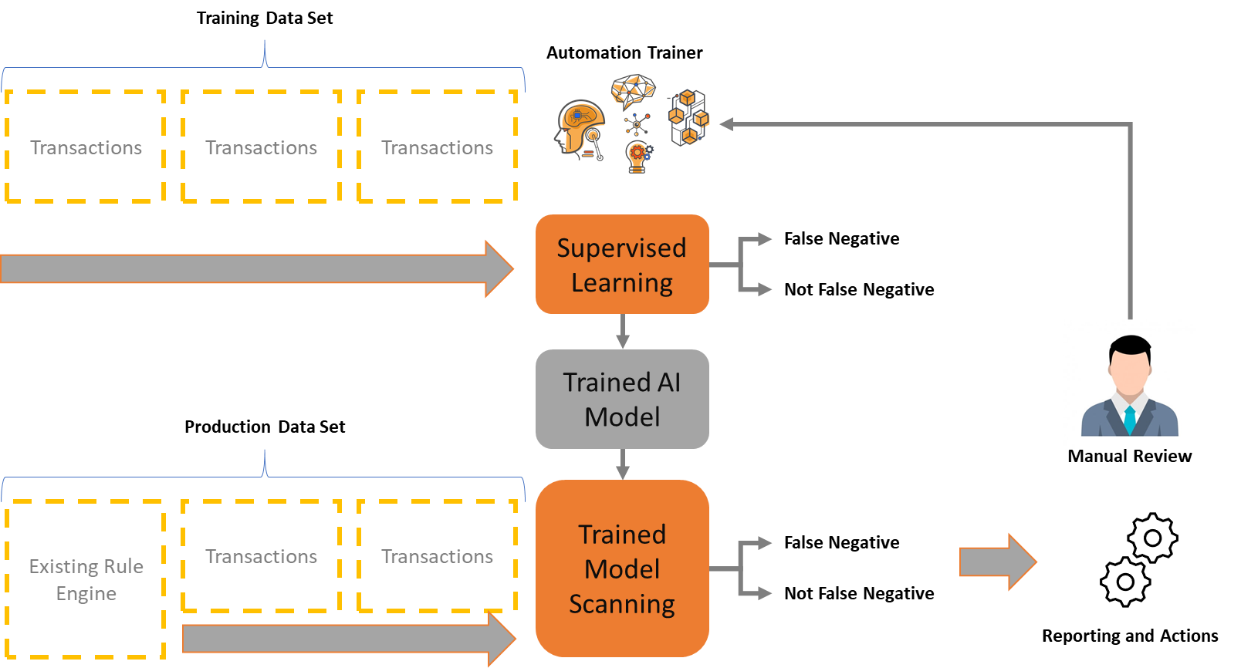
Figure 3: Correction of the Problems Identified with Supervised Learning
On the other hand, the banking sector can use the cluster and the unsupervised learning methodologies which don’t require humans to label them to determine the most important transactional features or patterns in opening new accounts, applying for loans and a variety of other transactions in the bank. The most clustered ML algorithms can provide a lookalike transaction whose similarities in behaviour can be alike. These factors are set to be the standard by which to measure how normal a transaction is. The abnormalities are then determined to be the outlying factors which don’t have a membership strong enough to be in put in any of the group clusters.
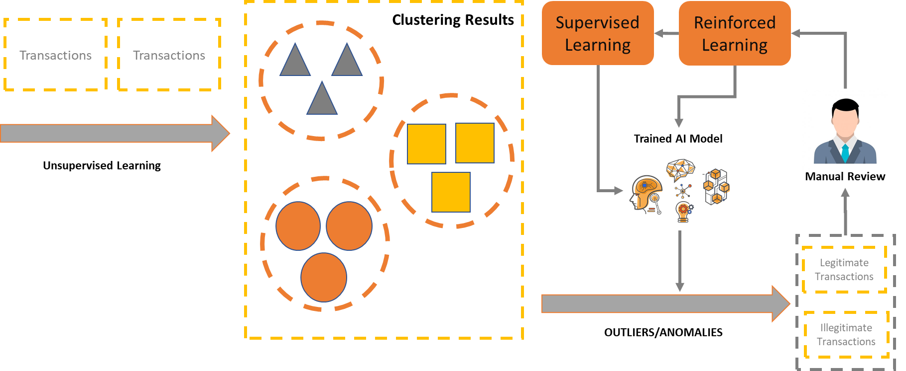
Figure 4: Clustering and unsupervised learning methods
For an abnormality detection fraud model system to be trained it has to be able to determine and create an automated notification to the user of the deviations it recognises that are outside the normal patterns. The staff in the operational environment will then have to identify whether the transactions are legitimate or not. Any alerts that are false can be set to be feedback to enable the machine to have a higher accuracy level by using learning by reinforcement

Evaluation and Training of the Model
Assessing and Measurement of A.I. Implementation
The implementation of A.I. solutions requires a keen look into the accurate and measure governance issues. Introduction of a toolkit to do implementation of the interpretability aspect, explain ability, robustness and security which manifests fairness in the implementation of A.I.
Interpretability or Explainability
The banking sector should think about implementing enough measures in the design phases which will ensure a certain level of the ability to explain how the materiality of the AI and its ability to be commiserated and appropriate Financial institutions should consider various factors during the implementation and building of an unexplainable A.I.
Level of Expansibility Confirmation
This factor identifies the verification and validation process for the different A.I. use in the case of expansibility. This is also evident in the context of explainability for the A.I. recommendation for an A.I. based recommendation system. This approach might be seen to be significant and higher because of errors which may be therein which may not have led to losses in investment but have caused reputational damage.
Start of the Design Phase
The people doing the development should consider how capable the systems are in the early stages in the design phase of the development. This approach will affect the choice of A.I. algorithm implemented in most financial institutions will determine the way the data will be processed, and which type of data will be collected.

Interpretation and Deploying of the solution
Big Data infrastructure to store learning data
Scientists who deal specifically with data science describe big data as having five specific dimensions and they include volume, veracity, value, velocity and variety dimensions. Volume is the amount of data which is produced every single second, veracity is how accurate and how the amount of quality the data has, The value is described as the short hand of the value of the data that is being collected and analysed, the velocity is the amount of speed being used to generate the data and the variety is the different kinds of data which are unconstructed and finally the veracity is described as how accurate and how qualified the data is.
The infrastructure needs have to consider the following factors:
- The efficiency of the data being transmitted with 5G computing
How efficient the exchange of data is would ensure that the enabler is able to successfully implement an A.I. especially with real time application. Edge computing and technology with effective implementation of significant exchange of information and resources which also reduces real-time exchange of data communication.
- Sentiment analysis
Machine learning algorithms have an increased ability for sentiment analysis, and this will continue to influence trading in the future. This is the perusal of large volumes of data that isn't structured such as videos and video transcriptions, social media posts, web pages, presentations, blogs and articles, and business documentation to find out the sentiment of a market (Jacobs Jr, 2018). This helps companies to understand what opinions people have and what they mean by voicing their opinions. It is very important for leaders in Business in the workplace and an excellent example of artificial intelligence in the finance field (Jacobs, 2018).
Human beings most often than not trade with intuition, but machine learning uses the abundance of the information at its disposal and do not require to use intuition and their forecasts are usually based on real time occurrence and accurate analysis. They can also monitor transactions including investigating alerts that pop up. These new technologies will play a very big role in the field of antimony laundering and ash for terrorism and can be used in conjunction with human judgement while implementing these processes. This damages their reputation in the business community and these institutions have to be strict to ensure financing of terrorism and combatting money laundering (Jacobs, 2018). Machine learning can be used to analyse know your client information to ensure due diligence is done to ensure effective analysis of client profiles for instance verifying the source of funds.

Sampling
The research will collect data at three points within the study these being
- Definition Phase - Collection of data to shape the approach and to get a better understanding of the models and how they are used.
  - This will be done by non-probability sampling from a group of respondents within the Asset Liability Management business unit. These respondents will be Subject Matter Experts (SMEs) with in the area
- Design Phase - Collection of data for the initial training of the model
  - This will be done by non-probability sampling from a group pre-existing data that has been used to report current liquidity. This will allow for the supervised training of the machine learning model
- Development Phase - Collection of data for the application of the new learnt capability
  - This will be done by simple probability sampling from a large selection of data sources. This will allow the research to validate the model learning and as well as extend the learning further
- Results Phase – Collection of data on the results of the Trained Model
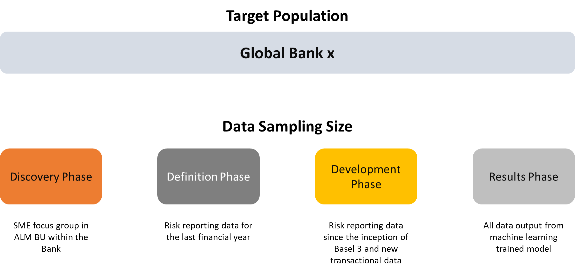
Figure 6: Data target population and sample size

DATA COLLECTION, ANALYSES AND REPORTING

Theoretical Framework
This section provides an evaluation of the relevant theoretical foundations and how they affect the financial industry. The chapter will focus on the context of the experiment’s framework is through the analysis of the questions discussed below:
- What process will be used to classify the various risk factors financial institutions face?
- The application of risk analysis through machine learning and the different approaches reliable and available for this analysis?
- What are the most appropriate metrics that can be used as a measure for machine learning and its effectiveness?
- What factors will distinguish the implementation of machine learning in the administration of financial risk?

What process will be used to classify the various risk factors financial institutions face?
Increased risk is among the factors that come at the cost of bank management in the pursuit of increased returns for the investors. Any business and especially the financial institutions are affected by several threats as an example liquidity, credit and market risk. Capital is essential for the mitigation of risks and especially in the implementation of practical approaches and strategies to acquire results. For most of the financial institutions, the credit risks have been the most influential for the organisations and normally the one requiring the greatest investment to implement (Gokul, 2018) effectively. Market risk can be defined as risks involved with such as foreign exchange risk, equity risk, interest risk and commodity risk. The threat of possible damage to the financial institution were the debtor fails to meet its responsibilities.
In certain instances, banks have described legal and compliance risk also under non-financial risk.
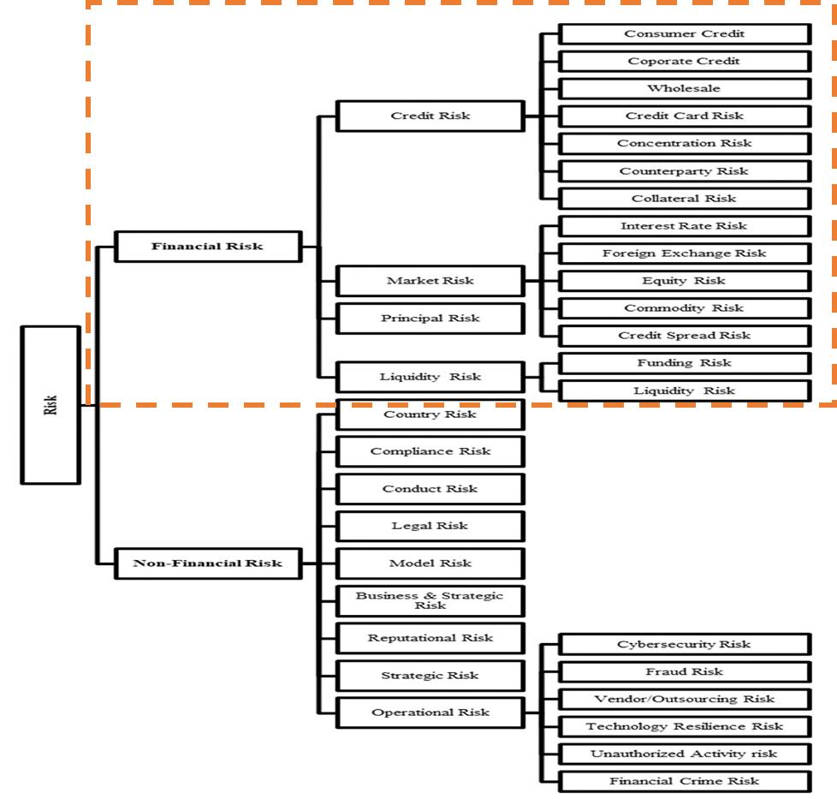
Figure 7: Financial Risk categorisation, with emphasis on the categories covered in the study

The application of risk analysis through machine learning and the different approaches reliable and available for this analysis?
The Planning Process - The bank will first have to identify the highest artificial intelligence opportunities which are aligned to their business strategies. They will then decide which A.I. solutions should be deployed and since artificial intelligence has a heterogeneous nature there usually isn’t a standard method to evaluate the various business cases.
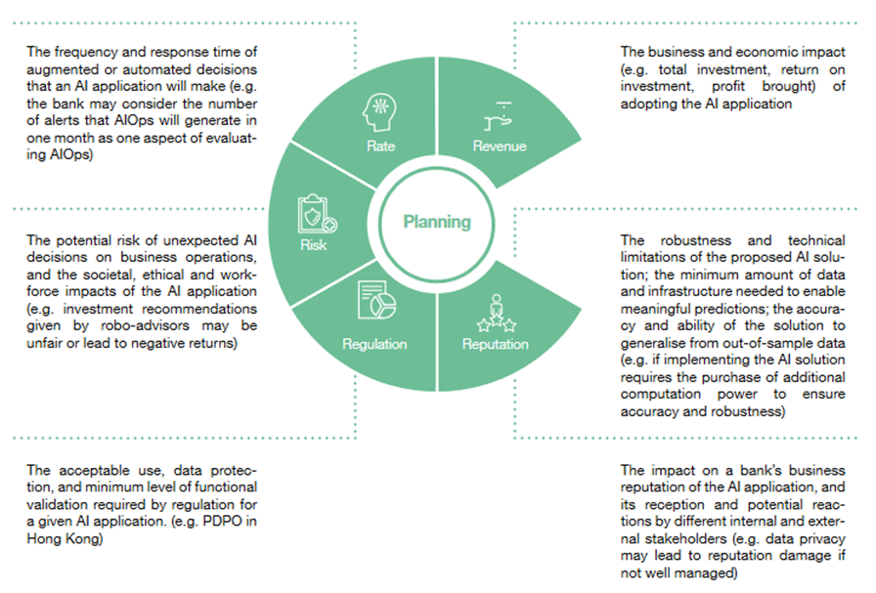
Figure 8: A.I. Planning process considerations
The bank needs to follow a very agile, well governed deployment and development lifecycle. This will include the following steps: Acquiring and selecting data, Training of the model, Evaluation and training of the model, Interpretation and deploying of the solution
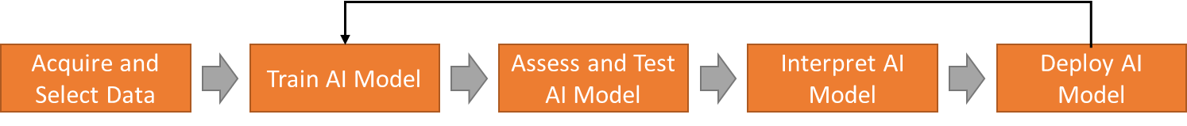
Figure 9: Steps in Development and Deployment of the AI/ ML Solution
Step 1
This entails definition, collection and preparation of all data that will be relevant in training the model. The selected information will be split into training and testing data.
Step 2
Selection of an algorithm and usage of the selected data to do training of the AI/ ML model. It is common for an AI/ ML algorithm to have a number of open source libraries and tool available for it to use as its very common for newer analytics processes to build models which utilise different packages and tools to give different performance and results. Lack of an integrated model in the development environment would result in a kind of version control and resulting effect would be inconsistency and error.
Step 3
The model is then checked for accuracy and fairness of results. This is where the testing data is utilised. This will allow the risk group to discover in what way the model would work on unseen information in the real world.
Step 4
This entails deployment of the trained model. All new ML/ AI models are constantly deployed and updated. A fool proof handover process should be implemented to prevent disruption of services in the current processes. This should be completed by doing a programmed uninterrupted test prior to deploying it. With more user response and real data, the model will be able to be adjusted and continuously enhanced.
What metrics will be used to measure machine learning risk analysis quality?

What are the most appropriate metrics that can be used as a measure for machine learning and its effectiveness?
The AI/ML solution requires monitoring and calibration because it is governed by tech risk management and explainable principles. The model review cycle will be designed in a comprehensive way to cover the whole model ecosystem. Constant periodic reviewing of the system will be done to ensure that the system was implemented robustly and manages cyber threats.
This includes revaluating the data and its sources, reviewing the models, and the contingency measures for example the human interventions and use of conventional processes and systems. Safeguards will be introduced for example scenario planning to prevent unintended interaction (Gokul, 2018). At this stage the model results should only be affected by production data that has accumulated so fairness and quality of the input data should be maintained.
The key foundation for building a responsible AI/ML is end to end governance of the solution. Chat box decisions will be made by the AI/ML, but the board or management will still be held responsible for all its decisions. It is critical in ensuring that it’s compliant to all the risk and governance frameworks the following considerations should be done:
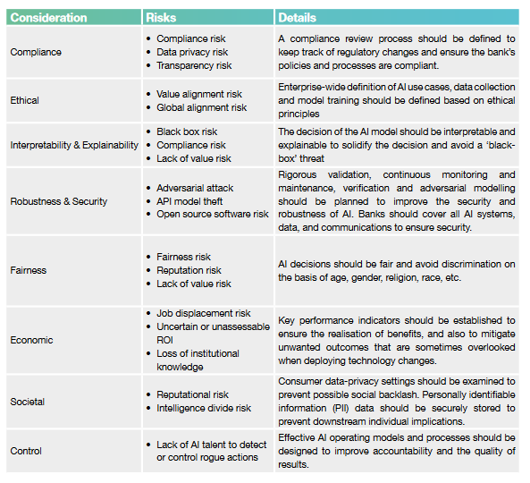
Figure 10: The Risk Management framework for the AI/ ML

What factors will distinguish the implementation of machine learning in the administration of financial risk?
Compliance is the most important thing when setting up these considerations since the banking sector is highly regulated and because AI/ML will shape the future of how they conduct business. Since the banks will require vast amounts of client data to train the AI/ML application banks globally will have to ensure they are compliant with the data regulation in dealing with customers personal information and any other relevant practices which have been approved or issued by the Commissioner of Privacy for Personal Data (PCPD) and other statutory regulations that have been given in by overseas or local practice guidelines. The bank Business units are supposed to develop, use and implement AI/ML solutions that can be defended ethically.

Proposed Data Collection and Processing
The data collection process is conducted at each phase in the research. The data that is output of each phase will be used as the input or refinement into the next phase
Data collected in in each phase will be used as follows
- Discovery phase data will be used to define the approach, document the expected results to define the initial machine learning model
- Definition phase data will be used to collect the initial data (Baseline), conduct initial runs of the ML model and refine any expected results
- Development phase final data (Baseline) will be used to validate the effectiveness and accuracy of the model
- Results phase data (Baseline) will be used to validate the results of the Machine Learning output versus the created baseline
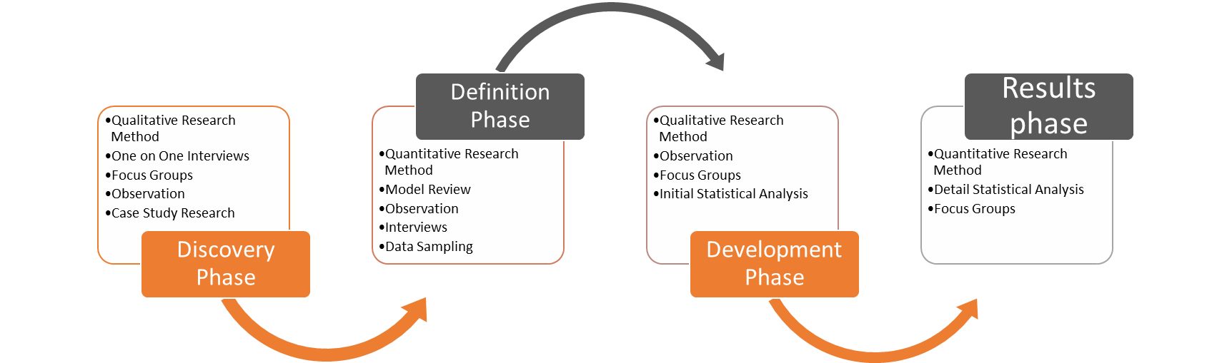
Figure 11: Approach to Data collection per phase
As part of the analysis of the results to validate the effectiveness of the machine learning process a baseline is required to measure the deviation from the mean and identify areas for improvement and additional focus.
The initial baseline to be created in the definition phase will include a baseline for capital requirements, liquidity and leverage ratios. In the creation of the baseline it is accepted that the minimum value would be the prescribed Basel III measures but in scenarios that the current bank reported values for capital requirements, liquidity and leverage ratios are more conservative then this value becomes the baseline value
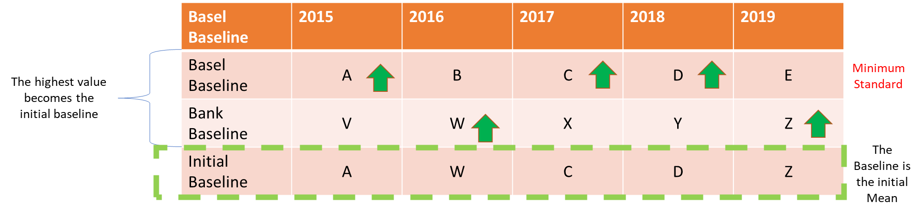
Figure 12: Initial baseline creation
Post the initial run of the machine learning solution and the analysis of the results, the area of focus and improvement becomes clear.
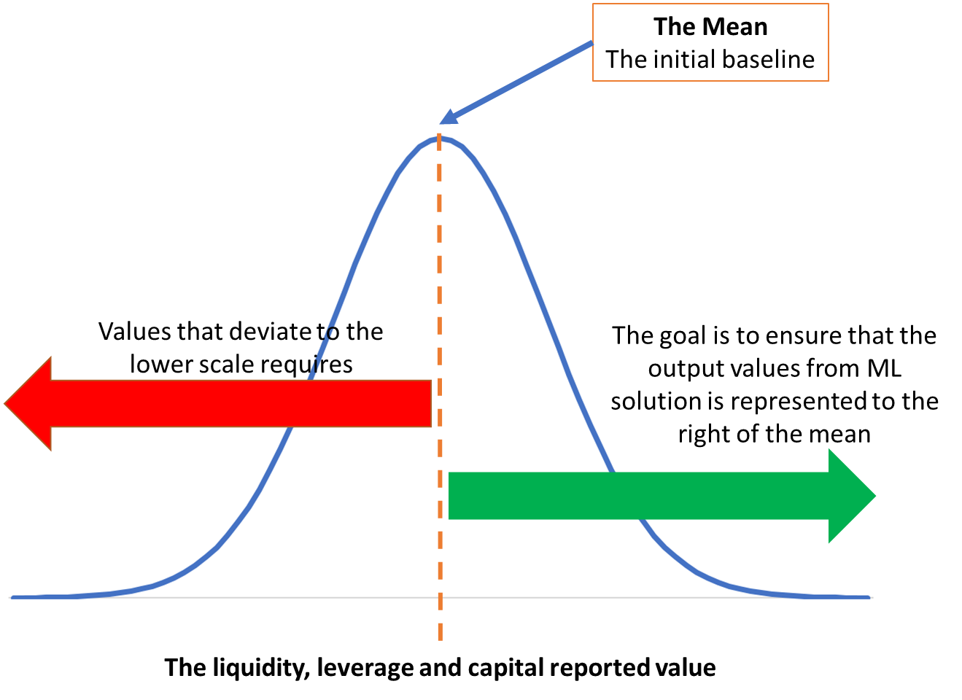
Figure 13: Liquidity, leverage, and capital deviation from the mean
The area that requires improvement will be refined further in the machine learning model to achieve baseline value. Any value that is more conservative than the baseline becomes the new baseline value.
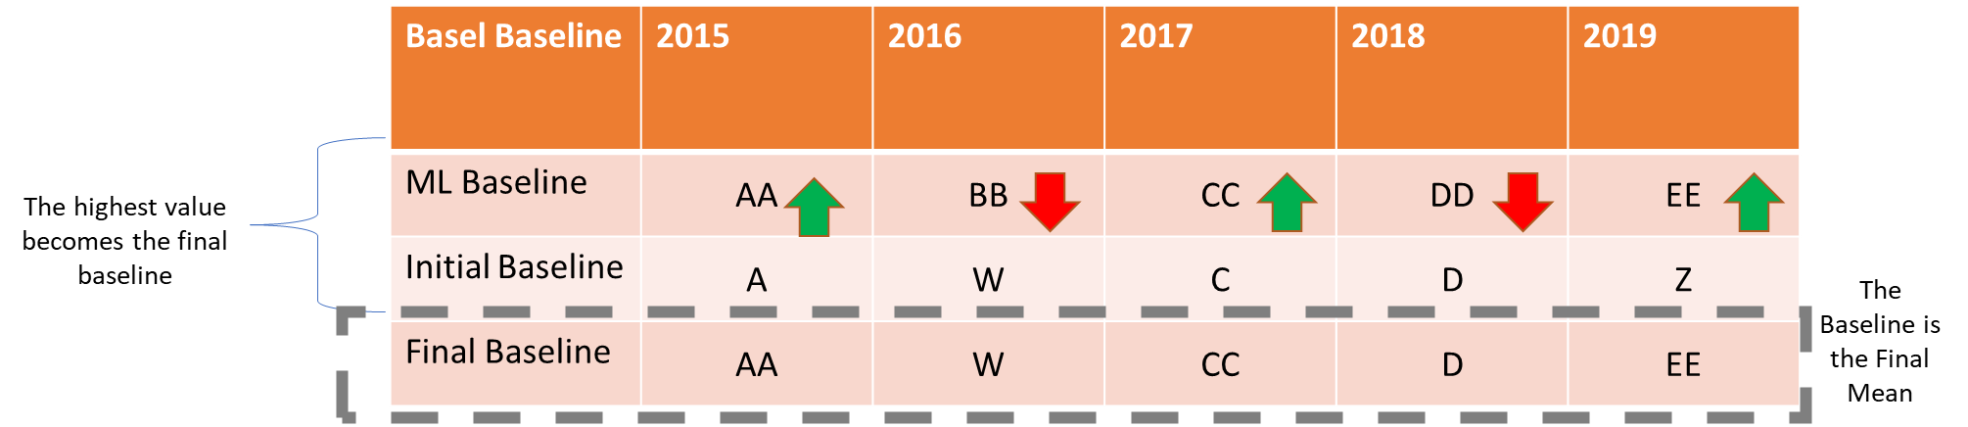
Figure 14: Refined baseline creation

CONCLUSIONS
Evidently, machine learning plays a major role in the performance of most of the financial institutions across the globe. This is in regard to how effective the application of the A.I. is and its reliability in today's financial system. The evaluation of the use of the machine learning tools is that they allow for the effective implementation of resources as well as reliability in data. The use of data especially in the financial business environment is key in not only promoting performance of the Business but also the organisation performs in the right way.

REFERENCES
Aziz, S. and Dowling, M., 2019. Machine learning and A.I. for risk management. In
Disrupting Finance (pp. 33-50). Palgrave Pivot, Cham.
Bussman, N., Giudici, P., Marinelli, D. and Papenbrock, J., 2019. Explainable A.I. in credit
risk management. credit risk management (December 18, 2019).
Gokul, B., 2018. Artificial Intelligence in Financial Services. Sansmaran Research Journal, 8(1), pp.3-5.
Holzinger, A., Kieseberg, P., Weippl, E. and Tjoa, A.M., 2018, August. Current advances,
trends and challenges of machine learning and knowledge extraction: from machine
learning to explainable A.I. In International Cross-Domain Conference for Machine
Learning and Knowledge Extraction (pp. 1-8). Springer, Cham.
Jacobs Jr, M., 2018. The validation of machine-learning models for the stress testing of credit
risk. Journal of Risk Management in Financial Institutions, 11(3), pp.218-243.
Jagtiani, J., Vermilyea, T. and Wall, L.D., 2018. The roles of big data and machine learning
in bank supervision. Forthcoming, Banking Perspectives.
Kou, G., Chao, X., Peng, Y., Alsaadi, F.E. and Herrera-Viedma, E., 2019. Machine learning
methods for systemic risk analysis in financial sectors. Technological and Economic
Development of Economy, 25(5), pp.716-742.
Mayenberger, D., 2019. How to overcome modelling and model risk management?
challenges? with artificial intelligence and machine learning. Journal of Risk
Management in Financial Institutions, 12(3), pp.241-255.
Punniyamoorthy, M. and Sridevi, P., 2016. Identification of a standard A.I. based technique
for credit risk analysis. Benchmarking: An International Journal.
Wall, L.D., 2018. Some financial regulatory implications of artificial intelligence. Journal of
Economics and Business, 100, pp.55-63.

APPENDICES

EXPECTED SCHEDULE
The researcher will have weekly scheduled meetings with his supervisor to track progress and troubleshoot any major issues. The researcher will also be consulting regularly with graduate students working within the course and other related projects.

